**FAST RATES FOR SUPPORT VECTOR MACHINES USING GAUSSIAN KERNELS**

Ayush Raj(IIT2018188), Harsh Bajaj(IIT2018190), Utkarsh Priyam(IIT2018197)

*VI Semester B.Tech, Department of Information Technology,*

*IIIT-Allahabad,Prayagraj, India*

***Abstract: This assignment discusses some optimization techniques to set up faster learning rates for a greater variety of distribution in SVM.***

1. **INTRODUCTION**

With very wide usage of numerous theoretical considerations, support vector machines have evolved greatly in recent years, but the learning performance still shows a lot of scope for improvement. We learnt concepts of Tsybakov's noise assumption and like local Rademacher averages to improve learning rates to as low as n -1 for some distributions.

1. **ALGORITHM**

Let T be training set   
Let C be classifier using ct

Y =( X ｘ Y)ⁿ  
T = { (x1 ,y1),...(xi ,yi),...(xn ,yn) } ƛ Y

Let f variable which is free.  
ct : X→R

1. We take gaussian kernel

P =|| x-x’ ||  
lf(x,x’) = exp(-Ω2 p22)  
where (x,x’) ƛ Y  
  
lf here is the RBF gaussian kernel The above would be valid for : f>0

1. Find gaussian sub-branch  
   Say s = {A,ƛ,e}  
   We calculate space of number ,  
   N(s)

= min{z ƛ Z},  
where Z={n>2 :g(s)∃x1,...,xn}  
  
where A⊂B is branch subset of B, which the super-branch.

1. On the sub-branch A,which is subset of E, we run the SVM with the following check condition : ⍴>2δ0.5  
   where ⍴ is calculated deviation.
2. Percentage error in output-  
    R(x) = 1 - e-x
3. **RESULT AND OUTPUT**

The algorithm successfully runs with different kernels printing the accuracy. The screenshot of the accuracies is at Fig 1.

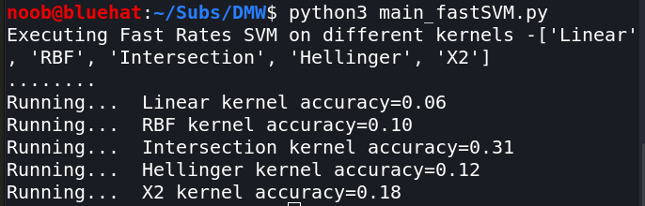

**Fig 1.**

1. **CONCLUSION**

We have discussed the geometric noise assumption that is proposed by the authors and how they are used to determine the properties of gaussian kernels which are used to describe the concentration of the measure |2n - 1| d Px - Px here is the marginal distribution of P wrt x.

1. **REFERENCES**

[1] Steinwart, Ingo and C. Scovel. “Fast rates for support vector machines using Gaussian kernels.” Annals of Statistics 35 (2007): 575-607.

[2] Auria, Laura, and Rouslan A. Moro. "Support vector machines (SVM) as a technique for solvency analysis." (2008).

[3] Ring, Matthias, and Bjoern M. Eskofier. "An approximation of the Gaussian RBF kernel for efficient classification with SVMs." Pattern Recognition Letters 84 (2016): 107-113.

[4] Lin, Yuanqing, et al. "Large-scale image classification: fast feature extraction and svm training." CVPR 2011. IEEE, 2011.