**National Institute of Technology**

**Warangal**

**Lab 3 Assignment**

**Name: Ayush Rana**

**Roll Number: 24CSM2R05**

**Course Title: Data Privacy**

**Department: Computer Science and Engineering**

**Program: M. Tech in Computer Science and**

**Information Security**

**Semester: 2**

1. Implement any 3 Perturbation Techniques to preserve data privacy.

**1. Additive Noise Perturbation**

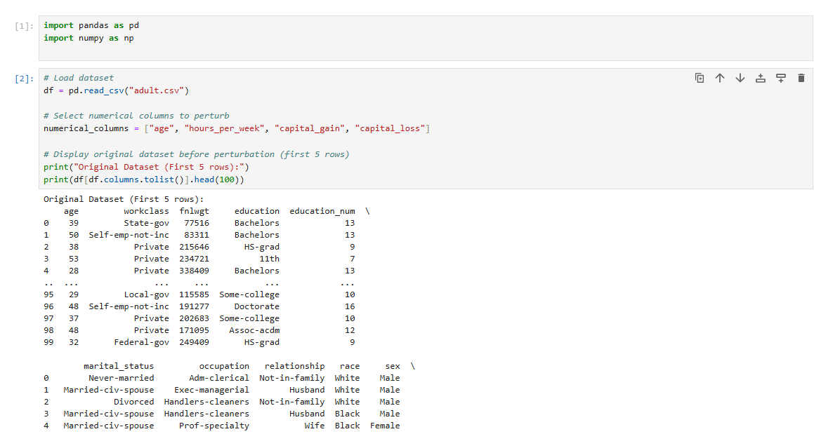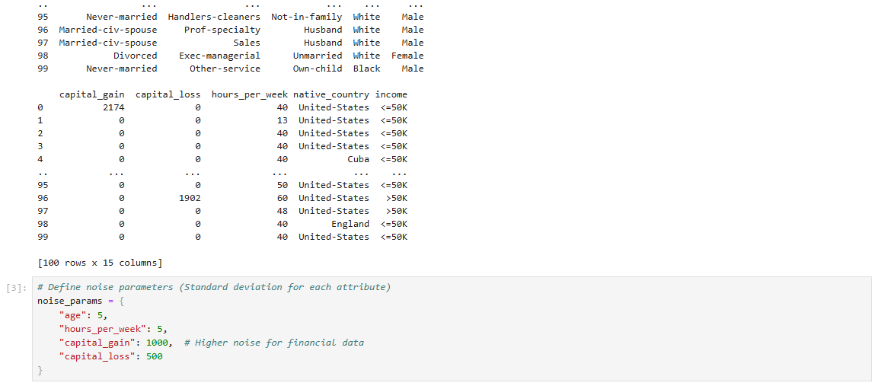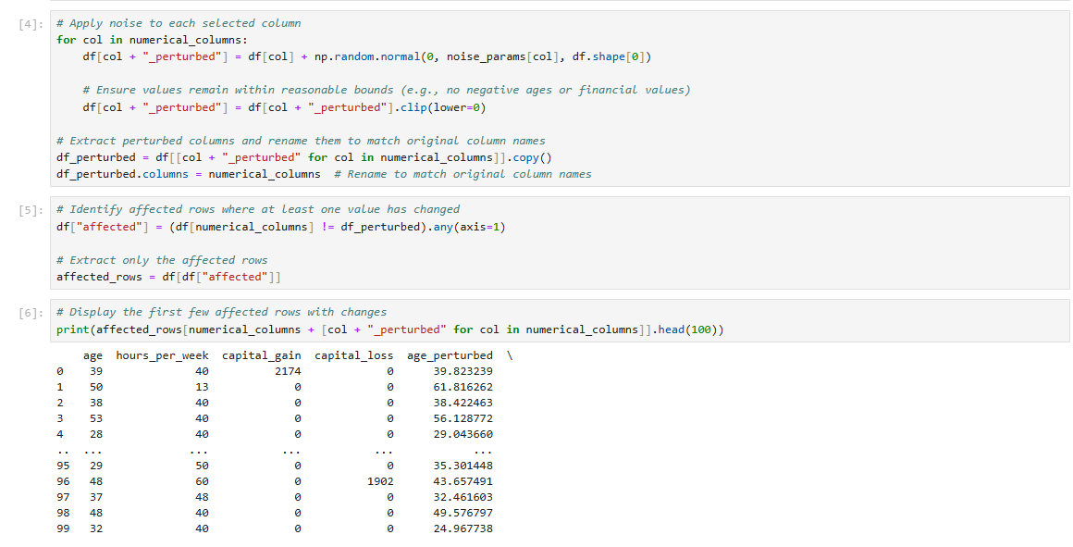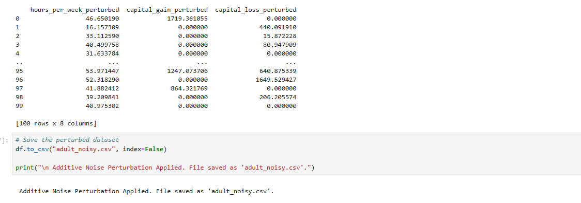

**2. Randomized Response (Data Swapping)**

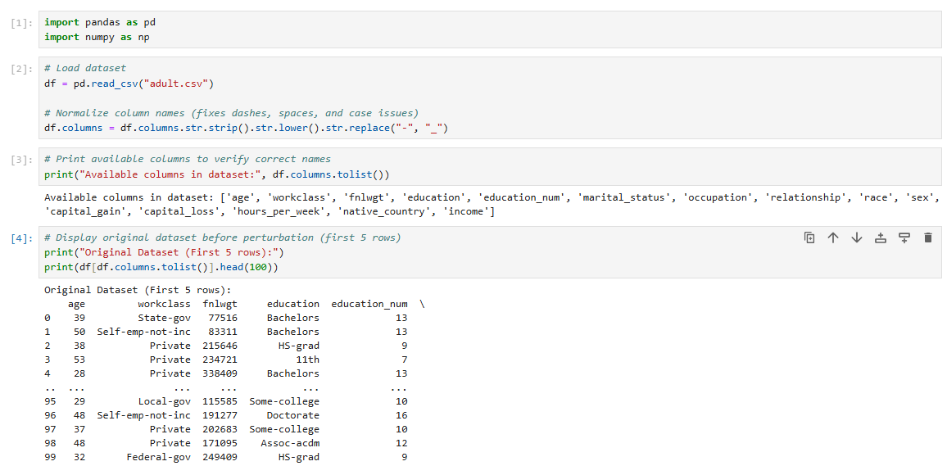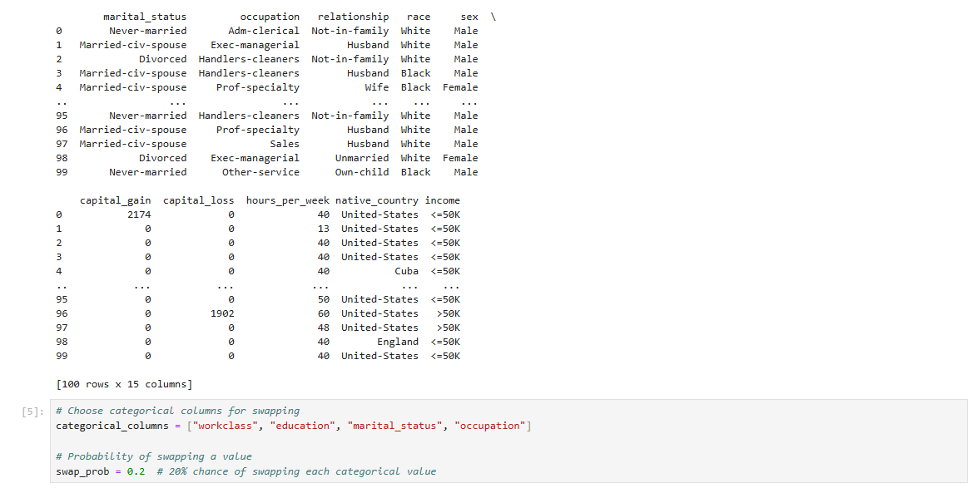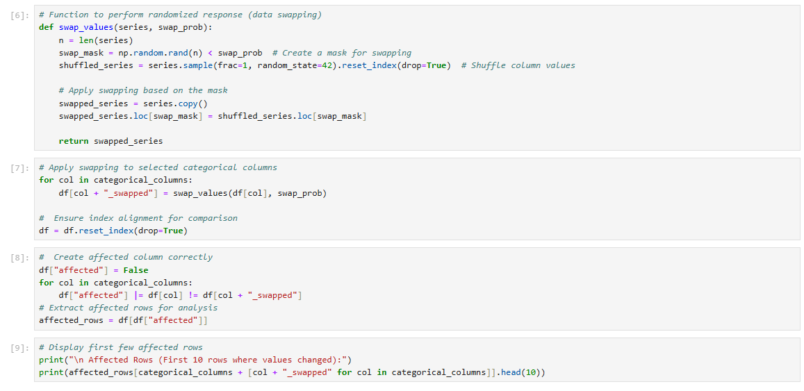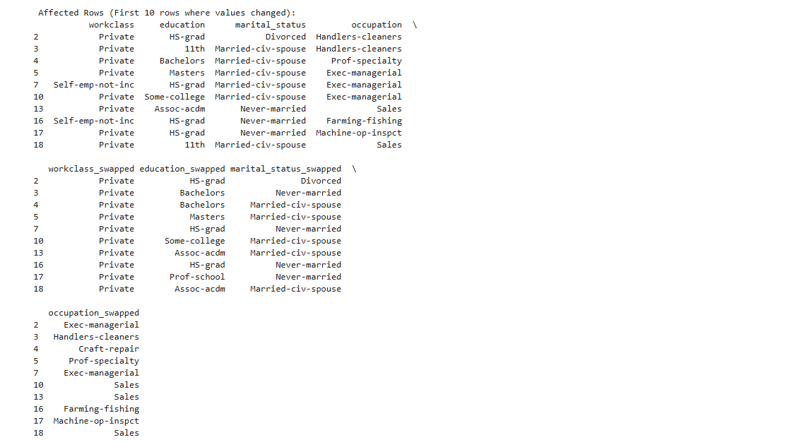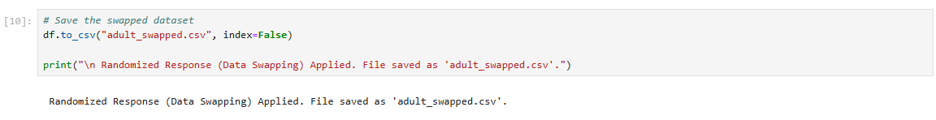

**3. Microaggregation**

