**National Institute of Technology**

**Warangal**

**Lab 1 Assignment**

**Name: Ayush Rana**

**Roll Number: 24CSM2R05**

**Course Title: Data Privacy**

**Department: Computer Science and Engineering**

**Program: M. Tech in Computer Science and**

**Information Security**

**Semester: 2**

**1. Implement K-Anonymization for the Dataset given in below link. ( Assume K =2,3,4 etc )**

**CODE:**

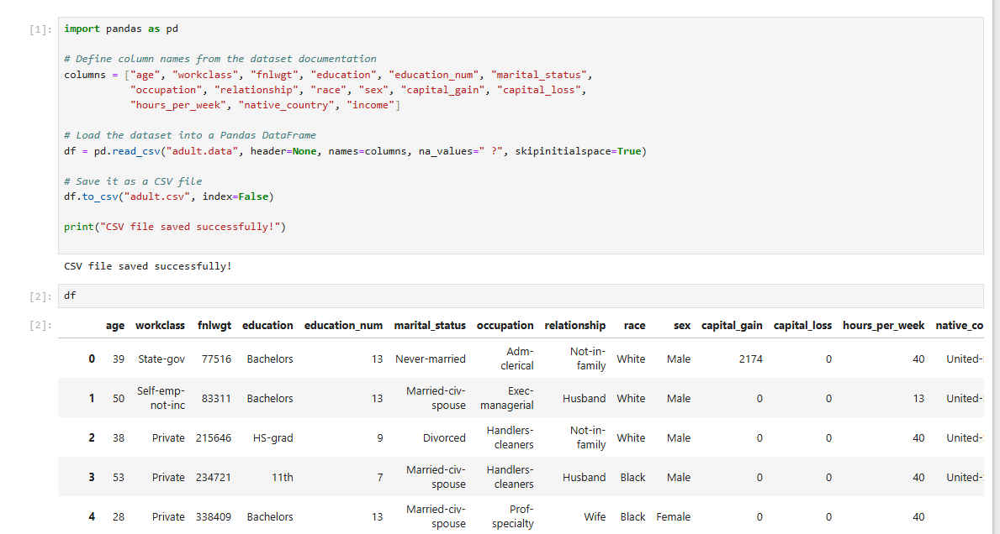

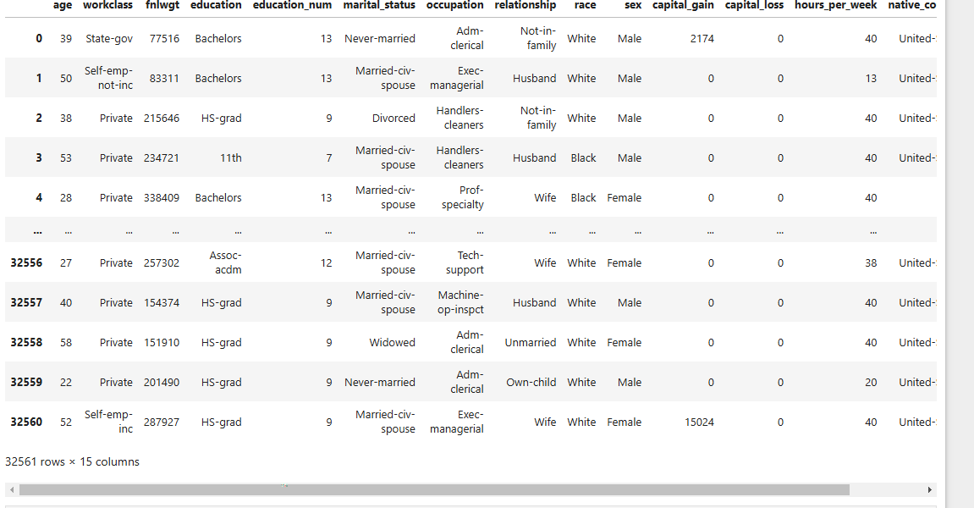

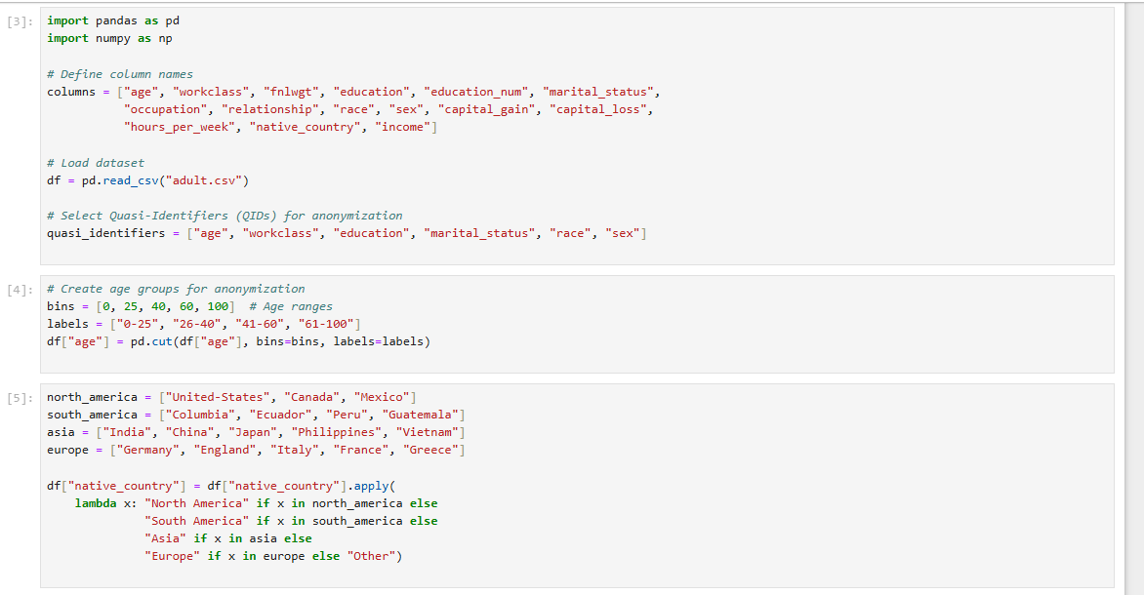

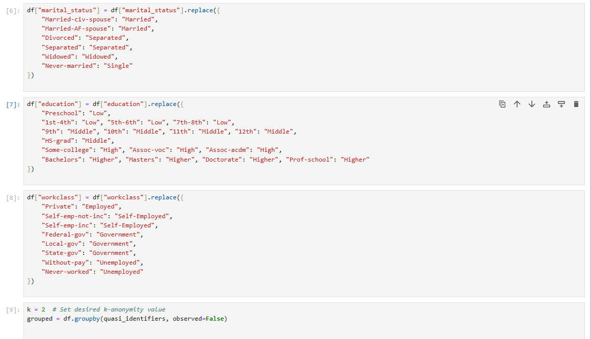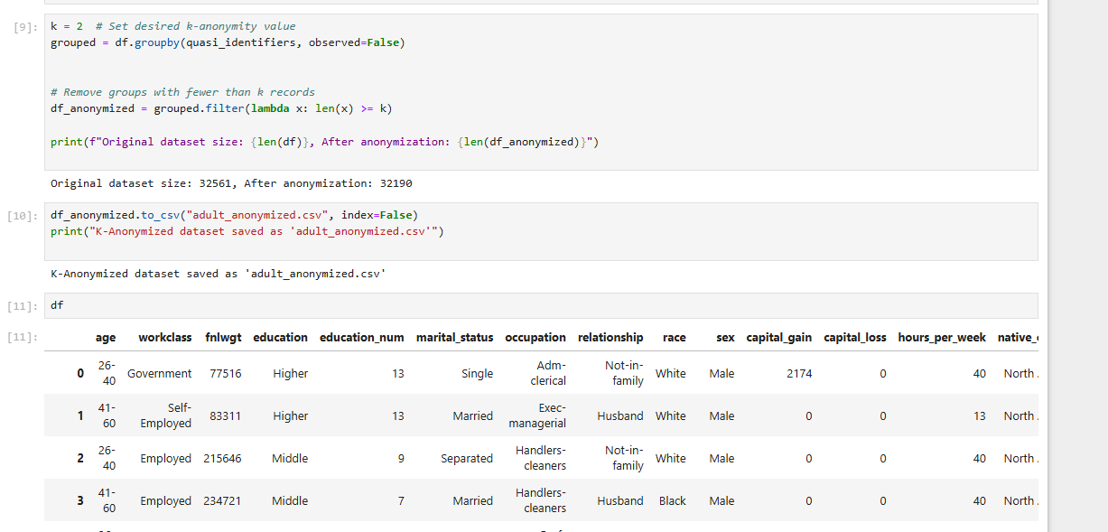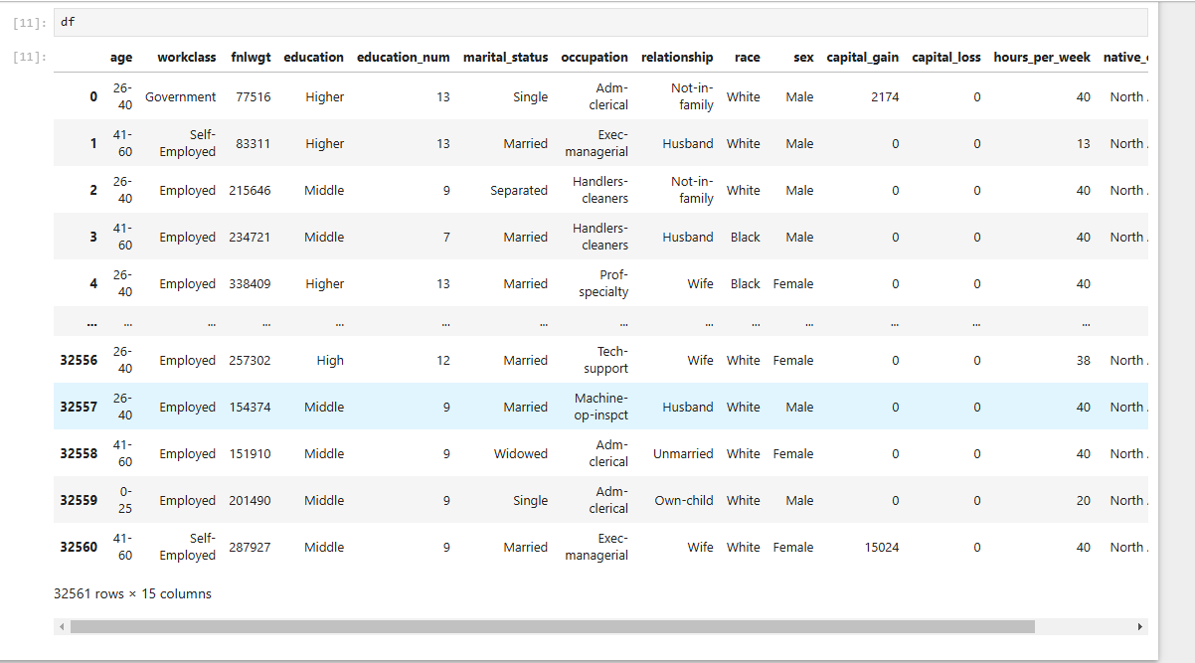

**2. Implement the K-Anonmization technique using Full Domain Generalization mechanism.**

**Code:**

