**National Institute of Technology**

**Warangal**

**Lab 2 Assignment**

**Name: Ayush Rana**

**Roll Number: 24CSM2R05**

**Course Title: Data Privacy**

**Department: Computer Science and Engineering**

**Program: M. Tech in Computer Science and**

**Information Security**

**Semester: 2**

**1. Implement (X,Y) -Anonymity for the adult data set via code.**

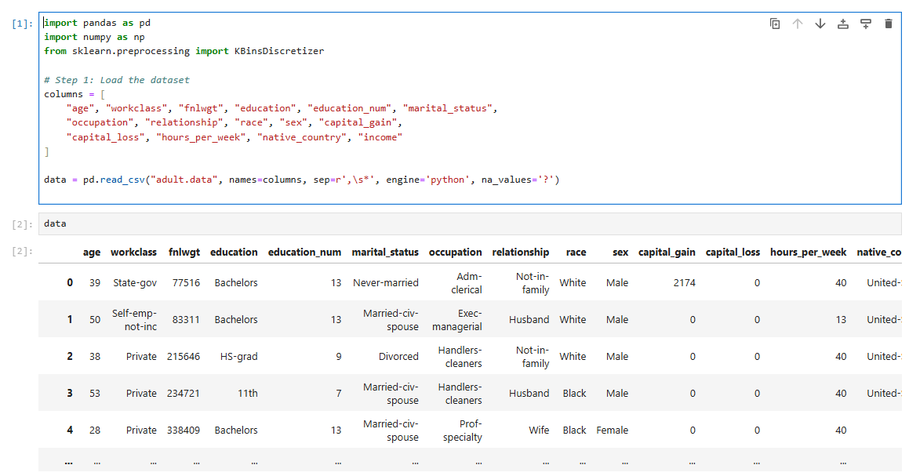 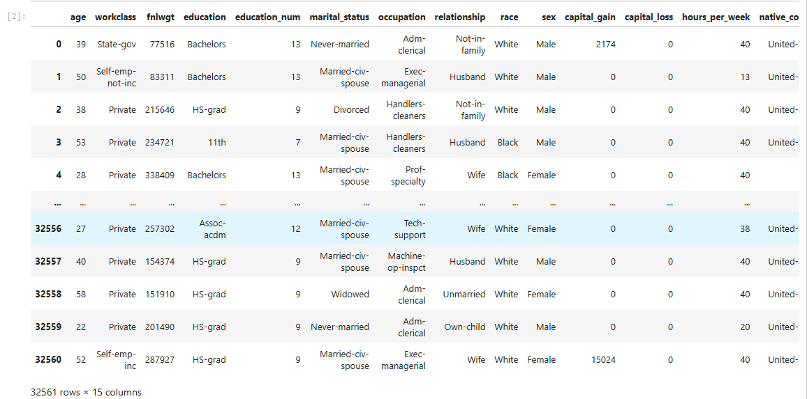 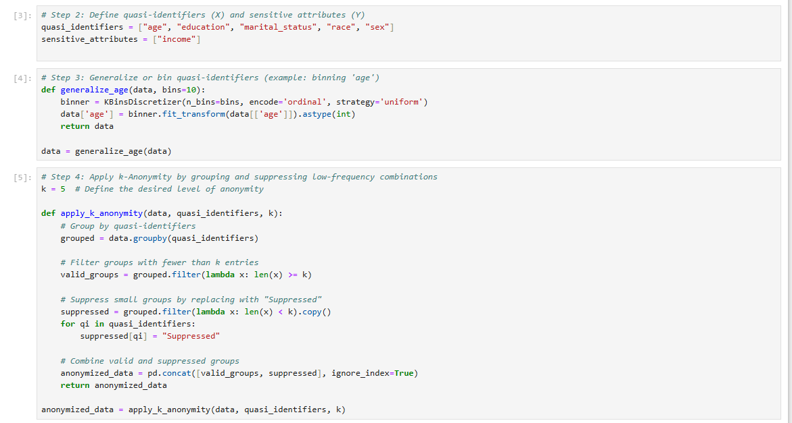 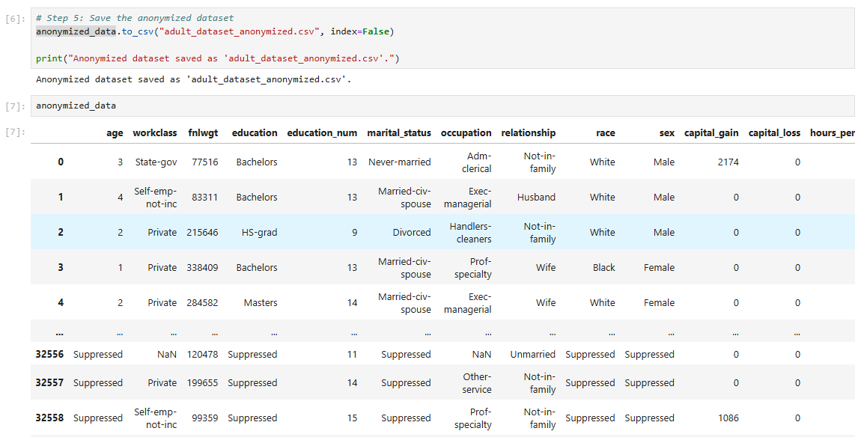 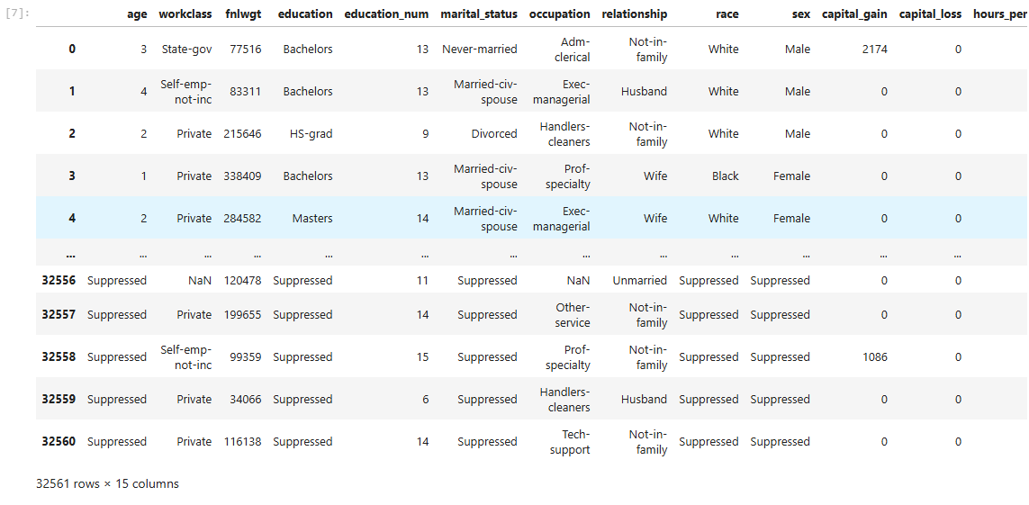

**2. Implement (X,Y) -Linkability for the adult data set via code.**

 