
Progressive Education Society's
Modern College of Engineering, Pune
MCA Department
A.Y.2022-23
410906: Web Technologies Lab
**********************************************************************************************
Class: SYMCA Shift / Div : A Batch: S1 Roll Number : 51020
Name: Vinayak M. Harmalkar Assignment No : 2 Date of Implementation : 16/09/2023
**********************************************************************************************
Q1) Create XML file to describe employee details and external DTD to it.

Program:

1) employee.dtd
<!ELEMENT employees (employee+)>
<!ELEMENT employee (id, name, department, salary)>
<!ELEMENT id (#PCDATA)>
<!ELEMENT name (#PCDATA)>
<!ELEMENT department (#PCDATA)>
<!ELEMENT salary (#PCDATA)>

<! ELEMNT employees (emplyoyee+)>
<! ELEMENT emplyee (id, name,department,salary)>
<! ELEMENT id (#PCDATA)>

2) employee.xml
<?xml version="1.0" encoding="UTF-8"?>
<!DOCTYPE employees SYSTEM "employee.dtd">
<employees>
<employee>
<id>001</id>
<name>Samira Katrin
</name>
<department>Data Scientist</department>
<salary>75000</salary>
</employee>
<employee>
<id>002</id>
<name>Anuja Athare</name>
<department>Front End Developer</department>
<salary>60000</salary>
</employee>
<employee>
<id>003</id>
<name>Mac Sadny</name>
<department>Finance</department>
<salary>80000</salary>
</employee>
</employees>

Output:

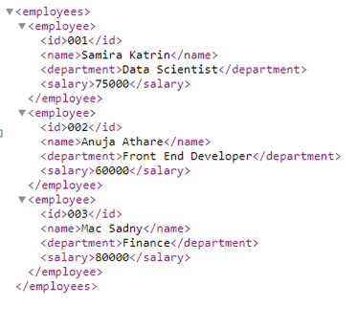

Q2) Design a DTD for an XML database of restaurants. This will check that the
XML file is well-formed and that it validates against the DTD you have given. If
the document is valid, you get no response; if invalid, you get an error message.

Program:

1) resto.dtd:

<!ELEMENT restaurants (restaurant+)>
<!ELEMENT restaurant (name, address, cuisine, rating, contact, menu?, reviews?)>
<!ELEMENT name (#PCDATA)>
<!ELEMENT address (street, city, state, zip)>
<!ELEMENT street (#PCDATA)>
<!ELEMENT city (#PCDATA)>
<!ELEMENT state (#PCDATA)>
<!ELEMENT zip (#PCDATA)>
<!ELEMENT cuisine (#PCDATA)>
<!ELEMENT rating (#PCDATA)>
<!ELEMENT contact (phone?, email?)>
<!ELEMENT phone (#PCDATA)>
<!ELEMENT email (#PCDATA)>
<!ELEMENT menu (dish+)>
<!ELEMENT dish (name, description, price)>
<!ELEMENT reviews (review+)>
<!ELEMENT review (customer, rating, comment)>
<!ELEMENT customer (#PCDATA)>
<!ELEMENT rating (#PCDATA)>
<!ELEMENT comment (#PCDATA)>

2) restaurants.xml :
<?xml version="1.0" encoding="UTF-8"?>
<!DOCTYPE restaurants SYSTEM "resto.dtd">
<restaurants>
<restaurant>
<name>Restaurant A</name>
<address>
<street>123 Main Street</street>
<city>Cityville</city>
<state>Stateville</state>
<zip>12345</zip>
</address>
<cuisine>Italian</cuisine>
<rating>4.5</rating>
<contact>
<phone>123-456-7890</phone>
<email>restaurantA@example.com</email>
</contact>
<menu>
<dish>
<name>Spaghetti Carbonara</name>
<description>Classic Italian pasta dish with eggs and pancetta.
</description>
<price>12.99</price>
</dish>
<dish>
<name>Margherita Pizza</name>
<description>Simple yet delicious pizza with tomatoes and basil.
</description>
<price>10.99</price>
</dish>
</menu>
<reviews>
<review>
<customer>Customer1</customer>
<rating>5</rating>
<comment>Excellent food and service!</comment>
</review>
<review>
<customer>Customer2</customer>
<rating>4</rating>
<comment>Great place, but a bit pricey.</comment>
</review>
</reviews>
</restaurant>
<restaurant>
</restaurant>
</restaurants>

Output:
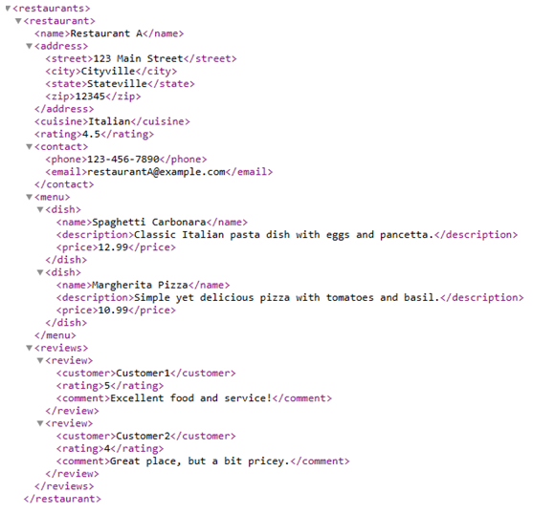

Q3.Create XML file for a student database. Next create the document type
definition for the xml structure and finally create the schema document for the
xml document.

Program:

student.xml:
<?xml version="1.0" encoding="UTF-8"?>
<students>
<student>
<studentID>001</studentID>
<firstName>Manav</firstName>
<lastName>Sanap</lastName>
<birthdate>1995-05-15</birthdate>
<email>manav.sanap@example.com</email>
<courses>
<course>Mathematics</course>
<course>Physics</course>
<course>Computer Science</course>
</courses>
</student>
<student>
<studentID>002</studentID>
<firstName>Sandy</firstName>
<lastName>Koneda</lastName>
<birthdate>1997-08-22</birthdate>
<email>sandy.k@example.com</email>
<courses>
<course>Chemistry</course>
<course>Biology</course>
<course>English</course>
</courses>
</student>
</students>

student.dtd:
<!ELEMENT students (student+)>
<!ELEMENT student (studentID, firstName, lastName, birthdate, email, courses)>
<!ELEMENT studentID (#PCDATA)>
<!ELEMENT firstName (#PCDATA)>
<!ELEMENT lastName (#PCDATA)>
<!ELEMENT birthdate (#PCDATA)>
<!ELEMENT email (#PCDATA)>
<!ELEMENT courses (course+)>
<!ELEMENT course (#PCDATA)>

student.xsd:
<?xml version="1.0"?>
<xs:schema xmlns:xs="http://www.w3.org/2001/XMLSchema">
<xs:element name="students">
<xs:complexType>
<xs:sequence>
<xs:element name="student" type="studentType" minOccurs="1" maxOccurs="unbounded"/>
</xs:sequence>
</xs:complexType>
</xs:element>

<xs:complexType name="studentType">
<xs:sequence>
<xs:element name="studentID" type="xs:string"/>
<xs:element name="firstName" type="xs:string"/>
<xs:element name="lastName" type="xs:string"/>
<xs:element name="birthdate" type="xs:date"/>
<xs:element name="email" type="xs:string"/>
<xs:element name="courses" type="coursesType"/>
</xs:sequence>
</xs:complexType>

<xs:complexType name="coursesType">
<xs:sequence>
<xs:element name="course" type="xs:string" minOccurs="1" maxOccurs="unbounded"/>
</xs:sequence>
</xs:complexType>
</xs:schema>

Output:
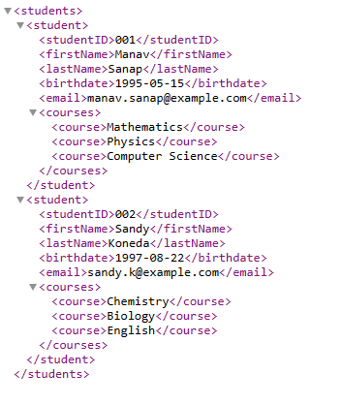

Q4).Open the XML file “amazon-extended.xml”. The file contains 2 types of
products: books and software. Create an XSL transformation document for
presenting all the products in the XML file. Transform the XML using the XSLT
you developed. Save the developed XSL transformation file as: “all-
products.xsl”. View the resulting HTML file in a browser window.

Program:

all-products.xsl:
<?xml version="1.0" encoding="UTF-8"?>
<xsl:stylesheet version="1.0" xmlns:xsl="http://www.w3.org/1999/XSL/Transform">
<xsl:output method="html" encoding="UTF-8"/>
<xsl:template match="/">
<html>
<head>
<title>All Products</title>
</head>
<body>
<h1>All Products</h1>
<xsl:apply-templates select="//product"/>
</body>
</html>
</xsl:template>
<xsl:template match="product">
<div class="product">
<h2><xsl:value-of select="name"/></h2>
<p>Type: <xsl:value-of select="type"/></p>
<p>Price: $<xsl:value-of select="price"/></p>
<p>Description: <xsl:value-of select="description"/></p>
</div>
</xsl:template>
</xsl:stylesheet>

transform.html
<!DOCTYPE html>
<html>
<head>
<title>XSLT Transformation</title>
</head>
<body>
<h1>XSLT Transformation</h1>
<xsl:template match="/">
<html>
<head>
<title>All Products</title>
</head>
<body>
<h1>All Products</h1>
<xsl:apply-templates select="//product"/>
</body>
</html>
</xsl:template>
<products>
<product>
<name>Book Title 1</name>
<type>Book</type><br>
<price>Price:19.99</price><br>
<description>A description of the book.</description><br>
</product><br>
<product>
<name>Software Product 1</name><br>
<type>Software</type><br>
<price>Price:49.99</price><br>
<description>Description of the software product.</description>
</product>
</products>
<script>

processor.importStylesheet(xslDom);
var result = processor.transformToFragment(xmlDom, document);

document.body.appendChild(result);
</script>
</body>
</html>

Output:
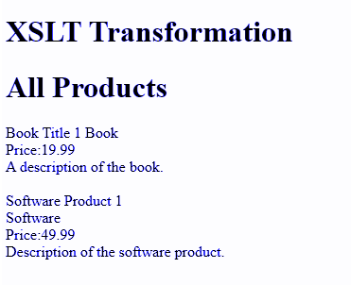

Q5) Create an XML document with the following sample real estate data

a. Root element real-estate will contain a sequence of sub-elements
agencies, owners, properties and flats, all with an empty content
Program:
<?xml version="1.0" encoding="UTF-8"?>
<real-estate>
<agencies></agencies>
<owners></owners>
<properties></properties>
<flats></flats>
</real-estate>
Output:

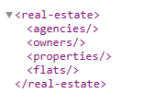

b. Ensure well-formedness

c. Create an internal DTD to ensure its validity and then try to break
It.

Program:

<!DOCTYPE real-estate [
<!ELEMENT real-estate (agencies, owners, properties, flats)>
<!ELEMENT agencies (agency+)>
<!ELEMENT agency (#PCDATA)>
<!ELEMENT owners (owner+)>
<!ELEMENT owner (#PCDATA)>
<!ELEMENT properties (property+)>
<!ELEMENT property (#PCDATA)>
<!ELEMENT flats (flat+)>
<!ELEMENT flat (#PCDATA)>
]>
<real-estate>
<agencies>
<agency>Agency A</agency>
<agency>Agency B</agency>
</agencies>
<owners>
<owner>Owner X</owner>
<owner>Owner Y</owner>
</owners>
<properties>
<property>Property 1</property>
<property>Property 2</property>
</properties>
<flats>
<flat>Flat A</flat>
<flat>Flat B</flat>
</flats>
</real-estate>
Output:
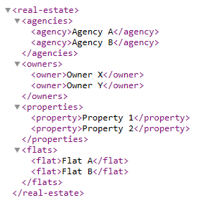
d. Move the DTD to an external file and validate the XML
document again

withoutDtd.xml :
<?xml version="1.0" encoding="UTF-8"?>
<real-estate>
<agencies>
<agency>Agency A</agency>
<agency>Agency B</agency>
</agencies>
<owners>
<owner>Owner X</owner>
<owner>Owner Y</owner>
</owners>
<properties>
<property>Property 1</property>
<property>Property 2</property>
</properties>
<flats>
<flat>Flat A</flat>
<flat>Flat B</flat>
</flats>
</real-estate>
moved.dtd:
<!ELEMENT real-estate (agencies, owners, properties, flats)>
<!ELEMENT agencies (agency+)>
<!ELEMENT agency (#PCDATA)>
<!ELEMENT owners (owner+)>
<!ELEMENT owner (#PCDATA)>
<!ELEMENT properties (property+)>
<!ELEMENT property (#PCDATA)>
<!ELEMENT flats (flat+)>
<!ELEMENT flat (#PCDATA)>

Output:

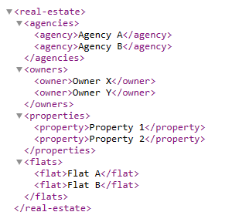

Modify the DTD schema: Using parameter entities and conditional sections,
declare 2 modes for the content of owners: ‒ Verbose • Everything ‒ Standard •
Everything except the description, Activate the standard mode and adjust the
XML document appropriately

Program:

real-estate.dtd:

<!ELEMENT real-estate (agencies, owners, properties, flats)>
<!ELEMENT agencies (agency+)>
<!ELEMENT agency (#PCDATA)>
<!ELEMENT owners (owner+)>

<!ENTITY % ownerContent "name, (description?)">
<!ENTITY % ownerMode "standard">

<!ELEMENT owner (%ownerContent;)>

<!ELEMENT properties (property+)>
<!ELEMENT property (#PCDATA)>
<!ELEMENT flats (flat+)>
<!ELEMENT flat (#PCDATA)>

real-estate.xml:
<?xml version="1.0" encoding="UTF-8"?>
<!DOCTYPE real-estate SYSTEM "real-estate.dtd" [
<!ENTITY % ownerMode "standard">
]>
<real-estate>
<agencies>
<agency>Mega</agency>
<agency>Spruha</agency>
</agencies>
<owners>
<owner>
<name>Jenny</name>
</owner>
<owner>
<name>Jack</name>
</owner>
</owners>
<properties>
<property>House</property>
<property>Plot</property>
</properties>
<flats>
<flat>Flat A</flat>
<flat>Flat B</flat>
</flats>
</real-estate>

Output:

