
Progressive Education Society's
Modern College of Engineering, Pune
MCA Department
A.Y.2022-23
410906: Web Technologies Lab
**********************************************************************************************
Class: SYMCA Shift / Div : A Batch: S1 Roll Number : 51023

Name: Bhavik S. Jain Assignment No : 1 Date of Implementation : 10/09/2023
**********************************************************************************************

Q 1) Create a static HTML page that displays the following output using frame:

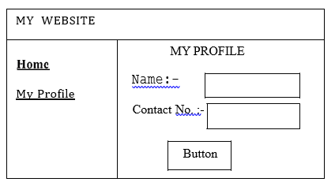

Program:

1) Index.html

<!DOCTYPE html>
<html>
<head>
<title>Profile InformationL</title>
</head>
<frameset rows="10%,*">
<frameset rows="100%">
<frame name="frame1" src="frame1.html">
</frameset>
<frameset cols="30%, *">
<frame name="frame2" src="home1.html">
<frame name="frame3" src="about:blank">
</frameset>
</html>

2) frame1.html:
<!DOCTYPE html>
<html>
<head>
<title>Frame 1</title>
</head>
<body>
<h1>MY WEBSITE</h1>
</body>
</html>

3) home.html

<!DOCTYPE html>
<html>
<head>
<title>My Profile</title>
</head>
<body>
<h1></h1>
<p>My Information.</p>
</body>
</html>

4) home1.html

<!DOCTYPE html>
<html>
<head>
<title>Home</title>
</head>
<body>
<a href="home.html" target="frame3">Home</a> <br></br>
<a href="profile.html" target="frame3">My Profile</a>
</body>
</html>

5] profil.html

<!DOCTYPE html>
<html>
<head>
<title>My Profile</title>
</head>
<body>
<h1>My Profile</h1>
<p>Name: <input type="text" id="nameInput" placeholder="Enter your name"></p>
<p>Contact No: <input placeholder="Enter your Contact No"></p>
<p><button type="submit">Button</button></p>

</body>
</html>

Output:

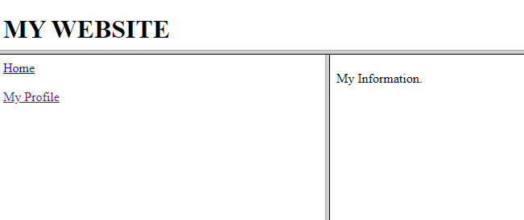

Q 2) Create an HTML document that describes nested ordered lists of cars.
The outer list must have three entries:
compact, midsize and sports.
Inside each of these lists there must be two sub-lists of body styles.
The compact and midsize car sub-lists are two doors and four doors; the sports car sublists are coupe and convertible. Each body style sub-list must have at least three entries, each of
which is the make and model of a particular car that fits the category. The outer
list must use uppercase Roman numerals, the middle lists must use uppercase
letters, and the inner lists must use Arabic numerals. The background color for
the compact car list must be pink; for the mid-size car list, it must be blue; for
the sports car list, it must be red. All of the styles must be in a document style
Sheet.

Program:

<!DOCTYPE html>
<html>
<head>
<meta charset="UTF-8">
<title>Cars List</title>
<style>
body {
font-family: Arial, sans-serif;
}

ol.outer {
list-style-type: upper-roman;
}

ol.middle {
list-style-type: upper-alpha;
}

ol.inner {
list-style-type: decimal;
}

.compact {
background-color: pink;
}

.midsize {
background-color: blue;
}

.sports {
background-color: red;
}
</style>
</head>
<body>
<h1>List of Cars</h1>
<ol class="outer">
<li>Compact
<ol class="middle compact">
<li>Two Doors
<ol class="inner">
<li>Honda Civic</li>
<li>Toyota Corolla</li>
<li>Ford Fiesta</li>
</ol>
</li>
<li>Four Doors
<ol class="inner">
<li>Hyundai Elantra</li>
<li>Nissan Sentra</li>
<li>Chevrolet Cruze</li>
</ol>
</li>
</ol>
</li>
<li>Midsize
<ol class="middle midsize">
<li>Two Doors
<ol class="inner">
<li>Toyota Camry</li>
<li>Honda Accord</li>
<li>Nissan Altima</li>
</ol>
</li>
<li>Four Doors
<ol class="inner">
<li>Ford Fusion</li>
<li>Chevrolet Malibu</li>
<li>Subaru Legacy</li>
</ol>
</li>
</ol>
</li>
<li>Sports
<ol class="middle sports">
<li>Coupe
<ol class="inner">
<li>Ford Mustang</li>
<li>Chevrolet Corvette</li>
<li>Porsche 911</li>
</ol>
</li>
<li>Convertible
<ol class="inner">
<li>Mazda MX-5 Miata</li>
<li>BMW Z4</li>
<li>Audi TT Roadster</li>
</ol>
</li>
</ol>
</li>
</ol>
</body>
</html>

Output:

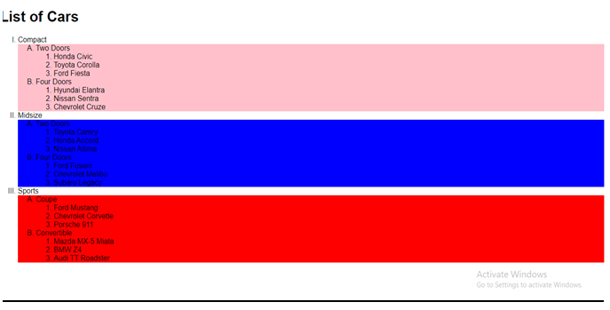

Q 3) Design and develop a suitable static web site for student admission process using
HTML and CSS

Program:

1) Student_Admission:

<!DOCTYPE html>
<html lang="en">

<head>
<meta charset="UTF-8">
<meta name="viewport" content="width=device-width, initial-scale=1.0">
<link rel="stylesheet" href="Q3A.css">
<title>Document</title>
</head>

<body>
<header>
<h1>Modern College of Engineering</h1>
<p>Lorem, ipsum dolor sit amet consectetur adipisicing elit. Modi rerum quis nobis corrupti dolore molestias
dignissimos neque veniam fugit ipsam?</p>
</header>
<form action="submit.html">
<p class="container">
<h3>The Modern College of Engineering is a private engineering college located in the heart of Pune city with 25
years of experience and expert</h3>
<fieldset>
<legend>Student Details : </legend>
<div class="mx">
<label for="fName">First Name : </label><input type="text" name="fName" class="normalInput" id="fName">
<label for="lName" class="my">LastName : </label>
<input type="text" class="normalInput" name="lName" id="lName"> <br><br>

<label for="phoneNo1">Phone No : </label>
<input type="number" class="normalInput" name="phoneNo1" id="phoneNo1">
<label for="email1" class="my">Email : </label>
<input type="email" name="email1" class="normalInput" id="email1">
<br><br>

<label for="tempAddress" class="">Your Address : </label>
<input type="text" name="address" class="normalInput" id="tempAddress">
</div>

</fieldset>
<fieldset>
<legend>Course Details</legend>
<div class="">
<label for="selectCourse">Select Course : </label>
<select name="selectCourse" class="normalInput" id="selectCourse">
<option value="MCA">Master of Computer Applications</option>
<option value="MBA">Master of Business Administration</option>
<option value="BE(IT)">Bachelor of Engineering(Information Technology)</option>
<option value="BE(CS)">Bachelor of Engineering(Computer Science)</option>
</select>
<br><br>

<label for="Elective">Select Electiove : </label>
<select name="selectElective" class="normalInput" id="Elective">
<option value="AI"> Artificial Intelligence </option>
<option value="ML"> Machine Learning </option>
<option value="BDA">Big Data Analytics</option>
</select>
</div>
</fieldset>
<fieldset>
<legend>Parent Details : </legend>
<div class="mx">
<label for="fName">First Name : </label><input type="text" name="fName" class="normalInput" id="fName">
<label for="lName" class="my">LastName : </label>
<input type="text" class="normalInput" name="lName" id="lName"> <br><br>

<label for="phoneNo1">Phone No : </label>
<input type="number" class="normalInput" name="phoneNo1" id="phoneNo1">
<label for="email1" class="my">Email : </label>
<input type="email" name="email1" class="normalInput" id="email1">
<br><br>

<label for="tempAddress" class="">Your Address : </label>
<input type="text" name="address" class="normalInput" id="tempAddress">
</div>
</fieldset>
<fieldset>
<legend>Submit Form</legend>
<div style="align-items: center;">
<input type="checkbox" name="terms" id="terms"><label for="terms">Agree With Terms and
Conditions</label><br><br>
<button class="submit">Submit</button>
</div>
</fieldset>
</p>
</form>
<footer>
<h3>This is Footer</h3>
<p>Lorem ipsum dolor sit amet consectetur adipisicing elit. Deserunt ratione a labore cupiditate veniam
molestiae. Corporis iste autem quisquam aut.</p>
</footer>
</body>

</html>

2) style.css
body{
background-color: beige;
}

header{
text-align: center;
background-color: rgb(255, 255, 194);
border: 2px solid red;
}
footer{
text-align:center;
background-color: rgb(255, 255, 194);
border: 2px groove red;
}

.my{
margin-left: 10%;
}

.normalInput{
width: 30%;
}

.mx{
margin-top: 0.5%;
margin-bottom: 0.5%;
}

.submit{
background-color:#67b26f ;
}

Output :

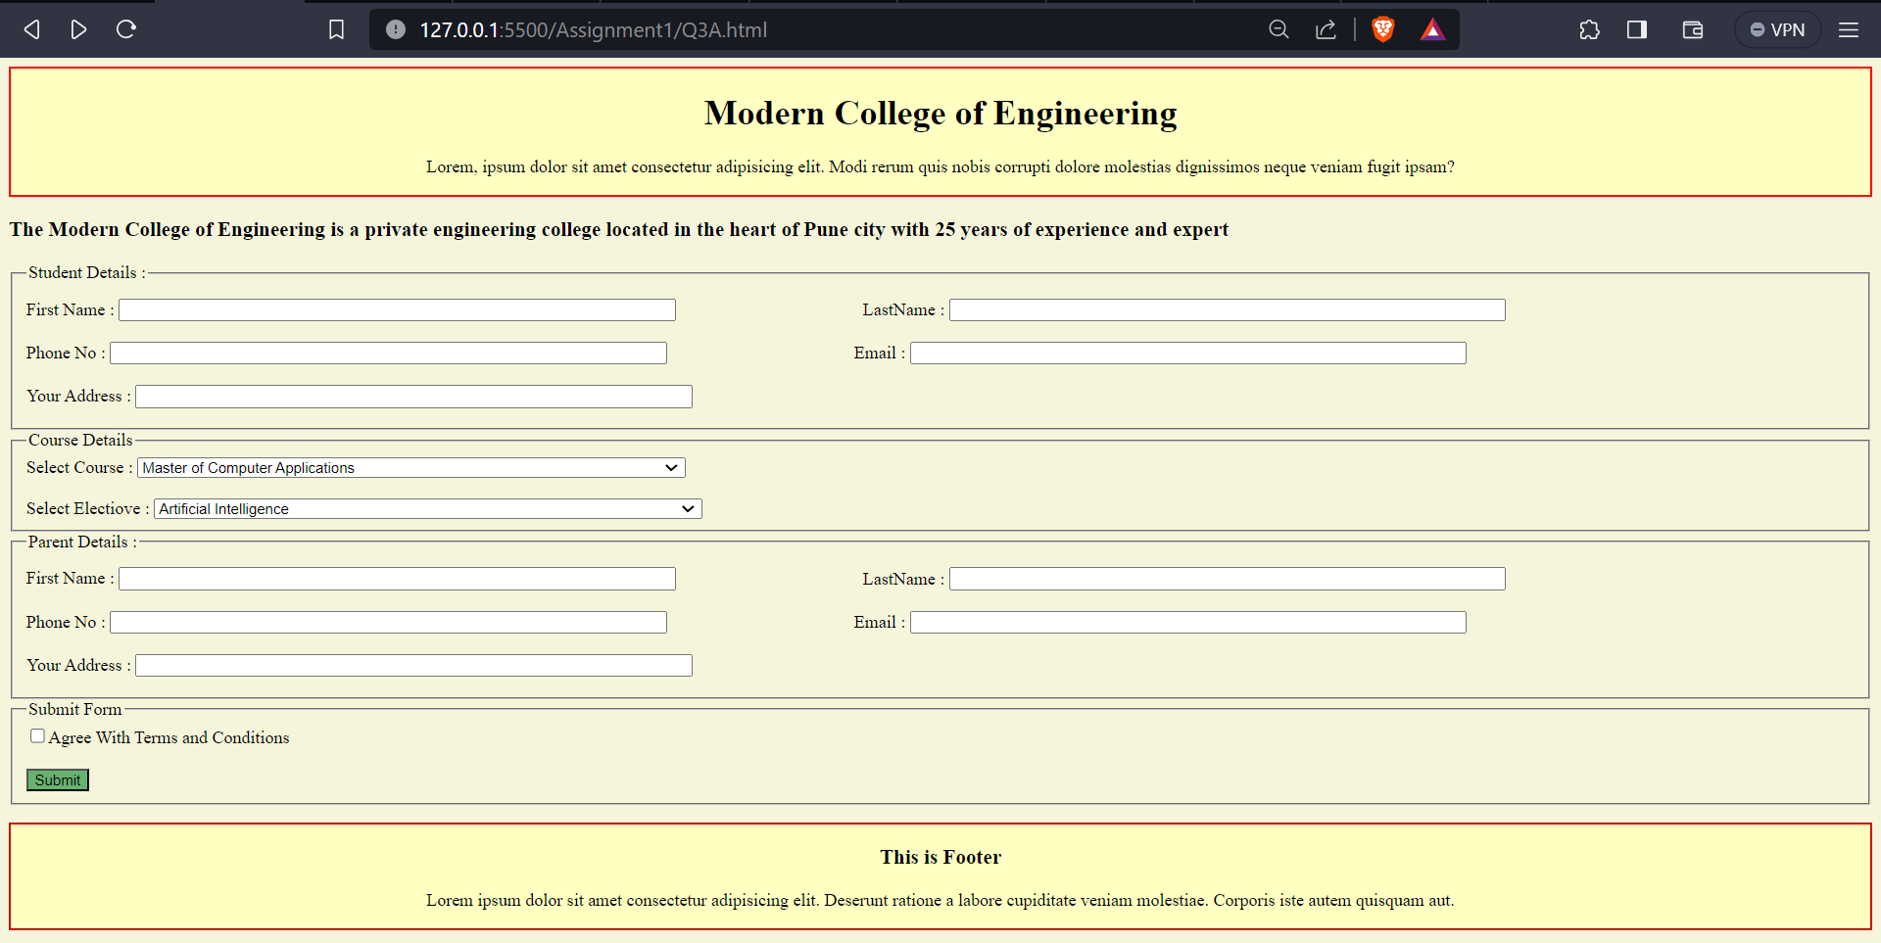

Q 4) Design external CSS to set the following rules and link in HTML file.
a. Give Heading
b. Set paragraph with font size 13,
c. Set text color as blue.
d. Set Heading text color as green.

Program:

1) index.html

<!DOCTYPE html>
<html lang="en">
<head>
<meta charset="UTF-8">
<meta name="viewport" content="width=device-width, initial-scale=1.0">
<title>Q4</title>
<link rel="stylesheet" href="style4.css">
</head>
<body>
<h1 class="head">Hello this is heading</h1>
<p>Lorem ipsum dolor sit, amet consectetur adipisicing elit. Dolore obcaecati sequi dicta consectetur, tenetur aliquid quae voluptatum ipsam, doloremque expedita quo, eaque deleniti nulla laudantium modi voluptatem blanditiis fugiat temporibus nesciunt enim! Fugiat explicabo ut assumenda magni magnam numquam id fugit corporis dicta, suscipit eaque similique. Voluptas distinctio provident repellendus assumenda eaque et dignissimos nesciunt laboriosam porro minus, repudiandae sequi harum fugit quidem odit non eveniet quas animi? Est temporibus necessitatibus molestias veniam! Esse obcaecati quaerat totam minus nihil deserunt optio animi tempora nam dolor porro provident iusto, distinctio error, accusamus ipsa velit inventore. Voluptate voluptatibus tempora doloribus maxime quo.</p>
<br>

</body>
</html>

2) styles.css

.head{
color: green;
}
p{
color: blue;
font-size: 13px;
}

Output:

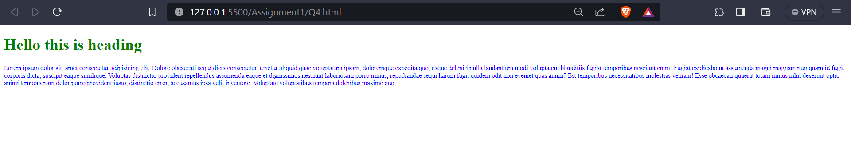

Que 5) Create an inline CSS that changes the font color of the h1 heading by setting the
color property to blue with center aligned And internal DTD for the Library
Information like Book Name, Author Name, Publication and Year of
Publication.
a. Ensure its validity
b. Then try to break it

Program:

1) index.html
<!DOCTYPE html [
<!ELEMENT booklist (book+)>
<!ELEMENT book (bookname, authorname, publication, year)>
<!ELEMENT bookname (#PCDATA)>
<!ELEMENT authorname (#PCDATA)>
<!ELEMENT publication (#PCDATA)>
<!ELEMENT year (#PCDATA)>
]>
<html lang="en">
<head>
<title>Library Information</title>
</head>
<body>
<h1 style="color: blue; text-align: center;">Library Information</h1>

<booklist>
<book>
<bookname>The Great Gatsby</bookname>
<authorname>F. Scott Fitzgerald</authorname>
<publication>Scribner</publication>
<year>1925</year>
</book>
</booklist>
</body>
</html>

Output:

