
Progressive Education Society's
Modern College of Engineering, Pune
MCA Department
A.Y.2022-23
(410906) Web Technologies Lab
*****************************************************************************************
Class: SY-MCA Shift / Div : A Roll Number : 51062

Name:Pratiksha Sonawane Assignment No : 3 Batch: S3
*****************************************************************************************
Q1. Write a Java Script code to check the password strength when user is typing his
password ( Do not write code on submit button)
Password length &gt;= 10 Strong
Password length &lt;10 and &gt;= 5 Medium
Password length &lt; 4 Weak

Code:
<!DOCTYPE html>
<html>
<head>
<title>Password Strength Checker</title>
</head>
<body>
<label for="password">Password:</label>
<input type="password" id="password">

<div id="strength"></div>

<script>
const passwordInput = document.getElementById('password');
const strengthIndicator = document.getElementById('strength');

passwordInput.addEventListener('input', () => {
const password = passwordInput.value;
const passwordLength = password.length;

if (passwordLength >= 10) {
strengthIndicator.textContent = 'Strong';
strengthIndicator.style.color = 'green';
} else if (passwordLength >= 5) {
strengthIndicator.textContent = 'Medium';
strengthIndicator.style.color = 'orange';
} else {
strengthIndicator.textContent = 'Weak';
strengthIndicator.style.color = 'red';
}
});
</script>
</body>
</html>

Output:
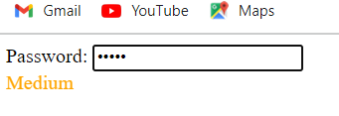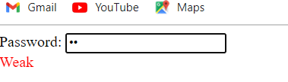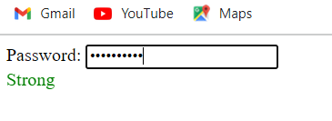

Q2. Write a Java Script functions that accepts a string as a parameter and converts the first letter of each word of the string in upper case. (Don’t use built in function)

Code:
<!DOCTYPE html>
<html>
<head>
<title>String Capitalization</title>
</head>
<body>
<form id="capitalizeForm">
<label for="inputString">Enter a string:</label>
<input type="text" id="inputString" required>
<button type="button" onclick="capitalizeAndDisplay()">Capitalize</button>
</form>

<div id="result"></div>

<script>
function capitalizeWords(inputString) {
const words = inputString.split(' ');
const capitalizedWords = [];

for (const word of words) {
const firstLetter = word.charAt(0).toUpperCase();
const restOfWord = word.slice(1).toLowerCase();
const capitalizedWord = firstLetter + restOfWord;
capitalizedWords.push(capitalizedWord);
}

return capitalizedWords.join(' ');
}

function capitalizeAndDisplay() {
const inputElement = document.getElementById('inputString');
const resultElement = document.getElementById('result');
const inputString = inputElement.value.trim(); // Remove leading/trailing spaces

if (inputString) {
const capitalizedString = capitalizeWords(inputString);
resultElement.textContent = "Capitalized String: " + capitalizedString;
} else {
resultElement.textContent = "Please enter a string.";
}
}
</script>
</body>
</html>

Output:
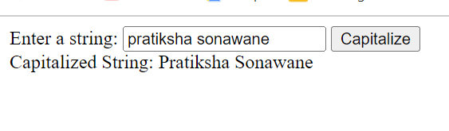

Q3. Write user defined Java Script function to take birth date as input compare it with the current date, check that the difference in dates should be more than 18 years and accordingly display an alert telling valid or invalid input.

Code:
<!DOCTYPE html>
<html>
<head>
<title>Date Comparison</title>
</head>
<body>
<form id="dateForm">
<label for="birthDate">Enter your birth date:</label>
<input type="date" id="birthDate" required>
<button type="button" onclick="checkAgeValidity()">Check Age</button>
</form>

<script>
function checkAgeValidity() {
const birthDateInput = document.getElementById('birthDate');
const birthDateValue = new Date(birthDateInput.value);
const currentDate = new Date();

// Calculate the difference in years
const ageDifference = currentDate.getFullYear() - birthDateValue.getFullYear();

// Check if the difference is more than 18 years
if (ageDifference >= 18) {
alert("Valid input. You are over 18 years old.");
} else {
alert("Invalid input. You are under 18 years old.");
}
}
</script>
</body>
</html>

Output:
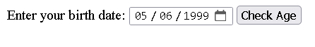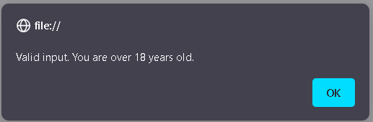
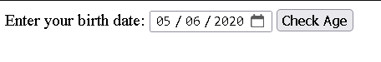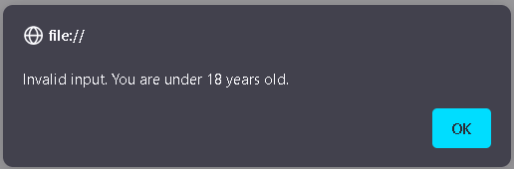

Q4. Write a JavaScript code to create a web Page which accepts various information and validate the information entered and display proper messages as shown below.

Code:
<!DOCTYPE html>
<html>
<head>
<title>Information Form</title>
</head>
<body>
<h2>Enter Your Information</h2>
<form id="infoForm" onsubmit="return validateForm()">
<label for="productId">Product ID:</label>
<input type="text" id="productId" required>
<span id="productIdError" class="error"></span><br>

<label for="description">Description:</label>
<textarea id="description" required></textarea>
<span id="descriptionError" class="error"></span><br>

<label for="creditCard">Credit Card No.:</label>
<input type="text" id="creditCard" required>
<span id="creditCardError" class="error"></span><br>

<label for="email">Your Email ID:</label>
<input type="email" id="email" required>
<span id="emailError" class="error"></span><br>

<button type="submit">Submit</button>
<button type="button" onclick="clearForm()">Clear</button>
</form>

<script>
function validateForm() {
const productId = document.getElementById('productId').value;
const description = document.getElementById('description').value;
const creditCard = document.getElementById('creditCard').value;
const email = document.getElementById('email').value;

const productIdPattern = /^[A-Za-z0-9]+$/;
const creditCardPattern = /^\d{16}$/;
const emailPattern = /^\S+@\S+\.\S+$/;

let isValid = true;

if (!productIdPattern.test(productId)) {
document.getElementById('productIdError').textContent = 'Invalid Product ID';
isValid = false;
} else {
document.getElementById('productIdError').textContent = '';
}

if (description.trim() === '') {
document.getElementById('descriptionError').textContent = 'Description cannot be empty';
isValid = false;
} else {
document.getElementById('descriptionError').textContent = '';
}

if (!creditCardPattern.test(creditCard)) {
document.getElementById('creditCardError').textContent = 'Invalid Credit Card Number';
isValid = false;
} else {
document.getElementById('creditCardError').textContent = '';
}

if (!emailPattern.test(email)) {
document.getElementById('emailError').textContent = 'Invalid Email ID';
isValid = false;
} else {
document.getElementById('emailError').textContent = '';
}

return isValid;
}

function clearForm() {
document.getElementById('infoForm').reset();
clearErrorMessages();
}

function clearErrorMessages() {
const errorElements = document.getElementsByClassName('error');
for (let i = 0; i < errorElements.length; i++) {
errorElements[i].textContent = '';
}
}
</script>
</body>
</html>

Output:

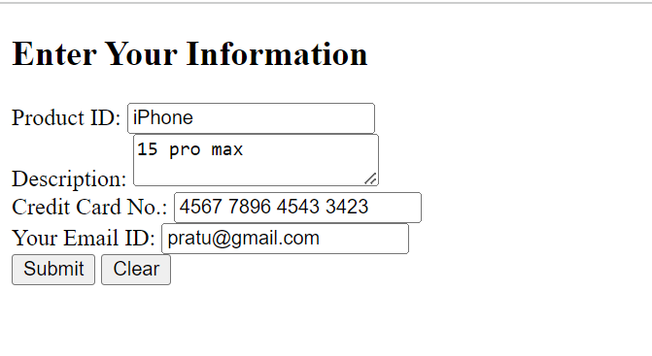

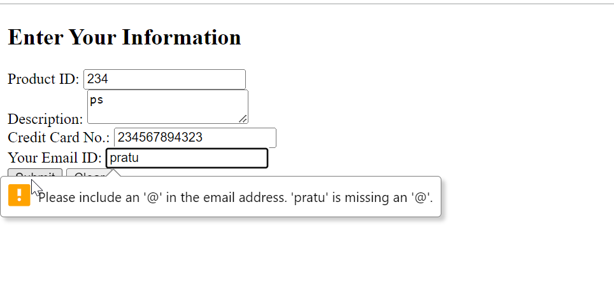

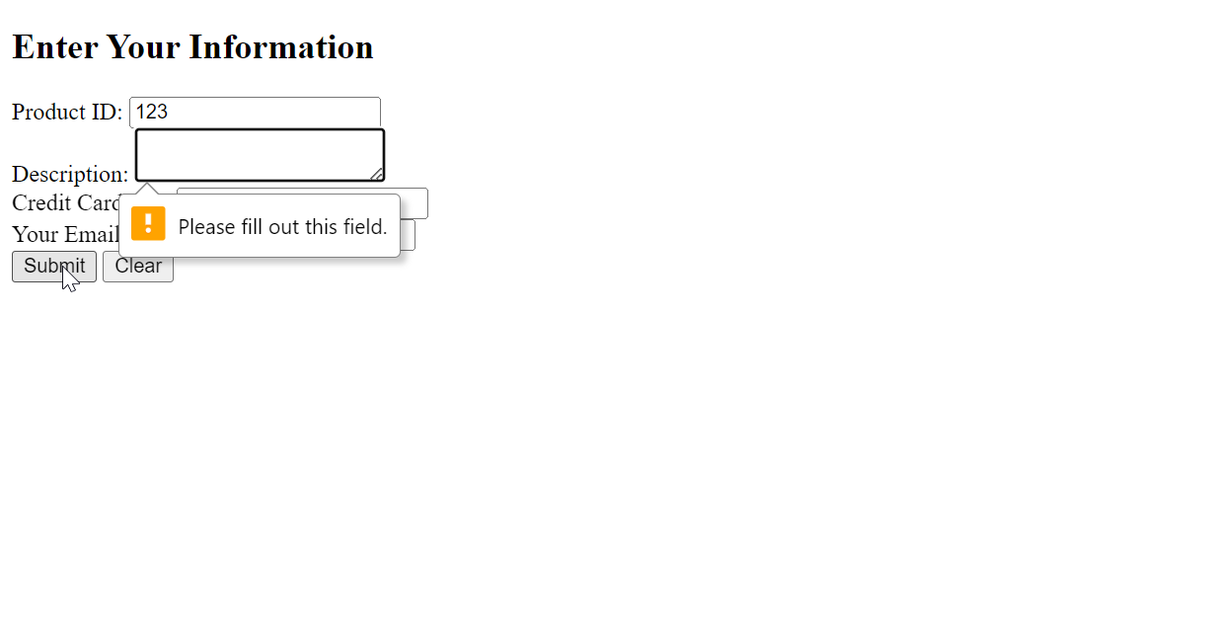

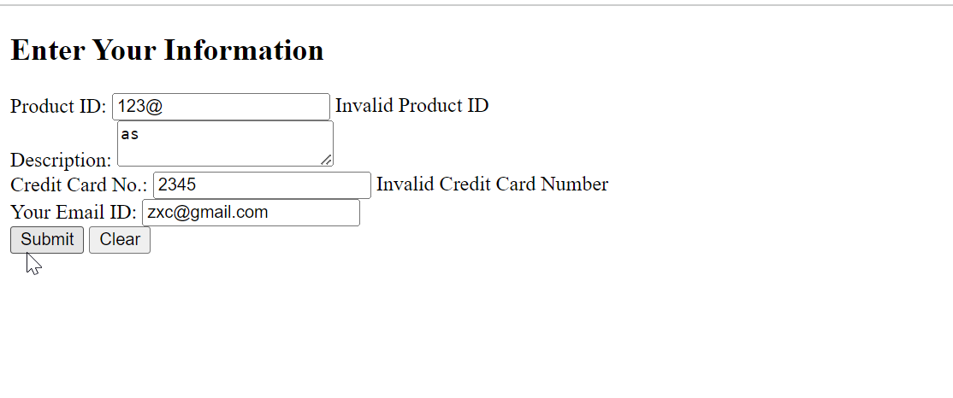

Q5. Write a JavaScript program to find an area of different geometric shapes

Code:
<!DOCTYPE html>
<html>
<head>
<title>Geometric Shape Area Calculator</title>
</head>
<body>
<h1>Geometric Shape Area Calculator</h1>
<p>Choose a geometric shape and enter the required parameters to calculate its area.</p>

<label for="shape">Select a shape:</label>
<select id="shape">
<option value="rectangle">Rectangle</option>
<option value="circle">Circle</option>
<option value="triangle">Triangle</option>
</select><br><br>

<div id="parameters">
<!-- The parameters will be dynamically generated based on the selected shape -->
</div><br>

<button onclick="calculateArea()">Calculate Area</button><br><br>

<p id="result"></p>

<script>
function calculateArea() {
const shape = document.getElementById("shape").value;
const resultElement = document.getElementById("result");

switch (shape) {
case "rectangle":
const length = parseFloat(document.getElementById("length").value);
const width = parseFloat(document.getElementById("width").value);
const rectangleArea = length * width;
resultElement.textContent = `The area of the rectangle is ${rectangleArea}`;
break;

case "circle":
const radius = parseFloat(document.getElementById("radius").value);
const circleArea = Math.PI * Math.pow(radius, 2);
resultElement.textContent = `The area of the circle is ${circleArea}`;
break;

case "triangle":
const base = parseFloat(document.getElementById("base").value);
const height = parseFloat(document.getElementById("height").value);
const triangleArea = 0.5 * base * height;
resultElement.textContent = `The area of the triangle is ${triangleArea}`;
break;

default:
resultElement.textContent = "Invalid choice. Please choose a shape.";
break;
}
}

// Dynamically generate input fields based on the selected shape
document.getElementById("shape").addEventListener("change", function () {
const selectedShape = this.value;
const parametersElement = document.getElementById("parameters");

parametersElement.innerHTML = "";

if (selectedShape === "rectangle") {
parametersElement.innerHTML = `
<label for="length">Length:</label>
<input type="number" id="length"><br><br>
<label for="width">Width:</label>
<input type="number" id="width"><br><br>
`;
} else if (selectedShape === "circle") {
parametersElement.innerHTML = `
<label for="radius">Radius:</label>
<input type="number" id="radius"><br><br>
`;
} else if (selectedShape === "triangle") {
parametersElement.innerHTML = `
<label for="base">Base:</label>
<input type="number" id="base"><br><br>
<label for="height">Height:</label>
<input type="number" id="height"><br><br>
`;
}
});
</script>
</body>
</html>

Output:
