
Progressive Education Society's

Modern College of Engineering, Pune
MCA Department A.Y.2022-23
(410906) Web Technologies Laboratory

************************************************************************** Class: SY-MCA Shift / Div: A Roll Number: 52062

Name: Pratiksha Sonawane Assignment No: 5 Date of Implementation: 31/10/2023

************************************************************************** Q1. Create a PHP code, which will retrieve the data captured by the HTML form, display the name of the form and also display the message Data Entered Successfully on the HTML form page, after performing the following validations
- The book name form field is not left blank.

The author name form field is not left blank.
- The publisher name form field is not left blank

The synopsis form field is not left blank.

Program:
Q1.html
<!DOCTYPE html>
<html>
<body>
<form action="Q1.php" method="post">
<h1>Book Details Form</h1>
Book name:<input type="text" name="book_name"><br><br> Author name:<input type="text" name="author_name"><br><br>
Publisher name:<input type="text" name="publisher_name"><br><br> Synopsis<br>
<textarea name="synopsis" placeholder="Start typing..."></textarea>
<br><br><input type="submit" value="Submit">
</form>
</body>
</html>

Q1.php
<?php
echo "Form Name: Book Details Form"; echo "<br><br>";
// Get the form data
$book_name = $_POST['book_name'];
$author_name = $_POST['author_name'];
$publisher_name = $_POST['publisher_name'];
$synopsis = $_POST['synopsis'];
// Perform the validations
if (empty($book_name) || empty($author_name) || empty($publisher_name)
|| empty($synopsis)) {
echo "Error: All fields must be filled in."; exit();
}
// Display the data entered successfully message echo "----Data entered successfully! ";
echo "<br>";

// Display the form data echo "Book Name: $book_name"; echo "<br>";
echo "Author Name: $author_name"; echo "<br>";
echo "Publisher Name: $publisher_name"; echo "<br>";
echo "Synopsis: $synopsis";
?>

Output:

Q1.html Q1.php
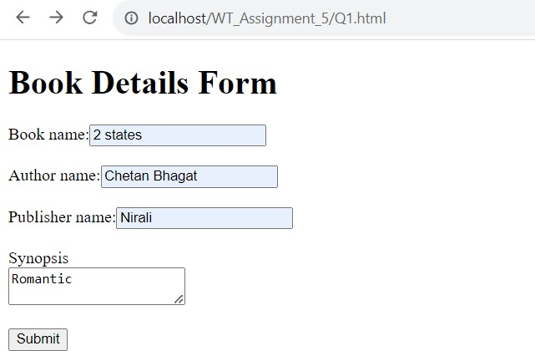
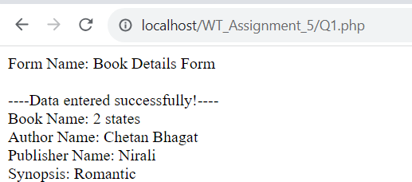

Q2. Use Cookies to retain some information for 30 minutes, dependent on logged-in users

Program:
Q2.html
<!DOCTYPE html>
<html>
<head>
<title>Login Page</title>
</head>
<body>
<h2>Login</h2>
<form action="Q2.php" method="post">
<label for="username">Username:</label>
<input type="text" name="username" required><br><br>
<label for="password">Password:</label>
<input type="password" name="password" required><br><br>
<input type="submit" value="Login">
</form>
</body>
</html>

Q2.php
<?php session_start();

// Function to set the user as logged in and set a cookie function setLoggedIn($username) {
$_SESSION['username'] = $username;

// Set a cookie to retain information for 30 minutes (30 * 60 seconds)
setcookie('loggedInUser', $username, time() + 1800, '/');
}

if ($_SERVER["REQUEST_METHOD"] == "POST") {
$username = $_POST['username']; // Get username from the login form
$password = $_POST['password']; // Get password from the login form

// Validate the username and password (You should use a more secure validation and authentication method in a real application)
// For demonstration purposes, a simple check is done here if ($username === 'user' && $password === 'user') {

// Set the user as logged in and create a cookie setLoggedIn($username);
echo "Login successful. Welcome, " . $username . "!";
} else {
echo "Invalid username or password. Please try again.";
}
}
?>

Output:

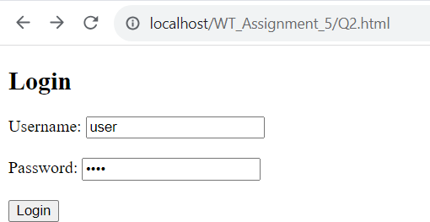
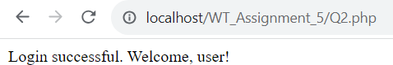
Q2.html Q2.php

Q3. Create an HTML page that contains a textbox, submit / reset button. Write a PHP program to display this information and store it into a text file.

Program:
Q3.html
<!DOCTYPE html>
<html>
<head>
<title>Form Submission</title>
</head>
<body>
<h2>Information for text file</h2>
<form action="Q3.php" method="post">
<label for="textInput">Enter Text:</label><br>
<textarea name="textInput" id="textInput" required></textarea><br><br>
<input type="submit" value="Submit">
<input type="reset" value="Reset">
</form>
</body>
</html>

Q3.php
<?php
if ($_SERVER["REQUEST_METHOD"] == "POST") {
// Get the text input from the form
$textInput = $_POST['textInput'];

// Display the entered information echo "You entered: " . $textInput;

// File to store the entered text
$file = 'entered_text.txt';

// Save the text into a text file
if (file_put_contents($file, $textInput . "\n", FILE_APPEND) !== false) {
echo "<br>Data stored successfully.";
} else {
echo "<br>Error storing data.";
}
}
?>

Output:

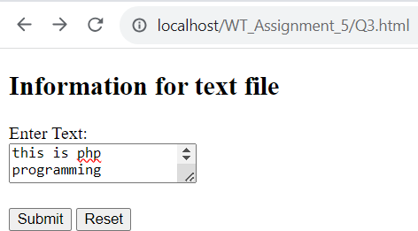
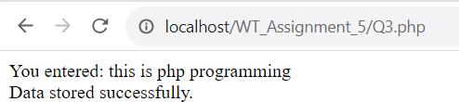
Q3.html Q3.php

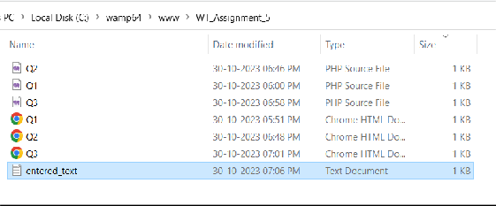
entered.txt file created

Q4. Define Class called Computer. Define Subclasses of Computers called Desktop and Laptop. Accept details of 3 categories. Show accepted information/by overriding display method. (Define at least three attributes in each class. Assume suitable data)

Program:
Q4.html
<!DOCTYPE html>
<html>
<head>
<title>Computer Details</title>
</head>
<body>
<h2>Enter Computer Details</h2>
<form action="Q4.php" method="post">
<label for="brand">Brand:</label>
<input type="text" name="brand" required><br><br>

<label for="model">Model:</label>
<input type="text" name="model" required><br><br>

<label for="processor">Processor:</label>
<input type="text" name="processor" required><br><br>

<label for="type">Type (Desktop or Laptop):</label>
<select name="type" required>
<option value="Desktop">Desktop</option>
<option value="Laptop">Laptop</option>
</select><br><br>

<label for="additional1">Additional Info 1:</label>
<input type="text" name="additional1" required><br><br>

<label for="additional2">Additional Info 2:</label>
<input type="text" name="additional2" required><br><br>

<label for="additional3">Additional Info 3:</label>
<input type="text" name="additional3" required><br><br>

<input type="submit" value="Submit">
<input type="reset" value="Reset">
</form>
</body></html>

Q4.php
<?php
class Computer { protected $brand; protected $model; protected $processor;

public function construct($brand, $model, $processor) {
$this->brand = $brand;
$this->model = $model;
$this->processor = $processor;
}

public function display() {
echo "<h3>Computer Details</h3>";
echo "Brand: " . $this->brand . "<br>"; echo "Model: " . $this->model . "<br>";
echo "Processor: " . $this->processor . "<br>";
}
}

class Desktop extends Computer { protected $keyboard; protected $monitor; protected $mouse;

public function construct($brand, $model, $processor, $keyboard,
$monitor, $mouse) {
parent:: construct($brand, $model, $processor);
$this->keyboard = $keyboard;
$this->monitor = $monitor;
$this->mouse = $mouse;
}

public function display() { parent::display();
echo "<h4>Desktop Details</h4>";
echo "Additional info 1: " . $this->keyboard . "<br>"; echo "Additional info 2: " . $this->monitor . "<br>"; echo "Additional info 3: " . $this->mouse . "<br>";
}
}

class Laptop extends Computer { protected $displaySize; protected $batteryLife; protected $weight;

public function construct($brand, $model, $processor,
$displaySize, $batteryLife, $weight) {
parent:: construct($brand, $model, $processor);
$this->displaySize = $displaySize;
$this->batteryLife = $batteryLife;
$this->weight = $weight;
}

public function display() { parent::display();
echo "<h4>Laptop Details</h4>";
echo "Additional info 1: " . $this->displaySize . "<br>"; echo "Additional info 2: " . $this->batteryLife . "<br>"; echo "Additional info 3: " . $this->weight . "<br>";
}
}

if ($_SERVER["REQUEST_METHOD"] == "POST") {
$brand = $_POST['brand'];
$model = $_POST['model'];
$processor = $_POST['processor'];
$type = $_POST['type'];
$additional1 = $_POST['additional1'];
$additional2 = $_POST['additional2'];
$additional3 = $_POST['additional3'];

if ($type === 'Desktop') {
$desktop = new Desktop($brand, $model, $processor,
$additional1, $additional2, $additional3);
$desktop->display();
} elseif ($type === 'Laptop') {
$laptop = new Laptop($brand, $model, $processor, $additional1,
$additional2, $additional3);
$laptop->display();
}
}
?>

Output:

Q4.html Q4.php
