]

Program-1.// Write a program in C++ for Linear Search / Sequential Search.

#include<iostream>
using namespace std;
int main() {
int a[10],i,f=0,element,index;
for(i=0;i<10;i++) {
cout << "Enter Element " << i << "= ";
cin >> a[i];
}
cout << "Enter element to search in array ";
cin >> element;
for(i=0;i<10;i++) {
if(a[i]==element) {
f=1;
index=i;
}
}
if(f==1)
cout << "element found at index " << index << endl;
else
cout << "element is not found" << endl;
system("pause");
return 0;
}
OUTPUT:
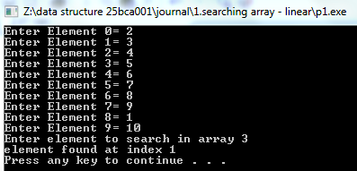

Program-2.// Write a program in C++ for Binary Search .
#include<iostream>
using namespace std;
int main() {
int a[10],i,f=0,element,index,beg,end,mid;
cout << "enter array to a assending order :: "<< endl;
for(i=0;i<10;i++) {
cout << "Enter Element " << i << "= ";
cin >> a[i];
}
cout << "Enter element to search in array ";
cin >> element;
beg=0;
end=9;
while(beg <= end) {
mid = (beg+end)/2;
if(a[mid] == element) {
f=1;
index = mid;
}
if(a[mid] > element)
end = mid-1;
else
beg = mid+1;
}
if(f==1)
cout << "element found at index " << index << endl;
else
cout << "element is not found" << endl;
system("pause");
return 0;
}
OUTPUT:
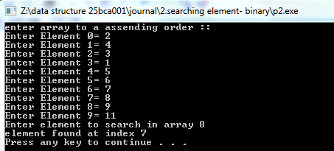

Program-3.// Write a program in C++ print value of variable and its address. (Using Class).
#include<iostream>
using namespace std;
class var{
public:
int var;
void input() {
cout << "Enter a value = ";
cin >> var;
}
void display() {
cout << "value of variable = " << var << endl;
cout << "Address of variable is = " << &var << endl;
}
};
int main() {
var v;
v.input();
v.display();
system("pause");
return 0;
}
OUTPUT:
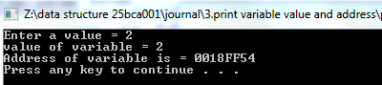

Program-4.//Write program to implement operations Create and display using Singly link list.
#include<iostream>
using namespace std;
class list{
public:
int data;
list *link;
};
List *start2 = NULL;
list *start = NULL;
list *temp = NULL;
void creation(){
int n,i,d;
cout << "Enter number of nodes to be created= ";
cin >>n;
i=0;
while(i!=n) {
if(n>0) {
if(i==0) {
cout << "node number: " << (i+1) << endl;
list *newnode = new list;
cout << "Enter the data to be entered= ";
cin >> d;
newnode->data=d;
newnode->link=NULL;
temp = newnode;
start = newnode;
}
else {
cout << "node number: "<<(i+1) << endl;
list *newnode = new list;
cout << "Enter the data to be entered= ";
cin >> d;
newnode->data=d;
newnode->link=NULL;
temp->link=newnode;
temp=newnode;
} }
i++;
}
cout << "start :"<<(start)<<" :: temp "<<(temp)<< endl;
}
void display() {
temp=start;
int i=1;
cout <<"\noutput:: " << endl;
while(temp!= NULL) {
//cout << "data of node" << i <<" : " << temp->data << endl;
cout << temp -> data << "-> " ;
i++;
temp = temp->link;
}
cout << "0"<< endl;
}
int main(){
int s;
creation();
cout << "first list :::" << endl;
display();
while(true) {
cout << "1.insert at begin" << endl;
cout <<"2.delete at last node"<< endl;
cout <<"3.delete at begin node"<< endl;
cout <<"4.insert at Last " << endl;
cout <<"5.split the list " << endl;
cout <<"6.merge the list " << endl;
cout <<"7.add insert after " << endl;
cout <<"8.add insert before " << endl;
cout << "9. node counting " << endl;
cout << endl;
cout << "select your choice no. :::";
cin >>s;
system("pause");
return 0;
}
OUTPUT:
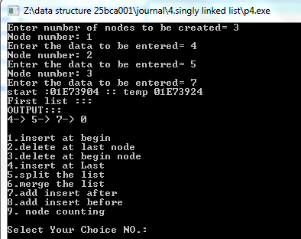

Program-5.//Write program to implement operations insert at begin using Singly link list.
void insertAtBegin(){
int d;
list *newnode = new list;
cout << "Enter the data=";
cin >> d;
newnode->data = d;
newnode->link=start;
start=newnode;
}
int main(){
switch (s) {
case 1:
insertAtBegin();
cout << "node added new list:::" << endl;
display();
break;
}
system("pause");
return 0;
}
OUTPUT:
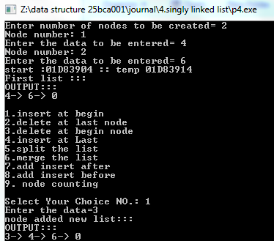

Program-6.//Write program to implement operations delete from first using Singly link list.
void deleteAtbegin()
{
list *temp=start;
start = start -> link;
cout << "Node data:" << temp->data <<endl ;
delete temp;
}
int main(){
case 3:
deleteAtbegin();
cout << "delete at begin new list :::" << endl;
display();
break;
}
system("pause");
return 0;
}
OUTPUT:
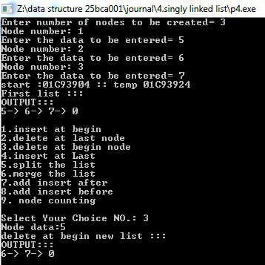

Program-7.// Write program to implement operations delete from last using Singly link list.
list *ptr;
void deleteAtLast() {
if(start==NULL) {
cout << "linked list is empty" << endl;
return;
}
if(start->link==NULL) {
delete start;
start = NULL;
return;
}
temp=start;
while(temp->link!=NULL) {
ptr=temp;
temp=temp->link;
}
delete temp;
ptr->link=NULL;
}
int main() {
case 2:
deleteAtLast();
cout<<"delete at last new list:::" << endl;
display();
break;
}
system("pause");
return 0;
}
OUTPUT:
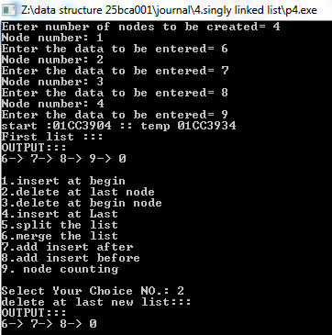

Program-8. // Write program to implement operations insert at last, Sorting, Splitting, Merging, Counting Operations (Total no. of nodes, even and odd no. of nodes) using Singly link list.
void insertAtLast(){
int d;
list *newnode = new list;
cout << "Enter the data=";
cin >> d;
newnode->data = d;
newnode->link = NULL;
if(start==NULL) {
start = newnode;
cout << "list empty; node added at fist" << endl;
return ;
}
else {
list *temp=start;
while(temp->link!=NULL)
temp=temp->link;
temp->link=newnode;
}
}
void split(){
if(start==NULL) {
cout << "list empty no splitting" << endl;
return;
}
int target;
cout << "Enter data from where to split the list=";
cin >> target;
list *cur = start;
while(cur!=NULL && cur->data!=target) {
cur = cur->link;
}
if(cur==NULL) {
cout << "data not found at list" << endl;
return;
}
if(cur->link==NULL) {
cout << "last,node,no more element to split" << endl;
return;
}
start2=cur->link;
cur->link=NULL;
}
void splitdisplay(){
if(start==NULL) {
cout << "list empty" << endl;
return;
}
else{
list *p1=start;
while(p1!=NULL){
cout << p1->data << "->";
p1=p1->link;
}
cout << "0" << endl;
}
if(start2==NULL) {
cout << "list empty" << endl;
return;
}
else {
list *p2=start2;
while(p2!=NULL) {
cout << p2->data << "->";
p2=p2->link;
}
cout << "0" << endl;
}
}
void merge(){
if(start2==NULL) {
cout << "list 2 empty to merge" << endl;
return;
}
if(start==NULL) {
start = start2;
start2=NULL;
cout << "list mergest at list 1 empty" << endl;
}
else {
list *cur=start;
while(cur->link!=NULL) {
cur=cur->link;
}
cur->link=start2;
start2=NULL;
}
}
void mergedisplay(){
cout << "Merge list :::" <<endl;
if(start==NULL)
cout << "empty list merge " << endl;
else {
list *temp=start;
while(temp!=NULL) {
cout << temp->data << "->";
temp=temp->link;
}
cout << "0" << endl;
}
}
void count(){
int even=0, odd=0;
list *temp=start;
while(temp!=NULL) {
if(temp->data % 2 == 0)
even+=1;
else
odd+=1;
temp=temp->link;
}
cout << "Total numbers of even nodes= " << even << endl;
cout << "Total numbers of odd nodes= " << odd << endl;
cout << "Total nubers of nodes= " << (even+odd) << endl;
}
int main(){
case 4:
insertAtLast();
cout << "insert at Last new list :::" << endl;
display();
break;
case 5:
split();
cout << "split at new list :::" << endl;
splitdisplay();
break;
case 6:
merge();
cout << "merge at new list :::" << endl;
mergedisplay();
break;
case 9:
cout << "node counting :::" << endl;
count();
break;
}
system("pause");
return 0;
}
OUTPUT:
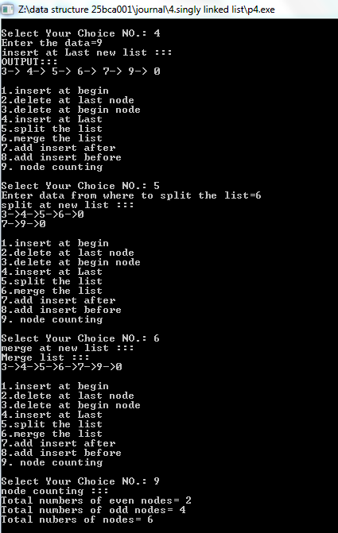

Program-9.//Write program to implement operations insert at specified location (Before or After the Node) and delete any specified node using Singly link list.
void insertafter(){
if(start==NULL) {
cout << "List empty" << endl;
return;
}
int target,d;
cout << "Enter where to add after= ";
cin >> target;
list *ptr =start;
while(ptr!=NULL && ptr->data!=target) {
ptr=ptr->link;
}
if(ptr==NULL) {
cout << "List empty" << endl;
return;
}
else{
list *newnode=new list;
cout << "Enter the data= ";
cin >> d;
newnode->data =d;
newnode->link=ptr->link;
ptr->link= newnode;
}
}
void insertbefore(){
if(start==NULL) {
cout << "list empty" << endl;
return;
}
int target,d;
cout << "Enter where to add before= ";
cin >> target;
list *temp = start;
list *ptr =start;
if(ptr==NULL) {
cout << "list empty" << endl;
return;
}
else {
list *newnode = new list;
cout << "Enter the data= ";
cin >> d;
newnode->data=d;
while(ptr->data!=target) {
temp=ptr;
ptr=ptr->link;
}
newnode->link=temp->link;
temp->link=newnode;
}
}
int main(){
case 7:
insertafter();
cout << "added insert after :::" << endl;
display();
break;
case 8:
insertbefore();
cout << "added insert before :::" << endl;
display();
break;
}
system("pause");
return 0;
}
OUTPUT:
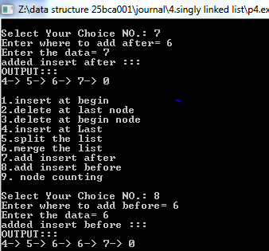

Program-10.// Write program to implement following operations using Doubly link list
//a.Insert at first
//b.Insert at Last
//c.Insert at specified location (Before or After the Node)
#include<iostream>
using namespace std;
class list{
public:
int data;
list *prev;
list *next;
};
list *start = NULL;
list *temp = NULL;
void creation(){
int n,i,d;
cout << "Enter number of nodes to be created= ";
cin >>n;
i=0;
while(i!=n) {
if(n>0) {
if(i==0) {
cout << "Node number: " << (i+1) << endl;
list *newnode = new list;
cout << "Enter the data to be entered= ";
cin >> d;
newnode->prev=NULL;
newnode->data=d;
newnode->next=NULL;
temp = newnode;
start = newnode;
}
else {
cout << "Node number: "<<(i+1) << endl;
list *newnode = new list;
cout << "Enter the data to be entered= ";
cin >> d;
newnode->prev=temp->next;
newnode->data=d;
temp->next=newnode;
temp=newnode;
}
}
i++;
}
}
void display(){
temp=start;
int i=1;
cout <<"OUTPUT::: " << endl;
while(temp!= NULL) {
cout << temp -> data << "-> " ;
i++;
temp = temp->next;
}
cout << "0"<< endl; }
//a. insert at first
void insertAtfirst(){
int d;
list *newnode = new list;
cout << "Enter the data=";
cin >> d;
if(start==NULL) {
newnode->prev=NULL;
newnode->data=d;
newnode->next=NULL;
cout << "list empty, node added at fist" << endl;
return ;
}
else {
newnode->prev=NULL;
newnode->data=d;
newnode->next=start;
start->prev=newnode;
start=newnode;
}
}
//b. insert at last
void insertAtLast(){
int d;
list *newnode = new list;
cout << "Enter the data=";
cin >> d;
newnode->data = d;
newnode->next = NULL;
if(start==NULL) {
newnode->prev=NULL;
start = newnode;
cout << "list empty, node added at last" << endl;
return ;
}
else {
list *temp=start;
while(temp->next!=NULL)
temp=temp->next;
newnode->prev=temp;
temp->next=newnode;
}
}
//c. insert at specified after and Before node
void insertAtbefore(){
int target,d;
cout << "Enter where to add before= ";
cin >> target;
list *temp = start;
list *ptr =start;
list *newnode = new list;
if(ptr==NULL) {
cout << "list empty" << endl;
start=newnode;
cout << "newnode added at first";
return;
}
else {
cout << "Enter the data= ";
cin >> d;
newnode->data=d;
while(ptr->data!=target) {
temp=ptr;
ptr=ptr->next;
}
newnode->prev=temp->prev;
newnode->next=temp->next;
temp->next=newnode;
}
}
void insertAtafter(){
int target,d;
cout << "Enter where to add after= ";
cin >> target;
list *newnode = new list;
cout << "Enter the data= ";
cin >> d;
newnode->data =d;
list *ptr =start;
while(ptr!=NULL && ptr->data!=target){
ptr=ptr->next;
}
if(ptr==NULL) {
cout << "List empty" << endl;
start=newnode;
cout << "node added as first";
return;
}
else{
newnode->prev=ptr->prev;
newnode->next=ptr->next;
ptr->next= newnode;
}
}
int main(){
int s;
creation();
cout << "First created list :::" << endl;
display();
while(true) {
cout << "---------------------------------------"<<endl;
cout << " SELECT "<< endl;
cout << "---------------------------------------"<<endl;
cout << "1.insert at first node " << endl;
cout << "2.insert at last node "<< endl;
cout << "3.insert before a specific node "<< endl;
cout << "4.insert after a specific node "<< endl;
cout << "5.delete at last node "<< endl;
cout << "6.delete at first node "<< endl;
cout << "7.delete specific node "<< endl;
cout << "---------------------------------------"<<endl;
cout << "Select Your Choice NO.: ";
cin >>s;
cout << "---------------------------------------"<<endl;
switch (s) {
case 1:
insertAtfirst();
cout << "Node added new list :::" << endl;
display();
break;
case 2:
insertAtLast();
cout << "Node added at last new list :::" << endl;
display();
break;
case 3:
insertAtbefore();
cout << "Insert before a specific node :::" << endl;
display();
break;
case 4:
insertAtafter();
cout << "Insert after a specific node :::" << endl;
display();
break;
default:
cout << "invalid value" << endl;
break;
}
}
system("pause");
return 0;
}
OUTPUT:
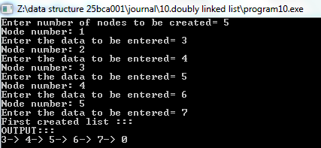
//insert at last and first
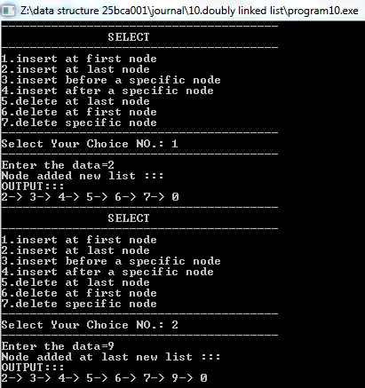
//insert after and before
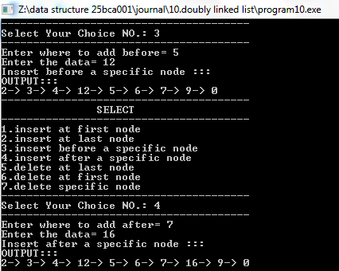

Program-11.//Write program to implement following operations using Doubly link list
- Delete from first , b. Delete from last , c. Delete any specified node
//b.delete at last
void deleteAtLast(){
list *ptr;
temp=start;
if(start==NULL) {
cout << "linked list is empty" << endl;
return;
}
if(start->next==NULL) {
delete start;
start = NULL;
return;
}
list *temp=start;
while(temp->next!=NULL) {
ptr=temp;
temp=temp->next;
}
delete temp;
ptr->prev=temp->next;
ptr->next=NULL;
}
//a.delete at first
void deleteAtfirst(){
list *temp=start;
start -> prev = NULL;
start = start -> next;
cout << "Delete node data:" << temp->data <<endl ;
delete (temp);
}
//c.delete at specific
void deletespecific(){
list *ptr=start;
int target;
cout << "Enter where to delete node = ";
cin >> target;
while(ptr->data!=target) {
temp = ptr;
ptr=ptr->next;
}
temp->prev=ptr->prev;
temp->next=ptr->next;
delete(ptr);
}
int main(){
case 5:
deleteAtLast();
cout << "Delete at last new list :::" << endl;
display();
break;
case 6:
deleteAtfirst();
cout << "Delete at first new list :::" << endl;
display();
break;
case 7:
deletespecific();
cout << "Delete specific node :::" << endl;
display();
break;
default:
cout << "invalid value" << endl;
break;
}
}
system("pause");
return 0;
}
OUTPUT:
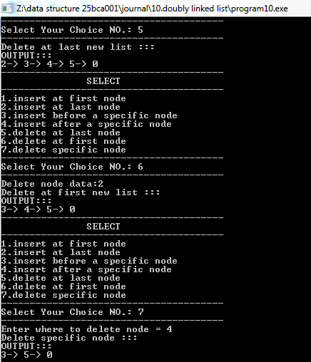

Program-12.//Write a program to implement bubble sort.
#include<iostream>
using namespace std;
int main() {
int arr[10],i,j,temp;
cout << " ::: Bubble sort ::: " << endl;
for(i=0;i<10;i++) {
cout << "Enter element " << (i+1) << " = ";
cin >> arr[i];
}
cout << endl;
cout << "Array element ::: "<< endl;
for(i=0;i<10;i++) {
cout << "a["<< i <<"] = " << arr[i] << ",";
}
for(i=0;i<10;i++) {
for(j=0;j<10;j++) {
if(arr[j]>arr[j+1]) {
temp=arr[j];
arr[j]=arr[j+1];
arr[j+1]=temp;
}
}
}
cout << endl;
cout << "Sorted array element ::: " << endl;
for(i=0;i<10;i++) {
cout << "a["<< i <<"] = " << arr[i] << ",";
}
system("pause");
return 0;
}
OUTPUT:
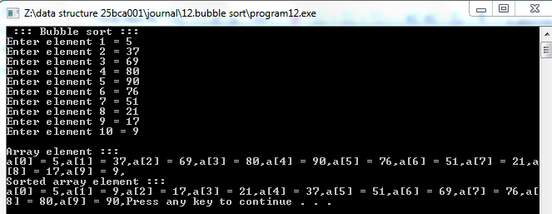

Program-13.//Write a program to implement insertion sort.
#include<iostream>
using namespace std;
int main() {
int arr[10],i,j,k,temp;
cout << " ::: INSERTION SORT ::: " << endl;
cout << "Enter array element:::" << endl;
for(i=0;i<10;i++) {
cout << "Enter element " << (i+1) << " = ";
cin >> arr[i];
}
cout << endl;
cout << "Array element ::: "<< endl;
for(i=0;i<10;i++) {
cout << "a["<< i <<"] = " << arr[i] << ",";
}
for(k=1;k<10;k++) {
temp=arr[k];
j=k-1;
while(temp<=arr[j]) {
arr[j+1]=arr[j];
j--;
if(j==-1) {
break;
}
}
arr[j+1]=temp;
}
cout << endl;
cout << "Sorted array element :::" << endl;
for(i=0;i<10;i++) {
cout << "a["<< i <<"] = " << arr[i] << ",";
}
system("pause");
return 0;
}
OUTPUT:
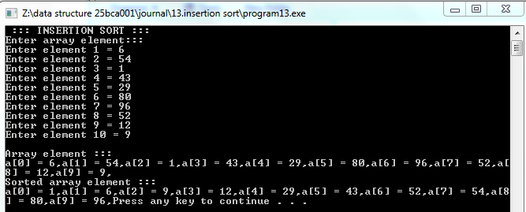

Program-14.//Write a program to implement selection sort.
#include<iostream>
using namespace std;
int i,j,arr[10],index,temp;
void selectionsort() {
for(i=0;i<10;i++) {
index=i;
for(j=i+1;j<10;j++) {
if(arr[j]<arr[index])
index=j;
}
temp=arr[i];
arr[i]=arr[index];
arr[index]=temp;
}
}
int main(){
cout << "SELECTION SORT:::" << endl;
for(i=0;i<10;i++) {
cout << "Enter element " <<(i+1) << "= ";
cin >> arr[i];
}
cout << "array elemet::: " << endl;
for(i=0;i<10;i++) {
cout << "a["<< i <<"] = " << arr[i] << ",";
}
selectionsort();
cout << endl;
cout << "sorted element " << endl;
for(i=0;i<10;i++) {
cout << "a["<< i <<"] = " << arr[i] << ",";
}
system("pause");
return 0;
}
OUTPUT:
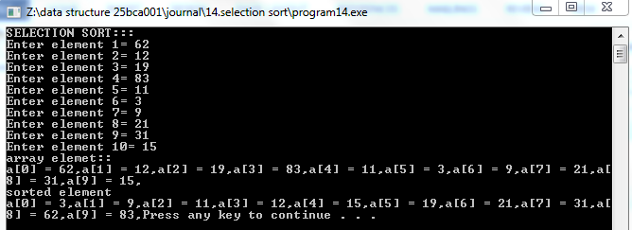

Program-15.//Write a program to implement quick sort.
#include<iostream>
using namespace std;
int beg=0,end=0,temp,loc;
int i,j,arr[10];
void partition(int b, int e) {
int left=b,right=e,f=0;
loc=b;
while(f==0) {
while((arr[loc]<=arr[right])&&loc!=right) {
right--;
}
if(loc==right)
f=1;
else if(arr[loc] > arr[right])
{
temp=arr[loc];
arr[loc]=arr[right];
arr[right]=temp;
loc=right;
}
if(f==0) {
while((arr[loc] >= arr[left]) && loc!=left) {
left++;
}
if(loc==left)
f=1;
else if(arr[loc] < arr[left]) {
temp=arr[loc];
arr[loc]=arr[left];
arr[left]=temp;
loc=left;
}
}
}
}
void quicksort(int beg,int end) {
if(beg<end) {
partition(beg,end);
quicksort(beg,loc-1);
quicksort(loc+1,end);
}
}
int main() {
cout << " :::QUICK SORT::: " << endl;
cout << "Enter array element::: " << endl;
for(i=0;i<10;i++) {
cout << "Enter element " <<(i+1) << "= ";
cin >> arr[i];
}
cout << "array elemet::" << endl;
for(i=0;i<10;i++) {
cout << "a["<< i <<"] = " << arr[i] << ",";
}
quicksort(0,9);
cout << endl;
cout << "sorted element " << endl;
for(i=0;i<10;i++) {
cout << "a["<< i <<"] = " << arr[i] << ",";
}
system("pause");
return 0;
}
OUTPUT:
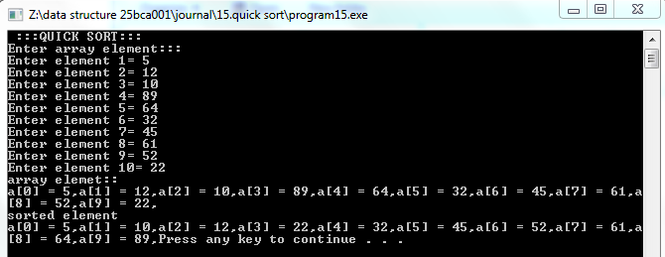

Program-16.//Write a program to implement merge sort.
#include<iostream>
using namespace std;
int beg=0,end=0,mid=0,temp[10];
int i,j,arr[10];
void mergesort(int a[],int b,int m, int e) {
beg=b,end=e;
int i=b, j=m+1,index=0;
while(i<=m && j<=e) {
if(a[i]<a[j]) {
temp[index]=a[i];
i++;
}
else {
temp[index]=a[j];
j++;
}
index++;
}
if(i>m) {
while(j<=e) {
temp[index]=a[j];
index++;
j++;
}
}
else {
while(i<=m) {
temp[index]=a[i];
index++;
i++;
}
}
int k=0;
while(k<index) {
a[b+k]=temp[k];
k++;
}
}
void merge(int a[],int b,int e) {
if(b<e) {
int m=(b+e)/2;
merge(a,b,m);
merge(a,m+1,e);
mergesort(a,b,m,e);
}
}
int main() {
cout << " :::MERGE SORT::: " << endl;
cout << "Enter array element::: " << endl;
for(i=0;i<10;i++) {
cout << "Enter element " <<(i+1) << "= ";
cin >> arr[i];
}
cout << "array elemet:::" << endl;
for(i=0;i<10;i++) {
cout << "a["<< i <<"] = " << arr[i] << ",";
}
merge(arr,0,9);
cout << endl;
cout << "sorted element:::" << endl;
for(i=0;i<10;i++) {
cout << "a["<< i <<"] = " << arr[i] << ",";
}
system("pause");
return 0;
}
OUTPUT:
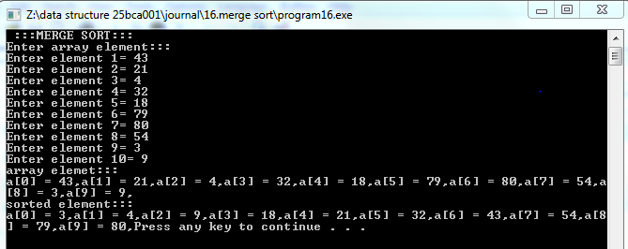

Program-17. //Write a program to implement following operations(PUSH,POP,PEEP)in stack Using Array.
#include<iostream>
using namespace std;
int stack[100];
int top = -1,MAX;
void display(int stack[]){
if(top == -1)
cout << "STACK IS EMPTY" << endl;
else {
for(int i=0;i<=top;i++) {
cout << stack[i] << " ";
}
}
cout << endl;
}
void push(int stack[],int val) {
if(top==MAX-1)
cout << "STACK IS FULL" << endl;
else {
top++;
stack[top]=val;
}
}
void pop(int stack[]) {
if(top==-1)
cout << "STACK IS EMPTY" << endl;
else {
int val;
val=stack[top];
top--;
cout << "Pop value is = " << val << endl;
}
}
void peep(int stack[]) {
if(top == NULL)
cout << "STACK IS EMPTY" << endl;
else {
cout << "peep element= " << stack[top] << endl;
}
}
int main() {
int val,s;
cout << "Enter min stack element(1-100) = ";
cin >> MAX;
cout << endl;
while(true) {
cout << "------------------------"<<endl;
cout << " SELECT "<< endl;
cout << "------------------------"<<endl;
cout << "1.Push operation " << endl;
cout <<"2.Pop operation "<< endl;
cout <<"3.Peep operaton "<< endl;
cout << "4.DISPLAY " << endl;
cout <<"Enter 0 to Exit " << endl;
cout << "------------------------"<<endl;
cout << "Select Your Choice NO.: ";
cin >>s;
cout << "------------------------"<<endl;
cout << endl;
switch (s) {
case 1:
cout << "Push operation::: " << endl;
cout << "Enter a value to push array= " ;
cin >> val;
push(stack,val);
break;
case 2:
cout << "Pop operation::: " << endl;
pop(stack);
break;
case 3:
cout << "Peep operation::: " << endl;
peep(stack);
break;
case 4:
cout << "STACK "<< endl;
display(stack);
break;
default:
cout << "invalid value" << endl;
break;
}
}
system("pause");
return 0;
}
OUTPUT:
//PUSH OPERATION: //POP OPERATION:
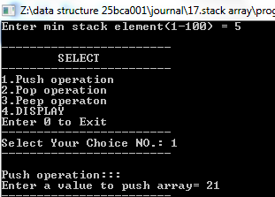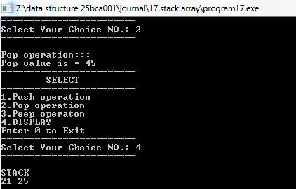

//PEEP OPERATION:
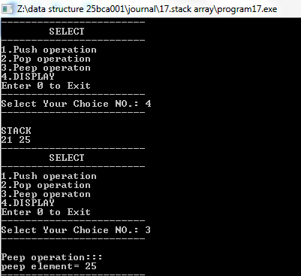

Program-18.//Write a program to implement following operations (PUSH,POP,PEEP ,CHANGE)in stack Using Linked List.
#include<iostream>
using namespace std;
class node {
public:
int data;
node *next;
};
node *top = NULL;
void push(int value) {
node *newnode = new node;
newnode->data=value;
newnode->next=top;
top=newnode;
}
void display() {
if(top==NULL)
cout << "STACK IS EMPTY" << endl;
node *temp=top;
while(temp!=NULL) {
cout << temp->data << "->";
temp=temp->next;
}
cout << "0" << endl;
}
void pop() {
if(top==NULL)
cout << "Stack is empty" << endl;
else {
node *temp=top;
cout << "Pop value is = " << temp->data << endl;
top=top->next;
delete temp;
}
}
void peep() {
if(top == NULL)
cout << "STACK IS EMPTY" << endl;
else {
cout << "Top element= " << top->data << endl;
}
}
void change() {
int target,d;
cout << "Enter data which to change= ";
cin >> target;
node *temp=top;
while(temp!=NULL && temp->data!=target) {
temp=temp->next;
}
if(temp==NULL) {
cout << "List empty" << endl;
return;
}
else {
cout << "Enter the data to change= ";
cin >> d;
temp->data=d;
}
}
int main() {
int value,s;
cout << endl;
while(true) {
cout << "------------------------"<<endl;
cout << " SELECT "<< endl;
cout << "------------------------"<<endl;
cout << "1.Push operation " << endl;
cout <<"2.Pop operation "<< endl;
cout <<"3.Peep operaton "<< endl;
cout << "4.DISPLAY " << endl;
cout << "5.Change " << endl;
cout <<"Enter 0 to Exit " << endl;
cout << "------------------------"<<endl;
cout << "Select Your Choice NO.: ";
cin >>s;
cout << "------------------------"<<endl;
cout << endl;
switch (s) {
case 1:
cout << "Push operation::: " << endl;
cout << "Enter a value to push= " ;
cin >> value;
push(value);
break;
case 2:
cout << "Pop operation::: " << endl;
pop();
break;
case 3:
cout << "Peep operation::: " << endl;
peep();
break;
case 4:
cout << "STACK "<< endl;
display();
break;
case 5:
cout << "change operation::: " << endl;
change();
break;
default:
cout << "invalid value" << endl;
break;
}
}
system("pause");
return 0;
}
OUTPUT:

//PUSH OPERATION: //POP and PEEP OPERATIONS:
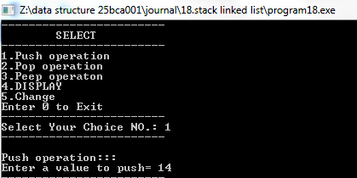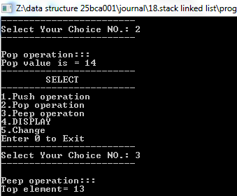

//DISPLAY AND CHANGE:
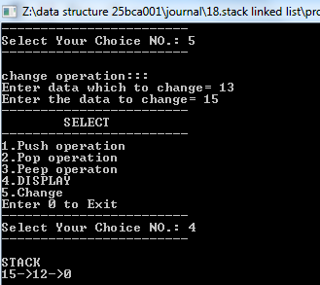

Program-19.//Write a program to implement Evaluation of given postfix expression.
#include<iostream>
using namespace std;
int main() {
char exp[30];
int stack[30],top=-1,i;
cout << "Enter postfix expression= ";
cin >> exp;
for(i=0;exp[i]!='\0';i++) {
char ch=exp[i];
if(ch>='0' && ch<='9') {
stack[++top] = ch-'0';
}
else {
int b=stack[top--];
int a=stack[top--];
switch(ch) {
case '+':
stack[++top]=a+b;
break;
case '-':
stack[++top]=a-b;
break;
case '*':
stack[++top]=a*b;
break;
case '/':
stack[++top]=a/b;
break;
}
}
}
cout << "Result: "<< stack[top] << endl;
system("pause");
return 0;
}
OUTPUT:
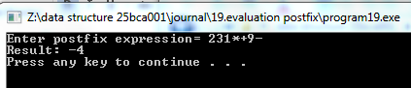

Program-20.//Write a program to implement conversion of infix expression into postfix expression (parentheses and non parentheses).
#include<iostream>
using namespace std;
char stack[100];
int top=-1,MAX;
bool isAlpanumeric(char ch) {
return(ch>='0' && ch<='9' || ch>='A' && ch<='Z' || ch>='a' && ch<='z');
}
int priority(char v) {
if(v=='+' || v=='-')
return 0;
if(v=='*' || v=='/')
return 1;
return -1;
}
void push(char stack[],char v) {
stack[++top]=v;
}
char pop(char stack[]) {
char v=' ';
if(top==-1)
cout << "stack empty" << endl;
else
v= stack[top--];
return v;
}
void change(char source[],char target[]) {
int i=0,j=0;
strcpy(target,"");
while(source[i] !='\0') {
if(source[i] == '(') {
push(stack,source[i]);
i++;
}
else if(source[i] == ')') {
while((top!=-1) && (stack[top]!='(')) {
target[j]=pop(stack);
j++;
}
if(top==-1)
cout << "Incorrect Expression" << endl;
pop(stack);
i++;
}
else if(isAlpanumeric(source[i])) {
target[j]=source[i];
j++;
i++;
}
else if(source[i]=='+' || source[i]=='-' || source[i]=='*' || source[i]=='/' || source[i]=='%') {
while((top!=-1) && (stack[top]!='(') && (priority(stack[top]) > priority(source[i]))) {
target[j]=pop(stack);
j++;
}
push(stack,source[i]);
i++;
}
else {
cout << "Element incorrect in expression " << endl;
return;
}
}
while((top!=-1) && (stack[top]!='(')) {
target[j]=pop(stack);
j++;
}
target[j]='\0';
}
int main() {
char i[100],p[100];
cout << "Enter min stack elements = ";
cin >> MAX;
cout << "Enter expression= ";
cin >> i;
change(i,p);
cout << "Answer = " << p << endl;
system("pause");
return 0;
}
OUTPUT:
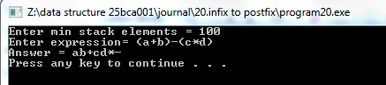

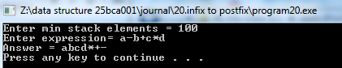

Program-21.//Write a program to implement recursion.
#include<iostream>
using namespace std;
int Fibonacci(int n) {
if (n==0)
return 0;
else if (n==1)
return 1;
else
return (Fibonacci(n-1) + Fibonacci(n-2));
}
int main() {
int n,i=0,res;
cout << "Enter the number of terms=" << endl;
cin >> n;
cout << "Fibonacci series:" << endl;
for(i=0; i<n; i++) {
res = Fibonacci(i);
cout << res << " ";
}
cout << endl;
system("pause");
return 0;
}
OUTPUT:
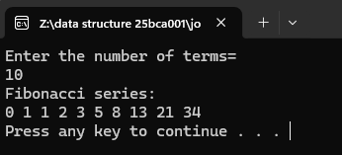

Program-22.//Write a program to reverse the string using the stack.
#include<iostream>
using namespace std;
int main() {
char str[100],stack[100];
int top=-1;
cout << "Enter a string: " ;
cin >> str;
for(int i=0;str[i]!='\0';i++) {
stack[++top]=str[i];
}
cout <<"The reversed string is: ";
while(top>=0) {
cout << stack[top];
top--;
}
cout << endl;
system("pause");
return 0;
}
OUTPUT:
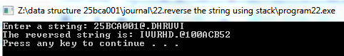

Program-23.//Write a program to implement Simple Queue operations using Linked List.
//• ENQUEUE
//• DEQUEUE
//• Traversal (display)
#include<iostream>
using namespace std;
class node{
public:
int data;
node *next;
};
node *front=NULL;
node *rear=NULL;
void Enqueue(){
int val;
node *newnode = new node;
cout << "Enter data= ";
cin >> val;
newnode->data = val;
if(front == NULL) {
front = rear = newnode;
front->next=rear->next=NULL;
}
else{
rear->next=newnode;
rear=newnode;
rear->next =NULL;
}
}
void Dequeue(){
if(front == NULL) {
cout << "queue is empty" << endl;
return;
}
node *temp=front;
cout << "data dequeue= " << temp->data << endl;
front=front->next;
delete temp;
}
void display(){
if(front == NULL) {
cout << "queue is empty" << endl;
return;
}
node *temp=front;
cout << "queue:::" << endl;
while(temp!=NULL) {
cout << temp->data << "->";
temp=temp->next;
}
cout << " 0 ";
}
int main(){
int s;
cout << "::: SIMPLE QUEUE :::" << endl;
while(true) {
cout << " SELECT " << endl;
cout <<"-----------------------"<<endl;
cout << "1.Enqueue " << endl;
cout <<"2.Dequeue "<< endl;
cout <<"3.Display "<< endl;
cout <<"Enter 0 to exit" << endl;
cout <<"---------------------"<< endl;
cout << "Select Your Choice NO.: ";
cin >>s;
switch (s) {
case 1:
Enqueue();
break;
case 2:
Dequeue();
break;
case 3:
display();
break;
case 4:
display();
break;
default:
cout << "invalid value" << endl;
break;
}
}
system("pause");
return 0;
}
OUTPUT:
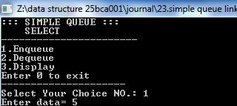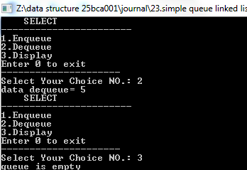

Program-24.//Write a program to implement Circular Queue operations Using Linked List.
//• ENQUEUE
//• DQUEUE
//• Traversal (display)
#include<iostream>
using namespace std;
class node{
public:
int data;
node *next;
};
node *front = NULL;
node *rear = NULL;
void Enqueue(){
int val;
node *newnode = new node;
cout << "Enter data= ";
cin >> val;
newnode->data = val;
if(front == NULL) {
front = rear = newnode;
rear->next=front;
}
else{
rear->next=newnode;
rear=newnode;
rear->next =front;
}
}
void Dequeue(){
if(front == NULL) {
cout << "queue is empty" << endl;
}
node *temp=front;
if(front==rear) {
cout << front->data <<"dequeue from queue" << endl;
delete front;
front =rear=NULL;
}
else{
cout << temp->data << " dequeue from queue " << endl;
front=front->next;
rear->next=front;
delete temp;
}
}
void display(){
if(front == NULL) {
cout << "queue is empty" << endl;
return;
}
node *temp=front;
cout << "queue:::" << endl;
do {
temp=temp->next;
cout << temp->data << "->";
}
while(temp!=front);
cout << "(back to " << front->data << ")" << endl;
}
int main() {
int s;
cout << "::: CIRCULAR QUEUE :::" << endl;
while(true) {
cout << " SELECT " << endl;
cout <<"-----------------------"<<endl;
cout << "1.Enqueue " << endl;
cout <<"2.Dequeue "<< endl;
cout <<"3.Display "<< endl;
cout <<"Enter 0 to exit" << endl;
cout <<"---------------------"<< endl;
cout << "Select Your Choice NO.: ";
cin >>s;
switch (s) {
case 1:
Enqueue();
break;
case 2:
Dequeue();
break;
case 3:
display();
break;
case 4:
display();
break;
default:
cout << "invalid value" << endl;
break;
}
}
system("pause");
return 0;
}
OUTPUT:
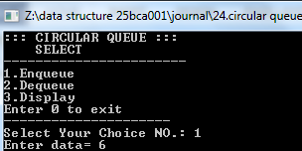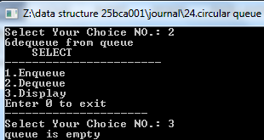

//25.Write a program to implement following operations on Binary Search Tree using Linked List.
//• Creation , • Insertion , • Traversal( In-order, Pre-order, Post-order)
#include<iostream>
using namespace std;
class node{
public:
node *left;
int data;
node *right;
};
node *create(int val){
node *newnode = new node;
newnode->data=val;
newnode->left=NULL;
newnode->right=NULL;
return newnode;
}
node *insert(node *ptr,int val){
if(ptr == NULL){
ptr=create(val);
}
else if(val < ptr->data)
ptr->left=insert(ptr->left,val);
else
ptr->right=insert(ptr->right,val);
return ptr;
}
void preorder(node *ptr){
if(ptr == NULL)return;
else{
cout << ptr->data << " ";
preorder(ptr->left);
preorder(ptr->right);
}
}
void postorder(node *ptr){
if(ptr==NULL)return;
else{
cout<<ptr->data <<" ";
postorder(ptr->right);
postorder(ptr->left);
}
}
void inorder(node *ptr){
if(ptr==NULL)return;
else{
inorder(ptr->left);
cout << ptr->data << " ";
inorder(ptr->right);
}
}
int main(){
int val,s;
node *root=NULL;
while(true) {
cout <<"\n----------------------"<< endl;
cout << " SELECT " << endl;
cout <<"-----------------------"<<endl;
cout << "1.Create binary search tree " << endl;
cout <<"2.Insert in binary search tree "<< endl;
cout <<"3.Inorder traversal "<< endl;
cout <<"4.Preorder traversal "<< endl;
cout <<"5.Postorder traversal "<< endl;
cout <<"Enter 0 to exit" << endl;
cout <<"---------------------"<< endl;
cout << "Select Your Choice NO.: ";
cin >>s;
switch (s) {
case 1:
cout << "Enter root node= ";
cin >>val;
root=create(val);
break;
case 2:
cout << "Enter data= ";
cin >>val;
insert(root,val);
break;
case 3:
cout << "Inorder traversal ";
inorder(root);
break;
case 4:
cout << "Preorder traversal ";
preorder(root);
break;
case 5:
cout << "Postorder traversal ";
postorder(root);
break;
default:
cout << "INVALID INPUT" << endl;
break;
}
}
system("pause");
return 0;
}
OUTPUT:

//create
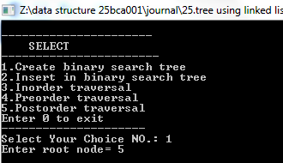

//insert
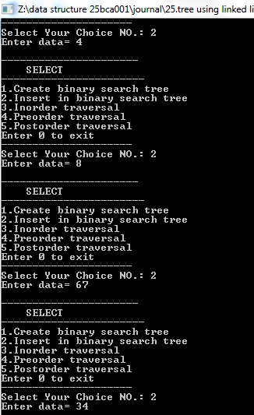

//traversal(inorder,postorder,preorder)


