**NAME – AYUSH BRIJESH SHAH**

**ID – 20DCS106**

**SUBJECT – DATABASE MANAGEMENT SYSTEM**

**SUBJECT CODE – CE246**

**SEMESTER - 4**

**PHARMACY DATABASE**

**MANAGEMENT SYSTEM**

**Introduction**

This DBMS project is based on Pharmacy Store Management System. It provide you the information of customers, workers, products and dealers of that pharmacy store.

In this project I have used SQL as well as PL/SQL queries.

**Data Entities:**

1. **Customers:** It has attributes of Customer Id (Primary Key), Customer Name, Contact Number and City.
2. **Dealer:** It has attributes of Dealer Id (Primary Key), Dealer Name, Dealer Contact and City
3. **Products:** It has attributes of Product Id (Primary Key), Product Name, Price, Quantity and Expiry Date. Expiry Date is of type Date.
4. **Workers:** It has attributes of Workers Id (Primary Key), Workers Name and Salary.

**ER DIAGRAM:**

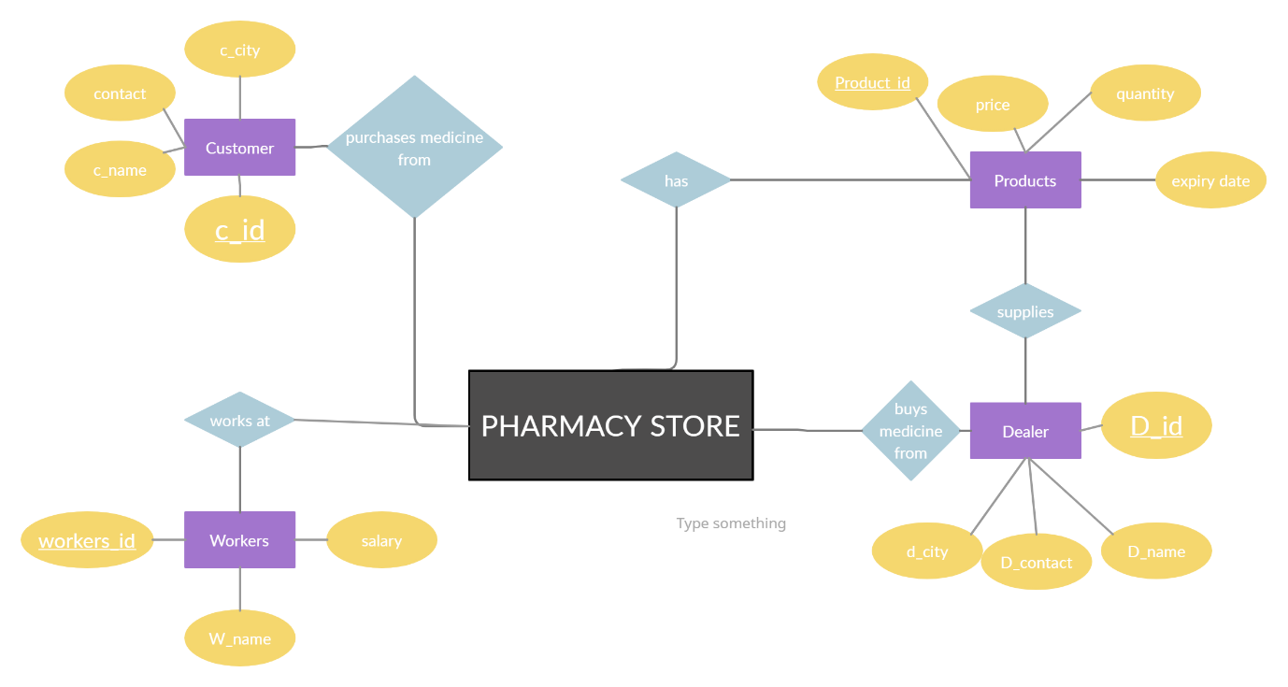

**TABLES**

1. **CUSTOMERS:**

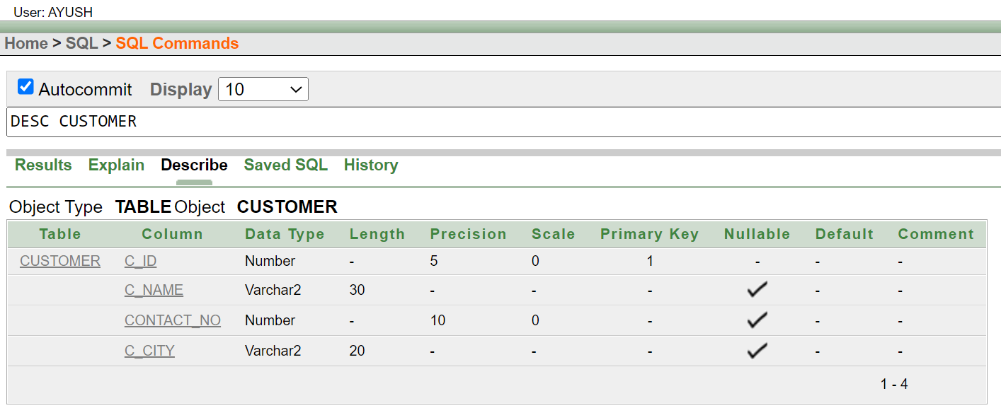

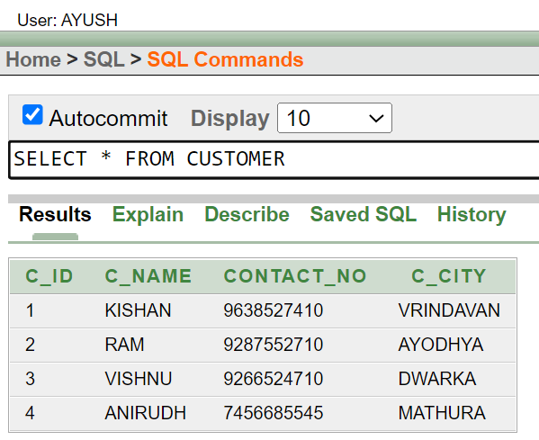

1. **DEALERS:**

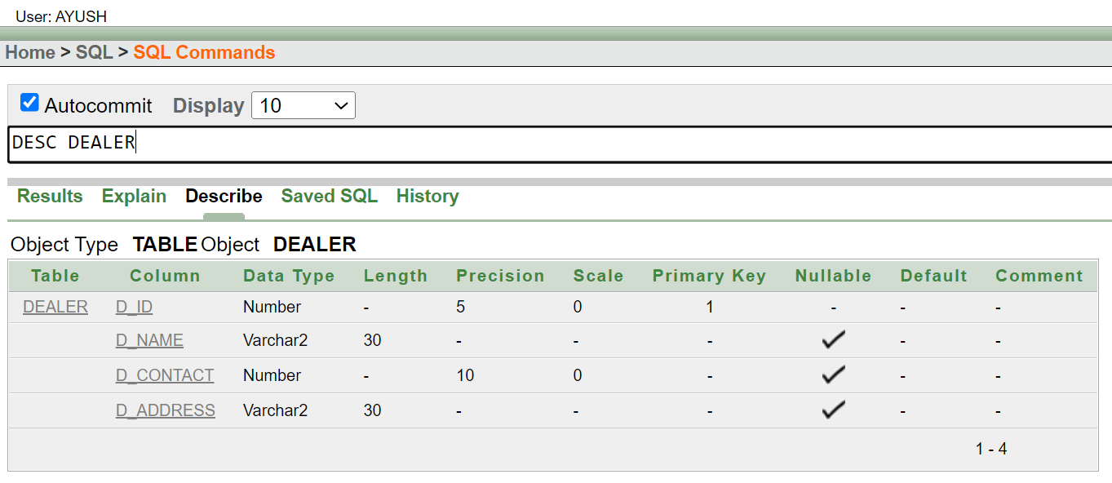

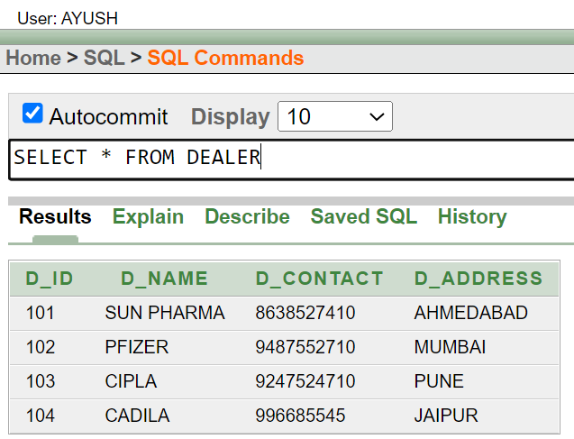

1. **PRODUCTS:**

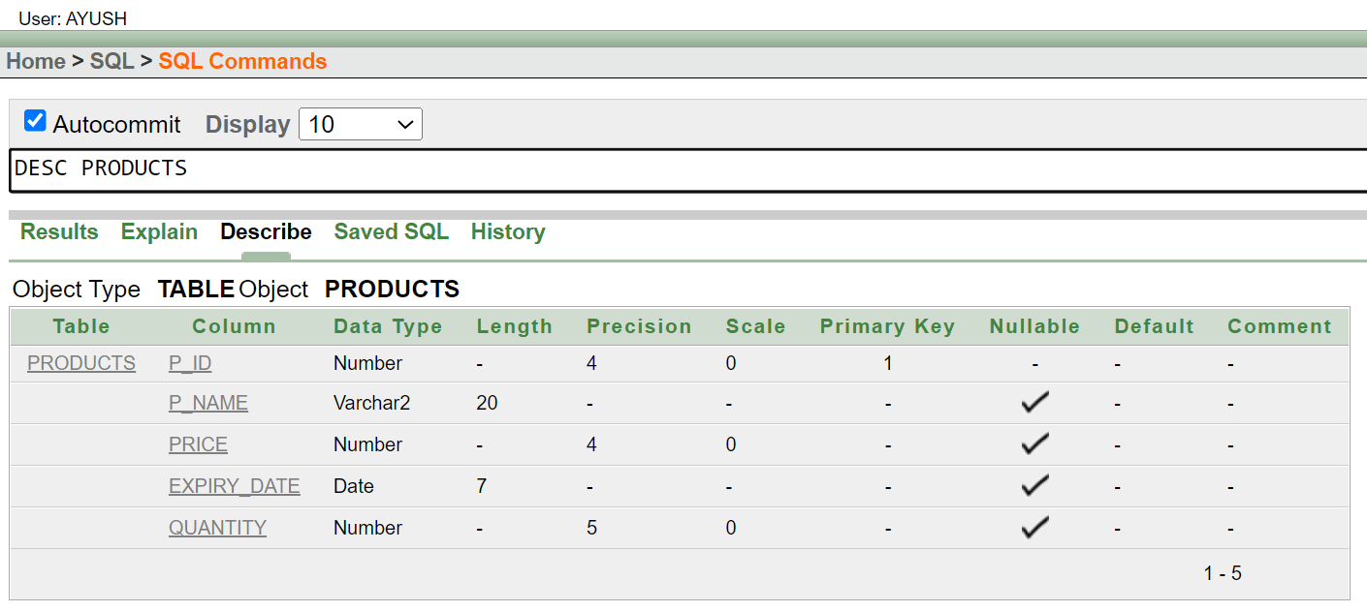

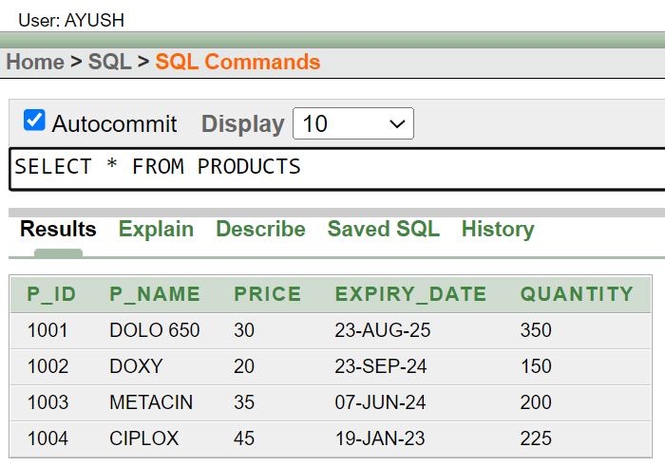

1. **WORKERS:**

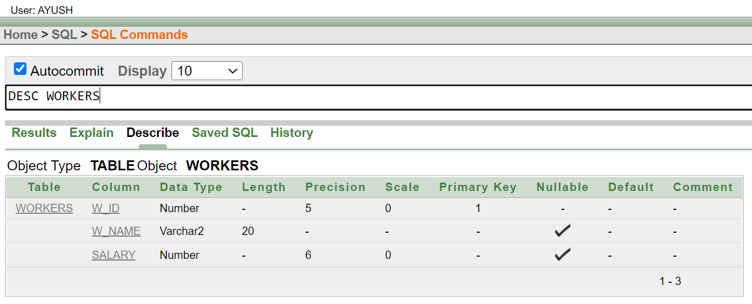

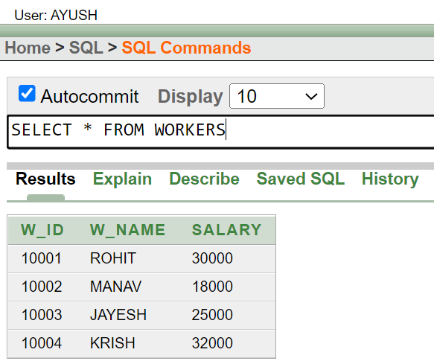

**Using PL/SQL:**

1. **FUNCTION:**

**CREATING FUNCTION:**

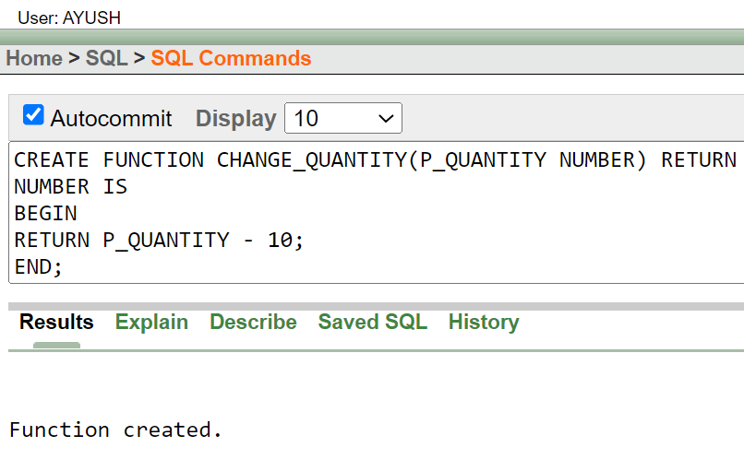

**AFTER UPDATION:**

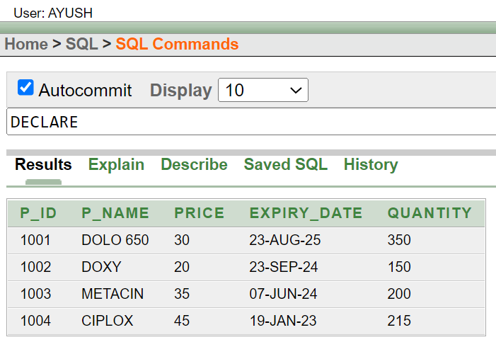

1. **TRIGGER:**

**CREATING A TRIGGER:**

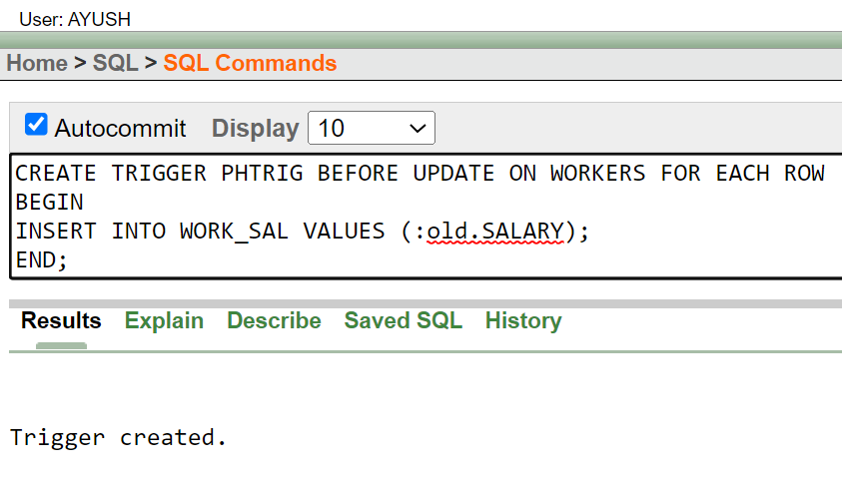

**UPDATION:**

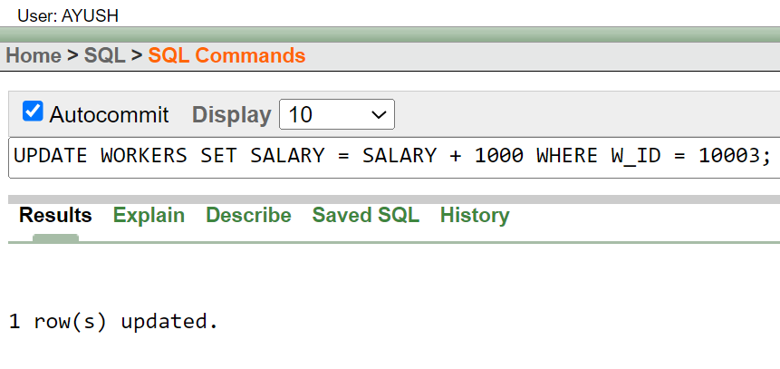

**DISPLAY:**

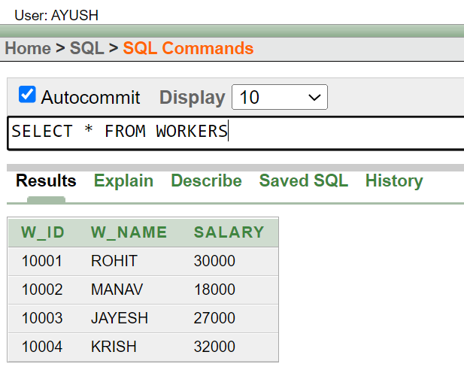

**DROPPING TRIGGER:**

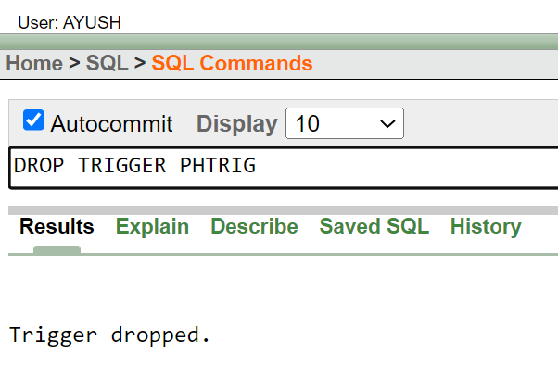

**SOURCE CODE:**

**CREATING TABLES AND INSERTING VALUES**

CUSTOMER TABLE

CREATE TABLE CUSTOMER (C_ID NUMBER PRIMARY KEY, C_NAME VARCHAR2(30), CONTACT_NO NUMBER(10), C_CITY VARCHAR2(20))

INSERT ALL

INTO CUSTOMER VALUES (001, 'KISHAN', 9638527410, 'VRINDAVAN')

INTO CUSTOMER VALUES (002, 'RAM', 9287552710, 'AYODHYA')

INTO CUSTOMER VALUES (003, 'VISHNU', 9266524710, 'DWARKA')

INTO CUSTOMER VALUES (004, 'ANIRUDH', 7456685545, 'MATHURA')

SELECT * FROM DUAL

**__________________________________________________________________________________________**

DEALER TABLE

CREATE TABLE DEALER (D_ID NUMBER(5) PRIMARY KEY, D_NAME VARCHAR2(30), D_CONTACT NUMBER(10), D_ADDRESS VARCHAR2(30))

INSERT ALL

INTO DEALER VALUES (101, 'SUN PHARMA', 8638527410, 'AHMEDABAD')

INTO DEALER VALUES (102, 'PFIZER', 9487552710, 'MUMBAI')

INTO DEALER VALUES (103, 'CIPLA', 9247524710, 'PUNE')

INTO DEALER VALUES (104, 'CADILA', 996685545, 'JAIPUR')

SELECT * FROM DUAL

**__________________________________________________________________________________________**

PRODUCTS TABLE

CREATE TABLE PRODUCTS (P_ID NUMBER(4) PRIMARY KEY, P_NAME VARCHAR2(20), PRICE NUMBER(4), EXPIRY_DATE DATE, QUANTITY NUMBER(5))

INSERT ALL

INTO PRODUCTS VALUES(1001, 'DOLO 650', 30, '23-AUG-25', 350)

INTO PRODUCTS VALUES(1002, 'DOXY', 20, '23-SEP-24', 150)

INTO PRODUCTS VALUES(1003, 'METACIN', 35, '07-JUN-24', 200)

INTO PRODUCTS VALUES(1004, 'CIPLOX', 45, '19-JAN-23', 225)

SELECT * FROM DUAL

**__________________________________________________________________________________________**

WORKERS TABLE

CREATE TABLE WORKERS (W_ID NUMBER(5) PRIMARY KEY, W_NAME VARCHAR2(20), SALARY NUMBER(6))

INSERT ALL

INTO WORKERS VALUES (10001, 'ROHIT', 30000)

INTO WORKERS VALUES (10002, 'MANAV', 18000)

INTO WORKERS VALUES (10003, 'JAYESH', 25000)

INTO WORKERS VALUES (10004, 'KRISH', 32000)

SELECT * FROM DUAL

**PL/SQL QUERIES – FUNCTION:**

CREATING FUNCTION

CREATE FUNCTION CHANGE_QUANTITY(P_QUANTITY NUMBER) RETURN

NUMBER IS

BEGIN

RETURN P_QUANTITY - 10;

END;

**__________________________________________________________________________________________**

FUNCTION CALLING

DECLARE

P_NO NUMBER :=:ENTER_PRODUCT_ID;

P_QUANTITY NUMBER;

A1 NUMBER;

BEGIN

SELECT P_ID INTO A1 FROM PRODUCTS WHERE P_ID = P_NO;

IF (A1 = P_NO) THEN

SELECT QUANTITY INTO P_QUANTITY FROM PRODUCTS WHERE P_ID = P_NO;

P_QUANTITY := CHANGE_QUANTITY(P_QUANTITY);

UPDATE PRODUCTS SET QUANTITY = P_QUANTITY WHERE P_ID = P_NO;

ELSE

DBMS_OUTPUT.PUT_LINE('RECORD NOT FOUND');

END IF;

**PL/SQL QUERIES – TRIGGER:**

CREATING AND IMPLEMENTING TRIGGER

CREATE TABLE WORK_SAL (WORK_SALARY NUMBER(6))

CREATE TRIGGER PHTRIG BEFORE UPDATE ON WORKERS FOR EACH ROW

BEGIN

INSERT INTO WORK_SAL VALUES (:old.SALARY);

END;

UPDATE WORKERS SET SALARY = SALARY + 1000 WHERE W_ID = 10003;

**__________________________________________________________________________________________**

DROPPING TRIGGER

DROP TRIGGER PHTRIG