PROJECT REPORT
Customer Churn Prediction using AI-Driven Data Analytics
AICTE | IBM SkillsBuild Data Analytics with AI Internship 2026
Conducted by BharatCares, in association with AICTE
Submitted by | AYUSH
Program | IBM SkillsBuild Data Analytics with AI
Internship | AICTE Academic Internship Program 2026
Organized by | BharatCares
Project Title | Customer Churn Prediction using AI-Driven Data Analytics
Submission Date | September 2026

1. Introduction
Customer churn refers to customers discontinuing their relationship with a service provider. For subscription-based businesses such as telecommunications companies, retaining an existing customer is significantly cheaper than acquiring a new one, which makes churn prediction a high-value business problem.
This project applies data analytics and Artificial Intelligence (AI) techniques to analyze customer behavior, identify the strongest drivers of churn, and build machine learning models that predict which customers are at risk of leaving. The project was completed as part of the IBM SkillsBuild Data Analytics with AI Academic Internship Program, organized by BharatCares in association with AICTE.

2. Problem Statement
Telecom companies lose substantial revenue every year due to customer churn, but often lack a systematic way to identify at-risk customers before they leave. The goal of this project is to build a data-driven model that:
- Analyzes historical customer data to uncover patterns behind churn
- Predicts the likelihood of a customer churning using machine learning
- Identifies the key features that most strongly influence churn
- Produces insights that support targeted, cost-effective retention strategies

3. Objectives
- Perform exploratory data analysis (EDA) to understand customer demographics, services, and account attributes
- Clean and preprocess the dataset for machine learning
- Train and compare multiple classification models (Logistic Regression, Random Forest)
- Evaluate models using accuracy, precision, recall, F1-score, and ROC-AUC
- Interpret feature importance to explain what drives churn
- Translate findings into actionable business recommendations

4. Dataset Description
This project follows the schema of the widely used IBM Telco Customer Churn dataset, available publicly on Kaggle:
Dataset link: https://www.kaggle.com/datasets/blastchar/telco-customer-churn
To make the project fully self-contained and runnable without external downloads, a synthetic dataset of 2,000 customer records was generated with the same column structure as the original dataset, and with churn probabilities derived from realistic risk factors (contract type, tenure, internet service, and payment method) so the statistical relationships mirror those documented in real-world churn studies.

4.1 Key Attributes
Category | Example Columns
Demographic | gender, SeniorCitizen, Partner, Dependents
Account | tenure, Contract, PaperlessBilling, PaymentMethod
Services | PhoneService, MultipleLines, InternetService, OnlineSecurity, TechSupport, StreamingTV
Billing | MonthlyCharges, TotalCharges
Target | Churn (Yes / No)

5. Methodology

5.1 Data Preprocessing
- Checked for missing values and verified data types
- Label-encoded categorical variables (e.g., Contract, PaymentMethod, InternetService)
- Standardized numeric features for the Logistic Regression model using StandardScaler
- Split data into 80% training and 20% testing sets, stratified by the churn label

5.2 Exploratory Data Analysis
EDA was performed to understand churn distribution and its relationship with key customer attributes.
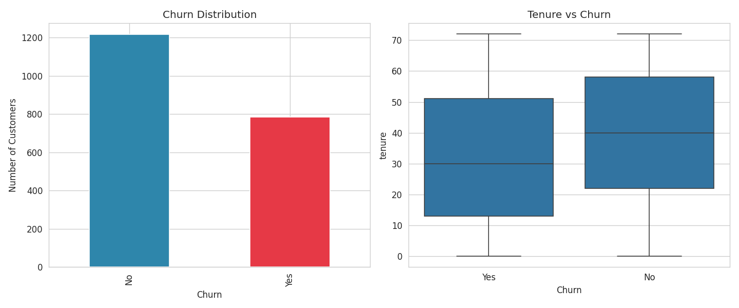
Figure 1: Overall churn distribution and tenure vs. churn
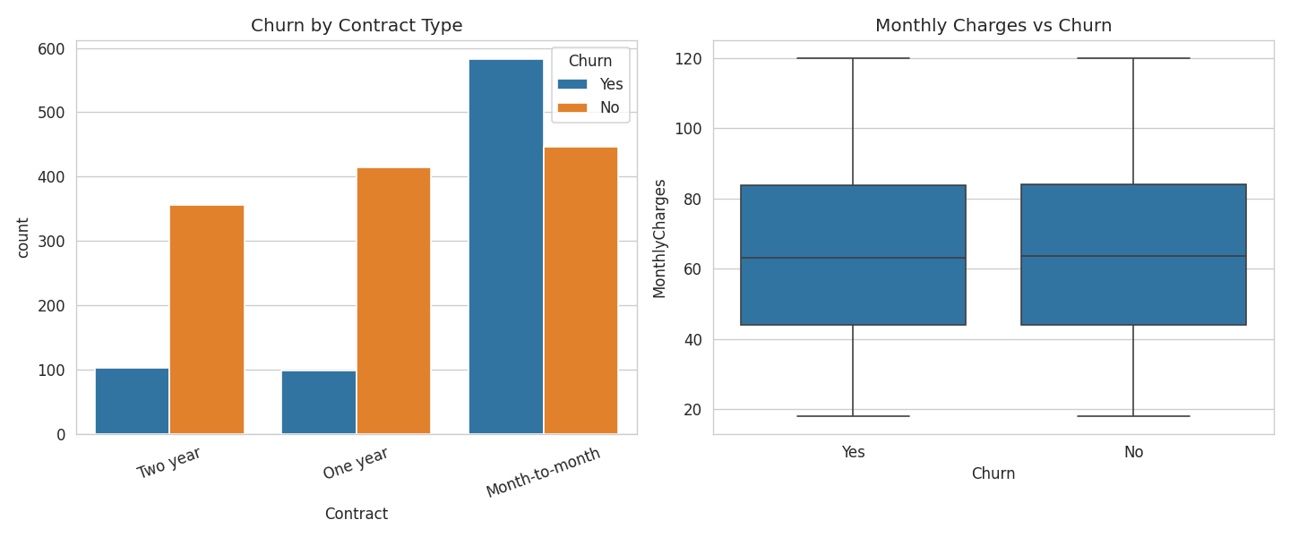
Figure 2: Churn by contract type and monthly charges vs. churn
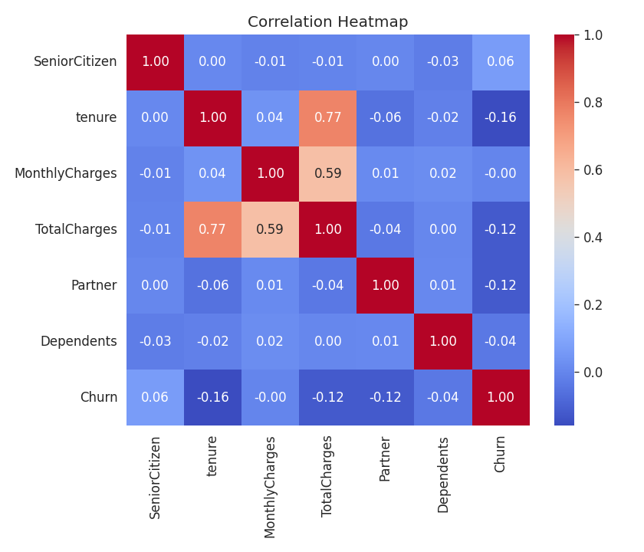
Figure 3: Correlation heatmap of key numeric features

5.3 Model Building (AI Layer)
Two supervised classification models were trained on the preprocessed dataset:
- Logistic Regression — a simple, interpretable linear baseline model
- Random Forest Classifier — an ensemble model capable of capturing non-linear relationships between features

6. Results & Evaluation
Both models were evaluated on the held-out test set using standard classification metrics.
Model | Accuracy | Precision | Recall | F1-score | ROC-AUC
Logistic Regression | 0.663 | 0.583 | 0.490 | 0.533 | 0.713
Random Forest | 0.695 | 0.621 | 0.573 | 0.596 | 0.746

The Random Forest model outperformed Logistic Regression across every metric, indicating that churn is driven by non-linear interactions between features rather than a purely linear relationship.
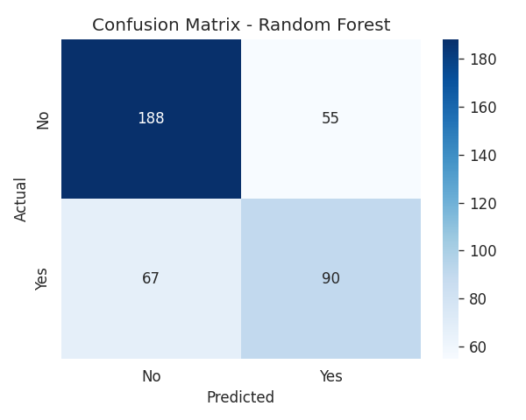
Figure 4: Confusion matrix for the best-performing model (Random Forest)
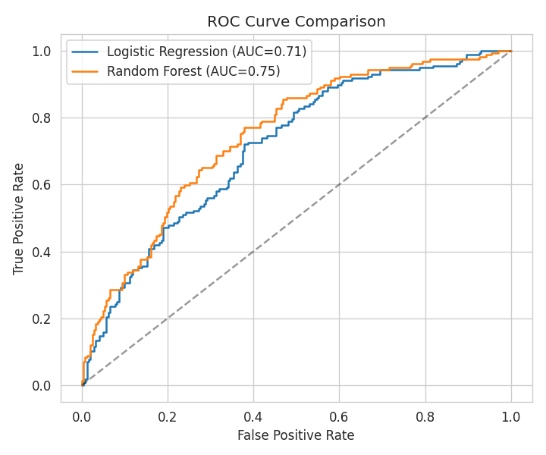
Figure 5: ROC curve comparison between the two models

7. Feature Importance (Explainable AI)
Feature importance analysis from the Random Forest model reveals which customer attributes most strongly influence churn predictions, making the model's decisions interpretable for business stakeholders.
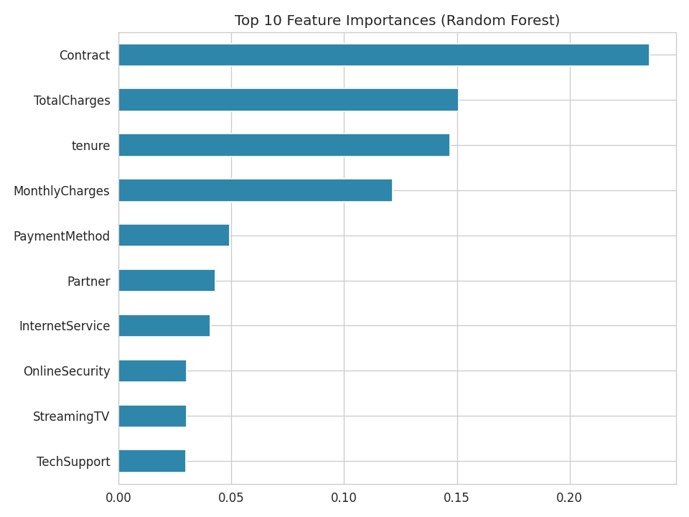
Figure 6: Top 10 features driving churn predictions
Contract type was the single strongest predictor, followed by total charges, tenure, and monthly charges. This aligns with the EDA findings in Section 5.2.

8. Business Insights & Recommendations
- Customers on month-to-month contracts represent the highest churn risk — offering incentives to switch to annual contracts could meaningfully reduce churn
- New customers (low tenure) churn more often — a structured onboarding or early-engagement program could improve retention in the first year
- High monthly charges correlate with higher churn — proactively offering loyalty discounts to high-paying, at-risk customers could reduce revenue loss
- Electronic check users show higher churn than automatic payment methods — encouraging migration to autopay may improve retention

9. Conclusion
This project demonstrates a complete AI-driven data analytics workflow — from raw data to actionable business insight — for the customer churn prediction problem. The Random Forest model achieved the strongest performance (ROC-AUC of 0.746) and identified contract type, charges, and tenure as the key churn drivers. These findings can directly inform targeted retention strategies for a telecom business.

10. Future Scope
- Train and validate the models on the real IBM Telco Customer Churn dataset from Kaggle
- Apply hyperparameter tuning (GridSearchCV / RandomizedSearchCV) and k-fold cross-validation
- Experiment with gradient-boosted models such as XGBoost or LightGBM
- Deploy the best model as a simple web app or API for real-time churn scoring

11. Technologies Used
Category | Tools / Libraries
Language | Python 3.11
Data Handling | pandas, numpy
Visualization | matplotlib, seaborn
Machine Learning | scikit-learn
Environment | Jupyter Notebook

12. References
1. Telco Customer Churn Dataset (IBM), Kaggle: https://www.kaggle.com/datasets/blastchar/telco-customer-churn
2. scikit-learn documentation: https://scikit-learn.org/stable/documentation.html
3. pandas documentation: https://pandas.pydata.org/docs/
4. Seaborn documentation: https://seaborn.pydata.org/

