**2.2 Requirements Specification**

**2.2.1 Problem Domain Description**

**2.2.1.1 Existing Business Operation**

**2.2.1.2 Summary of existing business limitations requiring resolution.**

**2.2.2 Functional Requirements**

**Basic Functionality Item Listing**

The students records, staff records, course records, attendance records, etc. holds many information and functions to be retrieved, create, edit, assign, maintain, archive, delete and many more.

Here are the records operation lists:

Table: 2.1 Basic Functionality Item Listing

|  |  |  |  |  |
| --- | --- | --- | --- | --- |
| **Area** | **Admin** | **Course Leader** | **Module Leader/Personal tutor** | **Student** |
| **Student Records** | Create, Edit, Archive, Display, Assign | No access | No access | View own records |
| **Staff Records** | Create, Edit, Archive, Display, Assign | View own records | View own records | No access |
| **Course Records** | No access | Create Structure, Edit, Display, Delete, Archive | No access | No access |
| **Module Management** | No access | Create, Delete, Archive | Edit, Archive, Display, Assign | View modules |
| **Assignment Management** | No access | Mark/Grade | Create, Edit, Delete, Archive, Grade | No access |
| **Attendance Records** | Action Poor Attendance | Create, Monitor | Create, Edit, Archive, Monitor, Display | View personal attendance |
| **Personal Tutor management** | No access | No access | Create, Edit, Assign, Display | No access |
| **Time Table Management** |  |  |  |  |
| **Diary management** |  |  |  |  |
| **Report Generation/ Management** | No access | Create, Display, Print | No access | No access |

Here is more clarified entity list for Student record:

Table: 2.2 Students Record

|  |
| --- |
| students |
| Name of entity | **Type/Format** | **Notes** |
| student_record_status | CHAR(Provisional, Live, Dormant) | Students current status |
| dormant | CHAR(Graduated, Withdrawal, Terminated) or NULL | Reason for dormancy. If not dormant it should be null |
| firstname | String (Limited to 25 characters) | First name of the student |
| middlename | String (Limited to 25 characters) | Middle name of the student |
| surname | String (Limited to 25 characters) | Last name of the student |
| address_term_time | String (Limited to 50 characters) | Term time address |
| address_non_term_time | String (Limited to 50 characters) | Non-term time if different |
| id | Integer (8 digits, no decimal place) Format (99999999) | student assigned ID number |
| password | Encrypted String (Limited to 32 characters to allow encryption) | Students password |
| phone_no | String (Limited to 25 characters) | Students telephone or mobile number |
| email | String (Limited to 50 characters) | Email address of student |
| course_code | String (Limited to 5 characters) | Current course code student is enrolled into |
| entry_qualification | String (Limited to 50 characters) | Qualification of the student |
| exit year | Date (DD-MM-YY) | Time duration for student to day in University |

Here is more clarified entity list for Administrator record:

Table: 2.3 Admin Record

|  |
| --- |
| admin |
| Name of entity | **Type/Format** | **Notes** |
| admin_record_status | CHAR(Live or Dormant) | admin current status |
| dormant | CHAR(Retired, Resigned, Misconduct) or NULL | Reason for dormancy. If not dormant it should be null |
| firstname | String (Limited to 25 characters) | First name of the administrator |
| middlename | String (Limited to 25 characters) | Middle name of the administrator |
| surname | String (Limited to 25 characters) | Last name of the administrator |
| address | String (Limited to 25 characters) | Address of administrator |
| id | Integer (8 digits, no decimal place) Format (99999999) | administrator assigned ID number |
| password | Encrypted String (Limited to 32 characters to allow encryption) | administrator password |
| phone_no | String (Limited to 25 characters) | administrator telephone or mobile number |
| email | String (Limited to 50 characters) | Email address of administrator |

Here is more clarified entity list for Module Leader record:

Table: 2.4 Module Leader Record

|  |
| --- |
| module_leader |
| Name of entity | **Type/Format** | **Notes** |
| module_leader_record_status | CHAR(Live or Dormant) | module leader current status |
| dormant | CHAR(Retired, Resigned, Misconduct) or NULL | Reason for dormancy. If not dormant it should be null |
| firstname | String (Limited to 25 characters) | First name of the module leader |
| middlename | String (Limited to 25 characters) | Middle name of the module leader |
| surname | String (Limited to 25 characters) | Last name of the module leader |
| address | String (Limited to 25 characters) | Address of module leader |
| id | Integer (8 digits, no decimal place) Format (99999999) | module leader assigned ID number |
| password | Encrypted String (Limited to 32 characters to allow encryption) | module leader password |
| phone_no | String (Limited to 25 characters) | Module leader telephone or mobile number |
| email | String (Limited to 50 characters) | Email address of module leader |
| role | String (Limited to 25 characters) | Eg: module tutor for XXXX, personal tutor, course leader |

Here is more clarified entity list for Course Leader record:

Table: 2.5 Course Leader Record

|  |
| --- |
| course_leader |
| Name of entity | **Type/Format** | **Notes** |
| course_leader_record_status | CHAR(Live or Dormant) | course leader current status |
| dormant | CHAR(Retired, Resigned, Misconduct) or NULL | Reason for dormancy. If not dormant it should be null |
| firstname | String (Limited to 25 characters) | First name of the course leader |
| middlename | String (Limited to 25 characters) | Middle name of the course leader |
| surname | String (Limited to 25 characters) | Last name of the course leader |
| address | String (Limited to 25 characters) | Address of course leader |
| Id | Integer (8 digits, no decimal place) Format (99999999) | course leader assigned ID number |
| password | Encrypted String (Limited to 32 characters to allow encryption) | course leader password |
| phone_no | String (Limited to 25 characters) | course leader telephone or mobile number |
| Email | String (Limited to 50 characters) | Email address of course leader |
| Role | String (Limited to 25 characters) | Eg: module tutor for XXXX, personal tutor, course leader |
| specialist_subject | String (Limited to 50 characters) | Eg: Computing-Database Technology |

**Functionality Operational Logic**

The following figures demonstrate how the new system will operate logically for key operations:

The following flowchart is a the create process of the system. The flowchart shows how records can be added to the database. After the interview it was informed that not all the users are allowed to user this process which is why we add a level of accessibility in the system. The admin is allowed to create new student records; the course leader is allowed to create the course structure whereas the student cannot create any records and therefore this function is not available to the student.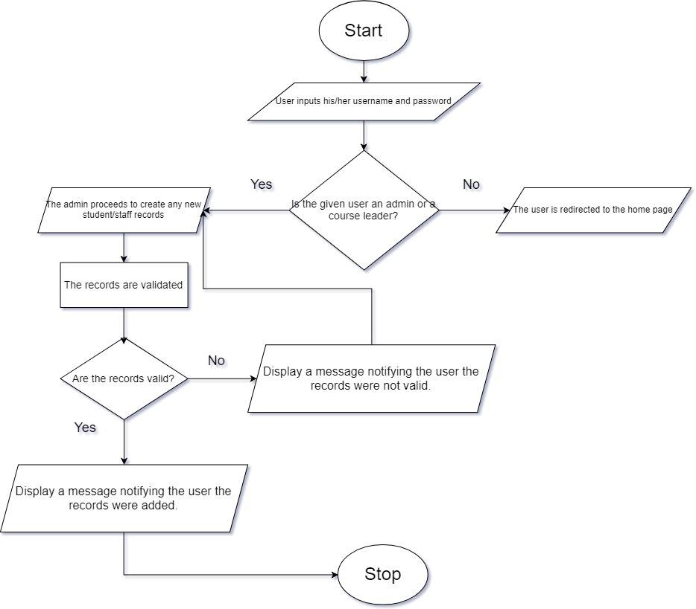

*Figure: 2.1 Create Records*

The following is a flow chart for the amend function. There may be records that might need to be edited later on which can be done using the amend function. This feature allows you to update the already existing records. This function also is not available to all the users as this may cause for data theft and other miscellaneous activities. Which is why the system uses a login system to prevent such things from happening. The amend feature is available for the admin, who can update the records of the students and the staffs, course leader, who can make changes to the course records and the module leader, who can edit the module information.

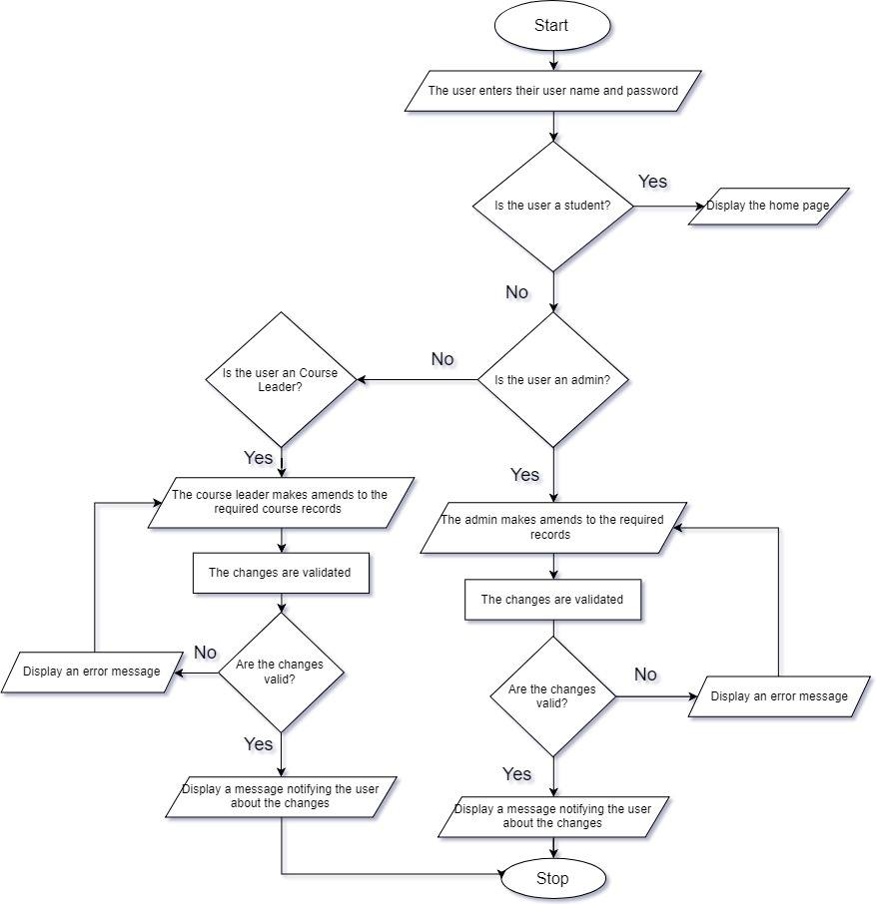

*Figure: 2.2 Amend Records*

This flow chart is for archiving the records. When a record is archived it is hidden from the public, the record however is not deleted it is simply hidden from the view of the public. The archive function is not available for the students because they cannot manipulate any records. The admin can archive student and staff records, the course leader can archive the course records and the module leader can archive the module details, student grade for that particular module or assignment details for that module.

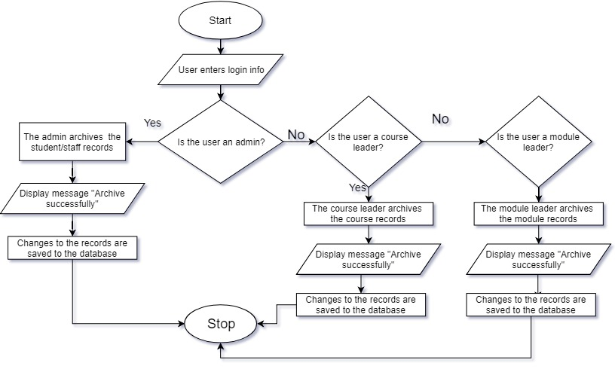

*Figure: 2.3 Archive Records*

The display function is used to view certain records as per the request of the user. However, all the records cannot be viewed by all the users. The admins can only view the student and staff records, the course leader can view the course details and the students’ performance in each module and monitor their attendance and the module leader can view the module records like the resources and other study materials for their own modules. The student can only view their own records.

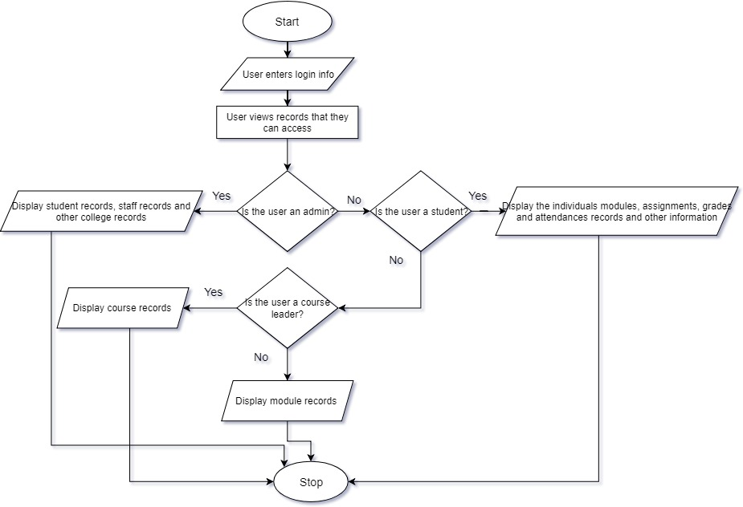

*Figure: 2.4 Display Records*

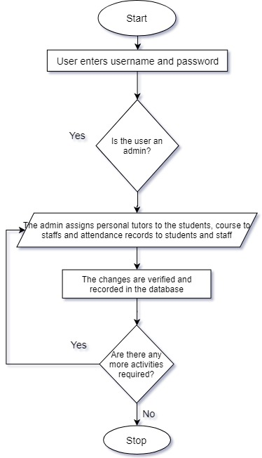

*Figure: 2.4 Display Records*

**Attribute Table and Associated Drop-Down (Sub-category listing) Selection Options**

This table lists the important attributes along with their brief description. In some cases, drop down list (sub-categories) are also mentioned below:

|  |  |
| --- | --- |
| **Attribute** | **Notes/ Examples** |
|  |  |
|  |  |
|  |  |
|  |  |
|  |  |
|  |  |
|  |  |
|  |  |
|  |  |
|  |  |
|  |  |
|  |  |
|  |  |
|  |  |
|  |  |
|  |  |
|  |  |

**Example External Output Format (for use with e-mail/letters/SMS/reports)**

**Failure to attend Personal Tutor Meeting**

DD/MM/YYYY

Dear Title First Name surname, (eg. XYZ)

Your name has been referred as a possible cause for concern by your module co-ordinator because you are recorded as: Not attending a personal tutorial meeting [ ]

It is essential that you see me as soon as possible. You must do this by Date(DD-MM-YY). The meeting will check and review your progress and find a means of resolving any difficulties you may be experiencing. The Student Code details the implications of 'failure to attend personal tutor meetings' and whilst there may be mitigating circumstances not known to us at this time, you should regard this letter as an informal warning that your continuation on the course may be at risk.

If for any reason you are experiencing difficulties which impact on your academic work, you should contact your personal tutor for advice. You must however see me as instructed by the -------------------.

Yours sincerely,

Module Co-Ordinater

To Students email-id

CC Student file / Course Leader

**Poor Attendance Letter**

DD/MM/YYYY

Dear Title First Name surname, (eg. Mr XYZ)

Your name has been referred as a possible cause for concern by your module co-ordinator because you are recorded as: Having poor or no attendance at classes [ ]

It is essential that you see me as soon as possible. You must do this by Date(DD-MM-YY). You are reminded that all students enrolling on a course at UCN are expected to meet the academic requirements of their programme. The Student Code details the implications of 'failure to meet required attendance' and whilst there may be mitigating circumstances not known to us at this time, you should regard this letter as an informal warning that your continuation on the course may be at risk. Failure to make contact may result in us deeming you to be withdrawn from your course.

If for any reason you are experiencing difficulties which impact on your academic work, you should contact your personal tutor for advice. You must however see me as instructed by the -------------------.

Yours sincerely,

Module Co-Ordinater

To Students email-id

CC Student file / Course Leader

**Failure to Submit Coursework**

DD/MM/YYYY

Dear Title First Name surname, (eg. Mr XYZ)

Your name has been referred as a possible cause for concern by your module co-ordinator because you are recorded as: Not submitting coursework [ ]

It is essential that you see me as soon as possible. You must do this by Date(DD-MM-YY). You are reminded that all students enrolling on a course at UCN are expected to meet the academic requirements of their programme. The Student Code details the implications of 'failure to meet academic, professional or vocational requirements' and whilst there may be mitigating circumstances not known to us at this time, you should regard this letter as an informal warning that your continuation on the course may be at risk. Failure to make contact may result in us deeming you to be withdrawn from your course.

If for any reason you are experiencing difficulties which impact on your academic work, you should contact your personal tutor for advice. You must however see me as instructed by the -------------------.

Yours sincerely,

Module Co-Ordinater

To Students email-id

CC Student file / Course Leader

**Address Amendment Letter**

DD/MM/YYYY

Dear Sir or Madam,

This letter is to notify you about my change of residency. As I have recently moved into new location, I would like to amend on my previous address on my profile. My full details are provided below:-

Name:

Students name

Uni ID:

University ID

Previous Address:

Street name, City, Country

(Eg: 345 New Road, Kathmandu, Nepal)

Current Address:

Street name, City, Country

(Eg: 451 Jorpati, Kathmandu, Nepal )

I would be very grateful for your help.

Thanks and regards,

(name of student)

To: Administrator

**Confirmation Letter**

DD/MM/YYYY

Dear Title First Name surname, (eg. Mr XYZ)

Your Amendment of Address from (previous address) to (new address) has been verified and confirmed.

Your Profile has been Updated successfully.

If you have any queries, please do contact, Student Service Office.

Yours sincerely,

Administrator

To Students email-id

**2.2.3 Performance Requirements**

**2.2.3.1 Speed**

**2.2.3.2 Capacity**

**2.2.3.3 Reliability**

**2.2.3.4 Usability**

**2.2.4 Design Constraints**

**2.2.5 Commercial Constraints**

**2.2.6 Acceptance Tests**