**Software Development Lifecycle (SDLC) at Etsy: A Practical Approach**

**Etsy’s**

**Getting to Know Etsy's Development Process**

AComparative Study of Different Models in Relation to Etsy’s Software Development

**Ayush B Shetty**

**Nitte Mahalinga Adyantaya Memorial Institute of Technology**

[**nnm23is029@nmamit.in**](mailto:nnm23is029@nmamit.in)

<https://github.com/ayushshetty13/sdlc_etsy/edit/main/README.md>

**Keywords: SDLC, Etsy’s, AWS, Integration, Testing, Scalability, Requirements validation**

**Abstract**

Design and environment of an online marketplace could well be considered fundamentally impossible to be done without a systematic and coherent approach for their software developments. This report discusses the various SDLC models used by Etsy to enhance user experience, secure transactions, and integrate technology-driven upgrades. We discuss the incremental, Spiral, and Waterfall approaches used by Etsy to keep itself in proper competition against rivals in e-commerce.

A detailed analysis of the approaches through which the Etsy development process achieves enhancements to its platform -- through continuous improvement, iterative enhancements, and regular features -- in order to deal with competitor and industry standards relevant to the online marketplace.

**Table of Contents**

**1.Introduction………………………………………………………………………………………………3**

**2.SDLC Models and Their Role in Etsy’s Growth……………………………………3-10**

**2.1 Incremental Development Model**

**2.2 Spiral Model**

**2.3 Waterfall Model**

**3.How Etsy Handles Software Requirements…………………………………………10-11**

**3.1 Functional Requirements**

**3.2 Non-functional Requirements**

**3.3 How Etsy Validates Its Requirements**

**4.Challenges in Software Development at Etsy………………………………………10**

**5.Future Trends in Etsy’s SDLC Approach……………………………………………….10-11**

**6.Conclusion………………………………………………………………………………………….11**

**7.References………………………………………………………………………………………….11**

**1. Introduction**

Software development encompasses more than just coding; it has become an art of establishing a reputation of safe, secure, scalable, and interactive marketplace where business objectives can be achieved. IIWES, Etsy was supposed to incorporate millions of independent sellers and buyers with an interface. For such a platform, software development must be structured and systematic.

Etsy runs the regular development cycle under coordination with new features and security upgrades. An SDLC would of an interim nature would suffice, propounding into an overall stable platform for Etsy. This report examines the SDLC methods proposed by Etsy and their ways of guaranteeing success.

Etsy’s SDLC framework allows for smooth software updates, the establishment of compliance in line with global regulations, and culminates into an optimized shopping experience geared toward buyers and sellers.

**2. SDLC Model and Their Contributions to Etsy's Growth**

**2.1 Incremental Development Model**

Development is staged and phased with the utmost reliance on feedback for the gradual evolution of Etsy. Software development is based on delivering the system in small, manageable segments or increments. For an e-commerce platform like Etsy, this model can be broken down into different phases, each adding specific functionality while allowing for feedback and refinement throughout the development process.

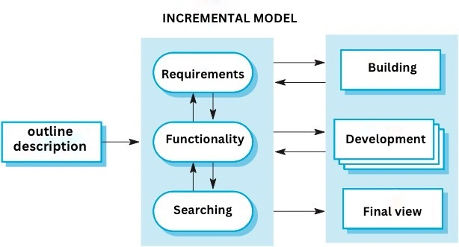

1. Initial Planning & Requirements Gathering:

Define the core vision of Etsy as a marketplace for handmade, vintage items, and craft supplies. Understand the basic needs of buyers and sellers. In its early stages (2005), Etsy was designed to provide an online marketplace that connected buyers with handmade sellers. The key goal was to create a platform for artisans to sell their products and to allow buyers to discover unique, handcrafted items. The initial requirements were focused on a simple, user-friendly interface that allowed sellers to list their products and buyers to browse and purchase.

2. Core E-commerce Functionality:

Build the foundation of the platform with essential features for a marketplace. After initial planning, Etsy launched its platform in 2005 with basic but critical e-commerce features. This included user registration for both buyers and sellers, product listings, and basic checkout. Sellers could upload their products with images, descriptions, and prices.3. Enhanced Search, Navigation, and Seller Tools:

Enhance the platform with better search and filtering systems, plus tools to help sellers manage their inventory and orders. Search by multiple attributes such as price range, seller location, and product type. A simple dashboard for sellers to manage their listings, sales, and customer interactions. Etsy introduced product suggestions based on buyer behaviour. A more polished platform with a better user experience and powerful tools for sellers.4. Social Features & Trust-Building Tools:

Foster social interaction on the platform and build trust through reviews and community engagement. They added features like customer reviews, favourites, and social sharing options. Buyers could leave ratings and reviews for both products and sellers. Integration with social media platforms to share items and shops, increasing visibility. Increased buyer trust and more social engagement, which helped Etsy grow its community of both buyers and sellers.

5. Mobile Optimization and App Development :

Make Etsy accessible on mobile devices by optimizing the website and developing a mobile app. As mobile usage grew, Etsy realized the importance of a seamless mobile experience. In 2010, Etsy developed a mobile-optimized website and later introduced native

**Functionality:**

The search algorithm is tweaked constantly to enhance product discoverability on Etsy.New seller tools and features, like automatic pricing suggestions, are rolled out progressively.Payment processing improvements are rolled out stepwise to ease disruption.

**Non-Functionality:**

Architectural flaws may emerge within that duration because multiple features are released one after the other.Older features may become obsolete with the growing demands of the platform.

**Risk & Change Management:**

This has less risk because Etsy can improve on feedback before each feature is fully deployed.Phased rollout gives the company the ability to respond quickly to market trends.

**The Etsy Case:**

First, Etsy may introduce a base AI-generated recommended products system, following up with a machine learning upgrade offering personalized suggestions based on user actions.The adding in of the incremental model allows multiple teams to work on different features in parallel, which can speed development overall.

**2.2 Spiral Model**

A hybrid model with an iterative aspect that emphasizes risk management, so well suited for large projects that change frequently over time. Software development is an iterative and risk-driven process, which combines elements of both the waterfall and incremental models. The process consists of repeated cycles or spirals where each cycle involves planning, risk assessment, development, testing, and review. This method is particularly useful for complex and large-scale projects like Etsy, where each iteration addresses specific goals, mitigates risks, and refines the system.

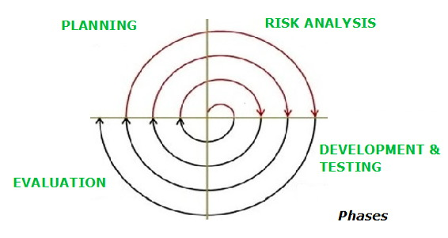

1. Planning and Requirements Gathering:

Understand the project goals, user requirements, and potential risks. In the first cycle, the focus is on establishing basic requirements, planning, and risk identification. User-friendly design for both sellers and buyers. Determining the needs of both buyers and sellers. Initial Planning setting high-level goals for the platform. The main risk at this stage was the lack of a clear business model and customer base. High-level requirements document.

2. Risk Analysis and Prototype Development:

Analyse and address the risks identified in the first phase while developing a prototype that demonstrates the platform's core functionality. The team created a simple version of the platform. At this stage, Etsy focused on developing a prototype that allowed users to list products and process basic transactions, but with many features still in development. Addressing high-priority risks. Developing a minimum viable product (MVP) for early-stage users to test. Gathering feedback from early adopters to refine the product. A working prototype of the Etsy platform. Feedback from a small set of users that highlighted issues with the design and user interface.

3. Design and Development :

Develop a more refined version of the system based on feedback, while continuing to assess and address risks. They had refined the initial prototype, but it was still a simple marketplace. Etsy now started to focus on improving the system based on early feedback. Enhanced product listing functionality. More robust search features categories, price ranges. Improving the user interface to make it more intuitive for both sellers and buyers. Addressing technical risks, such as ensuring reliable payment systems and securing user data. A functional e-commerce platform, albeit with limited features.

4. Testing, Feedback, and Refinement:

Test the system for bugs, gather extensive feedback, and refine the platform based on real-world usage and further risk analysis. The platform had to undergo extensive testing. The focus during this phase was on refining the system and addressing bugs, user feedback, and performance issues. This revealed areas for improvement in search functionality, checkout flow, and site performance. Risk management during this phase included security concerns , performance issues ,and scalability challenges. Improving product search algorithms, integrating more payment options, enhancing the seller dashboard, and making the site mobile-responsive. Refined features and a more stable, scalable platform.

5. Final Release and Deployment:

Deploy the final version of the platform, refine and stabilize it for production, and assess any remaining risks. Etsy's first major milestone was achieving a larger user base and attracting more sellers. Comprehensive testing before full-scale deployment, ensuring that all major features were stable and secure. Continuous monitoring to ensure the platform could handle increasing traffic and transactions. At this stage, the primary risks were related to scaling and ensuring the platform could handle the growing number of users.Ensured platform reliability and stability.

6. Maintenance and Evolution:

Maintain and evolve the system through continuous feedback and improvements. The platform entered a continuous phase of improvement, adding new features, expanding internationally, and refining the system based on user feedback. Regular updates to address bugs, improve performance, and optimize features. New tools for sellers analytics, marketing features, mobile optimization, mobile apps for iOS and Android, and internationalization to support different languages and currencies. Ongoing assessment of risks such as security issues, platform downtime, and competition. Regular monitoring for emerging risks and customer needs.

**Functionality:**

* Suitable for complex projects like Etsy's AI-based ad targeting.
* Assists in analysis of buyer transaction risks.
* Continuous upgrade and evolution with real-time data.

**Non-Functionality:**

* Very costly considering repeated testing and risk assessment.
* Requires savvy security and development skill set.
* Risk & Change Management:
* Best to find fraud and threat to security before it executes
* Allow for changes to be made after every cycle, thus making the system much resilient.

**Time & Cost Constraint:**

* Very expensive because there are constant test and development cycles.
* Slow development process, but would result in a very safe and robust platform.

**Why Etsy Uses This Model:**

Detects and eliminates security threats to ensure compliance with global standards like GDPR for personal data protection.

Allows iterating on the product before launching bigger things like new seller analytics dashboards, fraud detection tools, etc.

**Etsy Example:**

Before rolling out a stronger payment protection area for sellers, Etsy runs interim slots of tests to eradicate fraud loopholes and tune security on payment methods.

**2.3 Waterfall Model**

This Waterfall Model adopts a linear approach and works perfectly for those fixed projects that do not go through many changes during the course of development. Software development process that follows a linear and sequential approach. In this model, each phase must be completed before moving on to the next. While it’s less flexible compared to modern iterative approaches, the Waterfall model is still useful for projects with well-defined requirements and minimal changes during development.

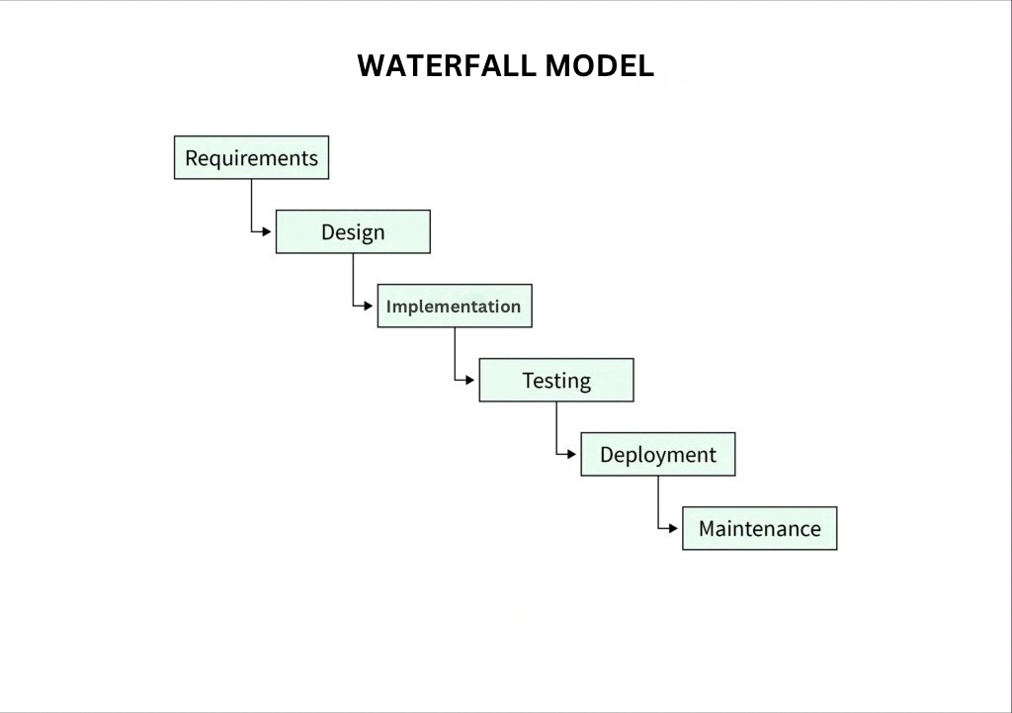

1. Requirement Gathering and Analysis :

Identify and document the complete set of requirements for the project, ensuring a clear understanding of what the platform needs to deliver. The initial vision was to create an online marketplace focused on handmade, vintage items, and craft supplies. The founders identified the core requirements, focusing on simplicity for both buyers and sellers. A platform where sellers can list handmade and vintage products. Integration of payment systems for transactions . Secure shopping experience for users. A clear outline of the goals and features Etsy needed to develop in its first iteration

2. System Design:

Create the system and software design based on the requirements gathered in the first phase. This includes high-level system architecture, database design, and defining how the software components will interact. The goal was to design a simple but robust platform to handle the basics of product listings, search, and payments. The platform was designed to allow for product listings, search, and basic e-commerce functionality. The database structure was designed to store user profiles, product information, and transaction data. The user interface focused on simplicity to allow easy navigation for both buyers and sellers. Initial wireframes or designs for how the site would appear to users.

3. Implementation:

Begin actual development of the system based on the design specifications. The developers would build the essential e-commerce features, ensuring they were functional and ready for testing. User registration and profile management. Product listing functionality. Search and categorization of products. A working website with basic functionality like user accounts, product listings, and a shopping cart. The actual code behind the platform, ready for initial testing.

4. Testing :

Test the system for bugs, security vulnerabilities, and performance issues. This phase ensures that the platform works as intended and meets the documented requirements. The testing at this stage would include ensuring that the user registration system worked, products could be listed and searched, and payments could be processed. Verifying that users can register, list products, search for products, and make payments. Ensuring the platform was easy to use for both buyers and sellers. Ensuring that sensitive data like payment information was handled securely. Documentation detailing any bugs, issues, or performance problems discovered during testing. Addressing any issues discovered in the testing phase.

5. Deployment:

Deploy the completed system to the production environment, making it available to users. Deployment would have included server setup, configuration, and launching the website to the public. Ensuring that the platform could handle traffic, store data securely, and perform well under load. Making the platform available to the general public and announcing the website as an online marketplace. Etsy started promoting the platform through word-of-mouth and online marketing. The public-facing Etsy platform where users can register, list products, and purchase items. The infrastructure supporting the live website, ensuring it runs smoothly.

6. Maintenance:

Provide ongoing support, updates, and bug fixes to keep the platform running smoothly and introduce new features as needed. This involved fixing bugs, addressing user feedback, optimizing the website, and introducing new features. Resolving any bugs or issues that users encountered. Adding new features, such as product recommendations, enhanced seller tools, and mobile app development. The platform needed to scale to accommodate more users and products. New versions of the platform with added features and bug fixes. Ongoing customer support to help resolve issues and answer questions from users.

**Functionality:**

* This works for the structured processes like integration of the third-party payment systems;
* It is a precise way that includes firm documentation and better handling for the development process.

**Non functionality:**

* This will not be good for changeable projects.
* Later on detection may be more expensive.

**Risk & Change Management:**

* High risk if the initial requirements are incorrect.
* It becomes very hard to incorporate changes after the development start.

**Time & Cost Constraints:**

* Facilitates low costs for small and well defined projects.
* Sequential execution makes it take some time to finish.

**Etsy Example:**

This is used for back-end infrastructure upgrades, which require a planned out process to implement changes.It guides Etsy compliance with financial and legal regulations regarding updates to their payment policies. Software Requirement Specification for Etsy

**3.1 Functional Requirements**

* User authentication- Secured logins, multifactor authentication, and password reset.
* Product management- User-friendly seller tools for listing and managing products.
* Cart and checkout- Smooth and secured transactions with many payment options.
* Order tracking and Customer Support- Buyers can view easy tracking of orders and their communication with customer support.

**3.2 Non-functional Requirements**

* Performance- Fast page loads even when shopping traffic is quite high.
* Security- Protect against cards and fraud by detecting and encrypting user data.
* Scalability- To accommodate the greater number of buyers and sellers.
* Experience- A seamless, easy-to-use experience on all devices.

**3.3 Etsy's Validation of Its Requirements**

Software development within Etsy follows the business direction and needs of the user and market.Very extensive testing before any software update is rolled out.The changes introduced through a proper management approach so disruption might be avoided.Etsy uses Artificial Intelligence-based monitoring systems to discover and stop spikes and manage the system's overall performance.

**4.Etsy software development challenges**

Scalability-System therein must be built quickly and robustly enough to accommodate unanticipated growth.Cyber security-Prevent from fraud, protecting sensitive customer data.Regulatory compliance-If and when changes are made to international legislation on taxes and laws.

**5.Future Trends in Etsy's SDLC Approach**

AI and automation-Speeding the development process with AI code editors and testing software.

Microservices architecture-Breaking up big systems into small but decoupled and modular services that can be improved and maintained easily.

Blockchain-The technology will provide the assurance of security and transparency within payments.

**6. Conclusion**

For Etsy, software development is much greater than mere software coding; it's an enabling environment for safe buying, selling, and browsing for millions of users around the world. By using different models of the SDLC, Etsy strikes a balance between continuously innovating and keeping its platform stable.The software development strategy will determine whether it is for a new search personalization initiative or to further establish the prevention measures to combat fraud: its very nature ensures its long-run success.

**7. References**

Sommerville, Ian. Software Engineering (9th Edition).

Developer Documentation, Etsy.

Etsy official website - <https://www.etsy.com/>