REPORT
OF
WEB DEVELOPMENT
AT
CODEC TECHNOLOGIES PVT. LTD.

Submitted To
School of Computer Science and Engineering
IILM University, Greater Noida, U.P.

In partial fulfilment of the requirement of degree of
B.Tech CSE



By
Roll Number of Student: 25SCS1003004676
Name of Student: AYUSH SINGH
Batch: 2025-29

2026-27

CANDIDATE'S DECLARATION

I, Ayush Singh, do hereby declare that the internship report titled “A Report on Web Development Internship at Codec Technologies Pvt. Ltd.” has been completed by me to fulfil the requirement for the award of the degree of Bachelor of Technology in CSE. All the references have been quoted and I have not taken as such any material from any other source. I affirm to you that this report is my own and has not been submitted to any other institute for any degree/diploma requirement and further I shall be solely responsible for any kind of copyright violation in this regard.

Signature
Student Name: Ayush Singh
Roll No.: 25SCS1003004676

ACKNOWLEDGEMENT

I am using this opportunity to express my gratitude to everyone who supported me throughout the internship program at Codec Technologies Pvt. Ltd. I am thankful for their aspiring guidance, invaluable constructive criticism, and friendly advice during this work. I would like to express my sincere gratitude to Dr. Anurag Shrivastava, Program Manager, and the entire team at Codec Technologies for giving me the opportunity to work as a Web Developer Intern and for their continuous support and mentorship throughout the one-month AICTE and ICAC approved internship program.
I am also grateful to the School of Computer Science and Engineering, IILM University, Greater Noida, for providing me the platform and encouragement to undertake this internship as part of my B.Tech CSE curriculum. I sincerely thank my faculty mentors for their truthful and illuminating views on a number of issues related to this work.
I express my gratitude to my parents for their blessings and constant support.

Signature
Student Name: Ayush Singh
Roll No.: 25SCS1003004676

TABLE OF CONTENTS

Chapter No. | Chapter Name | Page No.
 | Cover Page | ----
1. | Candidate’s Declaration | i
2. | Acknowledgement | ii
3. | Internship Completion Certificate | iii
4. | Project Description | 1
 | 4.1 Introduction
 | 4.2 Organization Profile
 | 4.3 Problem Statement
 | 4.4 Project Objectives
 | 4.5 Scope of the Project
 | 4.6 Technologies and Tools Used
 | 4.7 System Architecture
 | 4.8 Methodology
 | 4.9 Expected Outcomes
 | 4.10 Certificate of Completion
5. | Bibliography/References

INTERNSHIP COMPLETION CERTIFICATE

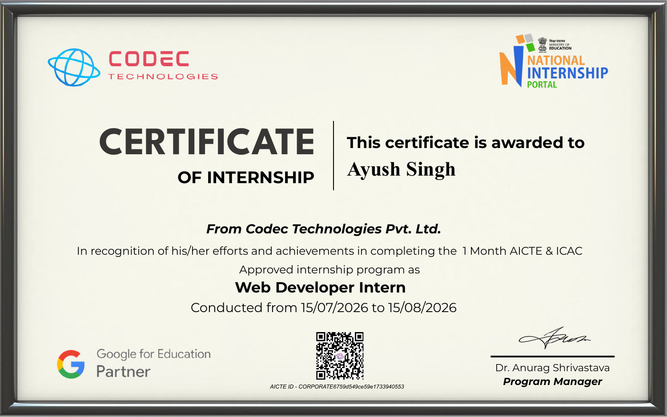

4. PROJECT DESCRIPTION
4.1 Introduction
This report presents an account of the one-month internship undertaken as a Web Developer Intern at Codec Technologies Pvt. Ltd. from 15th July 2026 to 15th August 2026, under the AICTE and ICAC approved internship program in association with the National Internship Portal, Ministry of Education, Government of India, and Google for Education. The internship provided an opportunity to gain hands-on, industry-oriented exposure to modern web development practices, moving beyond classroom theory into practical, project-based learning. Over the course of the program, the internship covered the fundamentals and advanced concepts of front-end and back-end web development, culminating in the design and development of functional web-based projects under the guidance of industry mentors.
4.2 Organization Profile
Codec Technologies Pvt. Ltd. is a technology-driven organization that offers AICTE and ICAC approved internship programs aimed at bridging the gap between academic learning and industry requirements. In partnership with the National Internship Portal and Google for Education, the organization provides structured, mentor-led training programs in domains such as web development, data science, artificial intelligence, and cybersecurity. The organization focuses on equipping students with practical, job-ready skills through project-based learning, live sessions, and real-world assignments, enabling interns to build a strong professional portfolio.
4.3 Problem Statement
Most students undergoing traditional academic curricula have limited exposure to real-world web development workflows, including responsive design, version control, and deployment practices. The internship was designed to address this gap by requiring the intern to design, build, and deploy a functional website/web application using industry-standard tools and practices, thereby simulating a real-world software development environment.
4.4 Project Objectives
- To understand the fundamentals of web development including HTML, CSS, and JavaScript.
- To gain practical experience with front-end frameworks/libraries used in modern web development.
- To learn the basics of back-end development and how front-end and back-end components interact.
- To understand responsive web design principles for cross-device compatibility.
- To gain familiarity with version control systems such as Git and GitHub.
- To design, develop, and deploy a functional web application as a capstone project.
4.5 Scope of the Project
The scope of the internship encompassed the complete web development lifecycle: requirement understanding, UI/UX design, front-end implementation, back-end integration, testing, and deployment. The training was structured to build competency progressively, starting with core web technologies and advancing towards building a complete, functional web application that could be showcased as a portfolio project.
4.6 Technologies and Tools Used
- Front-End: HTML5, CSS3, JavaScript
- Styling/Responsive Design: Bootstrap / Flexbox / CSS Grid
- Version Control: Git and GitHub
- Code Editor: Visual Studio Code
- Browser Developer Tools for debugging and testing
- Deployment Platform: GitHub Pages / Netlify
4.7 System Architecture
The web application developed during the internship followed a standard client-side architecture. The front-end layer, built using HTML, CSS, and JavaScript, was responsible for rendering the user interface and handling user interactions. Where applicable, a simple back-end/data layer was used to manage dynamic content. The architecture emphasized modularity, with separate components for the header, navigation, main content sections, and footer, ensuring the codebase remained organized, reusable, and easy to maintain.
4.8 Methodology
The internship followed a structured, mentor-guided methodology consisting of the following phases:
- Week 1: Orientation and fundamentals of HTML5 and CSS3, including semantic markup and styling.
- Week 2: JavaScript fundamentals - DOM manipulation, events, and interactivity.
- Week 3: Responsive web design and introduction to front-end frameworks/libraries; building UI components.
- Week 4: Capstone project development, testing, debugging, deployment, and final presentation/evaluation.
Throughout the program, regular mentor check-ins, live doubt-clearing sessions, and hands-on assignments ensured consistent skill development and timely completion of tasks.
4.9 Expected Outcomes
- A solid, practical understanding of front-end web development technologies.
- Ability to design and build responsive, cross-browser compatible websites.
- Hands-on experience with version control and collaborative development workflows using Git/GitHub.
- A deployed, functional web application to include in a professional portfolio.
- Improved problem-solving, debugging, and self-learning skills relevant to the software industry.
4.10 Certificate of Completion
The Internship Completion Certificate issued by Codec Technologies Pvt. Ltd., verifying successful completion of the one-month Web Developer Internship (15/07/2026 to 15/08/2026) under the AICTE and ICAC approved program, is attached as Chapter 3 of this report.

5. BIBLIOGRAPHY / REFERENCES
1. Mozilla Developer Network (MDN Web Docs) - https://developer.mozilla.org
2. W3Schools Online Web Tutorials - https://www.w3schools.com
3. GitHub Documentation - https://docs.github.com
4. Codec Technologies Pvt. Ltd. - Internship Program Study Material and Mentor Sessions
5. National Internship Portal, Ministry of Education, Government of India - https://internship.aicte-india.org

