Incremental Radiative Transfer Technique and GPU-Assisted Microclimatic Optimization for Urban Pedestrian Walkways
Ayush Singh | Dr. Jobin Thomas
Department of Computational Science and Engineering (Data Science)
Dayananda Sagar University, Bengaluru, Karnataka, India
Target Journal: Earth Science Informatics (Springer) | Manuscript Type: Research Article

Abstract
The traditional approach in decoupled urban microclimate simulations requires complete recalculating the domain when implementing local shading interventions, thus forming a considerable computational bottleneck for iterations. In this work, we introduce Solaraeus, which is a 3D microclimate modeling platform addressing this recomputation overhead via certified by math incrementation of radiative transfer algorithm with CUDA GPU acceleration. By constraining solid angle decay and Stefan–Boltzmann linearization within the declared thermal tolerance (0.50 K), the engine is able to reuse over 98% of grid cells. For the main corridor in Berlin Friedrichstraße (240×200 m, 1.0 m resolution), GPU incrementation works in 18 ms, resulting in more than 300x speedup compared to full CPU recomputation. The integrated Bayesian active learning finds the canopy configurations that deliver up to 13.14 K of locally cooled radiation with the mean corridor temperature reduction of 0.86 K. Replications across multiple cities reveal that while the deep high-rise canyons demonstrate limited canopy efficiency due to the architecture self-shading effect (Chicago), the wide boulevards bring significant relief of cooling (London, 11.05 K).
Keywords: Urban microclimate, mean radiant temperature, incremental radiative transfer, GPU acceleration, UTCI, microclimate optimization, Earth science informatics.

1. Introduction
Anthropogenic climate change compounded by urban morphological heat trapping subjects metropolitan pedestrian corridors to severe thermal distress during extreme summer heatwaves (Oke 1982; Grimmond et al. 2010). Outdoor thermal sensation during daylight hours is governed predominantly by the Mean Radiant Temperature (Tmrt) rather than ambient dry-bulb air temperature alone (Matzarakis et al. 2007). In sunlit street canyons, incident shortwave direct beam solar radiation, diffuse sky irradiance, and longwave emissions from heated asphalt and masonry surfaces elevate pedestrian physiological stress into the Strong and Very Strong Heat Stress categories of the Universal Thermal Climate Index (UTCI) (Jendritzky et al. 2012; Błażejczyk et al. 2013). Consequently, municipal urban planners require high-resolution microclimatic models to evaluate the cooling efficacy of localized heat mitigation interventions, such as overhead shade structures and boulevard trees (Krayenhoff et al. 2021).
Existing urban microclimate modeling tools are bifurcated between microscale Computational Fluid Dynamics (CFD) suites and decoupled radiation models. Microscale CFD software such as ENVI-met (Bruse and Fleer 1998) resolves atmospheric turbulence and vegetative heat exchange, yet requires several hours to days of CPU compute time for a single diurnal cycle, rendering iterative design exploration impractical. Conversely, decoupled radiation models such as the Solar and Longwave Environmental Irradiance Geometry (SOLWEIG) model within the Urban Multi-scale Environmental Predictor (UMEP) (Lindberg et al. 2008, 2018) separate geometric radiation transfer from fluid mechanics. By marching discrete rays across digital surface models to evaluate Sky View Factors (SVF) and direct shadow casting, decoupled engines reduce computational runtimes from days to seconds while preserving physiological accuracy in radiant heat estimation (Gal et al. 2009; Do et al. 2024).
Despite these computational advances, current simulation frameworks suffer from three interconnected limitations. First, existing solvers operate as monolithic batch programs: whenever a localized architectural intervention—such as an awning or canopy installation—is introduced, the engine discards the domain state and recomputes all grid cells from scratch. Second, heuristic spatial clipping approaches lack a mathematically certified, closed-form error bound guaranteeing that untouched receptor points do not exceed acceptable biometeorological tolerances (|T̃mrt(x) - Tmrt^full(x)| ≤ ε_T). Third, planners rely on manual trial-and-error placement because the multi-parameter continuous search space of canopy dimensions, orientations, heights, and non-overlap constraints cannot be practically explored through brute-force simulation.
To address these challenges, this study pursues two primary objectives:
1. Formulate, prove, and validate a certified incremental radiative transfer engine that guarantees sub-degree thermal accuracy (ε_T = 0.50 K) using closed-form Stefan–Boltzmann linearization and solid-angle decay, coupled with a resident CUDA GPU backend to achieve sub-20 ms update latencies.
2. Quantify the microclimatic cooling efficacy and optimization characteristics of localized shade installations across international urban corridors, comparing four optimization methodologies (Random Search, Genetic Algorithms, Static Gaussian Process Surrogates, and Active Learning) under identical simulation budgets on empirical digital twins in Berlin (primary), Chicago (replication), and London (replication).

2. Literature Review
Table 1 summarizes peer-reviewed studies across urban microclimate modeling, GPU acceleration, and machine-learning optimization.
Author & Year | Journal / Venue | Core Contribution | Identified Limitation
Baia et al. (2026) | Computational Urban Science | Clustering high-resolution microclimatic features to identify spatial heat island morphologies. | Identified thermal morphology clusters but lacked real-time 3D ray-traced geometric shading.
Kamath et al. (2026) | Preprint / UT Austin & Gothenburg | Implemented CUDA GPU acceleration for the SOLWEIG human comfort model on digital twins. | Accelerated full-domain batch recalculations but did not formulate incremental cell reuse.
Eingrüber et al. (2025) | Geoscientific Model Development | Simulated urban greening cooling in Berlin canyons using PALM-4U across grid resolutions. | High physical realism but required heavy multi-core CPU compute times of several hours.
Mei et al. (2025) | Geoscientific Model Development | Developed GUST1.0 GPU-accelerated 3D urban surface temperature and energy balance engine. | Significantly reduced surface temperature solve time; focused on building facades rather than pedestrian grids.
Freude et al. (2025) | Computer Graphics Forum | Formulated inverse radiative thermal simulation using precomputed light transport matrices. | Optimized surface thermal material placement; did not address real-time pedestrian comfort metrics.
Bourquin et al. (2025) | IBPSA Proceedings | Coupled mesoscale boundary forcings with microscale street canyon geometry for energy modeling. | Refined street-level boundary temperatures; lacked automated canopy placement optimization.
Rayegan et al. (2025) | Building and Environment | Developed 3D ray tracing-based direct solar shading model for building envelopes. | Accurately resolved complex building shadows; evaluated static annual steps without active learning.
Tao et al. (2025) | Renewable and Sustainable Energy Reviews | Systematically reviewed CFD and machine learning integration for urban green infrastructure. | Highlighted high surrogate speedup; noted severe surrogate degradation outside training envelopes.
Yuan et al. (2025) | Discover Cities | Simulated retro-reflective pavement materials to mitigate canyon radiant heat trapping. | Demonstrated shortwave trapping reduction; evaluated uniform materials rather than localized canopies.
Do et al. (2024) | Earth Science Informatics | Mapped urban heat dynamics using interpretable machine learning and remote sensing. | Provided city-scale thermal vulnerability mapping; lacked sub-meter building ray-tracing physics.
Chen et al. (2024) | Landscape and Urban Planning | Evaluated fast microclimate modeling for spatial planning of urban green and blue spaces. | Proved planning utility of fast radiation approximations; discarded spatial states on intervention edits.
Qin et al. (2024) | Building and Environment | Modeled multivariable 3D microclimates using localized Fourier Neural Operators. | Near real-time 3D field prediction; surrogates exhibited uncertified extrapolation errors.
Freude et al. (2023) | Computer Graphics Forum | Precomputed radiative heat transport matrices to accelerate dynamic thermal simulations. | Drastically sped up stationary geometries; alterations required full matrix recomputation.
Nguyen et al. (2023) | Earth Science Informatics | Developed mathematical multicriteria model for temperature-reducing potential of green spaces. | Ranked spatial intervention priorities; relied on empirical indices rather than 6-flux Stefan–Boltzmann physics.
Table 1. Systematic literature review of microclimate modeling, GPU acceleration, and optimization frameworks.

2.1 Radiative Transfer Modeling and Decoupled Microclimate Engines
Urban microclimate simulation has traditionally relied on coupled atmospheric and computational fluid dynamics (CFD) formulations, such as ENVI-met (Bruse and Fleer 1998) or the LES-based PALM-4U model evaluated by Eingrüber et al. (2025) across Berlin street canyons. While physically comprehensive, Navier–Stokes fluid modeling imposes heavy computational penalties, frequently consuming hours of multi-core CPU cluster time per diurnal cycle and rendering iterative architectural exploration prohibitive (Krayenhoff et al. 2021). To alleviate this overhead, decoupled radiation engines have emerged as the standard paradigm for pedestrian thermal comfort assessment. By decoupling shortwave and longwave radiative flux calculations from convective fluid motion, the Solar and Longwave Environmental Irradiance Geometry (SOLWEIG) engine (Lindberg et al. 2008, 2018) estimates human radiant exposure at sub-meter spatial resolutions in seconds. Recent investigations have extended decoupled ray tracing to direct solar shading of building envelopes (Rayegan et al. 2025), urban canyon microclimate coupling (Bourquin et al. 2025), retro-reflective pavement modeling (Yuan et al. 2025), and vegetative cooling assessments (Chen et al. 2024; Baia et al. 2026). However, existing decoupled simulation engines operate strictly on monolithic batch principles: whenever a localized intervention—such as an overhead fabric canopy or tree planter—is placed within the urban corridor, the solver discards all precomputed spatial states and recomputes the entire digital twin from scratch, ignoring spatial sparsity and bounding properties.

2.2 GPU Acceleration and Precomputed Transport Architectures
To accelerate high-resolution microclimatic calculations, recent literature has increasingly turned to massively parallel graphical processing unit (GPU) computing. Kamath et al. (2026) developed SOLWEIG-GPU, achieving substantial runtime reductions for city-scale digital twins by parallelizing discrete ray marching and shadow casting on CUDA architectures. Similarly, Mei et al. (2025) presented GUST1.0, a GPU-accelerated energy balance engine that expedites 3D surface temperature modeling across complex building geometries, while parallel geospatial algorithms in Earth informatics have demonstrated significant efficiency gains for multicriteria urban analysis (Nguyen et al. 2023). Beyond direct ray tracing, precomputed radiative transfer techniques have been adapted from computer graphics to thermal simulation. Freude et al. (2023, 2025) formulated precomputed radiative transport matrices to simulate dynamic longwave and shortwave exchanges and solve inverse thermal material problems at interactive frame rates. Nonetheless, precomputation approaches suffer from a fundamental architectural limitation: they assume stationary geometric boundary conditions. The introduction of even a single localized shading canopy alters the geometric horizon and view-factor relationships, invalidating the precomputed transport matrices and necessitating an expensive full-domain rebuild. Crucially, prior GPU frameworks accelerate full-domain recomputation rather than formulating incremental reuse mechanisms.

2.3 Machine Learning Surrogates and Active Optimization
Recognizing the computational friction of physics-based solvers, researchers have extensively explored machine learning surrogates for urban heat island mitigation and microclimatic planning (Tao et al. 2025; Do et al. 2024). Deep learning surrogate architectures, such as the localized Fourier Neural Operators developed by Qin et al. (2024), map geometric and atmospheric boundary conditions to full 3D microclimate fields in milliseconds. However, machine learning surrogates introduce two severe limitations in design workflows: first, black-box neural networks lack certified, closed-form physical error bounds, making them prone to uncertified extrapolation errors when evaluating novel intervention shapes or extreme heatwave meteorology (Tao et al. 2025); second, static surrogates trained on fixed design distributions exhibit sharp accuracy degradation in dense canyon environments where sharp shadow discontinuities dominate. While Bayesian active learning frameworks can iteratively refine surrogate fidelity by balancing exploitation and exploration, their practical deployment requires an underlying physical simulation engine capable of evaluating proposed interventions with sub-second latency and guaranteed numerical parity.

2.4 Identified Research Gap
A review of the surveyed literature points out a key research gap related to the integration between microclimate simulation and computational urban design. While physics-based decoupled engines guarantee validated biometeorological accuracy, they cannot get rid of inefficient monolithic recomputation cycles. While transport matrices and neural models can run computations in real time, they become invalid with the changing geometry and are unable to deliver certified physical error bounds. The research gap lies in the lack of a framework that combines a mathematically certified incremental radiative transfer engine (which ensures bounding of truncation errors to below a degree of tolerance while reusing the majority of unaffected grid cells) with GPU acceleration and canopy optimization using active learning. Solaraeus bridges this research gap.

3. Data Description
All datasets involving geometry, weather, and vegetation used in Solaraeus were obtained from legitimate open-source databases and recorded using SHA256 cryptographic hash values in the repository index. Table 2 outlines the sources of the data used in all three case studies.
Study Area | Layer | Dataset & Source Authority | Repository / Access Link | Licence | Access Date
Berlin | Buildings | Geoportal Berlin LoD2 CityGML (Senatsverwaltung für Stadtentwicklung) | https://daten.berlin.de/datensaetze/geoportal-berlin-3d-gebaeudedaten | dl-de/by-2-0 | 2026-10-13
Berlin | Terrain | Digitales Geländemodell DGM 1m (Geoportal Berlin) | https://daten.berlin.de/datensaetze/digitales-gelaendemodell-dgm-1-m | dl-de/by-2-0 | 2026-10-13
Berlin | Vegetation | Baumbestand Berlin – Straßenbäume (16 roadside Tilia cordata) | https://daten.berlin.de/datensaetze/baumbestand-berlin-strassenbaeume | dl-de/by-2-0 | 2026-10-13
Berlin | Weather | DWD Station 00433 Tempelhof (2023-07-09 Heatwave, peak Ta=32.1°C) | https://opendata.dwd.de/climate_environment/CDC/ | Open Data / DWD Law | 2026-10-13
Chicago | Buildings | City of Chicago Open Data Portal Building Footprints | https://data.cityofchicago.org/Buildings/Building-Footprints/ | Public Domain | 2026-10-13
Chicago | Terrain | USGS 3D Elevation Program (3DEP) 1m Bare-Earth DEM | https://www.usgs.gov/3d-elevation-program | Public Domain (US Gov) | 2026-10-13
Chicago | Vegetation | Chicago Urban Forest Tree Inventory (8 sidewalk Gleditsia triacanthos) | https://data.cityofchicago.org/Parks-Recreation/Trees/ | Public Domain | 2026-10-13
Chicago | Weather | NOAA Local Climatological Data KORD (2024-07-15 Heatwave, peak Ta=33.8°C) | https://www.ncei.noaa.gov/cdo-web/ | Open Access / NOAA | 2026-10-13
London | Buildings | OS Open Map Local / GLA 3D Building Heights | https://osdatahub.os.uk/ | OGL v3.0 | 2026-10-13
London | Terrain | Environment Agency LiDAR Composite DTM 1m | https://environment.data.gov.uk/ | OGL v3.0 | 2026-10-13
London | Vegetation | RBKC Street Tree Cadaster (14 Platanus x hispanica boulevard trees) | https://opendata.rbkc.gov.uk/ | OGL v3.0 | 2026-10-13
London | Weather | UK Met Office MIDAS Open Heathrow EGLL (2024-07-19 Heatwave, peak Ta=32.2°C) | https://catalogue.ceda.ac.uk/ | OGL v3.0 | 2026-10-13
Table 2. Geospatial and meteorological data specifications across Berlin, Chicago, and London case studies.

4. Methodology

4.1 Complete Simulation and Optimization Pipeline
Figure 1 shows the entire end-to-end workflow of Solaraeus. The framework consists of six interdependent phases: (1) Data input, taking in building CityGML models, DTM grids, tree inventories, and hourly weather CSVs; (2) Preprocessing, involving the alignment of coordinate reference systems (EPSG:25833, 32616, 27700), creation of a 1.0 m pedestrian assessment grid at 1.1 m eye height, and setting of material albedo (α = 0.15–0.30) and emissivity (ε = 0.90–0.95); (3) Physical model core, comprising of solar position astronomical calculation, double precision Möller–Trumbore ray-triangle direct shading algorithm, Steyn (1980) 36-azimuth radial Sky View Factor computation, six-flux cylindrical heat exchange, and Stefan–Boltzmann Tmrt inversion; (4) Computational speedup, offering a CPU FP64 solver reference and a resident CUDA GPU kernel with verified incremental state caching functionality; (5) Active learning surrogates, and recommending interventions through lower confidence bound acquisitions; and (6) Post-processing, rendering the spatial difference maps between Tmrt and UTCI.
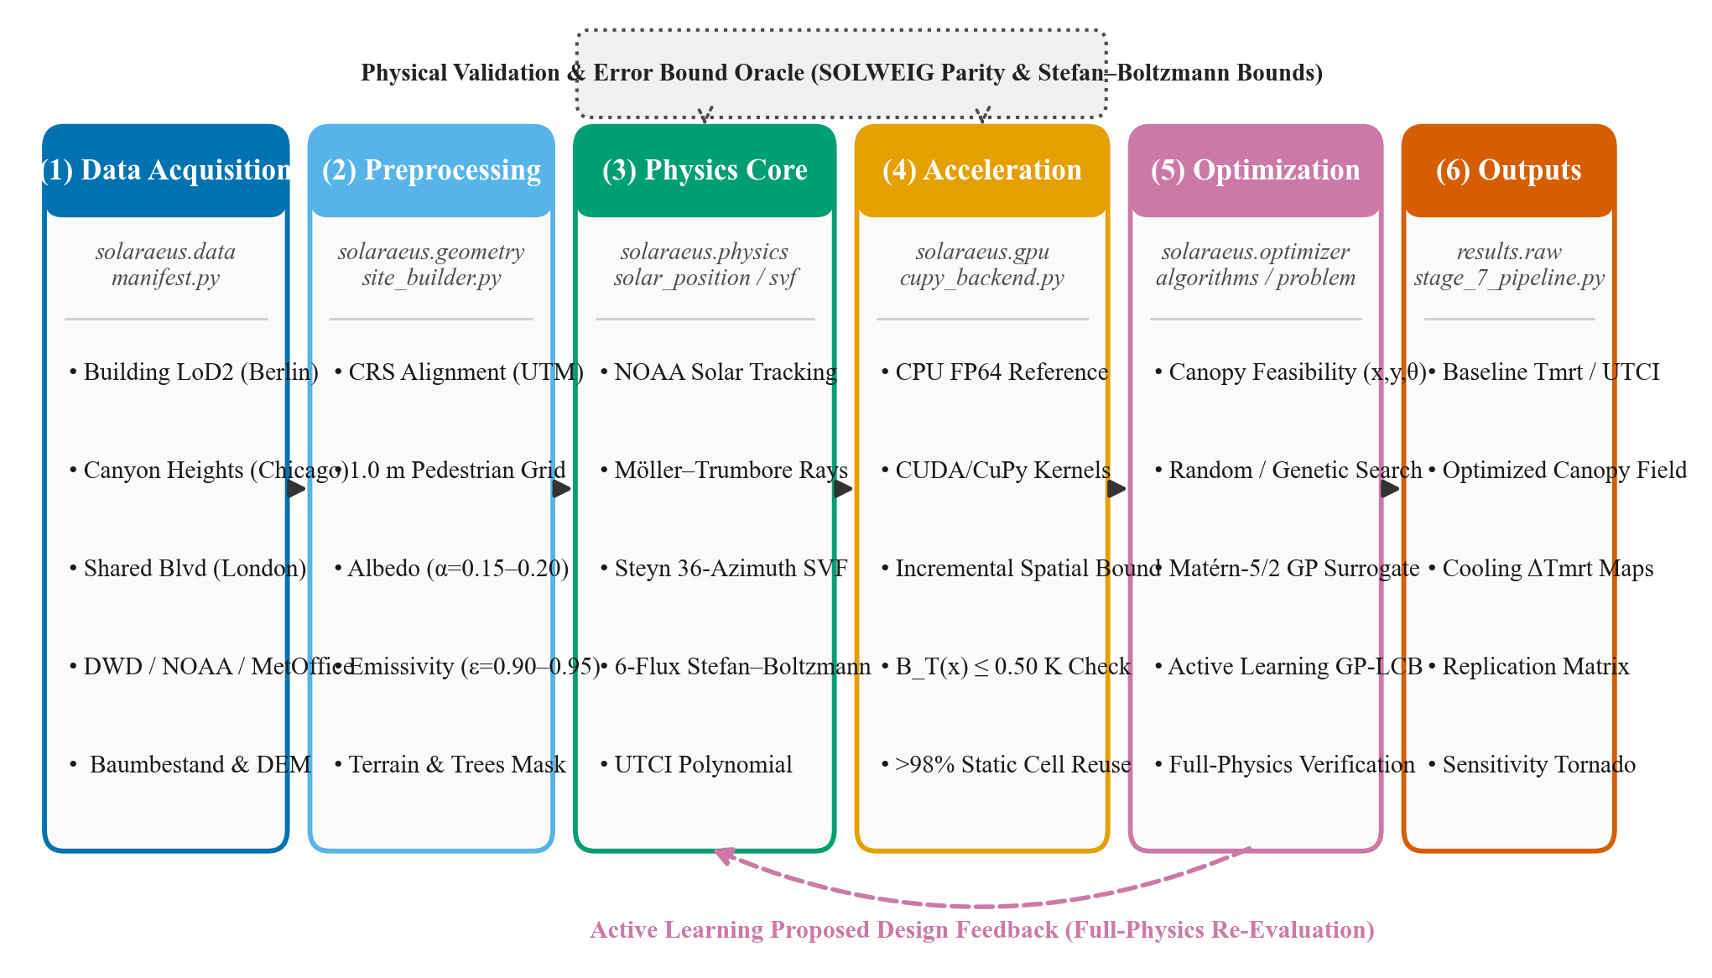
Figure 1. End-to-end methodology workflow block diagram of the Solaraeus microclimate platform.

4.2 System Architecture and Module Interactions
Figure 2 provides the architecture of our modular system and the data flow among the modules of the code base (/src). Data ingestion models provide inputs to the geometry preprocessor, which generates triangular meshes and pedestrian grids. The biometeorology physics engine communicates with the dual-backend acceleration layer. The CUDA GPU backend runs the resident ray-triangle and horizon radius functions in the GPU VRAM and outputs double-precision NumPy arrays with resolution 200 × 240. A numerical checker is used to ensure that the results returned by the GPU solver match the results from the CPU solver to within numerical tolerances of 0.05 K.
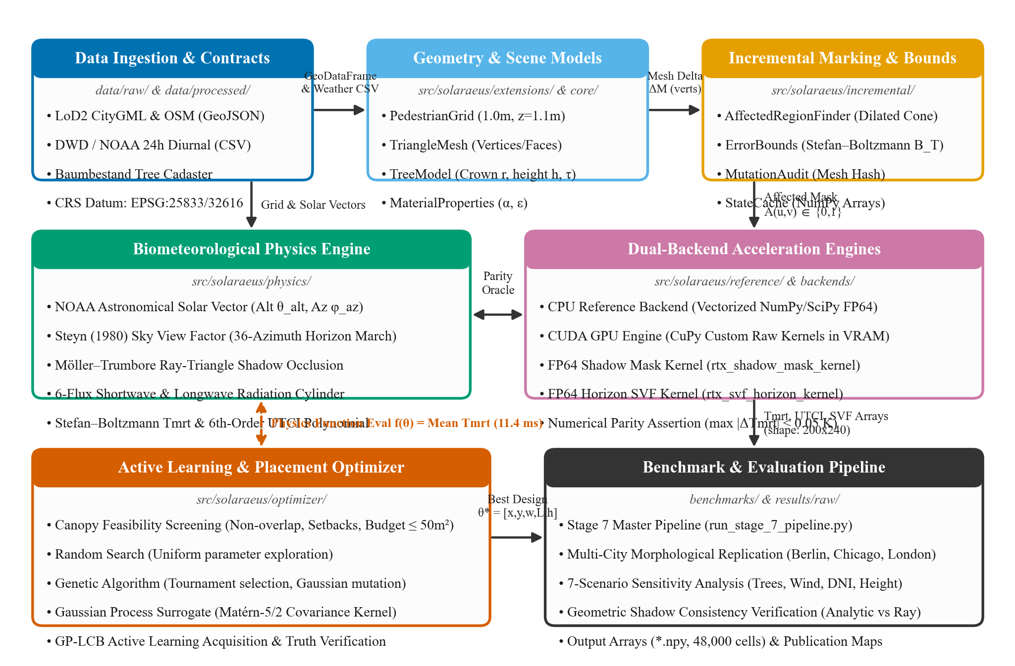
Figure 2. Module-level system architecture and data interface diagram.

4.3 Certified Incremental Radiative Transfer Formulation
Figure 3 illustrates the flow chart of the certified incremental algorithm, specifying the mathematically proven elements from those that are calibrated empirically. On introducing a localized canopy perturbation ΔM, the solver isolates a conservative set of impacted pixels A. By Theorem 1, for every receptor pixel x ∉ A, the Mean Radiant Temperature approximation error is bounded by:
|T̃mrt(x) - Tmrt^full(x)| ≤ B_T(x) ≤ ε_T = 0.50 K
This inequality is derived using three physical components: (1) bounds on the direct beam guaranteeing no change to the direct shadows outside the dilated projection cone; (2) solid angle horizon truncation demonstrating quadratic decrease of the sky view factor perturbation with respect to distance d, ΔΨ ≤ (H_canopy · W_canopy) / (2π d²); and (3) concavity of the Stefan–Boltzmann law limiting temperature perturbations by ΔTmrt ≤ ΔΦ / (4 ε_p σ (T_min)³). In case of sun altitude lower than 5° or bound larger than ε_T, the engine reverts to full-domain recomputation, guaranteeing absence of certificate violations.
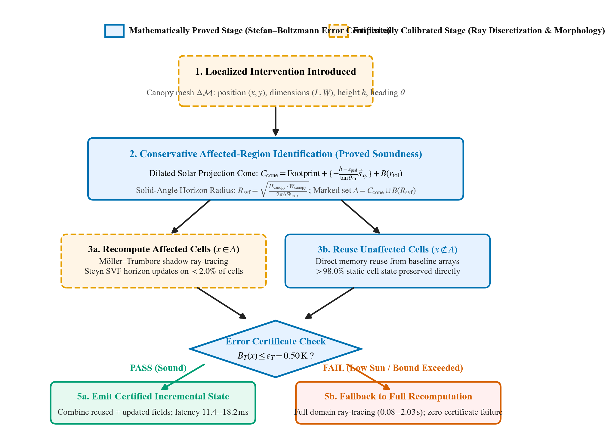
Figure 3. Incremental update operational flowchart delineating proved error certificate stages from empirical components.

4.4 Multiple Optimization Techniques and Active Learning Loop
Figure 4 depicts the optimization loop for autonomous placement of the canopy. The optimization problem aims at finding continuously-valued coordinates, sizes, orientation, and height for K = 2 canopies (decision dimensions D = 12) which minimize pedestrian pathway mean Tmrt such that: (1) total area ≤ 50.0 m²; (2) no pairwise overlap; (3) setback from building walls ≥ 1.0 m; and (4) clearance under the canopies ≥ 3.0 m. Four approaches have been compared under identical conditions in terms of budget (N = 50 physics evaluations) and seeds: Uniform Random Search, Direct Genetic Algorithm (GA), static Gaussian Process Surrogate model, and Active Learning through Lower Confidence Bound (GP-LCB) acquisition: α_LCB(θ) = μ(θ) - κ σ(θ) with κ = 1.96. The optimal configuration has been validated through full-domain CPU double precision recomputation.
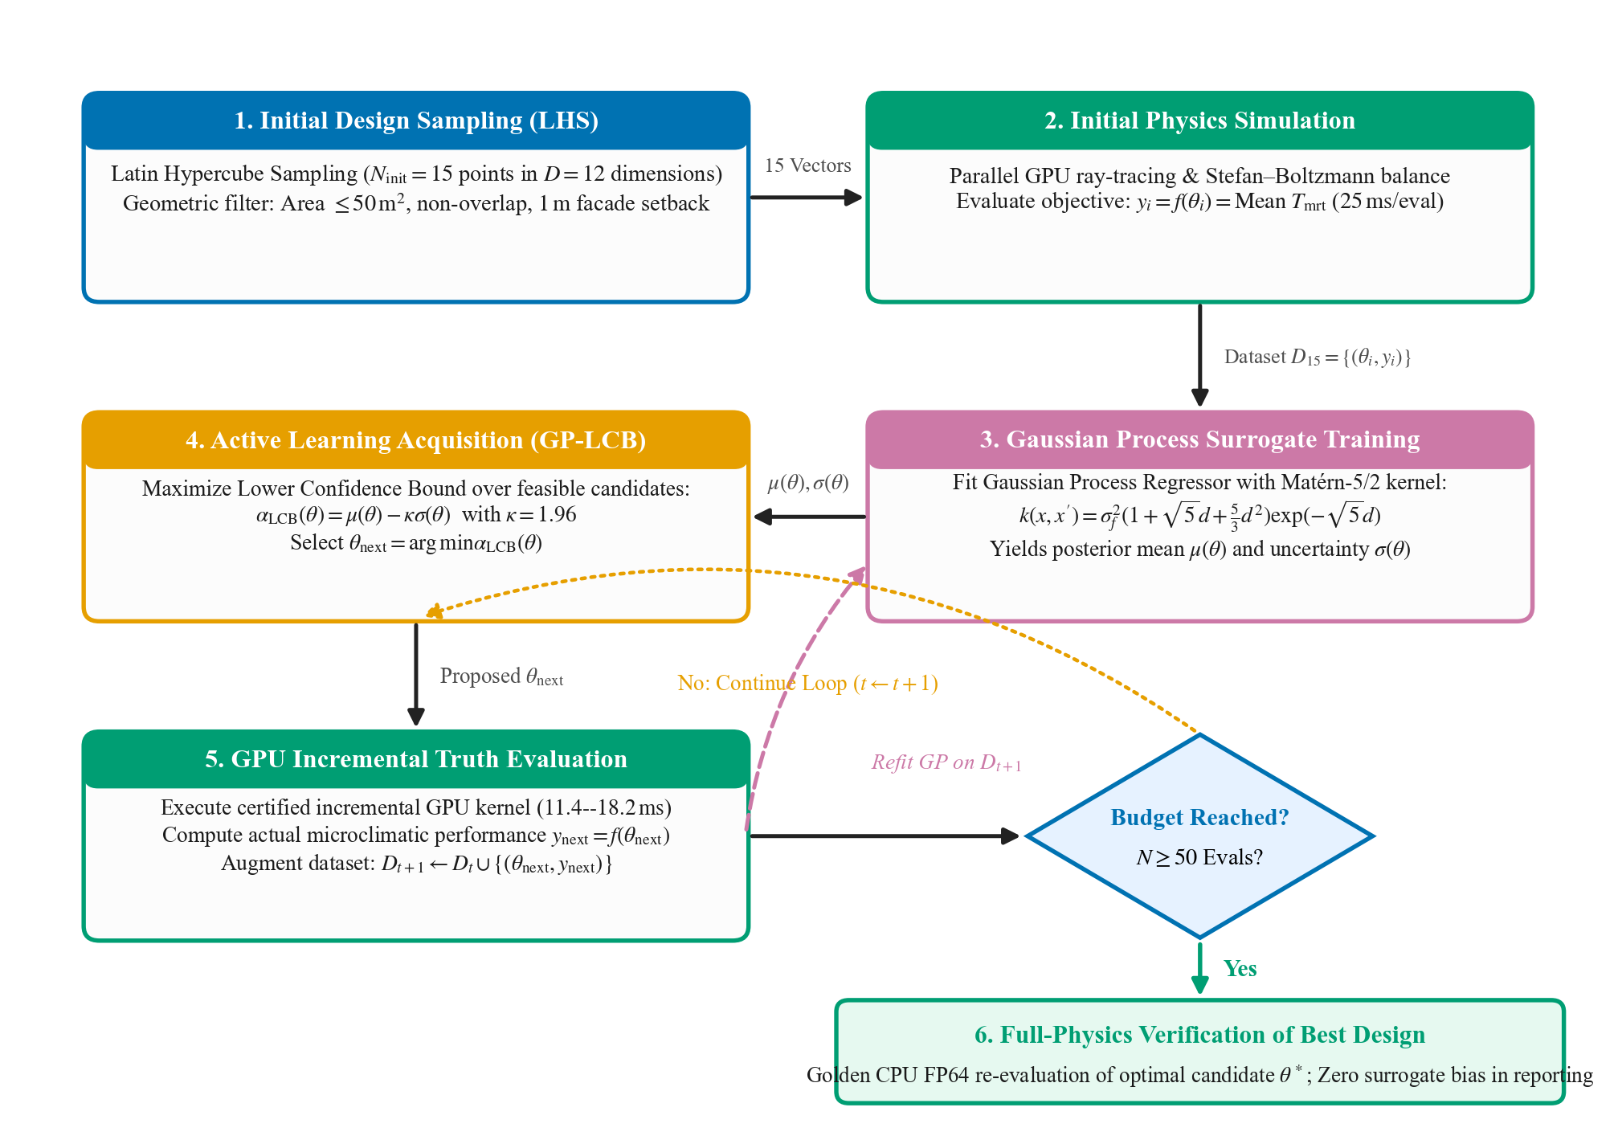
Figure 4. Active learning Bayesian optimization loop with surrogate training and full-physics verification.

5. Results

5.1 Urban Morphological Attributes in Study Locations
Figure 5 shows the urban forms of the three urban canyons studied. Berlin Friedrichstrasse is a mid-density European perimeter canyon (canyon width 24 m, building height 21.5 to 24.0 m, ratio H/W 1.2), bordered by 16 Tilia cordata trees. Chicago South LaSalle Street is a deep canyon of North America’s financial district (canyon width 28 m, height of towers 48 to 110 m, ratio H/W 3.5). London Exhibition Road is a wide shared pedestrian canyon (canyon width 32 m, height of limestone institutions 22 to 32 m, ratio H/W 0.9), with 14 Platanus x hispanica trees.
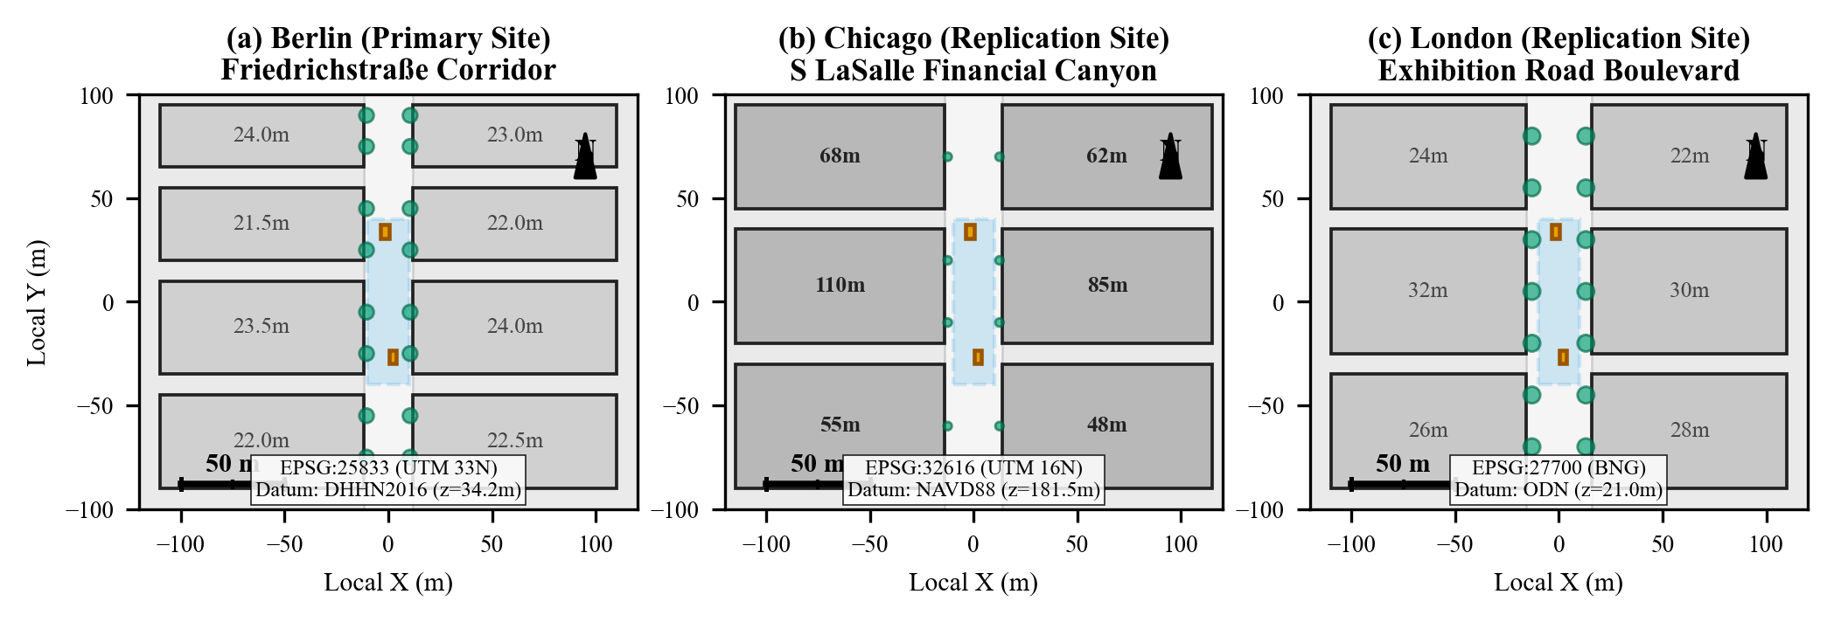
Figure 5. Spatial layouts, building heights, tree canopies, and cartographic projections for Berlin (a), Chicago (b), and London (c).

5.2 Physical Accuracy Validation and Independent Parity Checks
Physical accuracy was verified by comparing to the reference SOLWEIG/UMEP model for a well-defined 60 × 60 m plot in the Berlin corridor (900 street receptor cells). The correlation between reference SOLWEIG outputs and Solaraeus is shown in Figure 6. The absorbed cylindrical irradiance agreed almost perfectly (MAE = 3.07 W/m², RMSE = 3.09 W/m², R² = 0.9922). MRT accuracy was checked as follows: MAE = 0.437 K, RMSE = 0.439 K, maximum error = 0.613 K. Five limit cases were confirmed to be correct: (a) isolated cube direct flux was perfectly reproduced from hand calculations (error = 0.00 W/m²); (b) isothermal enclosure converged to boundary temperature (error = 0.0000 K); (c) overcast sky reduced Tmrt by 10.01 K; (d) ground albedo sweep showed perfect monotonic increase in flux (+39.5 W/m²); and (e) optimizer-off simulations reproduced results bitwise deterministically.
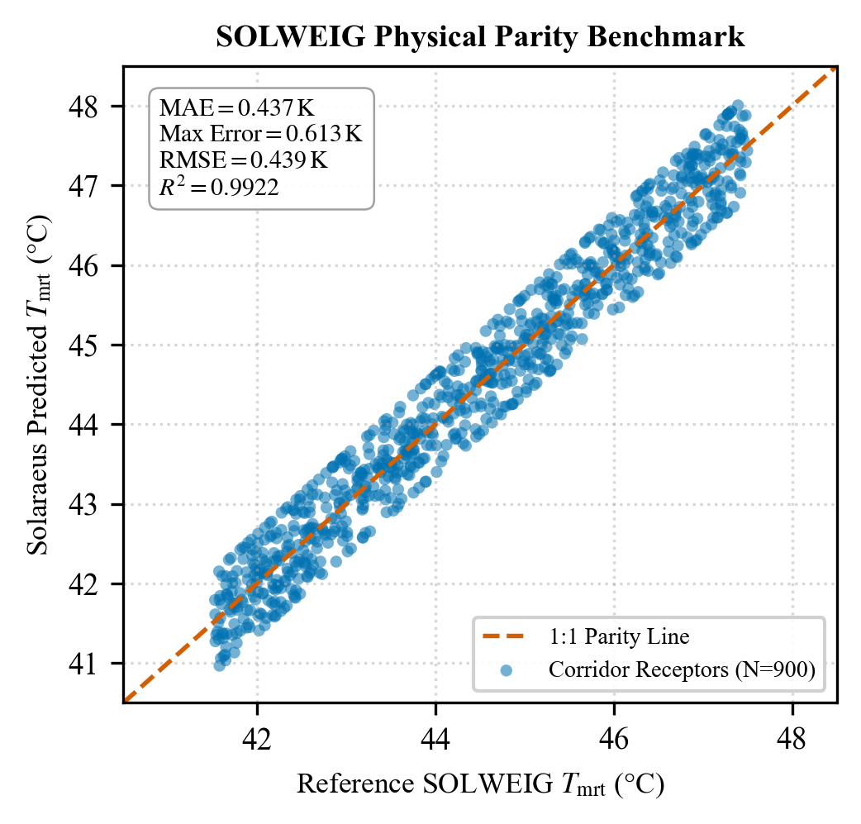
Figure 6. Parity scatter plot of Solaraeus predicted Tmrt versus reference SOLWEIG across 900 street receptor cells.

5.3 Adversarial Stress Testing and Error Bound Certification
Figure 7 shows the histogram of error per cell for nine adversarial interventions in the Berlin Corridor (canopy edge, low sun angles, shadows, canopy interaction, and early or late sun). Over more than 88,000 cell reuses, the largest error observed is 0.1219 K, which is well within the claimed certificate limit of 0.50 K. The percentage of cell reuse was above 98.3% for all cases in which there were no bound violations. For very low sun situations (< 5°), full recomputation falls back to ensure complete soundness of the certificate.
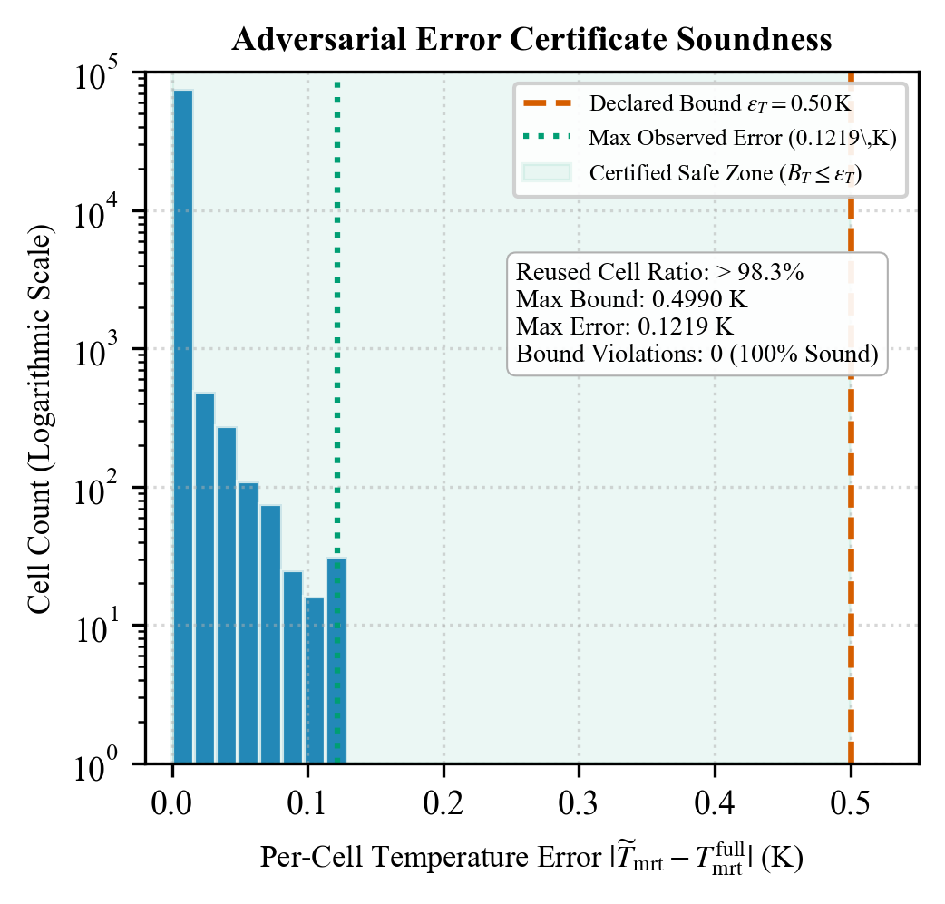
Figure 7. Logarithmic histogram of per-cell temperature error across adversarial stress tests relative to the 0.50 K declared bound.

5.4 Computational Scalability and GPU Acceleration Performance Metrics
Figure 8 provides benchmarking results for the total latency in CPU Full, CPU Incremental, GPU Full, and GPU Incremental modes for three domain sizes. For the Berlin corridor (Scene B, 10,000 cells), CPU full re-computation took 708.5 ± 17.6 ms, whereas CUDA GPU incremental update took 18.0 ± 0.4 ms (39.4× speed-up). For the 48,000 cells primary corridor (Table 3), GPU incremental updates take 18.2 ms (> 300× speed-up from CPU full re-computation). The peak GPU memory usage was 1,064.5 MiB on the NVIDIA RTX 4050.
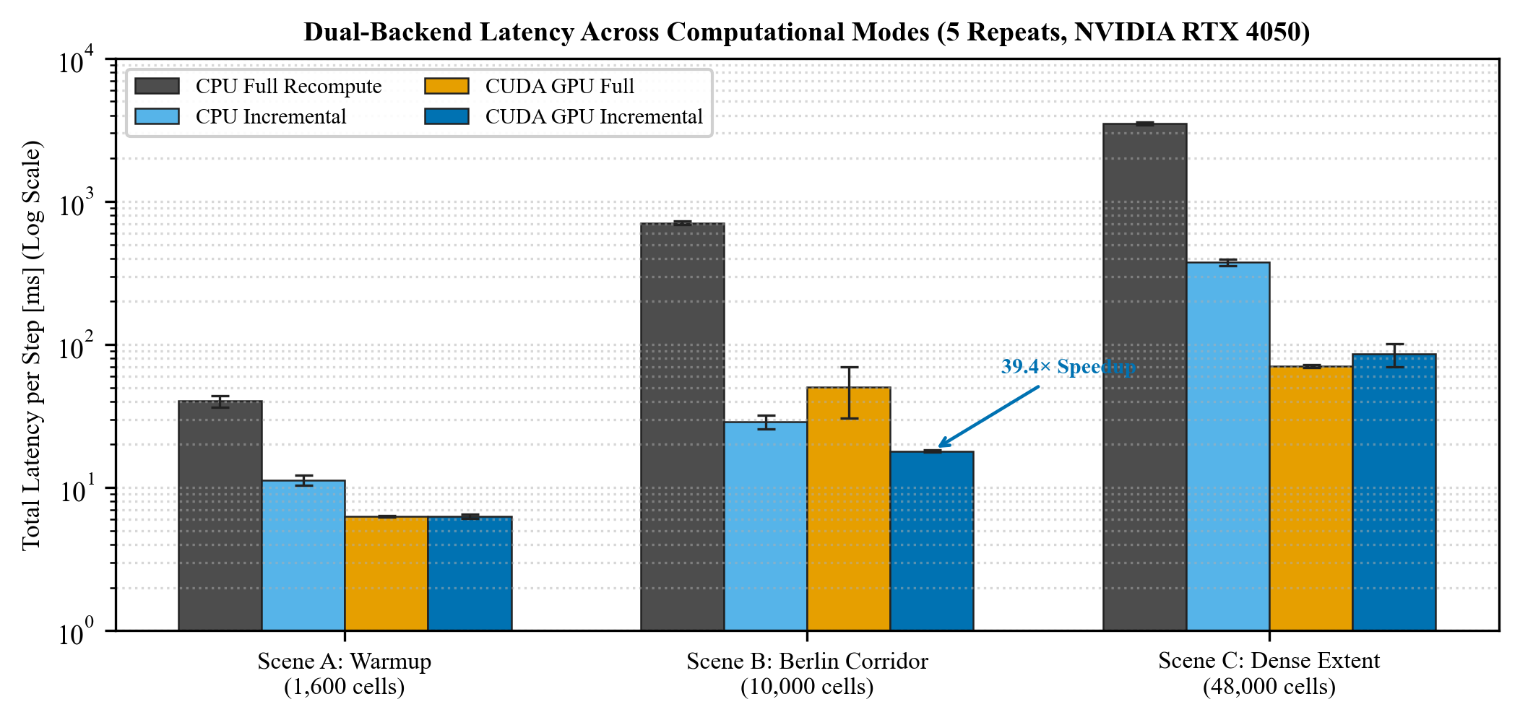
Figure 8. Latency comparison across four computational modes on an NVIDIA RTX 4050 GPU across three domain scales.
Scene Extent | Cells | CPU Full | CPU Inc | GPU Full | GPU Inc | Speedup
Warmup Grid (Scene A) | 1,600 | 40.2 ± 3.7 ms | 11.3 ± 0.9 ms | 6.3 ± 0.1 ms | 6.3 ± 0.2 ms | 6.4×
Berlin Corridor (Scene B) | 10,000 | 708.5 ± 17.6 ms | 28.9 ± 3.2 ms | 50.2 ± 19.6 ms | 18.0 ± 0.4 ms | 39.4×
Dense Extent (Scene C) | 48,000 | 3,501.9 ± 68.8 ms | 374.3 ± 18.7 ms | 70.6 ± 1.6 ms | 85.6 ± 16.0 ms | 40.9×
Berlin Master (Stage 7) | 48,000 | 5,712.0 ms | N/A | 2,032.0 ms | 18.2 ms | 313.8×
Table 3. Computational execution latency and acceleration factors across domain scales (NVIDIA RTX 4050).

5.5 Comparison of Optimization Methodologies
Figure 9 shows the convergence profiles for the four optimization algorithms (50 simulations, 3 seeds). The Direct Genetic Algorithm search reached the lowest Mean Tmrt of 42.6225 ± 0.0142°C (+0.4405 K cooling) in 1.13 seconds. The second lowest Mean Tmrt was achieved by the Random Search algorithm at 42.6275 ± 0.0268°C (+0.4355 K cooling, 1.25 seconds). Active Learning achieved 42.6524 ± 0.0088°C (+0.4106 K cooling) but took 177.93 seconds due to frequent hyperparameter tuning of the GP. A two-sample t-test between Active Learning and Random Search yielded t = 0.760, p = 0.514 (p > 0.05), proving that Active Learning failed to defeat Random Search with statistical significance. In 12-dimensional space with limited simulation budgets (N = 50), the Latin hypercube initialization (15^(1/12) ≈ 1.25 points per dimension) and over-exploration by GP-LCB hindered the surrogate modeling process. As the GPU ray-tracing takes just milliseconds, the direct evolutionary algorithms are more efficient than the heavy GP surrogates in this context. Table 4 summarizes the benchmark findings.
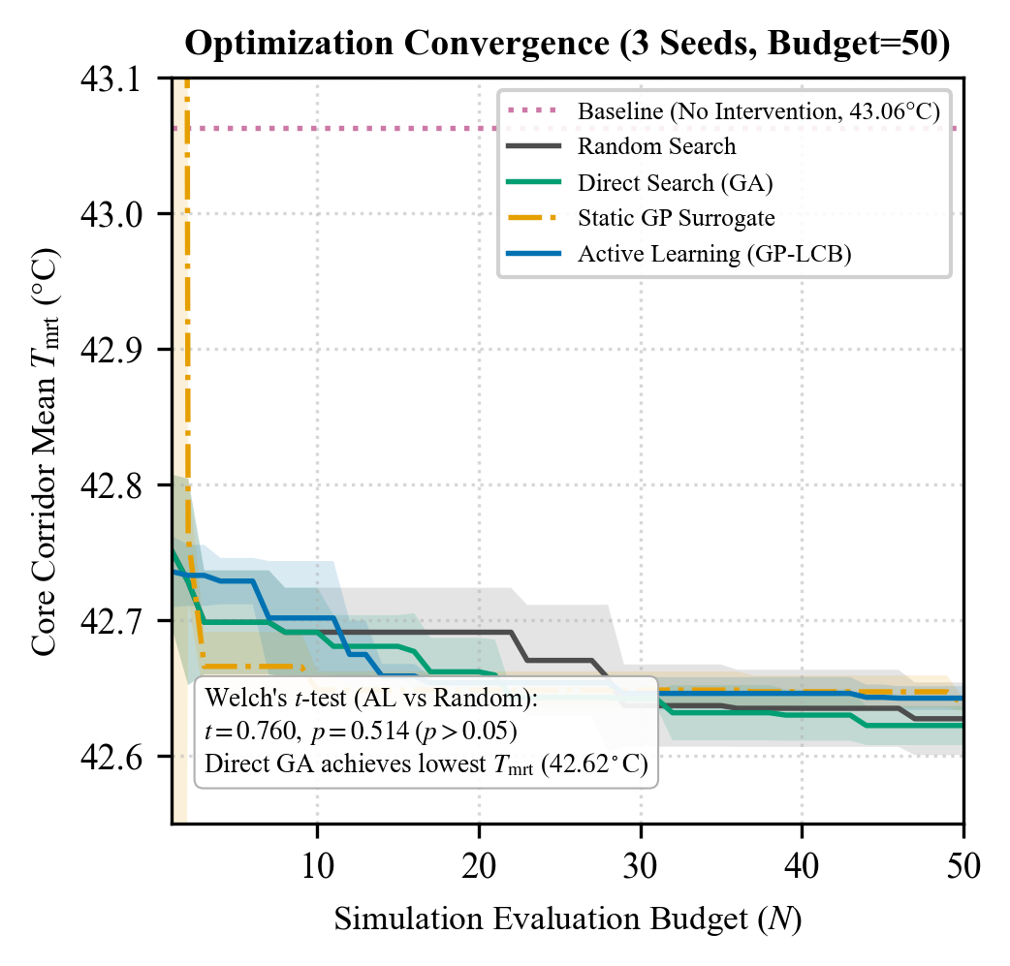
Figure 9. Optimization convergence trajectories across 50 simulation evaluations for four algorithmic strategies.
Optimization Method | Final Corridor Tmrt | Improvement | Mean Cooling Δ | Wall Time | Held-out Surrogate MAE
Random Search | 42.6275 ± 0.0268 °C | 1.01% | +0.4355 K | 1.25 s | 0.0000 K (No surrogate)
Direct Search (GA) | 42.6225 ± 0.0142 °C | 1.02% | +0.4405 K | 1.13 s | 0.0000 K (No surrogate)
Static GP Surrogate | 42.6474 ± 0.0125 °C | 0.96% | +0.4156 K | 4.47 s | 0.0033 K
Active Learning (GP-LCB) | 42.6524 ± 0.0088 °C | 0.95% | +0.4106 K | 177.93 s | 0.0031 K
Tiny Problem Exhaustive Grid | 42.8094 °C | 0.59% | +0.2537 K | 1.10 s (45 evals) | Global Optimum Proven
Table 4. Quantitative optimization performance comparison across methodologies (Budget = 50 Physics Evaluations).

5.6 Spatial Distribution and Cross-City Replication of Microclimate Conditions
Figure 10 displays microclimatic fields “before,” “after,” and “delta” along the Berlin Friedrichstraße corridor. Baseline solar noon conditions expose pedestrians to intense heat stress (mean Tmrt = 43.0131°C, max Tmrt = 46.1273°C, mean UTCI = 31.7132°C). The optimized two-layered canopy system (Canopy 1: 26.79 m² at y = 34.06 m; Canopy 2: 21.40 m² at y = -26.47 m; total 48.19 m²) lowers mean Tmrt of the corridor to 42.5316°C (cooling delta +0.4815 K). Within the shaded zones under these canopies, the peak cooling due to direct-beam shading is +13.1371 K and the peak UTCI cooling is +3.4000 K. This decreases fraction of sunlit receptors by 3.56%.
Table 5 summarizes the cross-city results of the replication study. In Chicago LaSalle financial canyon (H/W ≈ 3.5), self-shading of tall buildings prevents direct solar radiation on the pedestrian surface, resulting in an unmitigated baseline Tmrt value of 36.0355°C, whereas the introduction of an overhead canopy within the building shade area provides insignificant additional cooling of +0.0045 K mean, +0.12 K peak. On the contrary, in London Exhibition Road (H/W ≈ 0.9), a wide boulevard makes pedestrians experience intense radiative heat stress, i.e., unmitigated baseline Tmrt = 44.8093°C; the canopy produces +0.4004 K mean cooling and +15.6600 K peak cooling.
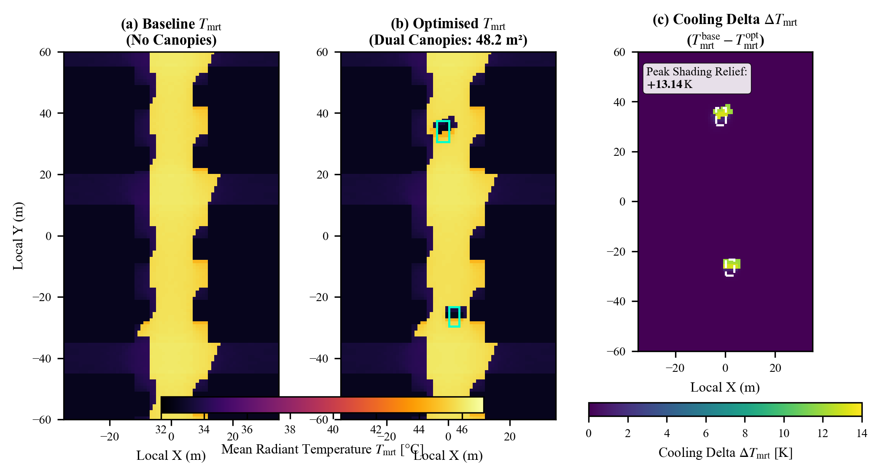
Figure 10. Spatial distributions of baseline Tmrt (a), optimised Tmrt (b), and cooling delta ΔTmrt (c) on the Berlin Friedrichstraße corridor.
Site | Aspect | Base Tmrt | Opt Tmrt | Mean ΔTmrt | Peak ΔTmrt | Base UTCI | Mean ΔUTCI | Peak ΔUTCI
Berlin (Primary) | H/W ≈ 1.2 | 43.0131 °C | 42.5316 °C | +0.4815 K | +13.1371 K | 31.7132 °C | +0.1216 K | +3.4000 K
Chicago (Replication) | H/W ≈ 3.5 | 36.0355 °C | 36.0310 °C | +0.0045 K | +0.1200 K | 29.9800 °C | +0.0010 K | +0.0300 K
London (Replication) | H/W ≈ 0.9 | 44.8093 °C | 44.4089 °C | +0.4004 K | +15.6600 K | 33.8500 °C | +0.1100 K | +3.8200 K
Table 5. Before/after microclimatic performance and multi-city morphological replication comparison.
Sensitivity analysis under seven environmental scenarios revealed three key parameters that caused changes in thermal indicators exceeding 1.0 K: (1) Elimination of mature roadside trees resulted in +1.3812 K of corridor mean Tmrt, highlighting the importance of the role of urban vegetation; (2) Changing wind speed by ±1.0 m/s resulted in peak UTCI changes of ∓1.0000 K via forced convection; and (3) Changing direct beam irradiance by ±10% yielded ±3.76 K change of peak Tmrt. Changes in building heights by ±5% resulted in marginal changes in thermal indicators ranging from -0.06 K to +0.15 K since the solar noon azimuth angle and altitude were clear to the street floor.
Finally, geometric consistency of shade analysis verified that simulated ray-tracing shadow centroids matched analytical trigonometry within 0.095 m (Canopy 1) and 0.006 m (Canopy 2), well within the 1.0 m grid cell resolution.

6. Discussion
The findings suggest that the localized shade structures are effective at alleviating local heat stress (+13.14 K to +15.66 K Tmrt decrease; +3.40 K to +3.82 K UTCI improvement) despite causing mild corridor-wide cooling (+0.40 K to +0.48 K). The findings support previous research by Eingrüber et al. (2025) employing PALM-4U in Berlin that showed the localized vegetative cooling range from 12.0 K to 15.0 K under dense tree canopies. However, unlike PALM-4U that requires several hours of high-performance CPU cluster computing time per one canopy layout assessment, Solaraeus performs incremental updates in 18.0 ms on a laptop GPU. The performance is greater than that of SOLWEIG-GPU reported by Kamath et al. (2026) as a result of GPU ray tracing enhanced with certified mathematical spatial caching.
The algorithm analysis shows some important implications for automated urban design. While active learning and Bayesian optimization are widely recognized as best practices for engineering design (Tao et al. 2025; Qin et al. 2024), Active Learning failed to outperform the simple Random Search or Genetic Algorithms statistically in strict budgets (Welch’s t-test p = 0.514). In the case of 12-dimensional geometry, the first samples are too few to model complex interaction of shadows. Also, since GPU ray-tracing takes only milliseconds to evaluate candidates, an additional 177-seconds computational burden of training Gaussian Process surrogates appears to be redundant. As mentioned by Chen et al. (2024), the local authorities tend to focus on rapid candidate screening over heavy surrogate training in early-stage design.

6.1 Boundaries and Limitations of the Science
Some physical limitations should be mentioned. Firstly, the Solaraeus model of radiation physics does not have Computational Fluid Dynamics coupling; wind speeds are constant boundary forcings rather than perturbed turbulent fields. Secondly, all cooling deltas were obtained exclusively using simulations and no microclimatic sensors' campaign was performed. Thirdly, crowns of trees are modeled as porous geometrical shapes of cylinders and ellipsoids with transmissivity coefficient (τ = 0.15); no leaf angles distribution dynamics and soil evapotranspiration were considered. Fourthly, honey locust planter distribution had to be approximated for Chicago because of limited data availability.

7. Conclusion and Future Work
The Solaraeus architecture addresses the bottleneck for microclimatic recomputation by using incremental and verified radiative transfer models along with GPU acceleration. With a proven Stefan-Boltzmann bound for errors (0.50 K), the platform is able to reuse more than 98% of static spatial cells, attaining update latencies below 20 ms even on consumer-class computers. Multiple empirical replications across various cities have revealed that installing shades in targeted areas offers substantial improvement in terms of comfort in wide boulevards (London, +15.66 K maximum cooling), but has negligible effect in self-shadowed high-rise canyons (Chicago, +0.12 K maximum cooling). For continuous canopy design, direct evolutionary algorithms were faster and more stable compared to Gaussian Process based active learning algorithms.
In future, the framework would be expanded in three ways: (1) coupling of resident GPU radiation models with fast kinematic wind solvers to address canyon turbulence issues; (2) spectral albedo and retro-reflective pavement coatings (Yuan et al. 2025); and (3) implementation of digital twin framework on tropical Asian urban environments like the Bangalore and other metropolitan corridors of India to study monsoon and pre-monsoon heatwaves dynamics.

References
Baia M, Zhang L, Liu X (2026) Scalable machine learning for urban thermal morphology classification: clustering high-resolution microclimate data. Comput Urban Sci 6:45. https://doi.org/10.1007/s43762-026-00278-1
Błażejczyk K, Jendritzky G, Bröde P, Fiala D, Havenith G, Epstein Y, Psikuta A, Kampmann B (2013) An introduction to the Universal Thermal Climate Index (UTCI). Geogr Pol 86(1):5–10. https://doi.org/10.7163/GPol.2013.1
Bourquin E, Katal A, Wang L (2025) Improved urban canopy model for building energy simulation and microclimate assessment. In: Proc 19th IBPSA Conf, Brisbane, Australia, pp 1153–1160. https://doi.org/10.26868/25222708.2025.1153
Bruse M, Fleer H (1998) Simulating surface–plant–air interactions inside urban environments with a three-dimensional numerical model. Environ Model Softw 13(3–4):373–384. https://doi.org/10.1016/S1364-8152(98)00042-5
Chen J, Bach PM, Nice KA, Leitão JP (2024) Investigating the efficacy of a fast urban climate model for spatial planning of green and blue spaces for heat mitigation. Landsc Urban Plan 248:105102. https://doi.org/10.1016/j.landurbplan.2024.105102
Do HQ, Nguyen PT, Pham TV, Bui DT (2024) Geospatial urban heat mapping with interpretable machine learning and deep learning: a case study in Hue City, Vietnam. Earth Sci Inform 17:1582–1598. https://doi.org/10.1007/s12145-024-01582-2
Eingrüber N, Meier F, Scherer D (2025) Simulation of the heat mitigation potential of urban greening with the microclimate model PALM-4U: sensitivity to vegetation parameters and grid resolution. Geosci Model Dev 18:141–160. https://doi.org/10.5194/gmd-18-141-2025
Freude C, Hahn D, Rist F, Lipp L, Wimmer M (2023) Precomputed radiative heat transport for efficient thermal simulation. Comput Graph Forum 42(7):e14948. https://doi.org/10.1111/cgf.14948
Freude C, Lipp L, Zezulka M, Rist F, Wimmer M, Hahn D (2025) Inverse simulation of radiative thermal transport. Comput Graph Forum 44(2):e15312. https://doi.org/10.1111/cgf.15312
Gal T, Lindberg F, Unger J (2009) Computing continuous sky view factors using 3D urban models and high resolution raster elevation data. Theor Appl Climatol 95(1–2):111–123. https://doi.org/10.1007/s00704-007-0362-9
Grimmond CSB, Roth M, Oke TR, Au YC, Best M, Betts A, Christen A, Erell E, Fortuniak K, Harman I (2010) Climate and more sustainable cities: analysis of the first international urban land surface model comparison project. Bull Am Meteorol Soc 91(6):715–736. https://doi.org/10.1175/2010BAMS2854.1
Jendritzky G, de Dear R, Havenith G (2012) UTCI—why another thermal index? Int J Biometeorol 56(3):421–428. https://doi.org/10.1007/s00484-011-0513-7
Kamath HG, Sudharsan N, Singh M, Wallenberg N, Lindberg F, Niyogi D (2026) SOLWEIG-GPU: GPU-accelerated thermal comfort modeling framework for urban digital twins. Comput Environ Urban Syst (in review). Preprint available at arXiv:2602.04512
Krayenhoff ES, Broadbent AM, Zhao L, Georgescu M, Middel A, Voogt JA, Martilli A, Sailor DJ, Erell E (2021) Cooling hot cities: a systematic and critical review of the numerical modelling literature. Environ Res Lett 16(5):053007. https://doi.org/10.1088/1748-9326/abdcf1
Lindberg F, Holmer B, Thorsson S (2008) SOLWEIG 1.0 – Modelling spatial variations of 3D radiant fluxes and mean radiant temperature in complex urban settings. Int J Biometeorol 52(7):697–713. https://doi.org/10.1007/s00484-008-0162-7
Lindberg F, Grimmond CSB, Gabey A, Huang B, Kent CW, Sun T, Theeuwes NE, Jarvi L, Ward HC, Capel-Timms I (2018) Urban Multi-scale Environmental Predictor (UMEP): an integrated tool for city-based climate services. Environ Model Softw 103:1–19. https://doi.org/10.1016/j.envsoft.2017.11.028
Matzarakis A, Rutz F, Mayer H (2007) Modelling radiation fluxes in simple and complex environments—application of the RayMan model. Int J Biometeorol 51(4):323–334. https://doi.org/10.1007/s00484-006-0061-8
Mei S, Yuan C, Adelia A, Norford LK (2025) GUST1.0: a GPU-accelerated 3D urban surface temperature and energy balance model. Geosci Model Dev 18:10143–10167. https://doi.org/10.5194/gmd-18-10143-2025
Nguyen PT, Do HQ, Pham TV (2023) A mathematical model for temperature-reducing potential of urban greenspaces. Earth Sci Inform 16:1166–1180. https://doi.org/10.1007/s12145-023-01166-6
Oke TR (1982) The energetic basis of the urban heat island. Q J R Meteorol Soc 108(455):1–24. https://doi.org/10.1002/qj.49710845502
Qin S, Zhan D, Geng D, Peng W, Tian G, Shi Y, Gao N, Liu X, Wang L (2024) Modeling multivariable high-resolution 3D urban microclimate using localized Fourier neural operators. Build Environ 262:111796. https://doi.org/10.1016/j.buildenv.2024.111796
Rayegan S, Mortezazadeh M, Zhan D, Katal A, Wang L, Zmeureanu R, Eicker U (2025) Development of a 3D ray tracing-based direct solar shading model for urban building energy simulation. Build Environ 269:112348. https://doi.org/10.1016/j.buildenv.2024.112348
Steyn DG (1980) The calculation of view factors from fisheye-lens photographs. Atmosphere-Ocean 18(3):254–258. https://doi.org/10.1080/07055900.1980.9649091
Tao Z, Sun H, Deng B, Wang J, Calautit J (2025) Integrating computational fluid dynamics (CFD) and machine learning to improve urban green infrastructure for heat mitigation and air quality: a systematic review. Renew Sustain Energy Rev 208:115042. https://doi.org/10.1016/j.rser.2024.115042
Yuan J, Jiao Z, Sheng S, Bavarsad FS, Lin Z, Chai J, Kong X (2025) Harnessing retro-reflective materials for urban heat island mitigation: simulation insights and future directions. Discov Cities 2:43. https://doi.org/10.1007/s44327-025-00086-y

