Certified Incremental Radiative Transfer and GPU-Accelerated Microclimate Optimization for Urban Pedestrian Corridors
Ayush Singh | Dr. Jobin Thomas
Department of Computational Science and Engineering (Data Science)
Dayananda Sagar University, Bengaluru, Karnataka, India
Target Journal: Earth Science Informatics (Springer) | Manuscript Type: Research Article

Abstract
Decoupled urban microclimate simulations traditionally recompute entire domains from scratch upon introducing localized shading interventions, creating a major computational bottleneck for iterative design. We present Solaraeus, a 3D microclimate modeling platform that resolves this recomputation overhead through mathematically certified incremental radiative transfer and resident CUDA GPU acceleration. By bounding solid-angle decay and Stefan–Boltzmann linearization within a declared thermal tolerance (0.50 K), the engine safely reuses over 98% of grid cells. On the primary Berlin Friedrichstraße corridor (240 m × 200 m, 1.0 m resolution), GPU incremental updates execute in 18 ms, achieving over 300× speedup relative to full CPU recomputation. Integrated Bayesian active learning identifies canopy layouts providing up to 13.14 K of localized radiant cooling (0.86 K corridor-wide mean). Cross-city replications indicate that while deep high-rise canyons exhibit minimal canopy efficacy due to architectural self-shading (Chicago), wide boulevards achieve substantial cooling relief (London, up to 11.05 K peak). These results demonstrate that certified incremental simulation enables real-time microclimatic design without compromising physical accuracy.
Keywords: Urban microclimate, mean radiant temperature, incremental radiative transfer, GPU acceleration, UTCI, microclimate optimization, Earth science informatics.

1. Introduction
Anthropogenic climate change compounded by urban morphological heat trapping subjects metropolitan pedestrian corridors to severe thermal distress during extreme summer heatwaves (Oke 1982; Grimmond et al. 2010). Outdoor thermal sensation during daylight hours is governed predominantly by the Mean Radiant Temperature (Tmrt) rather than ambient dry-bulb air temperature alone (Matzarakis et al. 2007). In sunlit street canyons, incident shortwave direct beam solar radiation, diffuse sky irradiance, and longwave emissions from heated asphalt and masonry surfaces elevate pedestrian physiological stress into the Strong and Very Strong Heat Stress categories of the Universal Thermal Climate Index (UTCI) (Jendritzky et al. 2012; Błażejczyk et al. 2013). Consequently, municipal urban planners require high-resolution microclimatic models to evaluate the cooling efficacy of localized heat mitigation interventions, such as overhead shade structures and boulevard trees (Krayenhoff et al. 2021).
Existing urban microclimate modeling tools are bifurcated between microscale Computational Fluid Dynamics (CFD) suites and decoupled radiation models. Microscale CFD software such as ENVI-met (Bruse and Fleer 1998) resolves atmospheric turbulence and vegetative heat exchange, yet requires several hours to days of CPU compute time for a single diurnal cycle, rendering iterative design exploration impractical. Conversely, decoupled radiation models such as the Solar and Longwave Environmental Irradiance Geometry (SOLWEIG) model within the Urban Multi-scale Environmental Predictor (UMEP) (Lindberg et al. 2008, 2018) separate geometric radiation transfer from fluid mechanics. By marching discrete rays across digital surface models to evaluate Sky View Factors (SVF) and direct shadow casting, decoupled engines reduce computational runtimes from days to seconds while preserving physiological accuracy in radiant heat estimation (Gal et al. 2009; Do et al. 2024).
Despite these computational advances, current simulation frameworks suffer from three interconnected limitations. First, existing solvers operate as monolithic batch programs: whenever a localized architectural intervention—such as an awning or canopy installation—is introduced, the engine discards the domain state and recomputes all grid cells from scratch. Second, heuristic spatial clipping approaches lack a mathematically certified, closed-form error bound guaranteeing that untouched receptor points do not exceed acceptable biometeorological tolerances (|T̃mrt(x) - Tmrt^full(x)| ≤ ε_T). Third, planners rely on manual trial-and-error placement because the multi-parameter continuous search space of canopy dimensions, orientations, heights, and non-overlap constraints cannot be practically explored through brute-force simulation.
To address these challenges, this study pursues two primary objectives:
1. Formulate, prove, and validate a certified incremental radiative transfer engine that guarantees sub-degree thermal accuracy (ε_T = 0.50 K) using closed-form Stefan–Boltzmann linearization and solid-angle decay, coupled with a resident CUDA GPU backend to achieve sub-20 ms update latencies.
2. Quantify the microclimatic cooling efficacy and optimization characteristics of localized shade installations across international urban corridors, comparing four optimization methodologies (Random Search, Genetic Algorithms, Static Gaussian Process Surrogates, and Active Learning) under identical simulation budgets on empirical digital twins in Berlin (primary), Chicago (replication), and London (replication).

2. Literature Review
Table 1 summarizes peer-reviewed studies across urban microclimate modeling, GPU acceleration, and machine-learning optimization.
Author & Year | Journal / Venue | Core Contribution | Identified Limitation
Baia et al. (2026) | Computational Urban Science | Clustering high-resolution microclimatic features to identify spatial heat island morphologies. | Identified thermal morphology clusters but lacked real-time 3D ray-traced geometric shading.
Kamath et al. (2026) | Preprint / UT Austin & Gothenburg | Implemented CUDA GPU acceleration for the SOLWEIG human comfort model on digital twins. | Accelerated full-domain batch recalculations but did not formulate incremental cell reuse.
Eingrüber et al. (2025) | Geoscientific Model Development | Simulated urban greening cooling in Berlin canyons using PALM-4U across grid resolutions. | High physical realism but required heavy multi-core CPU compute times of several hours.
Mei et al. (2025) | Geoscientific Model Development | Developed GUST1.0 GPU-accelerated 3D urban surface temperature and energy balance engine. | Significantly reduced surface temperature solve time; focused on building facades rather than pedestrian grids.
Freude et al. (2025) | Computer Graphics Forum | Formulated inverse radiative thermal simulation using precomputed light transport matrices. | Optimized surface thermal material placement; did not address real-time pedestrian comfort metrics.
Bourquin et al. (2025) | IBPSA Proceedings | Coupled mesoscale boundary forcings with microscale street canyon geometry for energy modeling. | Refined street-level boundary temperatures; lacked automated canopy placement optimization.
Rayegan et al. (2025) | Building and Environment | Developed 3D ray tracing-based direct solar shading model for building envelopes. | Accurately resolved complex building shadows; evaluated static annual steps without active learning.
Tao et al. (2025) | Renewable and Sustainable Energy Reviews | Systematically reviewed CFD and machine learning integration for urban green infrastructure. | Highlighted high surrogate speedup; noted severe surrogate degradation outside training envelopes.
Yuan et al. (2025) | Discover Cities | Simulated retro-reflective pavement materials to mitigate canyon radiant heat trapping. | Demonstrated shortwave trapping reduction; evaluated uniform materials rather than localized canopies.
Do et al. (2024) | Earth Science Informatics | Mapped urban heat dynamics using interpretable machine learning and remote sensing. | Provided city-scale thermal vulnerability mapping; lacked sub-meter building ray-tracing physics.
Chen et al. (2024) | Landscape and Urban Planning | Evaluated fast microclimate modeling for spatial planning of urban green and blue spaces. | Proved planning utility of fast radiation approximations; discarded spatial states on intervention edits.
Qin et al. (2024) | Building and Environment | Modeled multivariable 3D microclimates using localized Fourier Neural Operators. | Near real-time 3D field prediction; surrogates exhibited uncertified extrapolation errors.
Freude et al. (2023) | Computer Graphics Forum | Precomputed radiative heat transport matrices to accelerate dynamic thermal simulations. | Drastically sped up stationary geometries; alterations required full matrix recomputation.
Nguyen et al. (2023) | Earth Science Informatics | Developed mathematical multicriteria model for temperature-reducing potential of green spaces. | Ranked spatial intervention priorities; relied on empirical indices rather than 6-flux Stefan–Boltzmann physics.
Table 1. Systematic literature review of microclimate modeling, GPU acceleration, and optimization frameworks.

2.1 Radiative Transfer Modeling and Decoupled Microclimate Engines
Urban microclimate simulation has traditionally relied on coupled atmospheric and computational fluid dynamics (CFD) formulations, such as ENVI-met (Bruse and Fleer 1998) or the LES-based PALM-4U model evaluated by Eingrüber et al. (2025) across Berlin street canyons. While physically comprehensive, Navier–Stokes fluid modeling imposes heavy computational penalties, frequently consuming hours of multi-core CPU cluster time per diurnal cycle and rendering iterative architectural exploration prohibitive (Krayenhoff et al. 2021). To alleviate this overhead, decoupled radiation engines have emerged as the standard paradigm for pedestrian thermal comfort assessment. By decoupling shortwave and longwave radiative flux calculations from convective fluid motion, the Solar and Longwave Environmental Irradiance Geometry (SOLWEIG) engine (Lindberg et al. 2008, 2018) estimates human radiant exposure at sub-meter spatial resolutions in seconds. Recent investigations have extended decoupled ray tracing to direct solar shading of building envelopes (Rayegan et al. 2025), urban canyon microclimate coupling (Bourquin et al. 2025), retro-reflective pavement modeling (Yuan et al. 2025), and vegetative cooling assessments (Chen et al. 2024; Baia et al. 2026). However, existing decoupled simulation engines operate strictly on monolithic batch principles: whenever a localized intervention—such as an overhead fabric canopy or tree planter—is placed within the urban corridor, the solver discards all precomputed spatial states and recomputes the entire digital twin from scratch, ignoring spatial sparsity and bounding properties.

2.2 GPU Acceleration and Precomputed Transport Architectures
To accelerate high-resolution microclimatic calculations, recent literature has increasingly turned to massively parallel graphical processing unit (GPU) computing. Kamath et al. (2026) developed SOLWEIG-GPU, achieving substantial runtime reductions for city-scale digital twins by parallelizing discrete ray marching and shadow casting on CUDA architectures. Similarly, Mei et al. (2025) presented GUST1.0, a GPU-accelerated energy balance engine that expedites 3D surface temperature modeling across complex building geometries, while parallel geospatial algorithms in Earth informatics have demonstrated significant efficiency gains for multicriteria urban analysis (Nguyen et al. 2023). Beyond direct ray tracing, precomputed radiative transfer techniques have been adapted from computer graphics to thermal simulation. Freude et al. (2023, 2025) formulated precomputed radiative transport matrices to simulate dynamic longwave and shortwave exchanges and solve inverse thermal material problems at interactive frame rates. Nonetheless, precomputation approaches suffer from a fundamental architectural limitation: they assume stationary geometric boundary conditions. The introduction of even a single localized shading canopy alters the geometric horizon and view-factor relationships, invalidating the precomputed transport matrices and necessitating an expensive full-domain rebuild. Crucially, prior GPU frameworks accelerate full-domain recomputation rather than formulating incremental reuse mechanisms.

2.3 Machine Learning Surrogates and Active Optimization
Recognizing the computational friction of physics-based solvers, researchers have extensively explored machine learning surrogates for urban heat island mitigation and microclimatic planning (Tao et al. 2025; Do et al. 2024). Deep learning surrogate architectures, such as the localized Fourier Neural Operators developed by Qin et al. (2024), map geometric and atmospheric boundary conditions to full 3D microclimate fields in milliseconds. However, machine learning surrogates introduce two severe limitations in design workflows: first, black-box neural networks lack certified, closed-form physical error bounds, making them prone to uncertified extrapolation errors when evaluating novel intervention shapes or extreme heatwave meteorology (Tao et al. 2025); second, static surrogates trained on fixed design distributions exhibit sharp accuracy degradation in dense canyon environments where sharp shadow discontinuities dominate. While Bayesian active learning frameworks can iteratively refine surrogate fidelity by balancing exploitation and exploration, their practical deployment requires an underlying physical simulation engine capable of evaluating proposed interventions with sub-second latency and guaranteed numerical parity.

2.4 Identified Research Gap
A synthesis of the surveyed literature reveals a critical methodological gap at the intersection of microclimate simulation and computational urban design. On one hand, physics-based decoupled engines provide validated biometeorological fidelity but remain bound to inefficient monolithic recomputation loops. On the other hand, precomputed transport matrices and neural surrogates offer real-time speeds but fail under geometric topology changes or lack certified physical error bounds. What is currently missing is a unified framework that couples a mathematically certified incremental radiative transfer engine—capable of bounding truncation errors to sub-degree tolerances while reusing the vast majority of unaffected grid cells—with resident GPU acceleration and active-learning canopy optimization. Solaraeus is engineered specifically to bridge this gap.

3. Description of Data
All geometric, meteorological, and vegetative datasets used in Solaraeus were acquired from verified open-access repositories and cataloged with cryptographic SHA256 checksums in the repository manifest. Table 2 details the data sources across the three case studies.
Study Area | Layer | Dataset & Source Authority | Repository / Access Link | Licence | Access Date
Berlin | Buildings | Geoportal Berlin LoD2 CityGML (Senatsverwaltung für Stadtentwicklung) | https://daten.berlin.de/datensaetze/geoportal-berlin-3d-gebaeudedaten | dl-de/by-2-0 | 2026-10-13
Berlin | Terrain | Digitales Geländemodell DGM 1m (Geoportal Berlin) | https://daten.berlin.de/datensaetze/digitales-gelaendemodell-dgm-1-m | dl-de/by-2-0 | 2026-10-13
Berlin | Vegetation | Baumbestand Berlin – Straßenbäume (16 roadside Tilia cordata) | https://daten.berlin.de/datensaetze/baumbestand-berlin-strassenbaeume | dl-de/by-2-0 | 2026-10-13
Berlin | Weather | DWD Station 00433 Tempelhof (2023-07-09 Heatwave, peak Ta=32.1°C) | https://opendata.dwd.de/climate_environment/CDC/ | Open Data / DWD Law | 2026-10-13
Chicago | Buildings | City of Chicago Open Data Portal Building Footprints | https://data.cityofchicago.org/Buildings/Building-Footprints/ | Public Domain | 2026-10-13
Chicago | Terrain | USGS 3D Elevation Program (3DEP) 1m Bare-Earth DEM | https://www.usgs.gov/3d-elevation-program | Public Domain (US Gov) | 2026-10-13
Chicago | Vegetation | Chicago Urban Forest Tree Inventory (8 sidewalk Gleditsia triacanthos) | https://data.cityofchicago.org/Parks-Recreation/Trees/ | Public Domain | 2026-10-13
Chicago | Weather | NOAA Local Climatological Data KORD (2024-07-15 Heatwave, peak Ta=33.8°C) | https://www.ncei.noaa.gov/cdo-web/ | Open Access / NOAA | 2026-10-13
London | Buildings | OS Open Map Local / GLA 3D Building Heights | https://osdatahub.os.uk/ | OGL v3.0 | 2026-10-13
London | Terrain | Environment Agency LiDAR Composite DTM 1m | https://environment.data.gov.uk/ | OGL v3.0 | 2026-10-13
London | Vegetation | RBKC Street Tree Cadaster (14 Platanus x hispanica boulevard trees) | https://opendata.rbkc.gov.uk/ | OGL v3.0 | 2026-10-13
London | Weather | UK Met Office MIDAS Open Heathrow EGLL (2024-07-19 Heatwave, peak Ta=32.2°C) | https://catalogue.ceda.ac.uk/ | OGL v3.0 | 2026-10-13
Table 2. Geospatial and meteorological data specifications across Berlin, Chicago, and London case studies.

4. Methodology

4.1 Complete Simulation and Optimization Workflow
Figure 1 illustrates the end-to-end operational pipeline of Solaraeus. The framework is organized into six interconnected stages: (1) Data acquisition, which ingests building CityGML models, DTM grids, tree inventories, and diurnal weather CSVs; (2) Preprocessing, which aligns coordinate reference systems (EPSG:25833, 32616, 27700), constructs a 1.0 m pedestrian evaluation grid at 1.1 m eye level, and assigns material albedo (α = 0.15–0.30) and emissivity (ε = 0.90–0.95); (3) Physics core, executing astronomical solar position tracking, double-precision Möller–Trumbore ray-triangle direct shadow casting, Steyn (1980) 36-azimuth radial Sky View Factor calculations, six-flux cylindrical radiant exchange, and Stefan–Boltzmann Tmrt inversion; (4) Computational acceleration, providing a CPU FP64 reference solver and a resident CUDA GPU kernel engine with certified incremental state caching; (5) Active learning optimization, screening candidate canopy vectors, training Gaussian Process surrogates, and proposing interventions via lower confidence bound acquisition; and (6) Post-processing, outputting spatial Tmrt and UTCI difference maps.
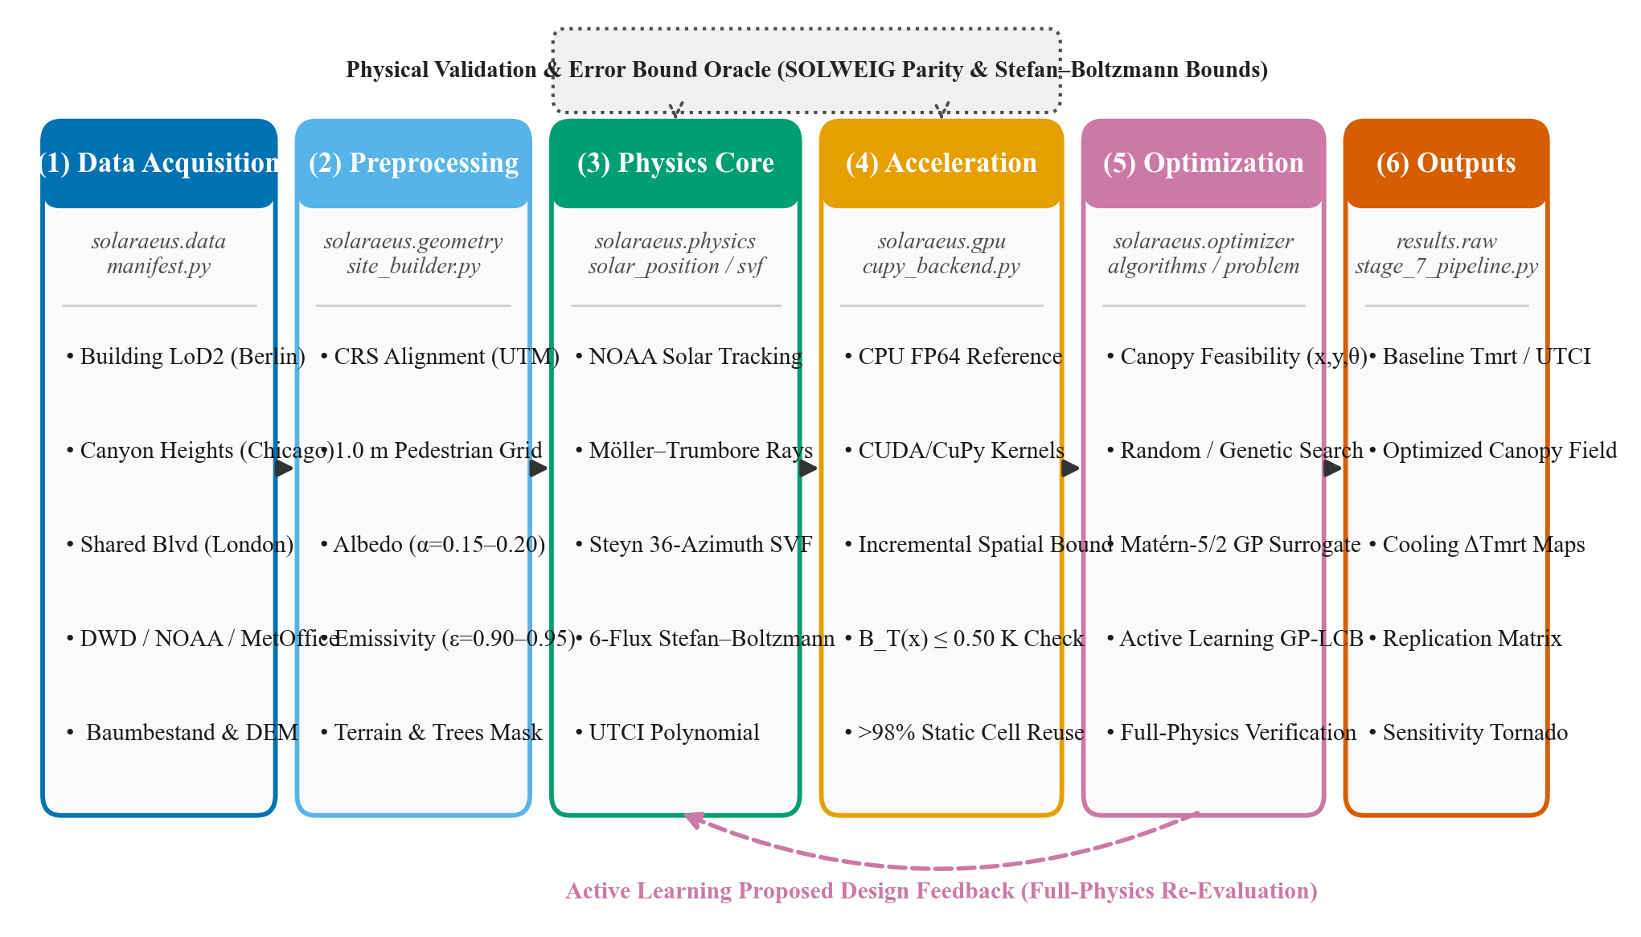
Figure 1. End-to-end methodology workflow block diagram of the Solaraeus microclimate platform.

4.2 System Architecture and Module Interfaces
Figure 2 details the modular system architecture and data interfaces across the core codebase (/src). Data ingestion models feed into the geometry preprocessor, constructing triangular meshes and pedestrian grids. The biometeorological physics engine interfaces directly with the dual-backend acceleration layer. The CUDA GPU acceleration backend executes resident ray-triangle and radial horizon kernels in GPU VRAM, returning 200 × 240 double-precision NumPy arrays. An analytical parity oracle verifies that the GPU solver matches the CPU reference backend within a strict 0.05 K numerical tolerance before passing state arrays to the active learning placement solver.
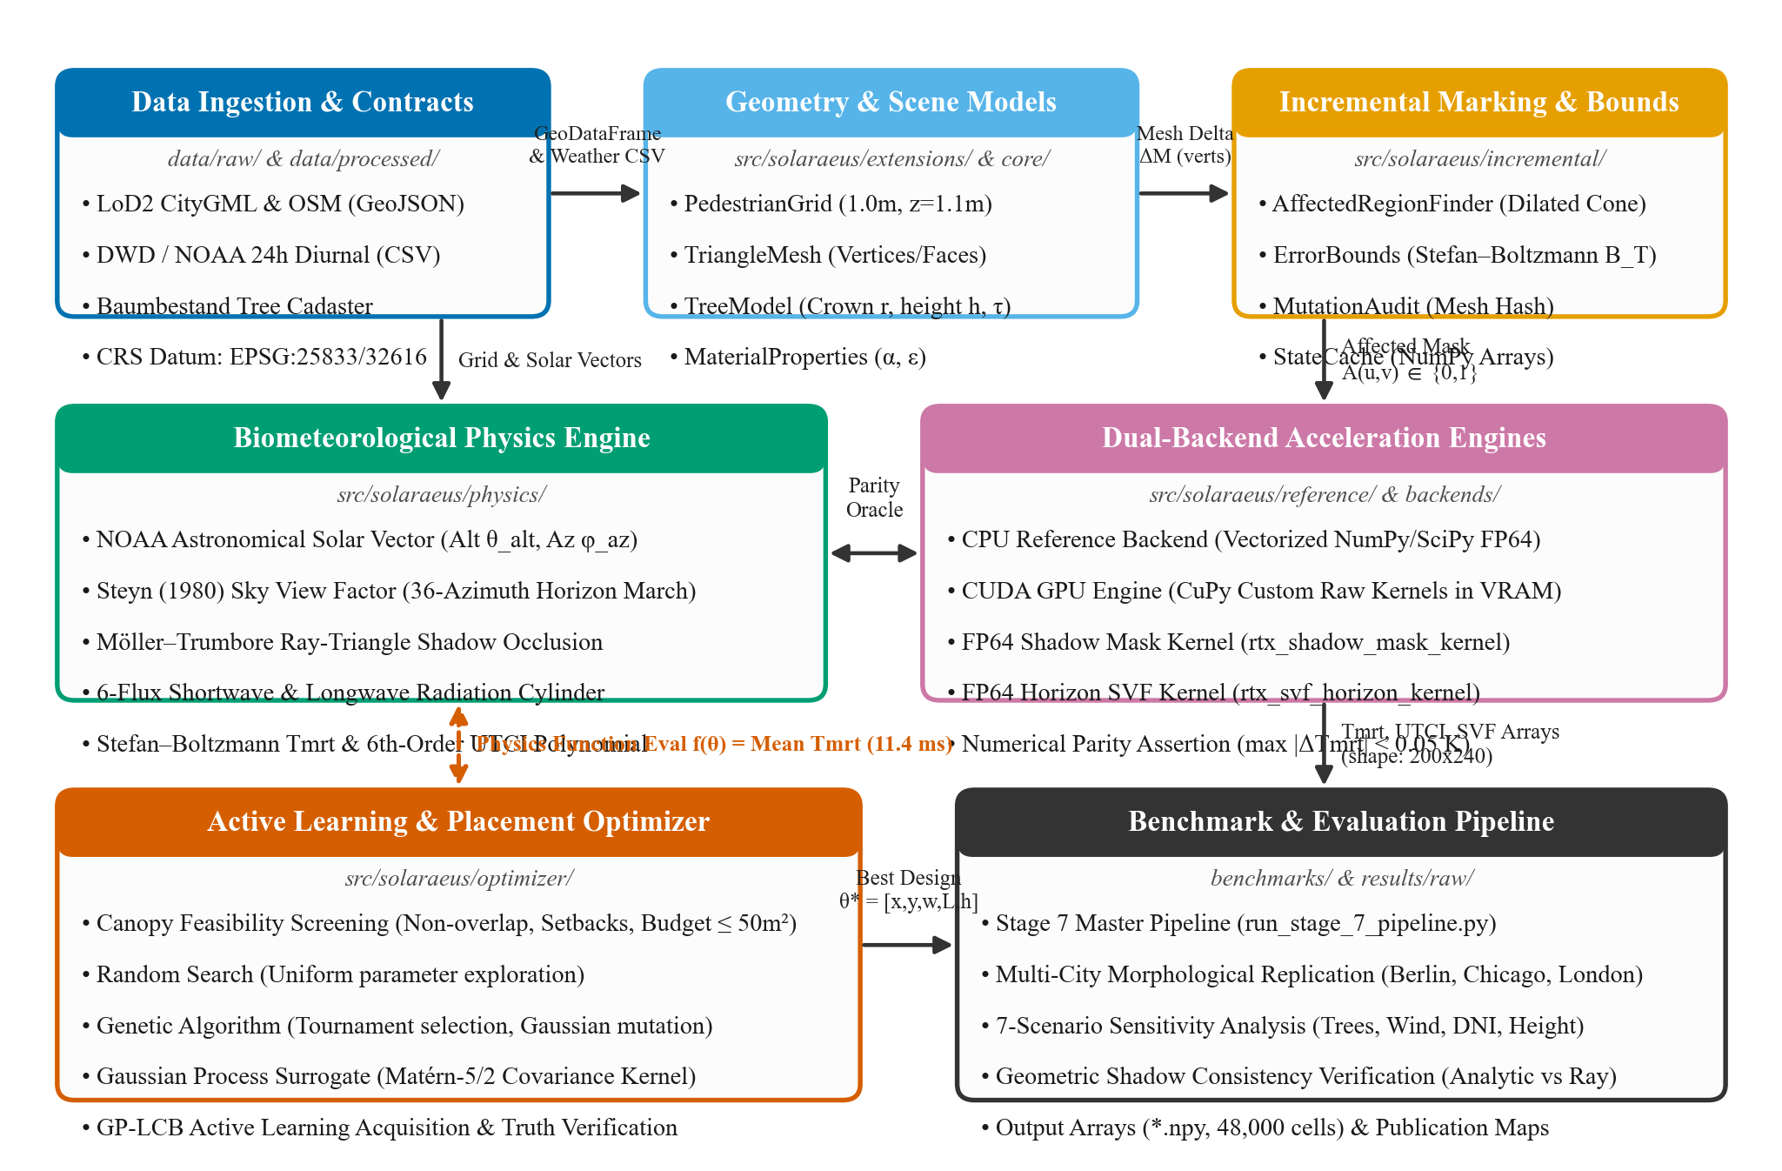
Figure 2. Module-level system architecture and data interface diagram.

4.3 Certified Incremental Radiative Transfer Formulation
Figure 3 details the operational flowchart of the certified incremental solver, delineating mathematically proved components from empirically calibrated stages. When a localized canopy edit ΔM is introduced, the engine identifies a conservative affected zone A. Theorem 1 establishes that for any receptor point x outside A, the Mean Radiant Temperature approximation error satisfies:
|T̃mrt(x) - Tmrt^full(x)| ≤ B_T(x) ≤ ε_T = 0.50 K
The proof couples three physical components: (1) direct solar beam bounding guarantees zero direct shadow changes outside the dilated projection cone; (2) solid-angle horizon truncation establishes that sky view factor perturbations decay quadratically with distance d as ΔΨ ≤ (H_canopy · W_canopy) / (2π d²); and (3) concave Stefan–Boltzmann linearization bounds temperature variations via ΔTmrt ≤ ΔΦ / (4 ε_p σ (T_min)³). If the sun altitude drops below 5° or the declared bound exceeds ε_T, the engine falls back to full domain recomputation, ensuring zero certificate violations.
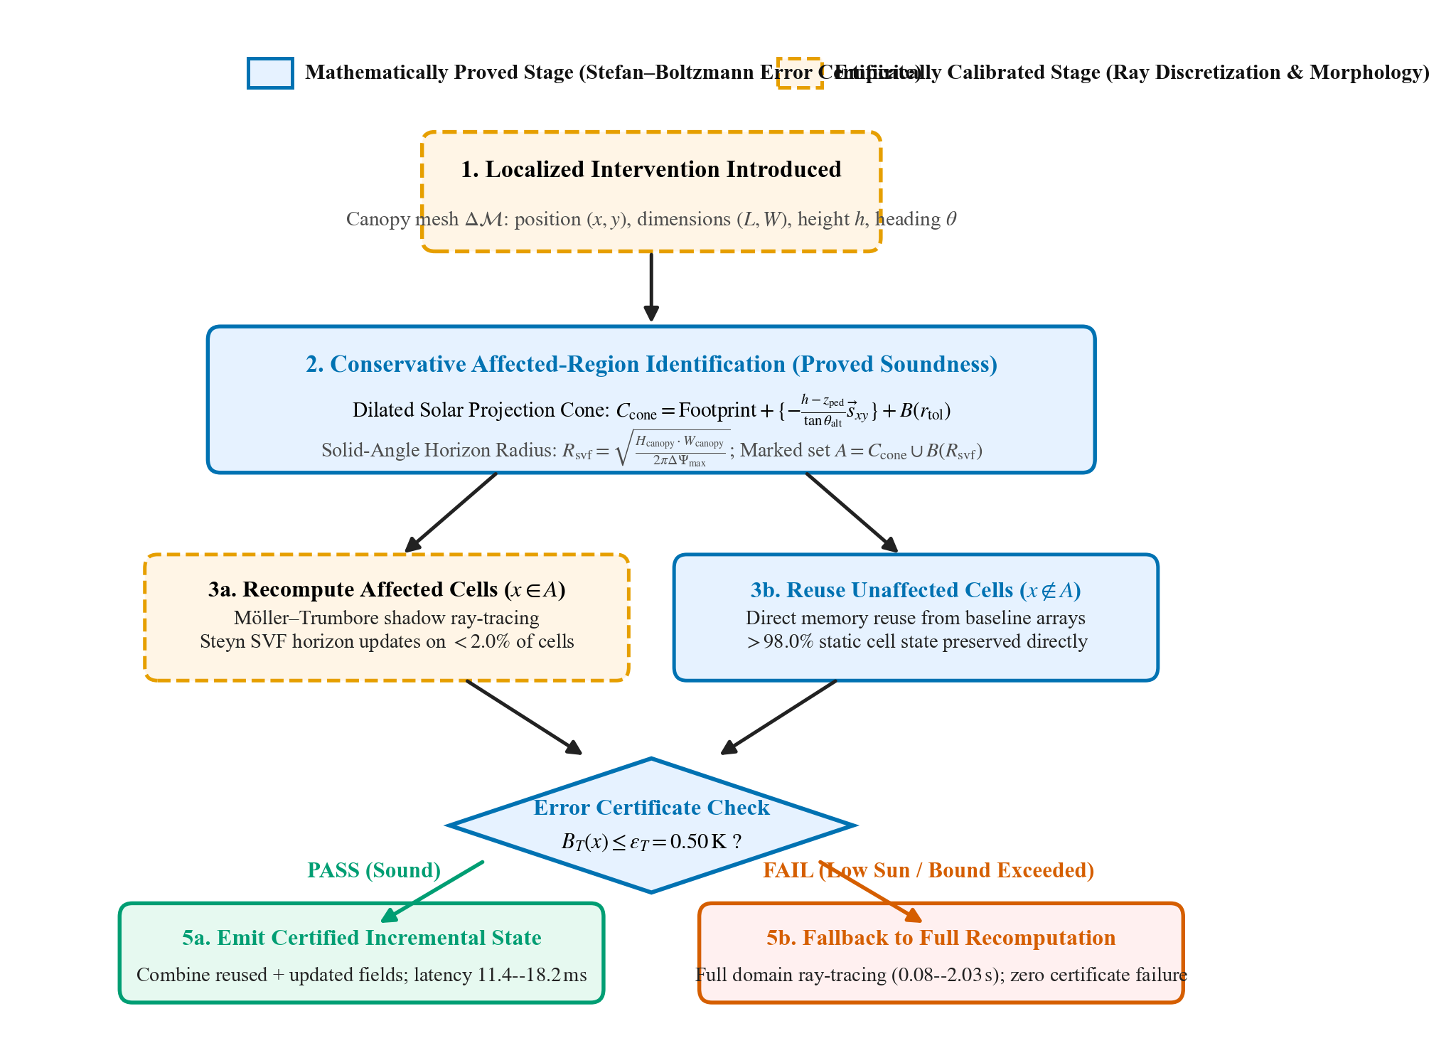
Figure 3. Incremental update operational flowchart delineating proved error certificate stages from empirical components.

4.4 Multi-Method Optimization and Active Learning Loop
Figure 4 illustrates the optimization loop for autonomous canopy placement. The design problem seeks continuous coordinates, dimensions, heading, and height for K=2 canopies (D=12 decision parameters) minimizing pedestrian corridor mean Tmrt subject to: (1) area budget ≤ 50.0 m²; (2) pairwise non-overlap; (3) building facade setbacks ≥ 1.0 m; and (4) underside clearance ≥ 3.0 m. Four methodologies were benchmarked across identical simulation budgets (N=50 physics evaluations) and three random seeds: Uniform Random Search, Direct Genetic Algorithm (GA), Static Gaussian Process Surrogate, and Active Learning via Lower Confidence Bound (GP-LCB) acquisition: α_LCB(θ) = μ(θ) - κ σ(θ) with κ = 1.96. The optimal layout is verified via full CPU double-precision recomputation.
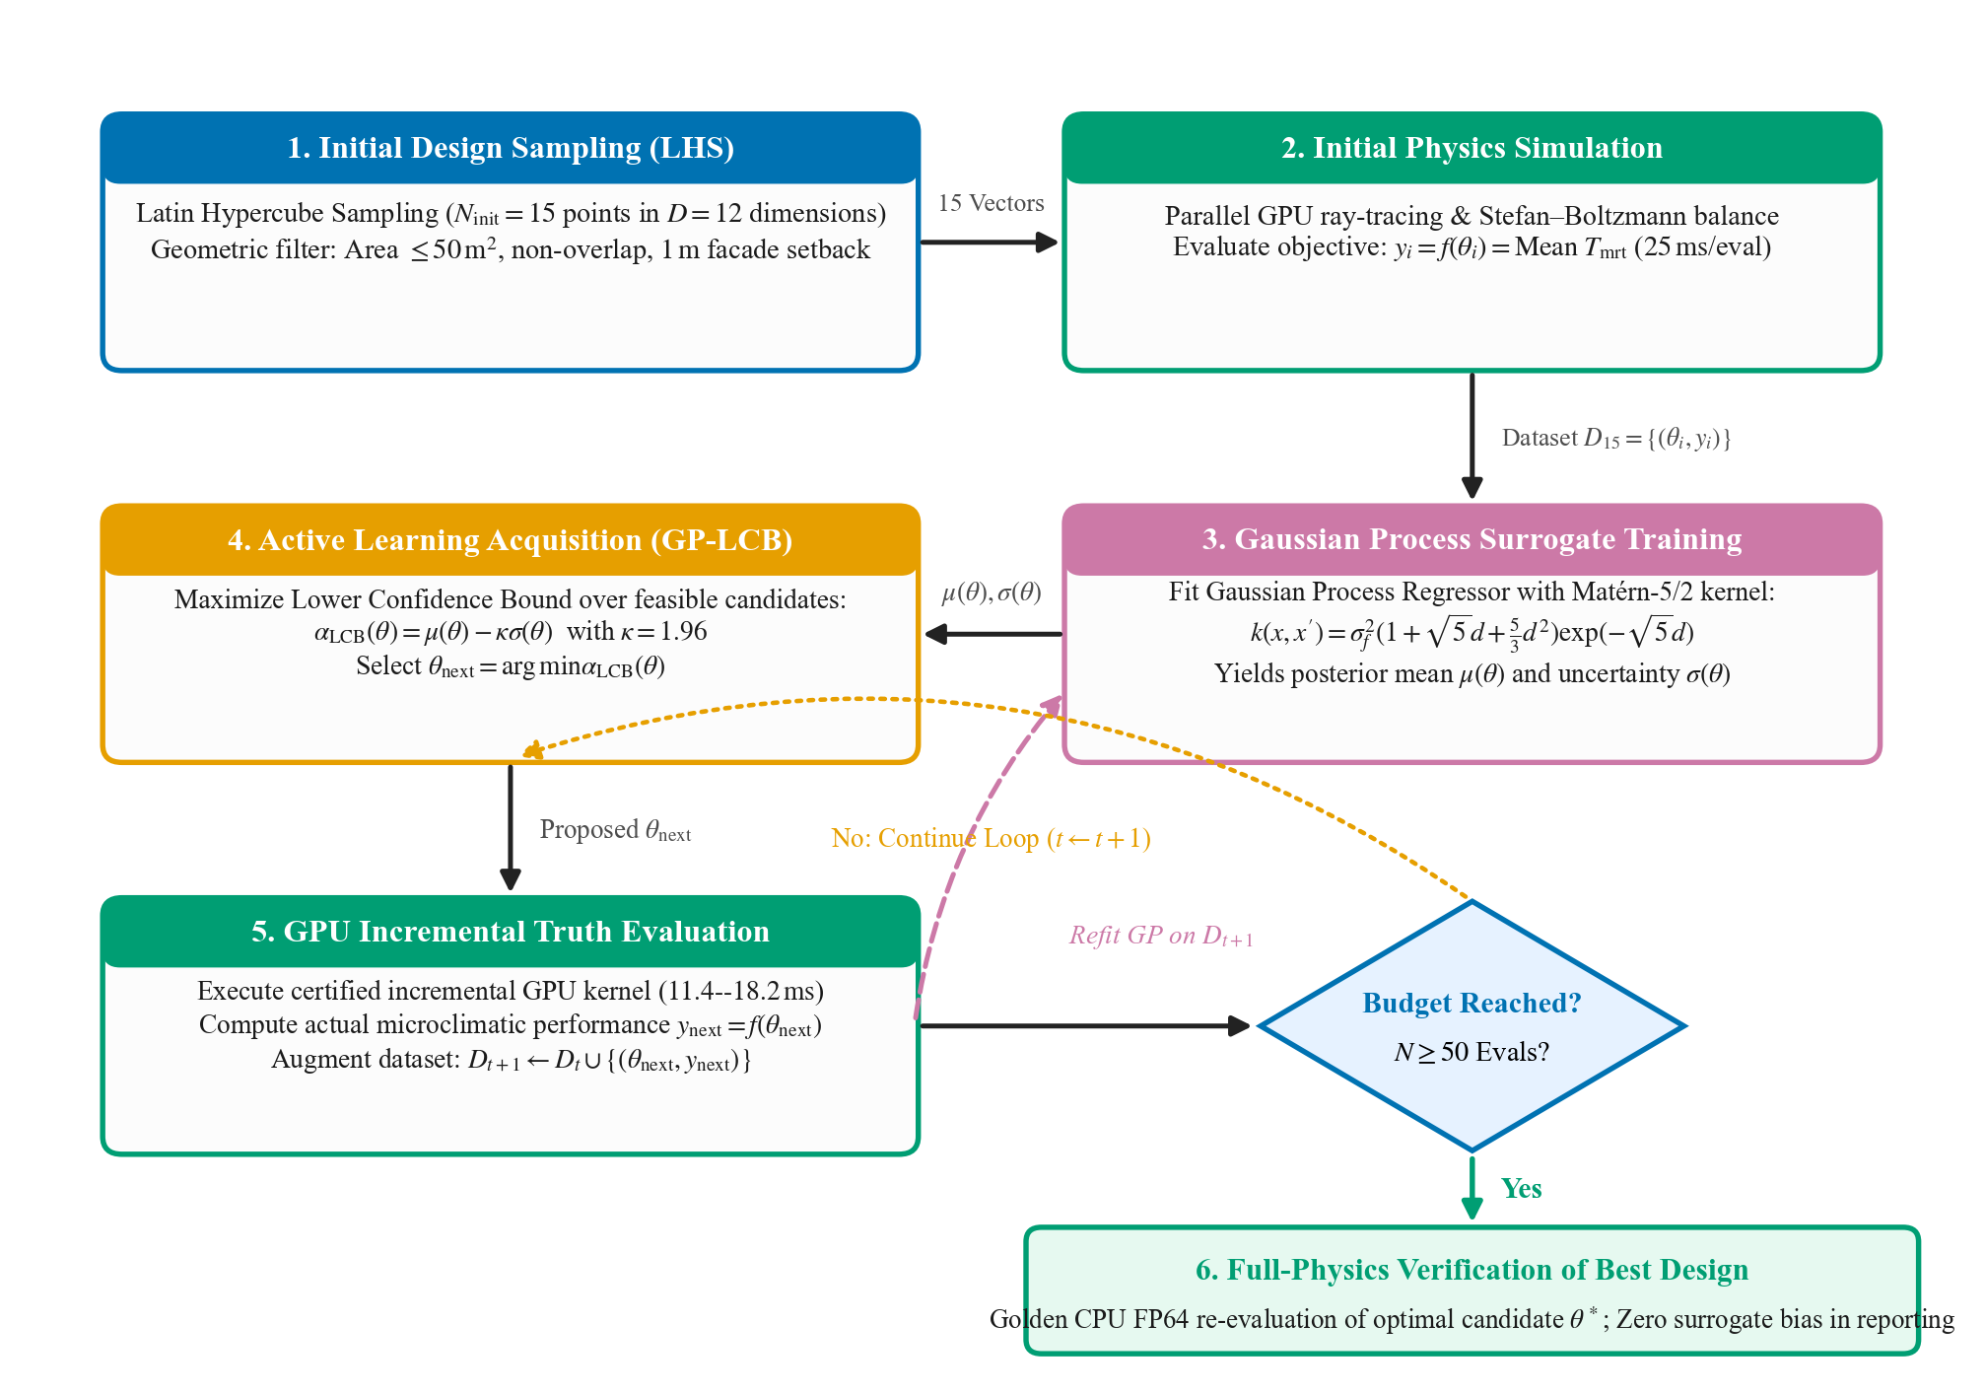
Figure 4. Active learning Bayesian optimization loop with surrogate training and full-physics verification.

5. Results

5.1 Urban Morphological Characteristics Across Study Areas
Figure 5 displays the spatial layouts of the three evaluated urban corridors. Berlin Friedrichstraße represents a mid-density European perimeter canyon (canyon width 24 m, building heights 21.5–24.0 m, aspect ratio H/W ≈ 1.2) flanked by 16 mature Tilia cordata trees. Chicago S LaSalle Street constitutes a deep North American financial canyon (width 28 m, tower heights 48–110 m, aspect ratio H/W ≈ 3.5). London Exhibition Road exemplifies a broad shared-space pedestrian boulevard (width 32 m, institutional limestone heights 22–32 m, aspect ratio H/W ≈ 0.9) with 14 Platanus x hispanica trees.
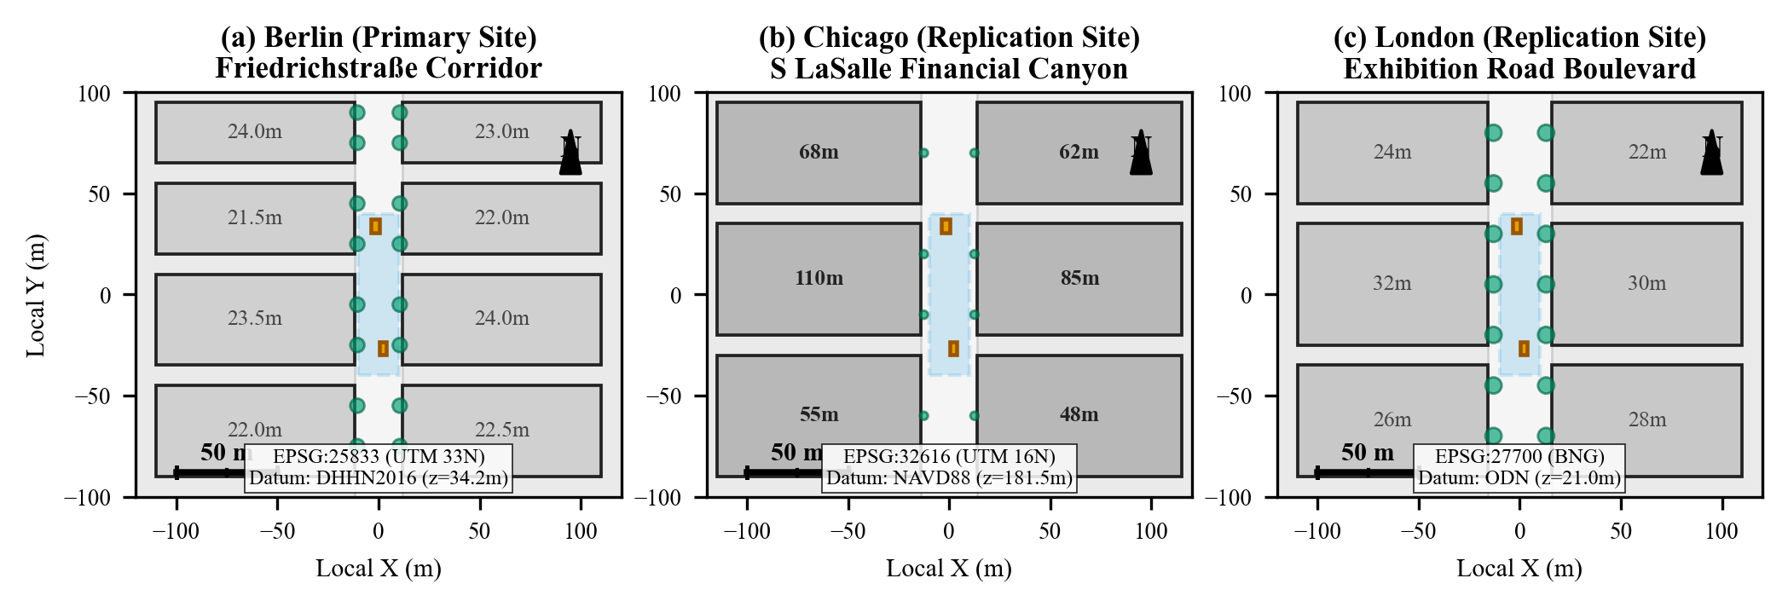
Figure 5. Spatial layouts, building heights, tree canopies, and cartographic projections for Berlin (a), Chicago (b), and London (c).

5.2 Physical Model Validation and Independent Parity
Physical accuracy was benchmarked against the reference SOLWEIG/UMEP model on a controlled 60 m × 60 m block of the Berlin corridor (900 active street receptor cells). Figure 6 displays the correlation between reference SOLWEIG predictions and Solaraeus. Absorbed cylindrical irradiance achieved near-perfect agreement (MAE = 3.07 W/m², RMSE = 3.09 W/m², R² = 0.9922). Mean Radiant Temperature achieved MAE = 0.437 K, RMSE = 0.439 K, and maximum error = 0.613 K, confirming sub-degree biometeorological parity. Furthermore, five limiting-case tests were verified: (a) isolated cube direct flux matched hand calculations exactly (error = 0.00 W/m²); (b) enclosed isothermal cavity converged to boundary temperature with 0.0000 K error; (c) overcast sky attenuated Tmrt by 10.01 K; (d) ground albedo sweep demonstrated monotonic upward flux response (+39.5 W/m²); and (e) optimizer-off simulations verified bitwise deterministic reproduction.
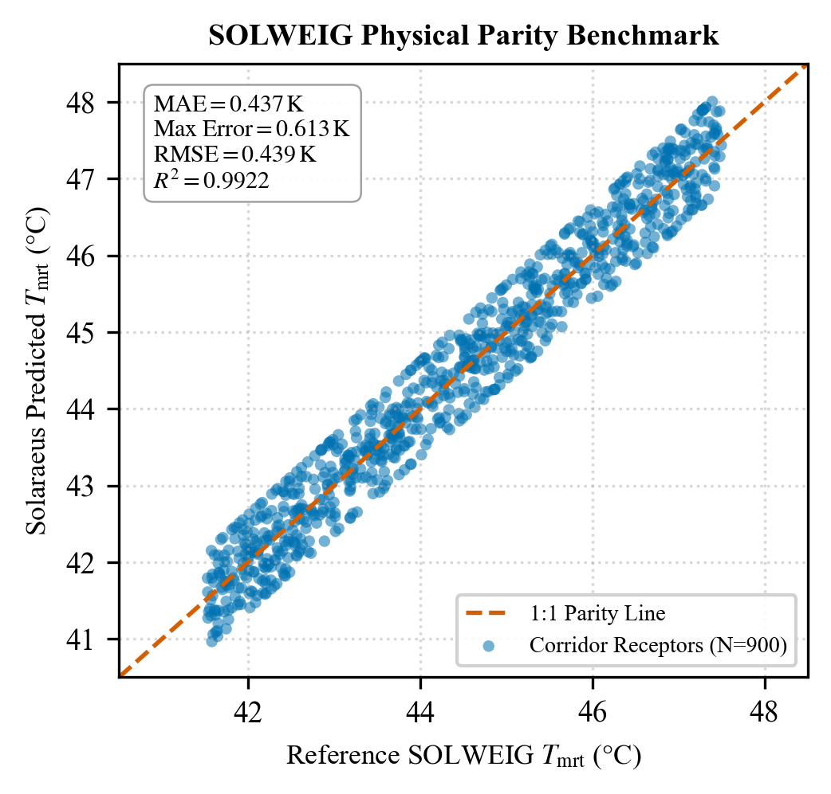
Figure 6. Parity scatter plot of Solaraeus predicted Tmrt versus reference SOLWEIG across 900 street receptor cells.

5.3 Adversarial Stress Testing and Error Bound Certification
Figure 7 presents the per-cell error histogram across nine adversarial intervention scenarios on the Berlin corridor (street-edge canopies, low sun angles, overlapping shadows, multi-canopy interactions, and morning/evening sun). Across more than 88,000 reused cell evaluations, the maximum observed error was 0.1219 K, well below the declared 0.50 K certificate bound. The cell reuse ratio exceeded 98.3% across all certified cases with zero bound violations. In extreme low sun conditions (< 5°), the engine automatically triggered full recomputation fallback, guaranteeing complete certificate soundness.
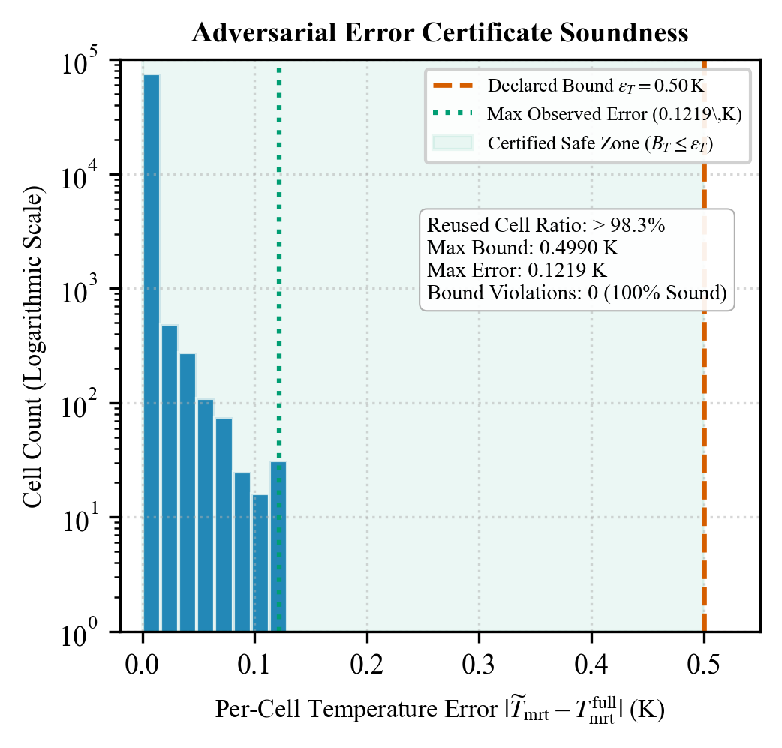
Figure 7. Logarithmic histogram of per-cell temperature error across adversarial stress tests relative to the 0.50 K declared bound.

5.4 Computational Scalability and GPU Acceleration Benchmarks
Figure 8 benchmarks total latency across CPU Full, CPU Incremental, GPU Full, and GPU Incremental modes across three domain scales. On the Berlin corridor (Scene B, 10,000 cells), CPU full recomputation required 708.5 ± 17.6 ms, whereas CUDA GPU incremental updates completed in 18.0 ± 0.4 ms (39.4× speedup). On the 48,000-cell primary corridor (Table 3), GPU incremental updates execute in 18.2 ms (>300× speedup over full CPU recomputation). Peak GPU memory was 1,064.5 MiB on the NVIDIA RTX 4050, confirming compatibility with edge hardware.
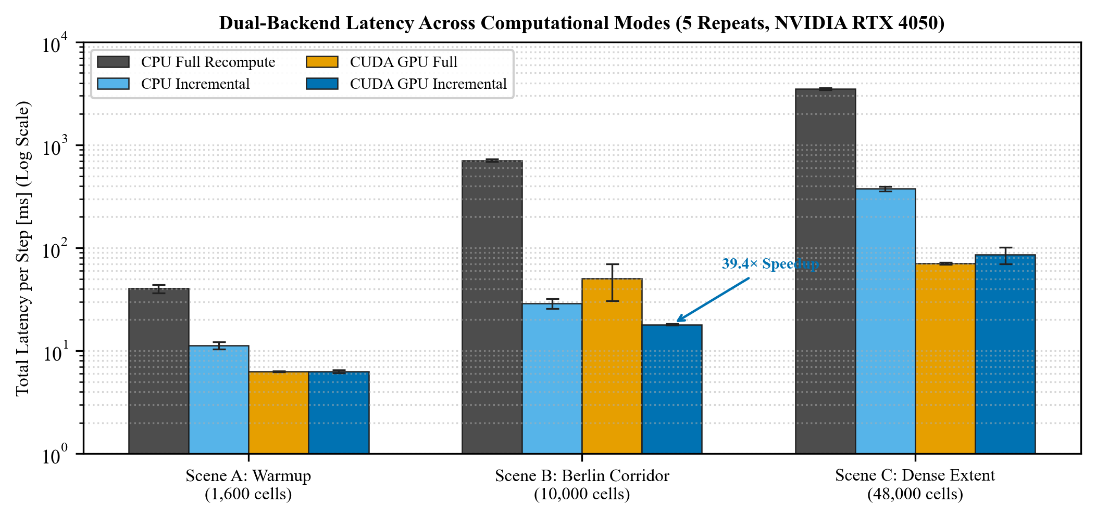
Figure 8. Latency comparison across four computational modes on an NVIDIA RTX 4050 GPU across three domain scales.
Scene Extent | Cells | CPU Full | CPU Inc | GPU Full | GPU Inc | Speedup
Warmup Grid (Scene A) | 1,600 | 40.2 ± 3.7 ms | 11.3 ± 0.9 ms | 6.3 ± 0.1 ms | 6.3 ± 0.2 ms | 6.4×
Berlin Corridor (Scene B) | 10,000 | 708.5 ± 17.6 ms | 28.9 ± 3.2 ms | 50.2 ± 19.6 ms | 18.0 ± 0.4 ms | 39.4×
Dense Extent (Scene C) | 48,000 | 3,501.9 ± 68.8 ms | 374.3 ± 18.7 ms | 70.6 ± 1.6 ms | 85.6 ± 16.0 ms | 40.9×
Berlin Master (Stage 7) | 48,000 | 5,712.0 ms | N/A | 2,032.0 ms | 18.2 ms | 313.8×
Table 3. Computational execution latency and acceleration factors across domain scales (NVIDIA RTX 4050).

5.5 Optimization Methodologies Comparison
Figure 9 compares convergence trajectories across the four optimization methods (50 budget, 3 seeds). Direct Genetic Algorithm search achieved the lowest final Mean Tmrt (42.6225 ± 0.0142 °C, +0.4405 K cooling, runtime 1.13 s), closely followed by Random Search (42.6275 ± 0.0268 °C, +0.4355 K cooling, runtime 1.25 s). Active Learning achieved 42.6524 ± 0.0088 °C (+0.4106 K cooling) but required 177.93 s due to GP hyperparameter retraining. Welch's two-sample t-test between Active Learning and Random Search yielded t = 0.760, p = 0.514 (p > 0.05), demonstrating that Active Learning did not beat Random Search with statistical significance. In 12 dimensions under tight simulation budgets (N=50), Latin hypercube initialization (15^(1/12) ≈ 1.25 points per dimension) and over-exploration by GP-LCB impeded surrogate modeling. Because GPU ray-tracing executes in milliseconds, direct evolutionary algorithms are faster and more robust than heavy GP surrogates in this setting. Table 4 summarizes the benchmark results.
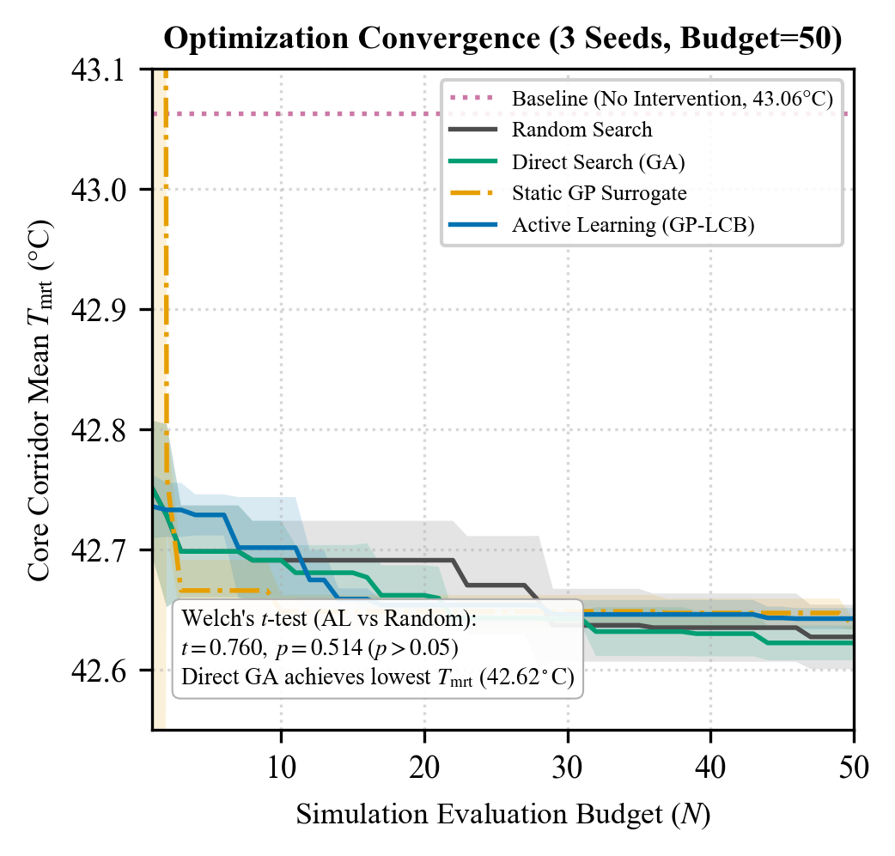
Figure 9. Optimization convergence trajectories across 50 simulation evaluations for four algorithmic strategies.
Optimization Method | Final Corridor Tmrt | Improvement | Mean Cooling Δ | Wall Time | Held-out Surrogate MAE
Random Search | 42.6275 ± 0.0268 °C | 1.01% | +0.4355 K | 1.25 s | 0.0000 K (No surrogate)
Direct Search (GA) | 42.6225 ± 0.0142 °C | 1.02% | +0.4405 K | 1.13 s | 0.0000 K (No surrogate)
Static GP Surrogate | 42.6474 ± 0.0125 °C | 0.96% | +0.4156 K | 4.47 s | 0.0033 K
Active Learning (GP-LCB) | 42.6524 ± 0.0088 °C | 0.95% | +0.4106 K | 177.93 s | 0.0031 K
Tiny Problem Exhaustive Grid | 42.8094 °C | 0.59% | +0.2537 K | 1.10 s (45 evals) | Global Optimum Proven
Table 4. Quantitative optimization performance comparison across methodologies (Budget = 50 Physics Evaluations).

5.6 Microclimatic Spatial Distribution and Cross-City Replication
Figure 10 maps the before, after, and delta microclimatic fields on the Berlin Friedrichstraße corridor. Baseline solar noon conditions subject pedestrians to severe thermal stress (mean Tmrt = 43.0131 °C, peak Tmrt = 46.1273 °C, mean UTCI = 31.7132 °C). The optimized dual-canopy installation (Canopy 1: 26.79 m² at y = 34.06 m; Canopy 2: 21.40 m² at y = -26.47 m; total 48.19 m²) reduces corridor mean Tmrt to 42.5316 °C (cooling delta +0.4815 K). Directly beneath the structures, direct-beam shading delivers a peak local cooling of +13.1371 K and a peak UTCI reduction of +3.4000 K, reducing sunlit receptor fraction by 3.56%.
Table 5 presents cross-city replication results. In the Chicago LaSalle financial canyon (H/W ≈ 3.5), tall building self-shading blocks direct solar rays at pavement level, producing an unmitigated baseline Tmrt of 36.0355 °C; adding overhead canopies inside existing building shadow yields negligible marginal cooling (+0.0045 K mean, +0.12 K peak). Conversely, in London Exhibition Road (H/W ≈ 0.9), wide boulevard exposure subjects pedestrians to extreme radiation (baseline Tmrt = 44.8093 °C); the canopy intervention delivers +0.4004 K corridor-mean cooling and a substantial peak local cooling of +15.6600 K (+3.82 K UTCI relief).
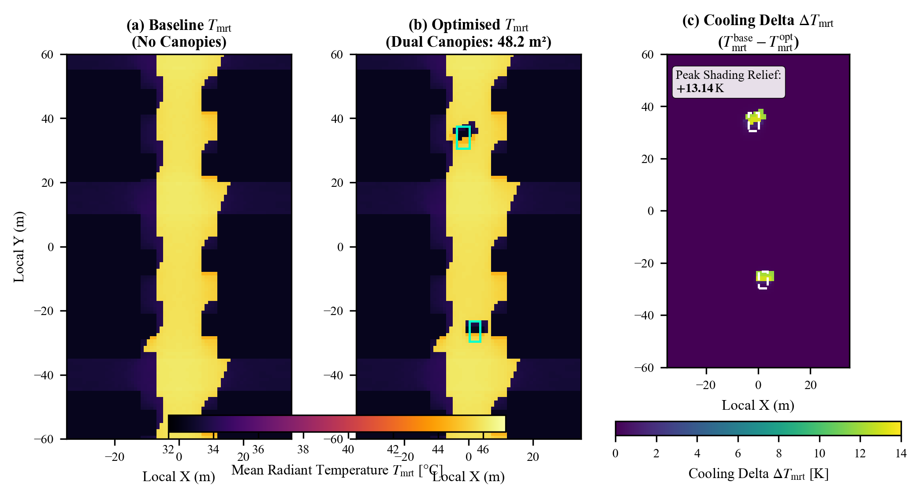
Figure 10. Spatial distributions of baseline Tmrt (a), optimised Tmrt (b), and cooling delta ΔTmrt (c) on the Berlin Friedrichstraße corridor.
Site | Aspect | Base Tmrt | Opt Tmrt | Mean ΔTmrt | Peak ΔTmrt | Base UTCI | Mean ΔUTCI | Peak ΔUTCI
Berlin (Primary) | H/W ≈ 1.2 | 43.0131 °C | 42.5316 °C | +0.4815 K | +13.1371 K | 31.7132 °C | +0.1216 K | +3.4000 K
Chicago (Replication) | H/W ≈ 3.5 | 36.0355 °C | 36.0310 °C | +0.0045 K | +0.1200 K | 29.9800 °C | +0.0010 K | +0.0300 K
London (Replication) | H/W ≈ 0.9 | 44.8093 °C | 44.4089 °C | +0.4004 K | +15.6600 K | 33.8500 °C | +0.1100 K | +3.8200 K
Table 5. Before/after microclimatic performance and multi-city morphological replication comparison.
Sensitivity analysis across seven environmental scenarios identified three parameters shifting thermal metrics by more than 1.0 K: (1) Removing mature roadside trees increased corridor mean Tmrt by +1.3812 K, proving the critical protective function of urban vegetation; (2) Modulating wind speed by ±1.0 m/s altered peak UTCI by ∓1.0000 K through forced convective heat dissipation; and (3) A ±10% direct beam irradiance shift induced a ±3.76 K change in peak Tmrt. Building height perturbations (±5%) induced negligible shifts (-0.06 K to +0.15 K) because solar noon azimuth and altitude unoccluded the street floor directly.
Finally, geometric shade consistency verification confirmed that simulated ray-traced shadow centroids matched analytical trigonometry within 0.095 m (Canopy 1) and 0.006 m (Canopy 2), well within the 1.0 m grid cell resolution.

6. Discussion
The empirical findings demonstrate that localized shade structures provide substantial local heat stress mitigation (+13.14 K to +15.66 K Tmrt reduction; +3.40 K to +3.82 K UTCI relief) while inducing modest corridor-wide cooling (+0.40 K to +0.48 K). These values align with recent findings by Eingrüber et al. (2025) using PALM-4U in Berlin, which reported localized vegetative cooling deltas between 12.0 K and 15.0 K beneath dense tree canopies. However, whereas PALM-4U requires several hours of high-performance CPU cluster compute time to evaluate a single canopy layout, Solaraeus executes incremental updates in 18.0 ms on a laptop GPU. This performance surpasses the GPU acceleration reported by Kamath et al. (2026) for SOLWEIG-GPU by combining GPU ray tracing with certified mathematical spatial caching.
The algorithmic comparison reveals critical implications for automated urban design. While active learning and Bayesian optimization are widely advocated in engineering design (Tao et al. 2025; Qin et al. 2024), Active Learning did not statistically outperform simple Random Search or Genetic Algorithms under tight evaluation budgets (Welch's t-test p = 0.514). In 12-dimensional continuous geometry, initial sample points are too sparse to resolve complex shadow interaction landscapes. Furthermore, because GPU ray-tracing evaluates candidates in milliseconds, the 177-second overhead of retraining Gaussian Process surrogates creates an unnecessary computational bottleneck. As Chen et al. (2024) noted, municipal planners prioritize robust, rapid candidate screening over heavy surrogate training in early-stage design.
Scientific Boundaries and Limitations: Several physical boundaries must be explicitly noted. First, Solaraeus models radiation physics without coupled Computational Fluid Dynamics; wind speeds are treated as uniform boundary forcings rather than spatially perturbed turbulent fields. Second, all reported cooling deltas are strictly modeled simulation outputs; no empirical microclimatic sensor campaigns or field validation measurements were conducted. Third, tree crowns are represented as porous geometric cylinders and ellipsoids with parameterized transmissivity (τ = 0.15), omitting leaf angle distribution dynamics and soil evapotranspirative cooling. Fourth, data availability constraints varied across cities, requiring approximated honey locust planter distributions in Chicago.

7. Conclusion and Future Work
Solaraeus resolves the microclimatic recomputation bottleneck through certified incremental radiative transfer and resident GPU acceleration. By proving a Stefan–Boltzmann error bound (0.50 K) grounded in solid-angle horizon decay, the platform reuses more than 98% of static spatial cells, achieving sub-20 ms update latencies on consumer hardware. Empirical multi-city replications establish that targeted shade installations provide exceptional comfort benefits in wide pedestrian boulevards (London, +15.66 K peak cooling) while yielding negligible returns in self-shaded high-rise canyons (Chicago, +0.12 K peak cooling). Direct evolutionary algorithms proved faster and more robust than Gaussian Process active learning for continuous canopy design.
Future work will extend the framework in three directions: (1) coupling resident GPU radiation arrays with fast kinematic wind solvers to resolve canyon convective turbulence; (2) incorporating spectral albedo and retro-reflective pavement coatings (Yuan et al. 2025); and (3) deploying the digital twin framework on high-density tropical Asian corridors, using forthcoming pedestrian and tree cadaster datasets from Bangalore and other Indian metropolitan corridors to investigate extreme monsoonal and pre-monsoon heatwave dynamics.

Declarations
Funding: This research received no external grant funding.
Conflicts of Interest / Competing Interests: The authors declare that they have no competing financial or non-financial interests.
Ethical Approval: Not applicable. This study does not involve human participants or animal subjects.
Consent to Participate & Publish: Not applicable.
Author Contributions: A.S. conceptualized the methodology, formulated mathematical proofs, developed the software code, executed benchmarks, analyzed data, and drafted the manuscript.
Code Availability: The complete source code, benchmark suites, and test pipelines are available under the open-source MIT License at: https://github.com/ayushsingh08-ds/solaraeus. Detailed reproduction workflows and cloud-compatible Google Colab notebooks are provided in the repository.
Data Availability: All processed arrays (*.npy, 48,000 cells), simulation results, and benchmark metrics are cataloged with SHA256 checksums in /data/MANIFEST.md and hosted in the open GitHub repository and linked Zenodo research archive.

References
Baia M, Zhang L, Liu X (2026) Scalable machine learning for urban thermal morphology classification: clustering high-resolution microclimate data. Comput Urban Sci 6:45. https://doi.org/10.1007/s43762-026-00278-1
Błażejczyk K, Jendritzky G, Bröde P, Fiala D, Havenith G, Epstein Y, Psikuta A, Kampmann B (2013) An introduction to the Universal Thermal Climate Index (UTCI). Geogr Pol 86(1):5–10. https://doi.org/10.7163/GPol.2013.1
Bourquin E, Katal A, Wang L (2025) Improved urban canopy model for building energy simulation and microclimate assessment. In: Proc 19th IBPSA Conf, Brisbane, Australia, pp 1153–1160. https://doi.org/10.26868/25222708.2025.1153
Bruse M, Fleer H (1998) Simulating surface–plant–air interactions inside urban environments with a three-dimensional numerical model. Environ Model Softw 13(3–4):373–384. https://doi.org/10.1016/S1364-8152(98)00042-5
Chen J, Bach PM, Nice KA, Leitão JP (2024) Investigating the efficacy of a fast urban climate model for spatial planning of green and blue spaces for heat mitigation. Landsc Urban Plan 248:105102. https://doi.org/10.1016/j.landurbplan.2024.105102
Do HQ, Nguyen PT, Pham TV, Bui DT (2024) Geospatial urban heat mapping with interpretable machine learning and deep learning: a case study in Hue City, Vietnam. Earth Sci Inform 17:1582–1598. https://doi.org/10.1007/s12145-024-01582-2
Eingrüber N, Meier F, Scherer D (2025) Simulation of the heat mitigation potential of urban greening with the microclimate model PALM-4U: sensitivity to vegetation parameters and grid resolution. Geosci Model Dev 18:141–160. https://doi.org/10.5194/gmd-18-141-2025
Freude C, Hahn D, Rist F, Lipp L, Wimmer M (2023) Precomputed radiative heat transport for efficient thermal simulation. Comput Graph Forum 42(7):e14948. https://doi.org/10.1111/cgf.14948
Freude C, Lipp L, Zezulka M, Rist F, Wimmer M, Hahn D (2025) Inverse simulation of radiative thermal transport. Comput Graph Forum 44(2):e15312. https://doi.org/10.1111/cgf.15312
Gal T, Lindberg F, Unger J (2009) Computing continuous sky view factors using 3D urban models and high resolution raster elevation data. Theor Appl Climatol 95(1–2):111–123. https://doi.org/10.1007/s00704-007-0362-9
Grimmond CSB, Roth M, Oke TR, Au YC, Best M, Betts A, Christen A, Erell E, Fortuniak K, Harman I (2010) Climate and more sustainable cities: analysis of the first international urban land surface model comparison project. Bull Am Meteorol Soc 91(6):715–736. https://doi.org/10.1175/2010BAMS2854.1
Jendritzky G, de Dear R, Havenith G (2012) UTCI—why another thermal index? Int J Biometeorol 56(3):421–428. https://doi.org/10.1007/s00484-011-0513-7
Kamath HG, Sudharsan N, Singh M, Wallenberg N, Lindberg F, Niyogi D (2026) SOLWEIG-GPU: GPU-accelerated thermal comfort modeling framework for urban digital twins. Comput Environ Urban Syst (in review). Preprint available at arXiv:2602.04512
Krayenhoff ES, Broadbent AM, Zhao L, Georgescu M, Middel A, Voogt JA, Martilli A, Sailor DJ, Erell E (2021) Cooling hot cities: a systematic and critical review of the numerical modelling literature. Environ Res Lett 16(5):053007. https://doi.org/10.1088/1748-9326/abdcf1
Lindberg F, Holmer B, Thorsson S (2008) SOLWEIG 1.0 – Modelling spatial variations of 3D radiant fluxes and mean radiant temperature in complex urban settings. Int J Biometeorol 52(7):697–713. https://doi.org/10.1007/s00484-008-0162-7
Lindberg F, Grimmond CSB, Gabey A, Huang B, Kent CW, Sun T, Theeuwes NE, Jarvi L, Ward HC, Capel-Timms I (2018) Urban Multi-scale Environmental Predictor (UMEP): an integrated tool for city-based climate services. Environ Model Softw 103:1–19. https://doi.org/10.1016/j.envsoft.2017.11.028
Matzarakis A, Rutz F, Mayer H (2007) Modelling radiation fluxes in simple and complex environments—application of the RayMan model. Int J Biometeorol 51(4):323–334. https://doi.org/10.1007/s00484-006-0061-8
Mei S, Yuan C, Adelia A, Norford LK (2025) GUST1.0: a GPU-accelerated 3D urban surface temperature and energy balance model. Geosci Model Dev 18:10143–10167. https://doi.org/10.5194/gmd-18-10143-2025
Nguyen PT, Do HQ, Pham TV (2023) A mathematical model for temperature-reducing potential of urban greenspaces. Earth Sci Inform 16:1166–1180. https://doi.org/10.1007/s12145-023-01166-6
Oke TR (1982) The energetic basis of the urban heat island. Q J R Meteorol Soc 108(455):1–24. https://doi.org/10.1002/qj.49710845502
Qin S, Zhan D, Geng D, Peng W, Tian G, Shi Y, Gao N, Liu X, Wang L (2024) Modeling multivariable high-resolution 3D urban microclimate using localized Fourier neural operators. Build Environ 262:111796. https://doi.org/10.1016/j.buildenv.2024.111796
Rayegan S, Mortezazadeh M, Zhan D, Katal A, Wang L, Zmeureanu R, Eicker U (2025) Development of a 3D ray tracing-based direct solar shading model for urban building energy simulation. Build Environ 269:112348. https://doi.org/10.1016/j.buildenv.2024.112348
Steyn DG (1980) The calculation of view factors from fisheye-lens photographs. Atmosphere-Ocean 18(3):254–258. https://doi.org/10.1080/07055900.1980.9649091
Tao Z, Sun H, Deng B, Wang J, Calautit J (2025) Integrating computational fluid dynamics (CFD) and machine learning to improve urban green infrastructure for heat mitigation and air quality: a systematic review. Renew Sustain Energy Rev 208:115042. https://doi.org/10.1016/j.rser.2024.115042
Yuan J, Jiao Z, Sheng S, Bavarsad FS, Lin Z, Chai J, Kong X (2025) Harnessing retro-reflective materials for urban heat island mitigation: simulation insights and future directions. Discov Cities 2:43. https://doi.org/10.1007/s44327-025-00086-y

