Project Report

Project Title: Advanced Disk Scheduling Simulator

(OPERATING SYSTEM - CSE316)
COMPUTER SCIENCE AND ENGINEERING

Section: 224HP

SR. NO. | NAME | ROLL NO. | REGISTRATION NO.
1. | AYUSH SINGH | 50 | 12409278
2. | TALLURI SNIGDHA | 49 | 12417373
3. | ARYAN SHAKYA | 18 | 12409142



Git-hub Link: https://github.com/ayushsingh2207/advanced-disk-scheduling-simulator

Advanced Disk Scheduling Simulator-Project Report

1. Project Overview
The Disk Scheduling Simulator is developed as an educational web form application to demonstrate the behavior and performance characteristics of different disk scheduling algorithms in operating systems.
The simulator allows users to enter a sequence of disk access requests as inputs, specify the starting head position, and select scheduling algorithms which we need to evaluate. The application then computes the complete seek sequence and associated metrics, enabling comparison among common disk scheduling strategies with clear insights.
This project is intended for operating systems learners, system designers, and anyone who wants to understand how disk head movement affects I/O efficiency. By combining real time visualization with metrics-based analysis, the simulator makes abstract scheduling concepts quite tangible.
The online software allows for the separation of user interface and algorithm engine functionality, thereby facilitating separation of concern. The front-end manages the user-friendly visualization and insight while the back-end processes the algorithm and provides the output.
The importance of disk scheduling cannot be understated because it is used to schedule I/O operations on disk drives. Disk scheduling plays an essential role in determining how requests are processed, and it influences system performance and user satisfaction.
The simulator supports four important algorithms: First Come First Served (FCFS), Shortest Seek Time First (SSTF), SCAN, and Circular SCAN (C-SCAN). Each algorithm has it’s unique characteristics that affect fairness, efficiency, and response times under different workload patterns.
Users can experiment with various input scenarios, including different request sequences, head positions, and disk sizes, to observe how algorithm performance varies. This hands-on approach helps build intuition about algorithmic tradeoffs in real-world disk I/O management.
The application provides both single-algorithm simulation and side-by-side comparison modes, making it an effective teaching tool for computer science courses and self-study. The interactive nature encourages exploration and deeper understanding of operating system concepts.

2. Module-Wise Breakdown
This section explores the project architecture module by module, describing the responsibilities, implementation details, and how each part contributes to the overall system.
A well-organized module structure simplifies maintenance for us and allows the project to scale with additional algorithms and visualization features over time.
The modular design follows best practices for web application development, separating concerns between data processing, business logic, and user interface (UI) components.
Each module is designed in such a way that it is independently testable and maintainable, reducing the complexity of debugging and feature additions.

2.1 Backend Architecture
The backend is implemented using Node.js and the Express framework. Its primary responsibility is to accept simulation requests from the frontend, validate input, select the appropriate disk scheduling algorithm, compute metrics, and return the results as JSON.
The backend entry point is server.js. It configures Express middleware for cross-origin resource sharing (CORS) and JSON parsing, and it mounts the API router under the /api path. The backend also includes a lightweight health-check route to confirm the server is running.
Server.js acts as the central configuration point, ensuring that all incoming requests are properly handled and that the application can communicate securely with the frontend during development.
The backend architecture is designed to be stateless, meaning each request is processed independently without maintaining session state, which simplifies scaling and deployment.
- routes/scheduling.js: Defines REST endpoints for simulation and comparison requests, then delegates processing to the controller layer. This module handles HTTP routing and ensures proper request/response formats.
- controllers/schedulingController.js: Validates incoming parameters, executes the requested algorithm (or all algorithms for comparison mode), and formats the result payload for the frontend. It acts as the business logic coordinator.
- algorithms/fcfs.js: Implements the First Come First Served algorithm, which processes requests in the order received. This simple algorithm serves as a baseline for comparison with more sophisticated methods.
- algorithms/sstf.js: Implements the Shortest Seek Time First algorithm, selecting the request closest to the current head position at each step. This greedy approach minimizes immediate seek time but can lead to starvation.
- algorithms/scan.js: Implements the SCAN algorithm, sweeping in one direction until the end of the disk and then reversing direction. This elevator-like algorithm provides more predictable service patterns.
- algorithms/cscan.js: Implements the C-SCAN algorithm, which moves in one direction and wraps back to the start without servicing requests on the return sweep. This variant reduces response time variance.
- utils/metrics.js: Calculates detailed performance metrics including total seek time, average seek time, maximum seek time, variance, standard deviation, throughput, and request count. These metrics provide quantitative evaluation of algorithm efficiency.

2.2 Frontend Architecture
The frontend is constructed with React and Vite, and it uses Tailwind CSS for design consistency. The primary objective of the frontend is to collect user input, present simulation controls, render performance results, and visualize disk head movement.
The application supports both single-algorithm simulation and simultaneous comparison of multiple algorithms, making it useful for learners who want to observe differences directly.
React enables the creation of reusable UI components, which improves code maintainability and allows for consistent user experiences across different parts of the application.
Vite provides fast development builds and hot module replacement, significantly improving developer productivity during the coding phase.
- src/App.jsx: The root component manages application state, loading status, mode selection, and error handling. It connects user interactions from the configuration panel to the results display. This component orchestrates the overall application flow.
- src/components/InputPanel.jsx: Provides form fields for disk request input, maximum track number, initial head position, algorithm selection, and direction control for SCAN. It also supplies random request generation for quick experimentation. This component handles all user input validation on the client side.
- src/components/ResultsPanel.jsx: Displays results in either single-algorithm or comparison view. It renders summaries, charts, and tables to make algorithm performance immediately understandable. This component adapts its layout based on the selected mode.
- src/components/DiskChart.jsx: Builds an interactive chart that plots the seek sequence and highlights head movement through the requested tracks. The chart uses Recharts library for smooth animations and responsive design.
- src/components/MetricsCard.jsx: Shows individual performance measurements in a compact card format, improving readability and focus. Each card displays a specific metric with appropriate formatting and units.
- src/services/api.js: Encapsulates network logic for POST /api/simulate and POST /api/compare, enabling the frontend to interact with the backend cleanly and asynchronously. This module handles HTTP requests and error responses.

3. Functionalities
This section describes the functions of the simulator in detail. It covers the main user flows, data validation, algorithm execution, comparison mode, and metric reporting. The features aim to offer a thorough learning experience. Users can explore disk scheduling concepts through hands-on experimentation.
Each function is designed with user experience in mind, providing clear feedback and simple controls to aid learning. The application manages edge cases well, such as empty request lists or invalid head positions. This ensures smooth operation under different input conditions. This application handles edge cases very well, such as empty request lists or invalid head positions, ensuring robust operation under various input conditions.
- User Input Interface: The simulator provides a responsive form for entering an array of disk track requests, which can be typed manually or generated automatically for experimentation. The interface includes helpful placeholders and validation messages.
- Validation Layer: The frontend and backend work together to validate inputs. The backend checks request values, head position bounds, algorithm selection, and track range before processing. This dual validation ensures data integrity.
- Single Algorithm Simulation: Users can simulate FCFS, SSTF, SCAN, or C-SCAN individually. Each simulation executes a complete seek sequence and returns the path taken by the disk head. Results include both visual and numerical representations.
- Comparison Mode: The compare feature runs all supported algorithms against the same input set and reports results side-by-side, highlighting the algorithm with the best total seek time. This mode facilitates direct algorithmic comparison.
- Performance Metrics: The backend computes metrics that quantify algorithm efficiency and consistency. These metrics help compare strategies beyond raw sequence order. Metrics include statistical measures like variance and standard deviation.
- Visualization: The frontend displays both a chart representation and a detailed list of the seek sequence, allowing users to understand the physical movement of the disk head. The chart updates dynamically based on simulation results.
- Error Feedback: Invalid input scenarios are communicated clearly to the user, reducing confusion and improving usability during experimentation. Error messages are contextual and suggest corrective actions.

3.1 Single Algorithm Processing Workflow
When a user selects a single algorithm and submits the form then the frontend packages the request data into a JSON payload, then the backend receives this payload and validates each field. After validation, the specified algorithm module runs and returns the computed sequence of tracks and seek distances. Finally, the backend assembles the response with the computed metrics and sends it back to the frontend for rendering.
The simulation flow consists of the following steps:
Input normalization and parsing of commas-separated track requests into numeric values. This step ensures consistent data format regardless of user input style.
Validation to ensure every track is within bounds and the head position is valid. Invalid inputs are rejected with specific error messages.
Algorithm selection logic that dispatches to the appropriate scheduling module. Each algorithm has its own implementation file for modularity.
Sequence computation that records the exact order in which requests are serviced. This sequence forms the basis for metric calculations.
Metric calculation based on the distances between consecutive head positions. Multiple metrics are computed to provide comprehensive performance analysis.
Result packaging and JSON response delivery back to the client. The response includes all necessary data for frontend rendering.
This workflow ensures that each simulation is processed efficiently and accurately, providing users with reliable results for educational purposes.

3.2 Comparison Mode Workflow
The comparison mode runs FCFS, SSTF, SCAN, and C-SCAN on the same request data set using identical input parameters. The backend calculates the result for each of the algorithm separately, and then the frontend presents the results in a comparative table that highlights the best performing algorithm in terms of total seek time.
This mode is particularly useful for learning because it shows the trade-offs between fairness, throughput, and seek cost among different scheduling strategies.
The comparison process runs all algorithms at the same time, making sure each one gets the same input conditions for a fair evaluation.
Results are combined and shown in one format, helping users quickly spot performance differences and strengths of each algorithm.
The algorithm that performs best is highlighted automatically, but users can look at all the metrics to see the full performance profile of each method.

4. Technology Used
The project uses the modern web development technologies to provide a smooth and interactive experiences while keeping the backend logic lightweight and extensible.
This technology stack was chosen for its maturity, community support and suitability for educational applications.
Each technological component was selected on the basis of their ability to support the project requirements while maintaining development efficiency very well.

4.1 Programming Languages
JavaScript: Used for both the frontend and the backend. The frontend is built with React and Vite, while the backend runs on Node.js. JavaScript provides a unified language across the full stack.
HTML: Provides the document structure for the web interface and serves the base page loaded by the browser. HTML5 features are used for semantic markup and accessibility.
CSS: Used for layout, responsive design, and styling of the user interface, including Tailwind CSS utility classes. CSS ensures the application looks professional and works on various screen sizes.

4.2 Libraries and Tools
React: Enables component-based UI development and declarative rendering. React simplifies building interactive user interfaces with reusable components.
Vite: Provides fast development startup, module hot replacement, and efficient build tooling. Vite improves the development experience with quick feedback loops.
Tailwind CSS: Supplies low-level CSS utility classes for rapid UI construction and responsive design. Tailwind allows for consistent styling without custom CSS files.
Recharts: Used for plotting the seek sequence chart and visualizing algorithm behavior. Recharts provides customizable and responsive chart components.
Express: Serves as the backend framework for routing and request handling. Express simplifies building RESTful APIs with middleware support.
cors: Allows the frontend to communicate with the backend API during development without cross-origin restrictions. CORS is essential for local development setups.

4.3 Other Tools
npm: Package manager used to install dependencies and run development scripts for both frontend and backend. npm manages the project dependencies and scripts.
GitHub: Recommended platform for version control, issue tracking, and repository management. GitHub provides collaboration features and project visibility.
Visual Studio Code: Suggested development environment for editing project code, debugging, and running scripts. VS Code offers excellent JavaScript and React support.

5. Flow Diagram
This flowchart presented here depicts the relationships between all the major components of the system. This flow chart represents the life cycle of the user's request from the point of its submission to that of receiving the processed results.
This flow chart demonstrates the processes that data go through from the user interface, then front-end processing, through the network communication to back-end processing and algorithm calculations, before coming to visualization.
Every rectangle in the flowchart depicts one of the major components of the system, while the arrows represent the movement of data and control through the system.
The flowchart is a useful guide for both developers and users of the system.
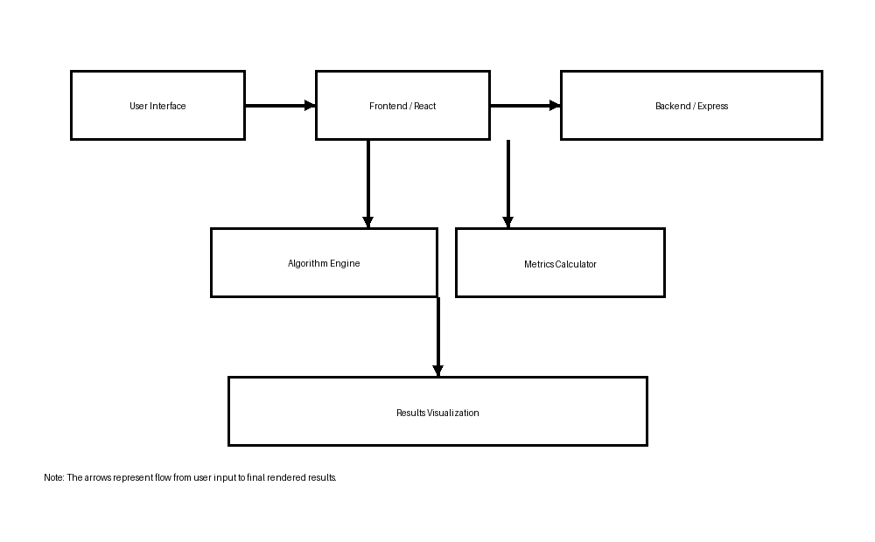

6. Revision Tracking on GitHub
Git-hub Repository Link: https://github.com/ayushsingh2207/advanced-disk-scheduling-simulator
Repository Name: advanced-disk-scheduling-simulator

7. Conclusion and Future Scope
The Disk Scheduling Simulator is very effective learning tool to see how disk scheduling algorithms works. It bridges theoretical book concepts with practical experimentation/implementation by exposing algorithm internals through simulation and performance metrics.
As an educational application, it enables learners to develop intuition about algorithmic tradeoffs, such as why SSTF may reduce seek cost but risk starvation, or why SCAN can provide more balanced service across the disk surface.
Future scope includes adding more advanced scheduling policies such as LOOK, C-LOOK, and multi-level queue scheduling, as well as supporting time-stamped requests and interactive animations of head movement. Another possible future enhancement is a file upload mechanism allowing real-world disk traces to be simulated directly from actual workload data.
This application would be even better enhanced by having user logins to save configurations, an image gallery of sample cases, and even integration with education platforms to allow automatic grading.
In summary, the simulator has been able to show the significance of disk scheduling in computer operating systems quite well..

8. References
React Documentation. https://react.dev/
Express Documentation. https://expressjs.com/
Vite Documentation. https://vitejs.dev/
Tailwind CSS Documentation. https://tailwindcss.com/
Operating Systems concepts and disk scheduling theory.
General web development resources for Node.js and React.
Academic papers on disk scheduling algorithms and performance analysis.

Appendix A: AI-Generated Project Elaboration/Breakdown Report
The AI report focuses on the system structure, implementation of algorithms, dataset handling, and user interactions. The decoupling of frontend visualization from the backend algorithm execution is emphasized, ensuring the modularity and extensibility of the simulator.
The backend routing layer gets requests for simulations and hands them over to controllers for execution. The appropriate algorithm is selected by controllers based on the input received and then invoked. The result from algorithms is computed in metrics and used alongside the simulation sequence in rendering.
Our frontend uses the modular React components to support the user input, chart visualization, and comparative result tables. InputPanel.jsx collects and normalizes data, while the ResultsPanel.jsx handles display logic for both single and comparison modes. The design encourages a clear feedback loop for learners.
It is designed to ensure that usability does not compromise learning. This involves using a proxy development server in the front-end to allow communication with the back-end API, which is still lightweight and designed for algorithmic correctness and metrics.
The project demonstrates good software engineering practices through its modular design, clear separation of concerns and the comprehensive error handling ability.

Appendix B: Problem Statement
10. Advanced Disk Scheduling Simulator
Description: Build a disk scheduling simulator to visualize algorithms like FCFS, SSTF, SCAN, and C-SCAN. Users should be able to input custom disk access requests and see how the algorithms minimize seek time. Include performance metrics like average seek time and system throughput.

