Activity Diagrams: swimlane activity diagrams of the main workflows
Case study: EV Charging Station Locator

1. Objective
To model the dynamic, step-by-step workflow of the EV Charging Station Locator with UML activity diagrams. Swimlanes show which actor or part of the system performs each activity. The diagrams are derived from the functional requirements in the SRS (FR-1 to FR-14) and the use cases.

2. Activity Diagrams Drawn
Diagram | Workflow | Based on
1A | Login and location selection | Register / Login, Get Current Location; FR-1, FR-2, FR-3
1B | Search, filter, view details and navigate | Search Charging Station, Find Nearest Station, Check Availability, View Station Details, Get Navigation; FR-4 to FR-14
2 | Book charging slot and make payment | Book Charging Slot, Make Payment (use cases)
3 | Admin manages charging stations | Add / Update Charging Station, Manage Users, Manage Bookings, Monitor Station Status
Diagrams 1A and 1B form one continuous workflow. They are joined by the connector node “A”, which only keeps each diagram readable on one page.

3. Notation Used
Symbol | Meaning
Filled circle | Initial node: where the activity starts
Rounded rectangle | Action / activity performed by the actor or system
Diamond (with guard labels such as [yes] / [no]) | Decision node: one flow is chosen depending on the condition. A small unlabelled diamond is a merge node where flows join.
Circle with inner filled circle | Activity final node: the flow ends
Circle with a letter | Connector linking two diagrams (A)
Arrow | Control flow between activities
Vertical lanes (swimlanes) | Partitions showing who is responsible: EV User, System, external service (orange header), Admin

4. Swimlanes and Their Roles
Swimlane | Role in the activities
EV User | Opens the app, logs in, enters or selects a location, selects a station and slot, enters payment details, receives confirmation.
Admin | Logs in and chooses operations to add / update stations, manage users and bookings, or monitor station status.
System | Validates input, queries and filters stations, calculates distance, displays results and details, creates and confirms bookings, updates the database.
Map / Geolocation Service | Detects the current location, provides station data and returns directions.
Payment Gateway | Authorizes and processes the payment.

5. Activity Diagram 1A: Login and Location Selection
Flow description:
- The EV User opens the application and enters credentials (or registers). The System validates them; invalid credentials return the user to the login step.
- After a valid login, the System requests location permission (FR-1).
- If permission is granted, the Map / Geolocation Service detects the current location through GPS. If it is denied, the user enters or selects a location manually (FR-2).
- The System validates the location (FR-3). An invalid location sends the user back to manual entry. A valid one continues to Diagram 1B through connector A.
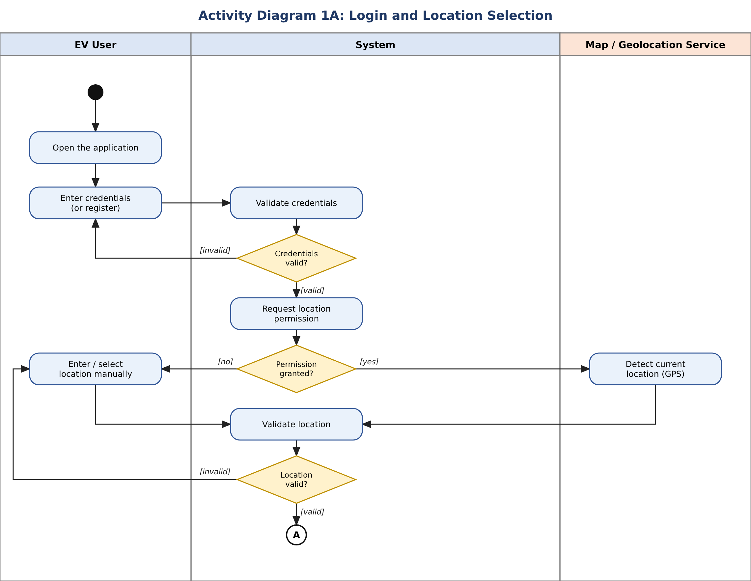
Figure 1: Activity diagram for login and location selection

6. Activity Diagram 1B: Search, Filter, View Details and Navigate
Flow description:
- The System queries stations within the search radius, fetching station data and availability from the data service (FR-4), and calculates the distance to each station (FR-5).
- If no station is found, a “No stations found” message is shown and the flow ends (FR-6). Otherwise the stations are displayed on a list / map.
- The user may refine the results: the System filters by connector type and availability and sorts by distance (FR-7 to FR-9).
- The user selects a station and the System displays its details: name, address, coordinates, connector, speed, chargers and availability (FR-10 to FR-12).
- If the user chooses Navigate, the System requests directions from the map service (FR-13). If the service is unavailable, an error message is shown (FR-14); otherwise the route is displayed.
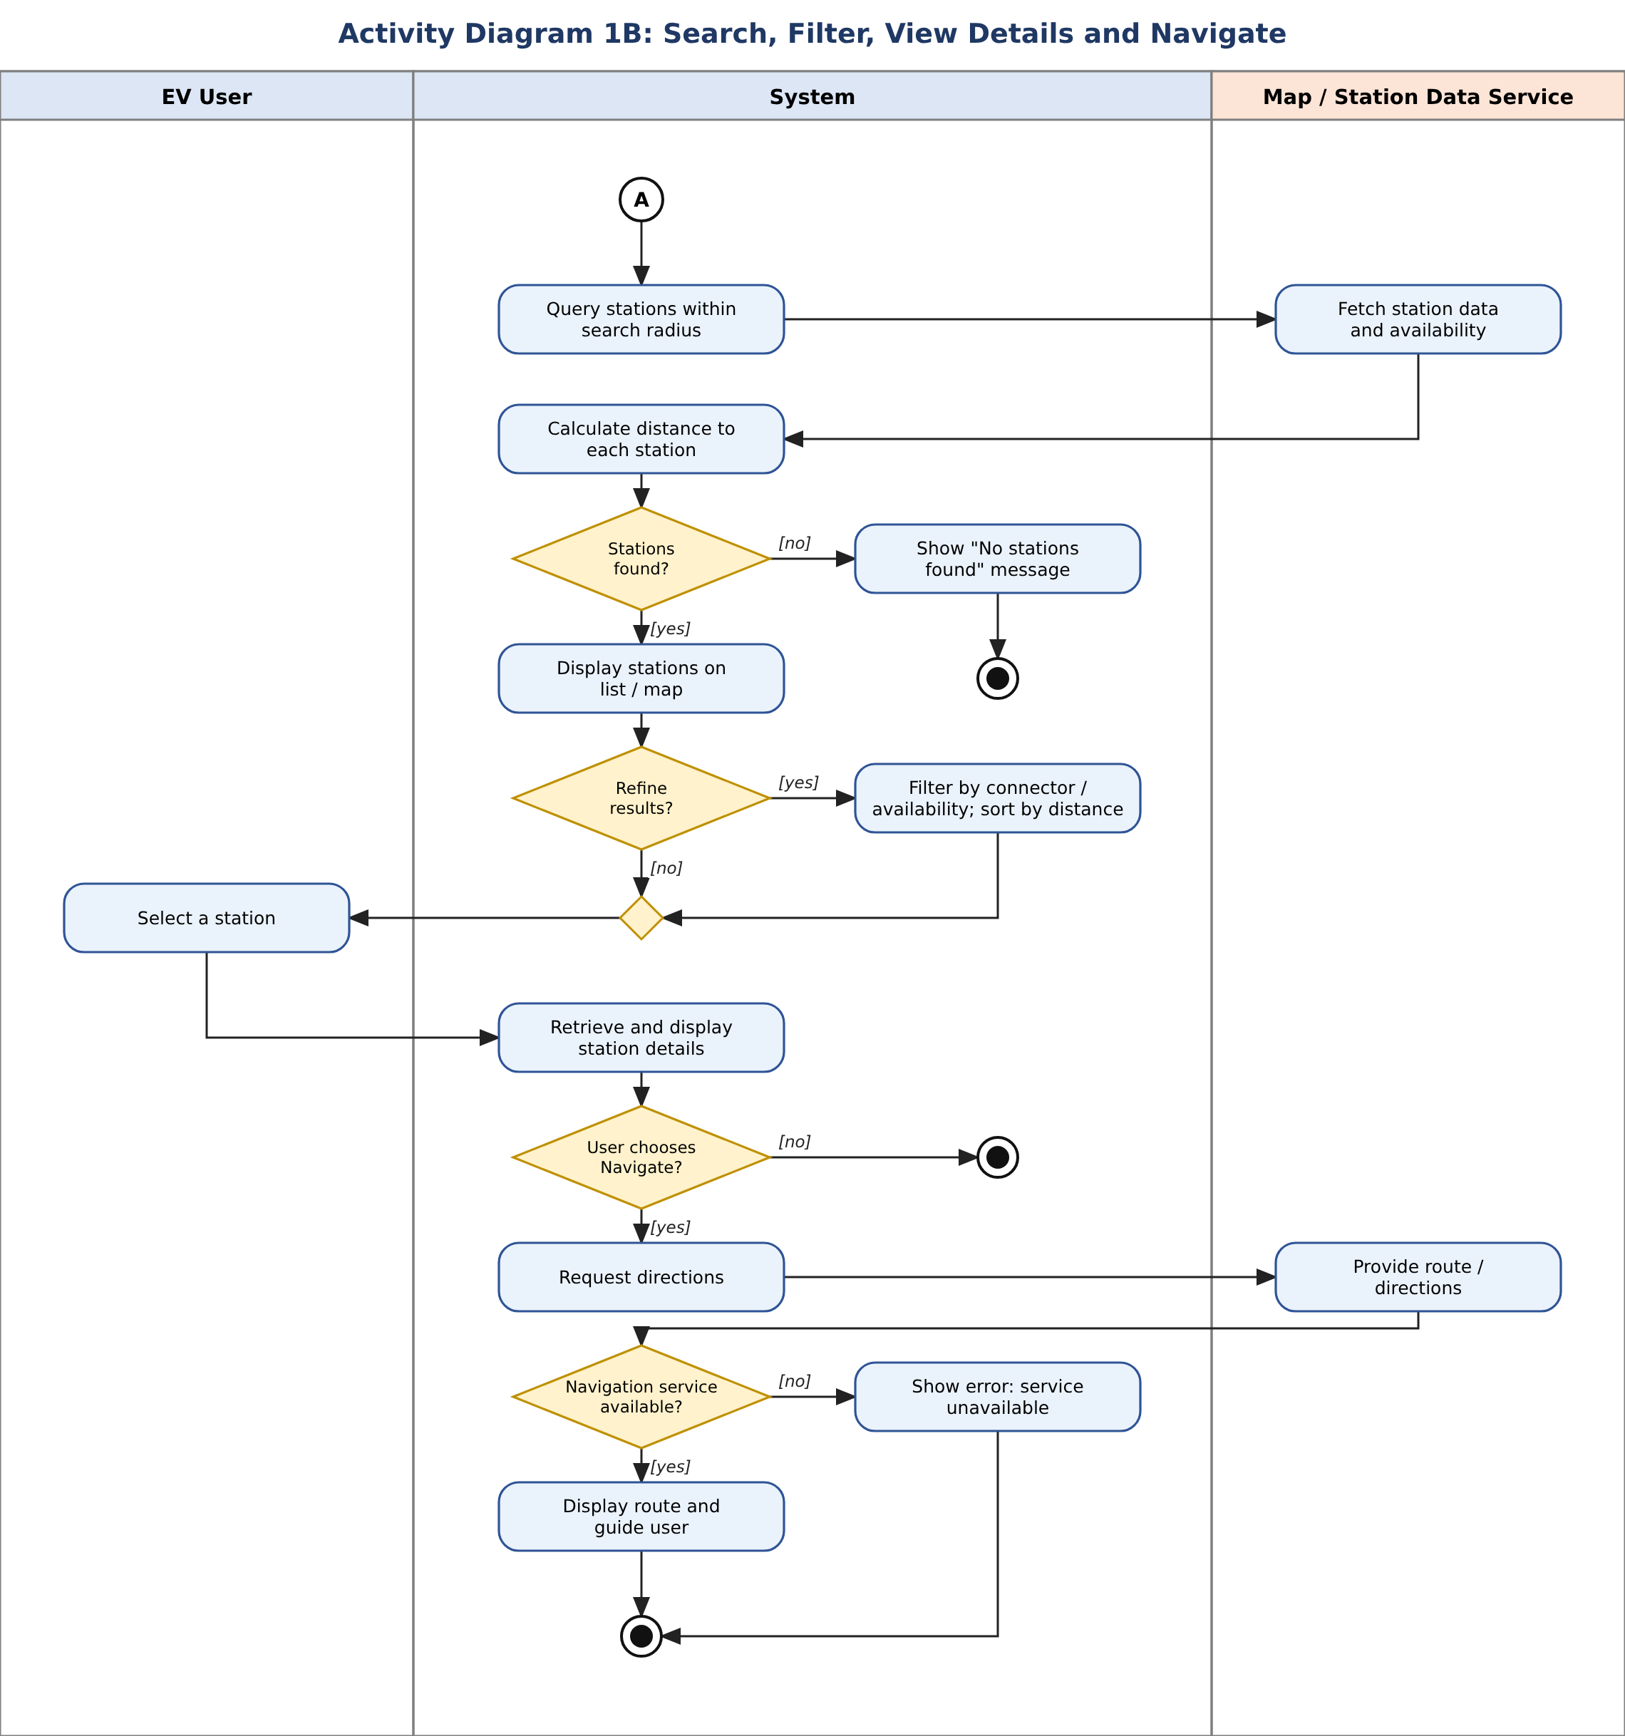
Figure 2: Activity diagram for search, filter, view details and navigation

7. Activity Diagram 2: Book Charging Slot and Make Payment
Flow description:
- The user selects a station and slot. The System checks availability. If the slot is not available, a message is shown and the flow ends.
- If the slot is available, the System creates a booking with status Pending and the user enters payment details.
- The System sends the payment request and the Payment Gateway authorizes and processes it.
- On success, the booking is confirmed, the slot is marked Reserved and a confirmation is sent to the user. On failure, the booking is cancelled, the slot is released and a failure message is shown.
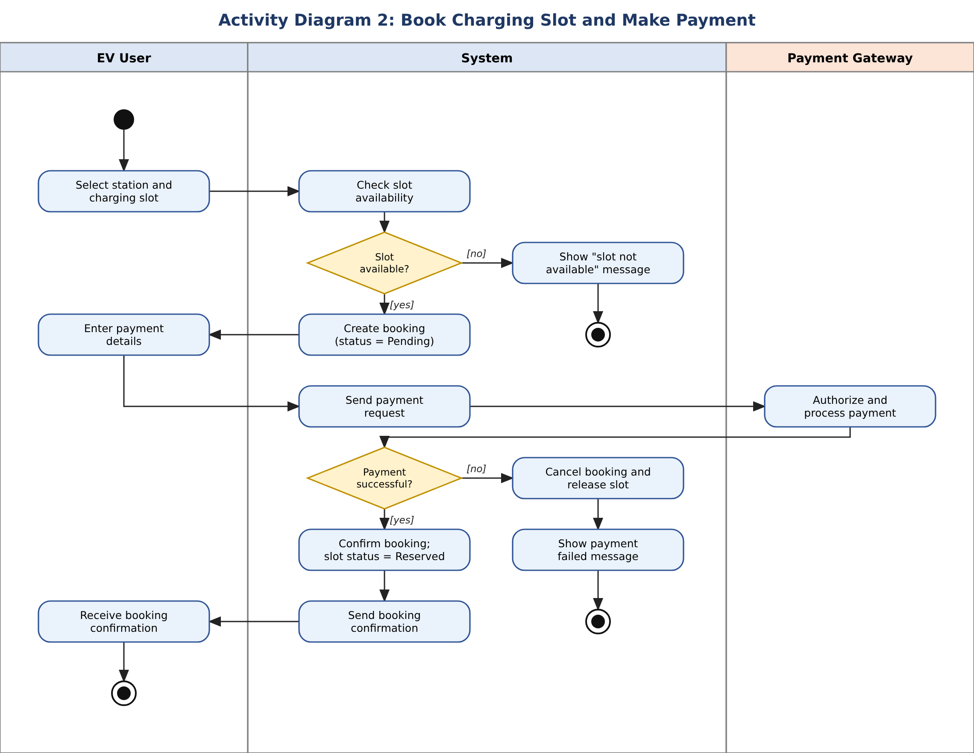
Figure 3: Activity diagram for slot booking and payment
Note: the SRS places real-time slot booking and payment outside the MVP (Sections 2.5 and 6). This diagram follows the Book Charging Slot and Make Payment use cases.

8. Activity Diagram 3: Admin Manages Charging Stations
Flow description:
- The Admin logs in and the System authenticates the credentials. If the Admin is not authorised, access is denied and the flow ends (SRS 5.3).
- The Admin chooses an operation. The System follows the matching branch: add / update station details (with validation), update user or booking records, or generate a station status report.
- The branches merge, the System updates the database and the Admin views the confirmation or report.
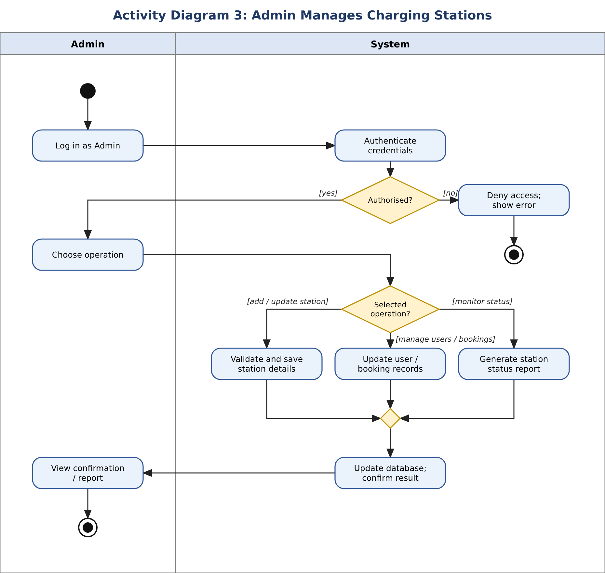
Figure 4: Activity diagram for admin operations

9. Conclusion
Four swimlane activity diagrams were drawn for the EV Charging Station Locator: login and location selection, search / filter / details / navigation, slot booking with payment, and admin station management. Each covers the main flow as well as alternate flows such as invalid login, denied location permission, no stations found, navigation failure, unavailable slot, payment failure and unauthorised access. Together they cover the functional requirements FR-1 to FR-14 and the use cases.

