Data Flow Diagrams: Level 0, Level 1 and Level 2
Case study: EV Charging Station Locator

1. Objective
To model how data moves through the EV Charging Station Locator: where it comes from, which processes transform it, where it is stored and where it goes. The DFDs are drawn at three levels (Level 0 context diagram, Level 1, Level 2) from the SRS (FR-1 to FR-14, Sections 3.3 and 6) and the use cases.

2. Notation Used (Gane and Sarson)
Symbol | Meaning
Orange rectangle | External entity: a source or destination of data outside the system (user, admin, external service)
Blue rounded rectangle with a number | Process: transforms incoming data into outgoing data (e.g. 3.0 Search & Filter Stations)
Yellow open-ended rectangle (D1, D2 …) | Data store: data held at rest (a database table)
Labelled arrow | Data flow: named data moving between the other symbols
* after a name | Duplicate of an entity or store, repeated only to avoid crossing lines
Rules followed: every flow has a name; every process has at least one input and one output; data never flows directly between two entities or two stores; and each lower level balances with its parent (same inputs and outputs).

3. External Entities
Entity | Role
EV User | Registers, logs in, provides a location, searches and filters stations, selects stations, navigates, books slots, pays, and rates stations.
Admin | Adds / updates stations, manages users and bookings, and monitors station status and reports.
Map / Geolocation Service | Returns the current coordinates and route data (SRS 3.3).
Charging Station Data Source | Supplies station listings and availability (SRS 3.3).
Payment Gateway | Authorizes and processes payments.

4. Data Stores
ID | Data store | Contents (matches the classes from the class diagram)
D1 | Users | userId, name, email, password hash, phone, role (User, EVUser, Admin)
D2 | Stations | Station details, location, slots and connectors (ChargingStation, Location, ChargingSlot, Connector)
D3 | Availability | Availability records and slot status (AvailabilityRecord, ChargingSlot.status)
D4 | Bookings | Booking records and status (Booking)
D5 | Payments | Payment records and transaction reference (Payment)
D6 | Reviews | Ratings and comments (Review)
D7 | Search History | Past searches of each user (SearchHistory)

5. Processes at Level 1
No. | Process | Related use case / requirement | Main data stores
1.0 | Manage User Account | Register / Login | D1
2.0 | Determine Location | Get Current Location; FR-1, FR-2, FR-3 | —
3.0 | Search & Filter Stations | Search Charging Station, Find Nearest, Check Availability; FR-4 to FR-9 | D2, D3, D7
4.0 | View Station Details | View Station Details; FR-10 to FR-12 | D2, D3, D6
5.0 | Provide Navigation | Get Navigation / Directions; FR-13, FR-14 | D2
6.0 | Book Slot & Process Payment | Book Charging Slot, Make Payment | D3, D4, D5
7.0 | Manage Ratings & Reviews | Rate / Review Station | D6
8.0 | Manage Stations, Users & Bookings | Add / Update Charging Station, Manage Users, Manage Bookings | D1, D2, D3, D4
9.0 | Monitor Status & Reports | Monitor Station Status / Reports | D2, D3, D4

6. Level 0 DFD (Context Diagram)
The whole system is shown as a single process (0) with the five external entities and the data flowing between them.
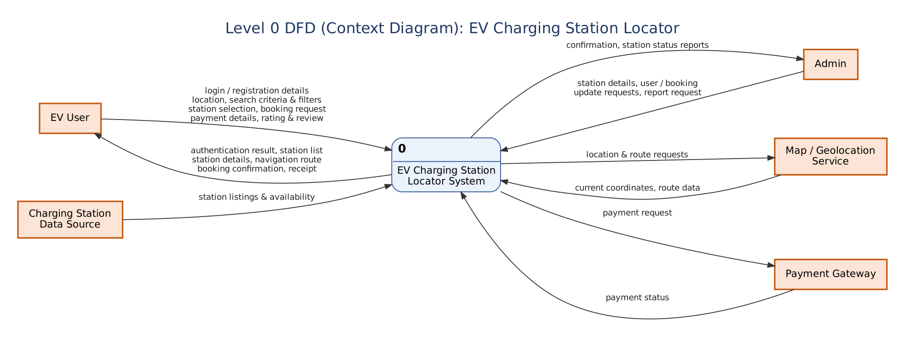
Figure 1: Level 0 DFD of the EV Charging Station Locator

7. Level 1 DFD
The system is decomposed into nine processes, drawn in three parts for readability. Processes 2.0 and 3.0 are linked by the “valid location” flow; stores marked * are repeated copies.
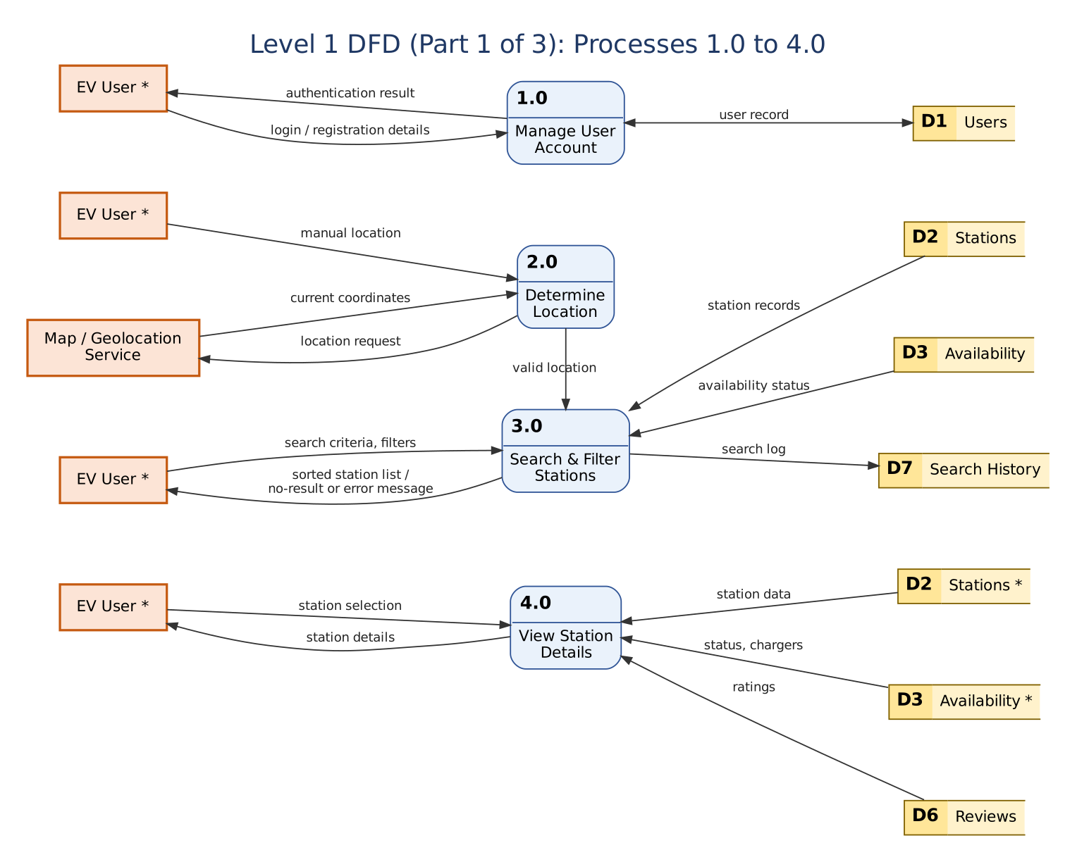
Figure 2: Level 1 DFD, Part 1 (processes 1.0 to 4.0)
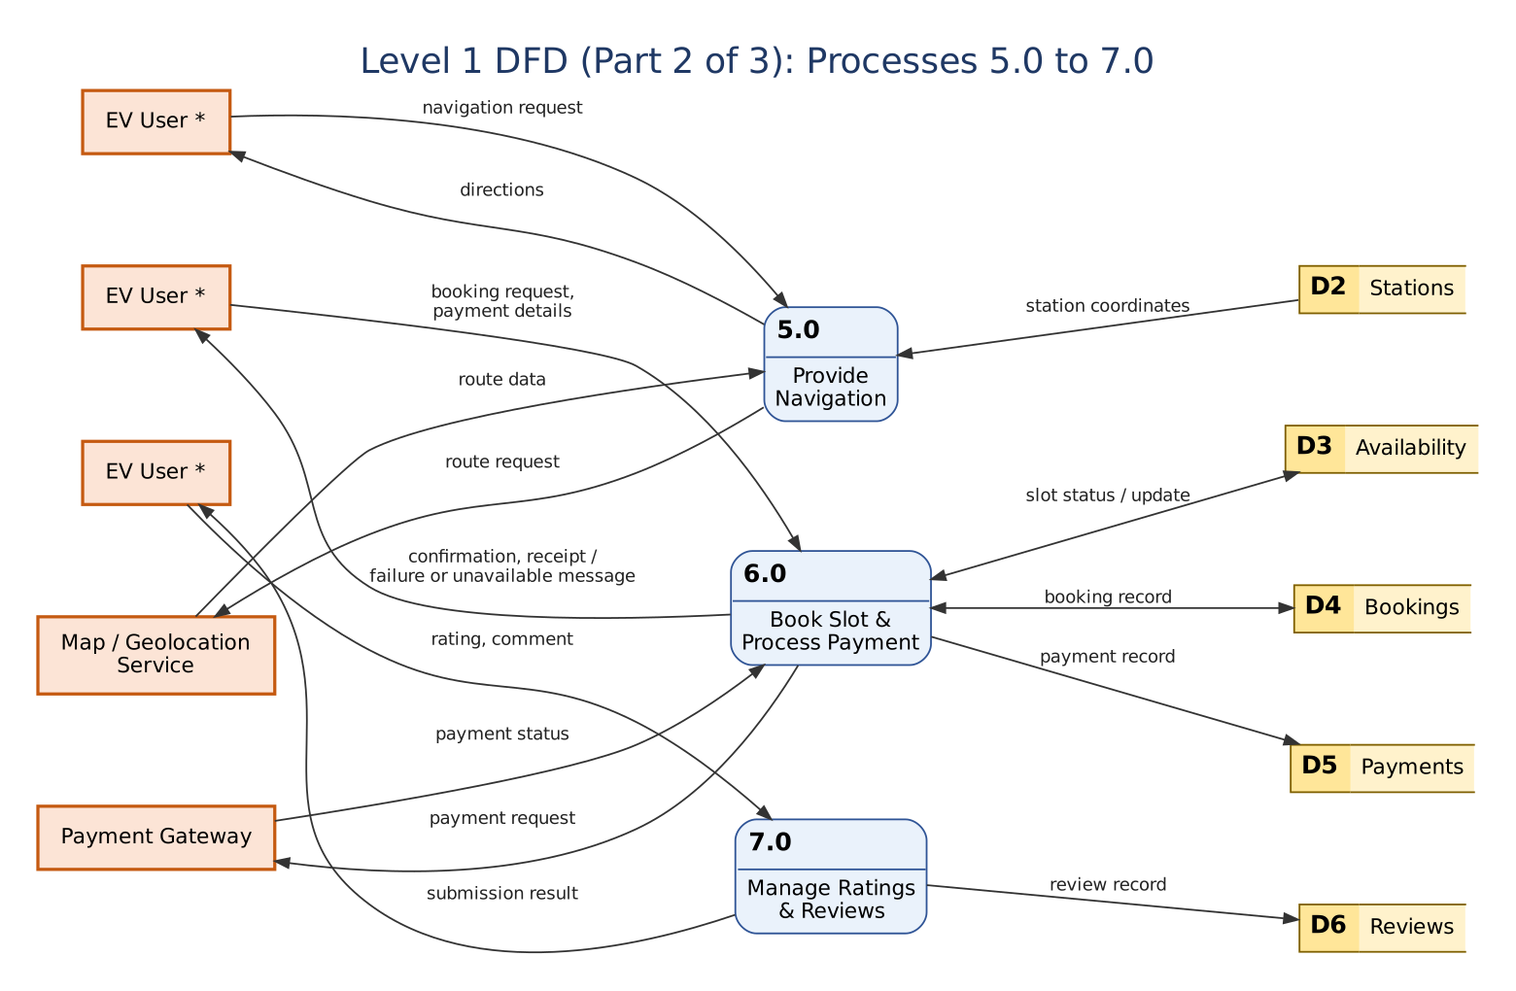
Figure 3: Level 1 DFD, Part 2 (processes 5.0 to 7.0)
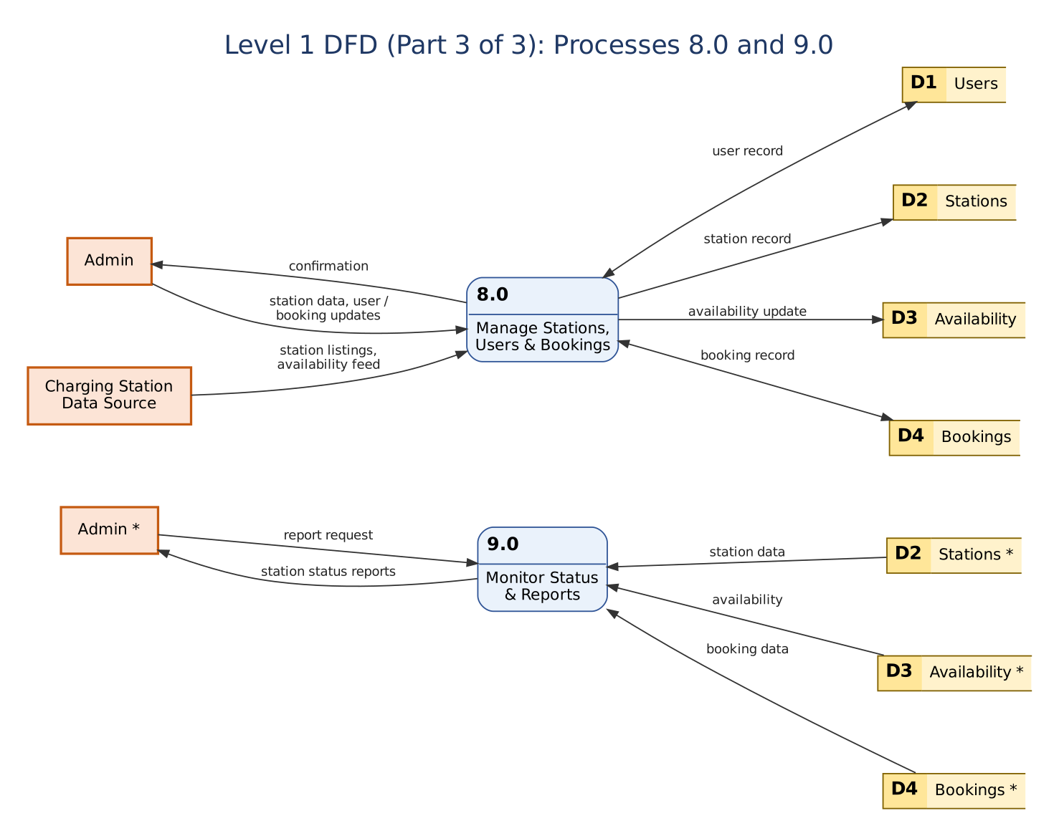
Figure 4: Level 1 DFD, Part 3 (processes 8.0 and 9.0)

8. Level 2 DFDs
The two processes with the most internal logic are expanded further.
Process 3.0 Search & Filter Stations is divided into validating the search input (3.1), retrieving the stations within the radius (3.2), calculating distance (3.3), applying filters (3.4) and sorting and displaying the results (3.5).
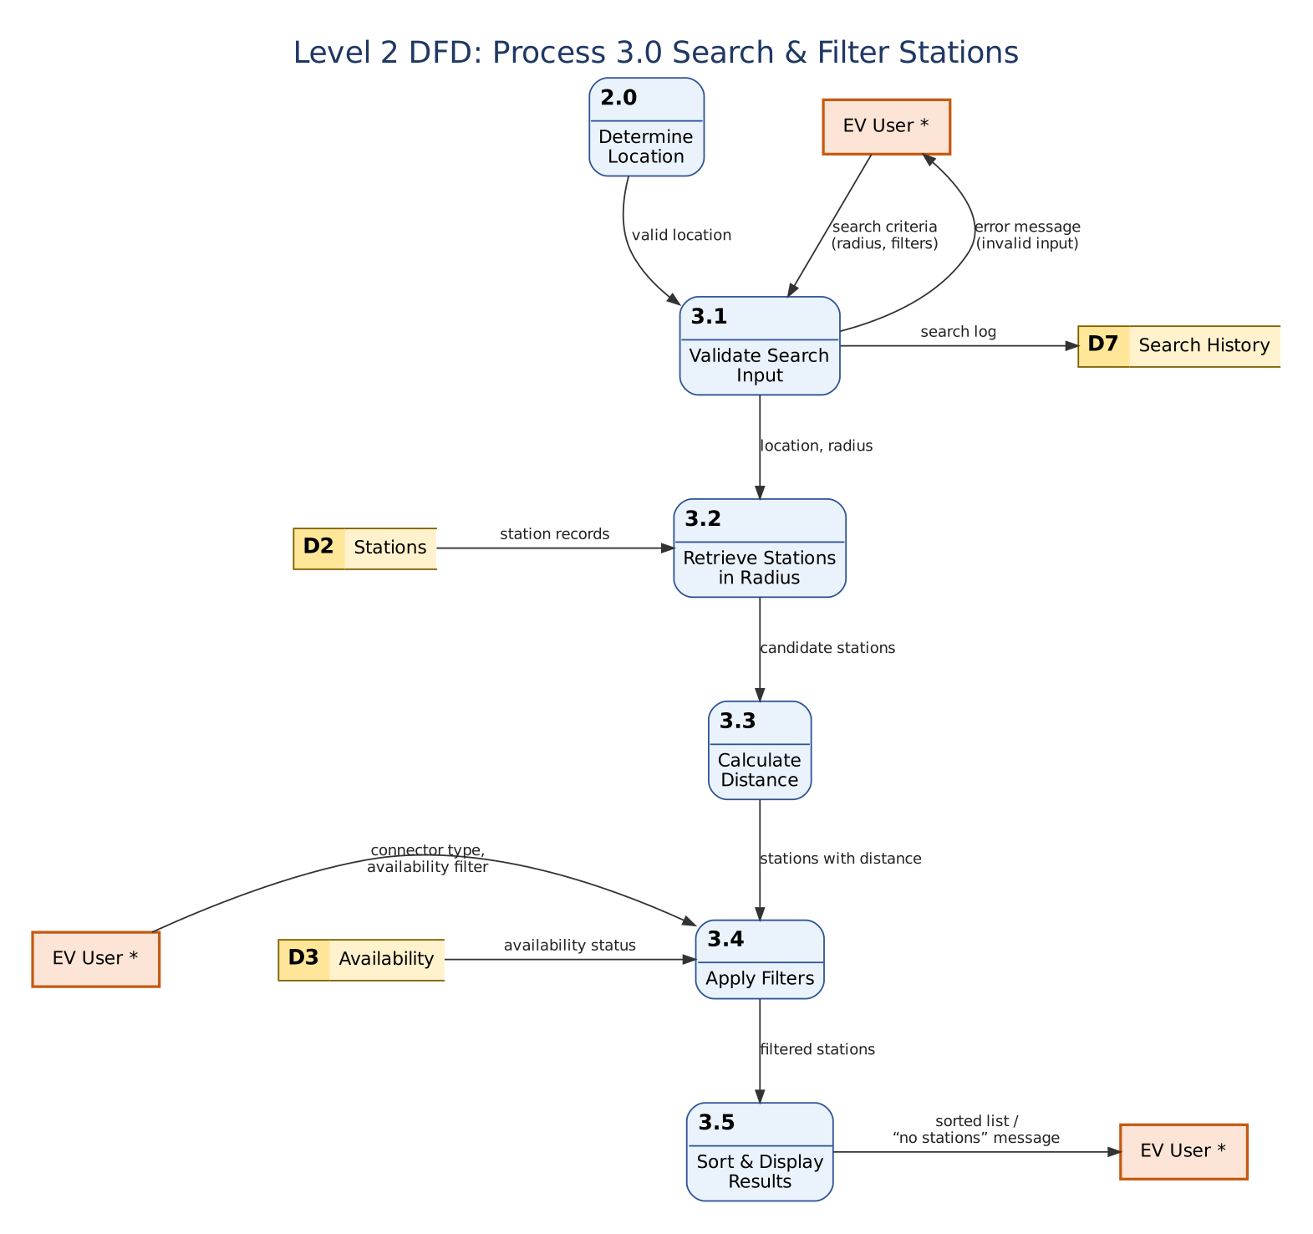
Figure 5: Level 2 DFD of process 3.0
Process 6.0 Book Slot & Process Payment is divided into checking slot availability (6.1), creating a booking (6.2), processing the payment (6.3) and confirming or cancelling the booking (6.4).
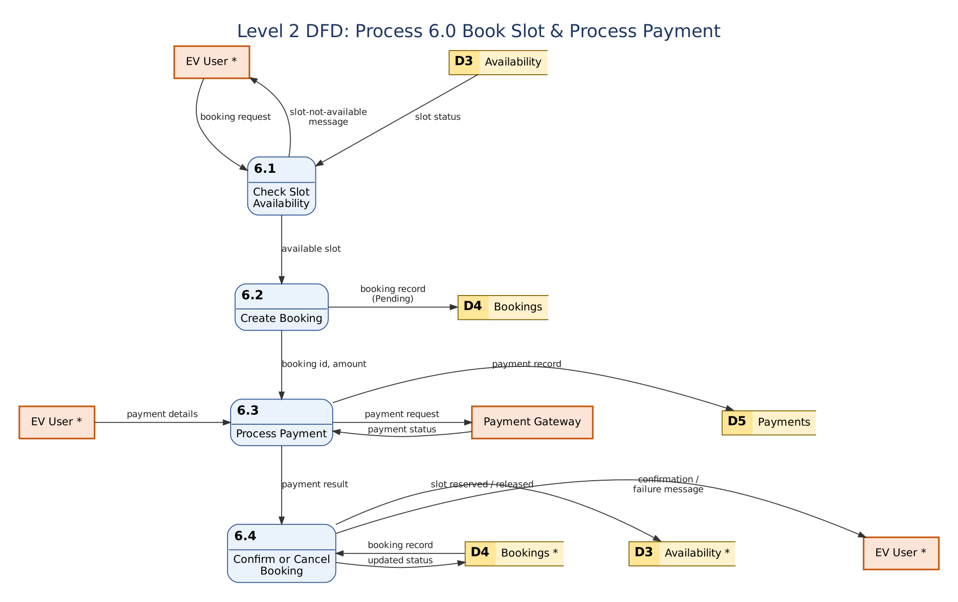
Figure 6: Level 2 DFD of process 6.0
Note: the SRS places real-time slot booking and payment outside the MVP (Sections 2.5 and 6). Process 6.0, Level 2 of 6.0 and the stores D4 and D5 follow the use cases.

9. Balancing Check
- Level 0 to Level 1: every flow on the context diagram (login details, location, search criteria, selections, payment details, station listings, route data, payment status and the outputs back to each entity) appears on a Level 1 process, with no new external flow added.
- Level 1 to Level 2 of 3.0: inputs are the valid location from 2.0, the search criteria and filters from the user, and reads of D2 and D3. Outputs are the sorted list or no-result / error message and the search log to D7. These are the same as for process 3.0 at Level 1.
- Level 1 to Level 2 of 6.0: inputs are the booking request and payment details from the user and the payment status from the gateway. Outputs are the confirmation or failure message, the payment request, and updates of D3, D4 and D5. These are the same as for process 6.0 at Level 1.

10. Conclusion
The EV Charging Station Locator was modelled with a Level 0 context diagram, a Level 1 DFD of nine processes and seven data stores, and Level 2 DFDs of the search and the booking-payment processes. The data stores map to the classes of the class diagram, and the processes map to the use cases and the requirements FR-1 to FR-14 of the SRS.

