Class Diagram: identified classes, strong and weak classes, and class diagram
Case study: EV Charging Station Locator

1. Objective
To identify the classes of the EV Charging Station Locator from the SRS (v1.0) and the use case diagram, classify each as a strong or weak class, and represent them with their attributes, operations and relationships in a UML class diagram.

2. Approach: Identifying the Classes
Noun analysis (grammatical parsing) was applied to the SRS functional requirements FR-1 to FR-14, the user classes (Section 2.3), the software interfaces (Section 3.3), the database requirement (Section 6) and the use cases. Each candidate noun was accepted as a class, or rejected as an attribute, operation or implementation detail.
Candidate noun | Decision | Reason
EV User, Admin, User | Accepted | Actors/roles with data and behaviour → User, EVUser, Admin
Charging Station | Accepted | Core entity of the system
Location (current / selected) | Accepted | Has latitude, longitude, address
Connector (type), Charger / Slot | Accepted | SRS Section 6 lists connectors; FR-11 “number of chargers”
Availability / Status | Accepted | SRS Section 6 lists availability records (FR-8, FR-12)
Booking, Payment, Review | Accepted | Appear in the use case diagram (the use case diagram)
Search, Filter, Sort | Accepted (as service) | Behaviour, grouped in the SearchService control class
Map / Geolocation Service | Accepted | External actor in SRS 3.3 and use case diagram
Payment Gateway | Accepted | External actor in use case diagram
Search Radius, Distance | Rejected as class | Attributes / operations (radiusKm, calculateDistance)
Connector Type, Charging Speed | Rejected as class | Simple attributes / enumerations
Navigation, Directions | Rejected as class | Operation of MapService (getDirections)
Database, REST API, Browser, App | Rejected | Implementation / technology, not problem-domain classes
Report | Rejected | Generated output of monitorStatus(); not persistent

3. Strong and Weak Classes
Strong class: an independent class that has its own identity (a primary key such as stationId) and can exist on its own.
Weak class: a class that cannot be identified or exist without an owner (strong) class. It has only a partial key, which together with the owner’s key identifies it. It is shown with a composition relationship (filled diamond ◆) to its owner, and its life cycle ends with the owner’s.
In the diagram, strong classes are blue and weak classes are orange with a thicker border.

3.1 Classification of Identified Classes
# | Class | Type | Justification / source
1 | User (abstract) | Strong | Own key userId; registered account (FR: Register/Login use case, SRS 5.3)
2 | EVUser | Strong | Specialisation of User; actor who searches, navigates, books, reviews
3 | Admin | Strong | Specialisation of User; station operator/admin (SRS 2.3)
4 | ChargingStation | Strong | Own key stationId; central entity (FR-4 to FR-12)
5 | Booking | Strong | Own key bookingId; “Book Charging Slot” use case
6 | Payment | Strong | Own key paymentId; “Make Payment” use case
7 | Review | Strong | Own key reviewId; “Rate / Review Station” use case
8 | SearchService | Strong | Control class that runs search, filter and sort (FR-4 to FR-9)
9 | MapService | Strong | External service actor: location, map and directions (SRS 3.3, FR-13)
10 | PaymentGateway | Strong | External actor shown in the use case diagram
11 | Location | Weak | No identity of its own; latitude/longitude only meaningful for a station (FR-10)
12 | ChargingSlot | Weak | Identified by (stationId + slotNo); a charger point inside a station (FR-11)
13 | Connector | Weak | Identified by (stationId + slotNo + connectorNo); plug type of a slot (FR-7, FR-11)
14 | AvailabilityRecord | Weak | Identified by (stationId + recordTime); status snapshot of a station (FR-8, FR-12)
15 | SearchHistory | Weak | Identified by (userId + searchNo); log of a user’s searches
Total: 15 classes (10 strong, 5 weak).

4. Attributes and Operations of Each Class
Class | Attributes | Operations
User | userId, name, email, passwordHash, phone | register(), login(), logout()
EVUser | vehicleModel, preferredConnector | searchStation(), findNearest(), viewStationDetails(), getNavigation(), bookSlot(), rateStation()
Admin | adminLevel | addStation(), updateStation(), manageUsers(), manageBookings(), monitorStatus()
ChargingStation | stationId, name, address, operatingHours, status, avgRating | getDetails(), updateStatus(), calculateDistance(loc), checkAvailability()
Booking | bookingId, startTime, endTime, status | createBooking(), confirm(), cancel()
Payment | paymentId, amount, method, status, transactionRef | makePayment(), refund()
Review | reviewId, rating, comment, reviewDate | submit(), edit(), delete()
SearchService | — (stateless) | searchStations(loc, radius, filter), findNearest(loc), applyFilter(filter), sortByDistance()
MapService | providerName | getCurrentLocation(), getDirections(from, to), renderMap()
PaymentGateway | gatewayName | authorize(amount), capture(), refund(txnRef)
Location (weak) | latitude, longitude, city, pincode | distanceTo(loc)
ChargingSlot (weak) | slotNo (partial key), status, powerKW, chargingSpeed | isAvailable(), reserve(), release()
Connector (weak) | connectorNo (partial key), connectorType | isCompatible(vehicle)
AvailabilityRecord (weak) | recordTime (partial key), availableChargers, status | getLatest()
SearchHistory (weak) | searchNo (partial key), searchTime, radiusKm, filters, resultCount | save(), clear()

5. Relationships Between Classes
Classes | Relationship | Multiplicity | Meaning
User → EVUser, Admin | Generalization (inheritance) | — | EVUser and Admin “is-a” User
EVUser – Booking | Association “makes” | 1 : 0..* | A user can make many bookings
EVUser – Review | Association “writes” | 1 : 0..* | A user can write many reviews
EVUser ◆ SearchHistory | Composition “keeps” | 1 : 0..* | History is deleted with the user
Admin – ChargingStation | Association “manages” | 1..* : 0..* | Admin adds / updates / monitors stations
ChargingStation – Review | Association “receives” | 1 : 0..* | Reviews are about one station
ChargingStation ◆ Location | Composition “located at” | 1 : 1 | Location cannot exist without station
ChargingStation ◆ ChargingSlot | Composition “has” | 1 : 1..* | A station has one or more chargers
ChargingStation ◆ AvailabilityRecord | Composition “logs” | 1 : 0..* | Availability history of the station
ChargingSlot ◆ Connector | Composition “has” | 1 : 1..* | Each charger has one or more connectors
Booking – ChargingSlot | Association “reserves” | 0..* : 1 | A booking reserves one slot
Booking – Payment | Association “paid by” | 1 : 0..1 | A booking may have one payment
Payment ⇢ PaymentGateway | Dependency «uses» | — | Gateway processes the payment
EVUser ⇢ SearchService | Dependency «uses» | — | User triggers search / filter
SearchService ⇢ ChargingStation | Dependency «queries» | — | Finds stations in radius
SearchService ⇢ MapService | Dependency «uses» | — | Gets current location and distance

6. Class Diagram
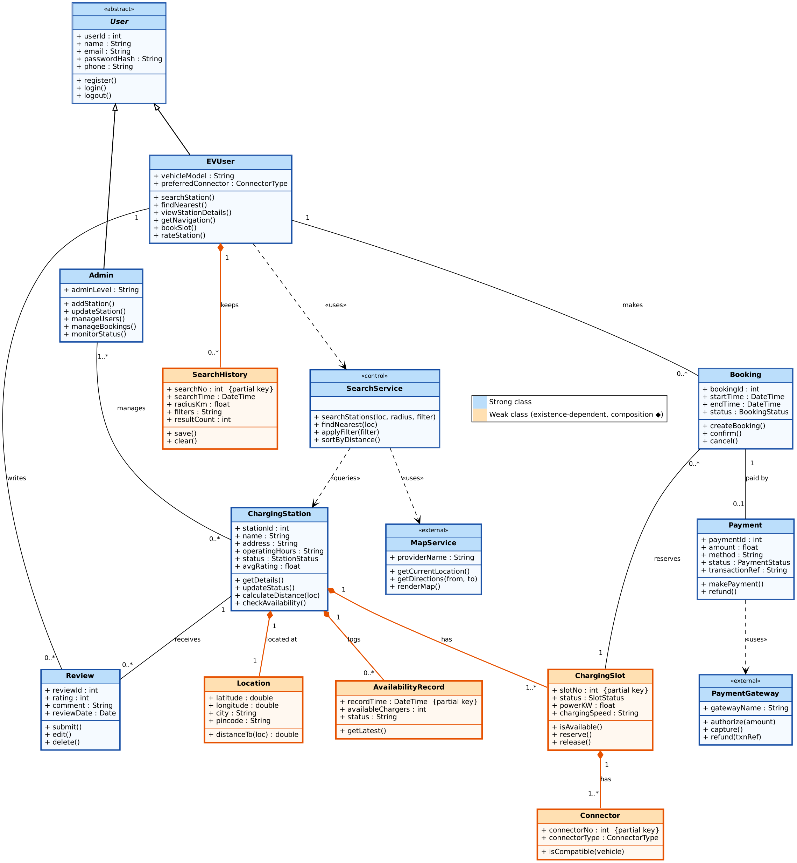
Figure: Class diagram of the EV Charging Station Locator (strong classes in blue, weak classes in orange).

7. Notes
- Booking, Payment, Review and PaymentGateway come from the use case diagram. The SRS treats real-time slot booking and payment as outside the MVP (Sections 2.5 and 6), so these four classes can be treated as extensions beyond the MVP.
- User is abstract. EVUser and Admin inherit its login and profile data, which matches the Register / Login use case shared by both.
- ChargingStation, Location, ChargingSlot, Connector and AvailabilityRecord together form the station data stored in the database (SRS Section 6).

8. Conclusion
Fifteen classes were identified from the SRS and use cases: ten strong classes (User, EVUser, Admin, ChargingStation, Booking, Payment, Review, SearchService, MapService, PaymentGateway) and five weak classes (Location, ChargingSlot, Connector, AvailabilityRecord, SearchHistory). The class diagram shows their attributes, operations, generalization, composition, association and dependency relationships with multiplicities, and forms the basis for the later design and sequence diagrams.

