NAME: AYUSH SINGH
CLASS: CSE-5B
ROLL: 202401100200111

Screenshot showing the GitHub Actions workflows
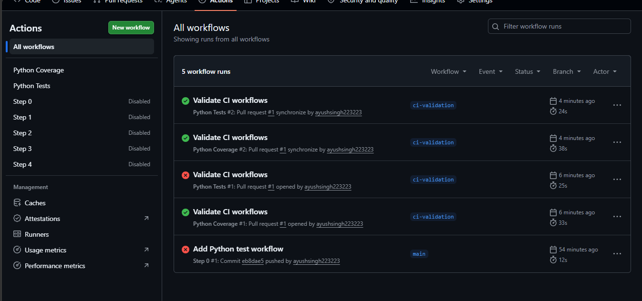

Screenshot showing a successful test workflow execution
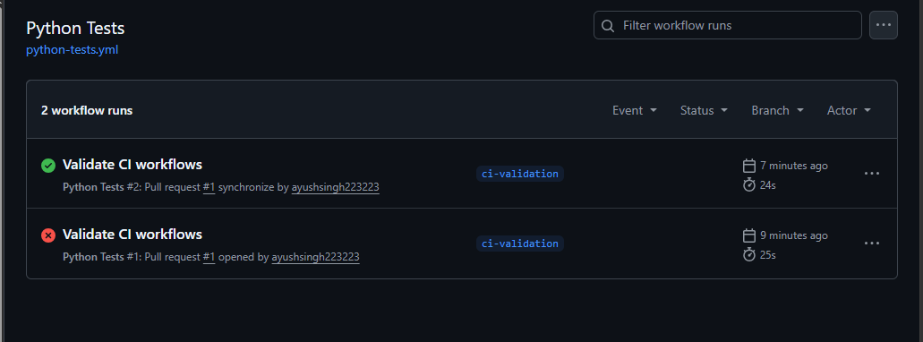

Screenshot showing the coverage result/comment on the pull request
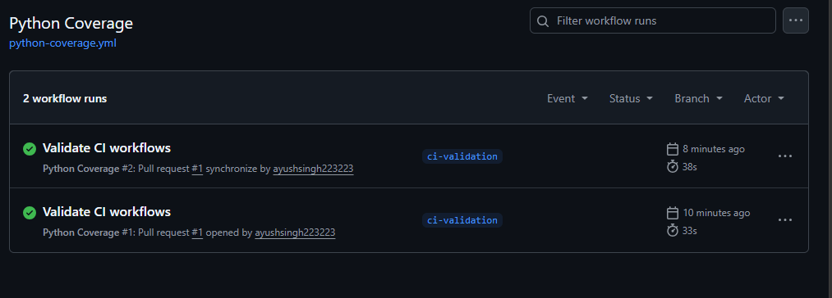

Screenshot showing the final repository/workflow files
