Curriculum Vitae

N. BALASUBRAMANIAN

No: L-137,

E-mail: nbalusubramanian@yahoo.com New ASTC Hudco,

Mobile: +91-9994631910, 9566667207 Hosur-635109,Tamil Nadu-India.

Objective:

Seeking a challenging position in an organization where my skills and knowledge can be best utilized in successful completion of the assignments and be responsible to provide the team leadership and creativity.

Experience:

Organization : GRS Engineering Pvt Ltd, Mysore
Period : July 2016 to Till Date
Department : Production
Designation : Manager

Organization : M/s. EL Forge Ltd, Chennai (IS-TS 16949)
Period : June 2015 to June 2016.
Department : Production
Designation : Manager

Organization : M/s. EL Forge Ltd, Hosur & Chennai (IS-TS 16949)
Period : 13 Years (1999 to May 2014)
Department : Production
Designation : Manager

Organization : M/s. Ram Krishna Forgings Ltd, Jamshedpur.
Period : 1 Year (1998 to 1999)
Department : Production
Designation : Supervisor.

Organization : M/s. MM Forgings Ltd, Tirchy.
Period : 8 Years (1990 to 1998)
Department : Production
Designation : Technical Assistant.

Responsibilities:

- Work Experience in Drop Hammers, Power Hammers, and Press Forgings and Up setters.

- Extensive experience directing Production, Quality, Safety and Cost Control for production area.

- Proven ability to design and enhance processes in support of continuous improvement programs.

- Deployed spot audits and root-cause analysis including remedial actions.

- Excellent interpersonal skills, recognized for seamlessly working with Cross functionality teams to identify and resolve quality and process issues.

- Expertise in production includes inventory management, safety, quality improvement, operations, scheduling and preventative maintenance.

- Demonstrated track record in training, mentoring and motivating teams to improve overall productivity and performance.

- Documented work procedures and processes for staff resources.

- Understanding of IS-TS 16949 requirements and certifications. Conduct ISO – TS 16949 System Internal auditing.

- Achieving the productivity as per planned.

Educational Qualification:

Diploma in Mechanical Engineering with aggregated 79% in the year of April 1989, from Government Polytechnic College, Trichy, Tamil Nadu.

SSLC in the year of April 1986 from Tamil Nadu State Board, Government High School, Tiruvallarai, Tamil Nadu, with 81%.

Areas of Interest:

Forging Industries
Manufacturing Industries

Personal Skills:

- Communication - Deals with internal peoples at all levels via telephone and email, to ensure successful communication via actively listening and probing questions.

- Problem solving - Resolves in-depth queries in a methodical manner independently to find appropriate resolutions, efficiencies and high level of quality.

- Team Player - Enjoys sharing knowledge and encouraging development of others to achieve specific team goals.

- Planning and organizing - Refined planning and organizational skills that balance work, team support and ad-hoc responsibilities in a timely and professional manner.

- Systems knowledge – Microsoft Office. Experience in preparing and analyzing reporting data for management accurately and to timescales.

Personal Details:

Date of Birth : 20th May. 1971.
Father’s Name : Mr. P. Natesan
Nationality : Indian.
Marital status : Married.
Language known : English, Tamil.
Permanent Address : 4/5A South Street,
Kalavaipatty, Tiruvallarai PO
Mannachanallur TK, Trichy Dist.

Declaration:

I hereby declare that the information furnished above is true to the best of my knowledge.
Place: 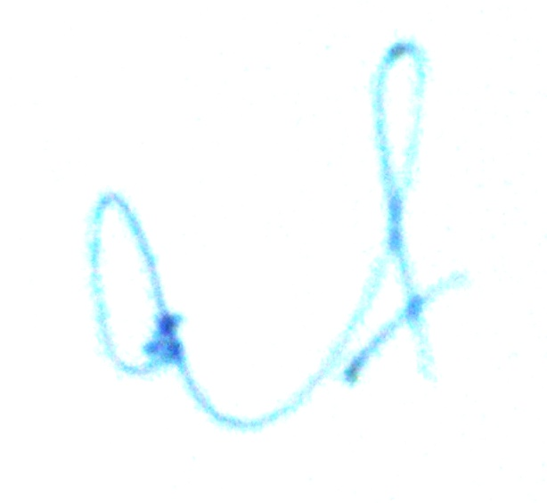
Date : (BALASUBRAMANIAN. N)

