CURRICULUM VITAE

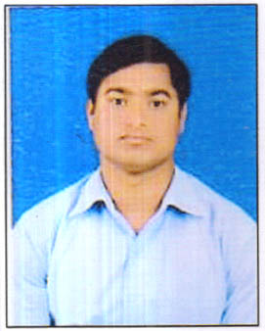
JOB PROFILE: - ……………

NAME: MD ATHAR AHMAD
VILL- BAHPURA
POST –BAHPURA
PATNA, BIHAR, PIN-801103
CONTRACT NO:-8789173780
EMAIL:-Athar786ahmad@gmail.com

Career Objective:-
To serve an educational institution with scientific determination and hard work by making full use my knowledge skill, ground in the idea that life should be viewed as a call to serve other.

Technical Qualification:-
- M.TECH in Production and Maintains from continental group of Institute, Punjab.
- B.TECH in mechanical Engineering from Netaji Subhas Institute of technology Bihta, Patna.

Educational Qualification:-
- Intermediate Examination from Bihar intermediate education council in 2010.
- Secondary School Examination from Bihar State Examination Board (BSEB ) in 2008.

Achievement:-
Two weeks practical training in Bokaro steel plant, Bokaro.

Professional Experience :-
- Four years work experience in Tata Motors ltd An authorized service centre in bihta and knowledge is CRM/DMS software and warranty knowledge because knowledge is commercial vehicle and PDI(pre delivery inspection and handle the team work and progress the company and dated is 15/09/2014 to 25/10/2018.
- Current work in service advisor in Rajeev tradecomm gopalganj an authorized service station Tata motors ltd and knowledge for the TDS(Tata digonastices system) and (INSITE) for the Cummins Engine and then after knowledge for the warranty system commercial vehicle and warranty for the vehicle parts then after the team work and dated is 05/11/2018

EXTRA knowledge:-
1st (PDI) & 2nd PDI
CRO
Service Advisor
TDS & INSITE
CRM/DMS system
Warranty work
Knowledge of computer
Knowledge of excel and ms word
Knowledge of power point

HOBBIES/INTRESTS: -
Traveling
Reading book on great personalities, national issue.
Surfing the football
Playing football and cricket etc.
Personal Summary:

Father’s; SARFRAZ AHMAD
Date of Birth 14/02/1993
Gender MALE
Marriage Status UNMARRIED
Nationality INDIAN
Languages Known ENGLISH HINDI AND URDU
Hobbies PLAYING FOOTBALL

Permanent address:
VILL -BAHPURA
POST -BAHPURA
PATNA-BIHAR
PIN-801103
Contract No:-8789173780

UNDERTAKING:-

I hereby declare that the information provided above is true to the best of my knowledge and belief.

Date……
Place………….. Md Athar Ahmad

