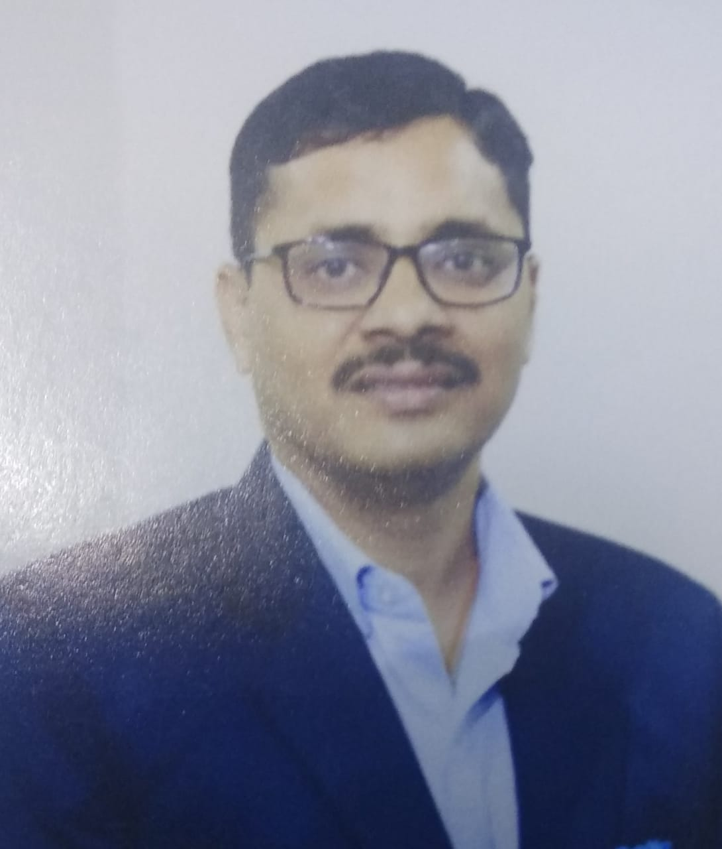

RAMA SHANKAR GUPTA
(B.Tech. – Agricultural Engg.)
B 208, Manglam Niket
Shastripuram, Agra-282007
Mob.No. - 9936038880
E Mail – gupta_ramas@rediffmail.com

Application Manager – (Agra – UP) with 18 years of qualitative experience in Sales & Marketing, Business Development, Channel Management, and Team Management.

CORE COMPETENCIES

- Developing and implementing procedures for maintaining sales through existing Dealers.
- Develop and appoint New Business Partner to enhance the sale.
- Analyzing market trends, tracking competitor activities, and providing valuable inputs for marketing strategy.
- Close interaction with Dealers to assist them to promote the product in remote markets.
- Monitoring Channel Sales and marketing activities; implementing an effective strategy to maximize sales and collections.
- Assisting channel partners.
- Recruiting, training, and monitoring the sales performance of team members to achieve set Tgt.
- Conducting meetings with Dealers, Dealer manpower, and subordinates for smooth functioning and operations.

PROFESSIONAL EXPERIENCE AND ACHIEVEMENT

INTERNATIONAL TRACTORS LTD. Mar’20-April’22.
(Application Manager – Solis-Yanmar)

- Area of Concentration: Western UP (Potato region).

- Key Responsibility: Execute the strategy and plan to meet sales target, evaluate market trends, set and distribute the target among channel partners, Increase coverage by appointment of channel partner in the vacant area, Plan and review promotion activity i.e. ensure sufficient HP generated through Field Activity, Monitor overall team ‘KRA’, weekly monitor Fund preservation of channel partner.
- Key Achievements: -

- Appointed 6 channel partners in the last 9 months.
- Achieve 80% of set targets in a given region.
- Fund Induction of Rs 130 Lakh (40 Lac Etawah, 60 Lac Mainpuri, 30 Lac Auriya) in form of CC and BG.

TRACTOR AND FARM EQUIPMENT LTD Oct’11-Mar’20
(Assistant Area Manager–Sales)

- Area of Concentration: Gorakhpur, Gonda, Balrampur, Shrawasti, Basti, Sant Kabir Nagar, Gorakhpur, Sidharth Nagar, Maharaj Ganj, Deoria, Padrona, Agra, Mathura, Hathras, Etawah, and Auriya.

- Key Responsibility: To achieve desired M.S. – Billing forecasting. Designing promo and scheme for dealer and dealer staff, analyzing the R.T.O. data to find out the weeks pockets of the territory and develop a strategy for that area, finance management and funds monitoring of dealer, development of infrastructure at the dealership.

- Key Achievements: -
- Got 1st Position in Massey Ka Viru Season Scheme (Heavyweight Category) at All India Level in current F.Y. (2019-20).
- Appointed 4 channel partners in Basti, Siddharth Nagar, Khalilabad, and Maharaj Ganj regions.
- Regain M.S. at Agra Dealership (By 90% growth in volume at Agra Dealership).
- Double the volume in Mathura district in F.Y.-2018-19.
- Appointed Etawah (Potato), Hata, Khalilabad, and Basti Dealer (Gorakhpur region) to improve coverage.
- Fund Induction of Rs 212 Lakh (80 Lac Agra, 42 Lac F. Sikri, 42 Lac Kirawali, and 50 Lac Mathura) in form of BG.

TRACTOR AND FARM EQUIPMENT LTD June’09-Oct’11
(Territory Manager–Sales)

- Area of Concentration: Lucknow, Kanpur, Barabanki, Unnao, Rai Bareily, Sultanpur, Amethi, Bahraich, Banda, Gonda, Balrampur, Shrawasti.

- Key Responsibility: Planning monthly sales Targets and promotion activities (Field Activity) through the existing channel network and developing various distribution points for proper area coverage. Fund preservation of each dealer.
- Key Achievements: -

- Gain in Market Share by 5% in Unnao, Barabanki, Bahraich, and Kushi Nagar districts.
- Awarded 2 times best TM (2010-11 & 2011-12) in the Lucknow region.
- Appointment of Dealer at Barabanki, Bilgram, and Ghatampur in project Operation Search.

ESCORTS LTD. Feb’08 – June’09
(Territory Business Manager – Sales)

- Area of Concentration: Jabalpur, Satna, Rewa, Sidhi.

- Key Responsibility: Achieve business parameters (BDRC) through sales team and dealer network, HP follow-up daily, Conduct Sales promotion activities (Customer Meet, Demonstration, Roadshow, & organization of Service camps, Mechanic Meet, etc.).
- Key Achievements: -

- Gain a Market Share by 4% in Satna & Rewa districts.
- Reduction in O/S by Rs.50 Lac from Sidhi Dealer.

INTERNATIONAL TRACTORS LTD. Jan’06-Jan’08.
(Assistant Manager – Sales)

- Area of Concentration: Muzaffar Nagar, Baghpat, Aligarh.

- Key Responsibility: Achievement of sales target through the sales team and dealer network. Sales promotion activities (conduction of Demonstration, Roadshow, & organization of Service camps, etc.), Induction of funds through CFL Sales team motivation, worked on area restructuring and dealer development.

- Key Achievements: -

- Provided a growth of 37% over last year’s sales in Muzaffarnagar and Bagpat Districts by working in Market Leadership Strategy – JUNOON 2006.
- Addition of Funds (2.15 Corer) through Channel Financing limit of Dealers.
- Increased area coverage through 5 dealer appointments in Muzaffarnagar and Bagpat Districts.

Standard Combines Pvt. Ltd. Apr’04-Dec’05
(Territory Executive – Sales)

- Area of Concentration: Agra, Mathura, Aligarh, Hathras, Etah, Mainpuri, Firozabad.

- Key Responsibility: Follow up on day-to-day activities - HP follow-up and implementation of company policies at the dealership.
- Key Achievements: -

- Appointed 3 dealers at Khair, Naujheel, and Etah to increase area coverage.

JOB PROFILE
- Responsible for sales and distribution in UPW and Potato regions.
- Manage a set of dealerships to achieve the business parameters like volumes, market share, collection, and deliveries for the Potato region.
- Designing schemes and Promos on tractors for the dealerships and dealer staff.
- To identify and develop weak areas and weak clusters through various marketing activities.
- To plan and implement strategies for Product promotion by ATL & BTL Activities and positioning & promoting the right product in the right market.
- Analysis of Market Intelligence data and recommendations/suggestions for counteraction.
- Daily and weekly reporting on activity conducted booking & delivery tracking etc.
- Hot prospects tracking and analysis which is generated through ATL & BTL Activities.
- Monitoring of TE, Field officers, DSP, and demonstrators for successful execution of field activities through them.

ACADEMIC QUALIFICATIONS

Year | Degree | Institute | CGPA / Percentage
2002 | B.Tech. (Agricultural Engg.) | C.S.A. University Kanpur | 7.15
1993 | XII (UP Board) | P.B.A.S. Inter College Hathras | 50.6%
1990 | X (UP Board) | P.B.A.S. Inter College Hathras | 47.0 %

PROJECTS / TRAINING
- Managing Development Program (MDP) to develop Leadership Quality.
- 2 days of training on 7 Habits.
- Forty days of training on Products at the Product Training Center - Chennai.
- Five days of training on Prospect Management System at Escorts Ltd. Faridabad.
- Fifteen days of training on product and marketing at International Tractors Limited Hoshiarpur.
- Dismantling and assembling of 35 hp Tractor from the southern region of farm machinery tractor training center Anantpur(A.P.)
- Testing of 5 H.P. engines including dismantling & assembling from the northern region of farm machinery tractor center Hissar (Haryana).

PERSONAL
- Indian citizen, Male, Married, Born on 7th June 1975
- Language is known - Hindi, English.

