CURRICULAM VITAE

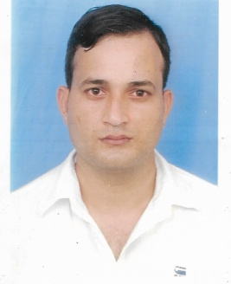
Name: Pardeep kumar
Address: V .P .O Gangoti
Joginder Nagar (HP)
Pin Code: 175032
E-mail ID:-pardeepkumar479@yahoo.com
Pardeeprana952@gmail.com
Contact No. 8872977045
CARREER OBJECTIVES

To obtain challenging and responsible position in an organization where in I contribute to the successful growth of an organization using my abilities and knowledge. "There is always a better way of doing things" is the common belief .And I also want to take experience, which is never ending process.

EDUCATIONAL QUALIFICATION

CNA ( COMPUTER NETWORK ADMINISTRATOR) | 2014 | Jetking Ludhiana
B.C.A ( Bachelors in Computer Application) | 2013 | Punjab Technical University
12th | 2010 | Govt. Sen. Sec School (Jalandhar)
10th | 2008 | Govt. Sen. Sec School (S.B.S. Nagar)

EXPERIENCE

- Worked in Reliance 4G as a Desktop Engineer for 1 year
- Worked in Axis Bank Currency Chest as a Cash Shorter for 6 Month
- Pursuing last One Year Worked in Shiv Shakti Bakers Pvt LTD Phillaur (Parle Biscuits Pvt. Ltd.) in DMS.

TECHNICAL SKILLS

- Degree Holder in Bachelor Computer Applications from Punjab Technical University , Punjab, 2013
- Half year Diploma in CNA(Hardware and Networking Engineer) from Jet king Ludhiana.2014

- Hardware & Operating System
- Installation of Microsoft Operating Systems including Windows
(XP, Vista, 7, 8, Server 2003, Server 2008).
- System Recovery, Data Backup & Restores.
- Software Installation and Solution.
- Troubleshoot the pc & laptop.
- Defragment of PC.

- Windows Server 2008
- Active Directory Domain Services (ADDS).
- Securities on all users.
- DHCP&DNS
- Server Backup & Restore
- Deployment of Windows by Windows Deployment Services (WDS).

- Systems Applications Products (SAP)
- Production Entry.
- Preparation Dispatch Paper
- GRN
- Computer Skill
- MS Office
- Photoshop

PERSONAL SKETCH

Father’s Name : Mr. Puran Chand

Add. : V.P.O. Khothran Dist. SBSN (Nawan Shahar) Pin Code -144632

Date of Birth : 15/07/1992

Sex : Male

Nationality : Indian

Marital Status : married

Languages Spoken: English, Hindi, Punjabi, Dogri

Strengths : Honest, Hardworking, and Punctual

I hereby declare that the above written particulars are true and correct to the best of my knowledge and belief.

Date: (Pardeep Kumar)

