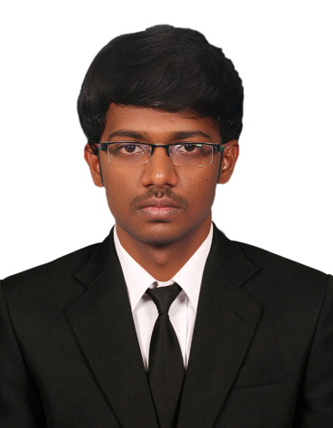 Mobile: 8220363867
Email: sunith886@gmail.com
SUNIT K

Career objective

To have a growth oriented and challenging career, where I can contribute my knowledge and skills to the organization and enhance my experience through continuous learning and teamwork.

Academic Qualification
Course | University/Board | Institute | Year of passing | Percentage/CGPA
B.E- Mechanical Engineering | Anna University | Muthayammal Engineering College | 2016 | 7.34(cgpa)
Higher Secondary | State board | St.Mary Magdalene Mat.Hr.Sec.School, Hosur | 2012 | 73.8
SSLC | Matric | St.Mary Magdalene Mat.Hr.Sec.School, Hosur | 2010 | 79

Software proficiency

  - Software known: Auto Cad, Creo,Catia, Ansys.
  - Office suite: MS-office.

Area of Interest

  - Manufacturing Technology
  - Automobile Engineering

Mini Project

  - Project Area : Manufacturing Technology
  - Project Title : “Fabrication Of Pneumatic Sheet Metal Cutter”

Main Project
  - Project Area : Design of Compression Molding Machine.
  - Project Title : “Design and fabrication of Compression
Molding Machine”
Memberships
- Member of Institute of Engineer (IE)
- Member of Society of Automotive Engineers (SAE)
- Member of Indian Society for Technical Education (ISTE)

Training and Workshops undergone

Implant training:
  - Organization : Tamilnadu State Transport Corporation (Salem) Ltd.
  - Duration :4 days
  - Knowledge Gained : Learnt about Functions and Assembling of Automobile

Work shop:

- Two and three wheeler technologies:
Place: Adhiyamaan College of Engg.
Period and Time:13-14th Sep 2013.
- Aeromodelling:
Place: NIT Trichy.
Period and Time: 13-15th March 2015.

Achievements and Extra-curricular activities

- Participated and won prizes in English essay competition at school level.
- Completed course on NPTEL about manufacturing systems technology.
- Won prizes at volleyball game during school level.
- Actively participated at BHARAT SCOUTS &GUIDES and JRC.

Personal Trait

  - Creative and logical
  - Problem solving ability
  - Co-operative and keen observer

Hobbies
- Listening to music
- Playing Volleyball

Personal Profile
Date of Birth : 29.04.1995
Gender : Male
Marital status : Single
Languages Known : Tamil, English, Kannada (speak).
Permanent Address : M-1371, Phase-x, 36th cross, new rayakotta housing board
Hosur-635109.

DECLARATION
I hereby declare that all the details furnished here are true to the best of my knowledge.

DATE: NAME : SUNIT K
PLACE: SIGNATURE:

