Prashant Mestry
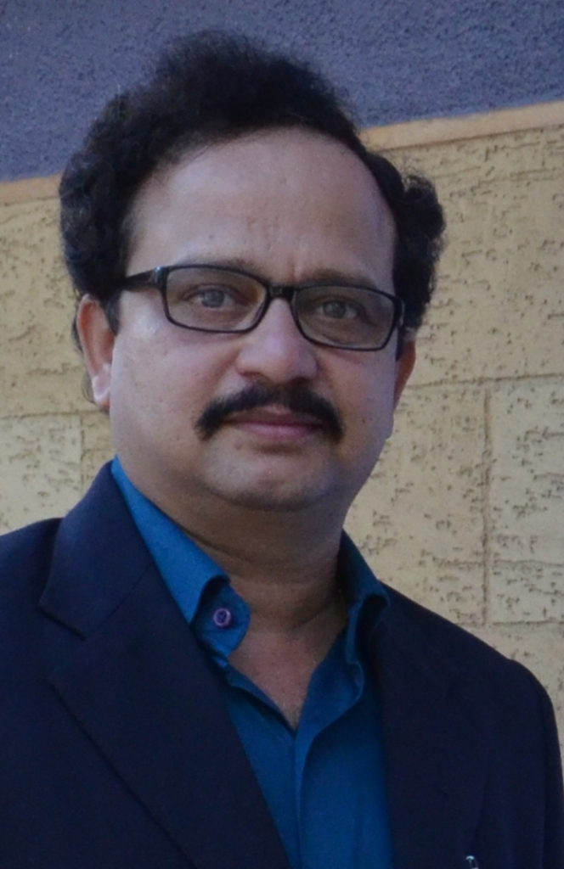e photo
Mobile: 91-9867018089 ~ E-Mail: mestry.prashant256@gmail.com

Seeking senior level place in Casting Sourcing & Casting Development

PROFILE SNAPSHOT

- 33 years experience in CI SG & Steel Casting area.
    - 5 Years in Sourcing of Casting & Foundry raw material
    - 9 Years in Casting development for all Mahindra sectors
    - 9 Years in Grey Cast Iron Foundry of Mahindra & Mahindra
    - 10 Years in working experience in steel foundry, Mukand Ltd

- Authority on selecting casting supplier in Mahindra & Mahindra.

- Recently Audited Erkunt Foundry, Turkey for Farm Division

CORE COMPETENCIES / Achievement

- Casting Development, critical castings like Cylinder Block and Cylinder Head and other
- Casting sourcing form over 100 suppliers all over India and Overseas.
- Worked in Production, Quality, Development, Sourcing
- Consistently Superior / Superior + / Excellent - rating in yearly Performance Appraisal.

EMPLOYMENT DETAILS

Current Job – April 2018 till date – Farm Division –
- Casting development
- Quality improvement for Farm Machinery Al casting parts
- Thin wall bigger housing development for new platform
- Responsible for all casting for Yuvo platform

Oct, 2013 onward - Head Ferrous Casting Sourcing, Mahindra & Mahindra, Mumbai

Key Result Areas:
- Responsible for buying casting @ 2.5 Lac MT/year from over 100 suppliers spread over India and overseas for all M&M sectors like –
Automotive Division,
Farm Division, Mahindra Truck & Bus Division,
Mahindra Heavy Engine Limited, Mahindra Electric,
Construction Division.
- Settlement of commercials in line with SBC for new project part & taking vendor on board within time line.
- Settlement of commercials for additional sources for building capacity.
- SBC & Commercial negotiation with vendor & Establish the quality product as per R&D requirement.
- Meeting yearly target of cost saving. Avoid price increase by doing small-small improvements.
- Considering the entire value engineering parameters with respect to components including second sourcing, change of material, change of dimensions, modifications in manufacturing process and bench-marking with competitor’s technology, etc.) to make the final product competitive
- Focusing on team building
- Developed Model Foundry for other casting suppliers to follow and eliminate losses.
- Core responsibility of selecting casting supplier for M&M.
- Core Team member for supplier “RISK” & “CAPABILITY” assessment
- Localization and saving forex for the organization.

Jul 2007 to Sep 2013 – Head Engine Part development – Through Special Process, Mahindra &
Mahindra, Mumbai

Focus Areas:
- Development of Casting in project time line with quality and delivery
- Vendor development for building technical capability
- Prepared a procedure so that casting development process has more scientifically focused.
- Wrote a book on “How to develop Cylinder Block” so that I can move to other area.
- Developed Scorpio, XUV 5oo, Maximo & TUV Cylinder Block with Teksid, China
- Training given to internal people for @1100 man hours
- IIF invited as a Speaker in Buy-Seller meet many times.
- Presented Technical papers in IIF

Jul 2006 to Jun 2007 – Head Quality Assurance – Ashok Iron, Belgaum

- Establishing the quality of regular parts through small-small improvements, Kaizens, POKA-YOKE
- Develop the quality culture through daily shop floor meeting with operators of different areas.
- Creating confidence in customer local as well as overseas.
- Attending customer complaints and ensuring elimination.

Nov 1996 to Jun 2006 – Head Molding, Core Shop, Melting, fettling, Quality – Mahindra & Mahindra,
Foundry, Mumbai
- Worked in various departments of Foundry as shift officer, Shift In charge, Department Head.

Nov -1987 to Nov 1996 – Joined as Jr. Engineer in Alloy Steel Foundry of Mukand Ltd, Kurla Mumbai
- This was the small section of main foundry, producing @100MT/M, in old days there was no proto technology and so initial sample use to produce in this section before it goes for regular production.
- Worked in all sections of Foundry, became Head of this section before I left.

PROFESSIONAL QUALIFICATIONS

Passing Year 1985 Metallurgy from, Nagpur with 61%
Passing Year 1987 Specialization in Foundry Tech, Bhagubai Institute, Parle, Mumbai with 73%
Passing Year 2001-3 Specialization in HR & Psychology
Passing Year 2005 PG in Operation Management, AIMA,

PERSONAL DETAILS

Date of Birth : 2nd May 1966
Permanent Address : Bldg. No. A3 / Flat No. 302, Swastik Residency, Near Sarswati School & Jr.
Collage, Ghodbandar Road, Thane 400615

Marital status : Married, Wife - HW
Children details : Daughter – Completed B. Arch, Working with CAD Center, Thane
: Son – Completing graduation in Photography from Symbiosis, Pune

M&M Appraisal Rating – in last 5 years - S+, S+, S, S+, S+, S

