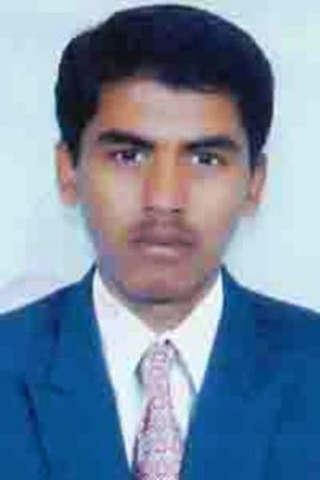
NIMBALKAR DATTATRAY VIKRAM

Permanent Address:
A/p-Bhavinimgaon
Tal: Shevgaon
Dist: Ahamadnagar(M.S)
Mobile: +91-8657595209
Correspondence Address:
CAET, VNMKV, parbhani
Dist: parbhani, (M.S)
Mobile: +91-8657595209

Career Objective

Intend to build a career with leading organization along with committed & dedicated people, who will help me to explore myself fully and offers professional growth while being resourceful, innovative and flexible.
Academic Qualification
Examination | University/Board | Passing Year | Percentage
M.-Tech (Farm Machinery and power) | VNMKV, Parbhani | 2017 | 82.60
B-Tech (Agril Engg) | VNMKV, Parbhani | 2015 | 82.20
HSC | Pune | 2011 | 73.67
SSC | pune | 2009 | 82.30
AcademicProject
- M.-Tech: “Design and Development of chaff cutter cum grinder machine”
- B-Tech: “performance evolution of rainfall simulator”
Work Experience
- CFMTTI BUDNI, *(mp) ONE MONTH
- Jai Bajarang Watershed Nanded ,Four Month
- Aditya Cad Cam Institute Parbhani One Month
- Continuous Experience Regarding as a Self Farmer and Handling Most of the Situations of the Farmer In Rural Area.

Computer Proficiency
I have knowledge confidently with the following application packages:
- Computer application i.e. MS Office, HTML, C++ ,
- MS PowerPoint, Internet etc. MSCIT , SOLIDE WORKS, CAD CAM.

Curricular–Activity :
- National level championship silver medal
- Athletes of Maharashtra.(state level championship silver medal’).
- winner university level championship (gold medal’).
- Participated in NSS activity.
- Build up the new relationship.
- Build up new friends every time
Competencies:
- Fast learner, adapt well to changes and pressures In workplace.
- Work effectively with diverse groups of people.
- Ambitious and committed to excellence.
- Sincere with a high level of integrity. Ability to rapidly build relationship and set up trust.

Personal data:
E-Mail:dnimbalkar7@gmail.com
Dob: 24th May1994.
Sex: Male
Nationality: Indian
Marital Status: Unmarried
Languages known:

English

Hindi

Marathi
Interest
Eating, Travelling.
Declaration
I hereby declare that the information provided above is all correct and to best of my knowledge and belief.

Place :Ahamadngar Date: / /2017. NIMBALKAR DATTATRAY

References : 1) SOLANKI S.N. (H.O.D FMPE CAET PARBHANI)

