RANJAN KUMAR DAS

PHONE: +91- 9337580496

E-Mail: [ranjanlaxmi6@gmail.com](mailto:ranjanlaxmi6@gmail.com)



An efficient professionalism in Spare Parts Business & Customer Service with an eminence experience of 9 years in autoancilary sector. Seeking for a high level assignment in after sales operation in a reputed industry to exploit my talent & expertise to height-up my carrier.

**Roles & Responsibility:**

* Managing & Handling of Channel Partners.
* Channel Partners development & network extension.
* Forecasting on monthly/quarterly & annually planning & its proper executions.
* A concrete focus on volumetric sales to achieve the yearly revenue.
* Disciplinary control on commercial i.e. collection, Order booking, Payment knock-off.
* Tracking distributor stock & widening secondary sales thru dealer/retailers networking.
* Significant of partline sales to increase spare business.
* Periodical audit for distributors/Dealers/Retailers for performance measurement.
* Round the clock (24X7) service support & timely resolution of MTTR.
* Mechanics skill upgradation & enhancement of technical capability
* Analysis of warranty failure & reports submission for quality improvement.
* Business promotional activity i.e. Branding/meeting/adv./Free Campaigning etc.
* Customer Satisfaction Index (CSI) & collecting feedback for analysis & enhancement.

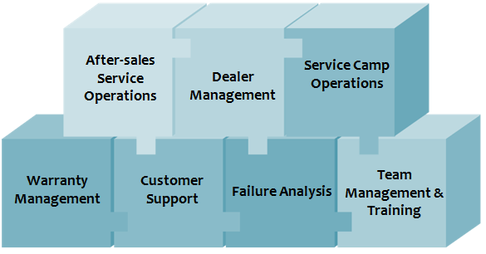

**Key Skills:**

* Spare Parts management.
* Dealers Operation & Management.
* Networking development & expansion.
* Process Management.
* Customers Management.
* Warranty Management.
* Capability Build-up.
* Business Promotional Management.

**Current Organization:**

**Greaves Cotton Limited**

* Designation: Assistant Manager Spare & Service
* Operational territory: Bihar & Jharkhand
* Location: Ranchi
* Date of Joining – 04-07-2018 to till date

**KRA (Key Result Area):**

* Financial- Spare Parts Turnover & Receivable.
* Process- Online Registration & Channel Partners periodic audits.
* Capability- Skill upgradation, GAT appointment & Promotional activity.
* Customer- Timely resolution of customer complaints, CSI & Warranty settlement.
* Innovation- Lubricants & New Products Sales.

**Academic Qualification:**

|  |  |  |  |  |
| --- | --- | --- | --- | --- |
| **Course** | **Subject** | **Institution** | **Year of Passing** | **Percentage %** |
| 10th /Matric | All | Board of Secondary Education, Odisha | 2006 | 79 |
| Diploma Engineering | Automobile | A.I.C.T.E. & V.T. Odisha | 2009 | 78 |

**Previous Organization:**

**Mahindra & Mahindra Limited**

* Designation: Sr. Territory Manager Service & Spare-FES.
* Operational territory: Karnataka, Bihar & Jharkhand
* Location: Patna
* Date of Joining – 18-08-2009
* Date of resignation -30-06-2018

**Key Achievements:**

* 10th Topper award in high school.
* Branch Topper award in engineering from then Governor of Odisha
* 4th times “SPOT AWARD” in M&M Ltd for best coordinator.
* Certificate of Appreciation for best sales & service performer of FY17 from CEO
* Certificate of Appreciation for Best Sales & Service Performer of FY18 by CEO

**Trainings Undergone:**

* Plant training at Mahindra & Mahindra Ltd., Pune.
* Plant training at Mico Bosch, Bangalore.
* Training at Trident plant, Bangalore.
* Service Excellency Program at Mahindra, Delhi.
* Time Management Program at Mahindra & Mahindra Ltd., Kolkata.
* TPM training at Mahindra & Mahindra Ltd., Kolkata
* 7 Habits of Highly effective people at M&M Ltd., Kolkata
* Plant training Greaves Cotton Ltd., Chennai.
* New products training at Greaves Cotton Ltd, Ranipet
* Service Excellence Program at Greaves Cotton Ltd., Pune.

**IT Skills:**

* Proficient in MS Office & presenting ability.

**Annual CTC:**

* **Annual CTC :** Rs: 7.12 Lacks

**Personal Dossier:**

* Date of Birth : 20-05-1989
* Current Address : C/o Mr.Prashad, House No. B-2,Morabadi, Ranchi
* Permanent Address :S/o Mr.Gadadhar Das, At/Po- Patpur, Cuttack, Odisha.
* Languages Known : Oriya, English & Hindi

**Declaration:**

I hereby declare that all above mentioned information are true and best of my knowledge and belief.

Date: Ranjan Kumar Das

Place: