**RANJAN KUMAR DAS**

**Contact: +91- 9337580496**

**E-mail: ranjanlaxmi**[**6@gmail.com**](mailto:6@gmail.com)



**“An effective Professionalism in Aftersales Operation & Networking Development”**

***Seeking a medium level assignments in After-Sales Operations, Dealer Development and Customer Service with a reputed Auto-ancillary Industry.***

**Profile Summary:**

“A competent professional with an experience of 8.5 years in Aftersales, Customer Management, Dealers operation & Developmental process & Spare Parts business, Warrant management, Products supports, Skill enhancement management & Promotional events etc in an automobile Industry”.

**Roles & Responsibility:**

* Dealers operation, developmental process, Capability building, Quality monitoring& Customers Service supports.
* Service network expansion, appointing dealers, sub-dealers& developing service system.
* Round the Clock (24 X7) Service Supports.
* Significant exposure in planning and executing preventive & corrective maintenance programs and recommending cost-effective solutions.
* Handling field complaints, arresting fault, Root cause analyzing & resolving within SLA timeline.
* Post-feedback on Customer satisfaction & further improvement on Service quality towards CSI.
* Products failure analysis &reduction of warranty cost on MOM basis.
* Forecasting on Spare Parts Sales thru Distributors, Dealers& Sub-dealers channel.
* Service revenue generation, Billing& Payment collection.
* Distributors &dealers stock Inventory monitoring& tracking.
* Quarterly & half-early dealer audit on Service quality, Parts, Field responsibility & customer’s centricity.
* Enhancing mechanics competency on technical skill, communication as well behavioral thru developing program.
* Ensuring high operational productivity of service networks through online software/portals based approached.
* Service Camp, Educating customer, interacting & encouraging on service supports to build a strong relationship.
* Effecting Quality tools like TPM, KIZEN & RISE Philosophy.

**Key Result Area:**

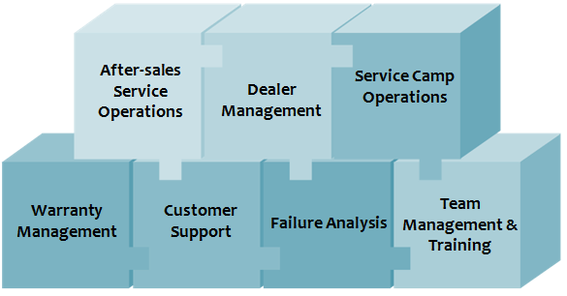

**Currently Organization: Greaves Cotton Ltd**

* Asst. Manager in Service & Spare Parts
* Location: **Ranchi, Jharkhand**.
* Working Periods: From 4th Jul’17 to till........**date**

**Previous Organization: Mahindra & Mahindra Ltd**

* Designation**: Senior Territory manager Service.**
* Location**: Ranchi, Jharkhand.**
* Working Periods: **18th Aug’09 to 30th Jun’16.**

**Training undergone:**

* + Training on Engines at Mahindra Plant, Mumbai
  + Training on Lucas Alternator & Self Starter, Chennai
  + Training on FIP & Nozzle in MICO, BOSCH, Bangalore
  + Training on Heavy diesel engine, Meerut.
  + Training on AC Alternator at Trident Power Craft, Bangalore
  + Customers reach out program training in Bangalore.
  + Presentation & Time management skills Training in Kolkata
  + TPM training in Kolkata
  + Products training in Chennai in Greaves Cotton Ltd.,

**Area of Operation:**

* At M&M : September 2009 – November 2012 in Bangalore (Karnataka), November 2012 – October 2015in Patna (Bihar& Jharkhand), November 2015 – June 2016 in Ranchi (Jharkhand)

**IT Skill:**

Proficient in MS Office and other Internet Applications

**Carrier Achievement:**

* 10th Topper award in high school.
* Branch Topper award in engineering from Governor of Odisha
* 4th times “SPOT AWARD” in M&M Ltd for best Co-ordinator in DC DG, EFFS Kit & highest service revenue creator.
* Appreciation on best service deliverance in M&M Ltd from GM & VP.
* Certificate of Appreciation in Greaves Cotton Ltd., by President AMB.
* Appreciation on field Services activity & customer support in Greaves Cotton Ltd.,

**Academic Qualification:**

|  |  |  |  |  |
| --- | --- | --- | --- | --- |
| **Course** | **Subject** | **Institution** | **Year of Passing** | **Percentage %** |
| 10th /Matric | All | Board of Secondary Education, Odisha | 2006 | 79 |
| Diploma Engineering | Automobile | A.I.C.T.E. & V.T. Odisha | 2009 | 78 |

**Personal Dossier:**

* **DOB** : 20-05-1989
* **S/o** : Mr. Gadadhar Das
* **Address** : At/Po- Patpur, Via- Bahugram, Dist.- Cuttack, PS.- Salepur, Pin-754200, Odisha
* **Language :** English, Hindi & Odiya.

**Declaration:**

I hereby declare that, all the above Information given here are true & best of my Knowledge & believe.

Date: Signature:

Place: Ranchi **Ranjan Kumar Das**