B.THIRUPATHI,

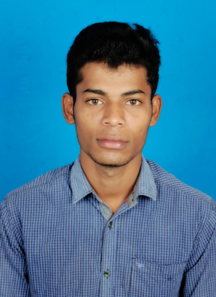

S/O C.BHARATHI,

2/27, CHITTLAKARAMPATTI (VIL),

O.G HALLI (PO),

DHARMAPURI (DT), Email:**thirupathir4455@gmail.com**

PIN: 636809 Mobile**:9894717504**

**CAREER OBJECTIVE**

To secure a professional position that utilizes my engineering education in the technical fields through teamwork, computer skills & creative thinking.

**EDUCATIONAL QUALIFICATION**

|  |  |  |  |
| --- | --- | --- | --- |
| **Qualification** | **Institution** | **Year** | **Percentage** |
| B.E  (Mechanical) | Jayam College of Engineering and Technology (Nallanur) | 2014-2018 | 70% |
| HSC | Thiyagi Subramaniya Siva Government Boys Higher Secondary School, Pauparapatti | 2013 | 85% |
| SSLC | Thiyagi Subramaniya Siva Government Boys Higher Secondary School, Pauparapaati | 2011 | 60% |

**COMPUTER SKILLS**

* AUTO CADD
* CREO
* CATIA.
* Ms office.

**AREA OF INTEREST**

* + Design Engineering.
  + Automobile Engineering.

**PROJECTS**

UG MINI PROJECT:

Design and Fabrication of **‘HYDRAULIC ROD BENDING MACHINE’.**

UG MAIN PROJECT**:**

Design and optimization of the ‘**CRANK SHAFT USING FINITE ELEMENT ANALYSIS’.**

**CO - CURRICULAR ACTIVITIES**

* + Attended a work shop‘**Core/IT** Industries Expectations from Engineering student’ atVinayaka Mission’s University, Salem on 18/02/2017.
  + Attended a work shop **‘ANSYS WORK BENCH’**at KSR Institute for Technology, Tiruchengode on 05/04/2017.
  + Attended a work shop**‘Royal Enfield Bike Surgery’** at Government College of Engineering, Bargur on 25/09/2017.

**IMPLANT TRAINING**

* Tamil Nadu State Transport, Dharmapuri(12/10/2016)

**PERSONAL STRENGTH**

* Good team worker
* Flexible and adaptable personality
* Confident
* Sportive

**HOBBIES**

* + - Playing cricket.
    - Surfing the internet.
    - Reading news paper.

**GOAL**

Short term : To get a mechanical based job.

Long term : To make new inventions in future.

**PERSONAL DETAILS**

Father’s Name : C.Bharathi,

Permanent Address : 2/27,Chittlakarampatti (village),

O.G Halli(po),pennagaram(tk),

Dharmapuri(dt)-636809.

Date of Birth : 12thAPRIL 1996.

Gender : Male

Language Known : Tamil, English

Marital Status : Single.

Religion : Hindu

Nationality : Indian.

**DECLARATION**

I do hereby declare that the above information is true to the best of my knowledge**.**

**Place: S**ignature,

**Date: (B.THIRUPATHI)**