**RESUME**



**VISHNU K**

**DIPLOMA IN MECHANICAL ENGINEERING**

+91 8138055658,+91 9946249404

[vishnuvkcfootprints@gmail.com](mailto:gurujivishnu1995@gmail.com)

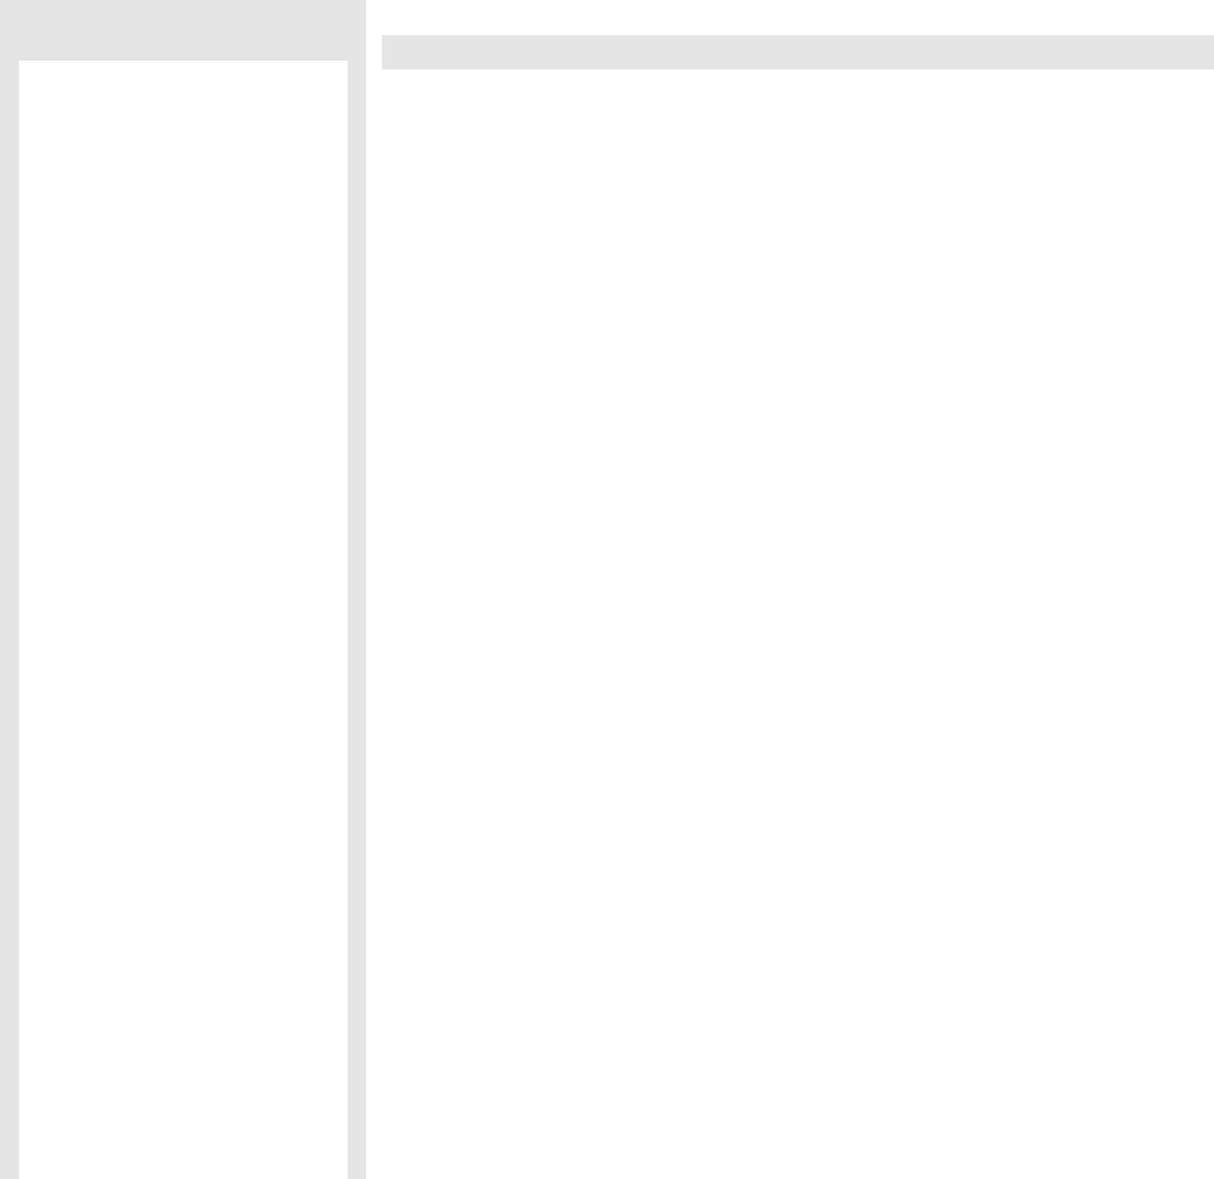

**CONTACT ADDRESS:**

**VISHNU K**



KUNDU THODIYIL, HOUSE

MAYANNUR

MAYANNUR (PO),

THRISSUR (DIST),

,

KERALA (STATE),



INDIA.

PIN: 679105



**EMAIL ID:**

[gurujivishnu1995@gmail.com](mailto:gurujivishnu1995@gmail.com)

[vishnuvkcfootprints@gmail.com](mailto:vishnuvkcfootprints@gmail.com)



**CONTACT NO****:**

+918138055658

+91 9946249404

+91 9809158898

**Personal Details:**

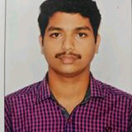

**Date of Birth:**01-12-1995

**Father’s Name:** UNNIKRISHNAN



**Age:**23

**Sex:**Male



**Marital Status:**Single



**Nationality:**Indian



**Languages Known:**English,Hindi

Malayalam and Tamil



**Hobbies:Vlogin**g, Travelling,

**CAREER OBJECTIVES**



To continuously enhance my communication, interpersonal and technical skills in challenging work environment and utilize it to conquer the Company Objective and to build a successful career. Take special interest and doing things beyond routine duties in my work.



**ACADAMIC QUALIFICATION**

.

|  |  |  |  |  |
| --- | --- | --- | --- | --- |
| YEAR | **QUALIFICATION** | **INSTITUTIONS** | **BOARD /**  **UNIVERSITY** | **MARKS**  **(%)** |
| 2016 | DIPLOMA  IN  MECHANICAL ENGINEERING | GOVT  POLYTECHNIC  COLLEGE,  PALAKKAD | DEPARTMENT  OF  TECHNICAL EDUCATION  KERALA | 80% |
| 2013 | PLUS TWO | TRK HSS  VANIAMKULAM | HIGHERSECONDARY  BOARD OF EDUCATION  KERALA | 78.7% |
| 2011 | SSLC | ST:THOMASHSS  MAYANNUR | KERALA STATE BOARD  OF PUBLIC  EXAMINATIONS  KERALA | 97% |



**SOFTWARE SKILLS**



* Operating system: Microsoft windows.
* Office tools: MS office.
* Other software: Autocad, Photoshop, SAP



**PERSONAL SKILLS**

* Hard working
* Patience
* Sincere



**EXPERIENCE**

* Incharge at VKC (production)
* Service Advisor at HP Yamaha palakkad
* Sales engineer at Redlands Ashlyn Motors(Farm&Garden machinery)

**ACADAMIC PROJECT**



* GRAVITY LIGHT



**INDUSTRIAL TRAINING**

* INSTRUMENTATION LTD, KANJIKKODE



**INDUSTRIAL VISIT**

* SIMCO, SHORNOOR



**DECLARATION**

I do hereby declare that the above information is true to the best of my knowledge**.**

**PLACE : THRISSUR** VISHNU.K

**DATE :20.06.2019**