**Avinash Kadam**

**Service Engineer**

Contact

**Address:**

Satara, maharashtra

**Phone:**

+91 7208808822

**Email:** Avinashkadam3119@gmail.com

Technological proficiencies

* Basic Computer
* Electrical & hydraulic knowledge
* L0/L1/L2 Training completed

Total Experience

|  |
| --- |
| 5.5 Year |
| 1 Aug 2014 - Till Date |

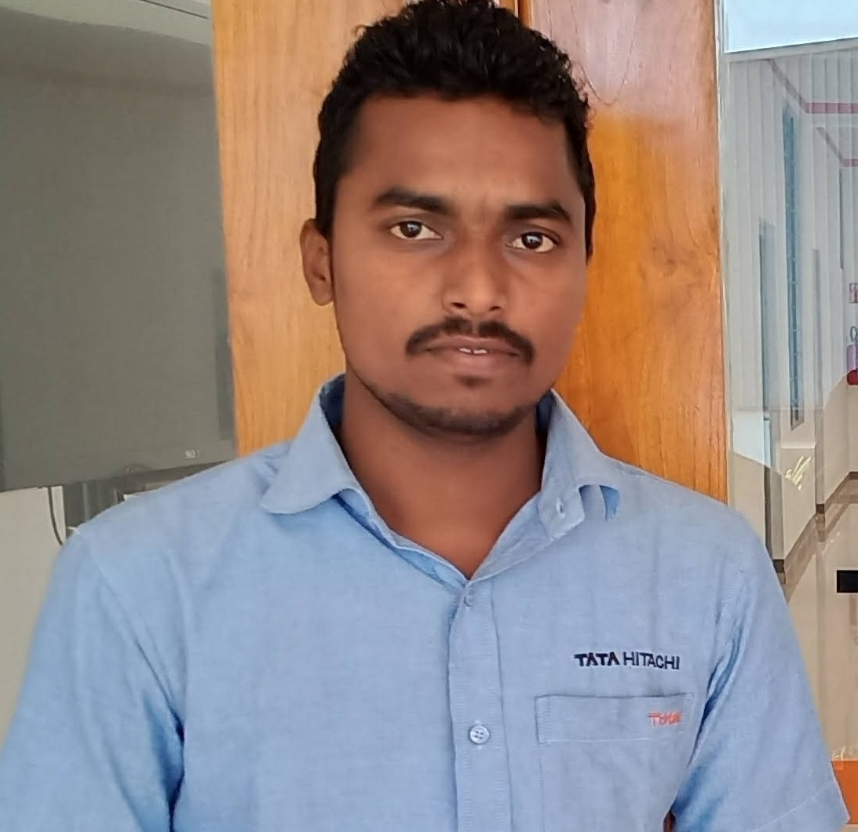

Summary

Knowledgeable Field Service Engineer with top strengths in planning, problem-solving and communication. Skilled in maintaining high customer satisfaction, controlling inventory and providing technical support

|  |
| --- |
|  |

Experience

**Service Engineer** - 08/2014 to 05/2017

**C S DIESEL ENGINEERING (L&T KOMATSU)**, Mumbai

* Examined faulty equipment, interpreted reports and analyzed customer complaints to diagnose equipment malfunction.
* Provided technical support to troubleshoot, repair and maintain operational efficiencies in hydraulic, mechanical and electrical systems.
* Performed onsite installation, modification and maintenance of systems and equipment.
* Checked safety practices and integrity of PPE.
* Scheduled service calls according to customer location and urgency of need.
* Inspected equipment and processes to reduce maintenance-related downtime incidents and mitigate equipment failures.

**Service Engineer** – 06/2017 to Currunt

**TOTAL EARTHMOVERS PVT LTD (TATA HITACHI** ),Mumbai

* Maintained tools and equipment, parts inventory and library of machine manuals.
* Scheduled service calls according to customer location and urgency of need.
* Examined faulty equipment, interpreted reports and analyzed customer complaints to diagnose equipment malfunction.
* Checked safety practices and integrity of PPE.

Education

Engineering Diploma: **Automobile engineering** - 2014

**MAHARASHTRA STATE BOARD OF TECHNICAL EDUCATION**, Mumbai

Certifications

Course on Computer Concepts: **MLCL, MAHARASHTRA**

L0/L1/L2/GI: **L&T KOMATSU, TATA HITACHI**.