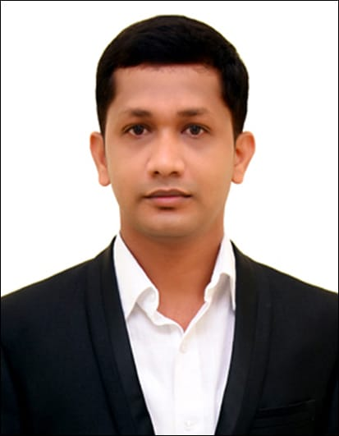

Keerthivasan V

Mobile: 9952553388

Email: [keertivijians@gmail.com](mailto:keerthivijians@gmail.com)

4/3/42, Thottarayan Kovil Street,

Melachokkanathapuram,

Bodinayakanur,

Theni – 625582.

**Career Objectives**

To work in an environment which encourages me to succeed and grow professionally where I can utilize my skills and knowledge appropriately.

**Academic Information**

* Completed MBA (Operations & Marketing Management) in Rathinam Institute of Management – 61%.
* Completed B.E(Automobile Engineering) in Karpagam Academy of Higher Education– 82%
* Completed Diploma (Mechanical Engineering) in Thanapandiyan Polytechnic College– 68%
* Completed SSLC in SCISM Matriculation Higher Secondary School– 58%

**Internship Details**

* Completed internship in Atri Holidays, for 30 days in the month of May and June 2019 in the Field of Operations.
* Completed internship in Tafe, for 30 days in the month of May and June 2019 in Field of Marketing.

**Area of Interest**

* Operations and Research.
* Digital Marketing.
* Channel Sales and Marketing.
* Business Development.

**Co-Curricular Activities**

* Presented a paper on the topic CONSUMER BEHAVIOUR IN SERVICES.
* Participated in the Two Day INTERNATIONAL ORKSHOP ON “Supply Chain and Logistics”.
* Participated in various Intercollege workshops.

**Soft Skills**

* Team Handling
* Adaptability
* Easy Learner

**Work Experience**

* Worked as a Sales Engineer & Administration Executive in Toyota Dealership (Anaamalais Toyota) For 8 Months Period.

**Key Result Area**

* Carrying out the requirement analysis,provide technical consulting and specialist assistance on sales solutions to management and customers.
* Generate and execute sales plans to achieve the monthly targets.
* To provide the day to day retail and store operations to the retail manager
* Work with the Sales team and other departments to help them learn about changes to market trends and development to procedures.

**Personal Information**

Age : 27 years

Father’s Name : Vijayagothandaraman S

Father’s Occupation : Farmer

Mother’s Name : SasikalaV

Spouse : Harani K

Mother’s Occupation : Home Maker

Date of Birth : 14/01/1994

Languages known : Tamil , English, Kannada

**Declaration**

I hereby declare that all the above given details furnished above are true to best of my knowledge.

Thank you

Place:

Date: Yours Truthfully,

Keerthivasan V