**DATASET1: GROUP4**

**About Tata Consultancy Services**

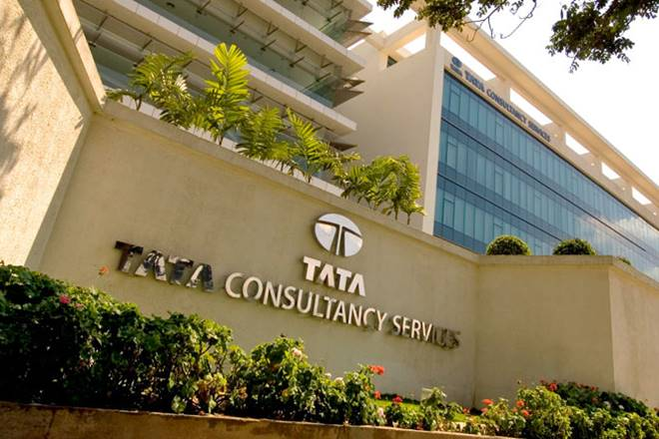

TATA Consultancy Services Limited is an Indian multinational information technology service and consulting company with headquartered in Mumbai, Maharashtra, India. It is a subsidiary of Tata Group and operates in 149 locations across 46 countries. TCS is the second largest Indian company by market capitalisation.

**Problem statement:**

We will forecast the net profit/loss for TCS over 8 years (i.e, 2011-2019) quarterly and find out how the profit/loss is dependent on total sales of each period. Also, we’ll calculate the accuracy of our forecast.

**Steps and interpretations:**

1. Checking Seasonality and trend

**Interpretation:**

Looking at the plots we get the following interpretations:

* Trend exists as upward
* Seasonality is not there

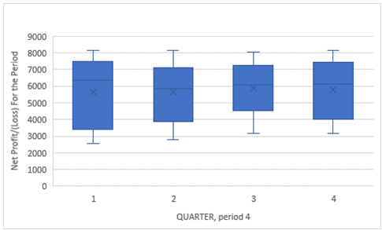

1. Finding Lag Number

PACF is significant till 1st lag.

Interpretation:

The autocorrelation factor shows a geometric decomposition. Significance cannot be determined based on the plot.

1. Forecasting Model (dependent variable – NetProfitLossForthePeriod and independent – NetSalesIncomefromoperations)

Interpretation:

As seen for the model description, the 2nd component shows (0,0,0) which means that seasonality does not exist. Difference is 1 for the 1st component.

|  |  |  |  |
| --- | --- | --- | --- |
| **Model Description** | | | |
|  | | | Model Type |
| Model ID | Net Profit/(Loss) For the Period | Model_1 | ARIMA(0,1,0)(0,0,0) |

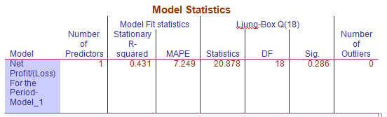

**Interpretation:**

As we know that for a good model, a MAPE between 0 to 10 is considered good, it is a good model for profit forecast prediction on TCS as our **MAPE is 7.25%.**

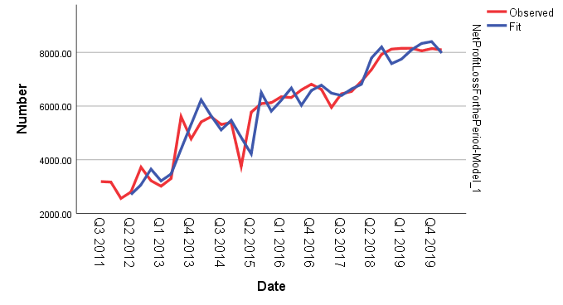

Judging from the plot, net profit increases for TCS along with the forecasted profit. Hence, it can be predicted that TCS will have a positive growth in terms of profit for the coming period.

1. MAPE of model

The MEAN ABSOLUTE % ERROR for the entire data is 7.25%

1. Forecasting Model without last two entry (dependent variable – NetProfitLossForthePeriod and independent – NetSalesIncomefromoperations)

The MEAN ABSOLUTE % ERROR for the entire data is 7.6%

The forecasted and observed values for the target entries correlate.

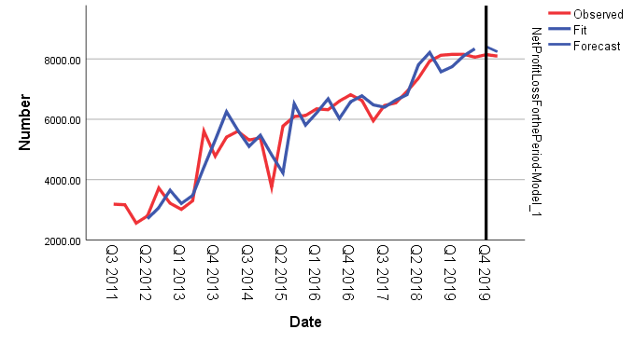

**Conclusion:**

Thus it can be inferred from the forecasted prediction that:

1. TCS will continue having a positive trend of profit in the coming period.
2. Predicted values for the deleted last two entries are also showing almost same values. Hence, prediction for forecast is good enough.
3. MAPE for the model is 7.25% which means a good accuracy in terms of forecast prediction. Operations in TCS are not seasonal and keep varying.
4. TCS is having an upward trend hence a positive growth.
5. Although profits fell in 2015 2nd quarter, TCS was able to make up and rose again.