**WEATHER FORCASTING USING DATA MINNING TECHNIQUES**

**MASTER OF COMPUTER. APPLICATION**

*By*

**AYUSH SRIVASTAVA (16MCA0147)**



**SITE**

March, 2018

**DECLARATION**

I hereby declare that the thesis entitled “weather forecasting analysis using data mining techniques” submitted by me, for the award of the degree of Specify the name of the degree VIT is a record of bonafide work carried out by me under the supervision of Gide Name I further declare that the work reported in this thesis has not been submitted and will not be submitted, either in part or in full, for the award of any other degree or diploma in this institute or any other institute or university.

Place: Vellore

Date: 1-01-2018 Signature of the Candidate:

**CERTIFICATE**

This is to certify that the thesis entitled “weather forecasting analysis using data mining techniques” submitted by AYUSH SRIVASTAVA(16MCA0147) (SITE) VIT, for the award of the degree of Name of the degree is a record of bonafide work carried out by him/her under my supervision. The contents of this report have not been submitted and will not be submitted either in part or in full, for the award of any other degree or diploma in this institute or any other institute or university. The Project report fulfils the requirements and regulations of VIT and in my opinion meets the necessary standards for submission.

**Signature of the Guide Signature of the HOD**

**Internal Examiner**

**ACKNOWLEDGEMENT**

It is my pleasure to express with deep sense of gratitude to Prof. Kavitha g, Assistant Professor,School of Information Technology and Engineering (SITE), Vellore Institute of Technology, for his constant guidance, continual encouragement, understanding; more than all, he taught me patience in my endeavor. My association with him is not confined to academics only, but it is a great opportunity on my part of work with an intellectual and expert in the field of Computer vision.

I would like to express my gratitude to Dr. G.Viswanathan, Chancellor, G.V.Selvam, Sankar Viswanathan, Sekar Viswanathan, Vice Presidents, Dr. Anand Samuel, Vice Chancellor, Dr.S.Narayanan, Pro-Vice Chancellor and Dr. Aswani Kumar Cherukuri, Dean, School of Information Technology and Engineering (SITE) for providing with an environment to work in and for his inspiration during the tenure of the course.

In jubilant mood I express ingeniously my whole-hearted thanks to Dr.M.Prabukumar, HoD, CACM, School of Information Technology and Engineering (SITE), VIT, Vellore, all teaching staff and members working as limbs of our university for their not-self-centred enthusiasm coupled with timely encouragements showered on me with zeal, which prompted the acquirement of the requisite knowledge to finalize my course study successfully. I would like to thank my parents for their support.

It is indeed a pleasure to thank my friends who persuaded and encouraged me to take up and complete this task. At last but not least, I express my gratitude and appreciation to all those who have helped me directly or indirectly toward the successful completion of this project.

Place: Vellore

Date :

**Ayush Srivastava**

**TABLE OF CONTENTS**

**ABSTRACT ……………………………………………………………...………......6**

**CHAPTER 1**

**INTRODUCTION…………………………………………………………………07**

* 1. MOTIVATION …………………………………………………………………12
  2. OBJECTIVE AND SCOPE …………………………………………………….12
  3. PROBLEM DEFINITION AND CHALLENGES ……………………………..13
  4. How do we perform weather forecasting………………………………………..15
  5. Reliability of weather forecast…………………………………………………..16
  6. Future work and opportunity…………………………………………………….18

**CHAPTER 2**

**LITERATURE SURVEY…………………………………………………………..19**

**CHAPTER 3**

**METHODOLOGY**

3.1 MODULE DESCRIBTION………………………………………………….......34

3.2 Methodology Used……………………………………………………………… 35

3.3 Other algorithm that can also be used………………………………………… 41

**CHAPTER 4**

**4** **SYSTEM DESIGN**

**4.1** USE CASE………………………………………………………………….........50

4.2 SEQUENCE………………………………………………………………………52

4.3 ARCHITECHTURE………………………………………………………………52

4.4 DATA FLOW……………………………………………………………………..53

**CHAPTER 5**

5.1 ABOUT R-STUDIO……………………………………………………………..54

5.2 ALGORITHMS AND ANALYSIS(graphs)……………….…………………….54

5.3 RESULT………………………………………………………………………….76

**CHAPTER 6**

REFRENCES…………………………………………………………………………77

**CHAPTER 7**

**CONCLUSIONS**

1. THESIS SUMMARY ………………………………………...………………….78
   1. LIMITATIONS ………………………………………………………….………79

**LIST OF FIGURES**

1. NAÏVE-BAYES EXAMPLE……………………………………38
2. USE CASE……………………………………………………....50
3. SEQUENCE DIAGRAME……….………………………..…….51
4. ARCHITECHURE DIAGRAME……………………….……….51
5. DATA FLOW DIAGRAME…………………………………….52
6. DATA-SET………………………………………………….......53
7. IMORTING DATASET…………………………………………54
8. PREPROCESSING………………………………………......54-56
9. REGRESSION ALGORITHM……………….……………....55-61
10. K-MEANS…….……………………………………..………63-65
11. NAÏVE-BAYES…………….………………………...……....66-75
12. RESULT AND ANALYSIS…...………………..……..…………76

**ABSTRACT**

Recently data mining has become one of the integral part of our technological world, since the day it came into existence it made the benchmark over IT-industries, but almost on every sector. Data mining is nothing but a combination of statistics , data base , machine learning , and so on list quiet big enough to write here, one can assume that every decision in today’s date are made with the help of data mining techniques. Basically data mining have been tied up in knot with the 2ndary analysis of huge data sets(large databases) so as to find the relationship (unsuspected) for which the owner of that particular data base is interested and ignoring the uninterested values. Data mining hence provide the full assistance for machine learning through analysis. Basically data mining was introduced in order gather the information from large amount of data set or database. From statistical point of view data mining it can be seen as the analysis of huge complex database for exploratory data. Because of this, field has made a deep impact on industries, markets, researchers etc. Since data mining what we have seen is closely related to statistics but it also consist some of the algorithm/methodology which are not at all related to the statistical field. “**Prediction**” is key for data mining analysis and it is the ultimate goal for data mining technology , for this purpose only the Data Mining was introduced , fields on which data mining is essential are :- Weather forecasting, Share market, Retail Industries, ETC. All these field uses data mining technologies i.e. algorithms eg clustering, classification, decision tree, etc. And in this report I have tried to analyze the weather with the help of which I’m trying to predict the future aspect of weather over the five cities of Austin (Badgerys Creek, Albury, Cobar, Coffs-Harbour). In-order to achieve this I have used three data mining algorithm. And then tried to compare their result with each other in order to get best out of the three results.

**Chapter 1**

1. **INTRODUCTION**

The climatic conditions ar dynamical unendingly and also the entire world is suffers from the dynamical climate and their aspect effects. thus pattern on dynamical climatic conditions ar needed to look at. With this aim the planned work is meant to analyze concerning the atmospheric condition pattern and their foretelling model. On the opposite hand data processing technique allows U.S. to analyse the info and extract the dear patterns from the info. thus so as to grasp unsteady patterns of the climatic conditions the info mining primarily based prophetic model is reportable during this work. The planned information model analyse the historical weather information and determine the numerous on the info. These known patterns from the historical information modify U.S. to approximate the approaching climatic conditions and their outcomes. to style Associate in Nursingd develop such an correct information model variety of techniques ar reviewed and most promising approaches ar collected.

“DATA MINING” this term is not at all new to us, it also means “*Data Fishing*”. This term “data mining ” was coined by the economist Michel lovell in 1960’s , but in 1990 it was the first time when data mining was appeared in database community, then the revolution started to begin in the industry.

The general definition of data mining states that:-

1“*Data mining is the set of process used in knowledge discovery process to disguise between previously unknown relationship and pattern within the data*” given by Sir. Ferruza.

It is divided in two parts:

* Supervised learning: Managed learning is the machine learning errand of taking in a capacity that maps a contribution to a yield in light of case input-yield pairs. It derives a capacity from named preparing information comprising of an arrangement of preparing examples. In regulated adapting, every illustration is a couple comprising of an info question (commonly a vector) and a coveted yield esteem (likewise called the supervisory flag). An administered learning calculation dissects the preparation information and produces an induced capacity, which can be utilized for mapping new illustrations. An ideal situation will take into account the calculation to accurately decide the class names for concealed examples.
* Un-Supervised learning: Unsupervised learning is a sort of machine learning calculation used to draw deductions from datasets comprising of info information without named reactions.

The most well-known unsupervised learning technique is bunch examination, which is utilized for exploratory information investigation to discover shrouded examples or gathering in information. The groups are demonstrated utilizing a measure of similitude which is characterized upon measurements, for example, Euclidean or probabilistic separation.

Algorithm that are used in this type of learning are:

1. Hierarchical bunching.

2. k-Means bunching

3. Gaussian blend models.

4. Self-arranging maps.

5. Hidden Markov models.

Data analysis involves three basic and simple steps. They are as follows:-

* **Pre-processing:-** Before applying relevant data ming algorithm on a certain dataset for example say dataset ‘A’ it has to be pre-processed. Since the raw data is always consist of some missing values or some attributes which we don’t need throughout the analysis , and also we are aware of the fact that data minig algorithm works on understandable formatted data. So in order convert raw data into understandable data we often go through pre-processing part.
* **Data mining :-** In this steps we apply algorithm into the pre-processed data.
* **Result Validation :**- It is the last but most important part for any type of analysis because in this stage we compare the result which we have obtained after applying algorithm.

There many algorithm that are use for analysis purpose, here in this report it is quiet hard to explain all the algorithm so as we know that algorithms are classified into three categories they are as follows :-

1. Clustering algorithm.
2. Decision tree algorithm.
3. Regression techniques.

**Clustering algorithm :-** Clustering may be thought of the foremost necessary unsupervised learning problem; therefore, as each different drawback of this type, it deals with finding a structure in a very assortment of unlabeled knowledge. A loose definition of agglomeration may be “the method of organizing objects into teams whose members area unit similar in some way”.A cluster is thus a group of objects that area unit “similar” between them and area unit “dissimilar” to the objects happiness to different clusters. For this situation we tend to just decide the four groups into that the data are frequently partitioned; the similitude standard is separate: 2 or a considerable measure of articles have a place with an equal bunch on the off chance that they're "close" steady with a given separation (for this situation geometrical separation). this is regularly known as separation based bunch.

Another very group is unique bunching: 2 or a great deal of articles have a place with an identical bunch if this one characterizes a motivation regular to any or every one of that items. In elective words, questions square measure grouped reliable with their reasonable unmistakable thoughts, not predictable with simple closeness measures.Motive of Clustering Algorithm. The objective of cluster is to work out the characteristic gathering amid an arrangement of untagged learning. However the best approach to choose what constitutes a legitimate cluster? It are regularly demonstrated that there's no supreme "best" basis which may be independent of a definitive point of the grouping. Subsequently, the client ought to give this rule, in such the way that the aftereffects of the cluster can suit their needs.

For example, we have a tendency to can be interested about discovering agents for uniform groups (information diminishment), discover "normal bunches" and depict their obscure properties ("regular" learning composes), find accommodating and fitting groupings ("helpful" learning classes) or find remarkable learning objects (anomaly discovery).

Different sort of Clustering Algorithm

1. **K-means :-** K closest neighbors might be a direct algorithmic decide that stores hard and fast there cases and orders new cases upheld a comparability live (e.g., separate capacities). KNN has been utilized in connected math estimation and example acknowledgment as of now inside the beginning of 1970's as a non-parametric strategy. In this report I have utilized K-Means bunching calculation to get group from the given dataset.
2. **Hierarchical clustering: -** In information handling and insights, stratified group (additionally alluded to as stratified bunch examination or HCA) could be a system of group investigation that looks to make a chain of importance of bunches. routes for stratified group ordinarily speak to 2 composes:
3. **Minkowski clustering** :- For higher dimensional information, a preferred live is that the Hermann Minkowski metric,

https://home.deib.polimi.it/matteucc/Clustering/tutorial_html/images/image007.gif

**4 Decision tree algorithm:** A decision tree could be a graphical illustration of attainable solutions to a choice supported sure conditions. It's known as a choice tree as a result of it starts with one box (or root), that then branches off into variety of solutions, similar to a tree.Decision trees ar useful, not solely as a result of they're graphics that assist you 'see' what you're thinking, however additionally as a result of creating a choice tree needs a scientific, documented thought method. Often, the most important limitation of our deciding is that we will solely choose from the notable alternatives. call trees facilitate formalize the group action method thus we will determine additional potential solutions.

Example:

Applied in world, call trees is terribly advanced and find yourself together with pages of choices. But, despite the complexness, call trees square measure all supported a similar principles. Here could be a basic example of a choice tree:

**Regression techniques:-**

In measurable displaying, relapse investigation is an arrangement of factual procedures for assessing the connections among factors. It incorporates numerous systems for displaying and investigating a few factors, when the emphasis is on the connection between a needy variable and at least one autonomous factors (or 'indicators'). All the more particularly, relapse investigation causes one see how the run of the mill estimation of the needy variable (or 'basis variable') changes when any of the free factors is differed, while the other autonomous factors are held settled.

Relapse examination is generally utilized for expectation and guaging, where its utilization has significant cover with the field of machine learning. Relapse examination is likewise used to comprehend which among the free factors are identified with the reliant variable, and to investigate the types of these connections. In confined conditions, relapse examination can be utilized to construe causal connections between the autonomous and ward factors. However this can prompt fantasies or false connections, so alert is fitting for instance, relationship does not demonstrate causation.

Some other example for data mining application :-

* **Future healthcare** :- Information mining holds pleasant potential to support wellbeing frameworks. It utilizes learning and investigation to spot best practices that enhance care and scale back costs. Specialists utilize information preparing approaches like multi-dimensional databases, machine adapting, delicate processing, learning representation and measurements. Mining will be acclimated foresee the amount of patients in each class. Procedures ar built up that guarantee that the patients get relevant care at the correct place and at the best possible time. information preparing may likewise encourage social insurance back up plans to locate misrepresentation and mishandle
* **Market retail analysis** :- Market retail examination might be a demonstrating strategy construct for the most part upon a hypothesis that in the event that you get a correct group of things you're a ton of apparently to search for another bunch of things. this technique could empower the distributer to know the securing conduct of a client. This information could encourage the distributer to get a handle on the purchaser's needs and change the store's design therefore. abuse absolutely differential examination correlation of results between various stores, between clients in various statistic groups might be finished.
* **Fraud detection :-** Billions of bucks are lost to the activity of fakes. old procedures of extortion location ar time overpowering and confounded. information preparing helps in giving substantive examples and transforming learning into information. Any information that is legitimate and accommodating is information. a perfect misrepresentation location framework should shield information of the considerable number of clients. An administered strategy incorporates grouping of test records. These records ar characterized shameful or non-fake. A model is built abuse this learning and furthermore the recipe is made to spot regardless of whether the record is shocking or not.
* **Criminal investigation :-**  Criminology might be a strategy that expects to spot wrongdoing qualities. genuinely wrongdoing investigation incorporates investigating and police work violations and their associations with lawbreakers. The high volume of wrongdoing knowledgesets Associate in Nursingd conjointly the nature of connections between these sorts of information have made humanism an adequate field for applying information preparing methods. Content based for the most part wrongdoing reports might be conceived again into information preparing documents. These information might be wont to perform wrongdoing coordinating technique.

**1.1.1 Motivation :-** Information Mining created as a substitution train for some reasons. To start with, the quantity of learning available for mining developed at a staggering pace as figuring innovation turned out to be wide sent. In particular, rapid systems enabled gigantic amount of learning to be exchanged and hack cleave diminishing plate costs suitable this information to be hang on cost-successfully. the measurements and extent of those new datasets is remarkable. As per a current exchange report (International information Corporation 2007), in 2006 161 Exabyte's (161 Billion Gigabytes) of learning were made and in 2010 988 Exabyte's of information are made. though these figures incorporate learning inside the kind of email, photographs and video, these and elective styles of information ar more being mined. old organization datasets, that typify fundamentally settled configuration numerical learning, additionally are very tremendous, with a few firms keeping up TB datasets that record every customer managing.

The above lines explain why in today’s date most of the researchers are moving towards data mining research. This also motivated me a lot to do a research for “WEATHER FORCASTING ANALYSIS USINH DATA MING TECHNIQUES ” , and the reason behind this is that in our day to day life we often make plans to hangout with our friends , family , etc but due to lack of knowledge of weather condition i.e. what it is going to be for next hour we make our plans and as soon as we are about to leave suddenly climate changes like for example let say ram make plan to go for a ride with his friends as the climate at 02:00pm  was around 17.0o C . So he thinks that it will remain the same for remaining day because of which he says the “we will leave for the drive at around 04:00pm”. But as soon as they about to leave temperature increases to 25.0o C. From this example I’m trying to tell that this problem is what we faces every time whenever we make plans. So in order to overcome this problem I tried to predict that whether we should make plans for outdoor activity or not.

**1.1.2 Challenges in weather forecasting analysis :-**

Customary forecast reminds U.S. of meteorologists sitting with the climate outlines unfurl in front of them and making estimates upheld their 'experience'. This ability is that the data assembled over years of perceptions and furthermore the foundation hypothesis on climate. Given a foundation condition, a particular climate design, say an infrequent weight space, has a tendency to develop on the common in an exceedingly bound strategy. This may be named as mean or 'climatological' conduct. Moreover barometrically changes have a correct amount of 'persistency'. In various words, once an espresso weight is made, it perseveres for a minute. Conjectures made by meteorologists upheld 'climatology' and 'industriousness' and experimental information with respect to development of climate frameworks ar alluded to as succinct gauges. Prior to the presence of PCs, this was the sole technique of expectation. Upton twelve hours or twenty four hours sooner, the meteorologists will really make heavenly conjectures bolstered this technique. However on the far side that this kind of gauge isn't useful.

It is difficult to achieve expository arrangements. Subsequently, the sole on account of foresee is exploitation numerical strategies. the popular thought of numerical forecast was conceived inside the ripe personality of the Quaker man of science Lewis Fry Richardson (1881– 1953) all through fighting – I. Richardson was pulled in by the achievement of round physical science wherever the movement of the planets and along these lines the transient request of the overshadowing may well be normal years ahead. in spite of the fact that circular uranology manages simple geometrical relations though meteorology must battle with Associate in Nursing colossally progressed mechanical and thermodynamic framework, Richardson contended that it should be feasible to continue from Associate in Nursing starting condition of the environment to a last state by an entirely task. Richardson World Health Organization presented with Associate in Nursing auto unit in France amid fighting I, worked through long evenings and built up a well ordered reconciliation strategy for assurance differential conditions and in 1922 uncovered one in everything about chief exceptional books in meteorology, Weather Prediction by Numerical technique. Here he presented an accumulation of conditions that he thought depict. the physical procedures overseeing the part marvels in conjunction with a strategy for his or her inexact determination. in spite of the fact that the case astounded out by Richardson inside the book was a tremendous disappointment, this was the beginning of numerical meteorology. Richardson, with tremendous work abuse his hand number cruncher, figured the alteration of weight at the surface over a measure of six hours for an area in Europe and got an answer that was in mistake by at least 2 requests of size. It ought to have required noteworthy boldness to distribute such a ridiculous outcome. we've motivation to be grateful to him for this mettle as this example dropped at center some of the characteristic troubles in assurance earth science conditions! all through following 20 years not a considerable measure of advance happened in numerical climate forecast (NWP). inside the late 40's Jule Charney (a pioneer of late meteorology World Health Organization was later a prof at the Massachussetts Institute of Technology) gave a hypothetical premise to beat the issues double dealing by Richardson.

**1.1.3 Importance of weather forecasting:**

Government organizations, organizations, the scholarly community, and along these lines the overall population have created imaginative manners by which to utilize figure item to expand financial intensity and profitability, propel examine venture, and slice back introduction to climate dangers. Over the entire range of clients, there ar developing necessities for rectify figures with bigger fleeting and reflection specificity. The interest for right, specific conjectures from various monetary areas has diode to the proceeded with development of the U.S. climate exchange, remarkably non-open conjecture administrations. Amid the previous 10 to fifteen years, upgrades in gauge quality have empowered the occasion of cutting edge and modified applications to suit the needs of fluctuated client groups. the need for different levels of detail is dictated by however the information is to be connected. for example, all through a winter storm, very surprising clients might want particular information pertinent to their business activities. the last open is regularly most interested by atmosphere which will affect their exercises and security. particular clients, similar to utility organizations, general wellbeing/air quality divisions, street teams, and carriers might want rather more particular estimates (e.g., wherever can the snow squall, how much, and when) to help check the need for changes in their activities. These clients require level of specificity not available from generally useful figures. changes in gauges for those specifics require focused on, consistent perception of the numerous parameters by to a great degree honed forecasters still as including those clients in agreeable style of future conjecture item.

Climatology and guaging is key since it affirms future atmosphere desires. Through the work of scope, one will affirm the shot of snow and hail achieving the surface. you'll be {able to} even have the capacity to decide the warm vitality from the sun that is open to an area. meteorology is that the logical investigation of atmospheres, that is sketched out in light of the fact that the mean climatic conditions over a measure of your chance. A branch of concentrate at interims part sciences, it moreover mulls over the factors and midpoints of short-run and long climatic conditions. meteorology is absolutely different|completely different} than meteorology and might be separated into various regions of study. various ways to deal with the present field is taken, together with archaic exploration, that spotlights on discovering the atmosphere through the span of the Earth's presence by looking at records of tree rings, shakes and dregs, and ice centers. Verifiable meteorology centers absolutely around atmosphere changes all through history and furthermore the impacts of the atmosphere on people and occasions after some time. albeit every meteorology and meteorology territory unit region unitas of concentrate that are pondered branches of tantamount territories of study, meteorology varies from meteorology because of its attention is on midpoints of climate and atmosphere over an extended measure of your chance. Meteorology concentrates extra on current climatic conditions like wetness, environmental weight, and temperatures and forecast the short-run climatic conditions to return. meteorology related visualization utilizes from OMICS group territory unit an open access diary named as Journal of meteorology and guess that endeavors to unharness issues quarterly and is determined to distribute new discoveries related with the circle of meteorology and forecast. The mission of the meteorology and visualization utilizes gives a gathering to business new discoveries on Environmental standards and innovation. by and by our essential examination objective is to empower and help the occasion of higher and speedier measures of Environmental movement. In cases wherever we have a tendency to trust we can contribute specifically, as unfriendly through feature crafted by others, we watch out for zone unit fabricating our own measures of meteorology and Weaher expectation.

**1.1.4 How do we perform weather forecasting:**

Investigation of climate information: Forecasting the climate starts by relentlessly attentive the condition of the air, the sea, and land surface. the planet fleeting Organization gives the structure to Associate in Nursing advancing overall suite of perceptive frameworks, similar to satellites, radars, and surface climate perceptions that guide in watching these conditions. Perceptions from non-open voters, prominently of precipitation sort and extreme climate, ar more available through online networking, stages like the portable Precipitation Identification near the base (mPING) activity, and through composed endeavors like the National Weather Service's Cooperative Observer program and hence the Community helpful Rain, Hail and Snow (CoCoRaHS) organize. Despite the fact that significant investigation challenges stay, researchers have made right shrewd advance in creating numerical methods to incorporate these perceptions into depictions of the land surface and climate condition at any given time. These investigations work the motivation for climate forecast on scales from singular mists to territorial serious climate occasions and universal examples. Examinations of present and past climate bolster a few various natural applications, together with essential logical examinations of the atmosphere framework.

Procedures utilized as a part of climate guaging in this report: For time scales on the request of a couple of minutes to a couple of hours, forecasters depend vigorously on an extrapolation of current climate patterns. Such gauges are regularly called "now throws." For example, radar livelinesss might be analyzed to anticipate the planning of a squall line while likewise considering changes in the ecological conditions with which the tempest may communicate. "Presently throwing" strategies regularly depend upon extrapolation, insights, and experience-based instinct as opposed to refined air models, yet they can be profoundly precise on short timescales.

At time sizes of a couple of hours to a month or increasingly, numerical climate expectation (NWP) is the overwhelming determining method. NWP, or PC based demonstrating of the environment, includes speaking to the current barometrical state on a three-dimensional matrix, applying the physical and dynamical conditions that represent how the air will change in time at every network point, and rehashing this procedure to create a conjecture of wanted length. PC memory and handling impediments direct the quantity of network focuses and unpredictability of little scale physical process parameterizations that can be sensibly utilized, with more indicates for the most part driving a superior arrangement. Present day NWP models are created and kept up in cooperation among various offices and are frequently combined with models of the land surface and sea*.*

* + 1. **Reliability of weather forecast (***present***):**
* The ability of a conjecture alludes to however redress the figure is contrasted with some reference or gauge expectation, similar to an estimate looked at against meteorology or industriousness of current conditions. The inevitable end product of earth science occasions varies bolstered the scale and worldly course of action of the occasion. Bigger frameworks square measure characteristically a considerable measure of predictable at a given time interim than square measure littler ones. inescapable result moreover diminishes in light of the fact that the time interim — the amount of your chance amongst this and once the improvement is expected to happen — will increment.

* For lead times of about twelve hours to 2 days, short-run gauges square measure for the most part issued for earth science marvels, as typhoons, sea tempests, and frontal frameworks and their accidental to shrewd climate parts (e.g., temperature, wind, and precipitation). a few of those estimates square measure impressively enhancing: two-day National typhoon Center violent wind track gauges issued in 2012 had a mean mistake of seventy nine miles when contrasted with a hundred and forty miles in 2002 and 192 miles in 1992. In like manner, two-day office Weather Prediction Center gauges of 24-hour amassed precipitation issued in 2012 were as right as one-day figures in 2006.
* Finally, month to month and occasional figures square measure for the most part issued for transient marvels that cowl regions beginning from the measurements of a landmass to the earth as a whole. ability in month to month and regular conjectures is remarkably factor from sum to sum, however the ability of government organization Climate Prediction Center one-and three-month gauges of temperature and precipitation hyperbolic by very twenty fifth in the vicinity of 2006 and 2013. will increment in conjecture ability at these lead times will generally be ascribed to enhanced comprehension of and ability to gauge real methods of substantial scale atmosphere fluctuation like the El Niño-Southern Oscillation and Madden-Julian Oscillation.

**1.6 Future work and opportunity:**

Openings exist for expanding gauge ability even a tiny bit time ranges. Notwithstanding, understanding these open doors would require extra investigation, close worldwide collaboration and coordination, enhanced perceptions of the environment, sea, and land surface, and furthermore the fuse of those perceptions into numerical models. Additionally, benefit will be gotten from higher deliberation determination of numerical models; increasingly intense supercomputers; more extensive utilize and change of model outfits; the occasion of information mining and picture techniques that change forecasters to frame higher utilization of model direction; and agreeable gauge advancement exercises among operational forecasters and analysts.

Past up the conjecture itself, change inside the correspondence and best utilization of estimate data is also required. investigation incorporation science is indispensable in particular open doors for future advances. for instance, investigation directed by social researchers over different orders has discovered that conveying climate notices over various media will expand the likelihood that people can get and impact this information. understudies have led changed investigations on very surprising open groups in regards to view of hazard and vulnerability. they're moreover working to investigate the relative worth of powerful correspondence of right climate gauges to adequate leaders. helpful investigation with social researchers will change forecasters to systemize best practices in expectation theory, correspondence, and instructing in the midst of fast mechanical alteration. an ascent inside the nearness and utilization of online networking is contributory to additional roads for giving climate data and gathering period perceptions.

**CHAPTER 2**

**Literature Survey:**

[1] In this paper creator needs to disclose to us that the strategy for recording the parameters of climate like breeze heading, wind speed moistness, precipitation, temperature and so on. Back Propagation recipe will be connected on these parameters so as topredict the long run climate. In "Order and Prediction of Future Weather by exploitation Back Propagation Algorithm" system, one parameter say temperature changes by some unit and in this way the minor departure from elective parameters say mugginess, temperature and rain are anticipated with importance temperature. amid this paper, entirely unexpected models that were utilized in the past for expectation square measure specified. This paper is that spend significant time in 3 parts, introductory is very surprising models that were utilized in expectation, second half is presenting a fresh out of the plastic new remote pack use for forecast and third half incorporates the back Propagation recipe will be connected on entirely unexpected parameters of figure. climate estimating might be a strategy for accumulation data on atmospherical conditions, that records the temperature, stickiness, precipitation, wind speed and its course and so on fast PCs, wired and remote sensors, earth science satellites and climate radars region unit the devices acclimated gather the climate data for forecast. a few earth science offices territory unit following up on future climate expectation in order to hinder from the natural condition bold. These division records the climate data speaks to inside the sort of pictures. the data recorded by the satellite painted inside the sort of pictures territory unit made available to the overall population.There square measure 2 strategies of retrieving the info:-

* Image Retrieval System
* Content Based System

In past, the parameters of climate were recorded for this time exclusively. By adjusting that strategy some different models were moreover built up that gave the information of climate inside the sort of pictures, diagrams and graphs. around then the occasion inside the expectation strategy happens and by applying a few calculations like k-closest neighbors, methods like delicate registering and picture recovery system were used so as to foresee the long run state of tempest, rain and so forth.

The present standing is keen and putting away of recorded information concerning the climate i.e. it records the temperature, moistness, rain for this measure of your chance or most for the coming twenty four hours, and causation those learning to the workstation for more strategy. It likewise can break down what will be the long run climate if there'll be an alteration in anyone parameter with some unit.

In future it is stretched out to see the readings for violent wind learning and also to broaden the shift of remote gadgets or sensors utilized for sending the information to the workstation. It likewise can be stretched out for forecast of gigantic regions at once.Below image shows the work of the author as Architecture diagram. Finally creator need to infers that the new innovation of remote medium are regularly utilized for estimating technique. In past, quantities of models were utilized for anticipating upheld Artificial Neural Network, Soft Computing or information handling origination. The framework will expand the reliableness, precision and consistency of recognizable proof and elucidation of climate pictures. It moreover infers that the back Propagation administer might be connected on the estimating data. Neural Networks ar equipped for demonstrating an estimate framework. The neural system flag process approach for anticipating is fit for yielding sensible outcomes and may be thought of as another to antiquated earth science approaches.

[2] Weather determining will be thought of inside the simple terms of blending the current situation with the climate with a pattern (see Doswell, 1986a,b: from now on re-ferred to as D86a,b) . In D86a,b changed parts of the guess strategy are thought of, however the subject of diagnosing and its relationship to scien-tific visualization merits extraordinary atten-tion. Indicative meteorology is gone head to head with the part of people in forecast, as specified in D86a. Really, predicting is a part of the investigation of me-teorology, however late history has made the dream of a duality between them. This paper makes an endeavor possibly anyway we tend to imagine analytic meteorology should continue. inside the technique, we tend to should give a reason for understanding why the hole amongst forecasters and re-searchers is scarcely envisioned. Thus, {this should to|this could} give some establishment to our as-sertion that analytic meteorology isn't a weight from that forecasters ought to be lightened. Rather, it's partner degree es-sential component of logical estimate ing. Albeit logical anticipating relies upon exploitation the thoughts created by scientistific examination, it's not basically exclusively quantitative and "objective" at its center. once material, quantitative data is plainly of decent worth. Be that as it may, clean information base doesn't coordinate the picture of frosty, hard,factual data and this subjective information inside the sort of theoretical models, is kind of profitable to prognosticating. For the anticipated future, it's not going that quantitative models alone can satisfy for visualization so we tend to as meteorologists and forecasters should in any case utilize subjective information about atmospherical procedures. while not the crucial advance of distinguishing proof, we tend to square quantify vulnerable to attempt and do thusly. a few promoters of most recent innovation don't see what a vital connection inside the chain of logical thinking is the analytic advance. a few consider it to be a tedious, dreary methodology ready for computerization. this may be unfortunate for the investigation of meteorology, as said in D86a. In any case, it'd be a slip to accept that new innovation isn't profitable in ID. Truth be told, we tend to trust that it's colossal potential to support the nature of period ID. The test is to supply the prognosticator with instruments that essentially upgrade his or her capacity to utilize logical standards to the errand.

In any case, we should dependably demonstrate one thing of what we tend to imagine. consider an extremely intuitive framework, with which an illusionist enters relate investigation by means of a lightweight pen. the pc may then judge the quantitative ramifications of the investigation (e.g., kinematic fields, quasigeostrophic driving, and so forth.) and demonstrate the outcomes on the examination. This progression can be perpetual, with the illusionist redaction the examination till happy with its quantitative ramifications. Such a framework would take advantage of the forecaster's subjective information and limit the shot of the illusionist forcing a model that is erroneous. There zone unit elective late mechanical developments that would be specified, a few possibly affecting symptomatic meteorology. it's trusted that we have\ delineated precisely what's proficient all through assignment by people, and its high worth in logical ways to deal with explanation. By executing mechanical developments in an exceedingly technique that recognizes this human commitment, every examination and tasks will takemaximum favorable position of those advancements.

[3] The whole world is affected by the dynamic clement and their aspect. to scale back this aspect effects up to some extent there ar several techniques and algorithms through that we will predict the weather on the idea of given information. when doing the analysis of existing techniques we have a tendency to conclude that data processing technique modify U.S.A. to investigate the given set {of information|of knowledge|of data} and extract the helpful information from the given data. so so as to know the unsteady patterns of climatic conditions, a prophetical model is studied. during this paper, we have a tendency to ar exploitation progressive K-means cluster formula that teams identical sort information sets along and to prefigure {the information|the info|the information} we have a tendency to ar exploitation R-tool that offers structural data. At the end, result are calculated on the idea of some mathematical conditions.

Big information contains huge quantity of knowledge within the structured, semi-structured and unstructured kind. That’s why it's terribly troublesome to method, manage and store to the current style of information. In recent years differing types of tools and techniques area unit there to handle massive information. data processing is one in every of them that we've utilized in this paper to manage weather connected information. during this paper we've used this data processing technique within the prediction of weather. Now days, folks of India stricken by dynamic clement and their aspect effects. commonly in agriculture field, farmers face several issues attributable to sudden climatic conditions. forecasting is directly rely upon the natural molecules gift within the air like Ozone(O3), atomic number 7 dioxide(NO2), dioxide (CO2), pollutant (SO2) etc. during this paper we've targeted on specific region in Punjab. to scale back these aspect effects up to some extent there area unit several techniques and algorithms through that we are able to predict the weather on the idea of given information. {data mining|data methoding} technique is employed in Weather prediction process. Weather is simplest environmental constraint in each part of our human life. thus forecasting goes too utilized in several fields like Food security disasters, Agriculture and science. In earlier years we've not any precise plan regarding climatic conditions. thus in those days, we have a tendency to round-faced several issues in food management method, business and agriculture field. But, currently within the era of advancement we've many ways to seek out climatic conditions. this can be the explanation behind applying data processing techniques to seek out the climatic conditions.

Under the section two of this paper we have a tendency to traumatize previous work wont to prefigure climatic conditions. any we've mentioned the fundamental techniques that have applied during this paper. These techniques facilitate in predicting the climatic conditions of “Punjab” town. completely different matters and their effects on weather area unit delineated within the next section. Then we've delineated the formula utilized in this paper. at the moment the appliance of latest approach on pollution information and analysis of the resultant prediction area unit delineated . Overall work and future scope is all over within the last section.

[4] Big information is outlined as an outsized quantity of information which needs new technologies to form doable to extract price from it by capturing and analysis method.0T Analytics typically involves learning past historical information to analysis potential trends. Weather prediction has been one in all the foremost fascinating and engaging domain and it plays a big role in meteorology. Weather prediction is to estimate of future atmospheric condition. atmospheric condition is that the state of atmosphere at a given time in terms of weather variables like precipitation, storm, cloud conditions, temperature, pressure, wind direction etc.Predicting the weather is crucial to assist making ready for the most effective and also the worst of the climate. This paper presents the review of huge information analytics for Weather Prediction and studies the profit of mistreatment it. Big knowledge analytics is that the method of examine the big knowledge sets containing a spread of knowledge varieties. The goll of analytics is to enhance the business by gaining info. {data mining|data methoding} could be a process that's wont to notice the helpful patterns from great amount of knowledge. {data mining|data methoding} may be outlined because the process of extract the antecedently unknown and helpful info from massive quantities of incomplete knowledge for employment. Weather prediction is that the application of technology to predict the action of the atmosphere for a given location. it's changing into more and more important for business, agriculturists, farmers, disaster management and connected organizations to grasp thenatural phenomena.The art of weather prediction began with exploitation the reoccurring astronomical and earth science events to assist them to watch the seasonal changes within the weather. Throughout these centuries, this try is created to supply forecasts supported weather changes and private observations. Weather prediction has been one amongst the foremost interest domains. The scientists square measure been making an attempt to forecast the earth science knowledge employing a massive set of ways, a number of them additional correct than others.The planned methodology aims at providing associate economical foretelling framework for predicting and watching the weather attribute datasets to predict precipitation. In past the parameters of weather were recorded just for this time solely. the longer term work can explore a operating model of choice which will be classifying the framework for continuous watching the climatical attributes and additionally to extend therange of wireless devices exploitation the algorithms to transmission the info. It is ceaselessly watching to predict precipitation and generate the report of foretelling.

[5] We adopt a direct measurement strategy to displaying and prognosticating day by day normal temperature in U.S. urban areas, and that we ask reliably on regardless of whether it ought to demonstrate accommodating from the vantage of members inside the climate subordinates showcase. the arrangement is, possibly incredibly, yes. measurement demonstrating uncovers restrictive mean progression and, essentially, strong contingent fluctuation flow in day by day normal temperature, and it uncovers sharp varieties between the conveyance of temperature and in this manner the circulation of temperature shocks. As we tend to contend, it furthermore holds guarantee for assembling the long-skyline prognosticative densities pivotal for assessment climate subordinates, so additional investigation into measurement foreseeing ways can likely demonstrate accommodating in climate subsidiaries contexts.Weather subsidiaries square measure an attractive new assortment of security, making prespecified payouts if prespecified climate occasions happen. The market has develop quickly. In 1997, the commercial center for climate subsidiaries was nonexistent. In 1998, the market was measurable at $500 million, in any case it had been still illiquid, with gigantic spreads and limited optional market movement. extra as of late, the market has develop to very $5 billion, with higher liquidity. shops like the Weather Risk (e.g., 1998, 2000) supplements to Risk Magazine have chronicled the occasion. Climate side-effect instruments epitomize climate swaps, alternatives, and plausibility collars (see, e.g., Geman 1999; Dischel 2002 for definitions and portrayals). The settlements of those instruments is likewise coupled to various "hidden" climate related factors, together with warming degree days, cooling degree days,growing degree days, normal temperature, most temperature, least temperature, (precipitation, snowfall), dampness, and daylight, among others—even the National Weather Service's temperature conjecture for the moving toward week. Most mercantilism is over the counter, however trade based mercantilism is picking up energy. for example, temperature-related subordinates, square measure recorded on the Chicago Mercantile Exchange (CME) for major U.S. urban areas.

Various consideration getting concerns construct climate subordinates totally not quite the same as "standard" subsidiaries. To start with, the hidden question (climate) isn't recorded in an exceedingly ware trade. Dislike fiscal subsidiaries, that square measure accommodating for worth supporting however not for sum supporting, climate subordinates square measure accommodating for sum supporting however not basically for worth supporting (despite the fact that the 2 square measure unmistakably related). That is, climate side-effect stock offer security against climate related changes in amounts, supplementing top to bottom ancient rarity worth hazard administration apparatuses effectively open through fates. Third, however liquidity in climate result markets has progressed never be almost in the same class as in old relic markets, because of climate is by its tendency an area particular and non institutionalized ancient rarity, dissimilar to, say, a specific review of oil.Weather displaying and articulation ar vital to each the request aspect and furthermore the give feature of the climate subordinates advertise. On the request aspect, to survey the potential for supporting against climate astonishes and figure the satisfactory supporting ways, one needs to affirm what amount "climate clamor" exists for climate subsidiaries to kill. this needs climate displaying and articulation. On the arrangement aspect, typical ways to deal with without arbitrage assessment ar immaterial in climate result settings, so the sole on account of worth decisions reliably is yet again by demonstrating and proclamation the hidden climate variable. Or maybe inquisitively, it looks that little idea has been given to the vital inquiry of however best to approach climate displaying and explanation inside the setting of climate side-effect request and give. Another consideration getting variable issue includes weatherrelated swings in income and offer expenses. it'll bear some significance with utilize the size of climate related swings in income as the least difficult approach to survey the potential for climate subordinates utilize. extraordinarily, we'd get a kick out of the chance to get a handle on however climate shocks Translate into profit amazes, that at that point convert into stock worth developments. Some consideration snatching nuances could emerge. together illustration, take note of that exclusively precise climate hazard should be evaluated, that raises the trouble of the best approach to unravel methodical and nonsystematic climate dangers. As a moment case, take note of that there is additionally nonlinearities inside the connection amongst costs and furthermore the climate iatrogenic by means of way reliance; for instance, if there's partner early stop, at that point it doesn't make a difference however keen the climate is accordingly; the harvest are destroyed, and costs are high.

[6]  This survey paper incontestible that there are differed contemplates related with fluctuated parts of haze. consistent and rising difficulties, recorded underneath, require any dynamic perceptions and numerical displaying ponders. Mist frames, creates, and disseminates as a consequences of confounded communications among changed local microphysical, dynamical, radiative and concoction forms, physical marvel conditions, and huge scale earth science forms, e.g., frontal frameworks. Accordingly, its definition and arrangement remain indistinct, as demonstrated by the numerous totally extraordinary names and grouping systems utilized. concentrated estimations of haze beneath differed conditions square measure required to higher parameterize its material science, and create amend explanation frameworks and recovery strategies abuse remote detecting data. any investigations abuse combos of 3D and 1-D numerical models, remote detecting techniques bolstered a greater scope of stations on satellites (e.g., MODIS), next to the watchful connected science examination of climatological data, may any improve our comprehension of issues related with the progress of haze nowcasting, and consequently the consistently changing character of haze underneath warming conditions. The overstated determination and testing rates from operational satellites like GOESR and METEOSAT may any enhance the nowcasting of mist. To cover the wide range of procedures worried in molding the nature of haze development and advancement, a thoroughly planned high-determination 3D haze show is required. the work of such a model turns into extra conceivable with the consistently expanding registering power made open with the new figuring frameworks ceaselessly being created. In any case, in a few things, the less expensive 1-D models still speak to a practical different, prominently inside the setting of in many cases refreshed appallingly short-run group site-particular estimates issued from beginning conditions decided from local perceptions. Given the inalienable vulnerability in introductory conditions and errors of physical parameterizations, haze articulation with troupes would conjointly give an assortment of possible results and in this manner enhance haze forecast. amid this regard, new examination on data absorption procedures and utilization of novel data sources giving higher starting conditions may prompt extra right gauges. Fundamental investigation keeps on being required with reference to the part of turbulence related communications amongst theatmosphere and a hidden confounded surface, prominently all through the steady administration inside the nighttime physical marvel. data from later or approaching field tests, joined with comes about because of a vast differ of models (Coordinate Numerical Simulation, gigantic Eddy Simulation, high-determination 1-D physical marvel and 3D mesoscale models) square measure required. Additionally, mist development inside the turbulent breeze conditions should be researched, adjacent to mist shaping largescale frameworks, e.g., frontal frameworks. despite the fact that there square measure endeavors represent considerable authority in haze, solidify mist, and blended stage mist, their physical understanding keeps on being referred to because of confined estimations of molecule sizes yet a hundred radiant motion unit and obscure nucleation procedures of ice precious stones in mist. Truth be told, mist and stop haze inside the northern scopes are regularly one in all the chief bold conditions for transportation that grasp avionics, marine, and land transportation. Figure two is gotten abuse surface perceptions from seven northern Canadian stations. This figure demonstrates that mist pervasiveness is presumably running related with rain, snow, or blended segment precipitation conditions however this figure doesn't indicate likelihood appropriations. warm haze and sprinkle happen at T>)10C and haze conditions happen at T<)30C. Thissuggests that field perceptions should have some expertise in the higher than T differ wherever models should be prepared to precisely gauge haze associated parameters, e.g., LWC, drinking water content (IWC), and perceivability esteems. This figure here conjointly recommends that heterogeneous nucleation at T>)40C is likely going the supply of mist molecule developments however haze microphysical properties must be constrained to be investigated for its effect on flying and transportation. connected arithmetic and climatological systems should be produced to help the arranging of future flying field areas and cutting edge avionics climate applications. bolstered thoroughly created climatologies, higher field programs are frequently produced for our any comprehension of physical parameterizations for particular applications. For occurrence, current parameterizations square measure connected for each sort of haze however averaging. Gultepe et al. Unadulterated appl. geophys.,scales square measure more often than not pondered. Truth be told, the number (scope and thickness) of haze over some scale could be a strong work of the averaging scale itself GULTEPE and Isaac (2007). so the occasion of scale-subordinate parameterizations is an indispensable issue to mull over. Future endeavors related with {the problems|the problems} abridged higher than would be exceptionally helpful to our higher comprehension of mist associated procedures and haze nowcasting/determining issues. it's our expectation that the papers presented amid this unique issue work the start for spic and span examination difficulties and discoveries on the theme of mist

[7] Weather Forecasting may be a scientific estimation of statement the weather. Weather is perceptive the state of atmosphere at the given amount of your time. To predict the weather is one in every of the foremost difficult task to all or any the researchers and soul. Parameters that area unit thought of for predicting weather area unit temperature, rainfall, humidness and wind. The prediction is created supported the past values. the longer term values area unit calculable supported the past meteoric record. thus it's termed as numerical based mostly model. Weather plays a significant role in Agriculture and therefore the industries. conveyance out the Accuracy within the weather prediction continues to be underneath analysis. during this paper we tend to specialize in numerous techniques that area unit used for weather prediction. Nearly concerning ten papers area unit compared with their downside, techniques and tools that area unit employed in the paper with its own advantage and disadvantage. many approaches area unit employed in however the synthetic neural network and therefore the conception of mathematical logic provides a best answer and prediction relatively.

[8] Weather prediction could be a real time difficult issue witnessed by the planet within the last decade. The prediction is turning into a lot of advanced because of the ever ever-changing atmospheric condition.Many models are mentioned for predicting the weather knowledge assumptive the connected attributes as freelance variables. For effective analysis of the weather, it's necessary to grasp numerous influencing factors that cause the weather changes. it's so necessary to spot the link between these attributes for higher understanding of the weather knowledge. during this article, a weather prediction model supported the spatial and temporal dependencies among the environmental condition variables beside foretelling analysis. Weather forecasting is taken into account because the most difficult drawback witnessed by the planet within the last decade. This indirectly had a control on effective prediction of the weather knowledge. thanks to the newest technological updates, the capabilities of retrieving and storing has increased; leading to the supply of large meteorology knowledge in numerous formats. This knowledge is generated each from the surface observation stations and aerial study stations. With the rise within the variety of weather stations, vast quantity of knowledge is out there on daily, weekly, monthly and yearly basis and therefore the knowledge is keep exponentially. This knowledge is keep and is formed offered for effective analysis of weather prediction, catastrophe foretelling and for the usage by alternative departments. within the last decade, with the advancements in science and technology, each empirical approaches and resurgent approaches were developed for the prediction of weather. In these models, the analysis of weather knowledge is dispensed victimization the statistic analysis by considering few variables, known as attributes for the analysis of the information, neglecting its importance. Most of the meteorologists have made important strides in foretelling the weather victimization models supported statistic. However, to investigate the connected knowledge from this large knowledge, mining techniques play a significant role. to own an efficient prediction; it's required to spot the correlation between the attributes of weather, that indirectly have a task within the weather changes. Hence, during this article a model is projected for effective weather prediction by considering varied attributes beside their correlations beside data processing techniques. In this paper, author want to that the weather information is taken into account with attributes, like wind pressure, humidity, Minimum and most Temperature, Forecast and sort, of Visakhapatnam town for a amount of 97days. The prediction experiment is allotted to guage, the weather for succeeding fifteen days by sanctioning the ARIMA model prediction algorithmic program model to predict the forecasts. at the start the ARIMA (1, 1,0), model is taken into account .These 2 models area unit wont to predict wind pressure and humidness for succeeding 15days, the comparison between expected results and real information is shown.

* **Arima model**

X ˆ (u) −X(u −1) = π

* **General equation**

X(u) = π +X(u −1) +φ(X(u −1) −X(u − 2))

[9] Author has discussded abiut that thed ,Weather conditions have an effect on multiple aspects of human life like economy, safety, security, and social activities. weather outlook considerably influences call and political beliefs, construction coming up with, productivity, and environmental risk management. mental image of atmospheric condition and trends assists the anticipation of sudden meteoric events and therefore helps with acceptable actions and mitigation systems to reduce the impact of them on human life and activities. In this author have propose AN interactive approach for visual analysis of weather trends and forecast errors in short-run weather outlook simulations. Our resolution consists of a multi-aspect system that gives totally different ways to check and analyze multiple runs, time-dependent information, and forecast errors. A key contribution of this work is that the comparative mental image technique that enables users to research attainable weather trends and patterns. we have a tendency to illustrate the usage of our approach with a case study designed and valid in conjunction with domain consultants. Atmospheric processes will be delineated by physical laws expressed in mathematical equations, that ar advanced and don't have actual solutions. The state of the atmosphere will be delineated by many meteorological variables which will be foretold (to a definite degree of accuracy) by numerical weather prediction models. The Weather analysis associated foretelling (WRF-Model) is an example of these models. Its optimum configuration and performance extremely depend upon the particular applications, together with aspects like geographic area, time of the year, and native forecast errors attributable to the regional model. Therefore, it's essential to judge tools that facilitate the analysis of multiple runs, time-dependent information, and forecast errors, significantly in terms of characteristic weather temporal patterns and characteristic model error behaviour.There are several efforts within the analysis of temporal information and temporal patterns. above all, work of Cotoetal contributed a crucial background to our work. It delineated a classification supported “time-signal curve types” for early detection of carcinoma, every curve kind painted a characteristic of de tumor. As an example, crves with incresing vlues were identified\as indcators of benign lesions. Furthermore, work of Konyha et al delineated the thought of families of curves. They outlined a curve as associate atomic information sort representing a simulation run, or temporal measurements from engineering domain issues. especially, they outlined families of curves as associate ensemble of multiple simulation runs, or measurements of a physical amount, and provided a group of tools for the analysis of this sort of knowledge. we have a tendency to use an identical thought applied to prognosis models. In our work, we tend to propose an answer to handle weather forecasts analysis by means that of a multi-aspect visual interactive dashboard (VIDa). It permits users to ascertain an outline of the short-run weather forecasts by means that of a mini-maps timeline. From there, to slim down the visual analysis of the meteorologic variables into additional details, we tend to introduce a comparative image technique for the analysis of weather outlook trends and errors. Moreover, our resolution has enforced an online front-end that runs on the net, that facilitates the printed and simple access of data. Our approach was received with high acceptance and regeneration from the domain specialists. Future works can address the extension of our comparative image technique to ensemble of forecasts runs, granting applied math error analysis and uncertainty analysis.

[10] This audit paper incontestible that there are fluctuated examines related with changed parts of mist. persistent and rising difficulties, recorded beneath, require any dynamic perceptions and numerical displaying thinks about. Haze shapes, creates, and disperses as an aftereffects of entangled connections among differed local microphysical, dynamical, radiative and substance forms, physical pheThe absorption of data into relate degree atmospherical model is depicted from beginning standards, with talk of the fluctuated wellsprings of information and displaying suspicions that allow United States of America to supplement generally too minimal direct empiric learning. the technique for including observational information thereto as of now inside the model state is said from a hypothesis outlook, with clear cases, bringing about a determination of the quality "OI" and variational examination conditions.

In this paper we have a tendency to examine the crucial material science of the atmospherical learning digestion drawback, so as to get a handle on the essential components to be thought of in its numerical determination. The key scientific procedure, the ideal blend of information, is moreover drawn closer from its hypothesis fundamentals. rich of this is frequently upheld prior papers (Lorenc, 1986, Lorenc anfd Hammon, 1988). The curiosity of this paper is its conveyance along of those amid a straightforwar instructive write, following the in assention documentation of Ide et al. (1995), with unpleasantly clear cases to help inside the physical elucidation of the examination conditions.

There territory unit too little perceptions at anyone time to see the condition of the climate. mSo in the event that we wish a top to bottom finish picture, we'd like further data. this is frequently offere as information of the conduct and plausible structure of the climate. for instance the information of the standard structure of a frontal misery allows some individual's to draw relate degree "examination" of the climatic condition, bolstered scattered perceptions. To progress on the far side this subjective approach, the conduct of the environment is encapsulated amid a PC demonstrate. Specifically, information of the advancement with time is exemplified amid an estimate demonstrate. This empowers United States of America to utilize perceptions disseminated in time. The model conjointly gives a normal methods for speaking to the environment. Absorption is that the technique for finding the model portrayal that is most as per the perceptions.

As a rule, information digestion return successive in time. The model composes and engenders forward the learning from past perceptions. the learning from new perceptions is utilized to change the model state, to be as predictable as feasible with them and furthermore the past data. it's the mastery with operational osmosis for NWP that there's normally more data inside the model state, from past perceptions, than there's amid another clump at one concise time. so it's key to save this inside the digestion procedure; it isn't just a question of fitting the new information. Since all information ought to be outlined inside the model, it's imperative that the model should be of adequately high determination, with physically practical detail, to speak to the learning found out. Some examination (see elective papers amid this volume) is examination non-successive information osmosis ways, especially multidimensional variational absorption. This paper is intended to supply the foundation for this, while not really expounding no conditions, and vast scale earth science forms, e.g., frontal frameworks. Therefore, its definition and arrangement remain misty, as demonstrated by the numerous totally unique names and order procedures utilized. concentrated estimations of haze beneath shifted conditions square measure required to higher parameterize its material science, and create rectify articulation frameworks and recovery procedures abuse remote detecting data. any investigations abuse combos of 3D and 1-D numerical models, remote detecting procedures upheld a greater scope of stations on satellites (e.g., MODIS), adjacent to the cautious connected arithmetic examination of climatological data, may any upgrade our comprehension of issues related with the progress of haze nowcasting, and thusly the regularly changing character of haze underneath warming conditions. The overstated determination and testing rates from operational satellites like GOESR and METEOSAT may any enhance the nowcasting of haze.

To cover the wide range of procedures worried in molding the nature of mist arrangement and advancement, a thoroughly planned high-determination 3D mist display is required. the work of such a model turns into extra conceivable with the consistently expanding processing power made open with the new registering frameworks interminably being produced. Be that as it may, in a few things, the less expensive 1-D models still speak to a reasonable different, strikingly inside the setting of regularly refreshed frightfully short-run group site-particular gauges issued from introductory conditions decided from local perceptions. Given the natural vulnerability in beginning conditions and mistakes of physical parameterizations, haze explanation with groups would conjointly give an assortment of feasible results and hence enhance mist forecast. amid this regard, new examination on data digestion methods and utilization of novel data sources giving higher introductory conditions may prompt extra right conjectures.

Fundamental examination keeps on being required with reference to the part of turbulence related cooperations amongst theatmosphere and a basic confused surface, prominently all through the steady administration inside the nighttime physical marvel. data from later or anticipated field tests, joined with comes about because of an expansive change of models (Coordinate Numerical Simulation, huge Eddy Simulation, high-determination 1-D physical marvel and 3D mesoscale models) square measure required. Additionally, mist arrangement inside the turbulent breeze conditions should be examined, next to haze framing largescale frameworks, e.g., frontal frameworks. in spite of the fact that there square measure endeavors represent considerable authority in haze, solidify haze, and blended stage mist, their physical understanding keeps on being referred to because of confined estimations of molecule sizes yet a hundred brilliant motion unit and obscure nucleation procedures of ice gems in mist. Truth be told, mist and stop haze inside the northern scopes are regularly one in all the preeminent bold conditions for transportation that grasp flight, marine, and land transportation. Figure two is gotten abuse surface perceptions from seven northern Canadian stations. This figure demonstrates that mist predominance is most likely running related with rain, snow, or blended segment precipitation conditions however this figure doesn't indicate likelihood appropriations. warm haze and shower happen at T>)10C and haze conditions happen at T<)30C. Thissuggests that field perceptions should have practical experience in the higher than T shift wherever models should be prepared to precisely estimate haze associated parameters, e.g., LWC, drinking water content (IWC), and perceivability esteems. This figure here conjointly recommends that heterogeneous nucleation at T>)40C is most likely going the supply of haze molecule developments however haze microphysical properties must be constrained to be investigated for its effect on flight and transportation. connected science and climatological procedures should be produced to help the arranging of future flying field areas and cutting edge flying climate applications. bolstered thoroughly created climatologies, higher field programs are frequently produced for our any comprehension of physical parameterizations for particular applications. Foroccurrence, current parameterizations square measure connected for each sort of mist however averaging. Gultepe et al. Unadulterated appl. geophys.,scales square measure as a rule not contemplated. Actually, the number (scope and thickness) of mist over some scale could be a tough work of the averaging scale itself GULTEPE and Isaac (2007). so the occasion of scale-subordinate parameterizations is a key issue to examine. Future endeavors related with {the problems|the problems} outlined higher than would be extremely valuable to our higher comprehension of mist associated procedures and mist nowcasting/guaging issues. it's our expectation that the papers presented amid this exceptional issue work the commence for pristine examination difficulties and discoveries on the subject of mist

[11] Grouping might be an intense apparatus that has been used in numerous expectation works, similar to measurement forecast, ongoing tempest identification, surge expectation so on. amid this paper, a nonexclusive approach for expectation is anticipated by the help of dynamic K-implies group algorithmic control expectation assumes an essential part in everyday applications.Weather determining of this paper is finished upheld the dynamic contamination data of West Bengal inside the times of 2009 and 2010. This paper normally utilizes regular Kmeans\ bunch on the most contamination information and a stock of climate class will be produced bolstered the most mean estimations of the clusters.Now once the new learning ar restoring, the dynamic K-implies is utilized to group those learning into those bunches whose climate class has been now plot. in this manner it develops a method to anticipate the climate without bounds learning without bounds days. This expectation information is totally bolstered the climate of West Bengal and this forecast strategy is produced to moderating the effects of air contaminations and dispatch focused on displaying calculations for expectation and estimates of climate occasions. Here precision of this approach is furthermore measured.prediction system is produced to moderating the effects of air contaminations and dispatch focused on displaying calculations for expectation and estimates of climate occasions. Here precision of this approach is moreover estimated. Estimating is to a great degree vital for forecast without bounds occasions. Science and innovation along has made essential advances over the past numerous years and abuse those propelled advances and couple of past examples, it develops the ability to anticipate the long run. Climate guaging is specifically reliant with the qualities of the particulate issues blessing inside the air. Climate determining goop This paper displays a technique for forecast climate of „West Bengal‟ through cluster. this procedure utilizes a contamination data that is spoken to in later area. The paper is sorted out into the six areas. Area 2 is comprising of work done aforesaid inside similar bearings; a short foundation history is roofed amid this segment. The approach is clarified complicatedly in area 3. The proposed demonstrate is clarified in area four; here shifted arranges square measure disclosed to perform forecast abuse incremental K-implies cluster. Area 5 is reproduction result; here the arranged system is connected over the check dataset and comes about square measure caught. and furthermore the last area i.e. segment six is conclusion and future extent of the arranged work.

[12] In this paper, a fresh out of the plastic new strategy is built up to anticipate bweather of moving toward days by the help of dynamic Kmeans grouping principle. this technique is fitting for the dynamic informationbases wherever the atmosphere information ar adjusted oftentimes. amid this paper the exactness of this strategy is ascertained. In future, elective dynamic bunch calculations is utilized to anticipate the climate and might contrast them with each other with find that lead among them give higher accurcy.

[13] as of late, a larger than usual amount of writing has developed on the use of counterfeit neural systems (ANNs) for electrical load expectation. ANNs ar fundamentally engaging owing to their capacity to demonstrate relate degree some nonlinear connection amongst load and climate factors. Climate estimates ar a key info once the ANN is utilized for expectation. This paper researches the use of climate gathering expectations inside the use of ANNs to stack forecast for lead times from one to 10 days ahead. A climate group expectation comprises of various circumstances for a climate variable. we tend to utilize these circumstances to give different circumstances to stack. The outcomes demonstrate that the ordinary of the heap circumstances might be an a considerable measure of right load gauge than that producedm exploitation old climate conjectures. we tend to utilize the heap circumstances to evaluate the vulnerability inside the ANN stack conjecture. This contrasts positively and gauges basically construct altogether in light of recorded load figure blunders. stack estimates ar required by utilities WHO must be constrained to anticipate their clients' request, and by those wishing to exchange power as an exchange merchandise on currency markets. Throughout the most recent decade, a great arrangement of consideration has been committed to the use of counterfeit neural systems (ANNs) to demonstrate load.Weather factors ar an imperative contribution to those models forshort-to medium-term expectation. A heap conjecture is made by subbing an estimate for each climate variable inside the ANN show. truly, single climate reason figures are utilized. A climate troupe forecast might be another kind of climate standpoint. It comprises of different circumstances at the more extended term cost of a climate variable. The circumstances ar called troupe individuals, and amid this paper each gathering forecast comprises of 51members. The troupe, in this way, passes on the level of vulnerability inside the climate variable. In, we tend to establish that there was benefit in exploitation gathering expectations in relapse stack forecast models.

This paper considers the use of those new climate gauges inside the nonlinear displaying surroundings of ANNs. seeable of this, we have a tendency to mull over the use of the run of the mill of the fifty one load circumstances as a degree gauge for stack. a general end in measurements is that the mean of a nonlinear perform of irregular factors isn't basically a proportional in light of the fact that the nonlinear capacity of the normal estimations of the arbitrary factors. Since ANN stack models ar nonlinear elements of climate factors, the standard method of embeddings single climate reason estimates adds up to approximating the desire of a nonlinear perform of irregular factors by an identical nonlinear perform of the normal estimations of the arbitrary factors. The mean of the fifty one load circumstances is engaging because of it's taking after taking the desire of partner degree gauge of the heap probability thickness perform (pdf). we tend to utilize the dissemination of the heap circumstances as partner degree contribution to assessing the vulnerability inside the heap figures. it's important to evaluate the vulnerability to deal with the framework stack speedily. A live of hazard is also useful once mercantilism power. the quality follow in ANN stack forecast examination is to overlook the effect of climate viewpoint precision; real climate is dominantly acclimated valuate ANN models.

In any case, climate standpoint mistake will truly affect stack conjecture exactness. In, it's incontestable that climate vulnerability data might be acclimated turn out enhanced load forecasts and expectation interims. this can be also appeared by our paper, that utilizations climate troupes to deliver the climate vulnerability data.

**CHAPTER 3**

**3. Methodology**

**3.1 MODULE DESCRIBTION**

**1- Setting up the working Directory.**

Setting up the Working Directory where All your Scripts will be saved and command for setting the working directory in R is setwd(“your directory path”) .

1a-Import the dataset into your working Environment Here (R studio) on this dataset will be applying various techniques and algorithm for Analysis, Command for Importing the dataset is (dataset name)<-read.csv

**2- Preprocessing the dataset.**

Pre-processing the dataset i.e Cleaning of the dataset, dataset may contain some scrap or may have some blank values in the row or may have some junk values into any particular cell, if not dealt it may hamper our analysis and further may lead to wrong prediction. So to do that one can replace the NA value by any dummy values or can omit all the NA values from the dataset.

**3- Summary of the dataset.**

Once the pre-processing is done and data is ready for the analysis Second Step is to summarise the data Set by doing the Summary of the dataset we get to the fields like mean, median, Quartile(first, second, third) and can get Max and Min field or value of the dataset Command for doing the Summary of the dataset is Summary(name of the dataset)

**4- Analysis and Applying the Algorithm.**

After Analysis of the dataset one can find that the MAX and MIN range of values in each column differ by quite a large amount for that one has to NORMALISE the dataset so that range of MAX and MIN lies between 0-1 this lead to accurate result and that NORMALISE function has to be applied in the column which will be used for the calculations or prediction , after MORMALISATION Applying the Algorithm is the next step, until now dataset has been analysed and also been NORMALISED one can apply various algorithm like clustering, classification, time-series based on the dataset here Data mining algorithm such as K-means Clustering which for the cluster and knn for prediction and then regression foe finding the linear relationship has been applied

**5-Analyzing the dataset and getting the result.**

After applying the algorithm analyse the result and various outcomes can be possible such as It can be deduced after analysis

**3.2 Methodology Used**

In this report in order obtained the result from the data set I have tried ti implement three of the basic algorithm of data mining.

* K-Means.
* Naïve Bayes.
* Regression analysis.

These algorithm though are quiet normal or we can say are commonly used , but then to by the combination of these algorithm one can obtain the accurate result and also the complexity of the analysis is also reduce. Therefore it is better to use this combination for better result. But one thing should be keep in mind that this combination of algorithm is limited for certain datatypes only not for all, therefore I’ll also explain those algorithm which can be used inpite of these three.

**3.2.1 K-Means: -**

The k-means algorthm is an unfussy iterative method just before parcel a known dataset enthused about a client one raced to of groups, k. This calculation has been open beside various specialists from corner to corner remarkable controls, the biggest part outstandingly Lloyd (1957, 1982), Forgey (1965), Friedman with Rubin (1967), or more McQueen (1967). A careful story of k-implies alongwith descrip-tions of many varieties are determined in. overcast in addition to Neuhoff give a lovely past social class implied for k-implies situated amid the predominant system of slope climbing March 1: figures Assignment. both facts central theme is assigned en route for its nearby centroid, among ties kaput arbitrarily. This consequences indoors a partitioning of the data.

Phase 2: Relocation of “means”. apiece cluster commissioner is relocated in the direction of the foundation (mean) of the whole figures points assigned on the way to it. proviso the statistics points arrive plus a probability rate (weights), it follows that the relocation is toward the expectations (weighted mean) of the facts partitions.

The algorithm converges what time the assignments (and for this reason the cj values) rebuff longer change. The algorithm execution is visually depicted hip Figure. tone with the purpose of every iteration requirements N k comparisons, which determines the instance complication of single iteration. The run to of itera- tions mandatory instead of meeting varies after that might depend happening N , nevertheless to the same degree a essential cut, this algorithm know how to exist painstaking linear modish the dataset size.

Individual release just before resolve is how toward measure “closest” wearing the assignment step. The evade assess of understanding is the Euclidean distance, indoors which argument solitary tin effortlessly put on view with the aim of the

non-negative detriment function, desire fall on every occasion at hand is a exchange now the assignment otherwise the relocation steps, with from now meeting is fail-safe taking part in a set come to of iterations. The greedy-descent natural history of k-means next to a non-convex asking price plus implies to facilitate the junction is just toward a citizen optimum, afterward in reality the algorithm is typically fairly precise on the way to the preliminary centroid locations. symbol illustrates how a poorer end result is obtained in place of the unaffected dataset for example in vogue Fig. 1 pro a discrete superior of the three early centroids.

*Limitation:-* Inside including up the street to center fragile set out toward introduction, the k-implies calculation endures since various new issues. In the first place, see with the motivation behind k-implies is a preventive method of reasoning of proper records sooner than a blend of k Gaussians in the organization of indistinguishable, isotropic covariance networks (σ 2I), while the easy-going dole out ments of records focuses just before blend gears are solidified set out toward assign each reality arrange just in transit for the biggest part likely segment. In this way, it decision influence when the figures isn't fit portrayed in practically isolated round balls, in the interest of illustration, condition within reach are non-covex molded groups including in the information. This glitch potentially will stay reduced through rescaling the actualities while in transit to "brighten" it past to bunching, generally through by methods for a different isolate assess to is further fitting in lieu of the dataset. rather than case, data theoretic grouping utilizes the KL-uniqueness while in transit to sum the detachedness including two certainties focuses in lieu of two discrete likelihood disseminations. It has been recently uncovered with the reason for capability single techniques remoteness through choosing a couple of segment of an indistinguishable fat gathering of divergences called Bregman divergences in the task rung additionally rolls out dismissal facilitate improvements, the essential properties of k-implies, tallying unmistakable meeting, direct detachment limits and also versatility, are held. This final product makes k-implies in actuality for an a considerable measure better classification of datasets subsequently broad similarly as a correct distinction is utilized. Basic calculation claim guaranteed its endless bearing a while later well ordered developed its adequacy since exceptionally.

**3.2.2 Naïve Bayes:-**

*About the algorithm:* It is a classification technique based on Bayes’ Theorem with an assumption of independence among predictors. In simple terms, a Naive Bayes classifier assumes that the presence of a particular feature in a class is unrelated to the presence of any other feature. For example, a fruit may be considered to be an apple if it is red, round, and about 3 inches in diameter. Even if these features depend on each other or upon the existence of the other features, all of these properties independently contribute to the probability that this fruit is an apple and that is why it is known as ‘Naive’.

Naive Bayes model is easy to build and particularly useful for very large data sets. Along with simplicity, Naive Bayes is known to outperform even highly sophisticated classification methods. Bayes theorem provides a way of calculating posterior probability P(c|x) from P(c), P(x) and P(x|c). Look at the equation below:

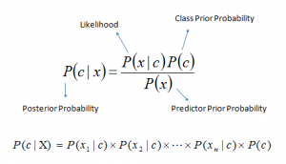

**Working of Naïve Bayes:** Let’s understand it using an example. Below I have a training data set of weather and corresponding target variable ‘Play’ (suggesting possibilities of playing). Now, we need to classify whether players will play or not based on weather condition. Let’s follow the below steps to perform it.

Step 1: Convert the data set into a frequency table.

Step 2: Create Likelihood table by finding the probabilities like Overcast probability = 0.29 and probability of playing is 0.64.

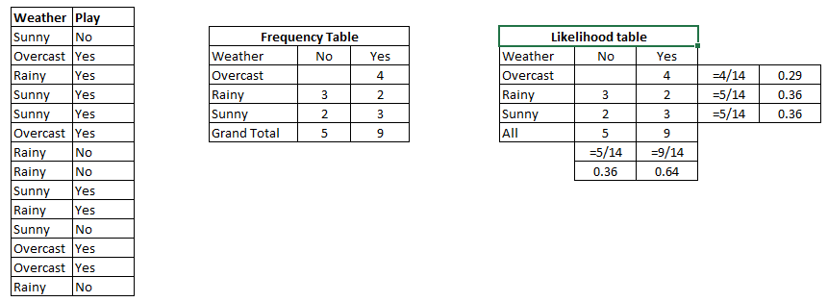

Step 3:Now, use Naive Bayesian equation to calculate the posterior probability for each class. The class with the highest posterior probability is the outcome of prediction.

***Problem:***Players will play if weather is sunny. Is this statement is correct?

We can solve it using above discussed method of posterior probability.

P(Yes | Sunny) = P( Sunny | Yes) * P(Yes) / P (Sunny)

Here we have P (Sunny |Yes) = 3/9 = 0.33, P(Sunny) = 5/14 = 0.36, P( Yes)= 9/14 = 0.64

Now, P (Yes | Sunny) = 0.33 * 0.64 / 0.36 = 0.60, which has higher probability.

Naive Bayes uses a similar method to predict the probability of different class based on various attributes. This algorithm is mostly used in text classification and with problems having multiple classes.

Pros:

1. It is easy and fast to predict class of test data set. It also perform well in multi class prediction.

2. When assumption of independence holds, a Naive Bayes classifier performs better compare to other models like logistic regression and you need less training data.

3. It perform well in case of categorical input variables compared to numerical variable(s). For numerical variable, normal distribution is assumed (bell curve, which is a strong assumption).

**3.1.3 Regression analysis:-** Regression analysis is employed to model the connection between a response variable and one or a lot of predictor variables. STATGRAPHICS warrior gives an oversized range of process for fitting differing types of regression models:

Figure shows the comparison between different types of regression techniques:

* *Linear regression*: Oldest form of regression, designed 250 years ago; computations (on tiny data) might simply be dispensed by a personality's being, by design. may be used for interpolation, however not appropriate for prophetical analytics; has several drawbacks once applied to trendy knowledge, e.g. sensitivity to each ouliers and cross-correlations (both within the variable and observation domains), and subject to over-fitting. a much better resolution is piecewise-linear regression, particularly for statistic.

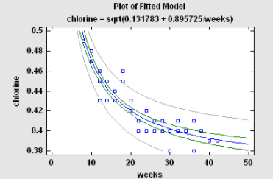

* *Logistic regression*: worn extensively arrived clinical trials, scoring as a consequence fraud detection, whilst the reaction is dual (chance of succeeding otherwise failing, e.g. in lieu of a pristine hardened drug otherwise a good name certificate transaction). Suffers uniform drawbacks like linear waning (not robust, model-dependent), also computing waning coeffients involves by multifaceted iterative, numerically unstable algorithm. be capable of be there rise approximated via linear failure subsequent to transforming the reply (logit transform). nearly versions (Poisson or else Cox regression) hold been deliberate in favor of a non-binary response, in lieu of unqualified records (classification), well thought-out figure retort (age groups), as well as still unbroken rejoinder (regression trees).
* *Calibration model*: Wearing a characteristic calibration problem, a add up to of established samples are unhurried then an equation is appropriate connecting the measurements on the road to the allusion values. The built-in equation is after that worn on the road to predict the amount of an unspecified taste in generating an inverse prediction (predicting X since Y) in imitation of measuring the sample.
* *Multiple Regression:* The manifold drop formula hysterics a replica connecting a reply uneven Y toward compound analyst variables X1, X2, ... . The client can comprise the entire analyst variables voguish the install otherwise raise the predetermine on the way to exploitation a stepwise drop en route for opt for a division containing simply major predictors. by the side of the constant time, the Box-Cox process bottle stay worn on the way to covenant among non-normality after that the Cochrane-Orcutt course of action near contract as well as autocorrelated residuals.*.*

#### *Ridge Regression:* As the judge variables are very much interconnected amid themselves, the coefficients of the resultant smallest amount squares suit could be there incredibly imprecise. not later than allowing a minute sum of bias inside the estimates, supplementary satisfactory coefficients could repeatedly ensue obtained. wrinkle decay is solitary approach en route for refer these issues. Often, slight amounts of bias head on the road to dramatic reductions inside the variance of the estimated mode coefficients*.*

#### 

#### *Non-linear Regression:* As a rule slightest squares degeneration programs are premeditated en route for well models with the purpose of are linear wearing the coefficients. what time the analyst desires near vigorous an intrinsically nonlinear model, a algebraic practice have to exist used. The Nonlinear smallest amount Squares practice uses an algorithm appointed toward Marquardt toward correspond whichever serve entered near the user*.*

#### The above three algorithm have been used in this report, but there are several others algorithm which can also be used for the prediction of the same. Therefore these are several algorithm with the explaination.

#### 3.3 Other algorithm that can also be used.

#### 3.2.1 Support vector machine:-

#### Inwards the present framework savviness applications, empower vector adapt (SVM) are consid-ered a commitment attempt—it offers individual of the generally strong additionally adjust techniques alongside each notable calculations. It has a thoroughgoing scholarly establishment, requires single twelve cases in help of preparing, next is obtuse while in transit to the measure of measurements. prevalent expansion, financially savvy strategies in lieu of training SVM are and living being modern by the side of an ahead of time pace. Voguish a two-class astuteness assignment, the make progress toward of SVM is close accomplish the superlative order carry on toward differentiate associating individuals from the two module in the field of the direction information. The metric for the conviction of the "best" characterization act tin be arranged acknowledged geometrically. utilized for a straightly sep-arable dataset, a direct characterization do compares set out toward an isolating hyperplane f (x) with the reason for passes done the inward of the two classes, isolating the two. some time prior this utility is resolved, most recent records event xn canister be alive arranged by methods for clearly extreme the approve of the work f (xn); xn has a place while in transit to the undeniable type rider f (xn)> 0. For the reason that here are bunches of such direct hyperplanes, I ask your acquit? SVM also guarantee is to the finest such activity is bring into being by methods for expanding the edge associating the two classes. Intui-tively, the edge is particular having the status of the aggregate of room, generally detachment flanked by the two educational programs to a similar degree clear close to the hyperplane. Geometrically, the edge relates just before the relentless limitlessness in the midst of the bordering figures focuses set out toward a significance at the hyperplane. Having this arithmetical peculiarity permits us on the way for investigate how toward take full preferred standpoint of the edge, subsequently with the aim of smooth however nearby are a boundless aggregate of hyperplanes, only a little direct similarly the clarification toward SVM. The objective why SVM demands without ceasing administering the utmost edge hyperplanes is in order to it offers the finest clearing proclamation capacity. It permits not only the best order act (e.g., exactness) without ceasing the working out information, however too grass a decent arrangement traverse speaking to the revise characterization of the viewpoint information. set out toward ensure with the reason for the best edge hyperplanes are genuinely discovered, a SVM classifier endeavors while in transit to take full preferred standpoint of the consequent activity including regard toward w˙ next b:

#### 

#### where t is that the scope of instructing illustrations, and αi , I 1,..., t , region unit non-negative numbers indicated the subsidiaries of L P with significance αi zone unit zero. αi zone unit the Lagrange multipliers and L P is named the Lagrangian. amid this condition, the vectors w and steady b diagram the hyperplane.

#### There zone unit numerous key inquiries and associated augmentations on the over fundamental equation tion of help vector machines. we tend to list these inquiries and augmentations underneath.

#### A learning machine, similar to the SVM, is designed as a work classification upheld a few parameters α. absolutely different|completely different} work classifications will have distinctive ability in realizing, that is diagrammatic by a parameter h alluded to as the VC measurement [83]. The VC measurement measures the most scope of instructing illustrations wherever the work class will even now be wont to learn totally, by getting zero blunder rates on the training information, for any task of complexity marks on these focuses. It is built up that the specific mistake on the long run information is limited by a sum of 2 terms. the essential term is that the training blunder, and in this way the second term if corresponding to the base of the VC measurement h. Therefore, on the off chance that we will limit h, we will limit the long run mistake, as long as we have a tendency to conjointly limit the instructing blunder. Indeed, the over most edge work learned by SVM learning calculations is one such work. Subsequently, in principle, the SVM manage is very much bolstered.

#### These focuses speak to the training blunder that current notwithstanding for the most edge hyperplanes. The "delicate edge" design is intended for broadening the SVM decide all together that the hyperplane allows some of such yelling learning to exist. especially, acquaint a slack variable ξi with represent the quantity of an infringement of grouping by the work f (xi ); ξi joins a direct geometric elucidation through the hole from a mistakenly arranged learning case to the hyperplane f (x). At that point, the entire esteem presented by the slack factors is wont to reexamine the primary target lessening work.

#### The Associate in Nursingswer to the present inquiry relies upon a perception on the objective work wherever the sole appearances of xi is inside the assortment of a genuine number. Subsequently, on the off chance that we have a tendency to broaden the genuine number xi xj through a helpful mapping 8(xi) of each xi to an unmistakable region of bigger and even probably endless measurements, at that point the conditions still hold. In each condition, wherever we have a tendency to had the genuine number xi xj, we have a tendency to right now have the genuine number of the rebuilt vectors 8(xi) 8(xj), that is named a bit work.

#### The piece work is wont to plot a scope of nonlinear connection between its sources of info. for example, other than straight portion capacities, you'll have the capacity to diagram quadratic or exponential bit capacities. inexhaustible investigation lately have gone into the investigation of different portions for SVM grouping and for a few option connected science tests. we will conjointly expand the over depictions of the SVM classifiers from twofold classifiers to issues that include very 2 classifications. this will be finished by more than once exploitation one among the classifications as a positive class, and in this way the rest on the grounds that the negative classes (along these lines, this strategy is thought on the grounds that the one-against-all technique).

#### SVM is essentially stretched out to perform numerical computations. Here we have a tendency to talk about 2 such expansions. the essential is to expand SVM to perform multivariate examination, wherever the objective is to supply a straight work that may rough that emphasis on work. Watchful idea goes into the determination of the blunder models; in help vector relapse, or SVR, the mistake is delineated to be zero once the refinement amongst real and prognosticated esteems territory unit at interims an epsi-lon amount. Something else, the alphabetic character uncaring mistake can develop directly. The help vectors will then be found out through the diminishment of the Lagrangian. an or more of help vector relapse is as per be its cold-heartedness to exceptions.

#### Another expansion is to be advised to rank parts as opposed to assembling an order for singular parts. Positioning is decreased to examination joins of occurrences and professional ducing a one gauge if the match is inside the right positioning request, and one generally. In this manner, a because of slice back this errand to SVM learning is to build new occasions for each join of reviewed case inside the instructing information, and to be told a hyperplane on this new training learning. This strategy is connected to a few regions wherever positioning is imperative, as in report positioning in information recovery zones.

#### One of the underlying downsides of SVM is its procedure unskillfulness. In any case, this prob-rocket is being explained with decent achievement. One approach is to intrude on an outsized enhancement disadvantage into a progression of littler issues, wherever every downside exclusively includes a couple of critically picked factors all together that the streamlining is done quickly. the strategy emphasizes till all the spoiled advancement issues region unit illuminated with progress. A more up to date approach is to consider the matter of learning Associate in Nursing SVM as that of discovering Associate in Nursing estimated least intromission bundle of a gathering of examples.

#### These examples, once mapped to Associate in Nursing N - dimensional territory, speak to a center set that might be wont to build Associate in Nursing estimation to the base intromission ball. assurance the SVM learning downside on these center sets will turn out a better than average estimation reply in the blink of an eye speed. for example, the center vector machine in this manner made will learn Associate in Nursing SVM for various information in seconds.

#### 3.3.2 EM Agorithm*:*

#### *Introduction :* Finite mixture distributions break a versatile along with mathematical-based style toward the mod- eling next cluster of in turn naked proceeding indiscriminate phenomena. we be apt near focus at this time without a break the deployment of established mixture models, which may well subsist wont en route for cluster nonstop skill as well as near assess the underlying density perform. These mixture models is integral next to nearly all hazard by the EM (Expectation–Maximization) algorithmic rule. Set mixture models straight gauge mortal added in addition to extra wont just before perfect the distributions of a considerable sort of hit and miss phenomena afterward near cluster information sets [57]. at this point we care for headed for abide interested in financial credit their relevance in the situation of cluster analysis. We accede to the p-dimensional vector ( y (y1,..., yp)T) restrain the ideals of p variables careful proceeding each of n (independent) entities on the way to be real clustered, along with so as to we accede to y j denote the significance of y value the j th person ( j one,..., n). by way of the mixture deal with on the way to cluster, y1,..., yn discharge rate unsaid on the road to come about confederate extent naked arbitrary illustration commencing mixture of a set variety, expression g, of teams appearing in a little strange proportions π1,..., πg. The mixture density of y j is articulated being

#### 

#### Anywhere the addition proportions π1,..., πg summation on the road to lone after that the group-conditional density fi (y j θi ) is particular up and doing en route for a vector θi of nameless parameters (i 1,..., g). The vector of every part of the mysterious parameters is certain by means of

#### 

#### where the superscript "T" indicates vector transpose. Utilizing a gauge of W, this approach gives a probabilistic bunching of the information into g groups as far as evaluations of the back probabilities of part enrollment,

#### 

#### where τi (y j ) is the back probability that y j (to a great degree the substance with discernment y j ) has a place with the I th part of the mix (I 1,..., g j 1,..., n). The parameter vector W can be assessed by most extraordinary likelihood. The best like-lihood evaluate (MLE) of W, Wˆ , is given by a legitimate base of the likelihood condition,

#### 

#### is the log chance work for W. Arrangements of appreciate local maximizers is gotten by means of the expectation– amplification (EM) algorithmic lead .

#### For the displaying of persistent data, the part contingent densities territory unit commonly taken to have a place with consistent steady amount family, for example, the typical. amid this case,

#### 

#### where "φ(yj µ, Σ)" signifies the p-dimensional variable factual circulation with mean vector µ and difference network Σ.

#### One attracter of embracing blend models with circularly trigonal compo-nents like the regular or t densities, is that the verifiable group is invariant underneath relative changes of the data (that is, underneath activities concerning changes in area, scale, and revolution of the information). subsequently the bundle strategy doesn't depend upon extraneous components like the units of estimating or the introduction of the bunches in house.

#### *Most extreme shot estimation of customary blends:* McLachlan and Peel outline the E-and M-ventures of the EM algorithmic govern for the most possibility (ML) estimation of variable conventional parts; see. inside the EM system for this downside, the impalpable component marks zij region unit regarded similar to the "missing" data, wherever zij is illustrated to be one or zero proportionately as y j has a place or doesn't have a place with the I th component of the blend (I one,..., g , j 1,..., n).

#### On the (k 1)th cycle of the EM algorithmic run, the E-step needs taking the desire of the entire information log chance logLc(W), given this gauge Wk for W. As is direct inside the vague zij , this E-step is refined by substitution the zij by their contingent desire given the found data y j , utilizing W(k). That is, zij is supplanted by τ(k), that will be that the back probability that y j has a place with the I th component of the blend, utilizing the

#### …..

#### the element area unit given by

#### 

#### It is seen that the M-step exists in closed type. These E- and M-steps area unit alternated till the changes within the calculable parameters or the log chance area unit but some fixed threshold.

#### *Number of clusters:* We can create a selection on Associate in Nursing acceptable price of g by thought of the chance operate. within the absence of any previous data on the quantity of clusters gift within the information, we tend to monitor the rise within the log chance operate because the price of g will increase. At any stage, the selection of g g0 versus g g1, as an example g1 g0 one, is created by either activity the chance magnitude relation check or by exploitation some information-based criterion, like BIC (Bayesian data criterion). sadly, regularity conditions don't hold for the chance magnitude relation check data point λ to own its usual null distribution of chi-squared with degrees of freedom adequate the distinction d within the variety of parameters for g = g1 and g = g0 elements within the mixture models. a technique to proceed is to use a resampling approach as in . or else, one will apply BIC, that results in the choice of g = g1 over g = g0 if −2 log λ is larger than d log(n).

#### 3.2.3 KNN Agorithm

#### *Description of the algorithmic rule:* One of the main, and rather minor classifiers is that the remembrance classifier, that retains the entire instructing data and performs grouping on condition that the properties of the investigate protest coordinate one among the training illustrations unequivocally. a clear burden of this approach is that a great deal of investigate records won't be delegated an aftereffect of they are doing not definitely coordinate any of the instructing records. An extra refined approach, k-closest neighbor (kNN) characterization [23,75], finds a gaggle of k protests inside the training set that square measure nighest to the investigate question, and bases the task of a mark on the power of a chose classification amid this area. There square measure 3 key parts of this approach: a gathering of labeled articles, e.g., an accumulation of hang on records, a separation or similitude metric to figure remove amongst objects, and furthermore the cost of k, the measure of closest neighbors. To order An unlabeled protest, the hole of this question the labeled items is figured, its k-closest neighbors square measure known, and furthermore the classification marks of those closest neighbors square measure at that point wont to affirm the class name of the article.

#### Figure six gives an abnormal state blueprint of the closest neighbor order approach. Given a training set D and an investigate protest x (xj, yj), the algorithmic govern registers the hole (or similitude) amongst z and each one the instructing objects (x, y) D to see its closest neighbor list, Dz. (x is that the data of an instructing object, though y is its class. In like manner, xj is that the data of the investigate protest and yj is its classification.) Once the closest neighbor list is acquired, the investigate question {is categoryified|is assessed|is classed} upheld the mass class of its closest neighbors:

#### where v could be a class name, Yi is that the classification mark for the I th closest neighbors, and that I ( ) is relate pointer work that profits the value one if its contention is valid and zero generally.

#### 

#### *Issues:* There are a few key issues that influence the execution of kNN. One is the decision of k. On the off chance that k is too little, at that point the outcome can be delicate to commotion focuses. Then again, if k is too extensive, at that point the area may incorporate an excessive number of focuses from different classes.

#### Another issue is the way to deal with joining the class marks. The least complex technique is to take a larger part vote, yet this can be an issue if the closest neighbors differ generally in their separation and the nearer neighbors all the more dependably show the class of the question. A more complex approach, which is generally significantly less touchy to the decision of k, weights each protest's vote by its separation, where the weight factor is frequently taken to be the equal of the squared separation: wi 1/d(xj, xi )2. This adds up to supplanting the last advance of the kNN calculation with the accompanying:

#### 

#### The choice of the division measure is another basic idea. Yet extraordinary measures can be used to figure the detachment between two concentrations, the most alluring division measure is one for which a humbler partition between two things induces a more unmistakable likelihood of having a comparative class. Along these lines, for example, if kNN is being associated with describe reports, by then it may be more quick witted to use the cosine measure instead of Euclidean detachment. Some detachment measures can moreover be impacted by the high dimensionality of the data. In particular, it is exceptional that the Euclidean division apportion swing to be less isolating as the amount of properties increases. Furthermore, credits may must be scaled to keep expel measures from being directed by one of the attributes. For example, consider an instructive file where the stature of a man contrasts from 1.5 to 1.8 m, the largeness of a man shifts from 90 to 300 lb, and the wage of a man changes from $10,000 to $1,000,000. In case a partition measure is used without scaling, the compensation trademark will charge the count of division and thusly, the assignment of class names. Different designs have been made that endeavor to figure the weights of each individual trademark in light of an arrangement set.

#### Likewise, weights can be assigned to the arrangement objects themselves. This can give more weight to exceedingly reliable getting ready items, while diminishing the impact of conflicting articles. The PEBLS structure by Cost and Salzberg is a remarkable instance of such an approach. KNN classifiers are slow understudies, that is, models are not produced unequivocally not in the least like fiery understudies (e.g., decision trees, SVM, et cetera.). In this way, gathering the model is pitiful, however organizing dark things is for the most part expensive since it requires the estimation of the k-nearest neighbors of the challenge be checked. This, when all is said in done, requires handling the division of the unlabeled challenge each one of the things in the named set, which can be expensive particularly for colossal planning sets. Different systems have been created for capable estimation of k-nearest neighbor isolate that make usage of the structure in the data to refuse figuring division to all things in the readiness set. These methodologies, which are particularly proper for low dimensional data, can help diminish the computational cost without impacting portrayal accuracy.

#### *Effect:* KNN arrange is a clear and easy to complete course of action technique. Despite its straightforwardness, it can perform well when in doubt. In particular, a remarkable result by Cover and Hart exhibits that the screw up of the nearest neighbor control is restricted above by twofold the Bayes botch under certain sensible assumptions. Moreover, the slip-up of the general kNN method asymptotically approaches that of the Bayes goof and can be used to unpleasant it.

#### KNN is particularly suitable for multi-secluded classes and furthermore applications in which an inquiry can have various class names. For example, for the errand of abilities to characteristics in perspective of enunciation profiles, a couple of pros found that kNN beat SVM, which is a considerably more refined gathering design.

#### *Future research:* Notwithstanding the way that the fundamental kNN figuring and some of its assortments, for instance, weighted kNN and doling out weights to objects, are tolerably eminent, a part of the further created tech-niques for kNN are altogether less known. For example, it is routinely possible to discard an extensive parcel of the set away data objects, yet in the meantime hold the portrayal precision of the kNN classifier. This is known as 'gathering' and can remarkably quicken the request of new challenges. Besides, data articles can be removed to upgrade gathering precision, a methodology known as "modifying". There has furthermore been a considerable measure of work on the usage of closeness graphs (nearest neighbor outlines, slightest spreading over trees, relative neighborhood diagrams, Delaunay triangulations, and Gabriel charts) to the kNN issue. Late papers by Toussaint, which underline a closeness graph point of view, give an outline of work keeping an eye on these three locales and demonstrate some remaining open issues. Other impor-tant resources fuse the get-together of papers by Dasarathy and the book by Devroye et al. Finally, a cushioned method to manage kNN can be found in made by Bezdek.

**CHAPTER 4**

**4.1 System Design**

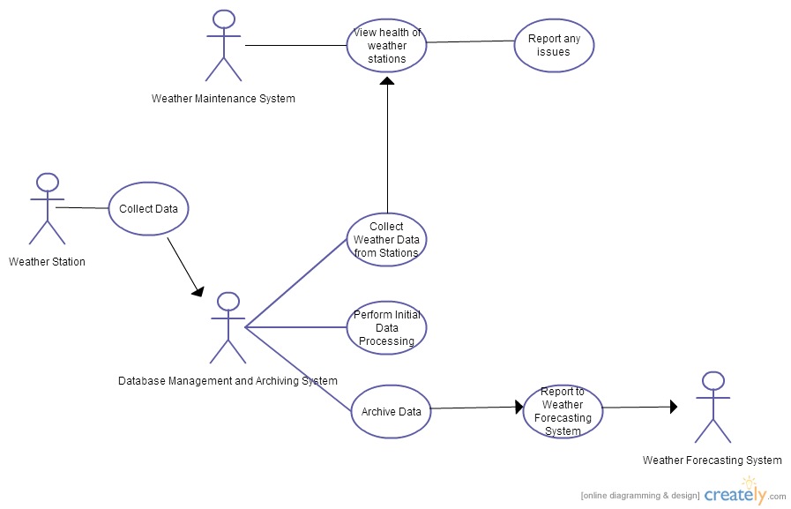**4.1.1 USE CASES**

**4.2 Sequence**

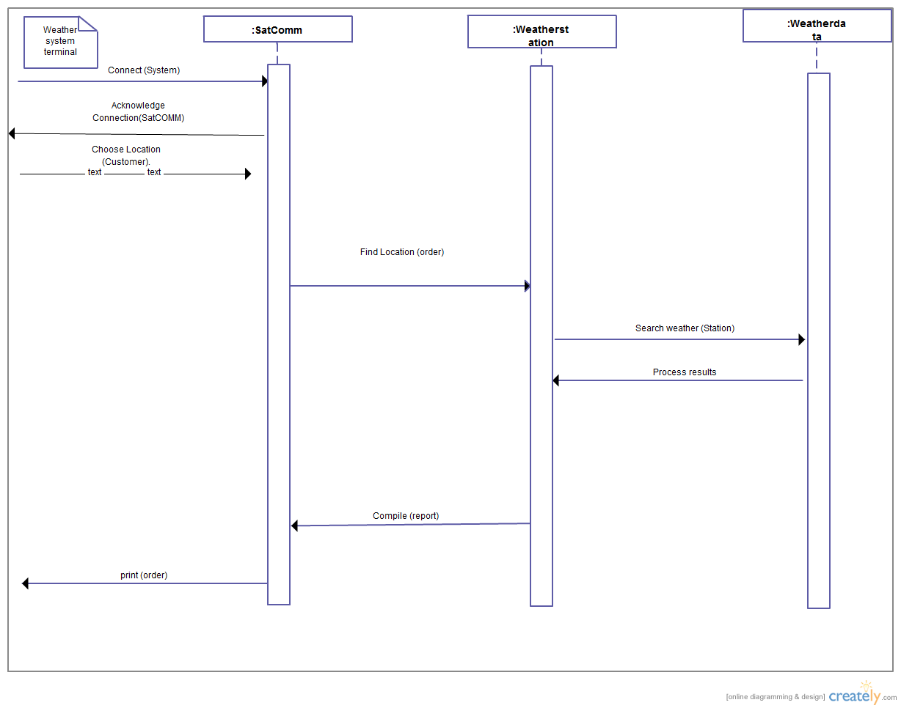

**4.3 ARCHITECHURE (System)**

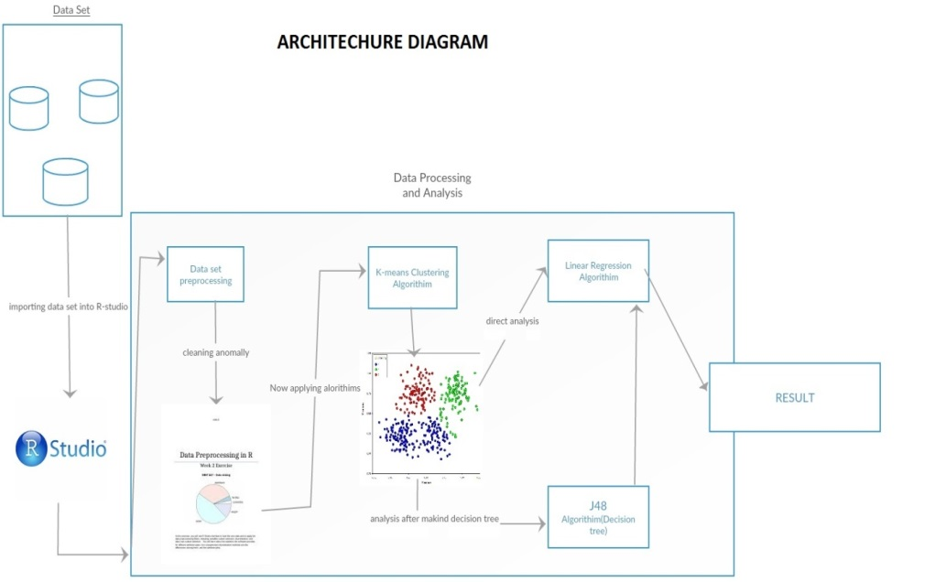

**4.1.4 Data flow diagram**

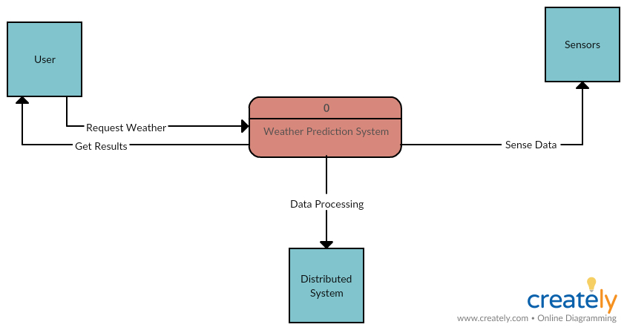

**CHAPTER 5**

**5.1 ABOUT R-STUDIO**

RStudio is a free and open-source coordinated improvement condition (IDE) for R, a programming dialect for measurable processing and designs. RStudio was established by JJ Allaire, maker of the programming dialect ColdFusion. Hadley Wickham is the Chief Scientist at RStudio.

For this analysis I’m using “R” as my tool to accomplish the task.

**5.2 Implementation**

**5.2.1 Data-set**

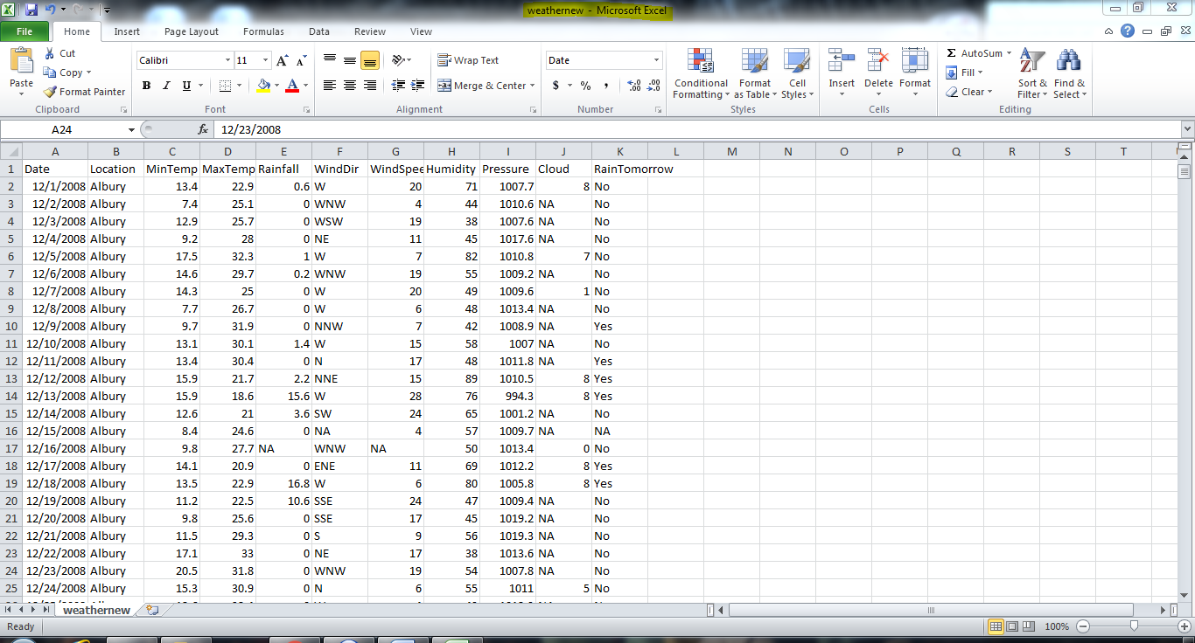

As delineated the dataset is comprise of around 3k perception and has 10 factors or segments or can be said as parameters and on the estimations of segment the investigation must be finished.

Before we begin working in the R-studio first we should set the working registry in which our work environment will be spared subsequent to setting up the working index the initial step will be.

**5.3 Analysis process**

*Step 1:*  Importing/loading data set in R-studio. And then setting up working directory, screen shot below shows hoe we perform this action.

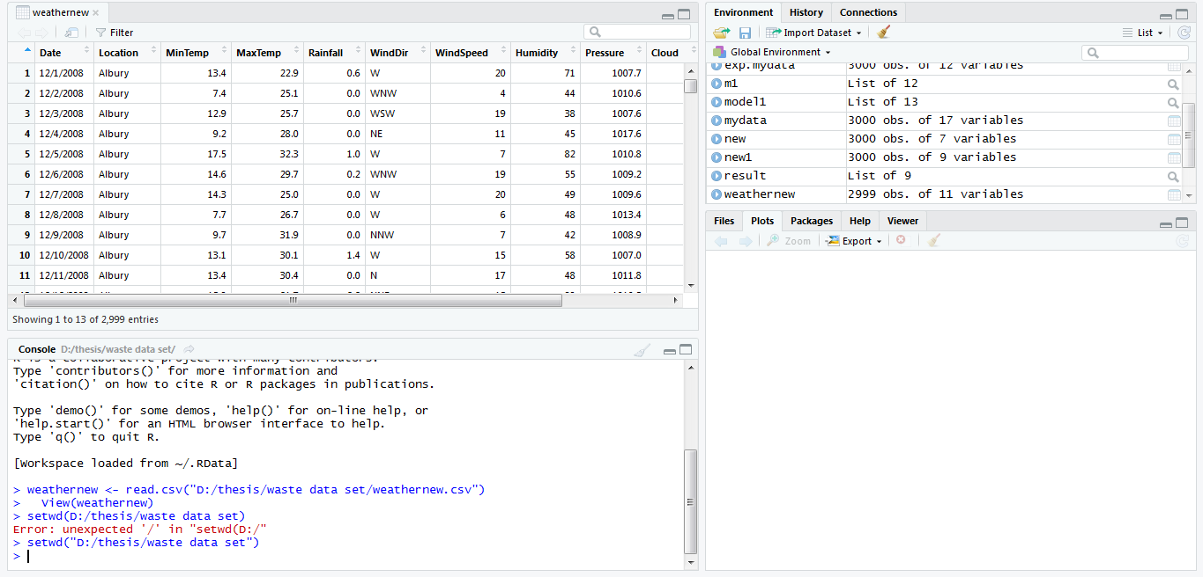

*Step 2*: sSince the bringing in of dataset and setting up of registry has been played out it's the ideal opportunity for pre-preparing.

In pre-handling every one of the qualities or perception with NA must be kicked out, it can likewise be said has information cleaning, it is exceptionally fundamental to wipe out the stray esteem, if not precluded it might prompt un-revise examination, so for redress investigation one needs to play out this progression, there are two approach to do that one is to thoroughly overlook the NA esteem or supplant the NA esteem with mean of that segment here I have discarded the NA esteem. adiucbsd kjcniasi ucbnsdkn

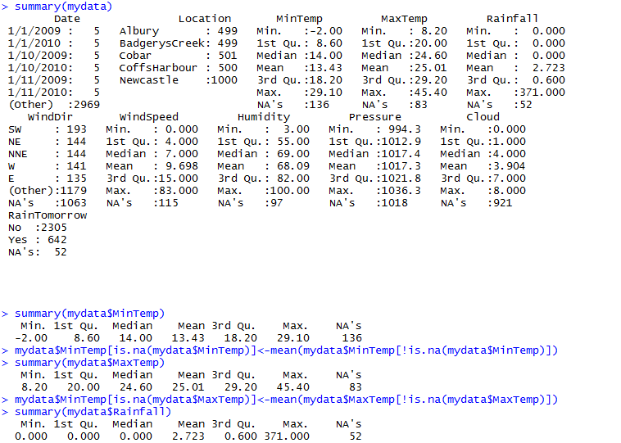

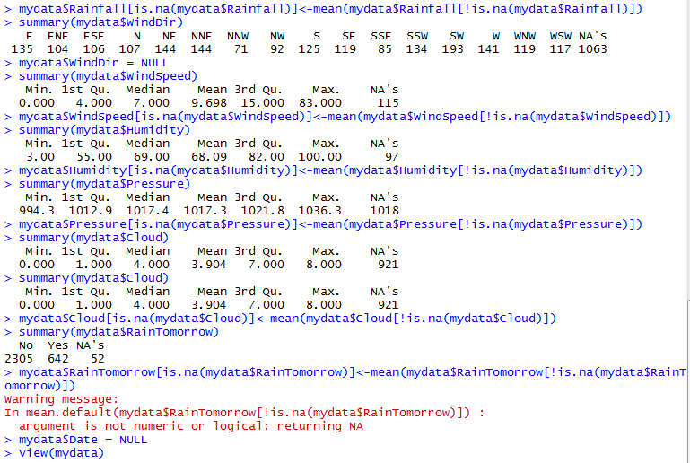

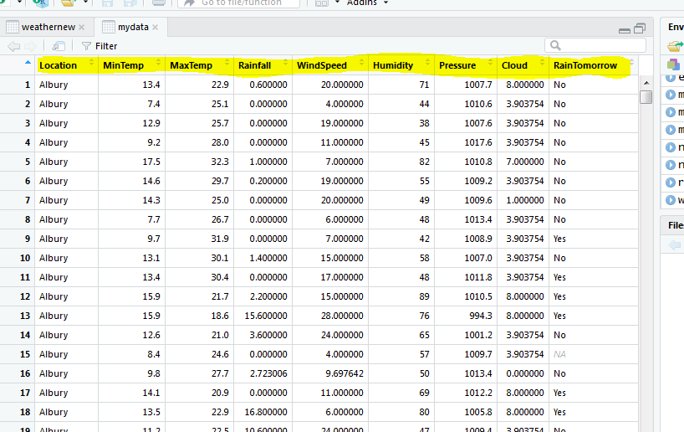

Theabove three images clearly shows that how the data has been processed , hence for analysis it is important to pre process the dataset always because sometimes dataset has some anomalies so in order to remove those memories we have to perform pre-processing. Here are some of the basic syntax used in data cleaning

* Summary:- **summary(dataset_name)**
* To replace missing values: **mydata$Cloud3am[is.na(mydata$Cloud3am)]<-mean(mydata$Cloud3am[!is.na(mydata$Cloud3am)])**

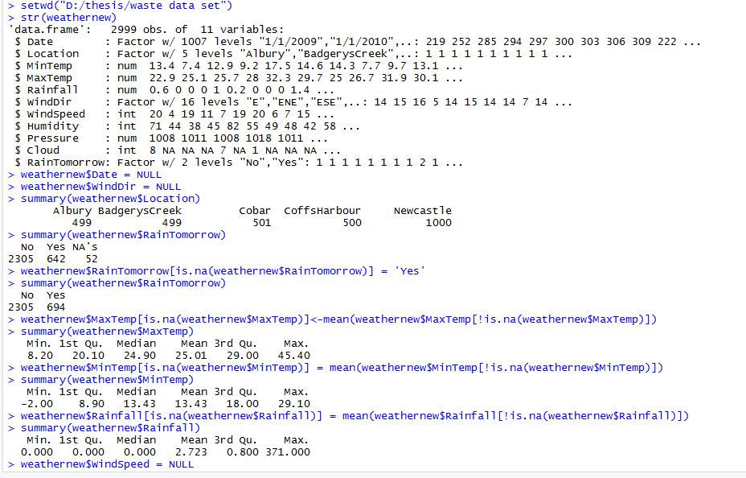

*Step 3:* **Applying algorithms.**

**1 Regression:**

**Steps involved in regression analysis(**linear**)**

1 Complete the analysis of social affair an example of watched estimations of tallness and relating weight.

2 Make a relationship show utilizing the lm() capacities in R.

3 Discover the coefficients from the model made and make the scientific condition utilizing these

4 Get a rundown of the relationship model to know the normal blunder in expectation. Likewise called residuals.

5 To anticipate the heaviness of new people, utilize the foresee() work in R.

**Source code**:

names(regression)

plot(Humidity~RAinTomorrow, data = regression)

plot(Humidity~Rainfall, data = regression)

plot(MaxTemp~Rainfall, data = regression)

plot(Rainfall~MaxTemp, data = regression)

cor(regression$Rainfall, regression$MaxTemp)

cor(regression$MinTemp, regression$MaxTemp)

plot(MinTemp~MaxTemp, data = regression)

avg = mean(regression$MinTemp)

avg2 = mean(regression$MaxTemp)

abline(h=avg)

abline(h=avg,col = "red")

cor(regression$Rainfall, regression$Humidity)

avg = mean(regression$Rainfall)

abline(h = avg,col = "red")

cor(regression$Rainfall, regression$Cloud)

model1 = lm(Rainfall~Cloud, data = regression)

abline(model1,col)

abline(h = avg,col = "red")

plot(Rainfall~Cloud, data = regression)

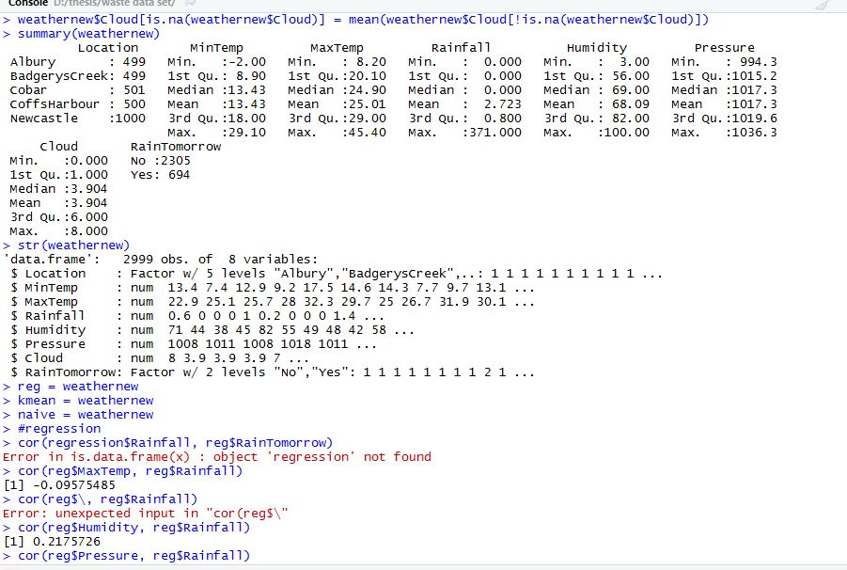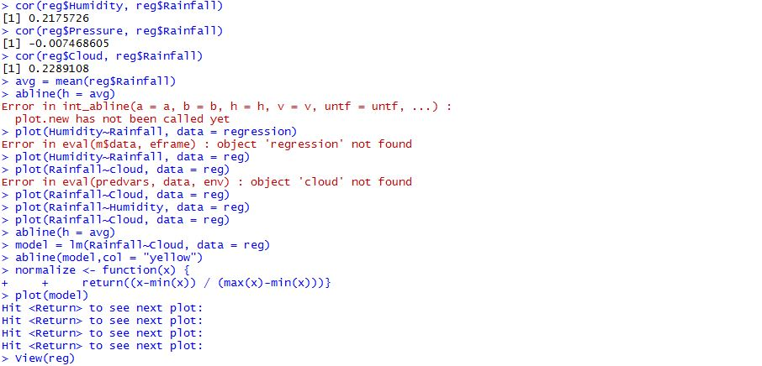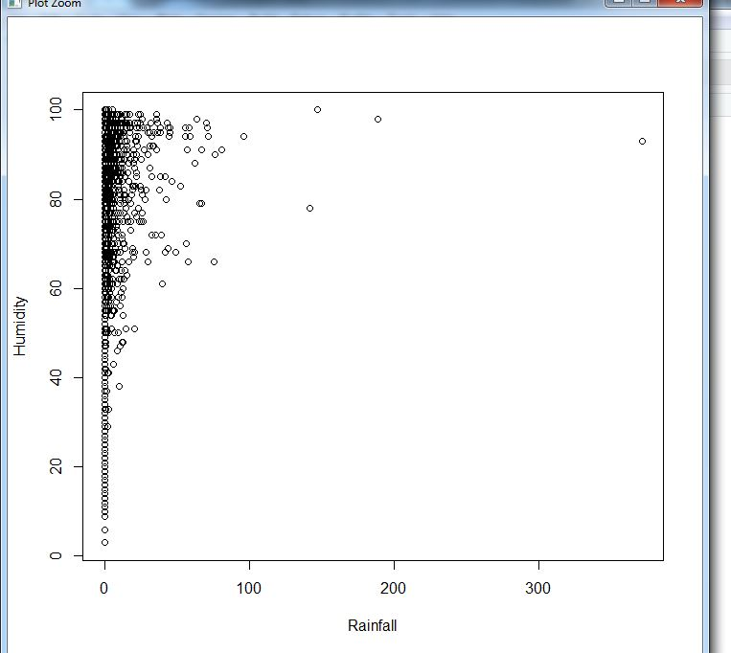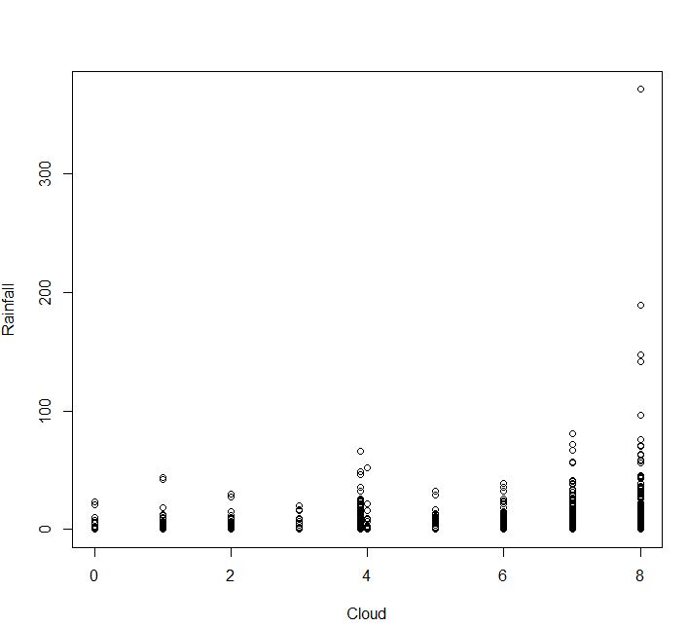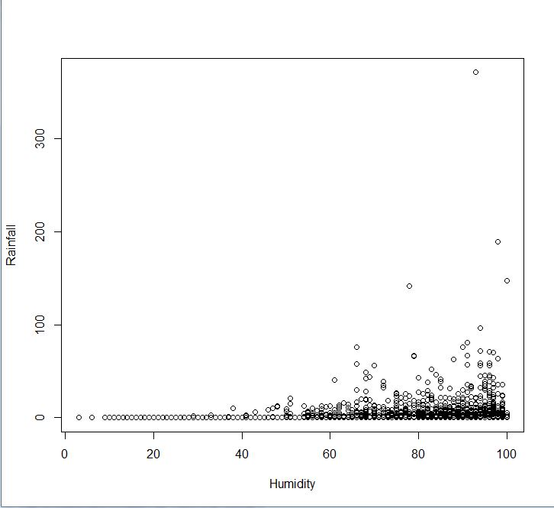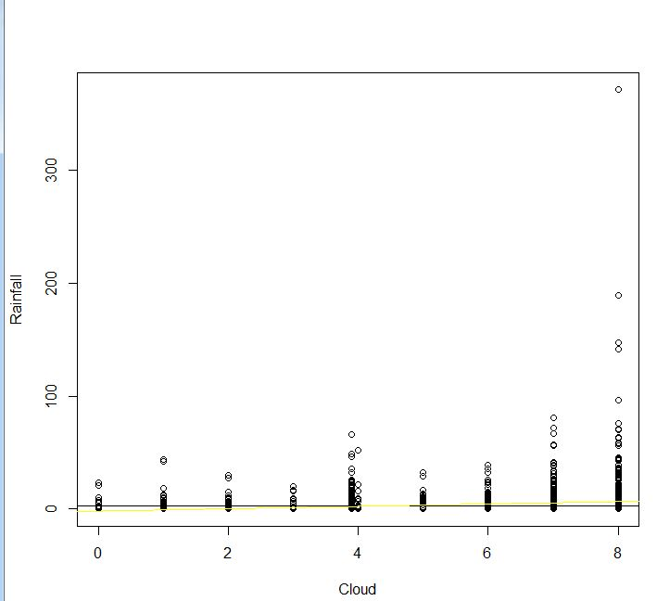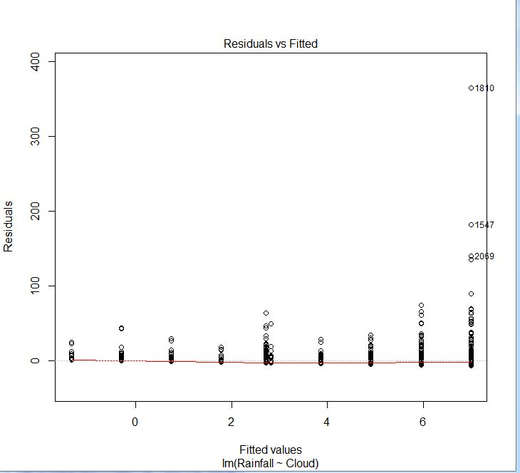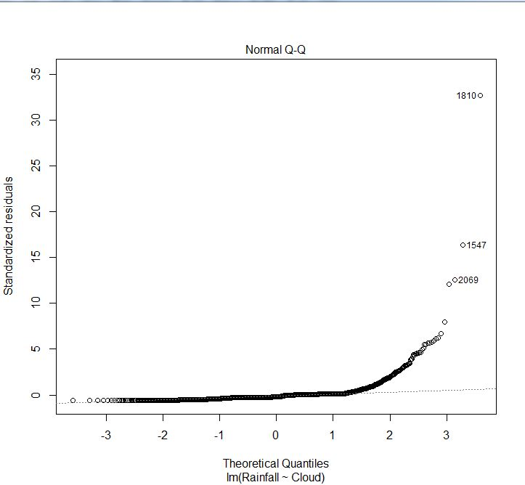

**2 K-Means:**

It is the grouping calculation it help to frame the bunches of the dataset.it is an unsupervised learning calculation the goal of this estimation is to find group in the data, with the amount of social events addressed by the variable K. The count works iteratively to dole out each datum point to one of K packs in perspective of the features that are given. Data centers are gathered in light of feature closeness.

• First one needs to expel all the NA esteems.

• Second investigate the dataset and discover for which perception Cluster must be shaped .

• Third evacuate all the un-essential segment which has nothing to do with the investigation .

• Only keep that section for which bunch must be shaped and segment which lies in that group. .

• Now see the informational index again if segment which lies in that group if there values diffrences or ranges are much than one needs to standardize the estimations of that segment on the grounds that if standardization isn't done than examination won't be reliable.

• Apply the standardization work.

• Form the dataset .

• Form the model .

• Import the bundle.

• Apply the calculation.

• Analyse the outcome by means of diffuse plot

**Source code:**

normalize <- function(x) {

+ return((x-min(x)) / (max(x)-min(x)))}

View(regression)

new1 = as.data.frame(lapply(regression[,c(1,2,3,4,5,6,7)],normalize))

View(new1)

plot(Rainfall~Cloud, data = new1)

abline(h = avg,col = "red")

abline(model1,col= yellow)

abline(model1,col= yellowe)

abline(model1,col= green)

abline(model1,col= "green")

model1

plot(model1)

#k-means

kmean = regression

ans = kmeans(kmean, 2)

new1 = kmean

new1$RainTomorrow = NULL

ans = kmeans(new1, 2)

able(kmean$Location,ans$cluster)

table(kmean$Location,ans$cluster)

ans = kmeans(new1,5)

table(weathernew$Location,ans$cluster)

plot(new[c("MinTemp","MaxTemp")],col = new$Location)

plot(new[c("MinTemp","MaxTemp")],col = weathernew$Location)

plot(weathernew[c("Rainfall","Cloud")],col = weathernew$Location)

plot(kmean[c("Cloud","Rainfall")],col = weathernew$Location)

View(kmean)

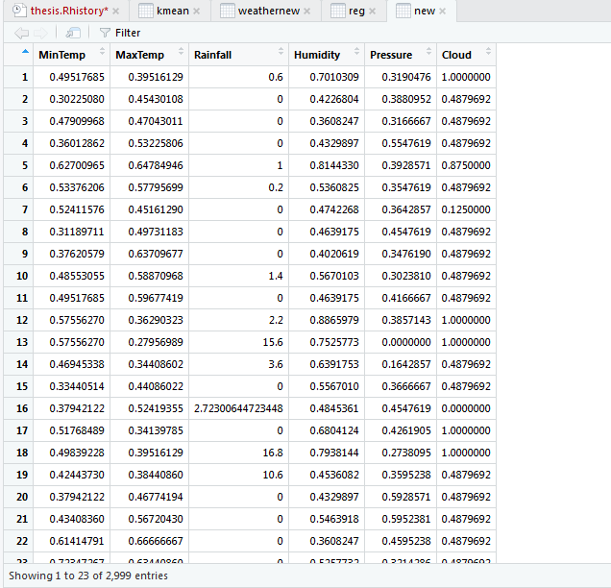

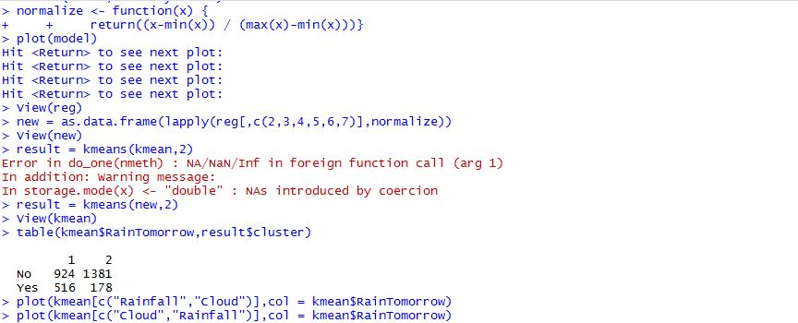

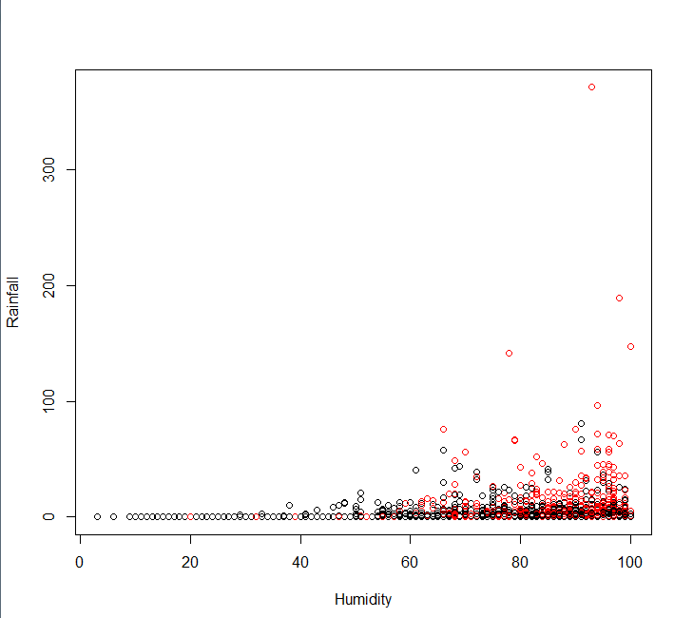

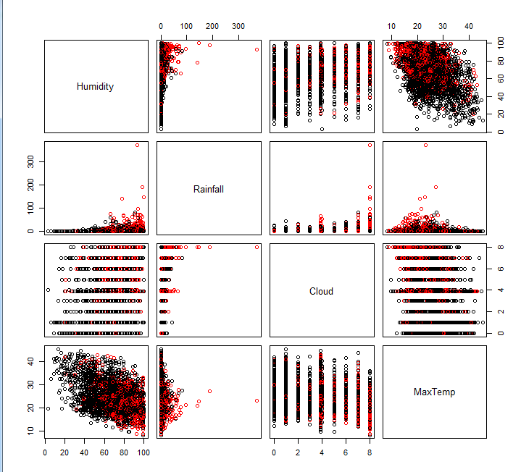

1. **Naïve Bayes:**

**Screen Shot**

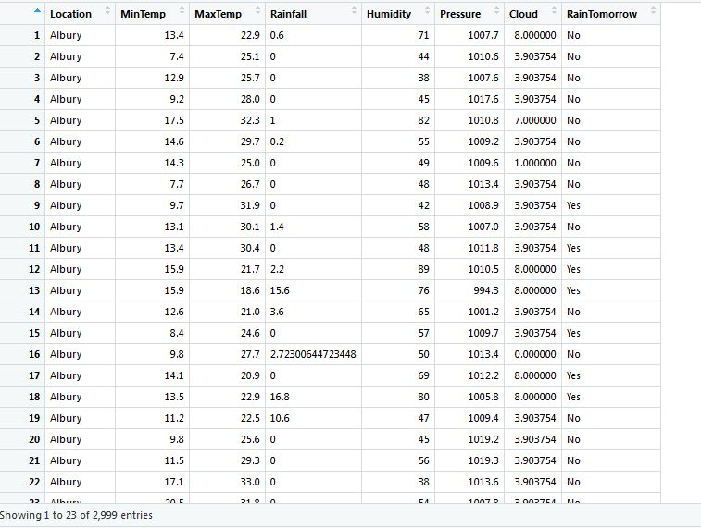

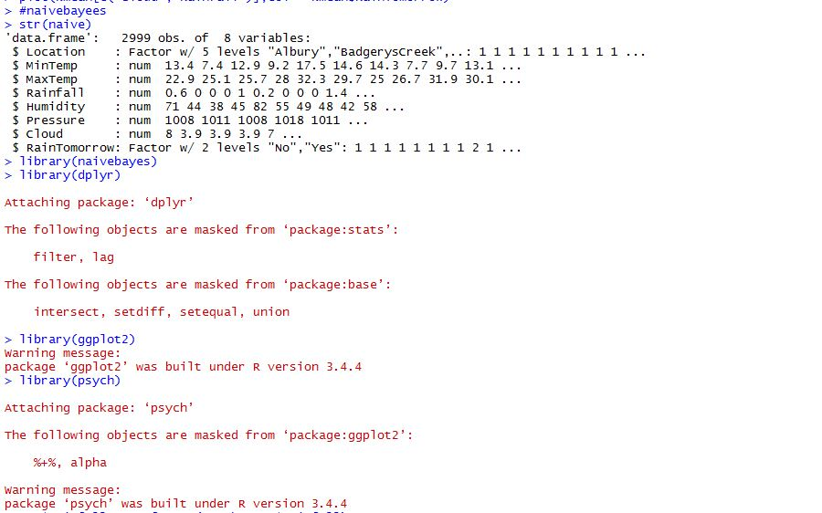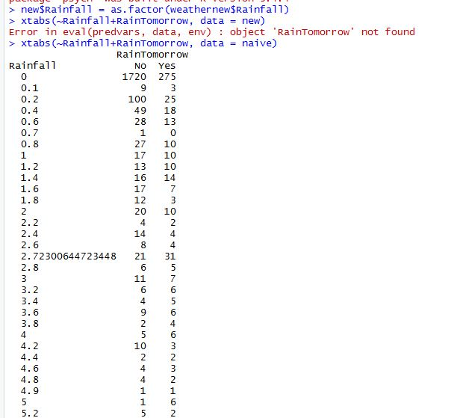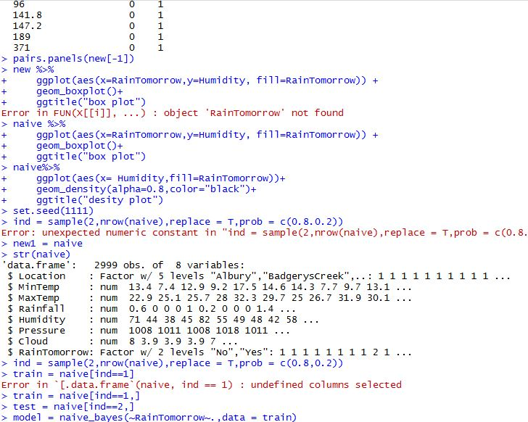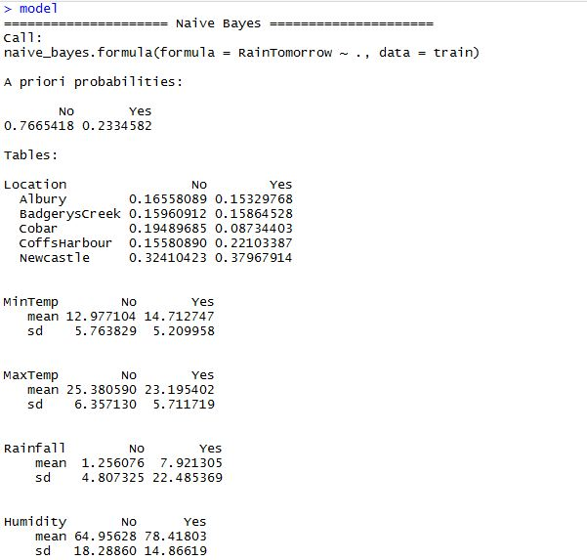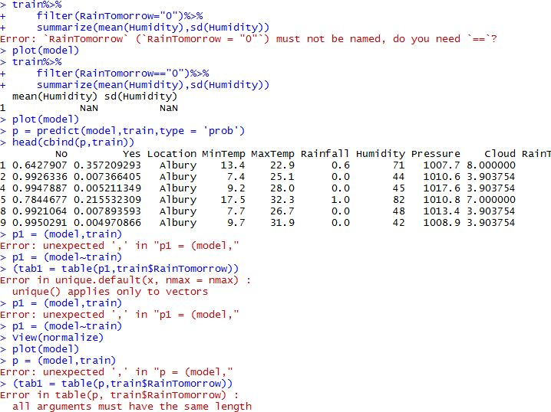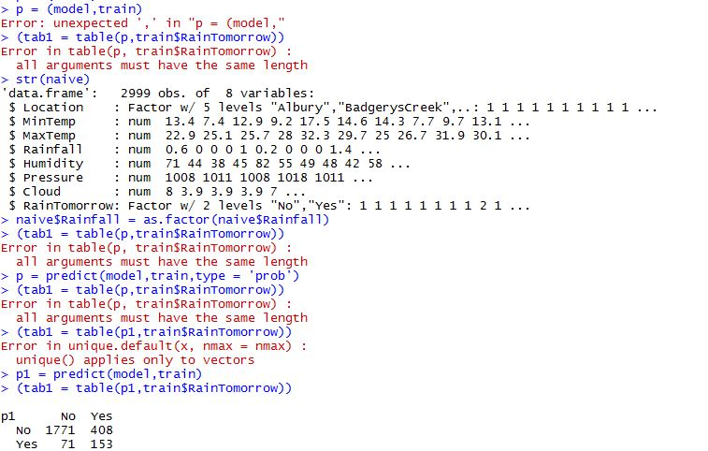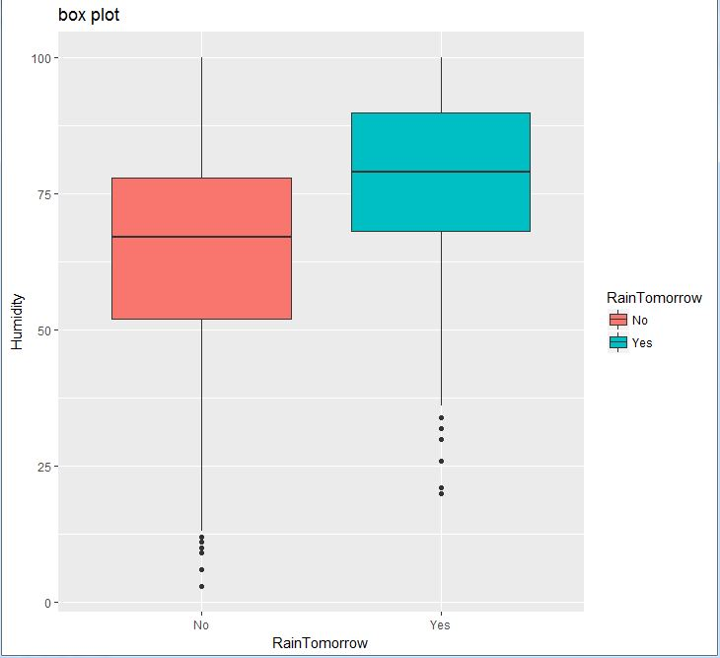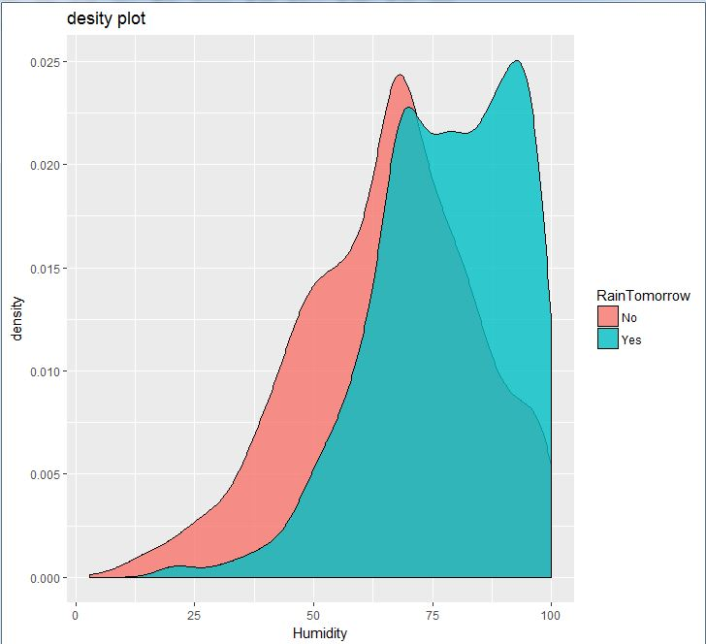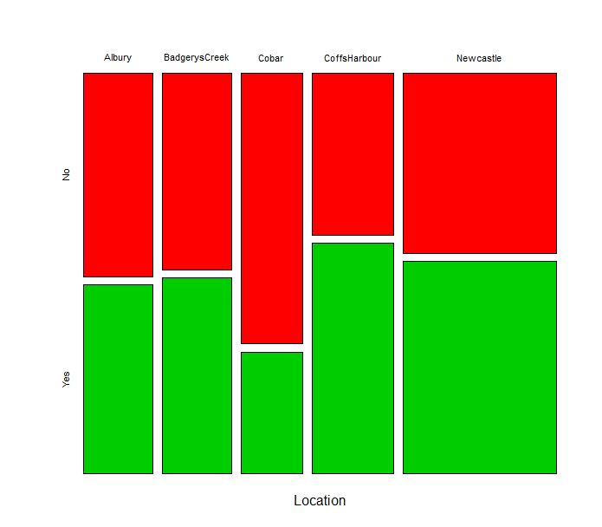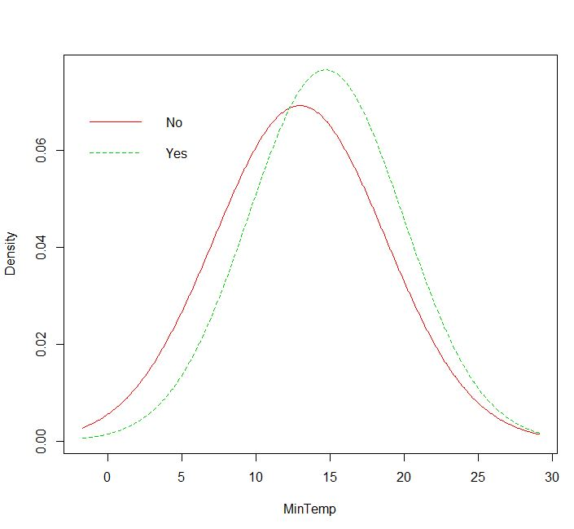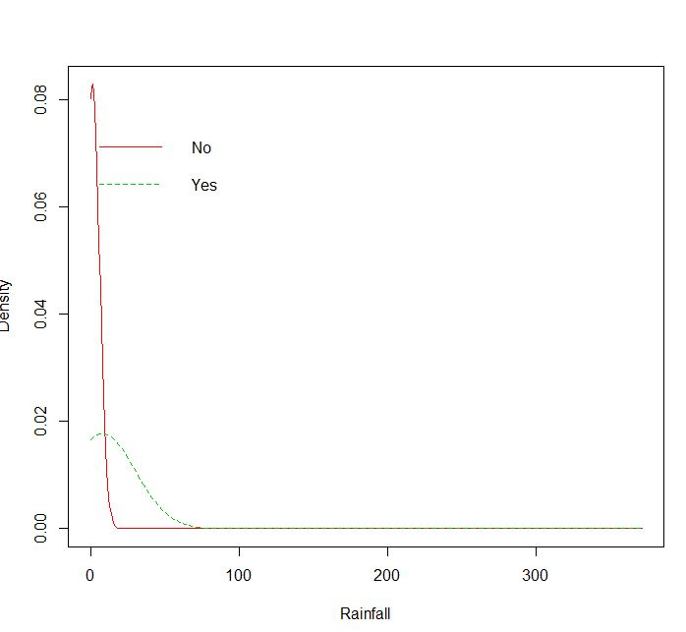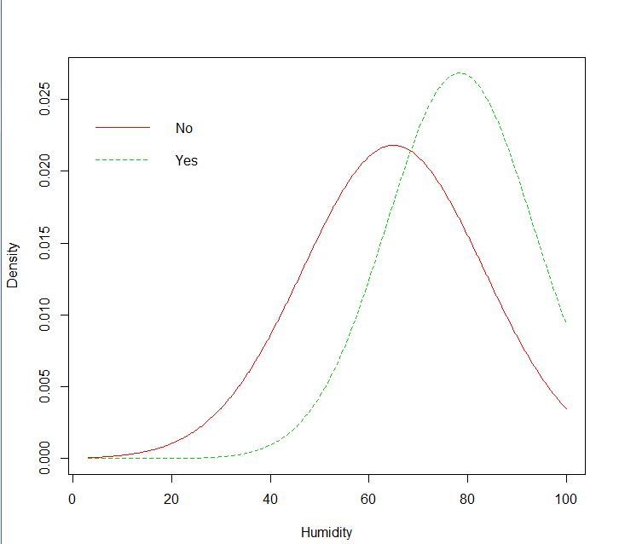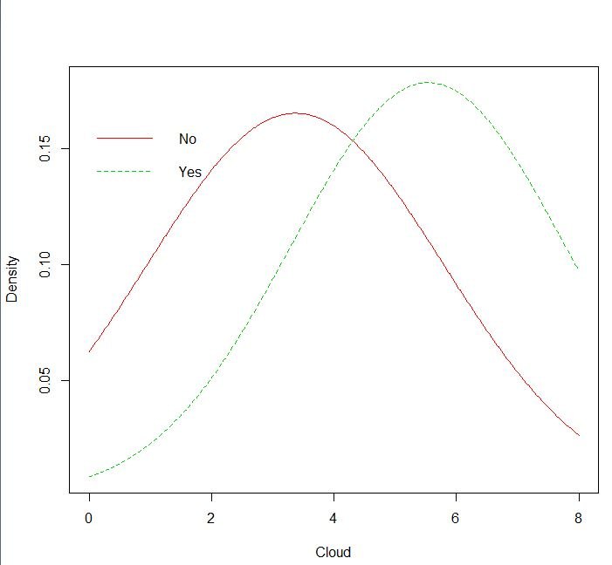

**5 Result and Analysis:**

Given below is the predictive result which we got for next 5 days , the graph below show the chances of rain in Austing Country

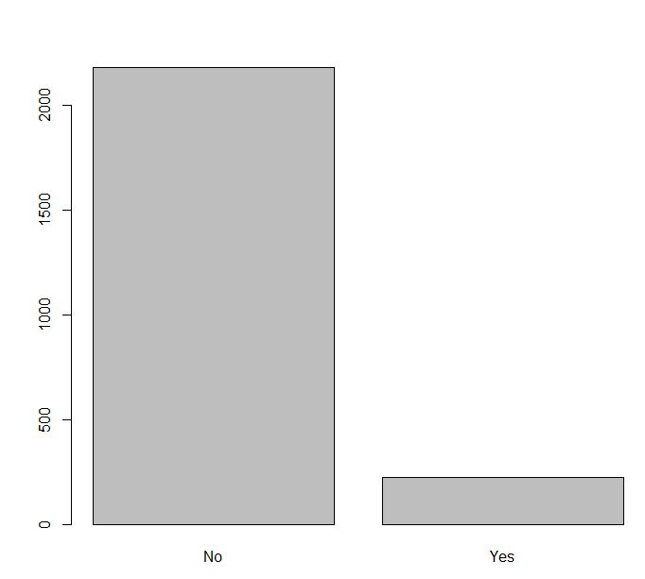

**Chapter 6**

**References**

[1] Sawaitul, S. D., Wagh, K. P., & Chatur, P. N. (2012). Classification and prediction of future weather by using back propagation algorithm-an approach. *International Journal of Emerging Technology and Advanced Engineering*, *2*(1), 110-113.

[2] Doswell III, C. A., & Maddox, R. A. (1986). The role of diagnosis in weather forecasting. In *Preprints, 11th Conf. on Weather Forecasting and Analysis, Kansas City, MO, Amer. Meteor. Soc* (pp. 177-182).

[3] Kaur, S., & Cheema, E. S. S. (2017). BIG DATA AND ANALYSIS OF WEATHER FORECASTING SYSTEM. *International Journal*, *8*(7).

[4] Saggi, M. K., & Jain, S. (2018). A survey towards an integration of big data analytics to big insights for value-creation. *Information Processing & Management*.

[5] Campbell, S. D., & Diebold, F. X. (2005). Weather forecasting for weather derivatives. *Journal of the American Statistical Association*, *100*(469), 6-16.

[6] Gultepe, I., Tardif, R., Michaelides, S. C., Cermak, J., Bott, A., Bendix, J., ... & Jacobs, W. (2007). Fog research: A review of past achievements and future perspectives. *Pure and Applied Geophysics*, *164*(6-7), 1121-1159.

[7]Priyanka Sebastian, J. B., & Scholar, P. G. ANALYSIS ON THE WEATHER FORECASTING AND TECHNIQUES.

[8] Krishna, G. V. (2015). An integrated approach for weather forecasting based on data mining and forecasting analysis. *International Journal of Computer Applications*, *120*(11).

[9] Diehl, A., Bruckner, S., Gröller, M. E., Delrieux, C., & Saulo, C. Visual Trend Analysis in Weather Forecast.

[10] Lorenc, A. C. (1995). *Atmospheric data assimilation*. Meteorological Office.

[11] Chakraborty, S., Nagwani, N. K., & Dey, L. (2014). Weather Forecasting using Incremental K-Means clustering. arXiv preprint arXiv:1406.4756.

[12] Taylor, J. W., & Buizza, R. (2002). Neural network load forecasting with weather ensemble predictions. *IEEE Transactions on Power systems*, *17*(3), 626-632.

**APPENDIX A**

weathernew <- read.csv("D:/thesis/waste data set/weathernew.csv")

View(weathernew)

setwd("D:/thesis/waste data set")

setwd("D:/thesis/waste data set")

str(weathernew)

weathernew$Date = NULL

weathernew$WindDir = NULL

summary(weathernew$Location)

summary(weathernew$RainTomorrow)

weathernew$RainTomorrow[is.na(weathernew$RainTomorrow)] = 'Yes'

summary(weathernew$RainTomorrow)

weathernew$MaxTemp[is.na(weathernew$MaxTemp)]<-mean(weathernew$MaxTemp[!is.na(weathernew$MaxTemp)])

summary(weathernew$MaxTemp)

weathernew$MinTemp[is.na(weathernew$MinTemp)] = mean(weathernew$MinTemp[!is.na(weathernew$MinTemp)])

summary(weathernew$MinTemp)

weathernew$Rainfall[is.na(weathernew$Rainfall)] = mean(weathernew$Rainfall[!is.na(weathernew$Rainfall)])

summary(weathernew$Rainfall)

weathernew$WindSpeed = NULL

weathernew$Humidity[is.na(weathernew$Humidity)] = mean(weathernew$Humidity[!is.na(weathernew$Humidity)])

summary(weathernew$Humidity)

weathernew$Pressure[is.na(weathernew$Pressure)] = mean(weathernew$Pressure[!is.na(weathernew$Pressure)])

weathernew$Cloud[is.na(weathernew$Cloud)] = mean(weathernew$Cloud[!is.na(weathernew$Cloud)])

summary(weathernew)

str(weathernew)

reg = weathernew

kmean = weathernew

naive = weathernew

#regression

cor(regression$Rainfall, reg$RainTomorrow)

cor(reg$MaxTemp, reg$Rainfall)

cor(reg$\, reg$Rainfall)

cor(reg$Humidity, reg$Rainfall)

cor(reg$Pressure, reg$Rainfall)

cor(reg$Cloud, reg$Rainfall)

avg = mean(reg$Rainfall)

abline(h = avg)

plot(Humidity~Rainfall, data = regression)

plot(Humidity~Rainfall, data = reg)

plot(Rainfall~cloud, data = reg)

plot(Rainfall~Cloud, data = reg)

plot(Rainfall~Humidity, data = reg)

plot(Rainfall~Cloud, data = reg)

abline(h = avg)

model = lm(Rainfall~Cloud, data = reg)

abline(model,col = "yellow")

normalize <- function(x) {

+ return((x-min(x)) / (max(x)-min(x)))}

plot(model)

View(reg)

new = as.data.frame(lapply(reg[,c(2,3,4,5,6,7)],normalize))

View(new)

result = kmeans(kmean,2)

result = kmeans(new,2)

View(kmean)

table(kmean$RainTomorrow,result$cluster)

plot(kmean[c("Rainfall","Cloud")],col = kmean$RainTomorrow)

plot(kmean[c("Cloud","Rainfall")],col = kmean$RainTomorrow)

#naivebayees

str(naive)

library(naivebayes)

library(dplyr)

library(ggplot2)

library(psych)

new$Rainfall = as.factor(weathernew$Rainfall)

xtabs(~Rainfall+RainTomorrow, data = new)

xtabs(~Rainfall+RainTomorrow, data = naive)

pairs.panels(new[-1])

new %>%

ggplot(aes(x=RainTomorrow,y=Humidity, fill=RainTomorrow)) +

geom_boxplot()+

ggtitle("box plot")

naive %>%

ggplot(aes(x=RainTomorrow,y=Humidity, fill=RainTomorrow)) +

geom_boxplot()+

ggtitle("box plot")

naive%>%

ggplot(aes(x= Humidity,fill=RainTomorrow))+

geom_density(alpha=0.8,color="black")+

ggtitle("desity plot")

set.seed(1111)

ind = sample(2,nrow(naive),replace = T,prob = c(0.8.0.2))

new1 = naive

str(naive)

ind = sample(2,nrow(naive),replace = T,prob = c(0.8,0.2))

train = naive[ind==1]

train = naive[ind==1,]

test = naive[ind==2,]

model = naive_bayes(~RainTomorrow~.,data = train)

model = naive_bayes(RainTomorrow~.,data = train)

model

train%>%

filter(RainTomorrow="0")%>%

summarize(mean(Humidity),sd(Humidity))

plot(model)

train%>%

filter(RainTomorrow=="0")%>%

summarize(mean(Humidity),sd(Humidity))

plot(model)

p = predict(model,train,type = 'prob')

head(cbind(p,train))

p1 = (model,train)

p1 = (model~train)

(tab1 = table(p1,train$RainTomorrow))

p1 = (model,train)

p1 = (model~train)

View(normalize)

plot(model)

p = (model,train)

(tab1 = table(p,train$RainTomorrow))

str(naive)

naive$Rainfall = as.factor(naive$Rainfall)

(tab1 = table(p,train$RainTomorrow))

p = predict(model,train,type = 'prob')

(tab1 = table(p,train$RainTomorrow))

(tab1 = table(p1,train$RainTomorrow))

p1 = predict(model,train)

(tab1 = table(p1,train$RainTomorrow))

View(kmean)

plot(kmean[c("Rainfall","Cloud")],col = kmean$RainTomorrow)

plot(kmean[c("Humidity","Rainfall")],col = kmean$RainTomorrow)

plot(kmean[c("Humidity","Rainfall","Cloud","MaxTemp")],col = kmean$RainTomorrow)

View(naive)

plot(p)

plot(p, col = "RainTomorrow")

plot(p, col = "naive$RainTomorrow")

plot(p1)

plot(p1, data = weathernew)

**PERSONAL INFORMATION**



NAME: Ayush Srivastava

SEX: Male

MARITAL STATUS: Unmaried

CONTACT NO : 9628552978,8726621991

ADDRESS : 1645/1 saraswati sadan naal gunj sipri bazar , Jhansi 284003

State: Uttar Pradesh

COUNTRY: India

