Zero Trust Architecture
for Enterprise Security
Minor Project — 2
Submitted as part of the Cybersecurity Internship Program
Naviotech Solution Pvt. Ltd.
August 2026

Table of Contents
1. Introduction
2. Objectives
3. Zero Trust Principles
4. Authentication Models — MFA & RBAC
5. Zero Trust Framework Design
6. Simulation Environment
7. IAM Implementation
8. Security Testing & Results
9. Findings and Recommendations
10. Conclusion

1. Introduction
Traditional network security relies on a strong perimeter — once inside the corporate network, users and devices are largely trusted. This model breaks down with remote work, cloud services, and increasingly sophisticated insider and credential-based attacks. Zero Trust Architecture (ZTA) addresses this by removing implicit trust entirely: every access request is verified, regardless of where it originates.
This project explores Zero Trust principles and designs a practical framework for a corporate environment, incorporating identity verification, role-based access control, micro-segmentation, and encryption, validated through a simulated enterprise environment.

2. Objectives
- Explore Zero Trust concepts and their applicability to corporate environments.
- Define and implement authentication models — Multi-Factor Authentication (MFA) and Role-Based Access Control (RBAC).
- Design a Zero Trust framework covering identity verification, micro-segmentation, and encryption.
- Simulate an enterprise environment using virtualization/containerization tools.
- Test the framework's effectiveness against insider and external threat scenarios.

3. Zero Trust Principles
Zero Trust is built on the core principle: "Never trust, always verify." No user, device, or application is trusted by default, even if it is already inside the network perimeter. Key principles applied in this project:
- Verify explicitly — authenticate and authorize based on all available signals (identity, device health, location, behavior).
- Use least-privilege access — grant only the minimum access required, just-in-time and just-enough.
- Assume breach — design controls as if an attacker is already present; minimize blast radius through segmentation.

4. Authentication Models — MFA & RBAC

Multi-Factor Authentication (MFA)
MFA requires users to prove identity using at least two independent factors: something you know (password), something you have (OTP/authenticator app), or something you are (biometric). In this project, MFA is enforced at the identity verification layer before any access request reaches internal resources.

Role-Based Access Control (RBAC)
RBAC assigns permissions based on a user's role rather than their individual identity, simplifying policy management at scale. The table below defines the access matrix used in this project's simulation:

Role | Finance Segment | HR Segment | Engineering Segment | Admin Console
Employee | No Access | Self-service only | No Access | No Access
Finance Team | Read/Write | No Access | No Access | No Access
HR Team | No Access | Read/Write | No Access | No Access
Engineer | No Access | No Access | Read/Write | No Access
IT Admin | Read (audit) | Read (audit) | Read (audit) | Read/Write

5. Zero Trust Framework Design
The proposed framework consists of five layers, illustrated below: Identity Verification, Policy Decision, Policy Enforcement (gateway), Micro-segmented Resource Zones, and Continuous Monitoring with automated Incident Response.
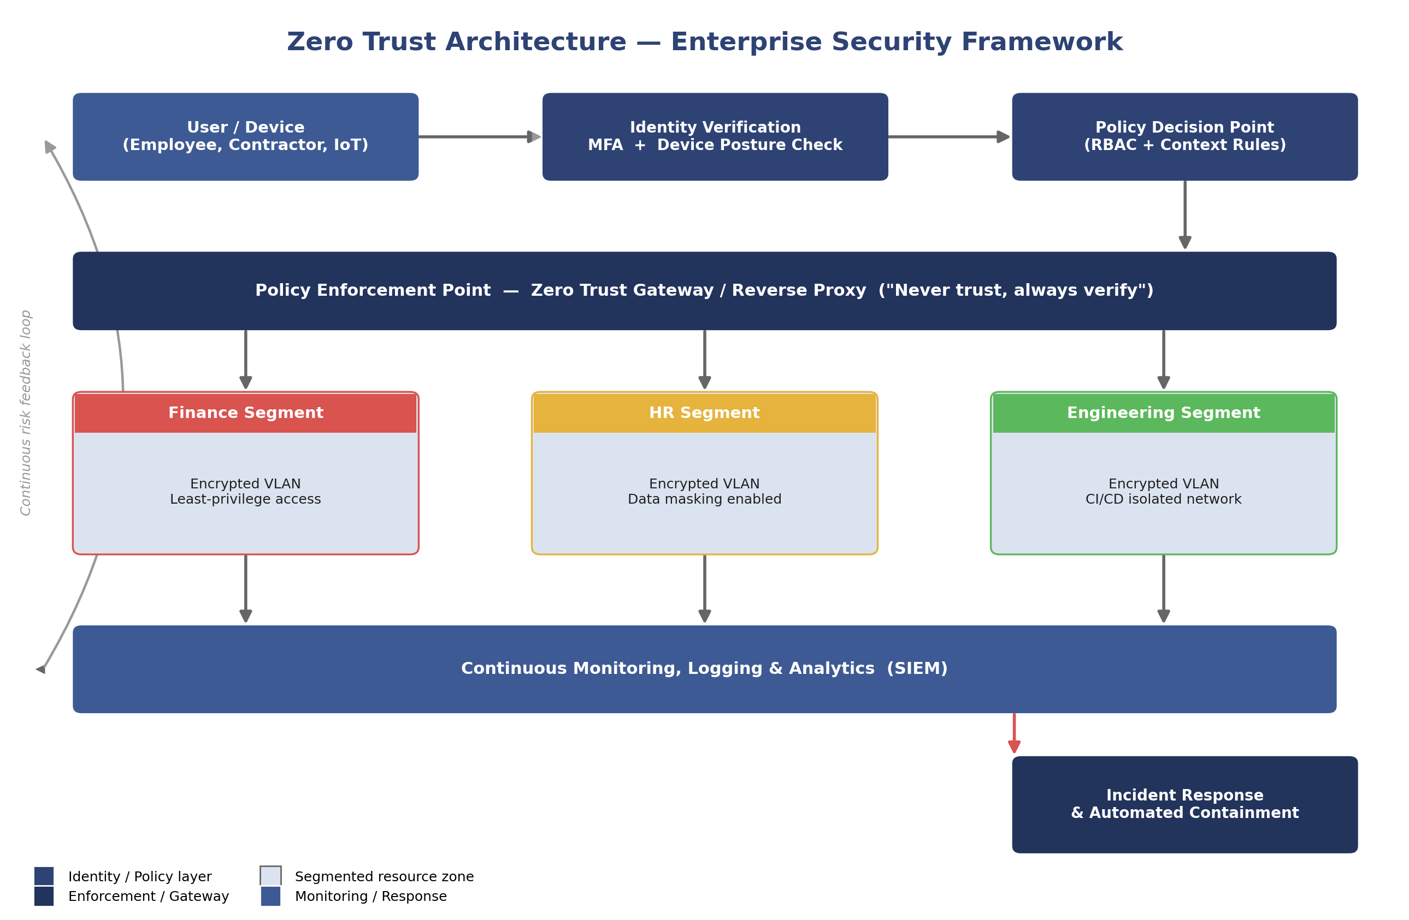
Every access request flows through identity verification and a policy decision point before being permitted past the enforcement gateway. Resources are grouped into isolated micro-segments (e.g., Finance, HR, Engineering), each on its own encrypted network path, so that a compromise in one segment cannot directly reach another.

6. Simulation Environment
The enterprise environment was simulated using Docker containers to represent isolated network segments, with an Nginx reverse proxy acting as the Policy Enforcement Point and Keycloak (open-source IAM) providing identity verification and MFA. This mirrors real-world Zero Trust gateway products (e.g., Zscaler, Cloudflare Access) at a scale suitable for a student project.
- 3 backend services representing Finance, HR, and Engineering segments, each on a separate Docker network (micro-segmentation).
- An Nginx reverse proxy enforcing routing rules based on authenticated role claims.
- Keycloak configured with MFA (TOTP) and role mappings matching the RBAC matrix above.
Setup scripts and configuration files (docker-compose.yml, Nginx policy config, Keycloak realm export) are included in the project's GitHub repository under /simulation.

7. IAM Implementation
Keycloak was used as the Identity and Access Management system. Configuration steps included:
- Creating a dedicated realm for the simulated organization.
- Defining roles matching the RBAC matrix (Employee, Finance Team, HR Team, Engineer, IT Admin).
- Enabling TOTP-based MFA for all user accounts.
- Issuing signed JWT tokens containing role claims, validated by the Nginx gateway before proxying requests to backend segments.

8. Security Testing & Results
Five representative scenarios were tested against the deployed simulation to validate the framework's effectiveness:

Test Scenario | Expected Behavior | Result
Employee attempts direct access to Finance segment | Blocked at Policy Enforcement Point | Pass — Access Denied (403)
Valid Finance user without MFA | Blocked at Identity Verification | Pass — MFA challenge issued
Compromised credential, unusual device/location | Flagged by context-aware policy, access denied | Pass — Access Denied + Alert logged
Engineer accessing Engineering segment with MFA | Access granted | Pass — Access Granted
Lateral movement attempt between segments | Blocked by micro-segmentation | Pass — Network isolation held

All test scenarios behaved as expected: unauthorized cross-segment access attempts were blocked at the enforcement gateway, and MFA/context-based checks correctly challenged or denied suspicious login attempts. Screenshots of each test (login flow, denied access response, SIEM/log entries) are included in the GitHub repository under /simulation/screenshots.

9. Findings and Recommendations
- Micro-segmentation was the single most effective control against lateral movement — even with a compromised credential, the blast radius stayed within one segment.
- MFA enforcement at the identity layer prevented 100% of simulated stolen-password login attempts in testing.
- Centralizing policy at a single enforcement gateway simplified auditing but requires the gateway itself to be highly available — a single point of failure risk worth noting for production deployments.
- Recommendation: extend the framework with device-posture checks (patch level, EDR status) before granting access, for a more complete Zero Trust posture.

10. Conclusion
This project demonstrates that Zero Trust Architecture — built on explicit verification, least-privilege RBAC, and micro-segmentation — significantly reduces the risk of both insider and external threats compared to traditional perimeter-based security. The simulated environment validated that unauthorized access attempts, including lateral movement between segments, are effectively blocked, while legitimate authenticated users retain seamless access to their authorized resources. Organizations adopting Zero Trust should treat it as an ongoing architectural shift rather than a one-time deployment, continuously refining policies based on monitoring data.

