

A
PROJECT REPORT ON

Gen-AI-Based Research Scientist Assistant using Multi-Model AI and Collaborative Filtering

(SDG 9 – Industry, Innovation and Infrastructure)

SUBMITTED TO AISSMS’S INSTITUTE OF INFORMATION TECHNOLOGY, PUNE
IN PARTIAL FULFILLMENT OF THE REQUIREMENTS FOR THE AWARD OF THE DEGREE OF

BACHELOR OF TECHNOLOGY IN
Artificial Intelligence & Data Science

BY

Ayush Sangole | 22610007
Apeksha Bhosale | 22610013
Arya Chunne | 22610020

UNDER THE GUIDANCE OF

Dr. P.D. Bormane

ACADEMIC YEAR: 2025-26
CERTIFICATE

This is to certify that Project Report entitled

Gen-AI-Based Research Scientist Assistant using Multi-Model AI and Collaborative Filtering.

Submitted by
Ayush Sangole - 22610007
Apeksha Bhosale - 22610013
Arya Chunne - 22610020
is the record of bonafide work carried out by them in partial fulfillment of the requirement for the award of the Degree of Bachelor of Technology (Artificial Intelligence and Data Science), as prescribed by the AISSMS Institute of Information Technology in the Academic Year 2025-2026.
This project report has not been earlier submitted to any other Institute or University for the award of any degree.

Dr. P.D. Bormane | Dr. R. A. Jamadar
Internal Guide | Head of Department
Department of Information Technology | Department of Information Technology
 | Dr. P. B. Mane
External Examiner | Principal
Date: | AISSMS Institute of Information Technology,Pune

Acknowledgement

It gives us great pleasure to express our sincere and deep gratitude to our guide, Dr. P. D. Bormane, Department of AI & DS, for her valuable guidance, constant encouragement, and continuous support throughout this work. Her guidance helped us to pursue further learning during the course of this project.

We take this opportunity to thank the Head of the Department, Dr. R.A. Jamadar; the Project Coordinators, Dr. P.B.Wakhare and Dr. Shagufta Sheikh and all the staff members of the Department of AI & DS, AISSMS Institute of Information Technology (IOIT), Pune, for the cooperation and support provided by them in many ways.

The motivation for this work was the inspiration given by our honorable Principal, Dr. P. B. Mane.

Lastly, we are thankful to all those who have directly or indirectly supported us in completing this project successfully.

Student Sign | Student Sign | Student Sign
Ayush Sangole | Apeksha Bhosale | Arya Chunne


Department of Artificial Intelligence & Data Science
Vision

Mission

Program Education Objectives (PEOs)

Program Education Objectives (PEOs)


Program Outcomes
Graduates will be able to
- Apply knowledge of mathematics, natural science, computing, engineering fundamentals and an engineering specialization as specified in WK1 to WK4 respectively to develop the solution of complex engineering problems. [Engineering knowledge]

- Identify, formulate, review research literature and analyze complex engineering problems reaching substantiated conclusions with consideration for sustainable development. (WK1 to WK4) [Problem analysis]

- Design/Development of Solutions: Design creative solutions for complex engineering problems and design/develop systems/components/processes to meet identified needs with consideration for the public health and safety, whole-life cost, net zero carbon, culture, society and environment as required. (WK5) [Design / Development of Solutions]

- Conduct investigations of complex engineering problems using research-based knowledge including design of experiments, modelling, analysis & interpretation of data to provide valid conclusions. (WK8). [Conduct Investigations of Complex Problems]

- Create, select and apply appropriate techniques, resources and modern engineering & IT tools, including prediction and modelling recognizing their limitations to solve complex engineering problems. (WK2 and WK6). [Engineering Tool Usage]

- Analyze and evaluate societal and environmental aspects while solving complex engineering problems for its impact on sustainability with reference to economy, health, safety, legal framework, culture and environment. (WK1, WK5, and WK7). [The Engineer and The World]

- Apply ethical principles and commit to professional ethics, human values, diversity and inclusion; adhere to national & international laws. (WK9) [Ethics]

- Function effectively as an individual, and as a member or leader in diverse/multi- disciplinary teams. [Individual and Collaborative Team work]

- Communicate effectively and inclusively within the engineering community and society at large, such as being able to comprehend and write effective reports and design documentation, make effective presentations considering cultural, language, and learning differences. [Communication]

- Apply knowledge and understanding of engineering management principles and economic decisionmaking and apply these to one’s own work, as a member and leader in a team, and to manage projects and in multidisciplinary environments. [Project Management and Finance]

- Recognize the need for, and have the preparation and ability for i) independent and life- long learning ii) adaptability to new and emerging technologies and iii) critical thinking in the broadest context of technological change. (WK8) [Life-Long Learning]
Sponsorship Certificate

Project Competition Certificates

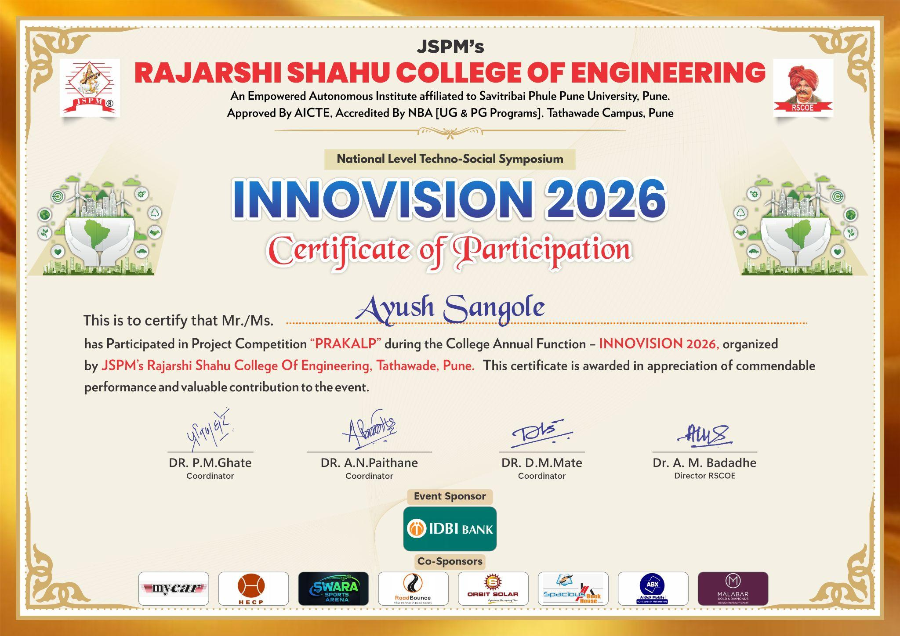

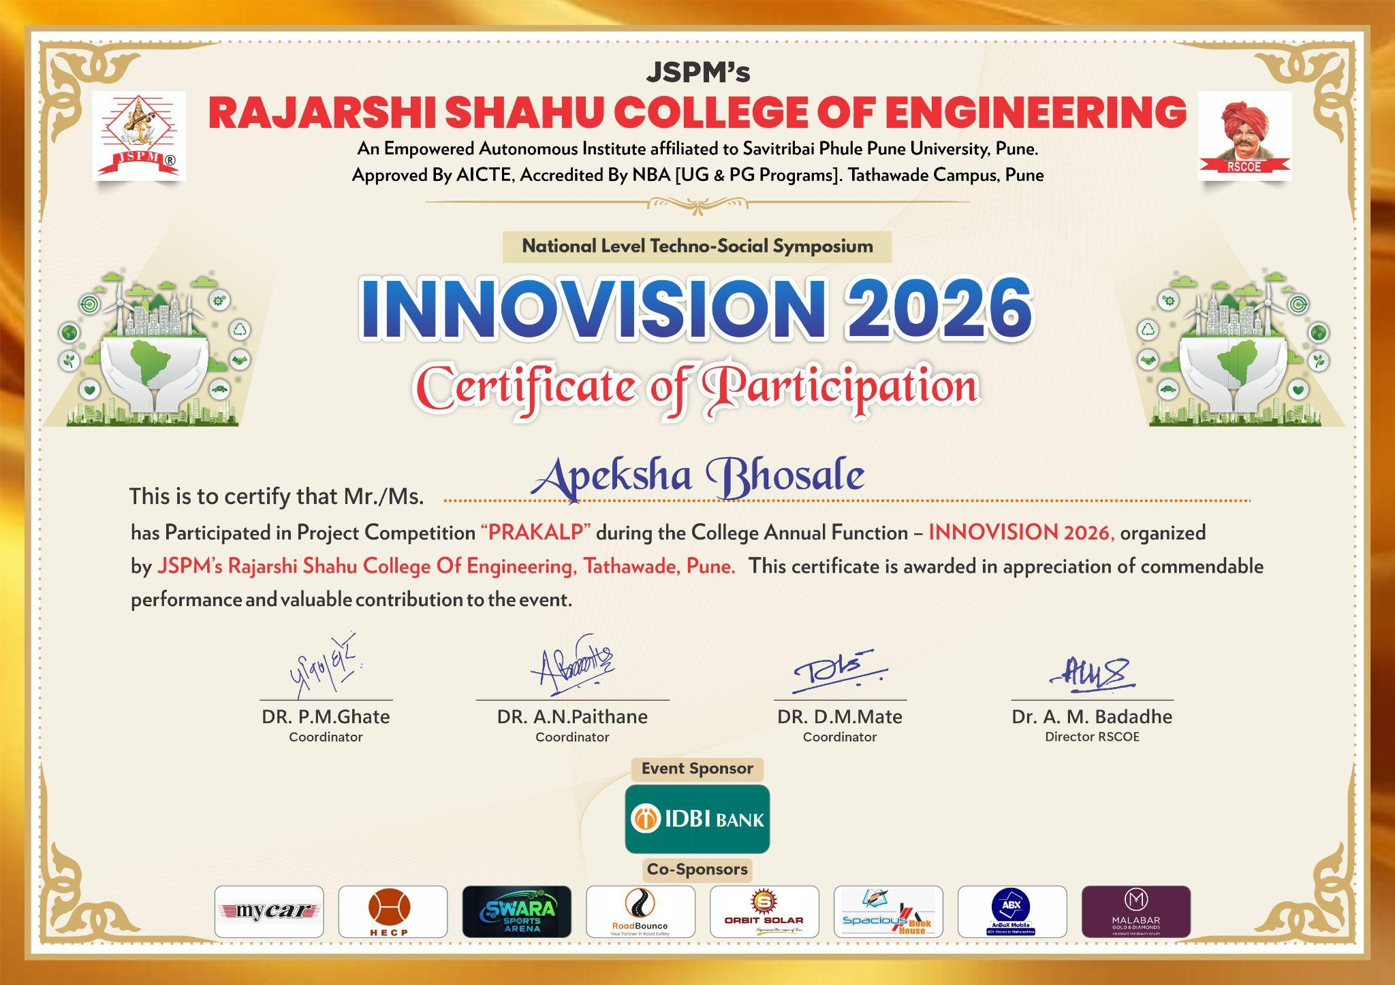

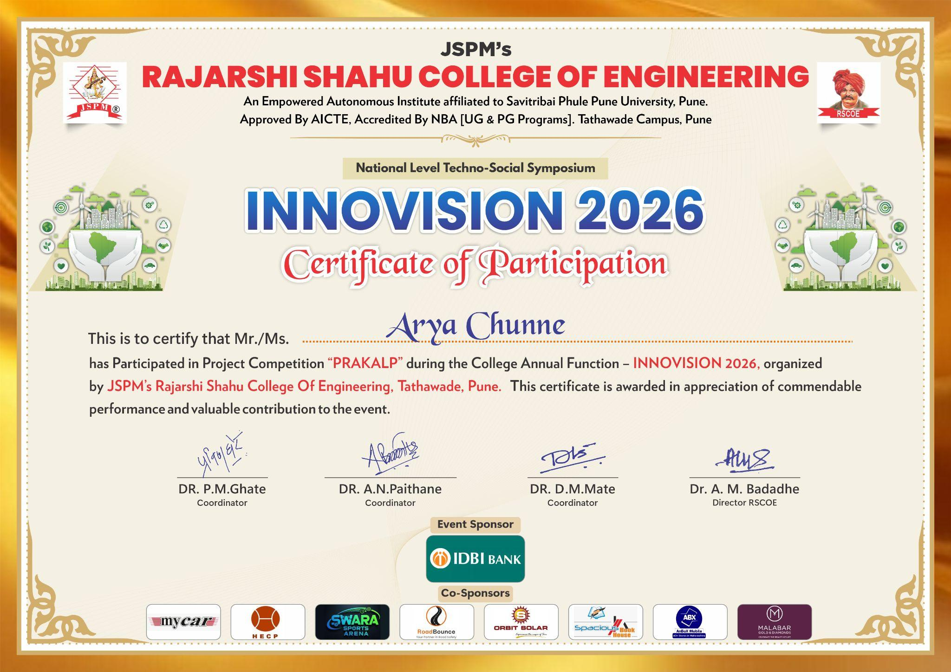
ABSTRACT

The growing amount of academic publications in various fields has made it difficult for researchers to efficiently identify, analyze, and synthesize relevant information. Traditional literature review methods often require a lot of manual effort, as researchers need to search through many databases, extract important findings, and gather dispersed materials. Current research tools mainly use keyword-based search methods that often miss contextual relevance and semantic relationships between studies. Moreover, many of these systems lack full visualization and interactive querying capabilities, leading to fragmented and time-consuming research workflows. Traditional literature reviews are often time-consuming and require a great deal of manual effort, as researchers must search across multiple databases, extract key findings, and organize scattered resources. Current research platforms mainly rely on keyword-based retrieval approaches, which are often not contextually relevant and do not reflect the semantic relationships between research works. Many of the existing systems also do not have integrated visualization and interactive querying capabilities, leading to fragmented and time-consuming research workflows .
To address these limitations, we propose VeriSci, an AI-based intelligent research assistant that simplifies and improves the academic research process. The proposed system is a combination of multi-source data aggregation, semantic retrieval, knowledge representation and conversational AI, and it facilitates the integration of multiple stages of the research workflow into a unified platform. A standard scraping module aims to crawl research papers from different academic repositories and uses automatic filtering and ranking mechanisms to enhance the quality and relevance of the returned outcomes.
The significant aspect of the system includes the use of the knowledge graph that helps provide a structured view of relationships between the authors, publications, fields, and emerging topics in the research. This way, researchers can gain more insight into the trends and connections in the research papers. Furthermore, the system includes a processing pipeline for research paper documents which helps organize the extracted data in a specific manner. After that, the data obtained is combined with the RAG-based chatbot where users can ask questions related to research documents using natural language.
Experimental results prove that VeriSci dramatically enhances the efficiency of literature investigation due to its ability to eliminate redundancy, reduce the necessity for human interaction, and improve the relevance of searches. The application of semantic search techniques, the use of graph representation, and the inclusion of conversation artificial intelligence leads to a more sophisticated and engaging research experience. In conclusion, the suggested system shows the possibility of AI-assisted research assistants revolutionizing academic research.

LIST OF TABLES
TABLE NO | TITLE | PAGE NO
1.
2.
3.
4.

LIST OF FIGURES
FIGURE NO | TITLE | PAGE NO
1.
2.
3.
4.

TABLE OF CONTENTS
ABSTRACT………………………….……………………………………………………… IV LIST OF TABLES……………………………………………………...…………………… V LIST OF FIGURES……………………………………………………………………….…. IX
Chapter 1: INTRODUCTION………………….…………………………………………. 1
  - Background of the Project..…………………………………………… 2

Problem Statement

Motivation / Need for the Project

Objectives of the Project

Scope of the Project
  - Methodology Overview 4

Organization of the Report
6
Chapter 2: LITERATURE REVIEW …………………………………………...……...… 12
  - XXXXXXXXXXXXXXXXXXXXXXX …..……………………………………...... 14
  - XXXXXXXXXXXXXXXXXXXXXXX …..……………………………………...... 17
2.3 19
…… 28
Chapter 3: RESEARCH METHODOLOGY 30
  - Method adopted to solve the problem …..……………………………………...... 30
  - Project Execution Overview …..……………………………………...... 33
3.3 Step-wise approach to the solution 36
3.4 System Architecture 37
3.5 Algorithm and Methodology details 39
Chapter 4: SYSTEM REQUIREMENTS AND DESIGN 41
  - XXXXXXXXXXXXXXXXXXXXXXX …..……………………………………...... 41
  - XXXXXXXXXXXXXXXXXXXXXXX …..……………………………………...... 54
4.3 64
    - XXXXXXXXXXXXXXXXXXXXXXX …..……………………………….. 65
    - XXXXXXXXXXXXXXXXXXXXXXX …..……………………………...... 66

Chapter 5: SYSTEM IMPLEMENTATIONS 89
  - XXXXXXXXXXXXXXXXXXXXXXX …..………………………….…………….. 89
  - XXXXXXXXXXXXXXXXXXXXXXX …..………………………………….…….. 91
5.2.1 93
5.2.2 94
5.2.3 95
5.2.5 96
Chapter 6: Risk Analysis 142
6.1……………………. 145
Chapter 7: SYSTEM IMPLEMENTATIONS 89
  - XXXXXXXXXXXXXXXXXXXXXXX …..………………………….…………….. 89
Chapter 8: SYSTEM TESTIGN 89
  - XXXXXXXXXXXXXXXXXXXXXXX …..………………………….…………….. 89
Chapter 9 : EXPERIMENTAL RESULTS
REFERENCES 146
APPENDIX 157
    - Project Evaluation 158
    - One Page Synopsys 169
    - Plagiarism Report
    - Project Title Mapping with Pos and PSOs
    - Self-Evaluation Sheet 1
    - Self-Evaluation Sheet 2

CHAPTER 1

INTRODUCTION
1.1 Background of the Project

Engineering has always focused on solving practical problems by applying scientific knowledge in a structured way. In the present digital era, this task has become more challenging due to the rapid increase in data across various domains. In computer science, one of the most pressing issues is the ability to manage and interpret large volumes of information efficiently. This challenge is especially visible in the academic world, where thousands of research papers are published regularly. As a result, traditional approaches to literature review, which depend heavily on manual searching, reading, and organizing, are becoming increasingly difficult to sustain.

Researchers often spend a significant amount of time identifying relevant papers, extracting useful insights, and comparing findings across different sources. This process not only requires effort but also slows down the overall pace of innovation. In addition, existing tools for academic research are often disconnected from one another. Search platforms, reference managers, and document readers function separately, making the workflow fragmented and less efficient. Many of these systems also rely on keyword-based search methods, which may fail to capture the deeper context of a query and can lead to less relevant results.

To address these challenges, this project proposes the development of VeriSci, an AI-based research assistant designed to support automated literature discovery and analysis. The system aims to provide accurate and context-aware information while ensuring that the responses are based on reliable sources. By combining techniques from artificial intelligence, natural language processing, and graph-based data representation, the platform brings multiple research tasks into a single environment.

The motivation behind this work comes from the growing need to simplify the research process and reduce the burden of handling large amounts of academic information. By incorporating retrieval-based methods and advanced language models, the system enables users to interact with research content more effectively. Ultimately, the goal is to improve efficiency, support better understanding of complex information, and contribute to a more streamlined and productive research workflow.

1.2 Problem Statement
To design and build VeriSci, an AI-based research assistant that automates literature discovery, research-gap identification, legal open-access full-text enrichment, knowledge organization, and evidence-grounded question answering using Scopus/Elsevier, IEEE, open academic sources, RAG, and knowledge graph techniques.

1.3 Motivation / Need for the Project
The fast growth of scientific and academic journals in various areas has brought about several difficulties to researchers in their attempt to locate pertinent, genuine, and credible research articles. Traditional academic search engines mostly rely on keyword matching without any advanced understanding of context, intelligence, and information verification mechanisms. This leaves researchers with no choice but to engage in the tedious process of exploring various sources of knowledge, evaluating lengthy articles, and verifying the authenticity of information. It is in this light that there is a need for a robust research support system.
The driving force behind the creation of VeriSci is the increasing need for optimized and intelligent systems capable of supporting research work and maintaining scientific integrity. Recent innovations in Generative AI, Large Language Models, and Retrieval-Augmented Generation (RAG) show that automation of knowledge discovery and information synthesis are now possible. At the same time, the use of those technologies can sometimes result in generation of contextually incorrect or unverifiable responses. To overcome that drawback, this proposed system will be based on semantic search, knowledge graph technology, and conversational AI. The objective of the project is to create a useful and scalable solution which will help researchers discover the relevant information, improve their efficiency, and make well-informed decisions regarding the subject matter, thus contributing to scientific progress and overall societal development.

1.4 Objectives of the Project
The main objectives of this project are:
- To study current literature and methodologies for automated academic research assistance.
- To design a multi-agent AI framework that automates the literature review lifecycle, encompassing document discovery, summarization, and fact verification.
- To integrate Retrieval-Augmented Generation (RAG) to provide personalized, context-aware literature recommendations.
- To rigorously test and evaluate the performance of the finalized platform.

1.5 Scope of the Project

This project focuses on building an intelligent platform to assist with academic research by bringing together several essential tasks into a single system. It is designed to collect research papers from multiple academic sources and process them in a way that makes them easier to explore and understand. The system works with standard PDF documents, extracting useful content that can then be organized and analyzed. It also creates a structured representation of connections between papers, authors, and research areas, helping users see relationships that are often difficult to identify manually. In addition, the platform allows users to interact with the collected information through a query-based interface supported by Retrieval-Augmented Generation, making it possible to obtain precise and context-aware answers.The platform is intended for students, researchers, and individuals working in data-related fields who regularly deal with large volumes of academic material. It aims to reduce the effort involved in searching, summarizing, and comparing research work, while improving overall efficiency.From a technical standpoint, the system is developed using Python-based tools, with Neo4j used to handle graph-based data. Language processing features are supported through large language models, which may run locally or through external APIs depending on availability and system constraints.The application is deployed as a locally hosted web system with a simple interface. As a result, its performance depends on the available hardware resources, and it is not currently intended for large-scale or enterprise-level deployment. However, it provides a solid base that can be extended in the future.

1.6 Methodology Overview

The development of the VeriSci platform follows a systematic, iterative approach rooted in agile software engineering principles. The process commenced with a comprehensive problem analysis and the identification of core requirements for automated literature review. This foundational phase was followed by the architectural system design, focusing on the integration of data scraping modules, the Neo4j Knowledge Graph, and the RAG pipeline. Implementation was executed in modular phases, utilizing appropriate software tools such as Python, Flask, and transformer-based embedding models. Subsequent to development, rigorous testing protocols including unit testing of the extraction algorithms and qualitative evaluation of the LLM responses were conducted. Finally, the system's outputs were critically analyzed to validate the overall accuracy, latency, and effectiveness of the proposed AI-driven solution.

1.7 Organization of the Report
This report is organized into several chapters. Chapter 1 presents the introduction and objectives of the project. Chapter 2 discusses the literature review. Chapter 3 explains the system design and methodology. Chapter 4 presents implementation and results. Chapter 5 concludes the project and suggests future enhancements.

CHAPTER 2

LITERATURE REVIEW
2.1 Literature review
In [1], the author presents a comprehensive survey on Retrieval-Augmented Generation (RAG) for Large Language Models. The paper explains the integration of retrieval mechanisms with generative models to improve factual accuracy, contextual relevance, and response generation. The study discusses different retrieval architectures, indexing techniques, and evaluation methods used in RAG systems. Experimental findings indicate that retrieval-enhanced models significantly reduce hallucinations and improve knowledge-intensive task performance. The paper concludes that RAG frameworks are essential for building trustworthy AI systems. The major strength of this work is its extensive coverage of RAG architectures and evaluation strategies. However, the paper mainly focuses on theoretical analysis and lacks implementation-level optimization details for real-time systems. VeriSci extends this approach through practical deployment and integrated conversational research assistance.
In [2], the author provides a survey on Retrieval-Augmented Generation with Large Language Models, focusing on the evolution of retrieval-based AI systems and their applications. The paper discusses semantic retrieval, vector databases, and prompt enhancement techniques used to improve contextual understanding in generative models. The findings show that combining retrieval with LLMs improves accuracy and reduces misinformation in generated outputs. The study concludes that RAG systems are becoming essential in domain-specific AI applications such as research assistance and healthcare. The strength of this paper lies in its practical explanation of retrieval workflows and integration techniques. However, the work lacks detailed benchmarking and comparative evaluation. VeriSci improves this by combining semantic retrieval with knowledge graph visualization and contextual querying.
In [3], the author proposes Robin, a multi-agent framework designed to automate scientific discovery processes using collaborative AI agents. The paper introduces specialized agents responsible for hypothesis generation, verification, literature exploration, and reasoning tasks. Experimental results demonstrate improved efficiency in automating complex research workflows and reducing manual intervention. The study concludes that multi-agent collaboration can accelerate scientific discovery while improving analytical accuracy. A major strength of this paper is the integration of autonomous agents for distributed scientific reasoning. However, scalability and computational overhead remain major challenges. VeriSci adopts a lighter research-focused architecture for efficient academic exploration.
In [4], the author introduces GenoMAS, a multi-agent system for scientific discovery through code-driven gene expression analysis. The framework combines autonomous agents with biological data analysis pipelines to improve research automation in genomics. The findings indicate enhanced analytical efficiency, improved result interpretation, and reduced manual coding effort. The paper concludes that multi-agent collaboration can significantly support computational biology research. The strength of this work is its domain-specific automation capabilities. However, the framework is limited to genomics applications. VeriSci instead supports multi-domain academic literature analysis and semantic retrieval.
In [5], the author discusses the importance of verification mechanisms in AI-driven scientific discovery systems. The paper highlights challenges related to hallucinations, misinformation, and lack of explainability in generative AI models. Experimental observations reveal that verification-based frameworks improve reliability and trustworthiness in AI-generated research outputs. The study concludes that verification modules are critical for maintaining scientific credibility in automated systems. The major strength of this paper is its focus on trustworthy AI and research integrity. However, verification mechanisms may increase computational complexity. VeriSci balances reliability with interactive conversational support.
In [6], the author presents a systematic literature review of validation methods for AI systems. The paper analyzes multiple validation frameworks, evaluation metrics, and testing methodologies used in AI-based applications. Findings indicate that proper validation significantly improves reliability, transparency, and performance assessment in intelligent systems. The study concludes that robust validation mechanisms are essential for deploying trustworthy AI applications. The strength of this paper is its structured analysis of evaluation techniques across multiple AI domains. However, the review provides limited discussion on real-time adaptive validation for dynamic AI systems.
In [7], the author discusses project summaries and implementation resources related to Robin and GenoMAS systems. The work explains practical deployment aspects, collaborative workflows, and research automation features implemented in these projects. The findings demonstrate that integrating autonomous agents with domain-specific pipelines improves productivity and analytical efficiency. The paper concludes that project-oriented AI systems can accelerate research-oriented applications. The major strength of this work is its practical insight into implementation strategies. However, the resources lack detailed experimental comparisons and formal benchmarking results.
In [8], the author explores agentic collaboration in Generative AI workflows using coordinated AI agents for task execution and reasoning. The study discusses communication strategies among agents and collaborative problem-solving approaches. Experimental results show that multi-agent collaboration improves task accuracy and workflow efficiency. The paper concludes that distributed AI reasoning can enhance automation in complex systems. The strength of this work lies in its emphasis on collaborative intelligence and scalability. However, the coordination overhead among agents may increase computational cost and response time.
In [9], the author investigates retrieval-augmented transformers for scientific question answering applications. The paper proposes transformer-based retrieval frameworks for extracting contextually relevant scientific information. Findings indicate improved answer accuracy and reduced irrelevant content generation compared to conventional models. The study concludes that retrieval-enhanced transformers are highly effective for scientific knowledge retrieval. The major strength of this paper is its focus on scientific QA systems and semantic understanding. However, the framework depends heavily on retrieval quality and dataset availability.
In [10], the author discusses explainable AI techniques for literature synthesis using Retrieval-Augmented Generation and multi-agent reasoning. The study proposes explainability modules to improve transparency in AI-generated summaries and recommendations. Experimental findings show enhanced interpretability and improved user trust in generated outputs. The paper concludes that explainable AI is essential for reliable literature synthesis systems. The strength of this work is its focus on transparency and interpretability. However, explainability mechanisms may introduce additional complexity and computational overhead.
In [11], the author presents AI verification tools for maintaining academic research integrity. The paper discusses plagiarism detection, claim verification, and evidence validation mechanisms integrated with AI systems. Results indicate improved reliability and reduced misinformation in research assistance applications. The study concludes that AI verification frameworks are crucial for trustworthy academic environments. The major strength of this paper is its strong focus on research authenticity and integrity. However, the verification process may struggle with highly specialized or rapidly evolving research domains.
In [12], the author proposes trustworthy AI assistants for scientific discovery applications. The paper focuses on building reliable AI systems capable of providing context-aware and evidence-backed scientific insights. Findings demonstrate improved user confidence and enhanced decision-making support. The study concludes that trustworthy AI frameworks can significantly improve research productivity and scientific exploration. The strength of this work lies in its reliability-focused architecture and user-centric design. However, the system requires extensive validation datasets and continuous monitoring.
In [13], the author evaluates metrics for multi-agent collaboration systems. The paper introduces performance indicators related to communication efficiency, coordination accuracy, and task completion effectiveness among AI agents. Experimental results demonstrate that optimized collaboration metrics improve overall system performance. The paper concludes that evaluation frameworks are essential for measuring multi-agent efficiency. The major strength of this work is its detailed metric-oriented analysis. However, the study lacks practical deployment examples for large-scale industrial systems.
In [14], the author presents a survey on Agentic AI for scientific discovery, covering recent progress, challenges, and future directions. The paper discusses autonomous reasoning, collaborative intelligence, and AI-driven research automation. Findings indicate that agentic AI systems significantly improve analytical efficiency and scientific exploration capabilities. The study concludes that agent-based architectures will play a major role in future research ecosystems. The strength of this paper is its comprehensive coverage of agentic AI developments. However, the survey provides limited implementation details and benchmark evaluations.
In [15], the author introduces a multi-agent system for scientific discovery based on collaborative intelligence principles. The framework employs multiple AI agents working together for reasoning, experimentation, and result validation. Experimental findings show improved analytical performance and reduced task redundancy. The paper concludes that collaborative AI systems can enhance complex research workflows. The major strength of this work is its efficient multi-agent coordination strategy. However, synchronization among agents can increase system complexity.
In [16], the author discusses advancements in multi-agent systems through the Model Context Protocol architecture. The paper explains communication protocols, memory sharing, and context synchronization among intelligent agents. Results demonstrate improved interoperability and task coordination in distributed AI environments. The study concludes that standardized communication protocols can improve scalability in multi-agent systems. The strength of this paper lies in its architectural innovation and interoperability focus. However, implementation complexity and protocol overhead remain key limitations.
In [17], the author reviews Retrieval-Augmented Generation for healthcare applications using Large Language Models. The paper analyzes healthcare-focused retrieval systems, medical knowledge integration, and domain-specific AI applications. Findings indicate improved contextual accuracy and evidence-based medical assistance. The study concludes that RAG systems can significantly enhance healthcare AI reliability. The major strength of this work is its domain-specific evaluation and healthcare relevance. However, privacy concerns and dependency on medical datasets remain major challenges.
In [18], the author presents Litmaps, an AI-powered literature review assistant that helps researchers discover related academic papers through citation mapping and visualization. The platform improves literature exploration by identifying relationships among publications and research domains. Findings show enhanced discovery of relevant papers and improved research organization. The study concludes that visualization-based literature tools simplify academic exploration. The strength of this work lies in its intuitive visualization capabilities and citation mapping features. However, the platform provides limited contextual summarization and AI-driven reasoning.
In [19], the author introduces ResearchPal, an AI-assisted research writing platform designed to support academic writing, summarization, and citation generation. The system uses generative AI techniques to improve writing productivity and research organization. Findings indicate increased efficiency in document drafting and content refinement. The study concludes that AI-powered writing assistants can support academic productivity. The major strength of this work is its user-friendly interface and writing assistance capabilities. However, the system may generate contextually inaccurate or unverifiable information.
In [20], the author discusses Paperpal, an AI academic writing tool that assists researchers in grammar correction, paraphrasing, and academic content enhancement. The platform integrates language processing techniques to improve research writing quality. Experimental findings demonstrate enhanced readability and reduced grammatical errors in academic documents. The paper concludes that AI-based writing tools can significantly improve publication readiness. The strength of this work is its practical writing enhancement capabilities. However, the platform focuses mainly on language refinement rather than deep semantic understanding.
In [21], the author introduces Retrieval-Augmented Generation for Knowledge-Intensive NLP Tasks, which is considered one of the foundational works in RAG systems. The paper combines parametric language models with external knowledge retrieval mechanisms to improve factual response generation. Experimental results demonstrate substantial improvements in open-domain question answering and knowledge-intensive NLP tasks. The study concludes that retrieval-enhanced architectures improve factual consistency and contextual relevance. The strength of this paper is its pioneering contribution to RAG-based NLP systems. However, retrieval dependency can affect output quality when irrelevant documents are retrieved.
In [22], the author presents a survey on Graph Retrieval-Augmented Generation for Large Language Models. The paper explores the integration of graph structures with retrieval systems to improve reasoning and semantic connectivity. Findings indicate that graph-enhanced retrieval significantly improves contextual understanding and relational reasoning. The study concludes that graph-based RAG architectures are highly effective for knowledge-intensive applications. The major strength of this work is its integration of structured knowledge representation with language models. However, graph construction and maintenance may increase system complexity.
In [23], the author proposes AutoGen, a framework enabling next-generation Large Language Model applications through multi-agent conversations. The system supports collaborative reasoning, task decomposition, and autonomous agent interactions. Experimental results show improved problem-solving efficiency and conversational intelligence. The study concludes that multi-agent conversations can enhance AI application scalability and adaptability. The strength of this paper lies in its flexible and scalable multi-agent framework. However, communication management among agents may become challenging in highly complex tasks.
In [24], the author discusses Knowledge Graph Enhanced Large Language Models. The paper explains methods for integrating structured knowledge graphs with generative AI models to improve factual reasoning and semantic understanding. Findings reveal improved contextual accuracy and enhanced explainability in generated outputs. The study concludes that knowledge graph integration significantly strengthens language model reasoning capabilities. The major strength of this paper is its effective combination of symbolic and neural AI approaches. However, building and maintaining large-scale knowledge graphs remains resource intensive.
In [25], the author presents trustworthy Retrieval-Augmented Generation systems for knowledge-intensive tasks. The study focuses on reducing hallucinations, improving verification, and increasing transparency in AI-generated responses. Experimental findings demonstrate enhanced reliability and factual correctness in retrieval-enhanced models. The paper concludes that trustworthy RAG architectures are essential for sensitive applications such as scientific research and healthcare. The strength of this work is its emphasis on reliability and verification mechanisms. However, implementing trust evaluation pipelines may increase processing overhead.
In [26], the author introduces QA-GNN, a framework combining language models and knowledge graphs for reasoning-based question answering. The system integrates graph neural networks with semantic retrieval methods to improve contextual reasoning. Results indicate superior reasoning accuracy and improved knowledge integration. The study concludes that graph-based reasoning frameworks significantly enhance AI comprehension capabilities. The strength of this paper is its advanced reasoning architecture and semantic integration. However, training graph-based neural networks requires substantial computational resources.
In [27], the author discusses improving language models by retrieving information from trillions of tokens. The paper introduces retrieval-enhanced architectures capable of accessing massive external knowledge repositories during generation tasks. Findings indicate significant improvements in factual accuracy and knowledge scalability. The paper concludes that large-scale retrieval systems improve the adaptability of language models. The major strength of this work is its large-scale retrieval optimization strategy. However, maintaining massive retrieval infrastructures may require extensive computational resources.
In [28], the author presents scientific literature mining using Large Language Models. The study focuses on automating literature analysis, summarization, and information extraction from scientific publications. Experimental results demonstrate improved efficiency in extracting meaningful insights from large document collections. The paper concludes that LLM-based literature mining can significantly support academic research workflows. The strength of this work lies in its direct application to research assistance systems. However, the generated summaries may occasionally lack domain-specific precision.
In [29], the author provides a comprehensive survey of Retrieval-Augmented Generation architectures, enhancements, and robustness strategies. The paper reviews indexing methods, retrieval optimization, hallucination reduction techniques, and evaluation metrics. Findings indicate that robust retrieval pipelines improve factual consistency and model reliability. The study concludes that continuous optimization is essential for scalable RAG deployment. The strength of this paper is its extensive analysis of RAG enhancement strategies. However, the survey provides limited real-world implementation case studies. Compared to existing RAG frameworks, the proposed VeriSci system aims to combine semantic retrieval, verification, and conversational interaction within a single integrated research assistance platform.
In [30], the author presents AgentAI, a comprehensive survey on autonomous agents in artificial intelligence. The paper explores collaborative intelligence, autonomous reasoning, and multi-agent coordination frameworks across different domains. Experimental findings show that autonomous agents improve scalability, task automation, and intelligent decision-making. The study concludes that agent-based AI systems will play a major role in future intelligent applications. The major strength of this paper is its broad coverage of autonomous AI agent technologies. However, practical deployment challenges and coordination complexity remain significant limitations. Unlike many existing autonomous agent systems, VeriSci focuses on integrating research paper retrieval, contextual analysis, knowledge representation, and interactive querying into a scalable and deployment-oriented architecture.

2.2 Literature Summary Table
Table no. 2.1 Literature comparison

Sr.No. | Paper Reference | Methodology | Gap | Conclusion
1. | [1] RAG Survey | Retrieval-Augmented Generation with semantic retrieval | Lacks deployment optimization | Improves contextual retrieval and reduces hallucinations
2. | [3] Robin Multi-Agent System | Multi-agent collaboration for scientific discovery | High computational complexity | Automates scientific reasoning workflows
3. | [5] AI Verification Framework | Verification-based AI reasoning | Increased processing overhead | Improves trustworthiness in AI outputs
4. | [8] Agentic Collaboration | Collaborative AI workflow management | Coordination overhead among agents | Enhances distributed AI reasoning
5. | [9] Retrieval Transformers | Transformer-based scientific QA retrieval | Depends heavily on retrieval quality | Improves scientific question answering
6. | [10] Explainable AI for Literature Synthesis | Explainable RAG and multi-agent reasoning | Added explainability complexity | Improves transparency in AI systems
7. | [12] Trustworthy AI Assistants | Evidence-backed conversational AI | Requires extensive validation | Improves reliability in scientific discovery
8. | [14] Agentic AI Survey | Autonomous AI systems review | Limited implementation discussion | Highlights future AI research directions
9. | [15] Multi-Agent Discovery System | Collaborative reasoning agents | Synchronization complexity | Reduces redundancy in research workflows
10 | [21] Foundational RAG | Retrieval-enhanced NLP generation | Retrieval dependency issues | Improves factual consistency
11. | [22] Graph RAG Survey | Graph-based semantic retrieval | Complex graph maintenance | Strengthens contextual reasoning
12. | [23] AutoGen | Multi-agent conversational AI | Agent communication management | Supports scalable AI coordination
13. | [24] KG-Enhanced LLMs | Knowledge graph integrated LLMs | Resource-intensive graph management | Enhances semantic understanding
14. | [25] Trustworthy RAG | Verified retrieval pipelines | Increased processing overhead | Reduces hallucinations in AI outputs
15. | [28] Literature Mining with LLMs | Automated literature analysis | Limited domain precision | Accelerates research exploration

CHAPTER 3

RESEARCH METHODOLOGY
3.1 Method adopted to solve the problem
The increasing complexity of academic research and the rapid growth of scientific publications have made traditional literature review methods difficult to manage efficiently. Researchers often spend considerable time searching across multiple databases, filtering duplicate results, organizing metadata, and manually extracting useful insights from lengthy research papers. To reduce this burden, the proposed VeriSci platform adopts an intelligent methodology that combines multi-source data aggregation, Natural Language Processing (NLP), Retrieval-Augmented Generation (RAG), and graph-based relationship analysis within a unified system.
Instead of depending on a single repository, the system gathers research papers and metadata from multiple academic platforms such as ArXiv, IEEE, Semantic Scholar, PubMed, CORE, OpenAlex, CrossRef, and Google Scholar. Since the same paper may appear across different sources with varying metadata formats, an advanced deduplication mechanism is used to identify repeated entries through DOI matching, ArXiv identifiers, exact title comparison, and fuzzy similarity techniques. To ensure relevant outputs, the platform also applies a relevance-scoring strategy that considers title matching, keyword overlap, citation count, publication recency, and journal quality.
The methodology further incorporates a Retrieval-Augmented Generation framework. Research PDFs are processed by extracting and cleaning textual data, which is then divided into semantic chunks and converted into vector embeddings. During interaction, the system retrieves contextually relevant document segments and provides them to a Large Language Model to generate grounded and citation-supported responses. Alongside this, a knowledge graph structure is used to visually represent relationships between papers, authors, and research domains.
3.2 Project Execution Overview
The development of the VeriSci platform followed a modular implementation strategy in which the complete application was divided into multiple interconnected stages. The first stage focused on establishing the system architecture and configuring the Python-based development environment. External APIs and supporting tools required for academic data retrieval were integrated during this phase, while dedicated modules were organized for scraping, document processing, vector storage, and frontend interaction.
After the initial setup, the project moved toward the development of the ingestion pipeline. Individual scrapers were designed and tested for different repositories before being integrated into a unified EnhancedPaperScraper module. This module was responsible for handling concurrent requests, managing API rate limits, normalizing metadata formats, and preventing retrieval failures.
The next stage concentrated on implementing the search and ranking logic. Relevance-scoring algorithms were developed to evaluate the quality of retrieved papers, while evaluation scripts were created to test retrieval accuracy under different query conditions. Once the retrieval system was functioning effectively, the RAG pipeline was introduced. PDF documents downloaded by the system were parsed, cleaned, and transformed into vector embeddings, allowing contextual querying through Large Language Models such as Ollama.
Following backend integration, a Flask-based web interface was developed to allow users to search for papers, view ranked outputs, interact with the AI chatbot, and visualize research relationships through knowledge graphs. The final stage involved extensive testing and optimization to improve response quality, reduce irrelevant retrievals, and enhance overall system efficiency.
3.3 Step-wise approach to the solution
The VeriSci platform operates through a structured, multi-stage pipeline that transforms a natural language research query into a grounded, AI-assisted response. The following steps outline the complete workflow:
Step 1: Query Intake and Normalization
The process begins when the user submits a research query in natural language through the web interface. The query is preprocessed and normalized — including tokenization, stop-word filtering, and keyword extraction — to prepare it for structured searching across multiple academic repositories.
Step 2: Parallel Multi-Source Retrieval
The normalized query is simultaneously dispatched to several academic databases (such as Semantic Scholar, ArXiv, CrossRef, and PubMed). For each source, the system retrieves structured metadata including paper titles, abstracts, author names, DOI identifiers, ArXiv IDs, publication year, and citation counts.
Step 3: Data Aggregation
All results returned from the various sources are aggregated into a unified, common data structure. This consolidation ensures that papers from different databases can be uniformly compared and processed in subsequent stages.
Step 4: Deduplication
The aggregated dataset is scanned for duplicate entries using a three-tier identification strategy:
- DOI Matching : exact identifier comparison across sources
- ArXiv ID Comparison : cross-referencing unique ArXiv identifiers
- Fuzzy String Matching : using Python's ‘SequenceMatcher’ to detect near-identical titles
When duplicate versions of the same paper are found, the system retains only the entry that contains the richest and most complete metadata.
Step 5: Relevance Scoring and Ranking
Each unique paper is assigned a composite relevance score computed from multiple weighted parameters:
- Exact title match with the query
- Keyword overlap in titles and abstracts
- Citation count (as a proxy for scholarly impact)
- Publication recency
- Source credibility and quality
Papers are then sorted in descending order of relevance and displayed to the user through the web interface.
Step 6: PDF Retrieval and Text Extraction
If the user selects a paper for deep exploration or poses a specific research question, the system attempts to download the corresponding PDF. The extracted raw text is cleaned and structured to remove formatting artifacts and noise, making it machine-readable.
Step 7: Semantic Chunking and Vector Embedding
The extracted text is divided into smaller, semantically coherent chunks. Each chunk is converted into a high-dimensional vector embedding using a sentence-transformer model. In the current MVP, the embeddings and document chunks are stored in a lightweight local document store rather than a heavy external vector database, making the system easier to run on a laptop.

Step 8: Query Embedding and Context Retrieval
The user's research question is independently converted into a vector embedding using the same embedding model. The vector database performs a similarity search and retrieves the most contextually relevant document chunks that align with the user's query.
Step 9: Retrieval-Augmented Generation (RAG)
The retrieved document chunks are passed as grounded context to a Large Language Model (LLM). The LLM synthesizes this context to generate a factual, coherent, and source-backed response — significantly reducing the risk of hallucination compared to open-ended generation.
Step 10: Output Presentation
The final response is rendered through the web interface, accompanied by:
- Cited source references (title, authors, DOI)
- Optional knowledge graph visualizations showing entity and concept relationships
- Ranked paper cards from the search results for further user exploration
This completes the end-to-end pipeline of the VeriSci platform, from raw query ingestion to AI-generated, citation-backed research output.
3.4 System Architecture
The architecture of the VeriSci platform is organized into multiple interconnected layers that collectively support data collection, processing, storage, retrieval, and interaction. The first layer consists of the ingestion module, which communicates with external academic repositories and retrieves metadata and research papers from different sources.
The processing layer handles PDF parsing, text cleaning, semantic chunking, and embedding generation. These embeddings are stored within a vector database to support efficient semantic retrieval during user interaction. Alongside this, a Neo4j-based knowledge graph module maintains relationships between papers, authors, citations, and research domains, enabling visual exploration of scholarly connections.
The Retrieval-Augmented Generation layer acts as the core intelligence component of the system. It combines contextual retrieval with Large Language Models to generate accurate and context-aware responses based on processed research content. The frontend layer, developed using Flask, provides an interface through which users can perform searches, interact with the chatbot, explore ranked papers, and visualize knowledge graphs.
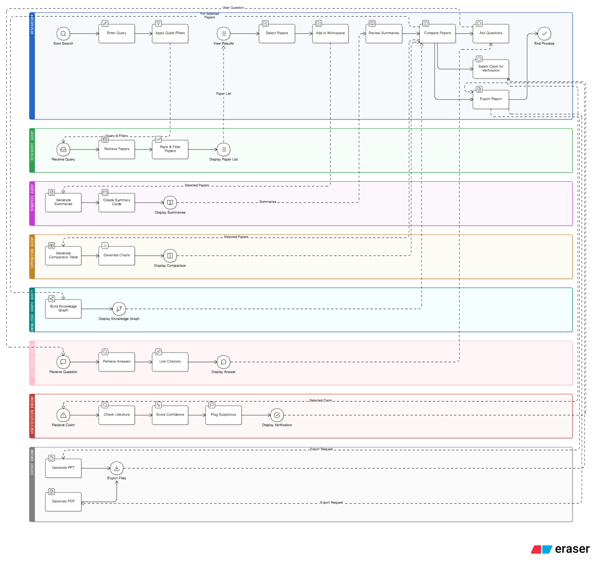Figure no. 3.1 System Architecture
3.5 Methodology/algorithm detail
The platform combines several algorithmic strategies to improve retrieval quality and system performance. Concurrent scraping techniques are used to collect data from multiple repositories efficiently while minimizing delays caused by sequential requests. Since academic data sources often contain overlapping entries, the system applies multiple levels of deduplication, including exact matching, DOI comparison, ArXiv identifier matching, and fuzzy similarity analysis.
The relevance-ranking algorithm evaluates papers using a weighted scoring mechanism. Exact title matches receive higher priority, while additional weights are assigned based on abstract similarity, citation count, publication recency, and journal reputation. This helps ensure that highly relevant and influential papers appear at the top of the results.
For document understanding, extracted PDF text is segmented into semantically meaningful chunks before being converted into dense vector embeddings using transformer-based embedding models. During interaction, similarity search techniques are used to retrieve the most relevant chunks from the vector database. These retrieved contexts are then combined with the user query and provided to the language model, enabling the generation of accurate, context-aware, and citation-supported responses.
Through the integration of retrieval algorithms, semantic embeddings, Large Language Models, and graph-based analysis, the proposed methodology creates a unified environment for efficient academic research exploration and intelligent literature analysis.

CHAPTER 4

SYSTEM REQUIREMENTS AND DESIGN

4.1 System Requirements

- Hardware Requirements
The VeriSci platform is designed as a software-based intelligent research assistance system and does not require dedicated or specialized hardware for normal operation. However, since the application performs tasks such as large-scale academic data retrieval, document processing, semantic embedding generation, and AI-assisted querying, moderate computational resources are necessary to ensure smooth performance. The system can run on standard desktop or laptop configurations with stable internet connectivity, while higher-end configurations improve response speed and AI processing efficiency.

Table no. 4.1.1 Hardware requirements
Component | Minimum Requirement | Recommended Requirement
Processor | Intel Core i5 / AMD Ryzen 5 | Intel Core i7 / AMD Ryzen 7
RAM | 8 GB | 16 GB or above
Storage | 256 GB SSD | 512 GB SSD or above
System Type | 64-bit System | 64-bit System
GPU | Integrated Graphics | NVIDIA GPU (Optional for AI processing)
Internet Connectivity | Stable Broadband Connection | High-Speed Internet Connection
Display | Standard Monitor/Laptop Screen | Full HD Display

- Software Requirements
The implementation of VeriSci relies primarily on Python-based technologies and AI-supporting libraries. The backend functionality is developed using Flask, while semantic processing and AI-based retrieval operations are supported through machine learning and NLP frameworks. The system also utilizes graph database technology for storing relationships between research entities.
Table no. 4.1.2 Software requirements
Software/Tool | Purpose
Python 3.x | Core development language
Flask 3.0.0 | Web application framework
Neo4j 5.14.0 | Graph database management
PyPDF2 | PDF text extraction
Tesseract OCR | Text extraction from scanned PDF’s
sentence-transformers | Embedding generation
scikit-learn | Similarity calculations and ranking
NumPy | Vector operations
Ollama / Claude API | Large Language Model integration
HTML, CSS, JavaScript | Frontend development
VS Code / PyCharm | Development environment

4.2 Data Flow Diagrams
The overall functioning of the VeriSci platform follows a continuous flow of data beginning from user interaction and ending with AI-generated outputs. Initially, the user enters a research query or uploads a research paper through the web interface. The system forwards the request to the academic aggregation module, which simultaneously communicates with multiple research repositories such as ArXiv, IEEE, Semantic Scholar, and PubMed.Fi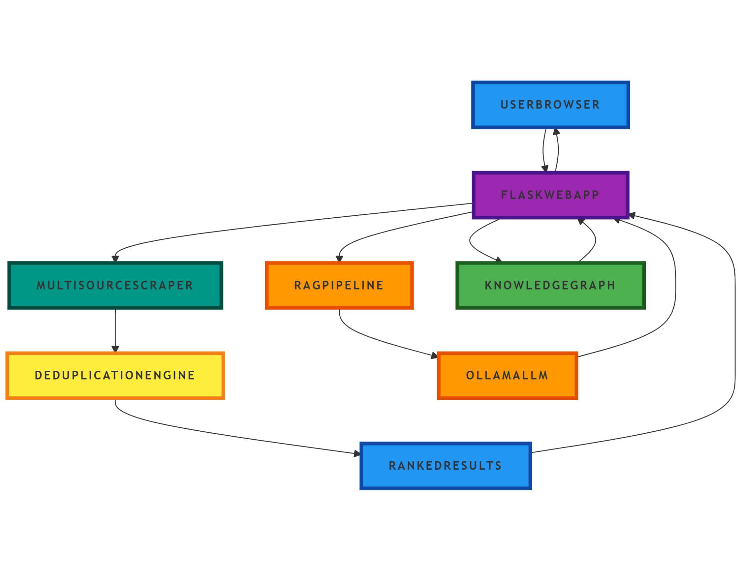
Fig. 4.1 Data Flow Diagram
The retrieved metadata and research documents are then processed through filtering and deduplication mechanisms before being stored temporarily for ranking and analysis. If PDF files are involved, the document processing module extracts textual content using PyPDF2 or OCR-based extraction techniques in cases where scanned documents are detected.
The extracted text is divided into semantic chunks and converted into vector embeddings. These embeddings are stored in the vector database and later used by the Retrieval-Augmented Generation module during question answering. Simultaneously, metadata related to papers, authors, citations, and research fields is organized within the Neo4j knowledge graph to support relationship visualization and contextual exploration.
When the user submits a query to the chatbot, the system compares the query embedding with stored vectors, retrieves the most relevant contextual information, and provides it to the language model. The generated answer, along with references and graph-based insights, is then displayed through the web interface.
4.3 Project Schedules
4.3.1 Project Task Set : The development of the VeriSci platform was carried out collaboratively by dividing the project into multiple technical and research-oriented tasks. Each phase of the project focused on a specific objective related to system design, implementation, testing, and research documentation.

Collaborative Tasks:
- Literature Survey and Research:
Team members collectively studied research papers, gathered references, and analyzed existing technologies related to RAG, multi-agent systems, and AI-based research assistance.
- System Design and Development:
The team collaboratively worked on architecture planning, frontend development, web scraping, NLP integration, database connectivity, and RAG implementation.
- Testing and Debugging:
All members participated in testing different modules of the system, identifying bugs, validating outputs, and improving retrieval accuracy and system performance.
- Documentation and Research Paper Preparation: The team jointly contributed to report writing, conference paper preparation, result analysis, diagram preparation, and project presentations.
- Project Review and Evaluation:
Regular discussions and review meetings were conducted to monitor project progress, implement suggestions, and ensure smooth execution of all project activities.

4.3.2 Timeline Chart
Sr. No. | Name / Title | Start Date | End Date
1 | Preliminary Survey | 01 Aug 2025 | 22 Aug 2025
2 | Introduction and Problem Statement | 22 Aug 2025 | 05 Sep 2025
3 | Literature Survey | 05 Sep 2025 | 25 Sep 2025
4 | Project Statement | 25 Sep 2025 | 03 Oct 2025
5 | Project Planning and Resource Allocation | 03 Oct 2025 | 17 Oct 2025
6 | System Design | 17 Oct 2025 | 14 Nov 2025
7 | Partial Report Submission | 14 Nov 2025 | 05 Dec 2025
8 | Software Requirement and Specification | 05 Dec 2025 | 02 Jan 2026
9 | Architecture Design | 02 Jan 2026 | 30 Jan 2026
10 | Implementation | 30 Jan 2026 | 20 Mar 2026
11 | Deployment | 20 Mar 2026 | 03 Apr 2026
12 | Testing | 03 Apr 2026 | 17 Apr 2026
13 | Paper Publish | 17 Apr 2026 | 24 Apr 2026
14 | Report Submission | 24 Apr 2026 | 08 May 2026

4.4 UML Design and Documentation
4.4.1 Activity Diagram
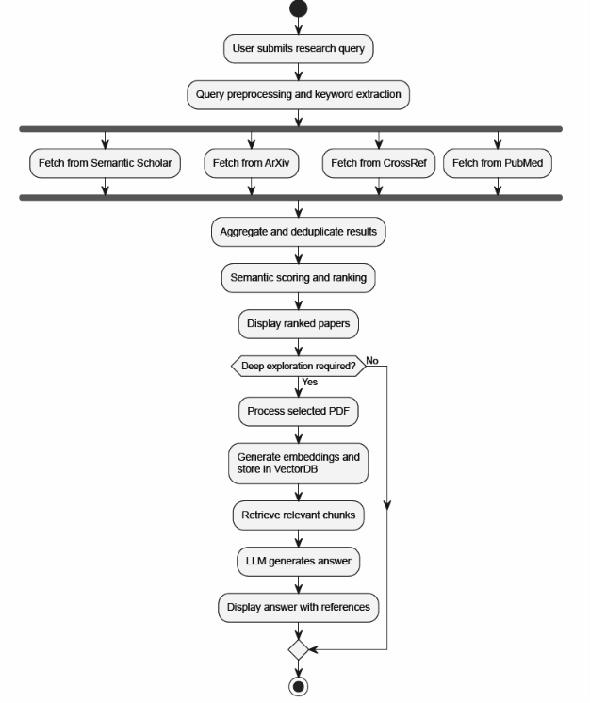
Figure no. 4.1 Activity diagram

.4.2 Sequence Diagram
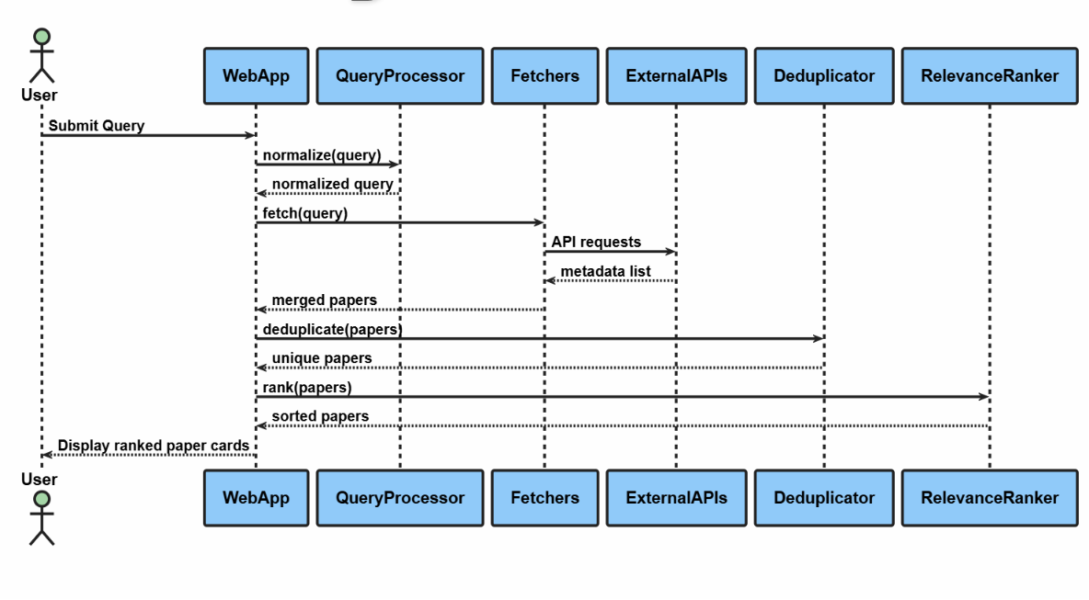Figure no. 4.2 Sequence 1 (Paper Search Flow)

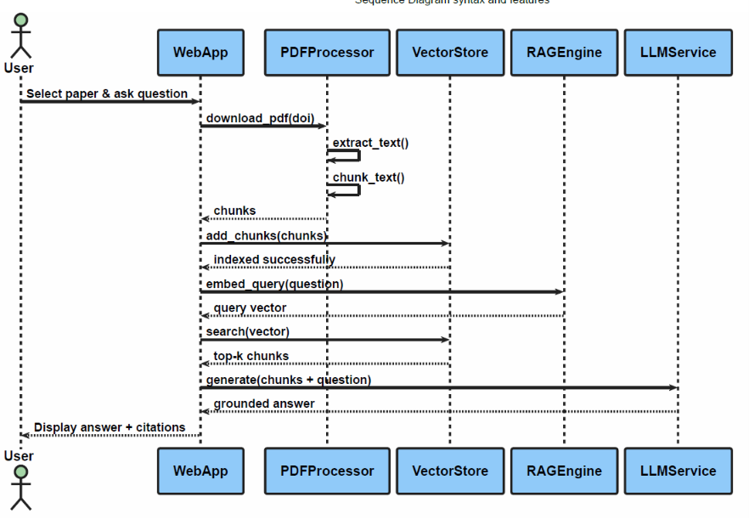
Figure no. 4.3 Sequence diagram 2 (RAG Q&A Flow)

4.4.3 Use Case diagram
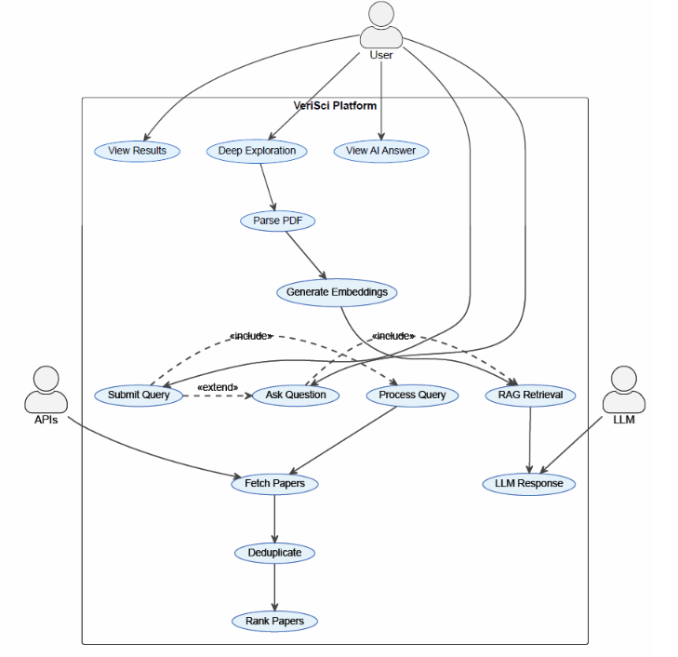
Figure no. 4.4 Use case diagram

4.5 Database Design
The VeriSci project uses three storage mechanisms for different responsibilities. Neo4j is used as the knowledge graph database for relationships between papers, authors, and research fields. A custom local document/vector store is used for Retrieval-Augmented Generation (RAG). A lightweight SQLite database stores workspaces and saved papers so that users can continue literature review work across sessions.
Here is the detailed breakdown of the database designs, for the VeriSci project:
1. Knowledge Graph Database: Neo4j
Neo4j is used to show how research papers, authors and research fields are connected. This helps us get an understanding of things find the most cited papers and do complex searches.
Graph Design & Schema:
Nodes are like the things in our graph. We have three kinds of nodes:
Paper: This is where we store the information about a research paper. It includes things like the title, a summary of the paper the year it was published the date it was published a link to the pdf, where it came from how times it has been cited, the journal it was published in a special number called the doi, a link to the paper and a unique id for the paper.
Author: This represents the people who did the research. The only thing we store about an author is their name.
Field: This is the area of research that the paper's about. Like the author we only store the name of the field.
Relationships are like the connections between these nodes. We have two kinds of relationships:
[:AUTHORED]: This connects an author to a paper they wrote.
[:IN_FIELD]: This connects a paper to the field it's about.
We also use indexes to make our searches faster. The system automatically creates indexes, for the title of a paper an authors name and the year a paper was published. This helps Neo4j find things when we do a search.

4.6 System Thinking –SOCME for Multidisciplinary Approach of Problem Solving
The System-Oriented Concept Map Extension (SOCME) for VeriSci represents the project as a set of interacting subsystems rather than a simple linear workflow. Following the reference format, the system is divided into core components and their interactions are described through labelled relationships. The main subsystems are User Interaction, Literature Retrieval, Paper Access, AI Analysis, Knowledge Organization, and Output/Storage.
Core Components Interaction
Researcher and User Interface: The researcher enters a topic, selects sources, manages workspaces, saves relevant papers, and requests research-gap analysis. The dashboard acts as the central interaction layer.
Literature Retrieval Subsystem: The query is sent to verified sources such as Scopus/Elsevier and IEEE, and to discovery/open-access sources such as Semantic Scholar, OpenAlex, ArXiv, CrossRef, PubMed, CORE, and Google Scholar. The retrieved metadata includes titles, authors, abstracts, DOI/EID values, publication year, citations, journal/source details, and links.
Metadata Normalization and Verification: Results from different APIs are converted into a common paper structure. Duplicate papers are removed using DOI matching, ArXiv identifiers, and fuzzy title comparison. DOI-bearing results are enriched with Scopus verification wherever available.
Paper Access Subsystem: If the user selects Deep Research, the system checks for legal open-access PDFs through existing PDF links, OpenAlex, Unpaywall, or arXiv. Available PDFs are downloaded only into a temporary cache, useful sections are extracted, and the temporary files are deleted after processing.
AI Analysis Subsystem: Abstracts, snippets, and extracted full-text sections are supplied to the RAG pipeline and research-gap generator. The system uses embeddings, similarity retrieval, and an LLM/Ollama chatbot to produce grounded answers and gap suggestions.
Knowledge Organization Subsystem: Paper, Author, and Field nodes are created in the Neo4j knowledge graph. Relationships such as AUTHORED and IN_FIELD help users understand connections between publications, contributors, and research domains.
Output and Storage Subsystem: SQLite stores workspaces and saved papers. The interface presents ranked search results, saved paper libraries, knowledge graph insights, research gap reports, and export-ready outputs.
Fig. 4.5 SOCME Diagram for VeriSci Research Gap Finder
Applications
Academic Literature Review: VeriSci helps students and researchers search multiple academic sources, remove duplicate records, and identify relevant papers faster.
Research Gap Identification: The system supports normal metadata-based gap analysis and Deep Research gap analysis using legal open-access full text where available.
Project Report Preparation: Saved papers, source metadata, gap summaries, and export features support report writing and documentation.
Knowledge Discovery: The knowledge graph allows users to explore author, paper, and field relationships for trend analysis.

CHAPTER 5

SYSTEM IMPLEMENTATION
5.1 Important Libraries /Packages
The VeriSci platform is a Python-based modular architecture designed for distributed data retrieval, complex document processing, and advanced natural language generation. To this end, the system includes a very specialized stack of open-source libraries and frameworks. The next section describes the main software dependencies of the platform, categorized according to their specific functional role in the computational pipeline.
5.1.1 Core Web & Application Infrastructure
- Flask (v3.0.0): Selected as the main web micro-framework, due to its lightweight architecture and high extensibility, to route HTTP requests and handle the backend Application Programming Interface (API).
- Werkzeug (v3.0.1) : Used as the underlying Web Server Gateway Interface (WSGI) library for Flask, to deal with low-level HTTP parsing, request routing and secure file upload handling.
- python-dotenv (v1.0.0): Added to load local environment variables securely and keep sensitive configuration data like API keys out of the application source code.
5.1.2 Data Acquisition and Web Scraping
- requests (v2.31.0): It was chosen as the main HTTP client to perform REST API calls to distributed academic repositories (e.g., IEEE, Semantic Scholar, ArXiv) due to its connection pooling and strong session management.
- beautifulsoup4 (v4.12.2): Used for parsing unstructured HyperText Markup Language (HTML) responses retrieved from web scraping activities.
- lxml (v4.9.3) is the backend parsing engine that is used by BeautifulSoup and was chosen because it can quickly parse large trees of Extensible Markup Language (XML) and HTML documents.
5.1.3 Document Handling and Digitization
- PyPDF2 (v3.0.1): Added to allow for extraction of raw text from digitally rendered Portable Document Format (PDF) files.
- pytesseract (v0.3.10): An Optical Character Recognition (OCR) engine to extract text from image-based or scanned research papers algorithmically.
- pdf2image (v1.16.3): Required as a preprocessing tool to rasterize PDF pages into standard image formats, a prerequisite step for the OCR pipeline.
- Pillow (v10.1.0): The core image processing library used to manipulate the pixel data of rasterized document pages before OCR extraction.

5.1.4 Artificial Intelligence and Vector Calculation
- sentence-transformers (v2.2.2): Used to create dense, high-dimensional vector embeddings of user queries and parsed document chunks, enabling semantic (not just lexical) search.
- scikit-learn (v1.3.2): Used specifically for its highly optimized cosine_similarity function, which mathematically computes the semantic proximity between query vectors and document chunk vectors. numpy (v1.24.3): The underlying mathematical library used to store vector data as multi-dimensional arrays and perform highly parallelized numerical sorting operations.
- anthropic (v0.8.1): Implemented as the client interface for interacting with the Large Language Model (LLM), enabling the final step of Retrieval-Augmented Generation (RAG) inference.
5.1.5 Data Storage and Export Tools
- neo4j (v5.14.0): Chosen as the graph database tool for designing the knowledge graph that facilitates topological modeling and querying of entity interactions (such as authors, publications, citations).
- python-docx (v1.1.0): Incorporated for creating documentation features that facilitate algorithmic production and exporting of research summary documents in Microsoft Word format.
5.2 Important Functions
The platform is based on various algorithms and functions that help in processing data starting from the time the query is inputted until the final AI-generated output. Some of the key functions that define the system architecture are outlined as follows:
1. Data Acquisition and Processing (EnhancedPaperScraper)
- search_all(query, sources, …)
Goal: Serves as the key coordinating function for data collection. This function accepts the sanitized user query and simultaneously sends queries to several scholarly APIs. It consolidates the raw JSON response data into a single format for further analysis.
- advanced_deduplication(papers)
Goal: Maintains the integrity of the dataset by detecting and eliminating duplicate records of papers fetched from the same sources. The process is done through three layers of verification – first DOI verification, then ArXiv ID comparison, and finally, by employing the SequenceMatcher algorithm (similarity threshold > 90%) to compare titles.

- compute_relevance_score(paper, query)
Goal: This is a relevance ranking heuristic function that returns a 0-100 relevance score for each distinct paper. The heuristic score is determined using exact title match scores, keyword overlap within the abstracts without stopwords, logarithmic citation score, and publication date relevance.
2. Custom Vector / Document Store for RAG
The project does not use a vector database like Pinecone or ChromaDB. Instead it uses a custom Document Store. This is a file-based mechanism. It is located in standalone_chatbot.py and ollama_chatbot.py. The Custom Vector / Document Store is used for the RAG pipeline.
Design & Architecture:
- Storage (pickle): Metadata, raw text, chunks, and vectorized embeddings of the documents are encoded in a Python dictionary and serialized to disk with pickle (e.g., saved as rag_storage/documents.pkl).
- Embeddings: Sentence-transformers embeddings (using all-MiniLM-L6-v2 model) are utilized for converting text chunks into vectorized form (NumPy array).
- Similarity Search: No external service is used for computing vector similarities. The cosine_similarity function from scikit-learn is employed to measure the distance between the query vector and all other chunk vectors in memory.
- Chunking Approach: Implements smart chunking with sentence awareness. Chunk size is set at 1000 characters, while the overlap is 200 characters.
- MMR Reranking: While retrieving chunks, MMR (Maximal Marginal Relevance) is utilized to rerank the most similar chunks, ensuring the LLM receives diversified input context.
5.3 Important Algorithms
5.3.1 Multi-Source Retrieval Algorithm
The multi-source retrieval algorithm accepts a research query and selected filters from the user interface. It sends the query to selected sources, prioritizing verified academic databases such as Scopus and IEEE while also supporting open academic sources for broader discovery. Requests are executed in parallel to reduce latency.
The returned records are normalized into a common paper dictionary. Duplicate records are removed using DOI matching, ArXiv ID comparison, and fuzzy title similarity. The final papers are ranked using relevance score, title match, keyword overlap, citation count, publication recency, source quality, and metadata completeness.
5.3.2 Deep Research Gap Algorithm
The normal gap finder uses titles, abstracts, keywords, citations, and source metadata to identify possible research gaps. Deep Research improves this by attempting to retrieve legal open-access PDFs. The system extracts compact evidence from sections such as abstract, methodology, results, limitations, conclusion, and future work. If full text is unavailable, the system falls back to metadata-only analysis.
5.3.3 RAG Question Answering Algorithm
Uploaded PDFs are processed by extracting text, cleaning it, dividing it into chunks, and converting each chunk into sentence-transformer embeddings. During question answering, the query embedding is compared with stored chunk embeddings using cosine similarity. Maximal Marginal Relevance is used to choose diverse and relevant chunks before sending context to the LLM.
5.3.4 Knowledge Graph Construction Algorithm
The knowledge graph construction algorithm converts paper metadata into Paper, Author, and Field nodes. Paper nodes store title, abstract, year, DOI, source, citations, journal, URL, and PDF availability. Authors are connected to papers using AUTHORED relationships, and papers are connected to domains through IN_FIELD relationships.

5.4 Important Data Structure
The main data structures used in the VeriSci platform are described below.
Paper Dictionary: A normalized dictionary containing title, authors, abstract, year, citations, source, journal, DOI, EID, URL, PDF URL, keywords, subject areas, Scopus verification status, and source metrics.
Search Cache JSON: Search results are stored temporarily as JSON cache files using a cache key derived from query parameters and selected sources. This reduces response time for repeated searches.
SQLite Workspace Tables: The workspaces table stores local research projects, while the saved_papers table stores selected papers, notes, tags, source details, DOI, year, citations, and the complete paper JSON.
RAG Document Store: The document store maintains metadata, extracted text, chunks, and embeddings in a lightweight local serialized format. This avoids dependence on external vector databases for the MVP.
Neo4j Graph Structure: Paper, Author, and Field nodes are linked through AUTHORED and IN_FIELD relationships. Indexing improves graph search by paper title, author name, and publication year.
Deep Research Evidence Object: This structure stores the paper title, source, DOI/EID, evidence level, full-text status, extracted sections, evidence snippets, and the number of characters used for analysis.
5.5 Graphics User Interface Screenshot
The user interface of VeriSci is organized as a dashboard-based web application. It allows users to search papers, manage workspaces, save selected papers, view paper details, generate research gaps, explore the knowledge graph, upload PDFs, and chat with uploaded documents.
The following screenshots should be added in this section:
Figure 5.1 Dashboard Workspace Screen
Figure 5.2 Search Interface with Scopus/IEEE and Open-Access Source Selection
Figure 5.3 Search Result Cards with Scopus Verification and PDF Badges
Figure 5.4 Deep Research Gap Finder Output
Figure 5.5 Knowledge Graph Explorer
Figure 5.6 PDF Chat/RAG Interface

CHAPTER 6

RISK ANALYSIS
6.1 Introduction to Risk Analysis
Risk analysis is an important part of software project development, especially in systems involving Artificial Intelligence, Retrieval-Augmented Generation (RAG), web scraping, and large-scale document processing. Since the VeriSci platform integrates multiple technologies such as Natural Language Processing, Knowledge Graphs, Large Language Models, OCR, and academic repository APIs, several technical and operational uncertainties may arise during development and deployment.
The purpose of risk analysis is to identify potential challenges that could affect system performance, data reliability, security, project timelines, and overall usability. By recognizing these risks at an early stage, appropriate mitigation and monitoring strategies can be implemented to reduce their impact and ensure smooth execution of the project.
The VeriSci platform handles large amounts of academic data collected from different research repositories. Therefore, risks related to API limitations, incorrect document extraction, semantic retrieval inaccuracies, system integration issues, and data security become important considerations during development. In addition, external dependencies such as internet connectivity, third-party APIs, and AI model availability can also influence the performance of the system.
A structured risk management approach helps in maintaining system stability, improving reliability, and ensuring continuous progress throughout the project lifecycle.
6.2 Risk Identification

6.2.1 Technical Risks

Incorrect Retrieval and Context Generation: The RAG-based system may sometimes retrieve partially relevant or unrelated research content due to semantic ambiguity in user queries.
- Reduced response accuracy
- Incorrect contextual answers
- Difficulty in handling broad or ambiguous research topics

OCR and PDF Extraction Errors : Research papers in scanned or image-based format may not always be processed accurately.
- Loss of important textual information
- Incorrect extraction of equations or references
- Reduced quality of generated embeddings

API Integration and Scraping Failures : The project depends on multiple academic repositories such as ArXiv, IEEE, and Semantic Scholar.
- API rate-limit issues
- Changes in repository response formats
- Incomplete metadata collection

6.2.2 Project Risks

Delay in AI Model Integration : Integrating embedding models, RAG pipelines, and Large Language Models may require additional experimentation and debugging.
- Extension in development timeline
- Delayed testing and deployment
- Increased implementation complexity

Research Paper and Documentation Delays : Conference paper preparation and report writing may require repeated revisions and plagiarism verification.
- Delay in submission deadlines
- Increased workload during final stages
- Documentation inconsistencies

6.2.3 Operational Risks

System Performance Issues : Processing large research PDFs and generating embeddings may consume significant computational resources.
- Slow response time
- Increased memory consumption
- Delayed query execution

Data Loss or Corruption : Failure during database updates or vector storage operations may lead to partial data loss.
- Missing research metadata
- Corrupted embeddings
- Inconsistent knowledge graph relationships

Security and Credential Exposure : Improper handling of API keys and database credentials may create security vulnerabilities.
- Unauthorized access to repositories
- Data misuse or leakage
- System compromise

6.2.4 External Risks

Dependency on Internet and Third-Party Services : The platform relies on external APIs and cloud-based AI services.
- Downtime of external services
- Internet connectivity issues
- Interrupted data retrieval

Rapid Changes in AI Technologies : Frequent updates in AI frameworks and models may affect compatibility.
- Deprecated libraries
- Integration challenges
- Additional maintenance effort
6.3 Types of Risks
• Technical Risks
Risks related to RAG implementation, OCR accuracy, embeddings, APIs, and semantic retrieval.
• Project Risks
Risks associated with project scheduling, documentation, integration delays, and testing.
• Operational Risks
Risks affecting runtime performance, data storage, security, and system reliability.
• External Risks
Risks caused by internet dependency, third-party services, and changing AI technologies.

6.4 Risk Classification Table
Risk ID | Risk Description | Type | Impact | Probability
R1 | Incorrect semantic retrieval and irrelevant RAG responses | Technical | High | Medium
R2 | OCR failure while processing scanned PDFs | Technical | High | Medium
R3 | API rate limits and scraping interruptions | Technical | High | High
R4 | Delay in integration of LLMs and embeddings | Project | Medium | Medium
R5 | High computational load during document processing | Operational | High | Medium
R6 | Loss or corruption of vector database information | Operational | High | Low
R7 | Exposure of API keys or credentials | Operational | Critical | Medium
R8 | Downtime of external repositories or AI services | External | Medium | High
R9 | Compatibility issues due to framework updates | External | Medium | Medium

6.5 Risk Assessment, Monitoring and Control with Tools

6.5.1 Risk Mitigation

1. Semantic Retrieval Optimization : To reduce irrelevant RAG outputs, embedding-based semantic search and reranking techniques such as Maximal Marginal Relevance (MMR) are implemented.

2. OCR Validation and Text Cleaning : The system performs preprocessing and text sanitization to improve extraction quality from scanned documents.

3. Secure API and Credential Handling : Sensitive credentials are stored using environment configuration files (.env) to prevent unauthorized access.

4. Backup and Data Recovery : Regular backups of metadata, embeddings, and graph database records are maintained to avoid permanent data loss.

5. Efficient Resource Management : Chunking techniques and optimized vector operations are used to reduce memory consumption and improve performance.

6. Modular System Design : The project follows a modular architecture, making it easier to isolate errors and update components independently.

6.5.2 Monitoring

1. API Monitoring : Repository APIs are continuously monitored for failures, rate limits, and response delays.

2. Database Monitoring : The Neo4j graph database and vector storage are checked regularly for consistency and integrity.

3. Performance Evaluation : Query response time and retrieval accuracy are tested periodically using evaluation scripts.

4. Error Logging : System logs are maintained to detect scraping failures, OCR issues, and runtime exceptions.

5. Security Monitoring : Credential usage and access permissions are reviewed regularly to avoid unauthorized system access.

6.5.3 Management and Control

1. Regular System Updates
Libraries, APIs, and AI frameworks are updated periodically to maintain compatibility and security.

2. Testing and Validation
Different research queries are tested continuously to evaluate system accuracy and contextual relevance.

3. Version Control and Backup
GitHub version control and local backups are maintained to track development progress and prevent code loss.

4. Team Coordination
Regular discussions and review meetings are conducted to monitor project progress and resolve technical challenges efficiently.

5. Documentation and Reporting
Detailed documentation of algorithms, modules, and testing procedures is maintained for future reference and project transparency.

Chapter 7
SYSTEM TESTING
7.1 Type of Testing
Testing was performed to verify the functional correctness, reliability, and integration of the VeriSci platform. The testing approach follows the reference blackbook structure and includes positive testing, negative testing, unit testing, and integration testing.
7.1.1 Positive Testing
Positive testing checks whether the system works correctly when valid inputs are provided. Test cases included searching valid research topics, selecting Scopus and IEEE sources, saving papers to a workspace, uploading readable PDFs, generating research gaps, exporting results, and viewing knowledge graph statistics. In all cases, the expected output was successful completion of the requested workflow with correct data display.
7.1.2 Negative Testing
Negative testing checks how the system behaves when invalid or incomplete inputs are given. Test cases included submitting an empty search query, uploading a non-PDF file, requesting RAG chat before indexing documents, selecting unavailable APIs, and running optional graph features when Neo4j is not active. The system handled these cases by showing validation messages or graceful error responses.
7.1.3 Unit Testing
Unit testing was performed on individual modules such as EnhancedPaperScraper, ScopusScraper, PDFProcessor, ResearchStore, RAG chatbot functions, export logic, and knowledge graph manager functions. Each unit was checked for expected input-output behavior, exception handling, and data consistency.
7.1.4 Integration Testing
Integration testing verified complete workflows across modules. The major workflows tested were search to save paper, search to knowledge graph insertion, PDF upload to RAG chat, search result to research gap generation, and Deep Research full-text extraction to evidence-based gap output.
7.2 Testing Summary
The testing process showed that the system can support the main research workflow from query search to paper saving, research gap analysis, knowledge graph organization, and PDF-based question answering. Optional services such as Ollama and Neo4j are handled separately, so the web application remains usable even if those services are temporarily unavailable.

Chapter 8

EXPERIMENTAL RESULTS

8.1 Results and Outputs

The implemented VeriSci platform successfully provides a unified environment for academic paper discovery, organization, research-gap identification, and document-grounded question answering. The search module retrieves papers from verified sources such as Scopus/Elsevier and IEEE, while also supporting open academic sources for wider coverage.

The result cards display title, authors, year, source, citations, DOI, journal, abstract, PDF availability, and Scopus verification status. This helps users quickly judge whether a paper is relevant and reliable. The workspace dashboard allows selected papers to be saved locally, making the literature review process more organized.

The Deep Research feature improves the quality of research-gap generation by using legal open-access PDFs whenever available. It extracts compact evidence from useful sections of the paper and deletes the temporary PDF after processing. This reduces laptop storage load while allowing stronger evidence-based analysis.

The RAG-based PDF chat module successfully answers user questions using uploaded research papers. The knowledge graph module organizes paper-author-field relationships and provides statistics and insights that support trend analysis.

8.2 Performance Observations

Parallel source searching reduces the delay caused by multiple API calls. Local caching improves repeated search performance because the system can reuse previous results instead of calling every external source again. OCR is disabled by default to keep normal PDF processing faster, but it can be enabled when scanned PDFs must be processed.

8.3 Suggested Result Figures

Figure 8.1 Search Results for a Research Topic

Figure 8.2 Workspace Saved Paper Library

Figure 8.3 Research Gap Finder Output

Figure 8.4 Deep Research Evidence Output

Figure 8.5 RAG Chat Response for Uploaded PDF

Figure 8.6 Knowledge Graph Visualization

8.4 Result Analysis

The results indicate that VeriSci works as a practical MVP for AI-assisted literature review. Its main strength is combining verified metadata, open-access discovery, temporary full-text enrichment, local workspace storage, RAG-based document chat, and graph-based knowledge organization into one application. The main limitation is that full-text analysis depends on legal open-access availability; paywalled papers may provide only metadata and abstracts.

CHAPTER 9
CONCLUSIONS AND FUTURE SCOPE
9.1 Conclusion
The VeriSci project successfully demonstrates an AI-based research assistance platform that supports the literature review lifecycle from paper discovery to research-gap identification. The system integrates Scopus/Elsevier, IEEE, and open academic sources to retrieve paper metadata, normalize results, remove duplicates, and rank papers according to relevance and quality.
The platform improves research productivity through workspace-based storage, legal open-access full-text enrichment, RAG-based PDF chat, and knowledge graph visualization. Deep Research addresses the earlier limitation of title-only search by temporarily downloading legal open-access PDFs, extracting useful evidence, and deleting files after processing.
Overall, VeriSci provides a practical MVP for students and researchers who need a unified tool for searching, organizing, analyzing, and understanding research papers. It shows how retrieval-based AI, local storage, knowledge graphs, and conversational interfaces can make academic research faster, more structured, and more evidence-driven.
9.2 Future Scope
1. Institutional Access Integration: The system can be extended to support university/library subscriptions for retrieving full text from subscribed sources in a legal manner.
2. Advanced Knowledge Graph: Future versions can add Dataset, Method, Metric, Institution, Model, and Research Gap nodes to detect deeper research patterns.
3. Automatic Literature Review Generation: The system can generate structured literature review drafts with comparison tables and citations.
4. Collaboration Features: Multiple users can work in shared research workspaces with comments, roles, and version history.
5. Citation Manager Integration: Zotero, Mendeley, or BibTeX synchronization can be added for smoother academic writing.
6. Cloud Deployment: Deploying the application on a cloud platform can make it accessible from any device and support larger experiments.
9.3 Applications
Academic Research: Students and researchers can use VeriSci to discover papers, compare sources, and identify possible research gaps.
Final-Year Project Work: The platform helps teams collect references, save important papers, prepare reports, and generate evidence-backed analysis.
Research Supervision: Guides and faculty members can use saved workspaces and knowledge graph insights to review student literature coverage.
Technical Writing: Exported metadata, summaries, and gap suggestions can support survey papers, project reports, and presentations.

REFERENCES
REFERENCES

- Number all the references.
- References has to be written in IEEE Transactions format.
- Use a chronological bibliography.
- Each listed reference in the bibliography must be cited in the text of the report.
- For a book, give the name(s) of author(s), title of the book, edition, chapter number, page number, publisher, location and year of publication.
- For a journal/conference paper, give the name(s) of authors, “title of paper”, name of journal/conference, volume and issue number (for journal), page numbers, month and year of publication.
Example:
- K. D. Shinde and Dr. P. B. Mane, “Augmenting rooftop solar energy penetration ratio with secondary distribution network using smart inverter for maximum power transfer capacity for subordinate grid- A review”, Taylor & Francis, vol-41, issue-6, 2019,
DOI:https://doi.org/10.1080/15567036.2018.1520353

- Shobha N. Pawar and Dr. Pradeep B. Mane, “Wide band PLL frequency synthesizer: A survey” , IEEE 2017 International Conference on Advances in Computing, Communication and Control (ICAC3), Dec-2017, DOI: 10.1109/ICAC3.2017.8318773

For World Wide Web page, write the URL.

- For a book, give the name(s) of author(s), title of the book, edition, chapter number, page number, publisher, location and year of publication.
e.g. Mane P.B. , Bormane D.S. and Itkarkar R.R. “Television Engineering Audio and Video systems” 1st edition, cp.1-4, 2016, Wiley Publication.

- For World Wide Web page, write the URL.

APPENDIX

APPENDIX

PROJECT EVALUATION

Project Review I Remark
Project Review II Remark
Project Review III Remark
Project Review IV Remark

Published papers proof
- Survey paper
- Result paper published / proof of acceptance & receipt of fees

ONE PAGE SYNOPSIS

- Plagiarism Report
- Project Title Mapping with POs and PSOs

Project Title:

Gr. No | PO1 | PO2 | PO3 | PO4 | PO5 | PO6 | PO7 | PO8 | PO9 | PO 10 | PO 11 | PSO 1 | PSO 2

Justification:

Project Outcome:


Department of Information Technology
BE Project/ Academic Year 2025-26
Self-Evaluation Sheet 1
Group Number:
Project Title:
- Student 1 name
- Student 2 name
- Student 3 name

Lite ratur e Surv ey (5) | Desig n (20) | Impleme ntation (20) | Test Result (5) | Attendanc e on the Project Day (10) | Worki ng accord ing to plan activit y (5) | Maintaini ng Log Book (5) | Research Paper (5) | Particip ation in Project/ Poster Compet ition (5) | Award/ Prize if any (5)

Observation and Comments of Guide:

Student Name: Sign
1
2
3

Guide Name: Sign
Department of Information Technology
BTech Project/ Academic Year 2025-26
Self-Evaluation Sheet 2

Group Number: B6 Project
Title:
Date:

- Describe your feelings about working on the project. Did you enjoy working on it?
- What was the hardest part about working on your project?
- List some of the things you learnt while working on your project?
- Were you satisfied with your final project?
- What did you like the best about your project?
- What did you like the least about the project?
- What was the most important thing that you learnt from doing your project that will help you in the future?

Student Name: Sign
1
2
3

Guide Name: Sign

