**Name : Kumar Ayush**

**Roll : 21051737**

**CSE-18**

**OPP Lab Assignment : 1**

1. **WAP to input name, roll number, and marks in 5 subjects for a student, and display it.**

#include <iostream>

using namespace std;

struct student{

char name[25];

int roll;

int marks[5];

};

int main()

{

struct student s1;

printf("enter name of the student : ");

scanf("%[^\n]s",s1.name);

printf("enter roll no. :");

scanf("%d",&s1.roll);

printf("enter marks of subject respectively : ");

for (int i=0 ; i<5 ; i++){

scanf("%d",&s1.marks[i]);

}

printf("The student details are : \n");

printf("name : %s \nRoll : %d\t",s1.name,s1.roll);

for(int i=0 ; i<5 ; i++){

printf("Marks in sub no. %d is : %d\n",i,s1.marks[i]);

}

return 0

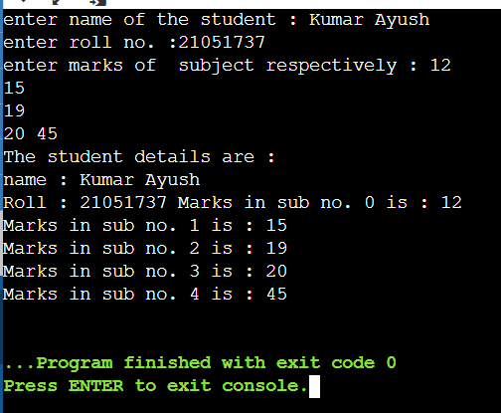

1. **WAP to input name, roll number, and marks in 5 subjects for n number of students. Write functions to:-**a. Find total marks and percentage of all n students.  
   b. Display details of a student with a given roll number.  
   c. Display the details for all the students having percentage in a given range.  
   d. Sort the array in ascending order of marks.

#include <iostream>

using namespace std;

struct student{

char name[25];

int roll;

int marks[5];

int total;

float prec;

};

int main()

{

int n;

printf("enter total no of student : ");

scanf("%d",&n);

printf("\n \n \n \n");

struct student s1[n];

for(int temp=0;temp<n;temp++){

printf("\nenter the details for student no: %d \n",temp+1);

printf("enter name of the student : ");

scanf("\n%[^\n]s",s1[temp].name);

printf("enter roll no. :");

scanf("%d",&s1[temp].roll);

printf("enter marks of subject respectively : ");

s1[temp].total=0;

for (int i=0 ; i<5 ; i++){

scanf("%d",&s1[temp].marks[i]);

s1[temp].total=s1[temp].total+s1[temp].marks[i];

s1[temp].prec=(s1[temp].total/5);

}

}

printf("\n \n \n \n");

for(int temp=0 ; temp<n ; temp++){

for(int j=0 ; j<5 ; j++){

int t;

for(int k=0 ;k<5 ; k++){

int i = k;

if(s1[temp].marks[i]>s1[temp].marks[i+1]){

t=s1[temp].marks[i];

s1[temp].marks[i]=s1[temp].marks[i+1];

s1[temp].marks[i+1]=t;

}

}

}

}

for(int temp=0 ; temp<n ; temp++){

printf("\n\nThe student details of student no. %d are : \n",temp);

printf("name : %s \nRoll : %d\n",s1[temp].name,s1[temp].roll);

for(int i=0 ; i<5 ; i++)

printf("Marks in sub no. %d is : %d\n",i+1,s1[temp].marks[i]);

printf("total marks : %d\npercentage : %fpercent",s1[temp].total,s1[temp].prec);

}

return 0;

}

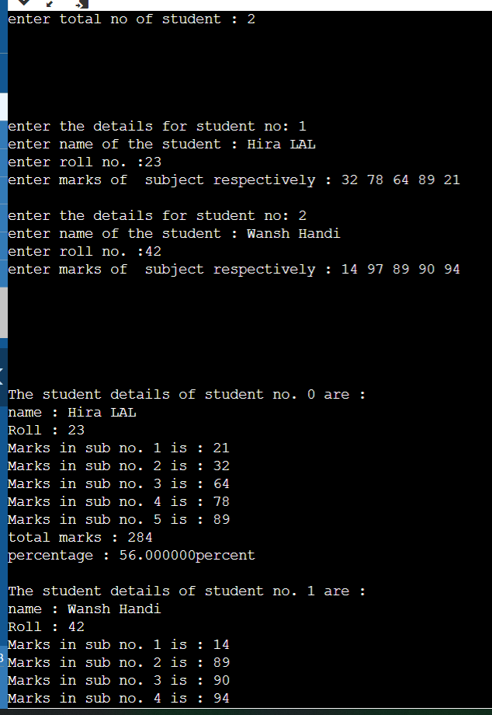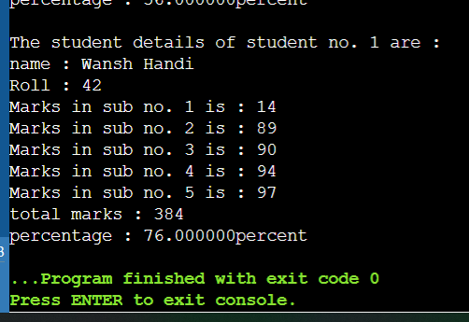

**iii. WAP to enter id, name, age, and basic salary of n number of employees. Calculate the gross salary of all the employees and display it along with all other details in a tabular form, using the pointer to structure.**[ Gross salary= Basic salary + DA + HRA,  
DA = 80% of Basic salary  
HRA=10% of Basic salary ]

#include <iostream>

#include<stdlib.h>

using namespace std;

struct emp{

char id[10];

char name[28];

int age;

int b_sal;

float g_sal;

}e;

int main()

{

int n_emp ;

float g;

cout << "enter no. of employee : " ;

std::cin >>n_emp;

struct emp *e=(struct emp*)calloc(n_emp,sizeof(struct emp));

for(int i=0 ; i<n_emp ; i++){

cout<<"\n\n\nenter details for employee "<<i+1<<" : \nenter name : ";

scanf("\n%[^\n]s",(e+i)->name);

cout<<"enter id : ";

cin>>(e+i)->id;

cout<<"enter age : ";

cin>>(e+i)->age;

cout<<"enter basic salary : $";

cin>>(e+i)->b_sal;

g=(e+i)->b_sal;

(e+i)->g_sal= g*1.9;

}

cout<<" ________________________________________________________________________________________________________________________\n";

cout<<"||______________________________________________________________________________________________________________________||\n";

cout<<"|| ID \t\t Name\t\t Age\t\t Basic salary\t\t Gross salary\t\t\n";

for(int i=0 ; i<n_emp ; i++){

cout<<"||______________________________________________________________________________________________________________________||\n";

printf("|| %s\t\t",(e+i)->id);

printf(" %s\t\t",(e+i)->name);

printf(" %d\t\t",(e+i)->age);

printf(" $%d\t\t\t",(e+i)->b_sal);

printf(" $%5.2f\t\t\n",(e+i)->g_sal);

}

return 0;

}

