-Python Project-

1.Libraries use-
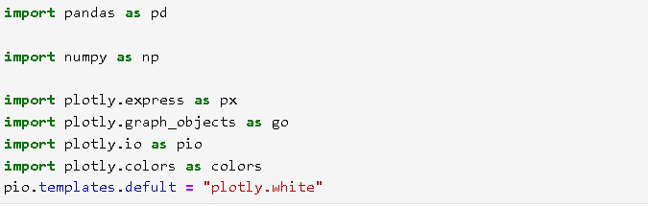

2. Inserting the Super Store Dataset-

- Data information-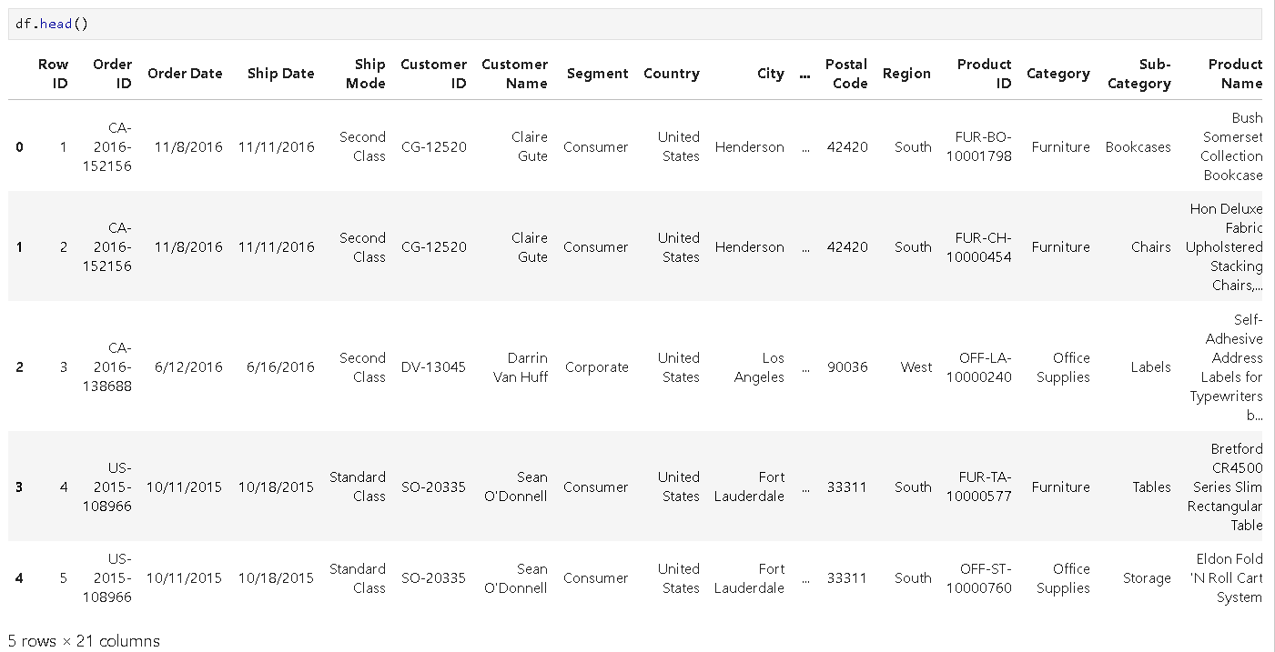

- DataFrame Information-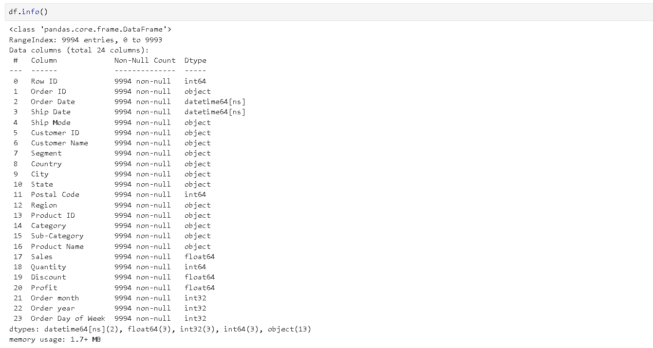

5.statistical summary of a DataFrame.-
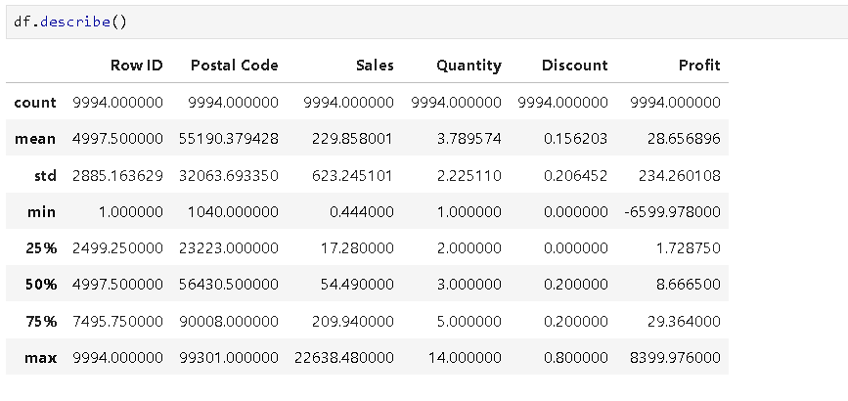

6.Converting date columns-
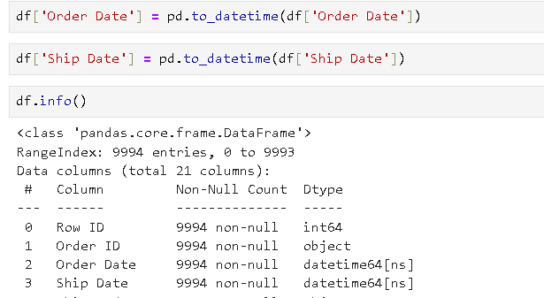

7. Adding new Columns for Analysis-
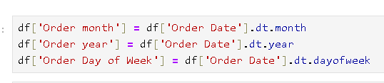

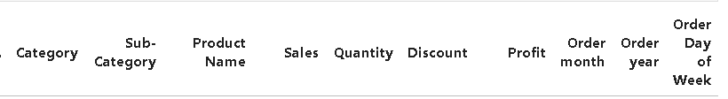

-Exploratory Data Analysis-

# Ques. You need to calculate the monthly sales of the store and identify which month has the highest sales and which months has the lowest sales

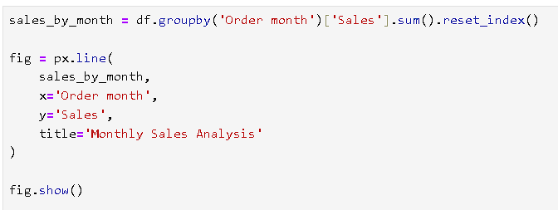

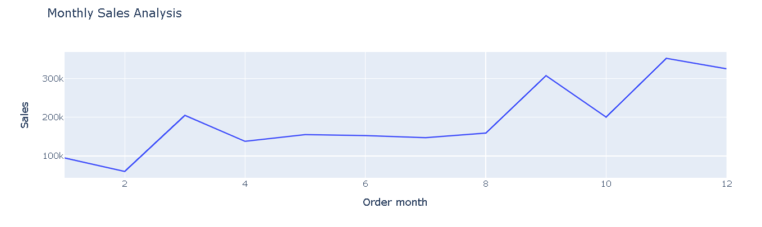
# Ans. Highest sales in 11th month and lowest sales in 2nd month

# Ques. You need to analyze sales based on product categories and determine which category has the lowest sales and which category has the highest sales.

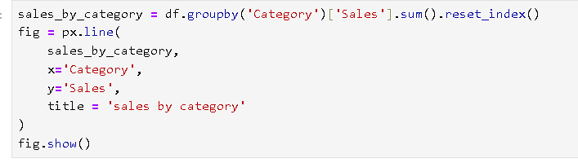

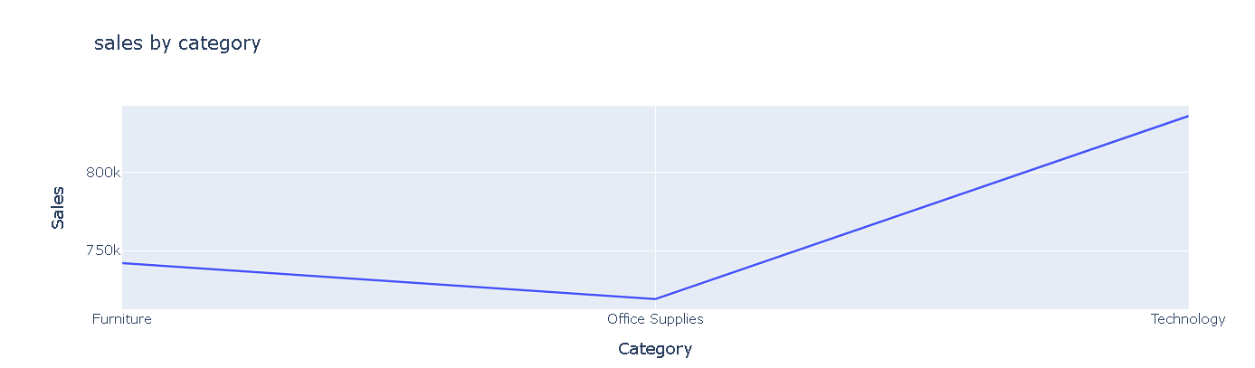

# Ans. Highest category is Technology and Lowest category is Office Supplies

# Ques. The sales analysis needs to be done on sub-category.

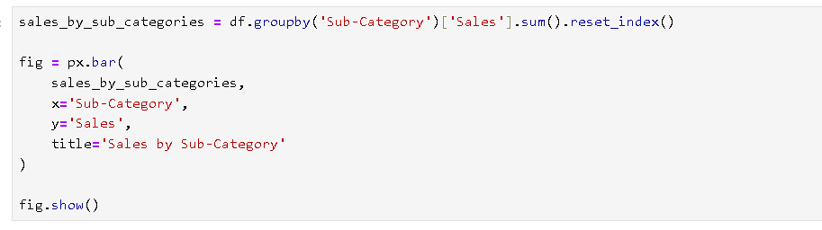

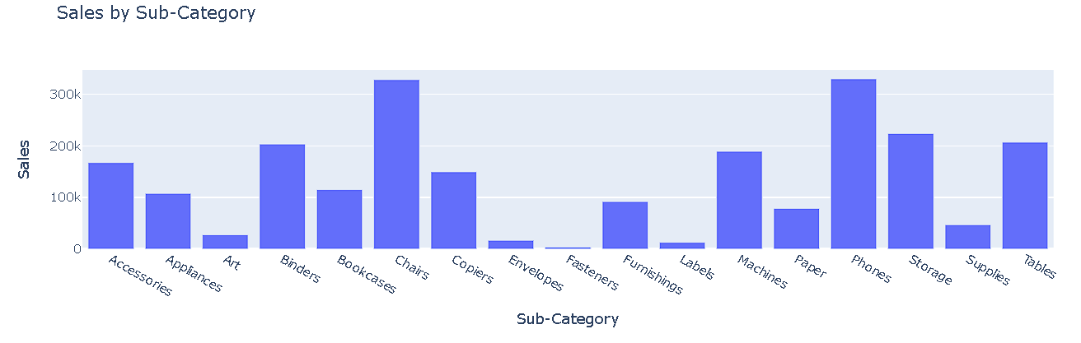

# Ans. Most sale Sub category is Chairs and least sale sab category is Fasteners.

# ques. You need to analyze the monthly profite from sales and dadetermine which month had the highest profit.

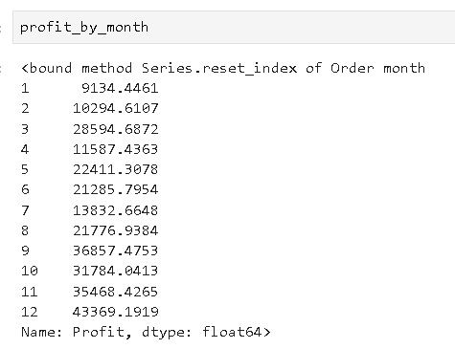

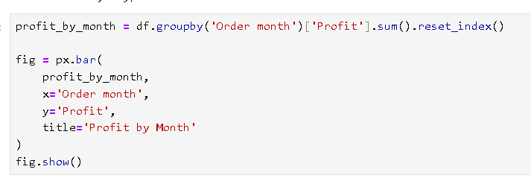

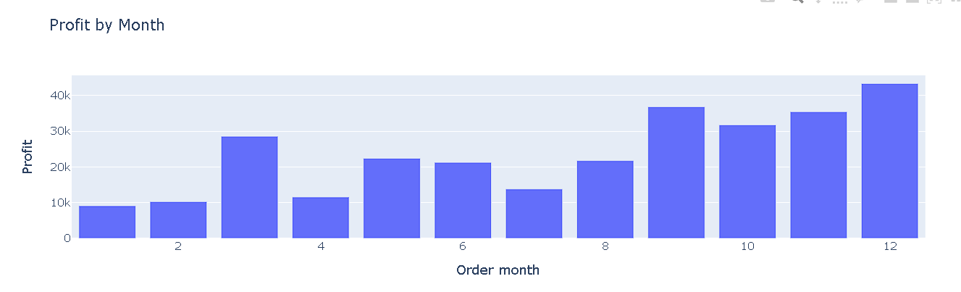

# Ans. The Highest profit month is 12th

# Ques. Analyze the profit by category and sub category.
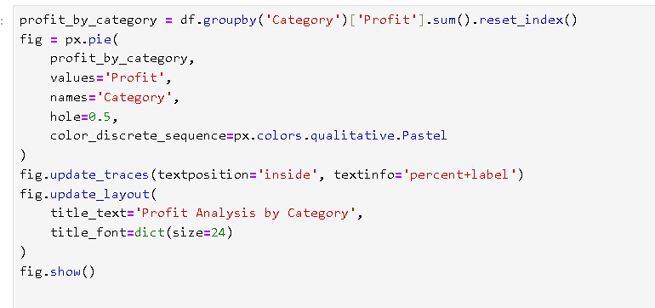

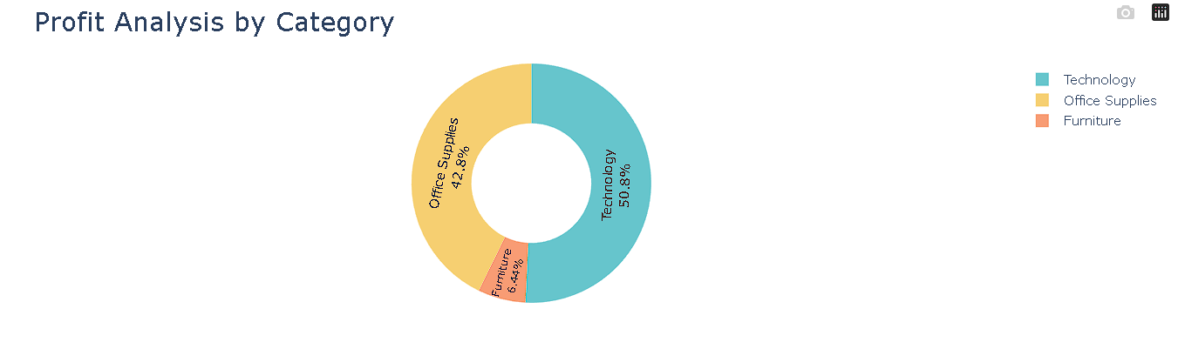

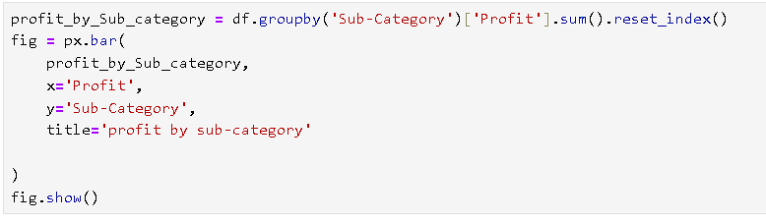

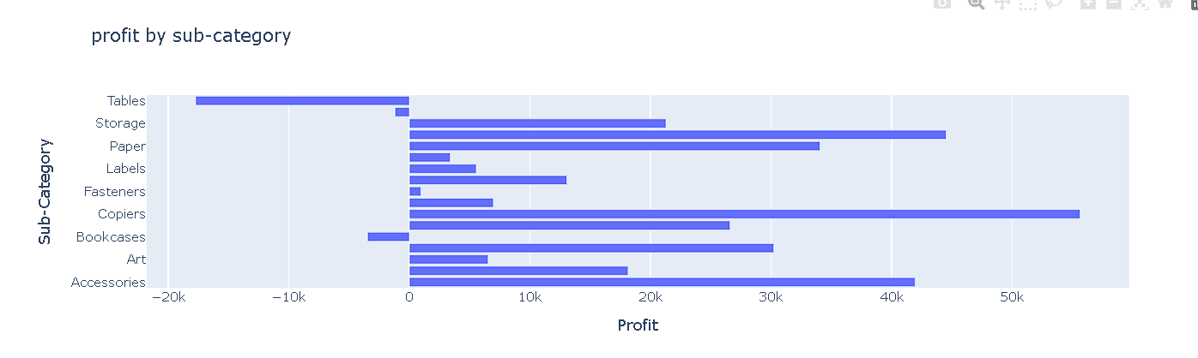

#Ans. the highest Category profite is technology, where as the highest sub-category is copier.

