Course Name: | Foundations of Generative AI Laboratory | Semester: | IV
Date of Performance: | 23 / 04 / 2026 | Batch No: | 3
Faculty Name: | Mr. Dinesh Auti | Roll No: | 16015024081
Faculty Sign & Date: |  | Grade/Marks: | ___/15

Experiment No: 10
Title: Mini Project - Real-world Application of Generative AI

Aim and Objective of the Experiment:
To design and develop a Stock Sentiment Engine that analyzes financial news headlines using Natural Language Processing and correlates the sentiment with real-time stock market data to generate an automated daily market briefing.

COs to be achieved:
CO1: Understand the foundational concepts and principles behind generative models in AI.
CO2: Develop skills to implement and train generative models using deep learning frameworks.
CO3: Explore and apply various generative models such as GANs, VAEs, and flow-based models.
CO4: Gain insight into the ethical implications, challenges, and advancements in generative AI technologies.
CO5: Use generative models for solving real-world problems in domains such as image synthesis, data augmentation, and text generation.

Tools used:
- Python 3.x
- TensorFlow / Keras
- PyTorch
- Jupyter Notebook / Google Colab
- NumPy
- Matplotlib (optional)

Introduction
In modern financial markets, news plays a crucial role in influencing stock prices. Investors rely on timely information to make decisions. This project focuses on building a Stock Sentiment Engine that extracts financial news from online sources and performs sentiment analysis using NLP techniques.
The system uses the VADER sentiment analysis model to classify news headlines as positive, negative, or neutral. It also integrates real-time stock data using Yahoo Finance to compare sentiment with actual market movement.
The project is implemented using Python and visualized through a user-friendly interface (Streamlit / Terminal), making it a complete end-to-end application.

Problem Statement
Investors face difficulty in quickly analyzing large volumes of financial news and understanding its impact on stock prices. There is a need for an automated system that can process news data, extract sentiment, and present insights in a simplified and visual manner.

Objective
- To fetch live financial news using RSS feeds
- To perform sentiment analysis using NLP (VADER model)
- To collect real-time stock data using Yahoo Finance
- To correlate news sentiment with stock performance
- To display results using an interactive interface
- To generate an automated market summary
Methodology
The system follows a step-by-step pipeline:
- Data Collection
News headlines are fetched using Google News RSS feeds, and stock data is obtained using the yfinance library.
- Preprocessing
Headlines are cleaned and passed to the sentiment analysis model.
- Sentiment Analysis
VADER (Valence Aware Dictionary and sEntiment Reasoner) is used to classify headlines into positive, negative, or neutral based on compound scores.
- StocData Analysis
Stock price changes are calculated using open and close values.
- Visualization
Candlestick charts are generated using Plotly to represent stock trends.
- Result Generation
A summary is created showing overall market sentiment and insights.

Result and Discussion
The system successfully analyzed real-time financial news and classified sentiment accurately. The results showed a correlation between positive sentiment and upward stock movement, and negative sentiment with downward trends.

The candlestick charts provided a clear visualization of stock performance. The project demonstrates how NLP can be applied in financial analytics to assist in decision-making.

However, the system uses slightly delayed market data (~15 minutes), which is a limitation of free APIs.

CODE :

stock_sentiment/
├── app.py
├── main.py
├── requirements.txt
app.py –

import streamlit as st
import feedparser
import yfinance as yf
from vaderSentiment.vaderSentiment import SentimentIntensityAnalyzer
import plotly.graph_objects as go

st.set_page_config(page_title="Stock Sentiment Engine", layout="wide")

analyzer = SentimentIntensityAnalyzer()

# -----------------------------
# Stock Options
# -----------------------------
stock_options = {
"Reliance": "RELIANCE.NS",
"TCS": "TCS.NS",
"Infosys": "INFY.NS",
"HDFC Bank": "HDFCBANK.NS",
"ICICI Bank": "ICICIBANK.NS",
"Wipro": "WIPRO.NS"
}

# -----------------------------
# Fetch News
# -----------------------------
def fetch_news():
url = "https://news.google.com/rss/search?q=stock+market+india"
feed = feedparser.parse(url)
return [entry.title for entry in feed.entries[:20]]

# -----------------------------
# Sentiment Analysis
# -----------------------------
def analyze(headlines):
pos = neg = neu = 0
results = []

for h in headlines:
score = analyzer.polarity_scores(h)['compound']

if score > 0.05:
sentiment = "Positive"
pos += 1
elif score < -0.05:
sentiment = "Negative"
neg += 1
else:
sentiment = "Neutral"
neu += 1

results.append((h, sentiment))

return results, pos, neg, neu

# -----------------------------
# Stock Data
# -----------------------------
def get_stocks(selected_list):
data_list = []

for name in selected_list:
symbol = stock_options[name]
data = yf.Ticker(symbol)
hist = data.history(period="1d")

if not hist.empty:
change = hist["Close"].iloc[-1] - hist["Open"].iloc[-1]
data_list.append((name, round(change, 2)))

return data_list

# -----------------------------
# Candlestick Chart
# -----------------------------
def plot_candles(symbol, name):
data = yf.Ticker(symbol)
hist = data.history(period="5d")

if hist.empty:
st.warning(f"No data for {name}")
return

fig = go.Figure(data=[go.Candlestick(
x=hist.index,
open=hist['Open'],
high=hist['High'],
low=hist['Low'],
close=hist['Close']
)])

fig.update_layout(
title=f"{name} Candlestick Chart (Last 5 Days)",
xaxis_title="Date",
yaxis_title="Price"
)

st.plotly_chart(fig, use_container_width=True)

# -----------------------------
# UI
# -----------------------------
st.title("📊 Stock Sentiment Engine")

selected = st.multiselect(
"📌 Select Stocks",
options=list(stock_options.keys()),
default=["Reliance", "TCS"]
)

if st.button("🔄 Refresh Data"):
headlines = fetch_news()
results, pos, neg, neu = analyze(headlines)
stocks = get_stocks(selected)

# Metrics
col1, col2, col3 = st.columns(3)
col1.metric("Positive", pos)
col2.metric("Negative", neg)
col3.metric("Neutral", neu)

# Market Mood
if pos > neg:
mood = "BULLISH 📈"
elif neg > pos:
mood = "BEARISH 📉"
else:
mood = "NEUTRAL ⚖️"

st.subheader(f"Market Sentiment: {mood}")

# Stock Table
st.subheader("💹 Selected Stocks")
st.table(stocks)

# Candlestick Charts
st.subheader("🕯️ Candlestick Charts")
for name in selected:
symbol = stock_options[name]
plot_candles(symbol, name)

# Headlines
st.subheader("📰 Headlines")
for h, s in results:
st.write(f"**{s}** — {h}")

# Summary
st.subheader("🧠 Summary")
st.write(f"Market shows {pos} positive, {neg} negative headlines → {mood}")

main.py –

import feedparser
import yfinance as yf
from vaderSentiment.vaderSentiment import SentimentIntensityAnalyzer
from rich.console import Console
from rich.table import Table

# Initialize
console = Console()
analyzer = SentimentIntensityAnalyzer()

# -----------------------------
# 1. Fetch News (Google RSS)
# -----------------------------
def fetch_news():
url = "https://news.google.com/rss/search?q=stock+market+india"
feed = feedparser.parse(url)
headlines = [entry.title for entry in feed.entries[:20]]
return headlines

# -----------------------------
# 2. Sentiment Analysis
# -----------------------------
def analyze_sentiment(headlines):
results = []

pos, neg, neu = 0, 0, 0

for h in headlines:
score = analyzer.polarity_scores(h)['compound']

if score > 0.05:
sentiment = "Positive"
pos += 1
elif score < -0.05:
sentiment = "Negative"
neg += 1
else:
sentiment = "Neutral"
neu += 1

results.append((h, sentiment, score))

return results, pos, neg, neu

# -----------------------------
# 3. Fetch Stock Data
# -----------------------------
def get_stock_data():
stocks = ["RELIANCE.NS", "TCS.NS", "INFY.NS"]

stock_info = []

for s in stocks:
data = yf.Ticker(s)
hist = data.history(period="1d")

if not hist.empty:
change = hist["Close"].iloc[-1] - hist["Open"].iloc[-1]
stock_info.append((s, round(change, 2)))

return stock_info

# -----------------------------
# 4. Generate Summary (No LLM)
# -----------------------------
def generate_summary(pos, neg, neu):
total = pos + neg + neu

if pos > neg:
mood = "BULLISH"
elif neg > pos:
mood = "BEARISH"
else:
mood = "NEUTRAL"

summary = f"Market sentiment appears {mood} with {pos} positive, {neg} negative headlines."
return mood, summary

# -----------------------------
# 5. Display Output
# -----------------------------
def display(headlines, results, pos, neg, neu, stocks, mood, summary):
console.print("\n📊 [bold cyan]STOCK SENTIMENT ENGINE — DAILY BRIEFING[/bold cyan]\n")

console.print(f"📰 Headlines Analyzed: {len(headlines)}\n")

console.print(f"🔹 Positive: {pos}")
console.print(f"🔹 Negative: {neg}")
console.print(f"🔹 Neutral: {neu}\n")

console.print(f"📈 Market Sentiment: [bold]{mood}[/bold]\n")

# Stock Table
table = Table(title="💹 Top Stocks")

table.add_column("Stock")
table.add_column("Change")

for s, change in stocks:
table.add_row(s, str(change))

console.print(table)

console.print("\n🧠 Summary:")
console.print(summary)

# -----------------------------
# MAIN
# -----------------------------
def main():
headlines = fetch_news()
results, pos, neg, neu = analyze_sentiment(headlines)
stocks = get_stock_data()
mood, summary = generate_summary(pos, neg, neu)

display(headlines, results, pos, neg, neu, stocks, mood, summary)

if __name__ == "__main__":
main()

requirements.txt – (requirements.txt is used to list all the dependencies (libraries) required for the project so that anyone can easily install them using a single command and run the project without errors.)

feedparser
yfinance
vaderSentiment
rich
plotext
streamlit
plotly

The project was executed by opening the project folder in a code editor terminal and activating the virtual environment. All required dependencies were installed using the pip package manager with the help of a requirements file.
After installing the necessary libraries, the application was executed using Streamlit, which launched the dashboard in a web browser. The system then fetched live news data, performed sentiment analysis, and displayed the results along with stock visualizations.

Commands to follow to run the program :
cd <project_folder>
.venv\Scripts\activate
pip install -r requirements.txt
python -m streamlit run app.py

OUTPUT :

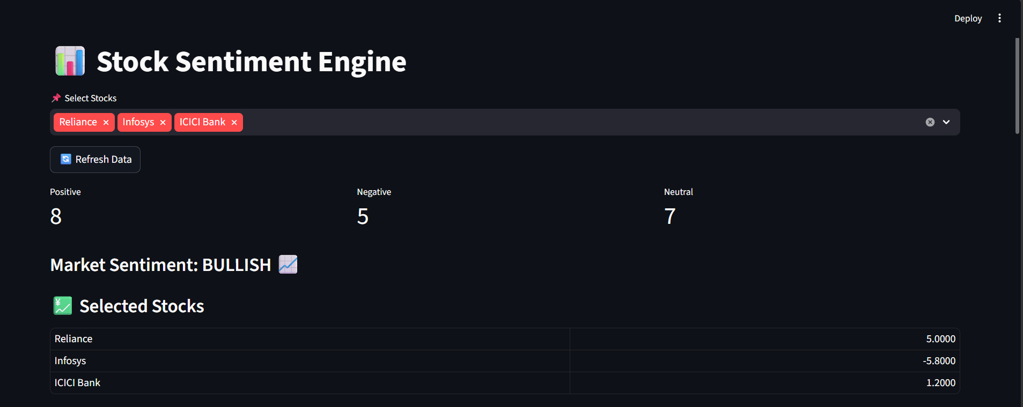
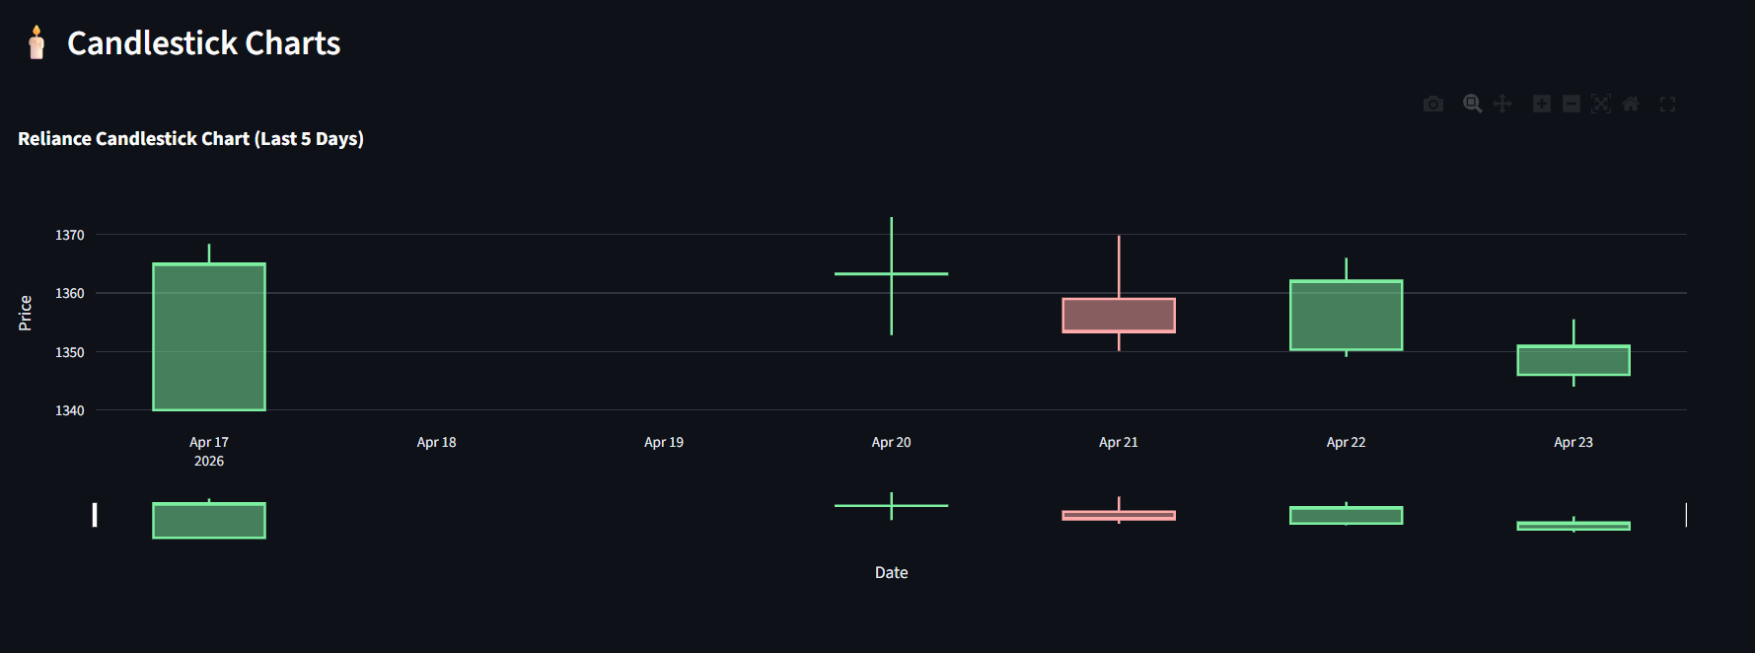
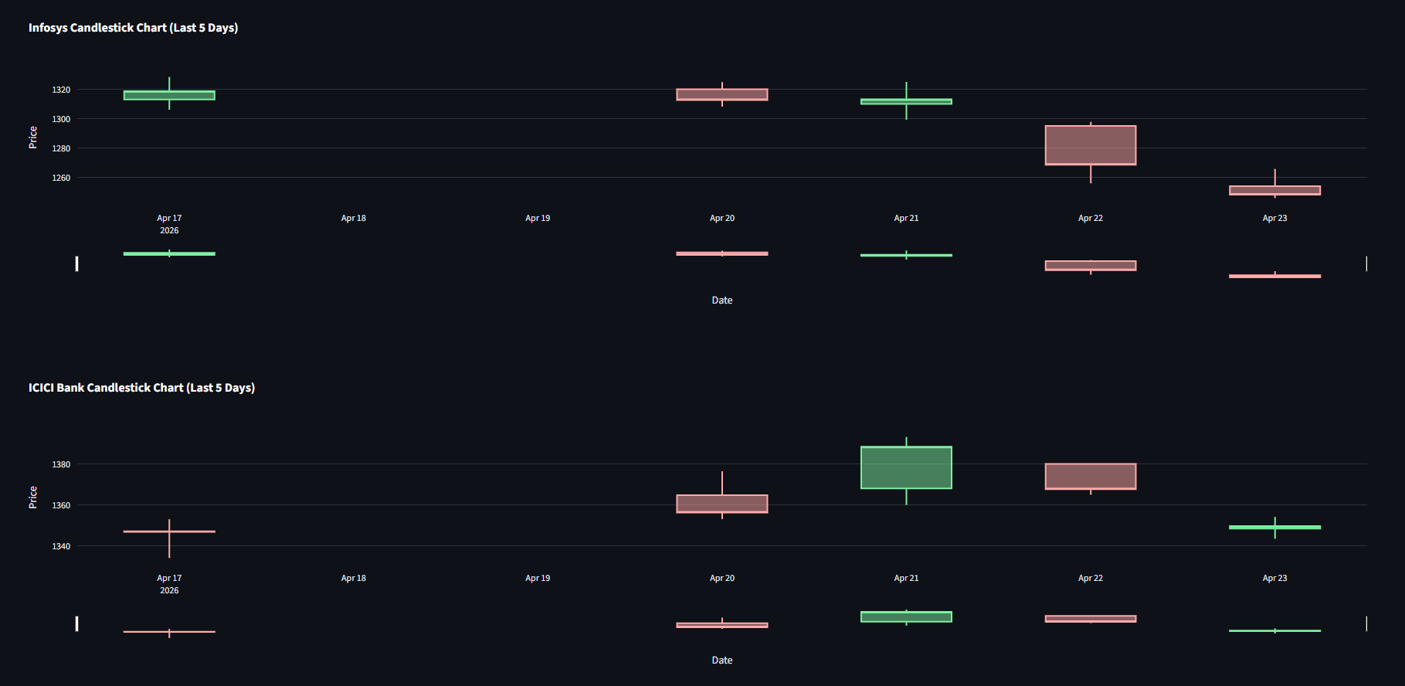

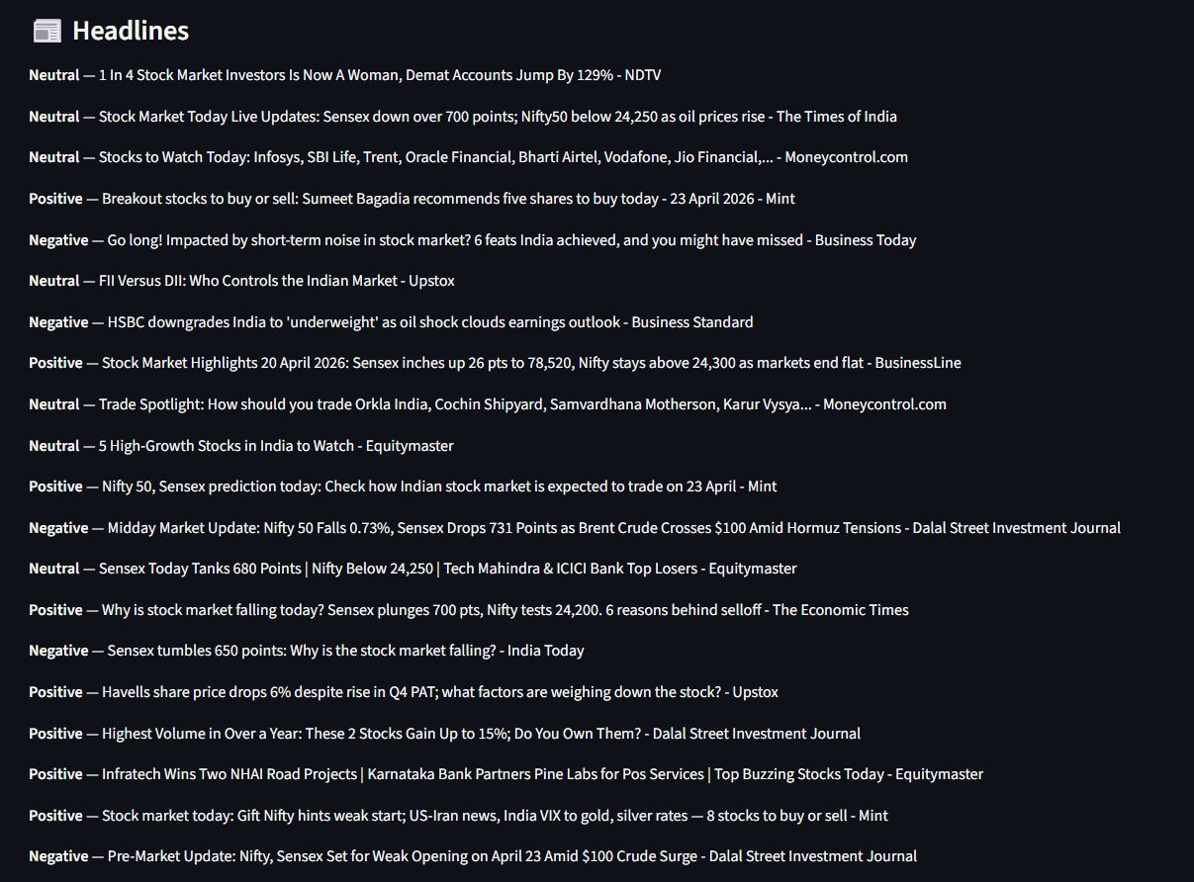

Conclusion:

The Stock Sentiment Engine demonstrates the integration of NLP and financial data analysis into a single automated system. It provides meaningful insights by combining news sentiment with stock performance. The project can be further extended with real-time APIs, machine learning models, and predictive analytics.

Signature of faculty in-charge with Date:

