Course Name: | Foundations of Generative AI Laboratory | Semester: | III
Date of Performance: | 27 / 01 / 2026 | Batch No: | (CSBS) A4
Faculty Name: | Prof. Dinesh Auti | Roll No: | 16015024081
Faculty Sign & Date: |  | Grade/Marks: | ___/15

Experiment No: 2
Title: Building and Training a Simple Autoencoder

Aim and Objective of the Experiment:
To understand the concept of autoencoders and implement a simple autoencoder model using TensorFlow and PyTorch for data reconstruction.

COs to be achieved:
CO2: Develop skills to implement and train generative models using deep learning frameworks.

Tools used:
- Python 3.x
- TensorFlow / Keras
- PyTorch
- Jupyter Notebook / Google Colab
- NumPy
- Matplotlib (optional)

Theory:
An autoencoder is a type of neural network used for data reconstruction and feature learning. It consists of two main components: an encoder and a decoder. The encoder compresses the input data into a lower-dimensional latent representation, and the decoder reconstructs the original data from this representation.

In a denoising autoencoder, noise is intentionally added to the input data, and the network is trained to reconstruct the original clean data. This allows the model to learn meaningful features while ignoring irrelevant noise. Autoencoders are widely used in generative modeling, dimensionality reduction, and image denoising tasks. Deep learning frameworks such as TensorFlow and PyTorch are used to implement and train these models efficiently using backpropagation and optimization techniques.

Code:
- Write a simple program that uses an autoencoder to remove noise from input data and reconstruct the original clean data.
Ans –

import tensorflow as tf
from tensorflow.keras import layers
import numpy as np
import matplotlib.pyplot as plt

# ======================================================
# Hyperparameters
# ======================================================
LATENT_DIM = 128
BATCH_SIZE = 256
EPOCHS = 70
BUFFER_SIZE = 60000

# ======================================================
# Load & preprocess MNIST [-1, 1]
# ======================================================
(x_train, _), _ = tf.keras.datasets.mnist.load_data()
x_train = (x_train.astype("float32") - 127.5) / 127.5
x_train = np.expand_dims(x_train, axis=-1)

dataset = tf.data.Dataset.from_tensor_slices(x_train)
dataset = dataset.shuffle(BUFFER_SIZE).batch(BATCH_SIZE, drop_remainder=True)

# ======================================================
# Generator
# ======================================================
generator = tf.keras.Sequential([
layers.Input(shape=(LATENT_DIM,)),
layers.Dense(256),
layers.BatchNormalization(),
layers.ReLU(),

layers.Dense(512),
layers.BatchNormalization(),
layers.ReLU(),

layers.Dense(28 * 28, activation="tanh"),
layers.Reshape((28, 28, 1))
])

# ======================================================
# Discriminator (NO sigmoid → logits)
# ======================================================
discriminator = tf.keras.Sequential([
layers.Flatten(input_shape=(28, 28, 1)),
layers.Dense(512, activation="relu"),
layers.Dense(256, activation="relu"),
layers.Dense(1)
])

# ======================================================
# Loss & Optimizers (min–max via logits)
# ======================================================
loss_fn = tf.keras.losses.BinaryCrossentropy(from_logits=True)

g_optimizer = tf.keras.optimizers.Adam(2e-4, beta_1=0.5)
d_optimizer = tf.keras.optimizers.Adam(2e-4, beta_1=0.5)

# ======================================================
# Training Step
# ======================================================
@tf.function
def train_step(real_images):
noise = tf.random.normal([BATCH_SIZE, LATENT_DIM])

with tf.GradientTape() as g_tape, tf.GradientTape() as d_tape:
fake_images = generator(noise, training=True)

real_logits = discriminator(real_images, training=True)
fake_logits = discriminator(fake_images, training=True)

# Label smoothing
real_labels = tf.ones_like(real_logits) * 0.9
fake_labels = tf.zeros_like(fake_logits)

# Generator loss: min −log(D(G(z)))
g_loss = loss_fn(tf.ones_like(fake_logits), fake_logits)

# Discriminator loss: max log(D(x)) + log(1 − D(G(z)))
d_loss = (
loss_fn(real_labels, real_logits) +
loss_fn(fake_labels, fake_logits)
)

g_grads = g_tape.gradient(g_loss, generator.trainable_variables)
d_grads = d_tape.gradient(d_loss, discriminator.trainable_variables)

g_optimizer.apply_gradients(zip(g_grads, generator.trainable_variables))
d_optimizer.apply_gradients(zip(d_grads, discriminator.trainable_variables))

return g_loss, d_loss

# ======================================================
# Training Loop
# ======================================================
for epoch in range(EPOCHS):
for batch in dataset:
g_loss, d_loss = train_step(batch)

print(f"Epoch {epoch+1}/{EPOCHS} | "
f"Generator Loss: {g_loss:.3f} | "
f"Discriminator Loss: {d_loss:.3f}")

# ======================================================
# Generate Images + Discriminator Probabilities
# ======================================================
noise = tf.random.normal([16, LATENT_DIM])
fake_images = generator(noise, training=False)
fake_logits = discriminator(fake_images, training=False)
fake_probs = tf.sigmoid(fake_logits)

print("\nDiscriminator probabilities for generated images:")
print(fake_probs.numpy().reshape(-1))

# ======================================================
# Visualization
# ======================================================
plt.figure(figsize=(4,4))
for i in range(16):
plt.subplot(4,4,i+1)
img = (fake_images[i,:,:,0] + 1) / 2.0 # tanh → [0,1]
plt.imshow(img, cmap="gray")
plt.axis("off")

plt.suptitle("Generated MNIST Images (Stable GAN)")
plt.show()

Output:
Epoch value 50 –

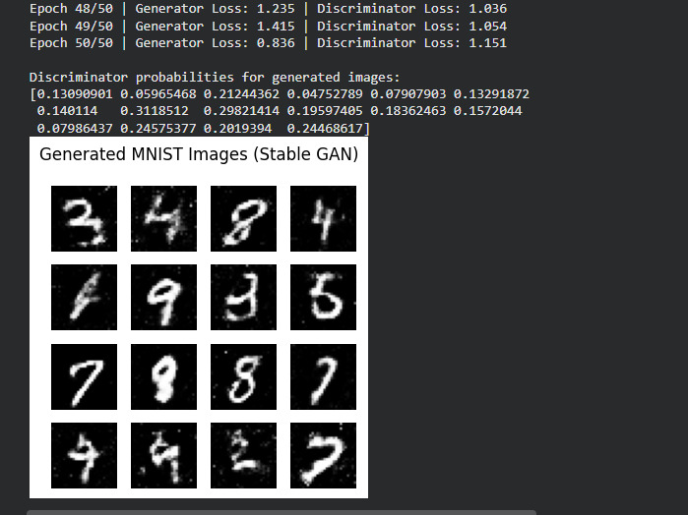

Epoch value 30 –
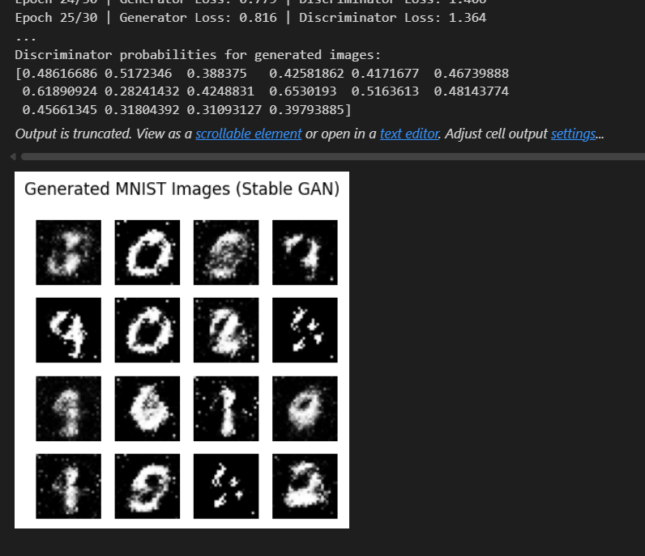

Epoch value 100 –

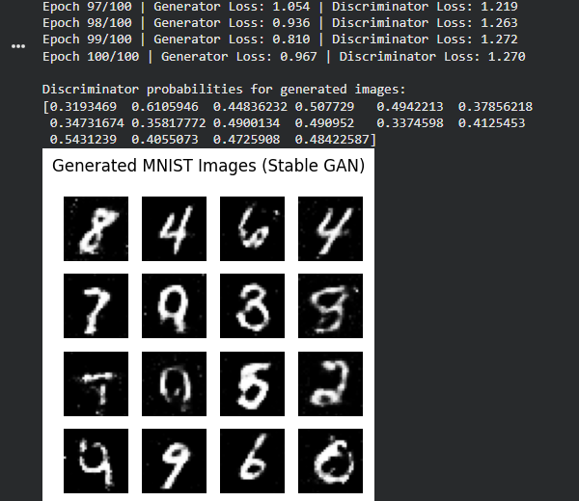

Epoch value 200 –
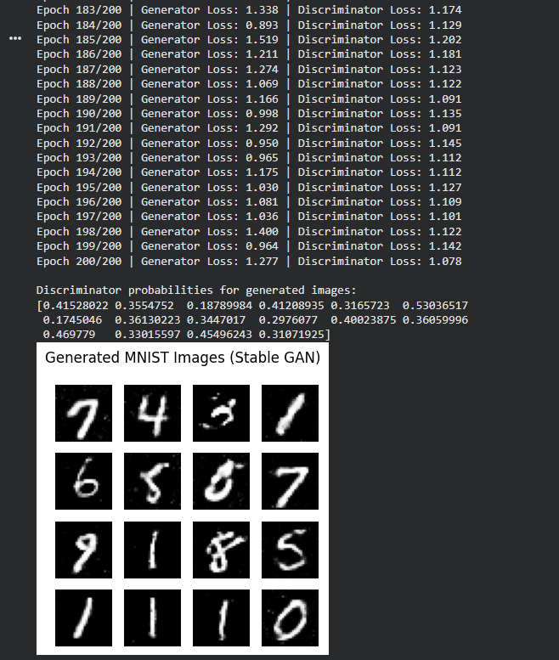

Post Lab Subjective/Objective type Questions:
- What is autoencoder? Mention one of its applications.
Ans –
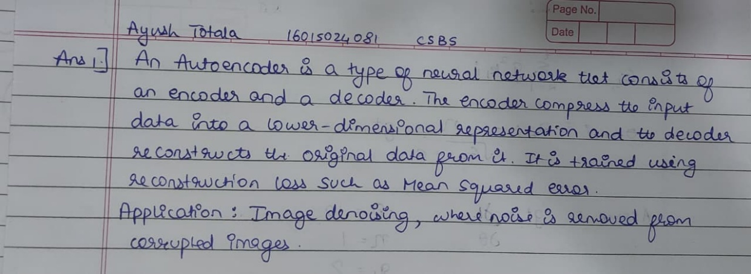
- Why a normal autoencoder is not truly generativeWhat is the difference between TensorFlow and PyTorch?
Ans –

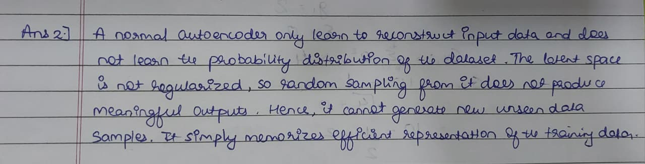
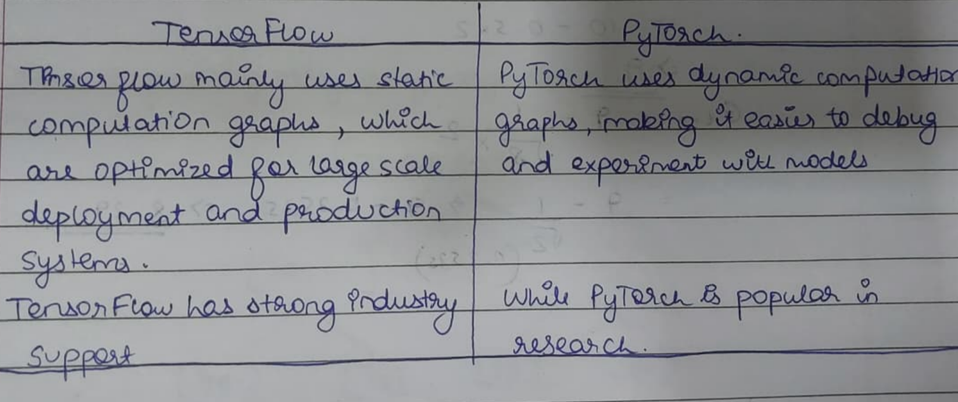
- How autoencoders become generative
Ans –
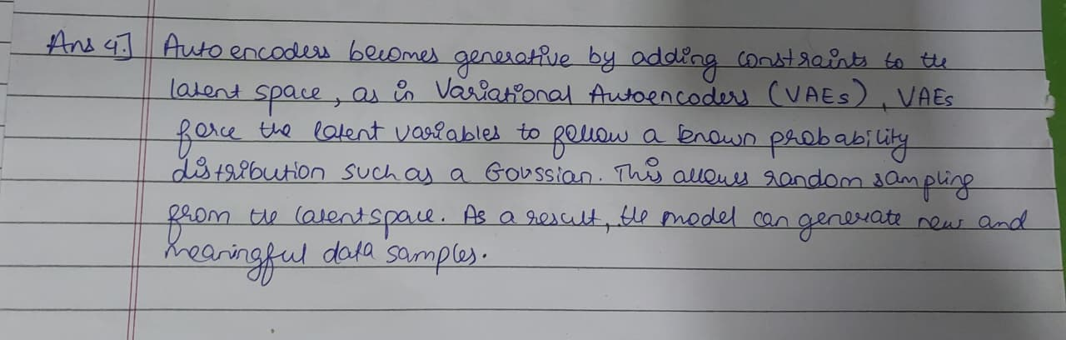

Conclusion:
In this experiment, I understood the basic concept of autoencoders and implemented a simple autoencoder using TensorFlow and PyTorch for data reconstruction. This helped me understand how encoder and decoder work together and improved my skills in implementing and training generative models using deep learning frameworks.

Signature of faculty in-charge with Date:

