Course Name: | Foundations of Generative AI Laboratory | Semester: | IV
Date of Performance: | 24 / 03 / 2026 | Batch No: | A4 (CSBS)
Faculty Name: | Mr. Dinesh Auti | Roll No: | 16015024081
Faculty Sign & Date: |  | Grade/Marks: | ___/15

ExperiExperiment No: 4
Title: Building and Training a Simple Autoencoder

Aim and Objective of the Experiment:
To design, implement, and train a simple autoencoder model using a deep learning framework in order to learn compressed (latent) representations of input data and reconstruct the original data with minimal loss.

COs to be achieved:
CO2: Develop skills to implement and train generative models using deep learning frameworks.
CO3: Explore and apply various generative models such as GANs, VAEs, and flow-based models.

Tools used:
- Python 3.x
- TensorFlow / Keras
- PyTorch
- Jupyter Notebook / Google Colab
- NumPy
- Matplotlib (optional)

Theory:
An autoencoder is an unsupervised deep learning model used to learn efficient representations of data. It consists of two main parts: an encoder, which compresses the input into a lower-dimensional latent space, and a decoder, which reconstructs the original input from this compressed representation.
The model is trained to minimize the reconstruction error (such as Mean Squared Error), ensuring that the output is as close as possible to the input. Autoencoders are widely used for tasks like dimensionality reduction, noise removal, and feature extraction.

Code:
Write a simple program using TensorFlow and PyTorch to build Autoencoder

import numpy as np
import tensorflow as tf
import matplotlib.pyplot as plt

from tensorflow.keras.layers import Input, Conv2D, Conv2DTranspose
from tensorflow.keras.layers import Dense, Flatten, Reshape, LeakyReLU
from tensorflow.keras.models import Model
from tensorflow.keras.datasets import mnist

# -----------------------------
# Load Dataset
# -----------------------------

(x_train,_),(x_test,_) = mnist.load_data()

# normalize
x_train = x_train.astype("float32") / 255
x_test = x_test.astype("float32") / 255

# reshape to CNN format
x_train = x_train.reshape(-1,28,28,1)
x_test = x_test.reshape(-1,28,28,1)

print("Training shape:",x_train.shape)

# -----------------------------
# Encoder
# -----------------------------

encoder_input = Input(shape=(28,28,1), name="encoder_input")

x = Conv2D(32,3,padding="same",name="encoder_conv_0")(encoder_input)
x = LeakyReLU()(x)

x = Conv2D(64,3,strides=2,padding="same",name="encoder_conv_1")(x)
x = LeakyReLU()(x)

x = Conv2D(64,3,strides=2,padding="same",name="encoder_conv_2")(x)
x = LeakyReLU()(x)

x = Conv2D(64,3,padding="same",name="encoder_conv_3")(x)
x = LeakyReLU()(x)

x = Flatten()(x)

encoder_output = Dense(2,name="encoder_output")(x)

encoder = Model(encoder_input,encoder_output,name="Encoder")

print("\nEncoder Summary")
encoder.summary()

# -----------------------------
# Decoder
# -----------------------------

decoder_input = Input(shape=(2,),name="decoder_input")

x = Dense(3136)(decoder_input)
x = Reshape((7,7,64))(x)

x = Conv2DTranspose(64,3,padding="same",name="decoder_conv_t_0")(x)
x = LeakyReLU()(x)

x = Conv2DTranspose(64,3,strides=2,padding="same",name="decoder_conv_t_1")(x)
x = LeakyReLU()(x)

x = Conv2DTranspose(32,3,strides=2,padding="same",name="decoder_conv_t_2")(x)
x = LeakyReLU()(x)

decoder_output = Conv2DTranspose(
1,3,padding="same",activation="sigmoid",name="decoder_conv_t_3"
)(x)

decoder = Model(decoder_input,decoder_output,name="Decoder")

print("\nDecoder Summary")
decoder.summary()

# -----------------------------
# Autoencoder
# -----------------------------

autoencoder_input = encoder_input
encoded = encoder(autoencoder_input)
decoded = decoder(encoded)

autoencoder = Model(autoencoder_input,decoded,name="Autoencoder")

autoencoder.compile(
optimizer="adam",
loss="mse"
)

print("\nAutoencoder Summary")
autoencoder.summary()

# -----------------------------
# Train Model
# -----------------------------

history = autoencoder.fit(
x_train,
x_train,
epochs=10,
batch_size=128,
validation_data=(x_test,x_test)
)

# -----------------------------
# Reconstruction
# -----------------------------

decoded_images = autoencoder.predict(x_test)

# -----------------------------
# Visualization
# -----------------------------

n = 10

plt.figure(figsize=(20,4))

for i in range(n):

# original
ax = plt.subplot(2,n,i+1)
plt.imshow(x_test[i].reshape(28,28),cmap="gray")
plt.title("Original")
plt.axis("off")

# reconstructed
ax = plt.subplot(2,n,i+1+n)
plt.imshow(decoded_images[i].reshape(28,28),cmap="gray")
plt.title("Reconstructed")
plt.axis("off")

plt.show()

Output:
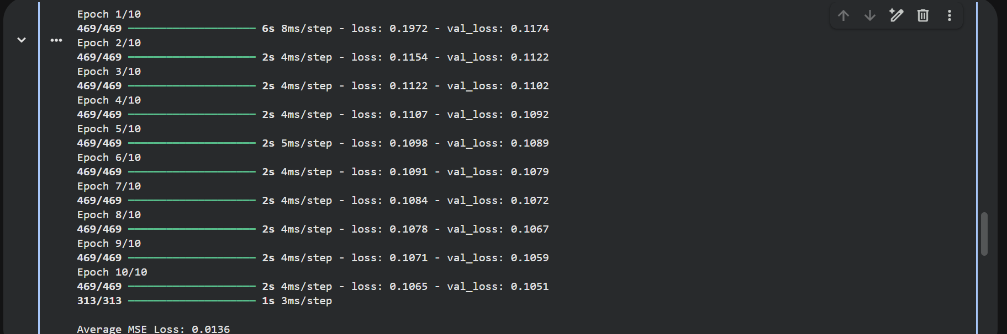

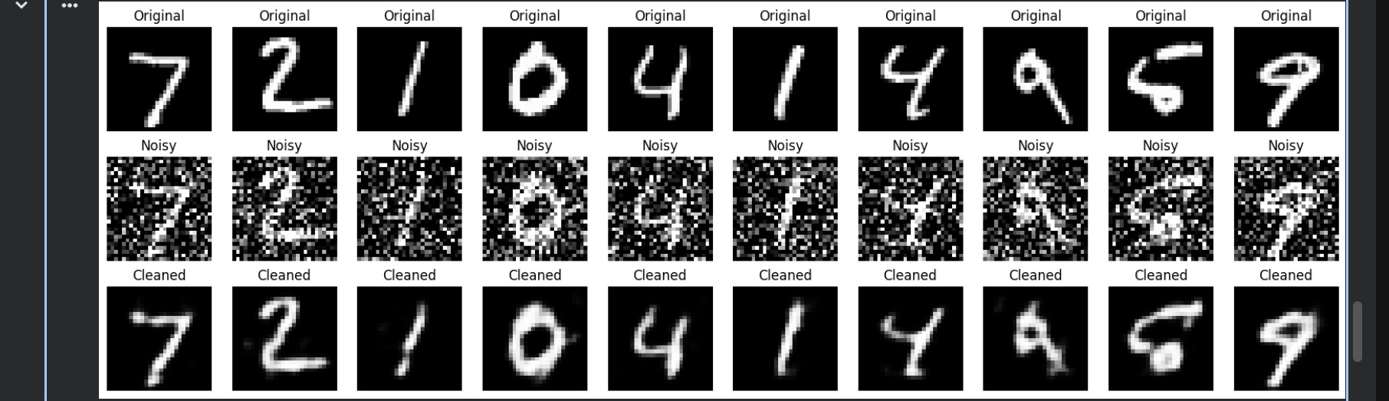

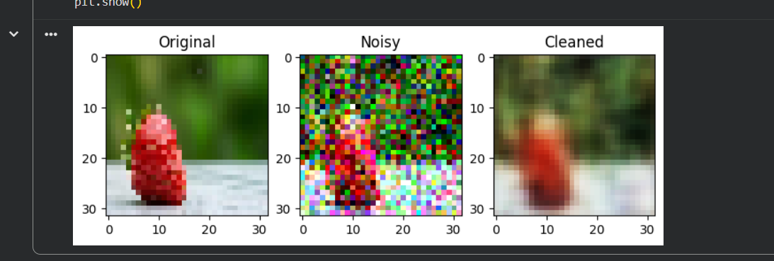

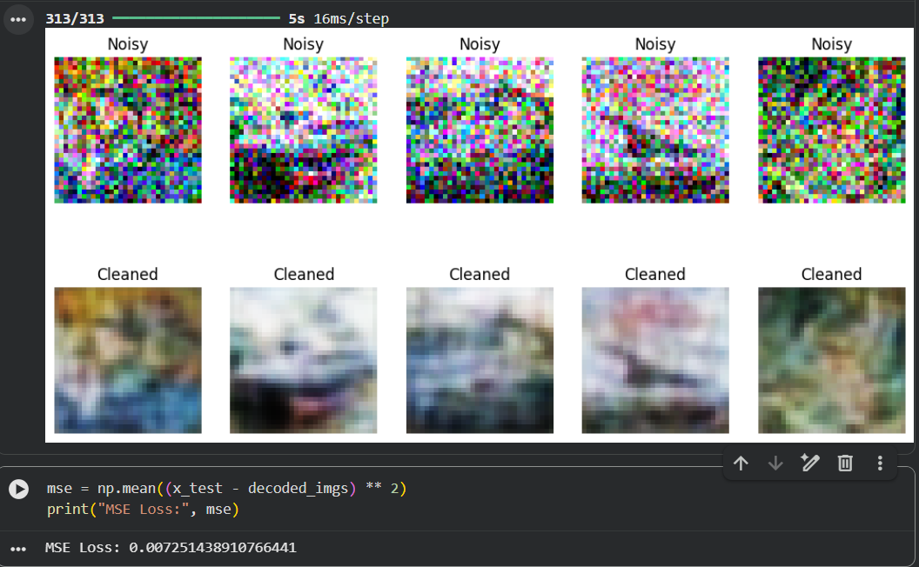

Post Lab Subjective/Objective type Questions:
- What is an autoencoder and what are its main components?
- What loss function is commonly used in training autoencoders? Why?
- What are the limitations of basic autoencoders?
- What is meant by the latent space (or bottleneck layer)? Why is it important?
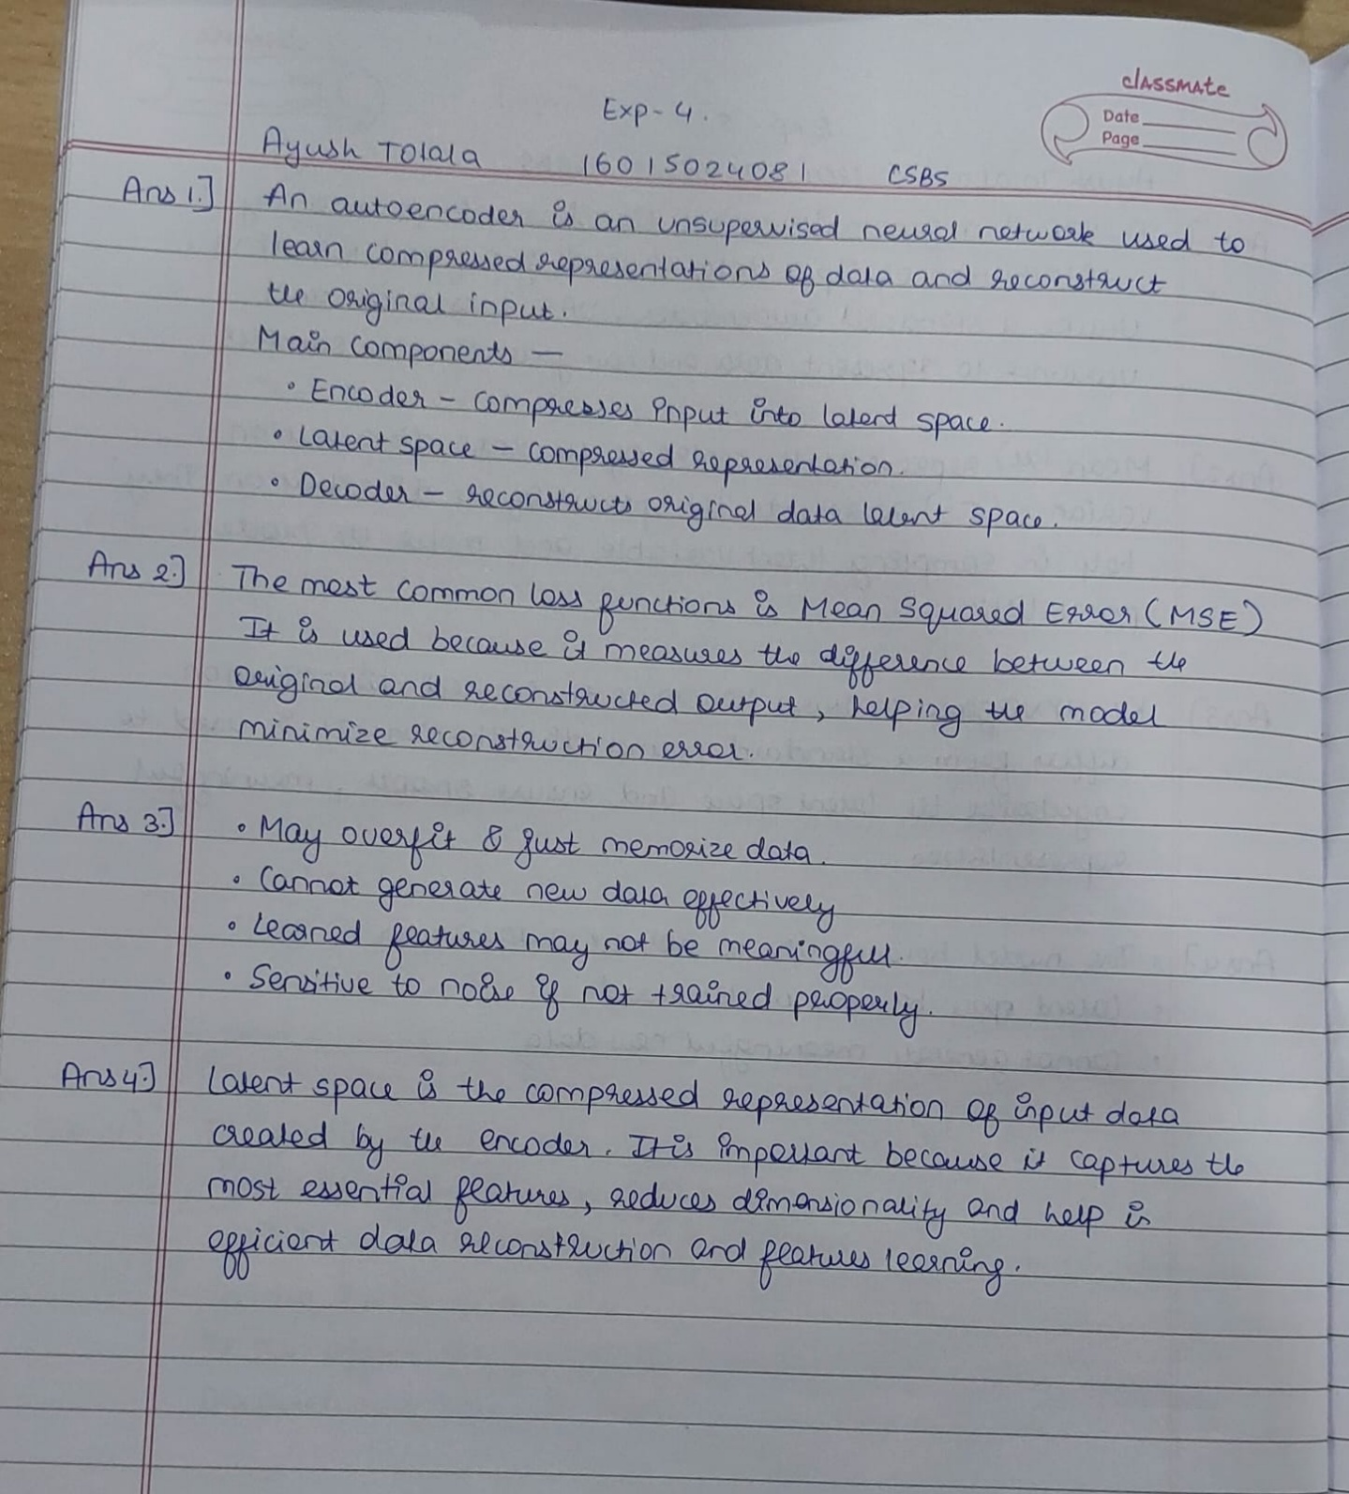

Conclusion:
The autoencoder model was successfully designed and trained to learn compressed representations of the input data. It was able to reconstruct the original images with minimal loss, showing that important features were preserved even after compression. The model also demonstrated effective noise reduction, highlighting its usefulness in image denoising and feature extraction. Overall, this experiment helped in understanding how deep learning models can automatically learn meaningful patterns from data.

Signature of faculty in-charge with Date:

