Course Name: | Foundations of Generative AI Laboratory | Semester: | IV
Date of Performance: | 24 / 03 /2026 | Batch No: | A4 (CSBS)
Faculty Name: | Mr. Dinesh Auti | Roll No: | 16015024081
Faculty Sign & Date: |  | Grade/Marks: | ___/15

Experiment No: 5
Title: Implementing a Variational Autoencoder (VAE) using TensorFlow/PyTorch and experimenting with latent space.

Aim and Objective of the Experiment:
To implement a Variational Autoencoder (VAE) using TensorFlow/PyTorch.

COs to be achieved:
CO2: Develop skills to implement and train generative models using deep learning frameworks.
CO3: Explore and apply various generative models such as GANs, VAEs, and flow-based models.

Tools used:
- Python 3.x
- TensorFlow / Keras
- PyTorch
- Jupyter Notebook / Google Colab
- NumPy
- Matplotlib (optional)

Theory:
A Variational Autoencoder (VAE) is a generative deep learning model that learns the probability distribution of input data instead of fixed representations. It consists of an encoder that maps input data to a latent space defined by mean (μ) and variance (σ²), and a decoder that reconstructs data from sampled latent variables.
The model uses a combination of reconstruction loss (to ensure accurate output) and KL divergence loss (to regularize the latent space and make it follow a normal distribution). By experimenting with the latent space, we can visualize data patterns, perform interpolation, and generate new data samples.

Code:
Write a simple program using TensorFlow and PyTorch to build VAE
import numpy as np
import tensorflow as tf
import matplotlib.pyplot as plt
from tensorflow.keras.layers import Input, Conv2D, Conv2DTranspose, Layer
from tensorflow.keras.layers import Dense, Flatten, Reshape, LeakyReLU
from tensorflow.keras.models import Model
from tensorflow.keras.datasets import mnist

# -----------------------------
# 1. Load Dataset
# -----------------------------
(x_train, _), (x_test, _) = mnist.load_data()

x_train = x_train.astype("float32") / 255
x_test = x_test.astype("float32") / 255

x_train = x_train.reshape(-1, 28, 28, 1)
x_test = x_test.reshape(-1, 28, 28, 1)

# -----------------------------
# 2. Sampling Layer
# -----------------------------
class Sampling(Layer):
def call(self, inputs):
z_mean, z_log_var = inputs
batch = tf.shape(z_mean)[0]
dim = tf.shape(z_mean)[1]
epsilon = tf.keras.backend.random_normal(shape=(batch, dim))
return z_mean + tf.exp(0.5 * z_log_var) * epsilon

# -----------------------------
# 3. Encoder
# -----------------------------
encoder_input = Input(shape=(28, 28, 1))

x = Conv2D(32, 3, padding="same")(encoder_input)
x = LeakyReLU()(x)
x = Conv2D(64, 3, strides=2, padding="same")(x)
x = LeakyReLU()(x)
x = Conv2D(64, 3, strides=2, padding="same")(x)
x = LeakyReLU()(x)
x = Conv2D(64, 3, padding="same")(x)
x = LeakyReLU()(x)

x = Flatten()(x)

z_mean = Dense(2)(x)
z_log_var = Dense(2)(x)

z = Sampling()([z_mean, z_log_var])

encoder = Model(encoder_input, [z_mean, z_log_var, z])

# -----------------------------
# 4. Decoder
# -----------------------------
decoder_input = Input(shape=(2,))

x = Dense(3136)(decoder_input)
x = Reshape((7, 7, 64))(x)

x = Conv2DTranspose(64, 3, padding="same")(x)
x = LeakyReLU()(x)
x = Conv2DTranspose(64, 3, strides=2, padding="same")(x)
x = LeakyReLU()(x)
x = Conv2DTranspose(32, 3, strides=2, padding="same")(x)
x = LeakyReLU()(x)

decoder_output = Conv2DTranspose(1, 3, activation="sigmoid", padding="same")(x)

decoder = Model(decoder_input, decoder_output)

# -----------------------------
# 5. VAE Model
# -----------------------------
class VAE(Model):
def __init__(self, encoder, decoder):
super(VAE, self).__init__()
self.encoder = encoder
self.decoder = decoder

def train_step(self, data):
if isinstance(data, tuple):
data = data[0]

with tf.GradientTape() as tape:
z_mean, z_log_var, z = self.encoder(data)
reconstruction = self.decoder(z)

# Reconstruction loss
reconstruction_loss = tf.reduce_mean(
tf.reduce_sum(tf.square(data - reconstruction), axis=[1,2,3])
)

# KL Divergence
kl_loss = -0.5 * (1 + z_log_var - tf.square(z_mean) - tf.exp(z_log_var))
kl_loss = tf.reduce_mean(tf.reduce_sum(kl_loss, axis=1))

total_loss = reconstruction_loss + kl_loss

grads = tape.gradient(total_loss, self.trainable_weights)
self.optimizer.apply_gradients(zip(grads, self.trainable_weights))

return {"loss": total_loss}

# -----------------------------
# 6. Train
# -----------------------------
vae = VAE(encoder, decoder)
vae.compile(optimizer="adam")

vae.fit(x_train, x_train,
epochs=20,
batch_size=128,
validation_data=(x_test, x_test))

# -----------------------------
# 7. Reconstruction
# -----------------------------
decoded_images = vae.predict(x_test)

# -----------------------------
# 8. Visualization
# -----------------------------
n = 10
plt.figure(figsize=(20,4))

for i in range(n):
plt.subplot(2, n, i+1)
plt.imshow(x_test[i].reshape(28,28), cmap='gray')
plt.title("Original")
plt.axis('off')

plt.subplot(2, n, i+1+n)
plt.imshow(decoded_images[i].reshape(28,28), cmap='gray')
plt.title("Reconstructed")
plt.axis('off')

plt.show()

Output:
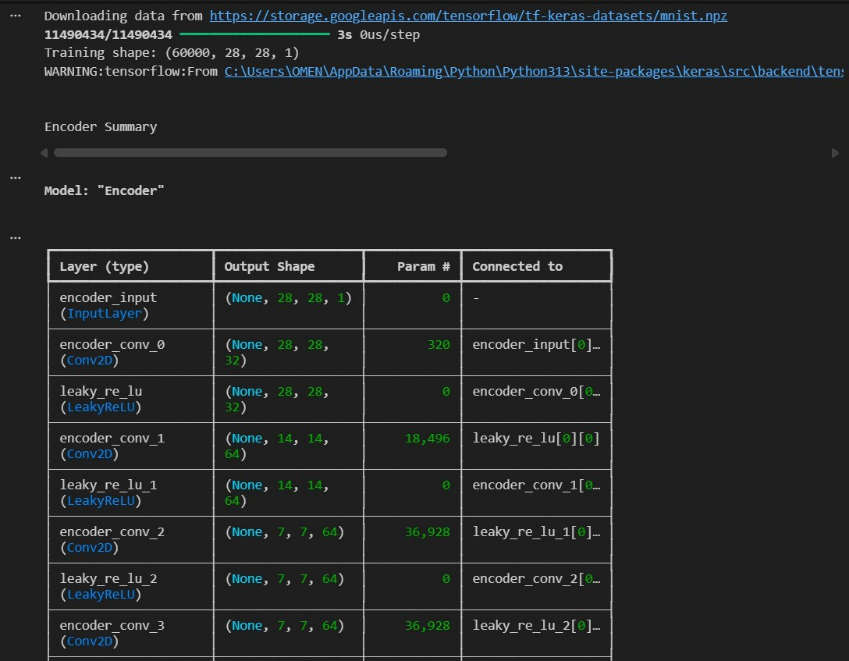
Output:
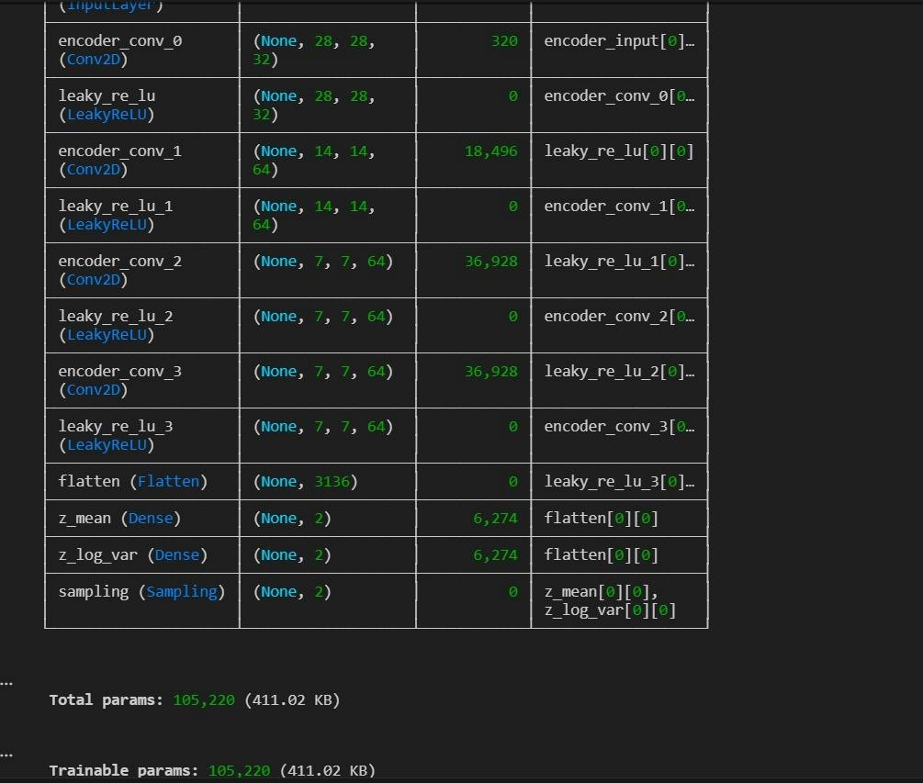
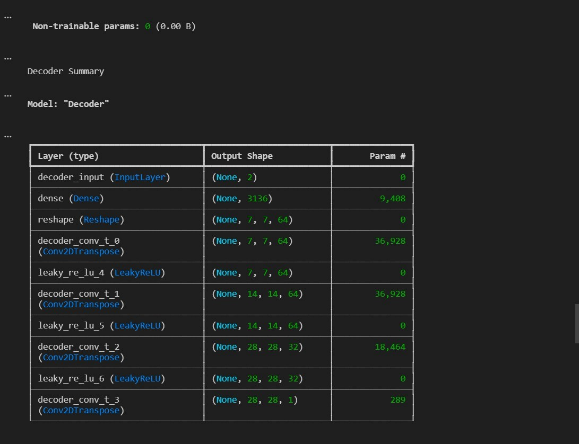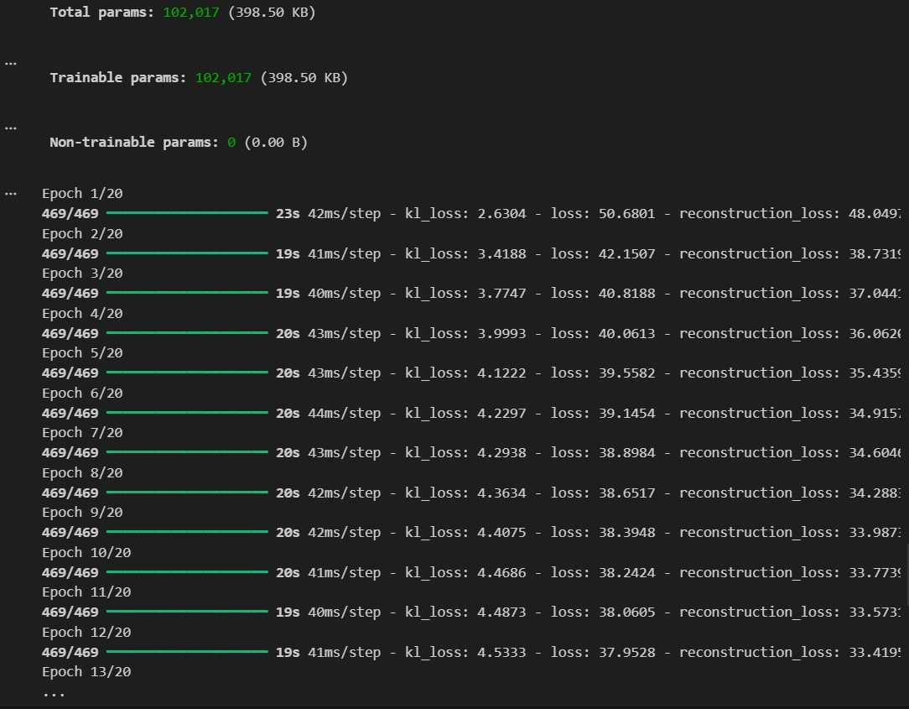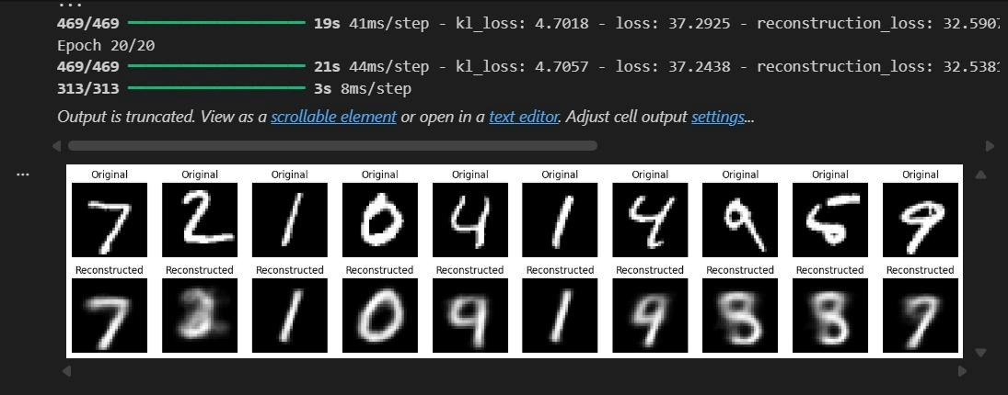

Post Lab Subjective/Objective type Questions:
- What is a Variational Autoencoder (VAE) and how does it differ from a standard autoencoder?
- What are the roles of mean (μ) and variance (σ²) in the encoder?
- What is KL divergence and why is it used in VAE loss?
- What happens if KL divergence is not included in the loss function?

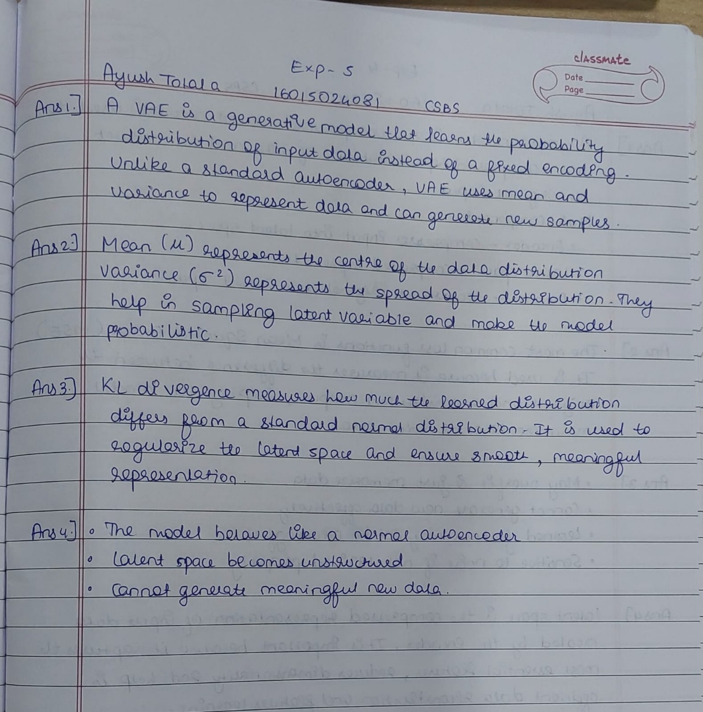

Conclusion:
The Variational Autoencoder (VAE) was successfully implemented using a deep learning framework. The model was able to learn meaningful latent representations and reconstruct input data effectively. This experiment demonstrated how VAEs can be used for data generation, compression, and understanding underlying data distributions.

Signature of faculty in-charge with Date:

