Course Name: | Foundations of Generative AI Laboratory | Semester: | IV
Date of Performance: | 24 / 03 /2026 | Batch No: | A4 (CSBS)
Faculty Name: | Mr. Dinesh Auti | Roll No: | 16015024081
Faculty Sign & Date: |  | Grade/Marks: | ___/15

Experiment No: 6
Title: Exploring Latent Spaces in VAEs

Aim and Objective of the Experiment:
To explore and analyze the latent space learned by a Variational Autoencoder (VAE) by visualizing encoded representations, performing interpolation between latent vectors, and generating new data samples.

COs to be achieved:
CO2: Develop skills to implement and train generative models using deep learning frameworks.
CO3: Explore and apply various generative models such as GANs, VAEs, and flow-based models.

Tools used:
- Python 3.x
- TensorFlow / Keras
- PyTorch
- Jupyter Notebook / Google Colab
- NumPy
- Matplotlib (optional)

Theory:
Latent space in a Variational Autoencoder (VAE) represents a compressed, continuous distribution of input data where similar data points are placed close to each other. The encoder maps input data into this space using mean (μ) and variance (σ²), and the decoder reconstructs data from sampled latent vectors.
By exploring the latent space, we can visualize how the model organizes data, perform interpolation between points to observe smooth transitions, and generate new data samples. This helps in understanding the learned features and the generative capability of the VAE.

Code:
Write a simple program to explore and analyze the latent space learned by a Variational Autoencoder (VAE) by visualizing encoded representations, performing interpolation between latent vectors, and generating new data samples.
import numpy as np
import matplotlib.pyplot as plt
from tensorflow.keras.datasets import mnist

# Load test data and labels (labels are needed to color the latent clusters) (_, _), (x_test, y_test) = mnist.load_data()
x_test = x_test.astype("float32") / 255.0 x_test = np.expand_dims(x_test, -1)

# ==========================================
# 1. Visualize Encoded Representations
# ==========================================
def visualize_latent_space(encoder, x_test, y_test): """Plots the 2D latent space colored by digit class.""" print("Mapping test set into the latent space...")

# In a VAE, the encoder returns [z_mean, z_log_var, z]. We use z_mean for plotting. z_mean, _, _ = encoder.predict(x_test, batch_size=128)

plt.figure(figsize=(10, 8))
scatter = plt.scatter(z_mean[:, 0], z_mean[:, 1], c=y_test, cmap="tab10", alpha=0.7, s=8) plt.colorbar(scatter, label="Digit Classes")
plt.title("VAE 2D Latent Space") plt.xlabel("z_mean[0]")
plt.ylabel("z_mean[1]") plt.grid(True, alpha=0.3) plt.show()

# ==========================================
# 2. Interpolate Between Latent Vectors
# ==========================================
def interpolate_latent_vectors(encoder, decoder, x_test, idx1=0, idx2=1, steps=10): """Morphs one image into another by walking smoothly through the latent space.""" print(f"Interpolating between image index {idx1} and {idx2}...")

# Extract the two starting images
img1, img2 = x_test[idx1], x_test[idx2]

# Get their latent representations (z_mean)
z1, _, _ = encoder.predict(np.expand_dims(img1, axis=0), verbose=0) z2, _, _ = encoder.predict(np.expand_dims(img2, axis=0), verbose=0)

# Create a linear path between the two points in latent space alphas = np.linspace(0, 1, steps)
latent_path = np.array([(1 - a) * z1[0] + a * z2[0] for a in alphas])

# Decode the points along the path back into images decoded_imgs = decoder.predict(latent_path, verbose=0)

# Plot the transition plt.figure(figsize=(15, 3)) for i in range(steps):
ax = plt.subplot(1, steps, i + 1) plt.imshow(decoded_imgs[i].reshape(28, 28), cmap="gray") plt.axis("off")
if i == 0: plt.title("Start")
elif i == steps - 1: plt.title("End")
plt.suptitle("Latent Space Interpolation") plt.show()

# ==========================================
# 3. Generate New Data Samples (Latent Manifold)
# ==========================================
def generate_latent_manifold(decoder, n=15, digit_size=28):

"""Generates a grid of new images by sampling evenly across the latent space.""" print("Generating synthetic data from the latent manifold...")

# Create an empty canvas for the grid
figure = np.zeros((digit_size * n, digit_size * n))

# Sample from a standard normal distribution (-3 to 3 covers 99.7% of the data) grid_x = np.linspace(-3, 3, n)
grid_y = np.linspace(-3, 3, n)[::-1] # Reverse y-axis for better visual layout

for i, yi in enumerate(grid_y): for j, xi in enumerate(grid_x):
# Create a 2D point (z) z_sample = np.array([[xi, yi]])

# Decode the point into a new image
x_decoded = decoder.predict(z_sample, verbose=0) digit = x_decoded[0].reshape(digit_size, digit_size)

# Place the digit on the canvas figure[
i * digit_size : (i + 1) * digit_size,
j * digit_size : (j + 1) * digit_size,
] = digit

plt.figure(figsize=(10, 10)) plt.imshow(figure, cmap="gray")
plt.title("Generated Digits (Latent Manifold)") plt.axis("off")
plt.show()

# ==========================================
# Execution
# ==========================================
if name == " main ":
# Ensure you pass your trained VAE 'encoder' and 'decoder' here

# 1. Plot the clustered latent space visualize_latent_space(encoder, x_test, y_test)

# 2. Smoothly morph a '7' (index 0) into a '2' (index 1) interpolate_latent_vectors(encoder, decoder, x_test, idx1=0, idx2=1, steps=10)

# 3. Generate a 15x15 grid of entirely new, synthetic digits generate_latent_manifold(decoder, n=15)

Output:
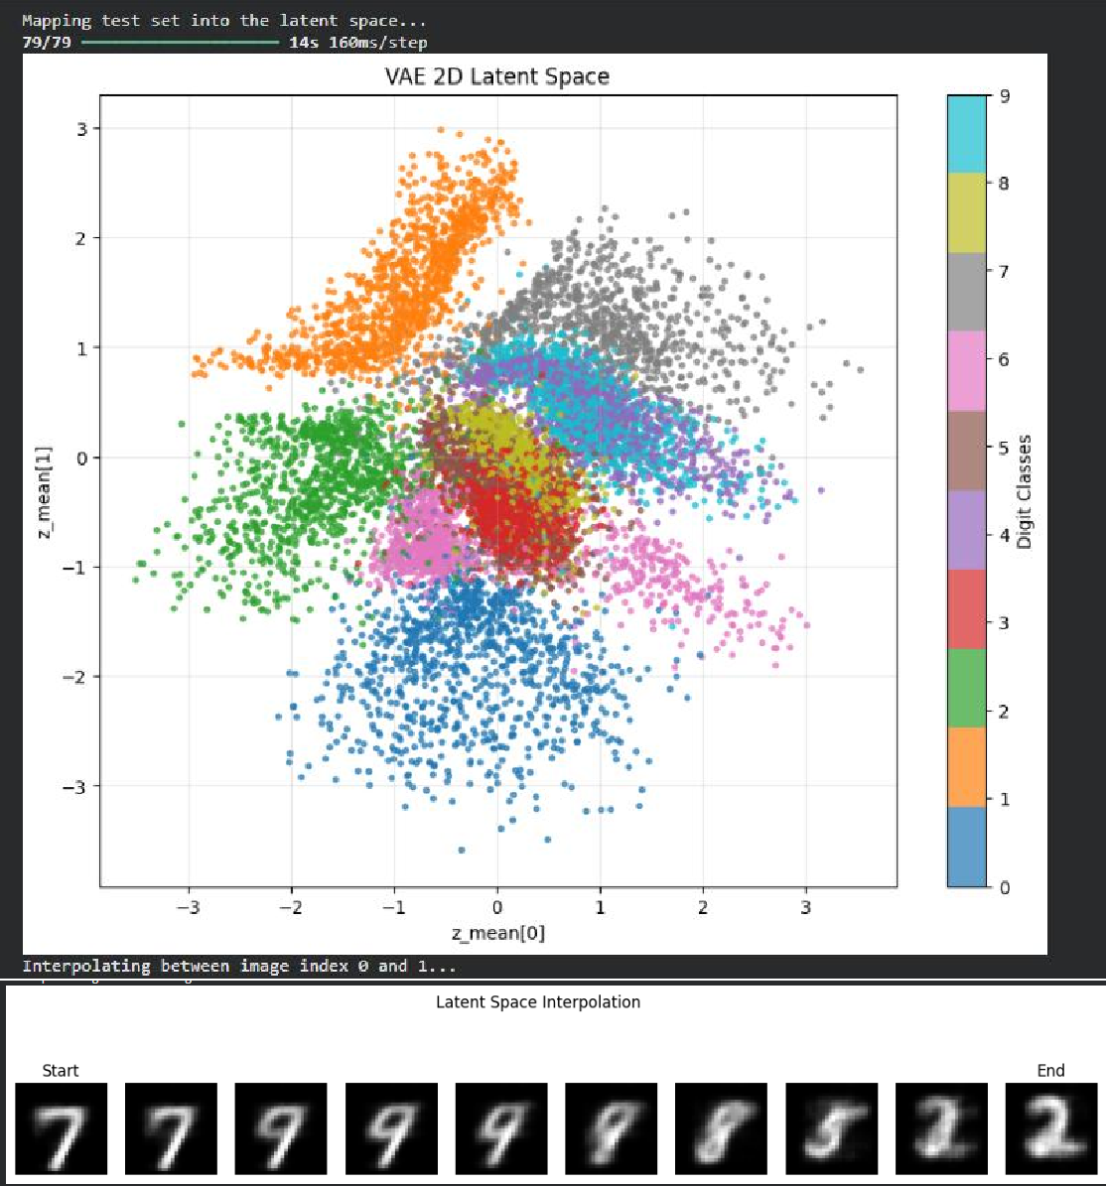
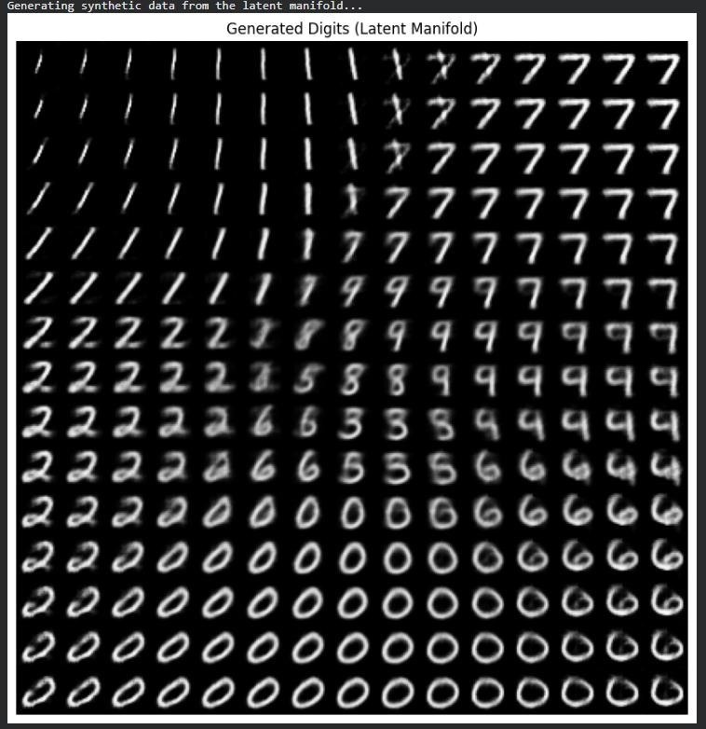

Post Lab Subjective/Objective type Questions:
- What is latent space in a Variational Autoencoder (VAE)?
- Why is latent space important in generative models?
- How does the size of latent space affect model performance?
- What happens if latent variables are highly correlated?

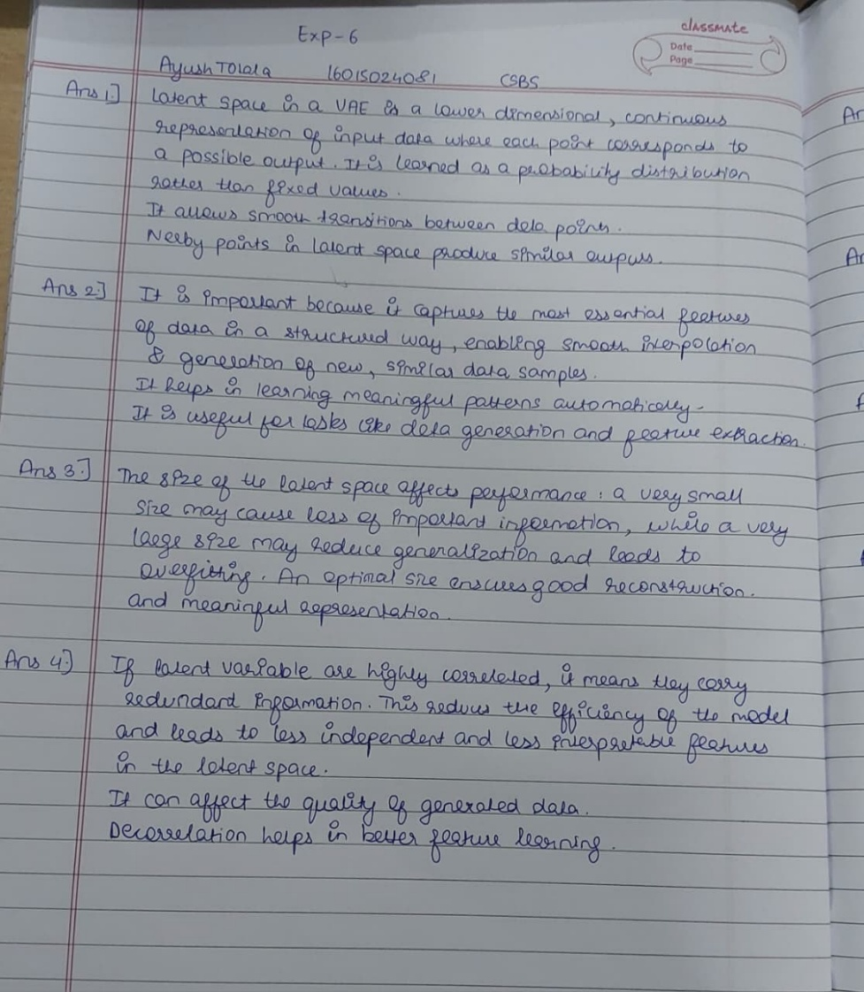

Conclusion:
The experiment successfully explored the latent space of the Variational Autoencoder by visualizing encoded representations and generating new data samples. Interpolation between latent vectors showed smooth transitions, indicating that the model learned meaningful and continuous features. Overall, it demonstrated the effectiveness of VAE in understanding and generating data through latent space representation.

Signature of faculty in-charge with Date:

