Course Name: | Foundations of Generative AI Laboratory | Semester: | III
Date of Performance: | 22 / 4 /26 | Batch No: | 3
Faculty Name: | Mr. Dinesh Auti | Roll No: | 16015024081
Faculty Sign & Date: |  | Grade/Marks: | ___/15

Experiment No: 9
Title: Fine-tuning Pre-trained Generative Models (e.g., GPT-3) for text generation

Aim and Objective of the Experiment:
To study and implement the fine-tuning of a pre-trained generative language model to generate coherent and domain-specific text.

COs to be achieved:
CO2: Develop skills to implement and train generative models using deep learning frameworks.
CO4: Gain insight into the ethical implications, challenges, and advancements in generative AI technologies.
CO5: Use generative models for solving real-world problems in domains such as image synthesis, data augmentation, and text generation.

Tools used:
- Python 3.x
- TensorFlow / Keras
- PyTorch
- Jupyter Notebook / Google Colab
- NumPy

Theory:
Pre-trained generative models like GPT-3 are trained on massive text corpora using self-supervised learning, where the model learns to predict the next word in a sequence.
Fine-tuning adapts this general knowledge to a specific domain, improving relevance and coherence.

Concepts
- Transformer Architecture: Uses self-attention to capture long-range dependencies
- Language Modeling: Predicting next token given previous tokens
- Transfer Learning: Reusing pre-trained knowledge
- Fine-tuning: Updating weights using domain-specific data

Training Objective

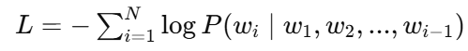

- This is the cross-entropy loss, which measures how well the model predicts the next word.

Code:
from datasets import Dataset
from transformers import GPT2Tokenizer, GPT2LMHeadModel
from transformers import Trainer, TrainingArguments

# -------------------------------
# Step 1: Dataset
# -------------------------------
texts = [
"Artificial Intelligence is transforming healthcare.",
"Machine learning helps in cancer detection.",
"Deep learning is used in medical imaging.",
"AI assists doctors in diagnosis."
]

dataset = Dataset.from_dict({"text": texts})

# -------------------------------
# Step 2: Model & Tokenizer
# -------------------------------
tokenizer = GPT2Tokenizer.from_pretrained("gpt2")
tokenizer.pad_token = tokenizer.eos_token

model = GPT2LMHeadModel.from_pretrained("gpt2")

# -------------------------------
# Step 3: Tokenization (FIX HERE)
# -------------------------------
def tokenize(example):
tokens = tokenizer(
example["text"],
padding="max_length",
truncation=True,
max_length=50
)

# ✅ IMPORTANT FIX
tokens["labels"] = tokens["input_ids"].copy()

return tokens

dataset = dataset.map(tokenize)

# -------------------------------
# Step 4: Training
# -------------------------------
training_args = TrainingArguments(
output_dir="./results",
num_train_epochs=1,
per_device_train_batch_size=2,
logging_steps=10,
report_to="none"
)

trainer = Trainer(
model=model,
args=training_args,
train_dataset=dataset
)

# -------------------------------
# Step 5: Train
# -------------------------------
trainer.train()

# -------------------------------
# Step 6: Generate Text
# -------------------------------
input_text = "AI in healthcare"
inputs = tokenizer.encode(input_text, return_tensors="pt")

output = model.generate(inputs, max_length=50)

print(tokenizer.decode(output[0]))

Output:
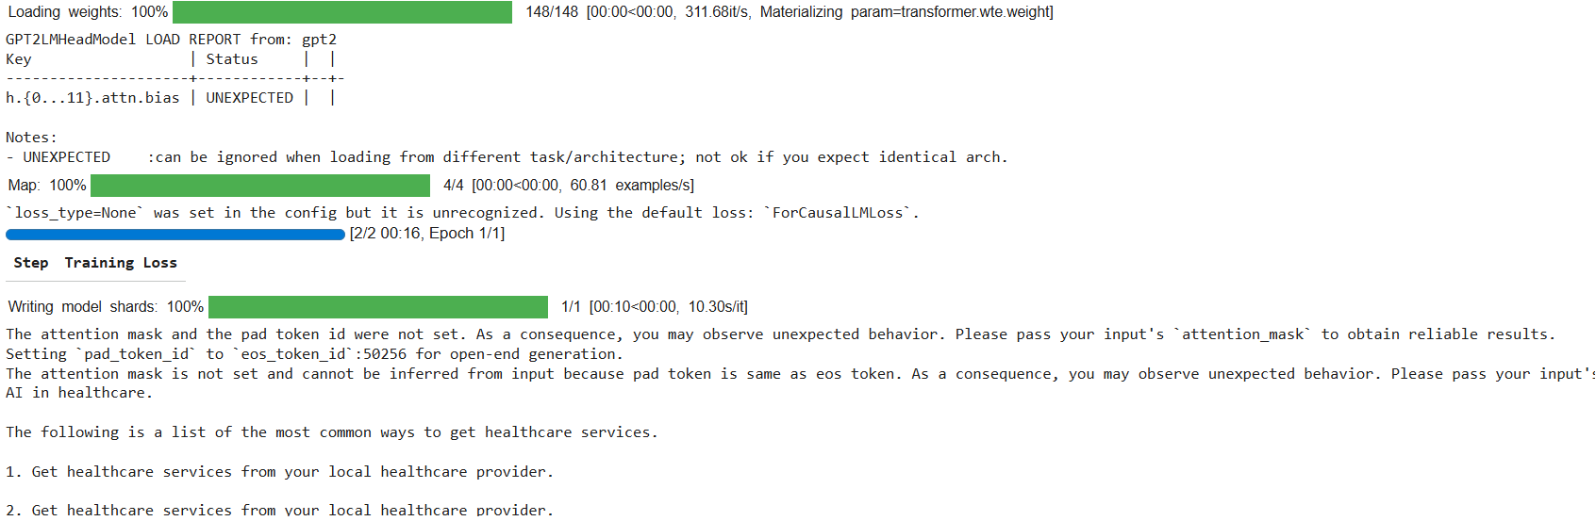

Post Lab Subjective/Objective type Questions:
- What type of task does a generative model perform?
- What is the role of a tokenizer in NLP?
- What is an LLM? And give example.
- How does an LLM work?
- What is the main idea behind self-attention?
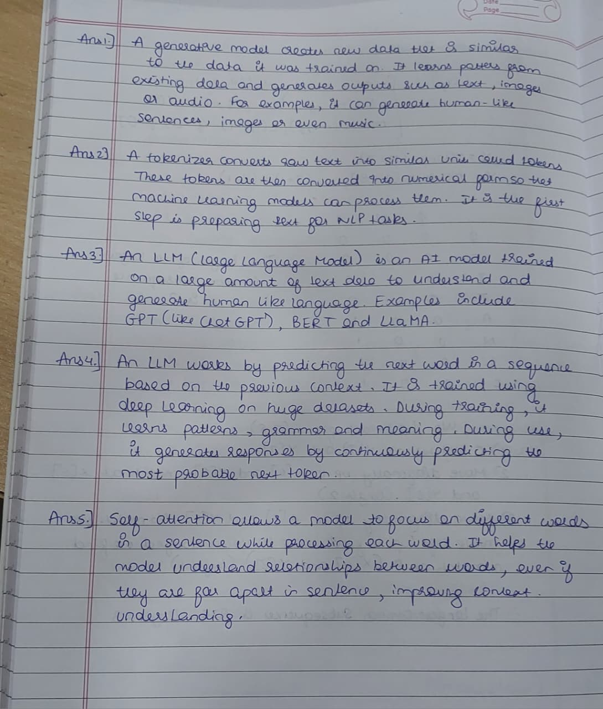

Conclusion:
This study demonstrates how a pre-trained generative language model can be adapted to a specific domain through fine-tuning. By training on targeted data, the model improves its ability to generate coherent, relevant, and context-aware text. This highlights the effectiveness of fine-tuning in enhancing model performance for specialized applications.

Signature of faculty in-charge with Date:

