 Experiment File

Course Code and Title

CSE1021 - Introduction to Problem Solving and Programming

**Submitted by: Submitted to:**

Praveen Kumar Patel Dr. Amrita Parashar

Registration No: 24BEC10140

**Experiment 1: Drawing flowchart using yEd tool/Raptor Tool Code 1:**

Flowchart: To check Whether the Given Number is Odd or Even

*Expected Output:*

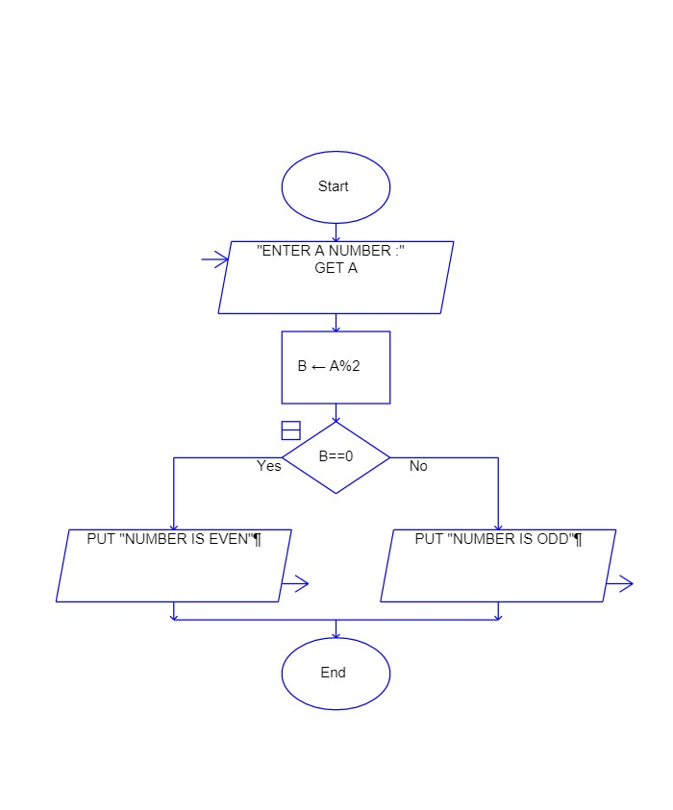

**Code 2:**

Flowchart: To Check Whether The Given Character is vowel or not

*Expected Output:*

