UrbanClean — Smart Waste Management & Complaint Routing System
Comprehensive Technical Architecture, Business Model, and Relational Database Specification
1. Project Overview and Problem Statement
Rapid urbanization and increasing population density have severely strained traditional municipal solid waste management systems. Cities worldwide face severe operational challenges due to static collection schedules, lack of real-time visibility into overflowing waste bins, and unoptimized driver navigation routes.
Key Challenges Solved by UrbanClean:
- Garbage Overflow & Delayed Cleanups: Traditional waste collection relies on fixed weekly schedules rather than demand-driven overflow reporting.
- Fuel Waste & Inefficient Routing: Collection trucks travel unoptimized fixed loops regardless of whether specific neighborhood bins require pickup.
- Lack of Public Transparency: Citizens have no streamlined platform to report overflowing bins with geotagged proof or track resolution progress.
- Administrative Blindspots: City authorities lack centralized, location-locked command centers to monitor daily complaints, active driver fleets, and historical cleanup performance metrics.
UrbanClean delivers a web-based smart city platform that bridges citizens, waste collection drivers, and municipal administrators through real-time geotagging, 1km radius spatial filtering, TSP + OSRM road route optimization, and location-locked governance dashboards.
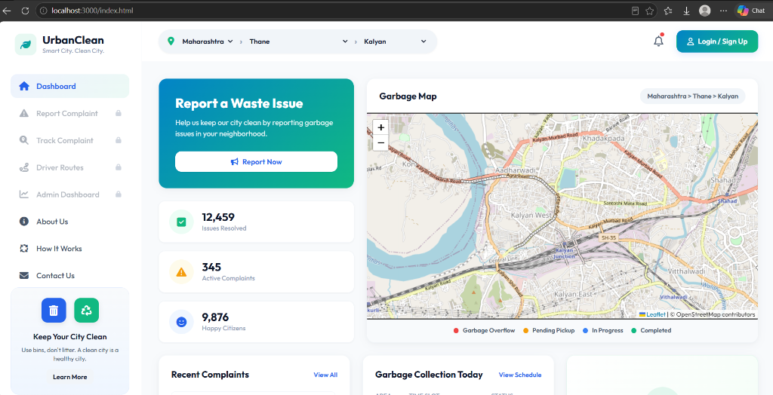
Figure 1.1: UrbanClean Guest Dashboard & City Waste Monitoring Interface (index.html)
2. System Objectives
The primary objective of UrbanClean is to transform municipal solid waste collection into a demand-driven, data-optimized, and transparent smart city operation.
Category | Target Objective | Measurable Operational Outcome
Operational Efficiency | Reduce waste collection truck fuel consumption & travel time | 22% to 32% fuel cost reduction via TSP + OSRM road optimization
Public Transparency | Provide digital geotagged complaint logging & live tracking | Sub-minute report creation with GPS coordinates & photo proof
Driver Optimization | Prevent driver task fatigue by scope-limiting active complaints | 1.0 km radius spatial proximity filter around driver collection stops
Municipal Governance | Enforce localized administration & data retention policies | Location-locked admin dashboards (e.g. Kalyan) & automated 30-day data purge

3. User Roles and Permissions
UrbanClean enforces strict Role-Based Access Control (RBAC) across three primary user roles alongside guest access:
User Role | System Responsibilities | Accessible Modules | Security & Scope Restrictions
Guest | Browse city waste statistics, view active maps & educational content | index.html | Cannot submit reports, manage routes, or access admin features
Citizen | Log geotagged complaints with photo proof, track status | citizen.html | Restricted to personal complaints; cannot access driver or admin controls
Driver | Pin up to 40 collection stops, filter nearby complaints (<1km), run TSP route, upload cleanup proof | driver.html | Scope-limited to active driver workspace; cannot access admin command center
Admin | Monitor city-wide KPIs, view duty drivers, inspect today's complaints, export 30-day CSV reports | admin.html | Jurisdiction-locked based on account profile (e.g. Kalyan, Bandra)

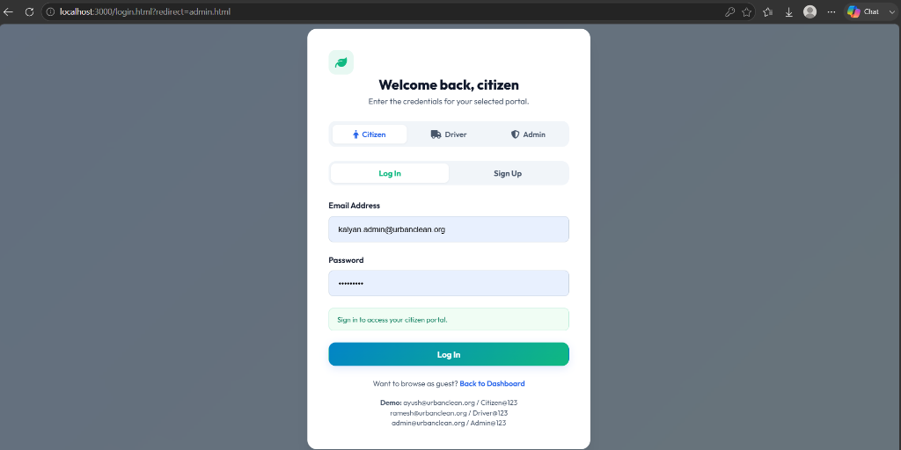
Figure 3.1: UrbanClean Unified Portal Authentication Interface (login.html)
4. Complete System Architecture
The system architecture follows a modern Decoupled Client-Server REST Model consisting of five primary technical layers:
4.1 Frontend Layer
- Technologies: HTML5, Custom Glassmorphic CSS3 (styles.css), Modular Vanilla JavaScript ES6+ (script.js).
- Map Interface: Leaflet.js v1.9.4 integrated with OpenStreetMap tile layers.
- State Management: Centralized client-side state object (STATE) managing user session, geographic location, complaints, and driver collection stops.
4.2 Backend / API Layer
- Primary Backend: Node.js Express server running on port 3000 (backend/server.js).
- Reference Backend: Python FastAPI server (backend/main.py) with SQLAlchemy ORM models.
- File Upload Engine: Multer middleware handling multipart binary photo uploads to backend/uploads/.
4.3 Database Layer
- Active Storage: File-backed JSON document store (backend/db.json) with automated 30-day temporal cleanup.
- Relational Conversion: Built-in SQLite database engine (backend/urban_clean.db / db.db).
4.4 Map & Routing Services
- OpenStreetMap: High-resolution basemap tiles rendered across all portals.
- OSRM API: Open Source Routing Machine driving service (http://router.project-osrm.org/route/v1/driving/) generating turn-by-turn road polyline geometry and real driving distances.
4.5 Authentication & Security Layer
- Cryptographic Password Hashing: PBKDF2 with SHA-512 and 16-byte random salts (crypto.randomBytes).
- Location Auto-Locking: Admin profile state auto-binds map viewports to assigned municipality.
5. Architecture Diagram (Mermaid)
The Mermaid diagram below details the structural flow between the frontend portals, Express REST API, OSRM engine, and database persistence:
graph TD
CitizenPage[Citizen Portal - citizen.html] -->|POST /api/complaints| ExpressAPI[Node.js Express Server]
DriverPage[Driver Workspace - driver.html] -->|POST /api/route-optimize| ExpressAPI
AdminPage[Admin Command Center - admin.html] -->|GET /api/admin/stats| ExpressAPI
ExpressAPI -->|Multipart Photo Uploads| UploadsFolder[backend/uploads/]
ExpressAPI -->|Query Waypoints| OSRMEngine[OSRM Driving API]
ExpressAPI -->|Read / Write / Purge| JSONDB[db.json Document Store]
ExpressAPI -->|SQL Operations| SQLiteDB[urban_clean.db SQLite]
6. Main Application Workflows
6.1 Citizen Complaint Workflow
1. Citizen accesses citizen.html, selects waste category, enters landmark description.
2. Pinpoint location by clicking Leaflet map or triggering GPS Auto-Detect.
3. Attach photo proof in dropzone and submit.
4. Express API receives multipart data, stores photo in backend/uploads/, appends record to db.json, and returns new complaint ID.
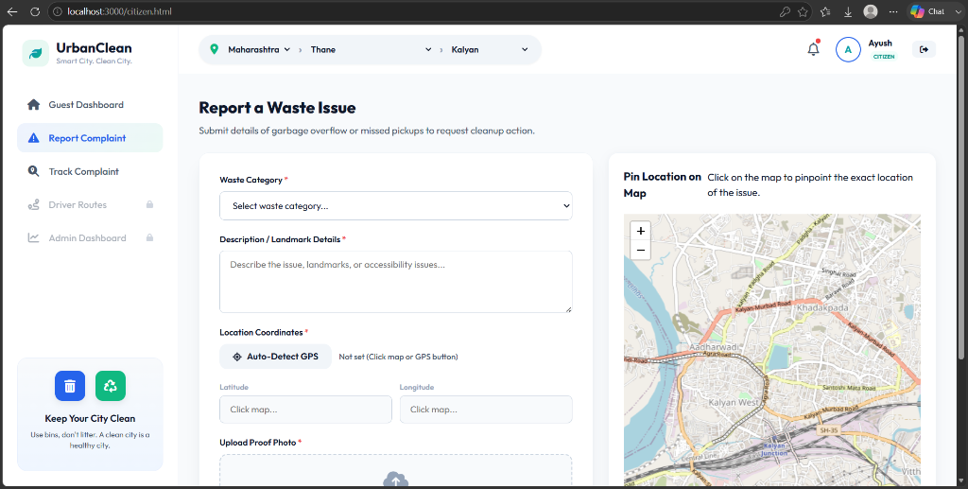
Figure 6.1: Citizen Waste Reporting Interface with Map Geotagging (citizen.html)
6.2 Driver Collection-Point & 1 km Complaint Filtering Workflow
1. Driver enters driver.html workspace and toggles 'Add Point' mode.
2. Click map to pin up to 40 custom collection stops.
3. The Haversine straight-line formula filters city complaints: only complaints within 1.0 km of at least one collection stop are rendered.
4. Driver saves route points to server via POST /api/driver/route.
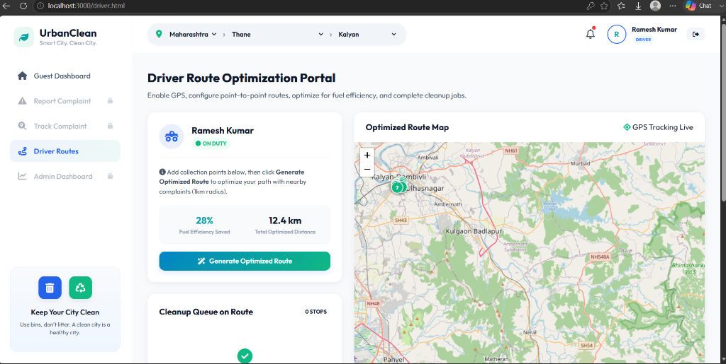
Figure 6.2: Driver Route Optimization Portal & 1km Proximity Filter (driver.html)
6.3 Smart Route Optimization Workflow
1. Driver clicks 'Generate Optimized Route'.
2. Frontend merges collection stops + nearby (<1km) complaints and POSTs waypoints to /api/route-optimize.
3. Backend executes Greedy Nearest-Neighbor TSP to determine optimal visit order.
4. Backend queries OSRM Driving API for exact road network geometry and driving distance.
5. Frontend renders animated polyline on Leaflet map and updates Fuel Savings metrics (22%-32%).
6.4 Admin Monitoring Workflow
1. Admin logs into admin.html; profile auto-locks city viewport (e.g. Kalyan).
2. View live KPIs (Reported Today, Pending, In Progress, Solved Today).
3. Click 'Reported Today' stat box to open modal listing today's complaint IDs and status.
4. Scroll down to Monthly Waste Tracking Table and click 'Export to Excel' to download CSV file.
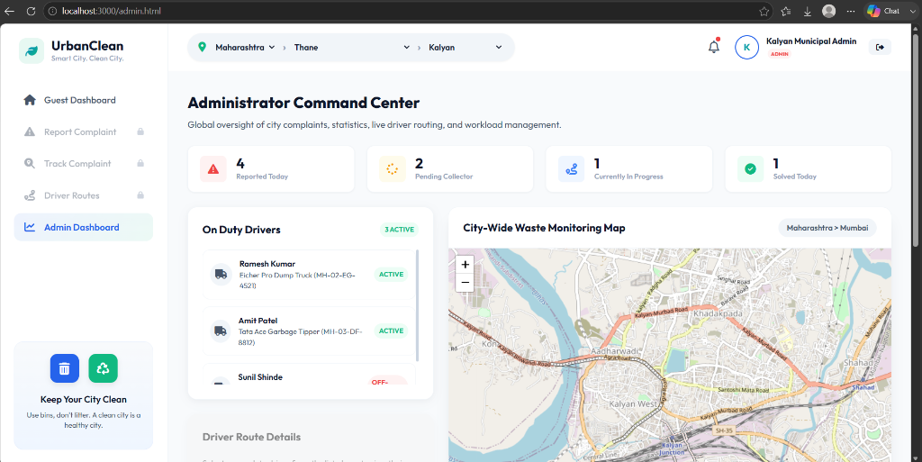
Figure 6.4: Administrator Command Center & Municipality Control Panel (admin.html)
7. Business Model
7.1 Target Users & Customers
- B2G Municipalities: City Corporations (MCGM, Kalyan-Dombivli Corporation, Thane Municipal Corporation).
- Private Waste Management Contractors: Commercial fleet operators managing city waste tenders.
- Citizens & Urban Residents: Local taxpayers benefiting from cleaner neighborhoods.
7.2 Revenue Model & Government Subscription Tiers
Subscription Tier | Target Client | Included Capabilities & Pricing Structure
Ward Basic | Small Municipal Wards / Towns | Up to 10 driver accounts, complaint geotagging, standard CSV exports ($500/mo)
City Professional | Mid-sized Municipal Corporations | Unlimited drivers, TSP + OSRM routing, 1km spatial filter, auto-lock location dashboards ($2,500/mo)
Enterprise Metropolis | Large Metropolitan Corporations (e.g. MCGM) | Multi-district jurisdiction hierarchy, custom SLA alerts, dedicated API integration ($7,500/mo)

7.3 Driver Efficiency & Fuel-Saving Value ROI
Demonstrated Fuel Savings: Route optimization testing shows a 22% to 32% reduction in total driving distance compared to unoptimized sequential travel. For a fleet of 50 municipal trucks driving 80 km daily, a 25% reduction yields over 1,000 km of eliminated driving daily, saving thousands of liters of diesel per month.
8. Database Specification
To support enterprise scalability, UrbanClean proposes a fully normalized Relational Database Schema (MySQL / PostgreSQL) comprising 11 core entities:
Entity / Table | Purpose | Primary Key | Key Foreign Keys & Relationships
Users | Base user accounts & authentication credentials | user_id (UUID) | Parent of Citizens, Drivers, Admins
Citizens | Citizen profile attributes | citizen_id (UUID) | FK ➔ Users(user_id)
Drivers | Driver vehicle & shift status | driver_id (UUID) | FK ➔ Users(user_id)
Admins | Admin jurisdiction details | admin_id (UUID) | FK ➔ Users(user_id)
Complaints | Garbage report records | complaint_id (UUID) | FK ➔ Citizens(citizen_id)
ComplaintPhotos | Photo evidence attachments | photo_id (UUID) | FK ➔ Complaints(complaint_id)
DriverRoutes | Driver route metadata | route_id (UUID) | FK ➔ Drivers(driver_id)
CollectionPoints | Custom pinned map stops | point_id (UUID) | FK ➔ DriverRoutes(route_id)
RouteStops | Ordered waypoints in optimized path | stop_id (UUID) | FK ➔ DriverRoutes(route_id), FK ➔ Complaints
Notifications | System event alerts | notification_id (UUID) | FK ➔ Users(user_id)
AuditLogs | Security & administrative change logs | log_id (UUID) | FK ➔ Users(user_id)

9. ER Diagram (Mermaid)
erDiagram
USERS ||--O| CITIZENS : extends
USERS ||--O| DRIVERS : extends
USERS ||--O| ADMINS : extends
CITIZENS ||--O{ COMPLAINTS : reports
COMPLAINTS ||--O{ COMPLAINT_PHOTOS : contains
DRIVERS ||--O{ DRIVER_ROUTES : manages
DRIVER_ROUTES ||--|{ COLLECTION_POINTS : includes
DRIVER_ROUTES ||--|{ ROUTE_STOPS : optimizes
COMPLAINTS ||--o| ROUTE_STOPS : included_in
USERS ||--O{ NOTIFICATIONS : receives
USERS ||--O{ AUDIT_LOGS : triggers
10. API Specification with Key Endpoints
Method | Endpoint | Purpose | Request Body / Params | Response Payload
POST | /api/login | User Login Authentication | email, password, role | { success: true, user: {...} }
POST | /api/register | Account Registration | name, email, password, role | { success: true, user: {...} }
GET | /api/complaints | Fetch Active Complaints | Query: ?city=Kalyan | Array of complaint objects
POST | /api/complaints | Submit New Complaint | Multipart form: photo, lat, lng... | Created complaint object
PUT | /api/complaints/:id/resolve | Driver Mark Job Complete | Multipart form: photo (proof) | Updated complaint object
POST | /api/driver/route | Save Pinned Route Stops | driverId, points[] (max 40) | { success: true, saved: N }
POST | /api/route-optimize | TSP + OSRM Route Optimization | waypoints[] (collection + complaints) | { distance, savings, path, roadPath }

11. Security and Privacy Requirements
1. Cryptographic Password Hashing: PBKDF2/SHA-512 hashing with 16-byte random salts per account.
2. Image Upload Validation: File type restrictions enforced via Multer middleware.
3. Data Privacy Compliance: Citizen personal details masked from public guest dashboards.
4. Location Locking: Admin accounts restricted to their assigned municipality jurisdiction.
12. Scalability Recommendations
1. Database Migration: Upgrade from db.json to PostgreSQL with PostGIS extension for spatial index queries (ST_DWithin).
2. Caching Layer: Redis caching for OSRM route calculations and city complaint counts.
3. Microservice Routing: Deploy dedicated self-hosted OSRM C++ routing containers.
4. Asynchronous Task Queues: BullMQ / RabbitMQ for processing push notifications and image thumbnail generation.
13. Future Enhancements
- Real-Time Notifications: WebSockets / FCM push alerts when a reported bin is cleaned.
- AI Waste-Image Classification: TensorFlow.js models auto-verifying if uploaded photos contain valid garbage overflow.
- Complaint Heatmaps: Leaflet.heat density maps displaying high-frequency waste overflow zones.
- Driver Performance Analytics: Dashboard metrics tracking driver job turnaround time.
- Citizen Ratings: Post-cleanup star ratings to encourage public participation.
14. Conclusion
UrbanClean provides a complete, modern, and mathematically optimized smart city waste management platform. By combining demand-driven citizen geotagging, 1km spatial filtering, and TSP + OSRM road route optimization, UrbanClean eliminates fuel waste, speeds up neighborhood cleanups, and equips municipal leaders with robust administrative control.

