Babu Banarasi Das University



Predictive Analytics

Name: Ayush Tripathi
Section: BCADS32
University Roll No: 1230258134
Semester: Vth
Submitted To: Mr. Ayushman Bhadauria

ACME Case Study
Predicting Customer Response
Background
ACME, a company selling sports products, wants to promote its new product: the XL Original Orange Baseball Cap.
To test customer interest, ACME sent a test mailing to 10,000 randomly selected customers and recorded their responses. Two datasets are provided:
- train_acme_customers.sav – training dataset containing customers who received the test mailing and their responses.
- test_acme_customers.sav – testing dataset containing customers who did not receive the test mailing (response field undefined).
Both datasets include the following fields:
- customer_id – customer’s identification number
- gender – customer’s gender
- email_address – customer’s e-mail address
- postal_code – customer’s postal code
- recency_01_01_2011 – last order date before Jan 1, 2011
- frequency_01_01_2011 – number of orders before Jan 1, 2011
- monetary_value_01_01_2011 – total purchase amount before Jan 1, 2011
- has_received_test_mailing – flag whether the customer received the Feb 1, 2011 test mailing
- response – whether the customer ordered the XL Original Orange Baseball Cap (only valid for training dataset customers)
- orderdate – date the cap was ordered (only forrespondents)
- days_between_test_and_order – days between test mailing and orderdate (only for respondents)
- ordered_within_month – whether the order happened within one month after mailing (only for respondents)

Tasks
1. Data Overview
- Import the training dataset into IBM SPSS Modeler.
- Run a Table node to summarize the data.
- How many records are in the training dataset?

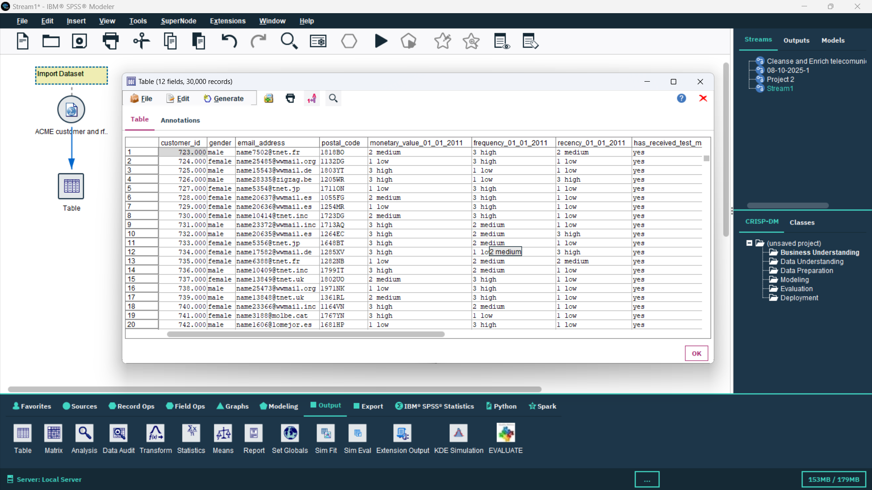
📸 Screenshot:

Import the dataset, use the table to get all the data (12 columns and 30000 rows)

2. Test Mailing Customers
- Select only customers who were in the test mailing.
- How many customers were included in the test mailing?

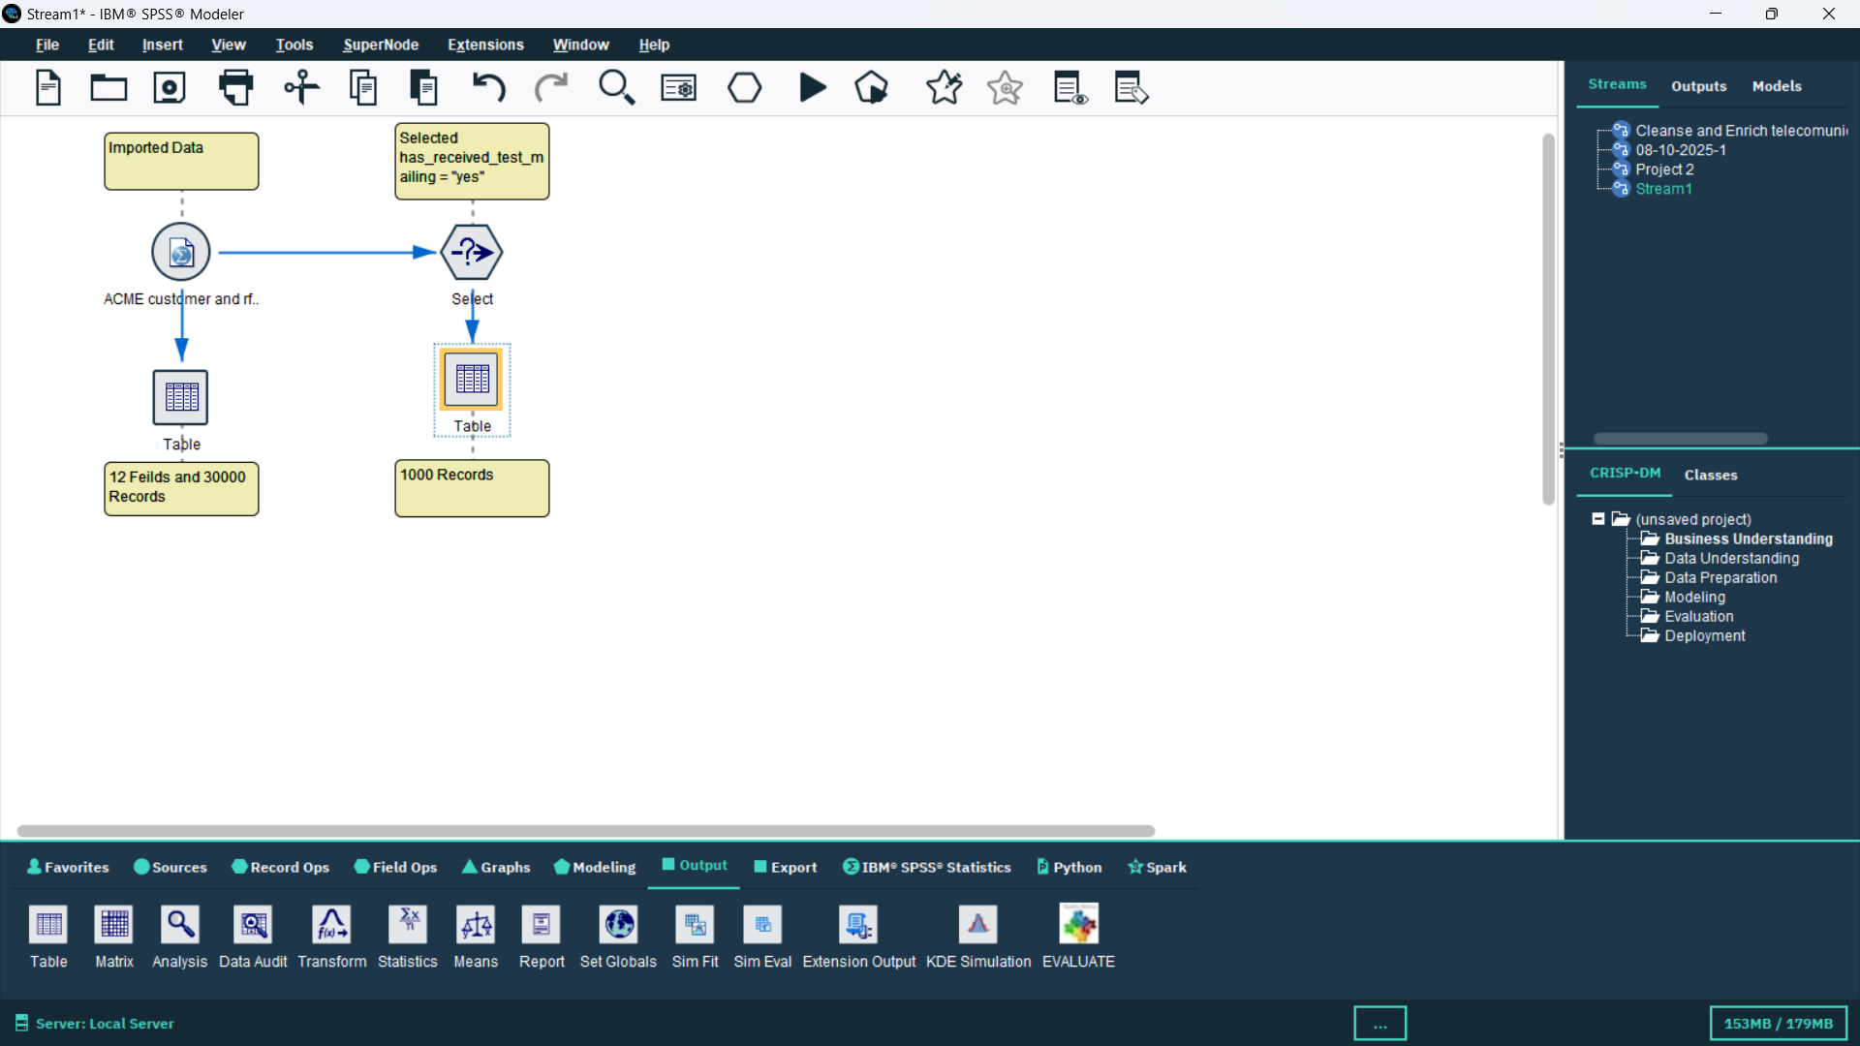
📸 Screenshot:

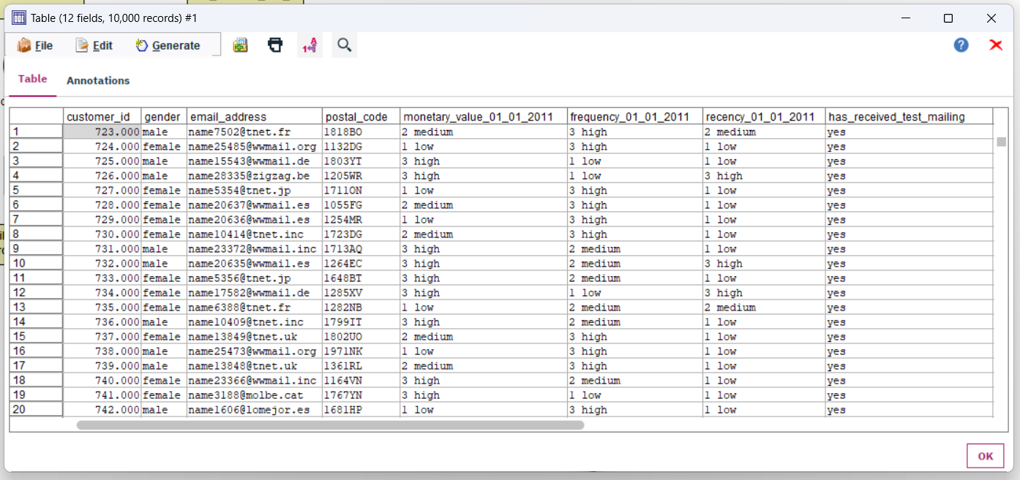
Filter the data for the “YES” value and generate the node, rename as training data. We got 10,000 records

2. Predictive Modeling
- Select Build a CHAID decision tree model to predict response , using:
- gender
- recency_01_01_2011
- frequency_01_01_2011
- monetary_value_01_01_2011
- Answer the following:
- Which field is used as the first split?
- Which group shows the highest response rate? What is the probability of responding for this group?
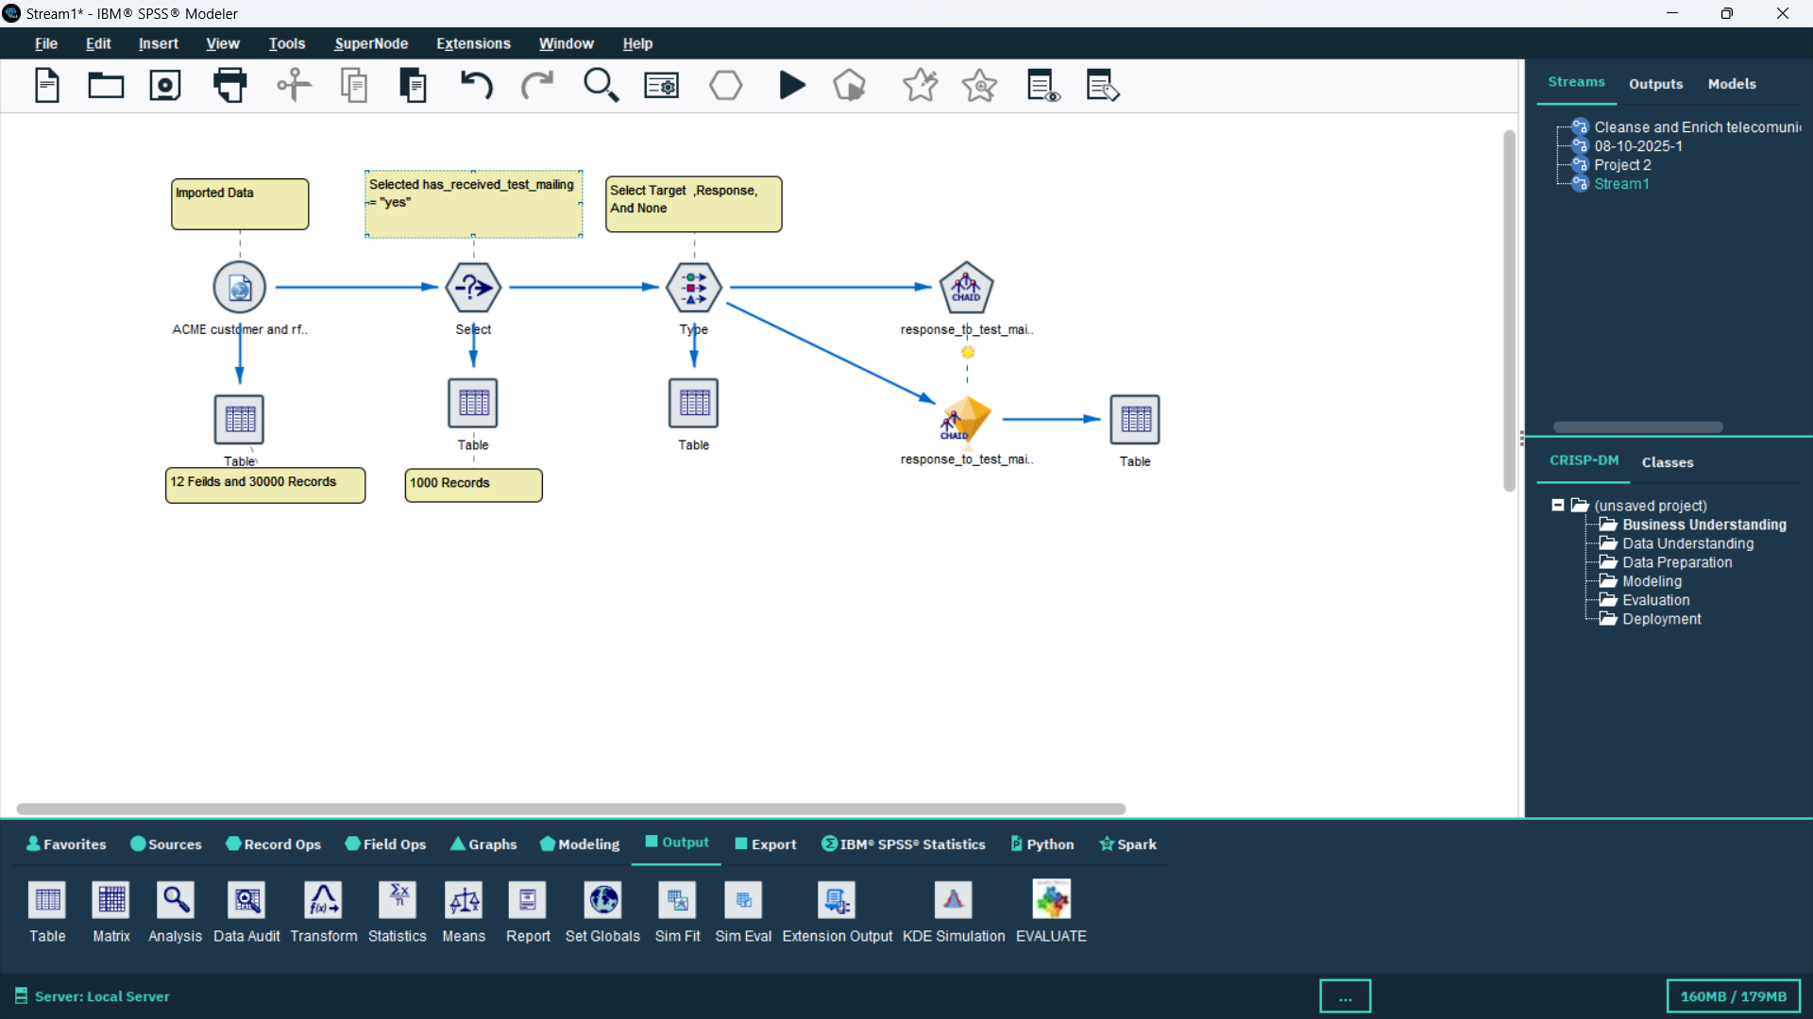
- How many customers were included in the test mailing?

Use the CHAID model and train the model with data.
Use the table to get the result after the model is trained
