UNIVERSITY OF MUMBAI
PROJECT DOCUMENTATION
BreastCare AI
A Local Research Platform for Breast Cancer Data Workflows

SUBMITTED BY
[Student Name]
Seat Number: [Seat Number]
Project Guide: [Name of Project Guide]
Department of Information Technology
University of Mumbai | [Academic Year]
Project documentation prepared in partial fulfilment of the requirements for the M.Sc. Part II examination.

PROJECT CERTIFICATE
This is to certify that the project entitled “BreastCare AI” submitted by [Student Name], Seat Number [Seat Number], in partial fulfilment of the requirements for the M.Sc. Part II Degree Examination, has been carried out under the guidance of [Name of Project Guide].
This document describes the implemented local research software, its experiments, and its limitations. The application is not a diagnostic tool and has not undergone clinical validation.
Date: __________________________
Project Guide: __________________________ Head of Department: __________________________
External Examiner: _______________________ College Stamp: ____________________________

ACKNOWLEDGEMENT
I would like to thank [Name of Project Guide] for guidance and feedback during the development of this project. I also acknowledge the Department of Information Technology, University of Mumbai, and the authors and maintainers of the datasets and software resources cited in this document. Please revise this section before submission to reflect the actual contributions and support received.
[Student Name] | [Date]

CONTENTS
Abstract and project scope
Chapter 1 Introduction
Chapter 2 Literature Review
Chapter 3 Methodology and Approach
Chapter 4 Proposed Design and UI/UX Design
Chapter 5 Conclusion
Bibliography - References and Links
Page numbers may be added after final screenshots and pagination are confirmed.

ABSTRACT
BreastCare AI is a local-first research prototype for breast-cancer-related data workflows. The project brings tabular data checks, report text extraction, technical imaging review, a research-only histopathology experiment, and separate genomics research planning into one interface. The software uses a React and TypeScript front end, a FastAPI service, and encrypted account-scoped local analysis history. Its current imaging workflows inspect metadata and headers; they do not make CT, MRI, or mammography predictions. The BreaKHis ResNet-18 experiment reports fold-wise results and an external BACH evaluation. On BACH, accuracy remained near chance and non-carcinoma specificity was low, so the classifier is not presented as transferable or clinically validated. A separate ClinVar BRCA1/BRCA2 artifact classifies variant annotations from public records; it does not estimate whether a person is an inherited carrier or predict cancer risk. This report describes the implementation, research methods, design, UI/UX, and evidence boundaries as of 29 October 2026. [1], [2], [3], [4]
Keywords: Breast cancer, digital pathology, medical imaging, BRCA1/BRCA2, research software
Research-use statement
This project is not a diagnostic product. No output should be used for screening, diagnosis, triage, treatment, or patient-care decisions. Clinical validation has not been performed.

CHAPTER 1 INTRODUCTION

1.1 Background
Breast-cancer research uses information from pathology, radiology, genomics, and clinical records. These data types differ in format and meaning. A histopathology image, a DICOM scan, a germline variant annotation, and a tumor somatic mutation are not interchangeable observations. The World Health Organization identifies early diagnosis and timely access to care as important parts of breast-cancer control [5]. Research software can support organized data review and reproducible experiments, but a working upload or model screen is not evidence that an algorithm is suitable for medical decisions.
BreastCare AI was developed as a local research workspace. It makes several data workflows available through one dashboard while showing whether a workflow performs descriptive analysis, text extraction, technical inspection, or research inference. A key requirement is to make unavailable models and research-only outputs explicit rather than implying that every module has a predictor. [4]

1.2 Problem Statement
Researchers often need to inspect heterogeneous breast-cancer datasets, preserve source files, document processing, and compare experiments. A single prototype can organize these tasks, but combining them under an AI label can also encourage users to assume that all modules make predictions. BreastCare AI addresses this communication and workflow problem by separating implemented utilities from model-development tracks that still lack suitable data, compatible checkpoints, or independent evaluation. [4]

1.3 Aim
The aim is to develop and document a local-first breast-cancer research platform that supports bounded data workflows, presents the evidence and status of its research models, and clearly limits interpretation to research use. [4]

1.4 Objectives
Build a responsive dashboard and account flow for a locally operated research workspace. [4]
Provide descriptive CSV analysis and report text extraction for human review. [6], [4]
Support technical review of selected raster, DICOM, NIfTI, and DICOM-series metadata without radiology inference. [4]
Expose optional BreaKHis histopathology checkpoints and report their training and external-evaluation evidence accurately. [1], [4]
Keep germline variant annotation, patient-level inherited-carrier status, and tumor somatic alterations as separate tasks. [3], [7], [4]
Store submitted source files and results in encrypted, account-scoped local history with preview, download, and deletion controls. [4]
State the limits of each module and prevent research outputs from being presented as clinical advice. [4]

1.5 Scope and Current Status
The current application includes seven workflow areas. Some are operational data-processing utilities; others are planning or metadata-review pages. The optional histopathology model is a research experiment whose external BACH results were poor. No CT-, MRI-, mammography-, or patient-level BRCA carrier-risk predictor is integrated into the application. [4]
Workflow | Implemented capability | Current boundary
CSV analysis | Schema, missingness, descriptive numeric statistics, category counts, and encrypted account history. | Descriptive analysis only; no medical prediction.
Doctor reports | Extract embedded PDF text or run local OCR on supported reports. | Text extraction only; OCR needs human checking and does not interpret medical meaning.
Histopathology | Optional local BreaKHis ResNet-18 and scratch-CNN checkpoints; Grad-CAM for ResNet-18. | Research-only; poor transfer on BACH; no patient use.
CT, MRI, X-ray and mammography | Single-file/series metadata and header review, including DICOM/NIfTI checks. | No modality-specific pixel inference or diagnosis.
BRCA genomics | De-identified cohort preflight and separate offline ClinVar variant-annotation artifact. | No patient-level carrier-risk predictor; ClinVar artifact is not app-integrated.
Account history | Encrypted account-scoped originals/results; readable summaries, previews, downloads, deletion. | Local research storage, not a clinical-record system.

1.6 Report Organization
Chapter 2 reviews the research literature and datasets relevant to the project. Chapter 3 describes the software architecture, module workflows, model-development approach, and current evidence. Chapter 4 presents the user and developer workflows, system design, and interface screens. Chapter 5 summarizes the project and its remaining work.

CHAPTER 2 LITERATURE REVIEW

2.1 Breast Cancer Research Context
Breast-cancer research spans screening images, diagnostic imaging, tissue pathology, inherited variant interpretation, and tumor-acquired changes. The WHO identifies BRCA1 and BRCA2 among high-penetrance inherited genes associated with breast-cancer risk, while clinical management depends on more than one data field [5]. Software should define the unit of analysis before training: an image, a curated variant record, a tumor sample, or a person with a confirmed clinical genetic result. [5], [3], [7]

2.2 Histopathology Datasets and BreaKHis
BreaKHis is a public breast histopathology image dataset introduced for benign-versus-malignant image classification. Its original paper describes 7,909 images from 82 patients at 40X, 100X, 200X, and 400X magnification [1]. The dataset supports controlled experiments, but images from the same patient can share appearance. Patient-group separation is important when estimating generalization. BreastCare AI trained separate magnification-specific ResNet-18 models using the supplied fold structure and held patient groups apart across fit, validation, and test partitions. [1], [4]

2.3 External Evaluation and BACH
The BACH challenge assembled breast histology images for classification and included four image-level categories: Normal, Benign, InSitu, and Invasive [2]. Evaluation on another dataset can reveal distribution shift, but one public benchmark is far short of clinical validation. In this project, saved BreaKHis checkpoints were evaluated on the same 400 BACH Photos images without retraining. For a binary summary, Benign and Normal were grouped as non-carcinoma while InSitu and Invasive were grouped as carcinoma. This study-specific mapping loses distinctions between the original categories and is reported with the results. [2], [4]

2.4 Convolutional Networks and Transfer Learning
Residual networks use skip connections to train deep image models and are common starting points for transfer-learning experiments [8]. BreastCare AI used an ImageNet-pretrained ResNet-18, froze early layers, and fine-tuned layer 4 and the classifier. Transfer learning does not remove differences in stains, magnification, scanners, patient populations, or label definitions. A strong internal score cannot replace external evaluation or justify clinical use. [8], [4]

2.5 Model Visualization
Grad-CAM uses class gradients to create a coarse localization map from convolutional features [9]. The optional worker can produce an overlay for the ResNet-18 checkpoint. A heatmap indicates image regions associated with a model output; it does not prove that those regions caused the prediction or establish a pathologist-level explanation. [9], [4]

2.6 Mammography and Cross-Sectional Imaging Data
CBIS-DDSM was curated for computer-aided detection and diagnosis research in mammography and includes decompressed images, lesion annotations, and pathology information [10]. The local BreastCare AI pilot is not training-ready: only two image/mask pairs have been verified, and mammography training is paused. QIN-BREAST on The Cancer Imaging Archive provides longitudinal PET/CT and MR imaging for treatment-response research [11]. It is a candidate source for future modality-specific studies, not a dataset already used to train a BreastCare AI CT or MRI model. The local CT/MRI folders remain unpopulated pending data-policy review. [10], [11], [12], [13], [4]

2.7 Germline and Somatic BRCA Data
ClinVar aggregates submitted interpretations of genetic variants and supports germline classifications as well as distinct somatic oncogenicity and clinical-impact classifications [3]. These are variant-level records from submitters, not a cohort of people with confirmed inherited-carrier outcomes. The project’s offline BRCA artifact uses public ClinVar BRCA1/BRCA2 annotations for a pathogenic/likely pathogenic versus benign/likely benign classification pilot. It is not a patient-level carrier detector or cancer-risk model. [3], [14], [4]
The project keeps open TCGA-BRCA somatic mutation files in a separate folder. Somatic MAF files describe alterations reported in tumor samples and are not a substitute for germline test results. The National Cancer Institute GDC documents the MAF format and how open somatic files are processed [7]. The app’s BRCA page provides a de-identified cohort preflight, not variant interpretation or patient prediction. [7], [4]

2.8 Research Gap and Design Response
Public datasets and deep-learning architectures enable experiments, but modality, target, patient grouping, data provenance, and independent evaluation determine what a result can support. The project gap is therefore not just the absence of another image classifier. It is the need for a transparent local environment that organizes data without confusing file checks or benchmark results with clinical evidence. BreastCare AI addresses that gap through module-specific status labels, scoped data workflows, encrypted history, and explicit research-only language. [1], [2], [8], [3], [4]

CHAPTER 3 METHODOLOGY AND APPROACH

3.1 Development Approach
The project followed an iterative software-development approach. Each module was implemented around a defined input, bounded processing step, and explicit output. The front end was connected to the API as features were added. Where a modality lacked suitable data or a compatible model, the interface reports a readiness or input-review state rather than fabricating inference. The local-first approach keeps normal processing on the student’s computer after dependencies are installed. [4]

3.2 System Architecture
The browser interface uses React, TypeScript, and Vite. It sends requests to a FastAPI backend, which validates account tokens, file types, and size limits before invoking module-specific processing. SQLite stores user accounts and encrypted analysis history. Passwords are stored as PBKDF2-HMAC hashes. Uploads and results are encrypted with a local Fernet key and restricted by account ownership. Optional histopathology inference runs in a separately configured Python environment so the app does not replace the existing PyTorch installation. [6], [4]
Layer | Role
React / TypeScript browser UI | Dashboard, account screens, module pages, file selection, status notices, readable summaries.
FastAPI service | Authentication, request validation, CSV analysis, OCR, imaging metadata review, and history controls.
Local processing | CSV statistics, PDF text/OCR, DICOM/NIfTI header review, DICOM-series consistency, optional histopathology worker.
SQLite and encryption | Account-scoped local history for supported originals and results; users can preview, download, and delete records.
Research data/model tracks | BreaKHis/BACH artifacts and a separate BRCA variant annotation artifact; CT/MRI model work unavailable, mammography paused.

3.3 Functional Processing Workflows
CSV analysis validates extension and content type, decodes common encodings, detects delimiters, validates row structure, then computes schema, missingness, numeric summaries, and frequent categories. The report workflow extracts embedded PDF text or uses local OCR on scanned PDFs and images; extracted text is returned for human review. Imaging review reads selected DICOM or NIfTI header fields or raster dimensions. DICOM-series review checks technical consistency across a group of instances. These imaging endpoints do not analyze pixels for cancer. [6], [4]
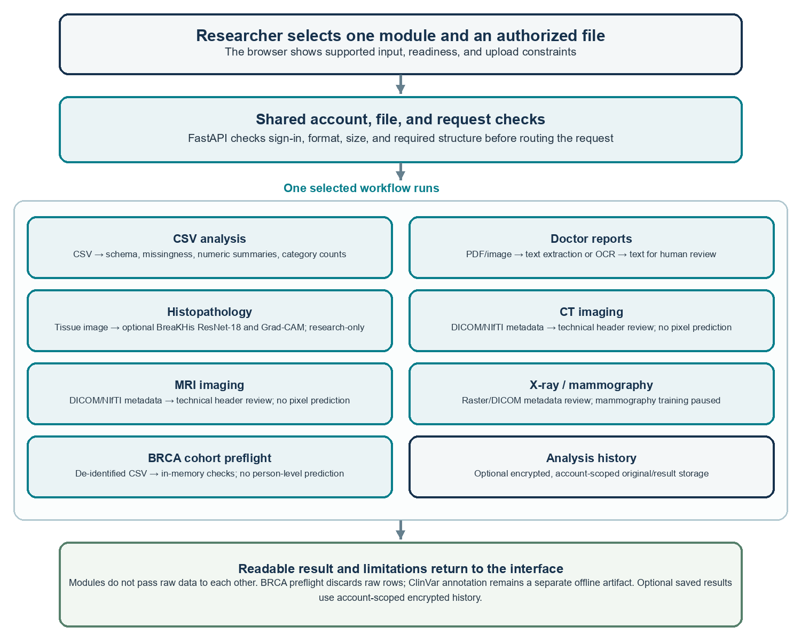
Figure 3.1. Module inputs, processing resources, shared data path, outputs, and boundaries.

3.4 Module Resources, Connections, and Data Flow
Each module receives a user-selected input through the browser and a shared FastAPI request path. The backend checks the signed-in account, file type, size, and required structure before routing the request to the selected module. Each module returns its own result to the interface; raw module outputs are not chained into another module. Where enabled, source files and results are stored in encrypted, account-scoped local history. The BRCA preflight processes rows in memory and discards them, while the separate ClinVar annotation artifact is not connected to the application. This design shares authentication and file-handling services without treating the seven workflows as one predictive model. [4]
Table 3.1. Module inputs, processing resources, outputs, and connections.
Module | Input / resource used | Operation and output | Connection / boundary
CSV analysis | User CSV; local parsing and summary logic | Schema, missingness, numeric summaries, category counts | Browser → API → CSV workflow → readable result; optional history
Doctor reports | PDF/image; local text extraction or OCR components | Extracted text for human review | Browser → API → report workflow → text result; not a diagnosis
Histopathology | Tissue image; optional BreaKHis ResNet-18 checkpoint; Grad-CAM worker when available | Research-only classification output and optional heatmap | Browser → API/model worker → result; not clinically validated
CT imaging | DICOM/NIfTI input; metadata/header reader | Technical metadata review | No pixel-based cancer prediction
MRI imaging | DICOM/NIfTI input; metadata/header reader | Technical metadata review | No pixel-based cancer prediction
X-ray / mammography | Supported raster/DICOM input; metadata reader | Technical metadata review | No pixel-based prediction; mammography training remains paused
BRCA cohort preflight | De-identified CSV; in-memory schema and aggregate checks | Readiness/data-quality summary | Raw rows discarded; no person-level inherited-risk prediction
Shared history | Optional saved source files/results; SQLite and local Fernet encryption | Account-scoped readable history, preview/download/delete | Shared storage service; not a prediction module. Offline ClinVar artifact is separate

3.5 Upload and Storage Controls
Backend limits are enforced before processing and displayed in the interface. Supported analysis uploads are retained in encrypted local account history where the workflow saves them. BRCA cohort preflight processes a de-identified CSV in memory and discards the raw rows. Use authorized, de-identified research data; this prototype is not designed for identifiable clinical records. [6], [4]
Input workflow | Maximum accepted size
CSV analysis and BRCA cohort preflight | 50 MB per file
Doctor report PDF or image | 25 MB; scanned PDF up to 20 pages
Histopathology image | 50 MB per file
Single DICOM or raster image | 50 MB per file
NIfTI file | 500 MB per file
DICOM series | Up to 500 instances / 250 MB total; 50 MB per instance

3.6 BreaKHis Training Protocol
An ImageNet-pretrained ResNet-18 was trained separately for four BreaKHis magnifications at 128 by 128 pixels. Earlier layers were frozen while layer 4 and the classifier were fine-tuned. Each of five official folds used a group-separated validation subset from training, with the official test partition held out. Training ran up to eight epochs with validation-loss early stopping, patience two. The owner used an existing CUDA-enabled NVIDIA RTX 3050 environment; this project did not install or pin PyTorch. Fold metrics are summarized as arithmetic means; official test partitions overlap and are not pooled as independent images. [1], [8], [4]
Table 3.2. Five-fold BreaKHis mean metrics. These are research split results, not patient-level performance estimates. [1], [4]
Magnification | Accuracy | Malignant recall | Benign specificity | Balanced accuracy
40X | 77.0% | 82.9% | 65.4% | 74.1%
100X | 77.2% | 83.7% | 64.4% | 74.1%
200X | 81.4% | 82.9% | 78.1% | 80.5%
400X | 81.3% | 83.0% | 78.2% | 80.6%

3.7 BACH External Evaluation
Twenty saved BreaKHis ResNet-18 checkpoints were evaluated without retraining on 400 BACH Photos images, with 100 in each original class. Images were resized in memory to 128 by 128, converted to RGB, and ImageNet-normalized. For the binary summary, Benign plus Normal were grouped as non-carcinoma, and InSitu plus Invasive as carcinoma. Every fold model was evaluated on the same images; fold-model variation is descriptive, not a confidence interval. [2], [4]
Table 3.3. BACH external research evaluation means. Near-chance accuracy and low non-carcinoma specificity indicate poor transfer in this setup, not clinical performance. [2], [4]
Training magnification | BACH accuracy | Carcinoma recall | Non-carcinoma specificity | Balanced accuracy
40X | 50.2% | 70.1% | 30.3% | 50.2%
100X | 49.2% | 79.6% | 18.7% | 49.2%
200X | 52.1% | 79.7% | 24.5% | 52.1%
400X | 49.2% | 85.7% | 12.6% | 49.2%

3.8 BRCA Genomics Method and Data Separation
The separate ClinVar artifact was trained on filtered BRCA1/BRCA2 variant records, not participant-level outcomes. After ambiguous-locus exclusions, 2,938 records were used: 2,357 for training and 581 for a grouped holdout. The split kept gene and GRCh38 locus groups separate. A logistic-regression pipeline used gene, variant/protein text, and molecular-consequence features. Holdout accuracy was 0.983, balanced accuracy 0.980, and ROC AUC 0.995. Because both training and holdout came from ClinVar, this result is internal to that database and is not independent clinical validation. It does not predict inherited carrier status or cancer risk and is not integrated into the app. [3], [14], [4]
Somatic TCGA-BRCA MAF files remain a separate tumor-data track. No supervised somatic prediction model was trained because the available files do not provide the patient-level outcome label required for the intended task. A future inherited-risk model requires an authorized cohort with genetic-test labels; public variant annotations or somatic tumor files are not substitutes. [7], [4]

3.9 Software Verification and Evidence Boundaries
Software verification covers whether the application builds, starts locally, validates requests, and returns expected utility outputs. A front-end production build and local API health response were confirmed during project work. Such checks establish software operation only. They do not measure diagnostic accuracy, clinical usefulness, safety, or generalization. Future predictive work requires authorized data, a prespecified endpoint, patient-level splits, reproducible preprocessing, independent evaluation, uncertainty reporting, and qualified clinical review. [4]
Interpretation of metrics
BreaKHis and ClinVar metrics describe their supplied research datasets and splits. BACH is an external dataset evaluation, but its near-chance results show that the current histopathology checkpoints did not transfer reliably in this setup. None of these scores is a clinical performance claim.

CHAPTER 4 PROPOSED DESIGN AND UI/UX DESIGN

4.1 Design Goals
The interface is designed for a student or researcher working locally with authorized, de-identified data. The main goals are to make workflows easy to find; show what a module can and cannot do; explain the next action before submission; provide clear progress and error feedback; present saved output in readable form; and keep research-only notices near model outputs. The screen flow avoids presenting incomplete modality tracks as clinical predictors. [4]

4.2 Proposed System Flow
Stage | User/system action | Outcome
1. Select workflow | Choose CSV, Reports, Histopathology, imaging review, or BRCA preflight. | Page shows accepted input, size limits, and supported processing.
2. Select file | Choose authorized, de-identified research data. | Filename and size are shown before submission.
3. Validate/process | Browser sends the file after the user selects the action. | API checks token, type, and size, then runs the stated operation.
4. Review output | Inspect summary, extracted text, metadata, or research-only model output. | Result includes scope and limitations.
5. Manage history | View readable results; preview, download, or delete originals. | Encrypted local history remains account-scoped and user-managed.

4.3 User and Developer Workflows
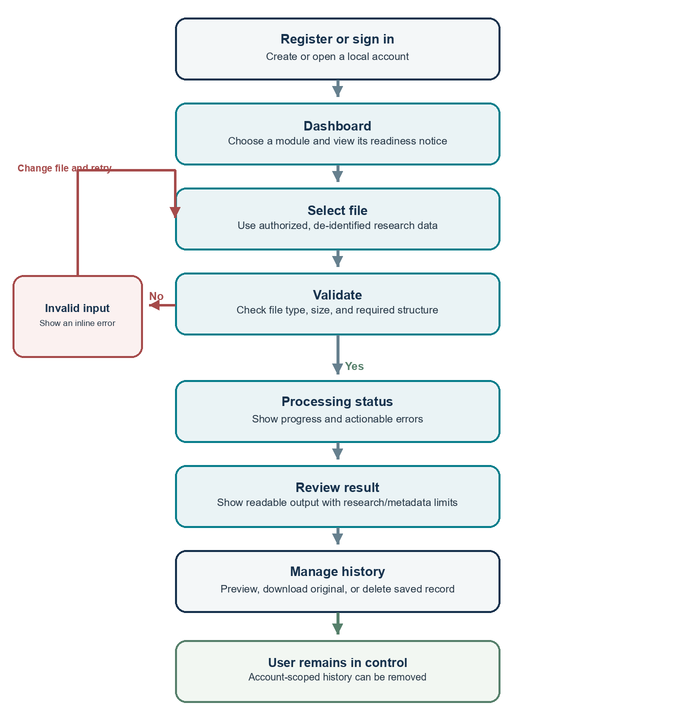
Figure 4.1. Proposed user workflow from sign-in through result review and history management.
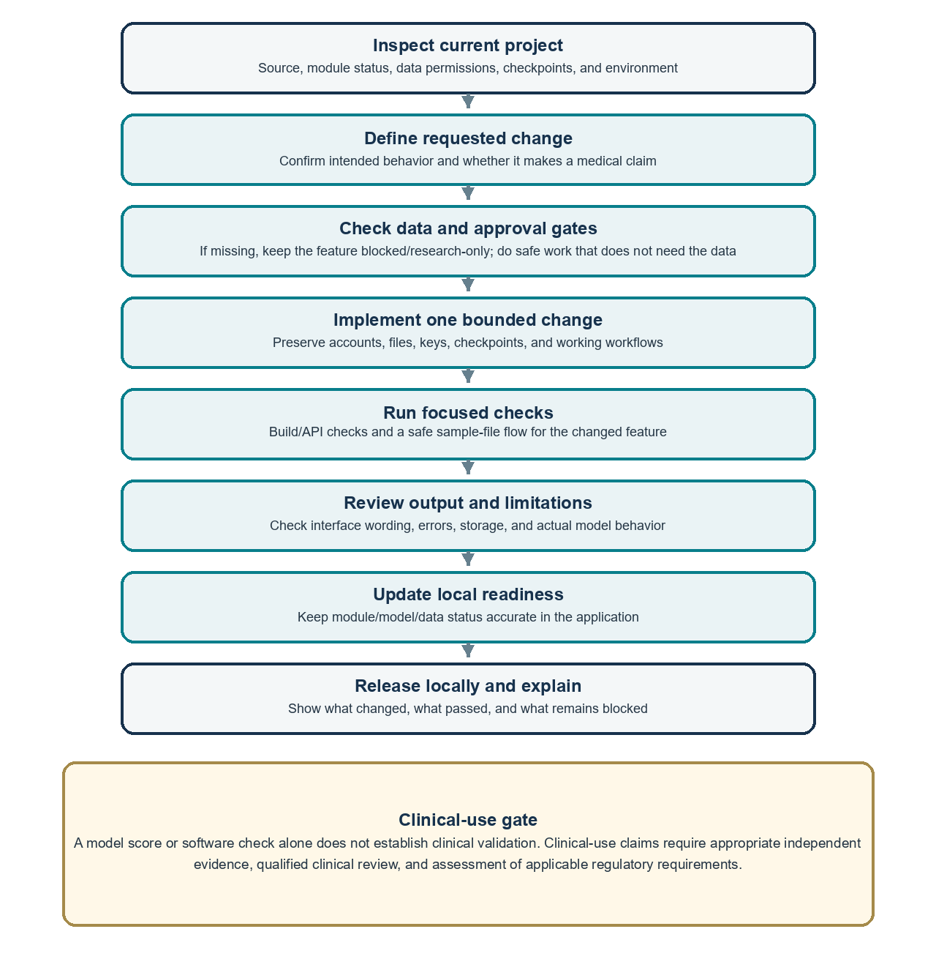
Figure 4.2. Developer/maintainer workflow for safe local changes and evidence-gated model work.
The developer/maintainer workflow describes project work outside the end-user application. It does not imply that the app contains an administrator account or admin dashboard. Data access, clinical scope, and evidence gates must be satisfied before a research workflow is promoted beyond its current capability. [4]

4.5 Navigation and Main Screens
Persistent navigation provides Dashboard, seven analysis modules, Model Registry, Experiment Results, Analysis History, and Settings. The Account control opens sign-in or registration; Sign out appears when a token is stored. Module pages place a file-selection card beside a status/readiness panel. This keeps file actions and cautions visible together. [4]

4.6 UI/UX Screen Descriptions
Dashboard. The starting page separates imaging workflows from tabular and document workflows. Module cards show short descriptions and readiness. The interface uses navy headings, teal actions, neutral surfaces, and warning badges for research-only or unavailable states. [4]
Analysis pages. CSV and report pages provide a file picker, selected-file summary, action button, inline errors, and structured results. Histopathology pages show checkpoint selection, configuration state, research warnings, and optional Grad-CAM controls. CT/MRI/X-ray pages accept supported single files or a DICOM series and describe metadata-only checks. The BRCA page performs de-identified cohort preflight and keeps inherited germline, tumor somatic, and variant annotation concepts distinct. [6], [4]
History and account pages. History lists saved records by type, size, and time. Users can open a readable result, preview supported image/PDF/CSV originals, download the complete original, or delete the entry. Authentication screens provide Register and Sign in modes with actionable form and session messages. [4]

4.7 Screenshot Areas
The blank areas below are reserved for screenshots from the final local interface. Capture only de-identified sample data and verify that no patient or personal information is visible. Captions identify each screen; the boxes are intentionally left empty. [4]
Figure 4.3. Dashboard and module navigation screenshot area.
Figure 4.4. CSV Analysis or Doctor Reports workflow screenshot area.
Figure 4.5. Histopathology workflow and research-only notice screenshot area.
Figure 4.6. CT, MRI, or X-ray metadata-review screen screenshot area.
Figure 4.7. BRCA cohort preflight and germline/somatic status screenshot area.
Figure 4.8. Readable Analysis History and original-file preview screenshot area.
Figure 4.9. Sign-in and registration screen screenshot area.

4.8 Accessibility, Feedback, and Privacy
The interface uses text labels in addition to icons, clear button names, visible selected-file information, and inline status/error notices. Responsive layouts adapt to narrower screens. Before submission, confirm keyboard focus visibility, readable contrast, heading order, and screenshot captions against the current application. Do not expose secret keys, real patient identifiers, or sensitive files in screenshots. The app is a local research prototype, not a clinical-record platform. [4], [15]

4.9 Limitations and Future Work
The BreaKHis model did not transfer reliably to BACH; no clinical validation has been performed. [2], [4]
CT/MRI candidate folders are empty; data access, endpoint definition, and cohort design remain prerequisites. [11], [13], [4]
Mammography training is paused; only two local image/mask pairs are verified, which is insufficient for training. [10], [4]
The ClinVar BRCA artifact is variant-level, not person-level, and is not app-integrated; its holdout is not an independent clinical cohort. [3], [14], [4]
Somatic TCGA-BRCA files are not a germline-carrier dataset and did not support the intended supervised outcome model. [7], [4]
Larger uploads consume additional disk space because source files and results remain in encrypted history until deleted. [4]
Future prediction requires authorized labelled data, patient-level separation, independent evaluation, and appropriate clinical and ethics oversight before clinical claims. [4]

CHAPTER 5 CONCLUSION
BreastCare AI is a functioning local research prototype for breast-cancer data workflows, not a complete medical AI system. It combines descriptive CSV analysis, report text extraction, metadata-only imaging review, encrypted account history, and optional histopathology research inference. It organizes separate BRCA germline variant and somatic tumor tracks without representing either as a patient-level risk predictor. The BACH evaluation and current data gaps define the limits on model claims. The interface keeps these boundaries visible and reserves space for final screenshots. [4]

BIBLIOGRAPHY - REFERENCES AND LINKS
[1] F. A. Spanhol, L. S. Oliveira, C. Petitjean, and L. Heutte. A Dataset for Breast Cancer Histopathological Image Classification. IEEE Transactions on Biomedical Engineering, 63(7), 1455-1462, 2016. doi:10.1109/TBME.2015.2496264. https://doi.org/10.1109/TBME.2015.2496264
[2] G. Aresta et al. BACH: Grand challenge on breast cancer histology images. Medical Image Analysis, 56, 122-139, 2019. doi:10.1016/j.media.2019.05.010. https://doi.org/10.1016/j.media.2019.05.010
[3] M. J. Landrum et al. ClinVar: updates to support classifications of both germline and somatic variants. Nucleic Acids Research, 53(D1), D1313-D1321, 2025. doi:10.1093/nar/gkae1090. https://doi.org/10.1093/nar/gkae1090
[4] Ayush. BreastCare AI application source, local model training/evaluation artifacts, and interface evidence. Unpublished project materials, accessed 29 October 2026.
[5] World Health Organization. Breast cancer. Fact sheet, 3 July 2026. https://www.who.int/news-room/fact-sheets/detail/breast-cancer
[6] FastAPI. Request Files and UploadFile documentation. https://fastapi.tiangolo.com/tutorial/request-files/
[7] National Cancer Institute. Genomic Data Commons: MAF file format and access documentation. https://docs.gdc.cancer.gov/Data/File_Formats/MAF_Format/
[8] K. He, X. Zhang, S. Ren, and J. Sun. Deep Residual Learning for Image Recognition. CVPR, 770-778, 2016. doi:10.1109/CVPR.2016.90. https://doi.org/10.1109/CVPR.2016.90
[9] R. R. Selvaraju et al. Grad-CAM: Visual Explanations from Deep Networks via Gradient-Based Localization. ICCV, 618-626, 2017. doi:10.1109/ICCV.2017.74. https://doi.org/10.1109/ICCV.2017.74
[10] R. S. Lee, F. Gimenez, A. Hoogi, K. K. Miyake, M. Gorovoy, and D. L. Rubin. A curated mammography data set for use in computer-aided detection and diagnosis research. Scientific Data, 4, 170177, 2017. doi:10.1038/sdata.2017.177. https://doi.org/10.1038/sdata.2017.177
[11] X. Li et al. Data From QIN-BREAST (Version 2). The Cancer Imaging Archive, 2016. doi:10.7937/K9/TCIA.2016.21JUEBH0. https://doi.org/10.7937/K9/TCIA.2016.21JUEBH0
[12] The Cancer Imaging Archive. QIN-BREAST collection record and dataset citation. https://www.cancerimagingarchive.net/collection/qin-breast/
[13] The Cancer Imaging Archive. Data Usage Policies and Restrictions. https://www.cancerimagingarchive.net/access-data/
[14] NCBI. ClinVar database and download documentation. https://www.ncbi.nlm.nih.gov/clinvar/docs/downloads/
[15] World Wide Web Consortium. Web Content Accessibility Guidelines (WCAG) 2.2, 2023. https://www.w3.org/TR/WCAG22/

